

# Linux Basic Commands Assignment

***Assignment Part-3***

Playing with files

1. Create a file like **nano file1.txt**

o Edit some data and then save the file

1. Now we will copy date from file1 to new file2

# o cp file1.txt file2.txt

* Then see the output of file2.txt, **cat file2.txt**
* Give screenshot

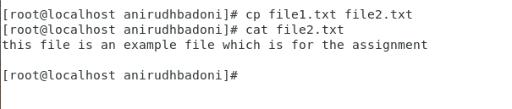

1. Now we will move the file2.txt to new folder **/home**

# mv file2.txt /home

* + Then go to **home** directory and check **ls,** file exits or not?
  + Given screenshot

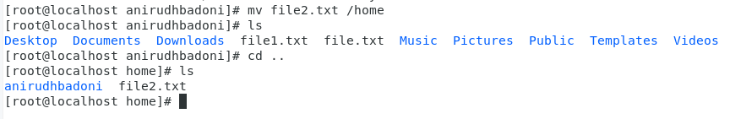

1. Then we create a new **file3.txt and file4.txt** in **home directory** and add content in it.
   * Now do **echo “Hello I am newline” > file3.txt** and provide the output of file3.txt
   * Now do **echo “Hello I am newline” >> file4.txt** and provide the output of file4.txt
   * **Tell the different between both step you follow and the reason behind it:- nano command is a text editor which is used to create a file whereas echo is the command used to print something on the screen .**
   * **The difference between both the steps is that in one (nano) we created a file then edited it and then saved it with nano command whereas in second (cat and echo) we first created the file with cat command and then we redirected the text from screen to the file from echo command.**

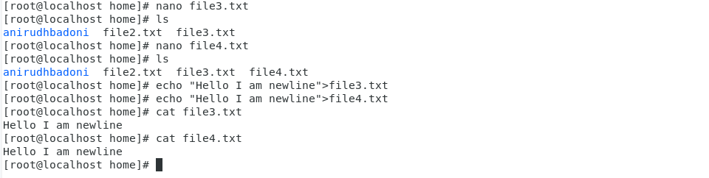

1. For remove a file or directory you can use the below two commands

* To delete a file – **rm <any_filename>**
* To delete a directory - **rmdir <any_directoryname>**