Experiment 1

Setting Up Python Environment and Libraries – Jupyter Notebook

Aim: To configure Python, Jupyter Notebook and verify the installation of essential data analytics libraries using the Space Mission dataset.

Procedure
- Install Jupyter Notebook using the command pip install notebook.
- Create a new Python notebook and rename it appropriately.
- Import the required libraries such as NumPy, Pandas, and Matplotlib.
- Verify the successful installation of the libraries by checking their versions.
- Load the Space Mission Dataset (all_space_mission_launches.csv) using the Pandas read_csv() function.
- Display the first few records of the dataset to verify successful loading.
- Examine the dataset structure using functions like info(), shape, and describe().
- Perform basic NumPy operations to verify numerical computation capabilities.
- Generate a simple visualization using Matplotlib to ensure the plotting library is functioning correctly.
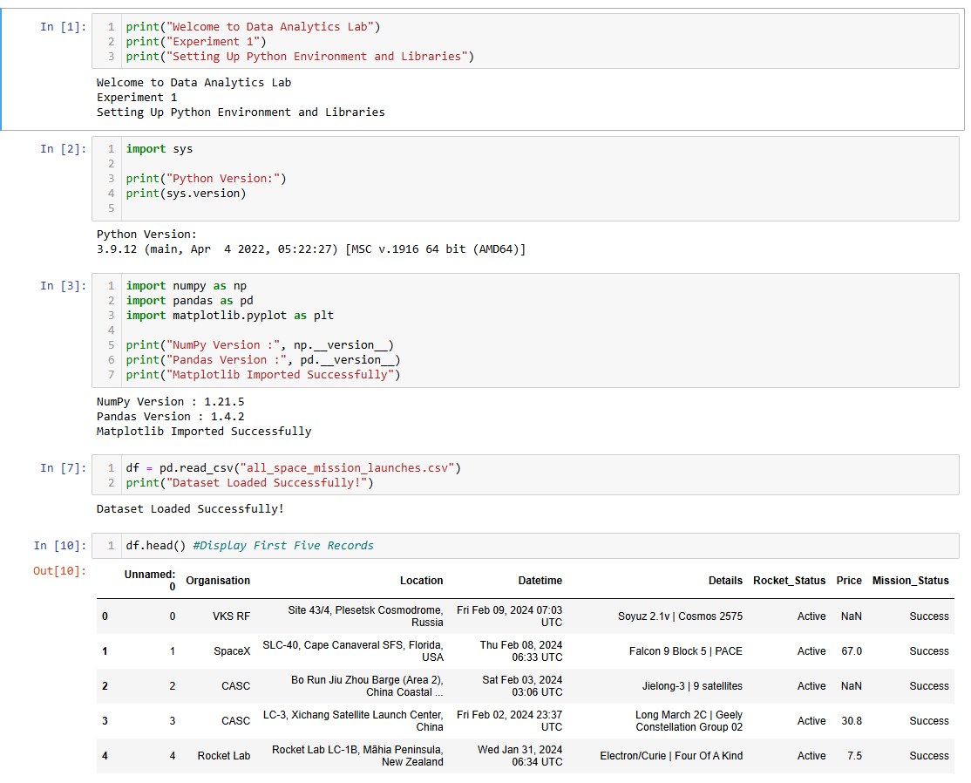
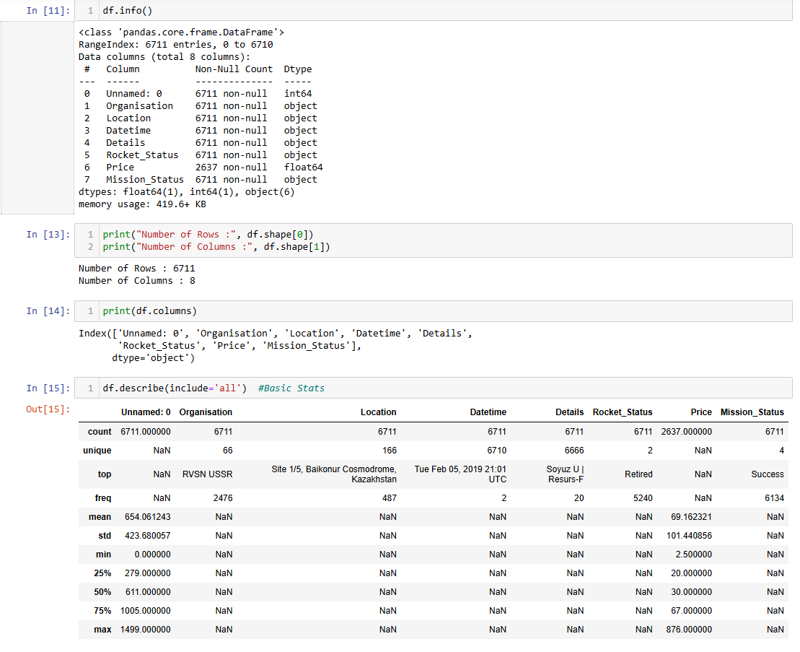
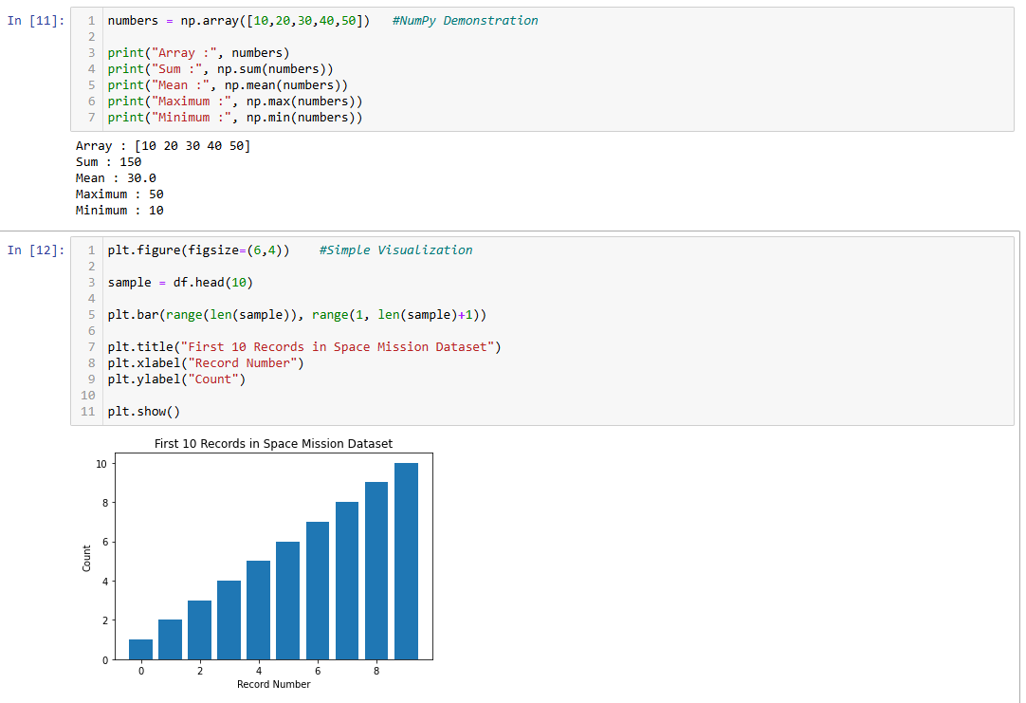

Experiment 2: Exploratory Data Analysis (EDA) – Data Import and Export
Aim:
To import the Space Mission dataset from various sources, perform basic exploratory data analysis using Pandas, and export the processed data into different file formats.

Procedure
- Open Jupyter Notebook and import the required libraries such as Pandas and SQLite3.
- Load the Space Mission Dataset (all_space_mission_launches.csv) using the read_csv() function.
- Display the first and last five records of the dataset using head() and tail().
- Examine the dataset structure using info(), shape, and dtypes.
- Generate a statistical summary using the describe() function.
- Identify missing values using the isnull().sum() function.
- Detect duplicate records using the duplicated() function and remove them if necessary.
- Save the dataset as an Excel file using the to_excel() function and verify it by importing it again with read_excel().
- Create an SQLite database and store the dataset as a table using the to_sql() function.
- Export the processed dataset to CSV, Excel, and JSON formats using to_csv(), to_excel(), and to_json().

