**RESULTS –**

1. Linear Regression –



1. Decision Tree

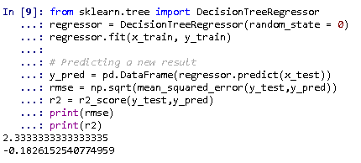

1. Random Forest

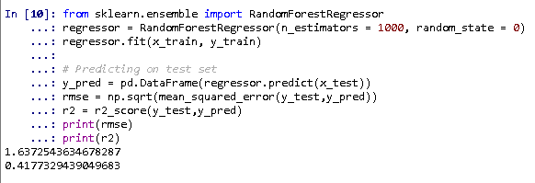

1. Polynomial Regression

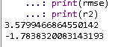

1. MLP Classifier –

