Networking

---------------------------------------------------------------------------

**Name:** Anirudh Nagulapalli **Active Learning:** L2 Switching with VLANs

**Description:**

The main goal of this Active Learning module - ‘L2 Switching with VLANs’ is to Install Cisco Packet Tracer, Create a Network Topology, Install Microsoft Visio, Recreate the same Topology in Visio, Configuring PCs, Configuring Switches, Verify the LANs are connected.

**Topology:**

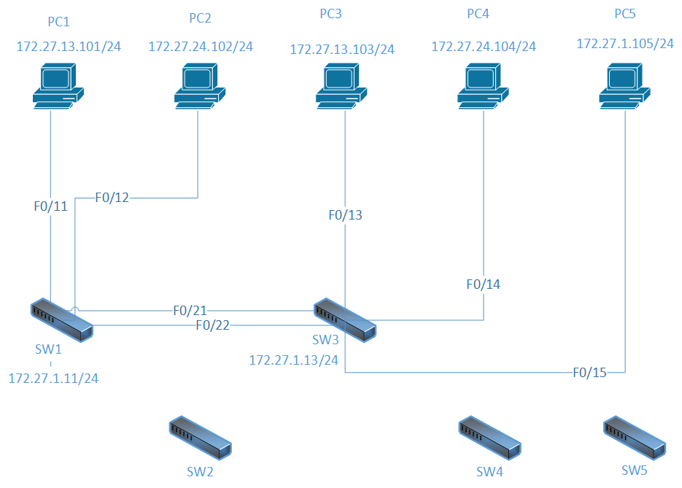

**Configuration Syntax:**

|  |  |
| --- | --- |
| **Syntax** | **Description** |
| Hostname Sw1 | Sets the hostname to Sw1 |
| Enable password Cisco | Sets the password to ‘Cisco’ and enables it |
| Int vlan 24 | Interface vlan ‘vlan number’ |
| Name PC2+PC4 | Sets the name of the VLAN to PC2+PC4 |
| Switchport mode trunk | Puts the interface into Trunk mode |
| Show int trunk | Display characteristics for interface trunk |
| Switchport mode access | Puts the interface into access mode |
| Switchport access vlan 24 | Assign the port to a vlan-id |
| Line con 0  Line vty 0 5 | Console line  Virtual terminal lines |
| Logging Synchronous | To synchronise messages coming from either con line or vty line |
| Transport input telnet | Used for User authentication from PC |

**Show Command Output:**

|  |  |
| --- | --- |
| **Syntax** | **Associated Output** |
| Sh vlan | Sw1#sh vlan    VLAN Name Status Ports  ---- -------------------------------- --------- -------------------------------  1 default active Fa0/1, Fa0/2, Fa0/3, Fa0/4  Fa0/5, Fa0/6, Fa0/7, Fa0/8  Fa0/9, Fa0/10, Fa0/13, Fa0/14  Fa0/15, Fa0/16, Fa0/17, Fa0/18  Fa0/19, Fa0/20, Fa0/22, Fa0/23  Fa0/24, Gig0/1, Gig0/2  13 PC1+PC3 active Fa0/11  24 PC2+PC4 active Fa0/12  1002 fddi-default act/unsup  1003 token-ring-default act/unsup  1004 fddinet-default act/unsup  1005 trnet-default act/unsup    VLAN Type SAID MTU Parent RingNo BridgeNo Stp BrdgMode Trans1 Trans2  ---- ----- ---------- ----- ------ ------ -------- ---- -------- ------ ------  1 enet 100001 1500 - - - - - 0 0  13 enet 100013 1500 - - - - - 0 0  24 enet 100024 1500 - - - - - 0 0  1002 fddi 101002 1500 - - - - - 0 0  1003 tr 101003 1500 - - - - - 0 0  1004 fdnet 101004 1500 - - - ieee - 0 0  1005 trnet 101005 1500 - - - ibm - 0 0    Remote SPAN VLANs  ------------------------------------------------------------------------------      Primary Secondary Type Ports  ------- --------- ----------------- ------------------------------------------ |
| Sh ip int brief | Interface IP-Address OK? Method Status Protocol    FastEthernet0/1 unassigned YES manual down down    FastEthernet0/2 unassigned YES manual down down    FastEthernet0/3 unassigned YES manual down down    FastEthernet0/4 unassigned YES manual down down    FastEthernet0/5 unassigned YES manual down down    FastEthernet0/6 unassigned YES manual down down    FastEthernet0/7 unassigned YES manual down down    FastEthernet0/8 unassigned YES manual down down    FastEthernet0/9 unassigned YES manual down down    FastEthernet0/10 unassigned YES manual down down    FastEthernet0/11 unassigned YES manual up up    FastEthernet0/12 unassigned YES manual up up    FastEthernet0/13 unassigned YES manual down down    FastEthernet0/14 unassigned YES manual down down    FastEthernet0/15 unassigned YES manual down down    FastEthernet0/16 unassigned YES manual down down    FastEthernet0/17 unassigned YES manual down down    FastEthernet0/18 unassigned YES manual down down    FastEthernet0/19 unassigned YES manual down down    FastEthernet0/20 unassigned YES manual down down    FastEthernet0/21 unassigned YES manual up up    FastEthernet0/22 unassigned YES manual up up    FastEthernet0/23 unassigned YES manual down down    FastEthernet0/24 unassigned YES manual down down    GigabitEthernet0/1 unassigned YES manual down down    GigabitEthernet0/2 unassigned YES manual down down    Vlan1 172.27.1.11 YES manual up up    Vlan13 unassigned YES manual up up    Vlan24 unassigned YES manual up up |
| Sh int trunk | Port Mode Encapsulation Status Native vlan  Fa0/21 on 802.1q trunking 1    Port Vlans allowed on trunk  Fa0/21 1-1005    Port Vlans allowed and active in management domain  Fa0/21 1,13,24    Port Vlans in spanning tree forwarding state and not pruned  Fa0/21 none |

**What worked, What didn’t?**

Downloading Wineskin Winery was easy. But the actual problem has arised while installing ‘PacketTracer70_64bit_setup.exe’. After installation, while running Cisco Packet Tracer, it didn’t respond at all. I’ve then googled about it and have seen some users posting Packet Tracer 6 works well with Os X El Capitan. I then logged into <https://www.netacad.com> and downloaded ‘PacketTracer63_setup.exe’ which actually worked as expected. Everything else was fine.

**Configuration Files:**

Attached files

AL-L2-VLANs-Nagulapalli.pkt

Sw1-Nagulapalli.txt

Sw3-Nagulapalli.txt