Networking

---------------------------------------------------------------------------

**Name:** Anirudh Nagulapalli **Active Learning:** Static Routing

**Description:**

The main goal of this Active Learning module - ‘Static Routing’ is to create a network topology consisting of PC’s, Switches and Routers using Cisco Packet Tracer, Configuring them as per the requirements. The idea is to set up the elements in different networks into a single one so that any component can reach each and every other component.

**Topology:**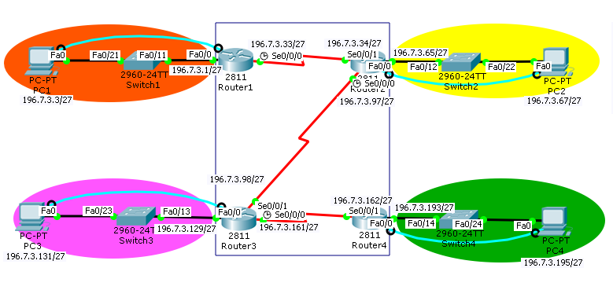

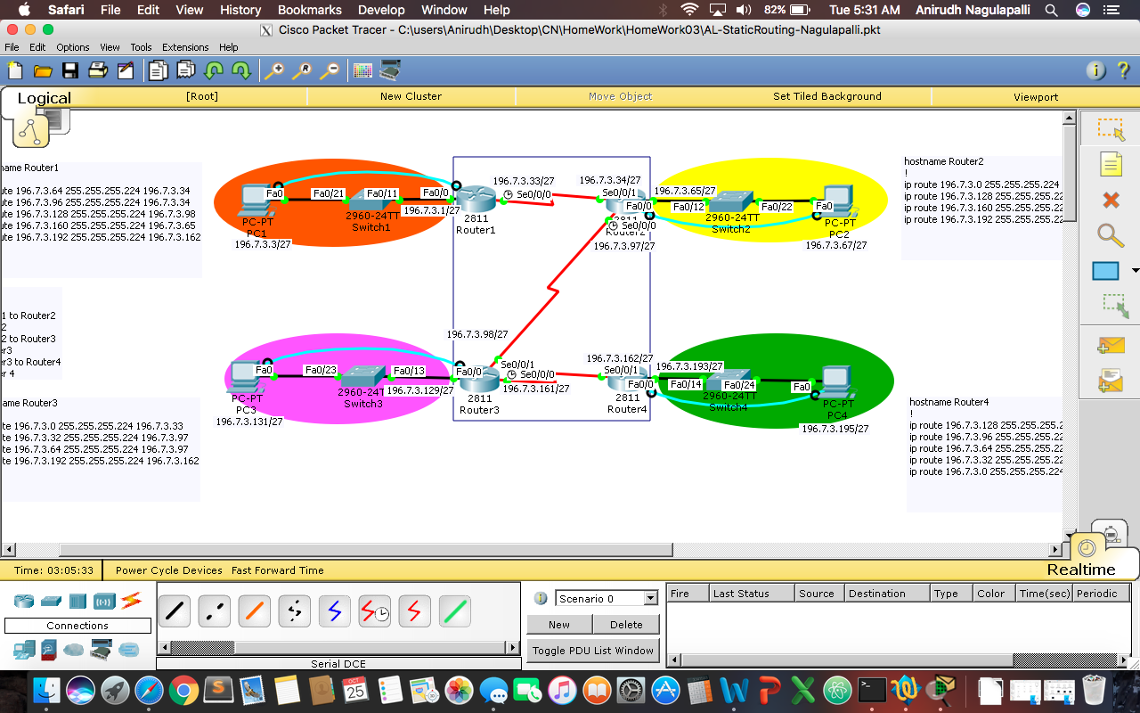

**Configuration Syntax:**

|  |  |
| --- | --- |
| **Syntax** | **Description** |
| Hostname Router1 | Sets the hostname to Router1 |
| Enable password Cisco | Sets the password to ‘Cisco’ and enables it |
| Enable secret Cisco | Sets the encrypted password ‘Cisco’ and enables it |
| Int f0/0 | Interface of Fast Ethernet is created |
| Int s0/0/0 | Interface of Serial port is created |
| Ip address 196.7.3.3 255.255.255.224 | Assigns an ip with the given submask |
| No shutdown | Doesn’t let the interface to shutdown |
| Ping 196.7.3.195 | Pings the device with the associated ip |
| Login | Enables a login prompt |
| Line con 0  Line vty 0 5 | Console line  Virtual terminal lines |
| Logging Synchronous | To synchronise messages coming from either con line or vty lines |

**Show Command Output:**

|  |  |
| --- | --- |
| **Syntax** | **Associated Output** |
| Sh ip route | Shows the routing table |
| Sh run | Displays the Interfaces used (in separate .txt files) |
| Ping 196.7.3.195  (From PC1) |  |
| Tracert 196.7.3.3  (From PC4) |  |

**Troubleshooting Syntax**

I used the ‘sh ip route’ to check if the Static Routing was performed correctly or not.

Also used ‘no ip route [Destination Network address] [Destination Network Subnet mask ] [Next hop Router address]’ to delete the unnecessary routing.

**What worked, What didn’t?**

Everything worked out fine except the routing from Router4. The coming back part (Router3 to Router2), (Router2 to Router1) felt confusing. But figured that out.

**Configuration Files:**

Attached files

AL-StaticRouting-Nagulapalli.pkt

Router1_startup-config.txt

Router2_startup-config.txt

Router3_startup-config.txt

Router4_startup-config.txt