Networking

---------------------------------------------------------------------------

**Name:** Anirudh Nagulapalli **Active Learning:** IPv4 and IPv6 Static Routing

**Description:**

The main goal of this Active Learning module - ‘IPv4 and IPv6 Static Routing’ is to create a network topology consisting of PC’s, Switches and Routers using Cisco Packet Tracer, Configuring them as per the requirements. The idea is to use IPv6 addressing along with IP addressing so that any component can ping/reach any other component using the help of Static Routing.

**Topology:**

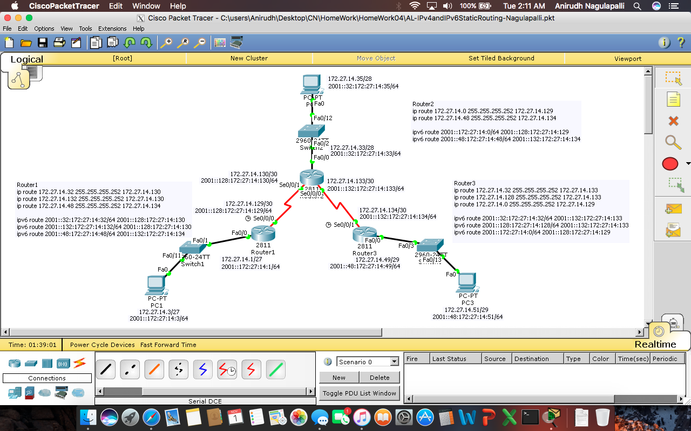

**Configuration Syntax:**

|  |  |
| --- | --- |
| **Syntax** | **Description** |
| Hostname Router1 | Sets the hostname to Router1 |
| Enable password Cisco | Sets the password to ‘Cisco’ and enables it |
| Enable secret Cisco | Sets the encrypted password ‘Cisco’ and enables it |
| Int f0/0 | Interface of Fast Ethernet is created |
| Int s0/0/0 | Interface of Serial port is created |
| Ip address 172.27.14.3 255.255.255.240 | Assigns an ip with the given submask |
| No shutdown | Doesn’t let the interface to shutdown |
| Ping 172.27.14.51 | Pings the device with the associated ip |
| Login | Enables a login prompt |
| Line con 0  Line vty 0 5 | Console line  Virtual terminal lines |
| Logging Synchronous | To synchronise messages coming from either con line or vty lines |
| ip route 172.27.14.32 255.255.255.252 172.27.14.130 | Used for creating static IP routes |
| ipv6 route 2001::32:172:27:14:32/64 2001::128:172:27:14:130 | Used for creating static IPv6 routes |

**Show Command Output:**

|  |  |
| --- | --- |
| **Syntax** | **Associated Output** |
| Sh ip route | Shows the ip routing table |
| Sh ipv6 route | Shows the ipv6 routing table |
| Ping 172.27.14.51  (From PC1 to PC3) |  |
| Ping 2001::48:172:27:14:51  (From PC1 to PC3) |  |

**Troubleshooting Syntax**

I used the ‘sh ip route’ to check if the IP Static Routing was performed correctly or not and ‘sh ipv6 route’ for IPv6 Static Routing.

Also used ‘no ip route [Destination Network address] [Destination Network Subnet mask] [Next hop Router address]’ to delete the unnecessary routing.

**What worked, What didn’t?**

Everything worked. But I didn’t remember to enable the "IPv6 unicast-routing" globally before configuring IPv6. So I wasn’t able to ping PC3 and PC1. Ones declaration is done, was able to ping without any error.

**Configuration Files:**

Attached files

AL-IPv4andIPv6StaticRouting-Nagulapalli.pkt