AI-DRIVEN CAPACITY INTELLIGENCE
Predictive Capacity Roadmap & Solution Architecture
APM Metric Intelligence — Driver-Based Capacity Prediction and Independent Metric Projection
Prepared for: Netraa Capacity Intelligence Programme
Client-Facing Consulting & Solution Architecture Document
Condensed Executive Edition
Confidential — Prepared for Executive and Technical Review

Contents
1. Executive Summary
2. Business & Operational Context
3. The Two Capacity Intelligence Problems
4. Proposed Solution Vision
5. Executive-Level Architecture
6. Detailed Solution Architecture
7. Common Data & Feature Foundation
8. Problem 1 — Driver-Based Capacity Prediction
9. Dependency Discovery
10. Dependent Metric Prediction
11. Multi-Stage Prediction Pipeline
12. Model-per-Metric Architecture
13. Future System State Simulation
14. Neural Network Capacity Prediction
15. Capacity Optimization Engine
16. What-If Simulation Engine
17. Problem 2 — Independent Metric Projection
18. Forecasting & Capacity Risk
19. Unified Capacity Intelligence
20. Decision Framework
21. Dashboard Design
22. AI/ML Model Architecture
23. Mathematical Formulation
24. AI Algorithm Justification
25. Data Preprocessing Pipeline
26. Explainability & Governance
27. Implementation Roadmap
28. Indicative Timeline
29. Milestones & Deliverables
30. Production Architecture & MLOps
31. Risks, Assumptions & Open Points
32. Client Outcomes
33. Future Enhancements
34. Executive Conclusion

1. Executive Summary
Enterprise infrastructure and application teams today rely primarily on reactive monitoring — dashboards and alerts describing what is happening right now. This is effective for detecting incidents after they occur, but it cannot tell a team what is about to happen, what would happen if demand changed, or how much capacity will be required in future.
The solution evolves observability from “What is happening now?” to “What will happen next?”, “What happens if transaction volume changes?”, and “How much capacity will be required?”

This roadmap moves Netraa from reactive monitoring to predictive capacity intelligence by building two complementary AI-driven capabilities on a shared data foundation:
- Driver-Based Capacity Prediction — if a known driver metric changes to X, what will downstream application/infrastructure metrics become, and how much CPU, Memory and Disk capacity will be required?
- Independent Metric Projection — based on ~1 year of historical behavior, where is an individual metric (CPU, Memory, Disk) heading, and when will it breach its capacity threshold?
Both are built on a common, standardized 60–100-metric feature store and converge at an insight layer into a single Unified Capacity Intelligence view surfaced through the Netraa Dashboard.
KEY INSIGHT
The solution separates the problem of predicting system behavior from the problem of predicting required infrastructure capacity.

2. Business & Operational Context
Reactive monitoring answers questions only after an issue surfaces. For capacity planning, this is insufficient — provisioning, scaling and budget decisions require a forward-looking view of demand and resource consumption. Two everyday operational questions motivate this programme:
- If workload/throughput increases to X, what will the rest of the application and infrastructure look like, and how much CPU, Memory and Disk capacity will be required?
- Based on the last year of CPU, Memory, Disk and other metric behavior, where is each metric heading, how strong is the trend, and when will it become a capacity risk?
The first is a scenario/what-if question depending on a known driver; the second is a trend-continuation question needing no assumed driver. The roadmap answers both using a shared data foundation but two independent analytical engines.

Why Traditional Capacity Planning Fails
- A single metric (e.g. CPU) does not move in isolation — it is the downstream effect of many interacting driver and intermediate metrics
- Static thresholds do not adapt to seasonality, business growth, or architectural change
- Manual estimation cannot simulate “what-if” scenarios before they occur
- Reactive alerting only surfaces a problem after service quality has already degraded

Vision & Business Objectives
The vision is a common intelligence layer that learns relationships between driver, intermediate and target metrics directly from historical observability data, and uses that structure to simulate future system states, predict required infrastructure, and recommend the most efficient — not the largest safe — configuration.
- Move from reactive, threshold-based alerting to proactive, prediction-based capacity planning
- Enable what-if scenario simulation ahead of business events (traffic growth, new features, seasonal peaks)
- Right-size infrastructure — avoid both under-provisioning (SLA risk) and over-provisioning (cost)
- Provide explainable, auditable capacity recommendations rather than opaque black-box outputs
SLA PRESERVATION OBJECTIVE
Any capacity recommendation — from the driver-based engine, optimization engine, or independent forecasting engine — must preserve agreed response-time SLAs. Capacity is minimized subject to response time remaining within its service-level agreement.

3. The Two Capacity Intelligence Problems
KEY INSIGHT
Dependency discovery determines “what changes and why,” while the capacity model determines “how much infrastructure is required.”

Dimension | Problem 1 — Driver-Based Prediction | Problem 2 — Independent Projection
Core Question | If a driver changes to X, what downstream metrics/capacity result? | Where is a metric heading based on ~1yr history, and when does it breach threshold?
Input | 1 known raw driver metric | 365 days of historical data per metric
Logic Flow | Driver → dependent metrics → predict → capacity → scaling | History → trend → direction/strength → projection → breach → risk
Dependency | Independent of Problem 2 | Independent of Problem 1
Primary Value | What-if / scenario capacity planning | Proactive, trend-based capacity planning

Problem 1 — Driver-Based Capacity Prediction
If a known driver metric changes to X, what will happen to downstream metrics, and how much CPU/Memory/Disk capacity will be required?
Only the driver is known at prediction time; downstream metrics must be inferred. Stage 1 predicts dependent metrics; Stage 2 uses the predicted state to estimate CPU, Memory and Disk capacity. Logic: 1 Known Driver → Identify Dependent Metrics → Predict Dependent Metrics → Predict Resource Capacity → Recommend Scaling.
Illustrative: driver service_cpm = 5,000 → predicted downstream state (up to 99 metrics) → Neural Network output CPU 11.8 cores / Memory 14.6 GB / Disk 42 MB/s → current 8 cores → recommendation: scale to 12 cores.

Problem 2 — Independent Metric Projection
Based on ~1 year of history for a metric such as CPU, Memory or Disk, what is the future utilization, and when is the capacity threshold likely to be breached?
An independent forecasting capability, not dependent on the driver-based model. Logic: 365 Days History → Trend Analysis → Direction → Strength → Growth Rate → Future Projection → Threshold Breach → Capacity Risk.
Illustrative: CPU trend increasing strongly, current 72%, projected (6mo) 85%, confidence 91%, capacity risk High.

4. Proposed Solution Vision
The architecture is positioned as one AI Capacity Intelligence Platform with two independent analytical engines sharing a common data and feature foundation.
KEY INSIGHT
Independent projection provides a second lens that identifies capacity risks even when no explicit workload scenario is provided.

5. Executive-Level Architecture
Observability data flows through a common ingestion/feature layer, splits into two purpose-built AI engines, and converges into a single decision layer surfaced on the Netraa Dashboard. The two branches share the same preprocessed feature store but remain independent modelling problems, converging only at the insight/decision layer.
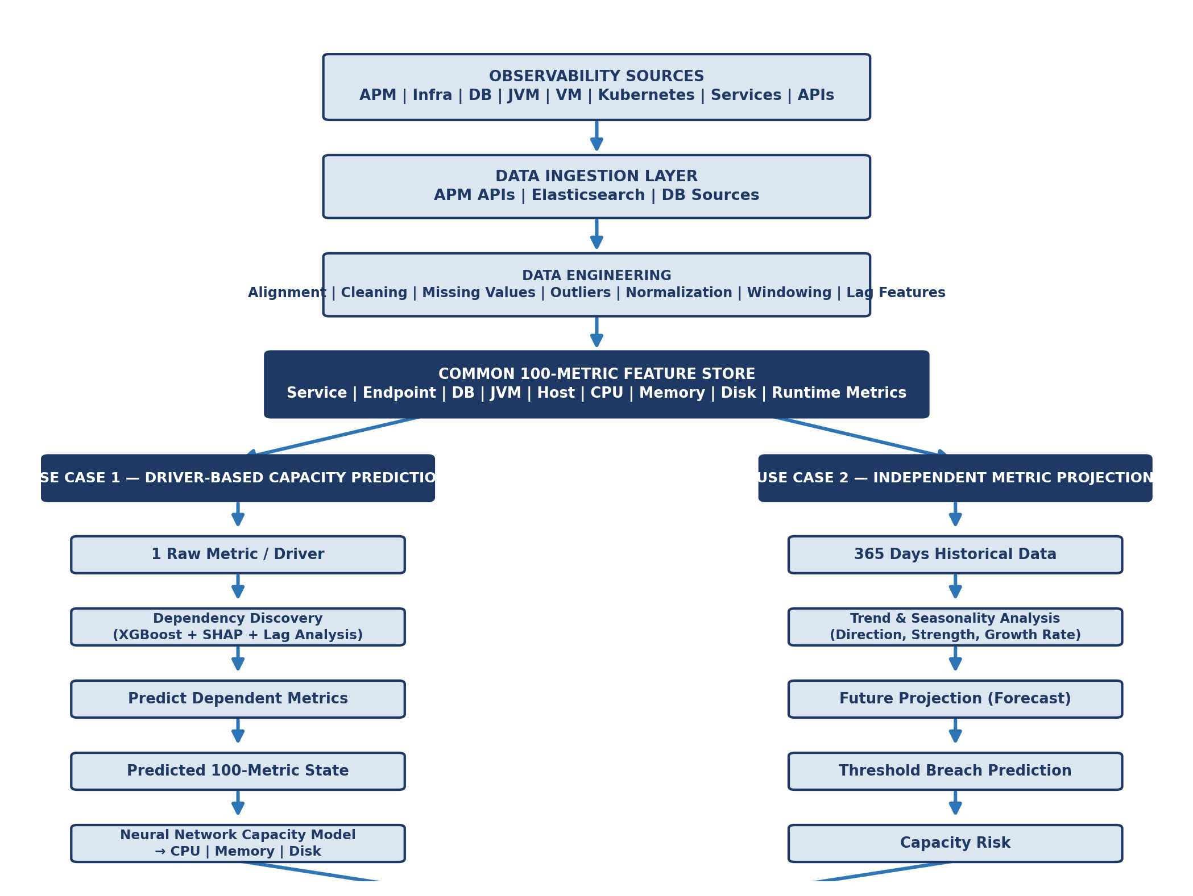

6. Detailed Solution Architecture
The architecture spans eight logical layers, from data sources to the client-facing experience layer:
Layer | Description / Contents
1. Observability Sources | APM, Services, Endpoints, App Instances, JVM/CLR, DBs, Infra, CPU/Mem/Disk, Runtime metrics
2. Data Ingestion | APM APIs, Elasticsearch, Database sources
3. Data Engineering | Extraction, cleaning, missing/outlier handling, time alignment, differencing, normalization, windowing, lag/calendar features
4. Feature Store | Common, standardized 100-metric feature space shared by both engines
5. AI/ML Layer | Dependency discovery, dependent metric prediction, capacity prediction, independent projection
6. Explainability & Governance | SHAP, confidence, prediction intervals, model version, data provenance
7. Decision & Recommendation | Capacity gap, threshold breach, risk level, scaling recommendation, confidence
8. Netraa Experience Layer | Predictive Dashboard, What-If Analysis, Dependency Graph, Forecast View, Capacity Risk

7. Common Data & Feature Foundation
Both engines are built on the same common 100-metric feature store spanning Service, Endpoint, Database, JVM, Host, CPU, Memory, Disk and runtime metrics — allowing consistent development, governance and monitoring across independent problems.
KEY INSIGHT
A single, trusted feature foundation reduces duplicate data engineering effort and ensures both engines reason over a consistent view of the environment.

Metric Classification
Metric Class | Definition | Example
Driver | Known/hypothesized inputs a user can set to ask a what-if question | Service CPM, concurrent users
Intermediate | Sit between driver and target — predicted, not set directly | Network Tx/Rx, DB Calls, Queue Depth, Heap, GC
Target | Infrastructure capacity metrics the business cares about | CPU, Memory, Disk, Network, Pods, VM Count
Independent Forecast | Forecast from own history, independent of any driver | CPU, Memory, Disk, Storage

Driver Metric Selection
Candidate driver metrics are validated and ranked using: Mutual Information (linear/non-linear association), SHAP (contribution to outcomes), Feature Importance (model-native ranking), and Correlation Ranking (baseline linear check).

8. Problem 1 — Driver-Based Capacity Prediction
The pipeline takes a single known/hypothesized driver metric and propagates its effect through dependency discovery, dependent-metric prediction, and finally a neural network capacity model.

9. Dependency Discovery
Objective: if service_cpm changes from 5,000 to X, which metrics change, by how much, in which direction, and after what delay? Signals combined: XGBoost predictive relevance, SHAP contribution, cross-correlation, lag analysis, and Granger causality where applicable. A dependency is accepted only when sufficient evidence supports it, combining predictive relevance and temporal precedence.
Dependent Metric | Strength | Direction | Lag
database_access_cpm | 0.84 | + | 1 min
JVM CPU | 0.78 | + | 2 min
JVM Thread Count | 0.64 | + | 2 min
Key Deliverable: Explainable Dependency Map

10. Dependent Metric Prediction
Once dependencies are identified: given a new driver value, what will the dependent metrics become? Each prediction contains predicted value, P10/P50/P90, confidence, dependency strength, direction and lag.
Illustrative: service_cpm = 5,000 → service_instance_cpm = 1,250 | thread_pool = 178 | JVM GC = 340ms | DB CPM = 3,100 | JVM Heap = 6.2GB ...
Key Deliverable: Predicted System State

11. Multi-Stage Prediction Pipeline
Rather than predicting capacity directly from the driver in one step, the pipeline propagates the driver's effect through a chain of intermediate metrics — each stage's output becomes context for the next — before arriving at a complete future system state. This staged approach keeps each prediction easier to validate and explain, and lets the dependency graph (not a fixed schema) determine which metric chain is relevant.

12. Model-per-Metric Architecture
Because different metrics exhibit different statistical behavior (e.g. bursty network traffic vs. smoothly varying heap usage), each dependent metric gets its own regression model rather than one shared model. Candidates: XGBoost, CatBoost, Random Forest; best-performing model per metric is auto-selected on validation performance.

13. Future System State Simulation
Given a hypothesized driver value, the pipeline and model-per-metric layer simulate a complete future system state — the full set of predicted intermediate and target values.
Metric | Current (350 CPM) | Simulated (500 CPM)
CPU | 55% | Predicted from simulated state
Memory | 12 GB | Predicted from simulated state
Network Tx | — | 150 MB/s
DB Calls | — | 3,200

14. Neural Network Capacity Prediction
Answers: given the predicted/simulated future system state, how much infrastructure capacity is required? Architecture: 100-node input layer (with provenance mask) → 128-node hidden → 64-node hidden → parallel outputs (CPU, Memory, Disk, Network, Pods, VM Count) → Capacity Demand → Capacity Gap → Scaling Recommendation.
Capacity | Predicted Requirement | Current | Recommendation
CPU | 11.8 cores | 8 cores | Scale to 12
Memory | 14.6 GB | 16 GB | Sufficient
Disk I/O | 42 MB/s | 35 MB/s | Increase I/O capacity
Key Deliverable: Capacity Prediction & Scaling Recommendation Engine

15. Capacity Optimization Engine
Reframes the question: rather than predicting a single requirement, find the smallest, most cost-efficient configuration that keeps predicted response time within SLA.
Minimize CPU, Memory, Disk, Pods, and VMs — subject to Response Time ≤ SLA

KEY INSIGHT
The optimization engine turns capacity prediction into a cost-aware recommendation — it recommends the most efficient configuration that still protects response-time commitments.

16. What-If Simulation Engine
Lets a user pose a hypothetical change to any admissible driver metric and see the resulting future system state, capacity requirement, and SLA risk — without waiting for the change to occur in production.
Scenario | Change
Traffic growth | Service CPM: 350 → 500
User growth | Concurrent users: 5,000 → 8,000
Dependency degradation | Database latency doubles

17. Problem 2 — Independent Metric Projection
Not dependent on Problem 1. Objective: predict each individual metric from its own historical behavior, using ~365 days of history for CPU, Memory, Disk and Volume.

18. Forecasting & Capacity Risk
Historical trend data is processed for direction, strength, growth rate, volatility and seasonality. A time-series model projects the metric at 1/3/6/12-month horizons, feeding threshold-breach analysis and capacity-risk classification. Candidate families: SARIMA (seasonal, stable trend), Prophet (robust to gaps, interpretable), LSTM (long-range, non-linear dependencies). Best family selected per metric.
Attribute | Value
Direction | Increasing
Strength | Strong
Growth | +2% per month
Forecast (6mo) | 85%
Confidence | 91%
Risk / Breach | High / ~6 months
Key Deliverable: Independent Metric Forecast & Capacity Risk Report

19. Unified Capacity Intelligence
The two branches converge at the insight layer — not merged into one model.
Capability | Problem 1 | Problem 2
Question | What if workload becomes X? | Where is the metric heading?
Input | 1 raw driver metric | 365 days historical metric
Approach | Dependency discovery + prediction | Time-series forecasting
AI | XGBoost + SHAP | Time-series model
Capacity model | Neural Network | Threshold / capacity analysis
Output | Required capacity | Future utilization
Two complementary views: Scenario View — “If demand increases, what capacity will I need?” and Forecast View — “If the trend continues, when will I need more capacity?”

20. Decision Framework
A simple decision framework helps a team choose which engine to use: use the Driver-Based engine when a specific workload change or business event is being planned; use Independent Projection when monitoring ongoing organic trend risk with no specific scenario in mind.

21. Dashboard Design
The Netraa Dashboard is the client-facing layer through which engineering, SRE and infrastructure teams interact with both engines, organized around six functional areas:
Dashboard Area | Purpose
Driver Selection | Choose the admissible driver metric and current/candidate value
Scenario Simulator | Run what-if simulations and view the resulting future system state
Capacity Recommendation | View required and optimized CPU/Memory/Disk/Network/Pods/VM Count
SLA Risk | View predicted response time against the agreed SLA
Future Forecast | View independent metric projections, thresholds, time-to-breach
Dependency Graph | Explore the explainable dependency graph for a selected driver

22. AI/ML Model Architecture
Component | Purpose | Input | Output
Dependency Discovery | Identify dependent metrics | Historical 100 metrics | Dependencies
XGBoost | Predict dependent metrics | Driver + historical features | Predicted metrics
SHAP | Explain predictions | XGBoost model | Feature importance
Neural Network | Predict capacity | Predicted system state | CPU/Memory/Disk
Time-Series Model | Independent projection | Historical individual metric | Future metric value

23. Mathematical Formulation
The pipeline can be summarized in three expressions:
Dependent Metric Prediction: Mi = f(driver)

Capacity Aggregation: CPU = g(M1, M2, ..., Mn)

Constrained Optimization: Minimize [CPU, Memory, Disk] subject to Response Time ≤ SLA

f represents the per-metric prediction models (Model-per-Metric Architecture), g represents the Neural Network Capacity Model, and the optimization step represents the Capacity Optimization Engine.

24. AI Algorithm Justification
Algorithm | Why It Is Used
XGBoost | Strong on tabular, spike-heavy APM data; native feature importance supports driver selection
CatBoost | Handles categorical/irregular features well; alternative candidate in model-per-metric selection
Neural Network | Learns a shared, non-linear representation across the 100-metric state for coherent multi-output capacity predictions
SHAP | Consistent, per-prediction feature attribution for driver selection and dependency explainability
Prophet | Interpretable trend/seasonality decomposition; robust to gaps in historical data
LSTM | Captures longer-range temporal dependencies where sufficient history/complexity exists

25. Data Preprocessing Pipeline
Stage | Description
Alignment | All metric streams resampled to a common time grid (1-min buckets recommended)
Cleaning | Handle missing, invalid, duplicate and incomplete records
Differencing | Convert values to interval changes to identify what changed together
Normalization | Robust Scaling (median/IQR) for spike-heavy data; z-score where appropriate
Windowing | Rolling windows for temporal context
Lag Features | Capture delayed downstream effects
Calendar Features | Capture time-of-day and day-of-week patterns
Chronological Split | Train/validation/test split without future leakage

26. Explainability & Governance
Every prediction is accompanied by explainability and governance metadata so teams can trust and audit the recommendation:
- SHAP-based feature attribution
- Confidence scores
- Prediction intervals (P10/P50/P90)
- Model version
- Data provenance
- Observed vs. predicted vs. imputed value flags

27. Implementation Roadmap
Organized into nine phases (0–8). Phase 0 and 1 are foundational and sequential; later phases can run partly in parallel once the feature foundation is established.
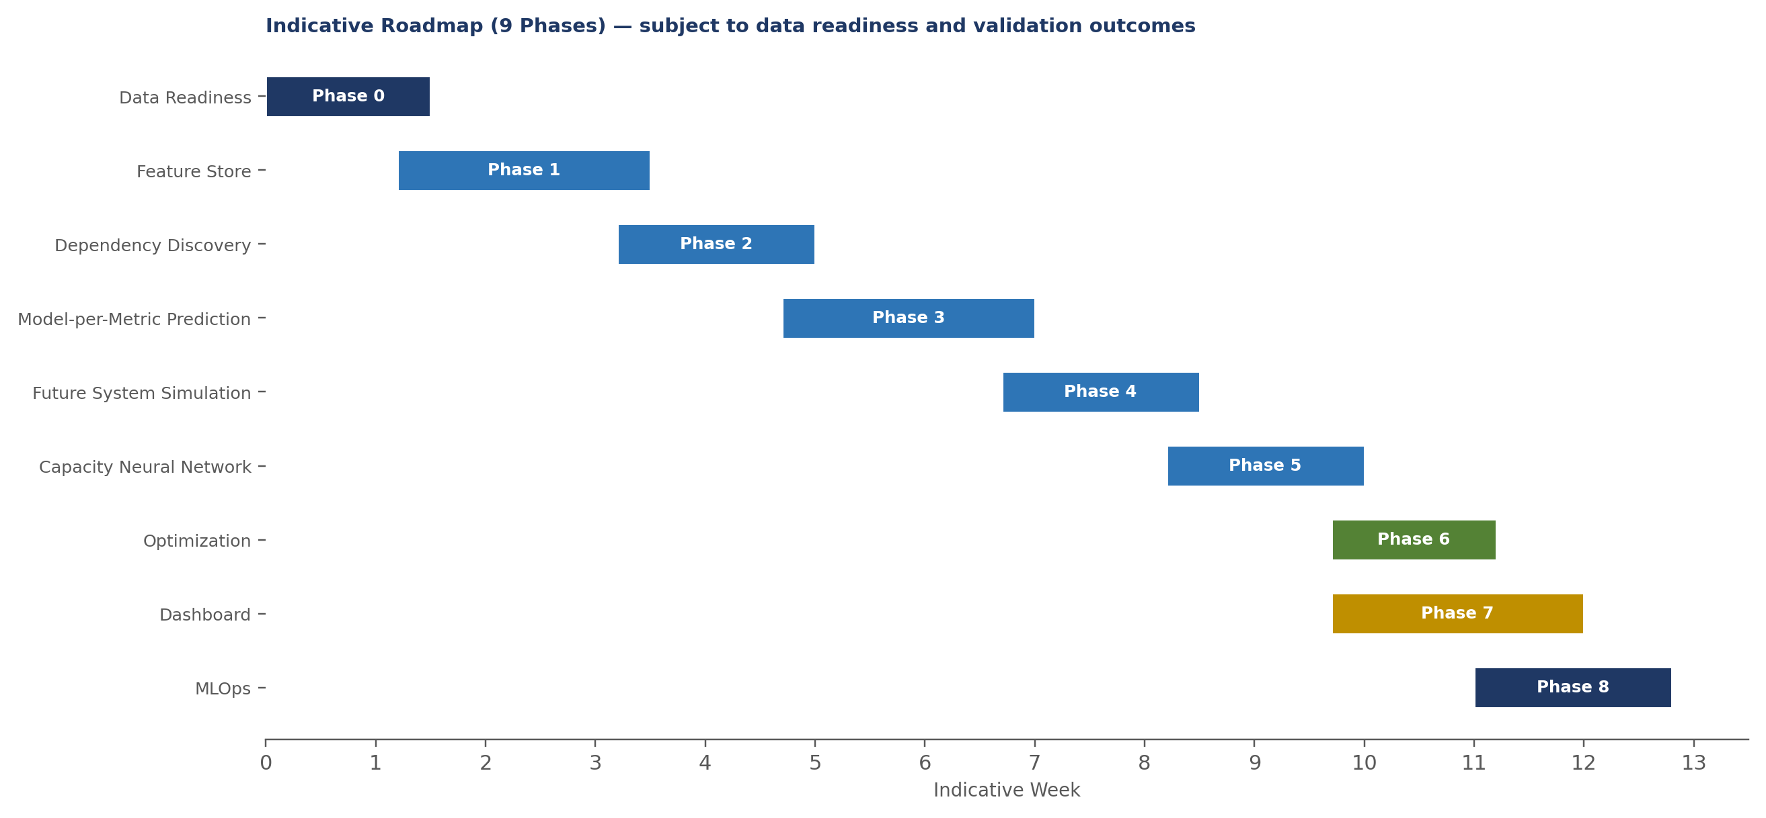
Phase | Objective | Deliverable
0 — Data Readiness | Establish whether available data supports reliable prediction | Data Readiness & Feasibility Assessment
1 — Feature Store | Create a trusted, reusable data/feature foundation for both use cases | Production-ready Metric Feature Store
2 — Dependency Discovery | Determine which metrics change, how much, direction, delay | Explainable Dependency Map/Graph
3 — Model-per-Metric Prediction | Predict each dependent metric using the best-performing model | Predicted System State
4 — Future System Simulation | Simulate the complete future system state from a driver value | Future System State vector
5 — Capacity Neural Network | Determine required infrastructure capacity from the future state | Capacity Prediction & Scaling Recommendation Engine
6 — Optimization | Convert capacity prediction into a minimum-cost, SLA-preserving recommendation | Optimized, SLA-aware capacity recommendation
7 — Dashboard | Deliver the client-facing experience layer for both engines | Netraa Predictive Capacity Dashboard
8 — MLOps | Move from proof of concept to a production capability | Production-grade MLOps pipeline

28. Indicative Timeline
Overall indicative roadmap: approximately 13 weeks, with several phases (Dependency Discovery, Model-per-Metric Prediction, Future System Simulation, Capacity Neural Network, Independent Metric Projection) capable of running partly in parallel once the data foundation is established. Optimization and Dashboard work can begin before MLOps productionization is complete.
OPEN POINT
Indicative timeline is subject to data readiness, historical data availability, model validation results, and client environment dependencies — not a guaranteed commitment.

29. Milestones & Deliverables
# | Milestone | Description
1 | Data Readiness | 100 metrics successfully collected, aligned and validated
2 | AI Dependency Intelligence | Given driver = X, identify/explain which downstream metrics change
3 | Predictive System State | Predict downstream application/infrastructure state via the pipeline
4 | Capacity Intelligence | Convert predicted state into CPU/Memory/Disk/Network/Pods/VM requirements
5 | SLA-Aware Optimization | Convert capacity prediction into minimum-cost, SLA-preserving configuration
6 | Predictive Forecasting | Forecast independent metrics from 365 days of data; identify capacity risks
7 | Unified Dashboard | Deliver scenario simulation, recommendation, SLA risk, forecast, dependency views

Recommended Client Deliverables
- 100-Metric Data Readiness Report & Common Feature Store
- Driver Dependency Graph & Strength/Direction/Lag Report
- Single-Metric Driver What-If Prediction API
- Model-per-Metric Prediction Layer & Future System State Simulation Engine
- Capacity Prediction Model (CPU/Memory/Disk/Network/Pods/VM Count)
- SLA-Aware Capacity Optimization Engine & What-If Simulation Engine
- Independent Metric Forecasting Engine & Capacity Threshold Breach Prediction
- Unified Predictive Capacity Dashboard
- Model Performance & Drift Monitoring, Production API & MLOps Pipeline

30. Production Architecture & MLOps
The final phase moves the solution from proof of concept to a production capability, combining streaming ingestion, orchestration, a shared feature store, model registry, low-latency serving and container-based deployment.
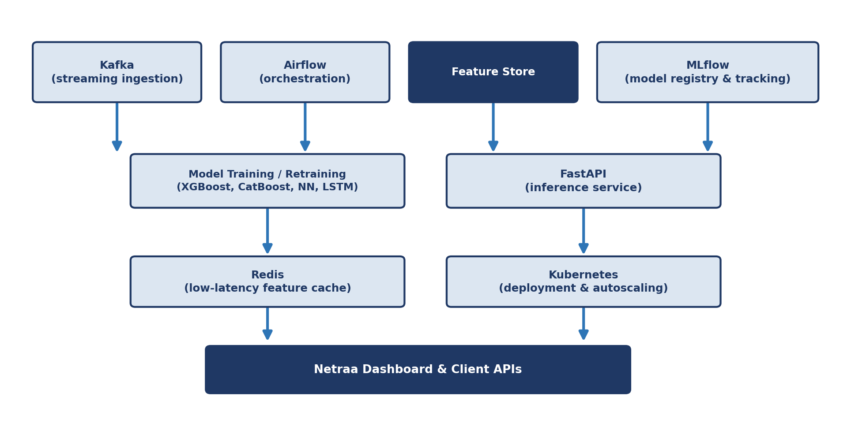

MLOps Practices
- Model registry and versioning (MLflow); automated retraining and orchestration (Airflow)
- Data drift and concept drift detection; model performance and prediction confidence monitoring
- Automated model rollback; low-latency feature caching (Redis) and streaming ingestion (Kafka)
- API-based inference (FastAPI), containerized deployment and autoscaling (Kubernetes)
- Dashboard and capacity recommendation integration
Recommended production stack: XGBoost, CatBoost, SHAP, PyTorch/TensorFlow, Prophet/LSTM, MLflow, Airflow/Dagster, FastAPI, Kubernetes, Redis, Kafka, ONNX/TorchServe.

31. Risks, Assumptions & Open Points
- At least 365 days of historical data is assumed available for Problem 2 — to be validated per metric/environment in Phase 0
- Model-validation methodology and acceptance thresholds are not fully specified and should be agreed with the client prior to production sign-off
- Data quality, sampling frequency and infrastructure change history can materially affect discovery and forecasting — to be confirmed in Phase 0
- The optimization engine's solver method and response-time prediction model are to be defined during Phase 6
- Network, Pods and VM Count as additional outputs, and driver-selection combination logic, should be validated against the live environment
- No production client results or validated accuracy figures are claimed beyond illustrative examples carried over from the original technical design

32. Client Outcomes
- 100-Metric Feature Foundation & Explainable Dependency Graph
- Driver-Based What-If Prediction & Predicted/Simulated Future System State
- CPU/Memory/Disk/Network/Pods/VM Count Capacity Prediction & SLA-Aware Optimization
- Scaling Recommendations & Independent Metric Forecasting
- Capacity Threshold Prediction & Capacity Risk Identification
- Unified Predictive Capacity Dashboard, Model Explainability, Monitoring and Retraining

33. Future Enhancements
Beyond the scope of this roadmap, discussed as potential future directions once the core platform is in production:
- Extending the optimization engine to jointly plan across multiple services or a full application topology
- Incorporating cost data directly into the optimization objective alongside capacity minimization
- Expanding the forecasting engine to additional resource types (e.g. network egress, storage IOPS)
- Closed-loop automation — allowing validated recommendations to trigger scaling actions under defined guardrails
OPEN POINT
These are directions for future discussion rather than committed scope, included here for completeness only.

34. Executive Conclusion
The proposed roadmap takes Netraa from monitoring what is happening today to predicting what will happen tomorrow and simulating what will happen if business demand changes.

The solution establishes a common 100-metric intelligence layer and builds two complementary AI capabilities: a driver-based capacity prediction engine answering “What capacity will I need if workload changes to X?” and an independent forecasting engine answering “When will my current capacity become insufficient if the trend continues?” Between prediction and recommendation, an optimization layer ensures any recommendation is the most cost-efficient configuration that still preserves the response-time SLA.
Together, these capabilities enable proactive capacity planning, what-if analysis, SLA-aware optimization, early capacity-risk detection, and data-driven infrastructure scaling decisions.

