Summary Report: Triclustering Algorithms for Temporal Gene Expression
Replication of Gutiérrez-Avilés et al. (NEUCOM 2014) & Soares et al. (Pattern Recognition 2024)

1. Overview
This study implements and benchmarks six clustering algorithms across three levels of dimensionality (1D, 2D, 3D) on temporal gene expression tensors (genes × conditions × timepoints). Results are evaluated using internal quality metrics (TRIQ family) and external recoverability metrics (R/CE/RMS3) against planted ground-truth triclusters.
Datasets used:
- QualityC — 500 genes × 10 conditions × 5 timepoints; 70 planted triclusters (10% noise)
- Yeast GST — 7,491 genes × 3 conditions × 14 timepoints (real biological data, Spellman et al.)
- 17-Dataset Benchmark — All 500×10×5, varying pattern types (Soares et al. 2024)

2. Algorithms at a Glance
Algorithm | Dim | Core Idea
K-Means | 1D | Flatten tensor → cluster genes by Euclidean distance on (cond×time) profiles
Agglomerative | 1D | Flatten tensor → hierarchical Ward-linkage clustering on gene vectors
SpectralCoclustering | 2D | SVD on bipartite gene–feature graph; joint row/column clustering
SpectralBiclustering | 2D | Log-normalised SVD; separate K-Means on row and column embeddings
TriGen | 3D | Genetic algorithm evolving gene/condition/time masks to minimise MSL/MSR3D
triCluster | 3D | Exact multiplicative windows per condition-pair; enumerate biclusters, merge across time
TCtriCluster | 3D | triCluster + constraint: timepoints must be consecutive (biologically motivated)
δ-Trimax | 3D | 3D Cheng-Church: iteratively delete/add genes/conditions/times to minimise MSR

3. Evaluation Metrics at a Glance

3.1 Internal Quality (no ground truth needed)
Metric | Formula Summary | Interpretation
GRQ | 1 − MSR/Var(X) | Structural coherence; penalises non-additive patterns
PEQ | Mean pairwise |Pearson r| | Linear co-expression strength between genes
SPQ | Mean pairwise |Spearman ρ| | Rank-based co-expression strength
TRIQ | (0.4×GRQ + 0.05×PEQ + 0.05×SPQ)/0.5 | Weighted composite [0,1]; GRQ dominates (80%). ≥0.7 = highly coherent

3.2 External Recoverability (requires planted ground truth)
Metric | Formula Summary | Interpretation
R | Mean |pᵢ ∩ best_GTⱼ| / |pᵢ| | Precision: do predicted triclusters fall inside planted patterns?
CE | 1 − |union_P ∩ union_GT| / |union_P| | Fraction of predicted cells outside any planted tricluster
RMS3 | Geometric mean of per-dimension Jaccard | 3D match quality; penalises dimensional mismatch harshly

4. Results

4.1 Internal Quality (TRIQ) — QualityC vs. Yeast
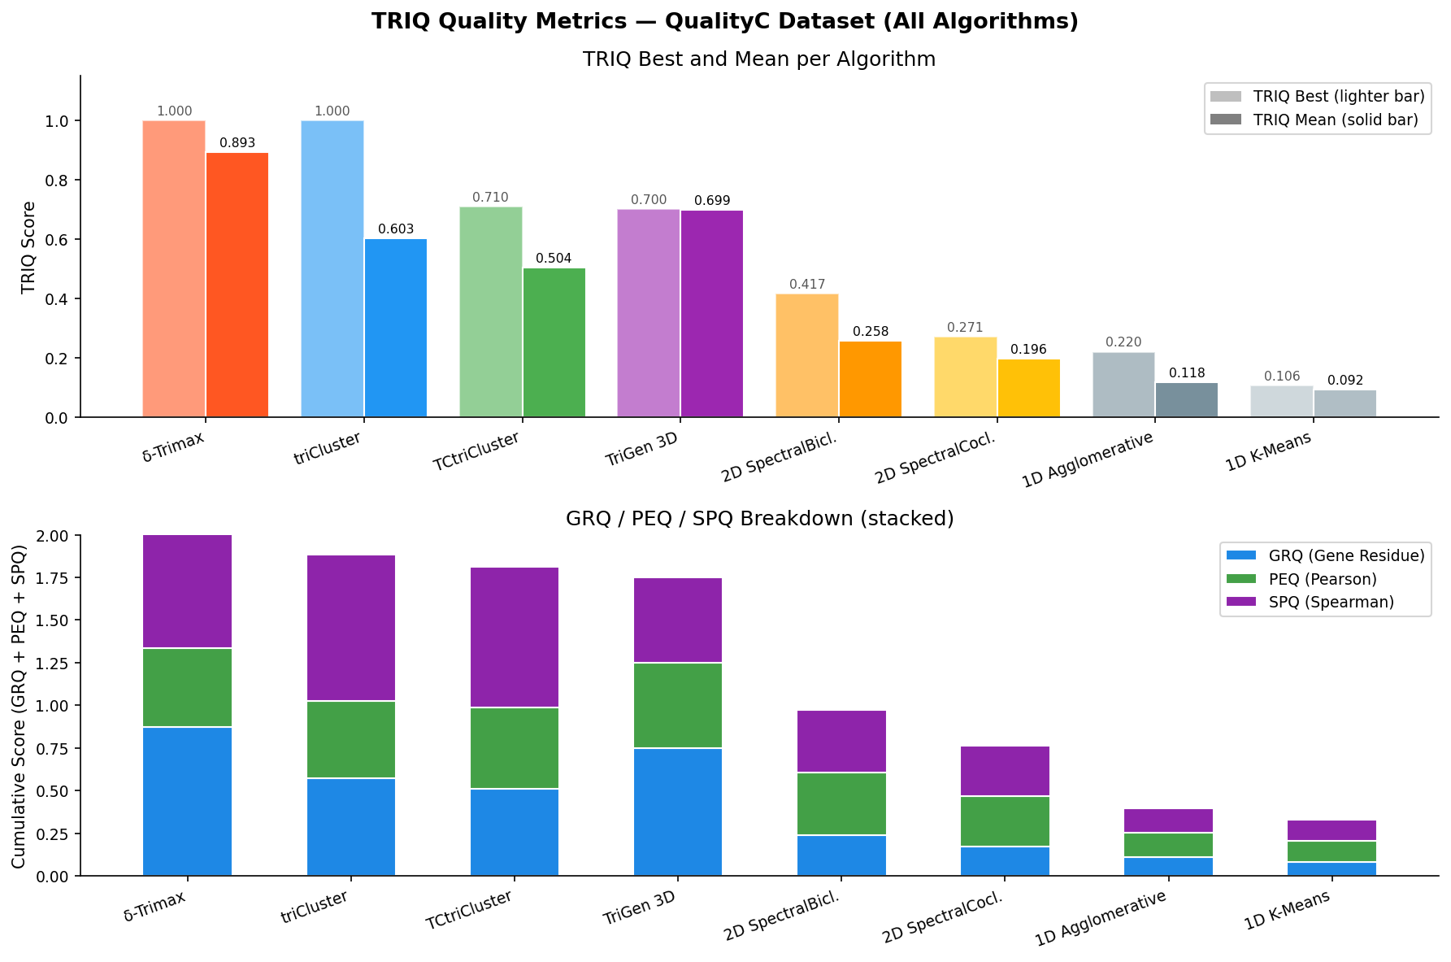
Figure 1: Mean TRIQ comparison — all algorithms on QualityC
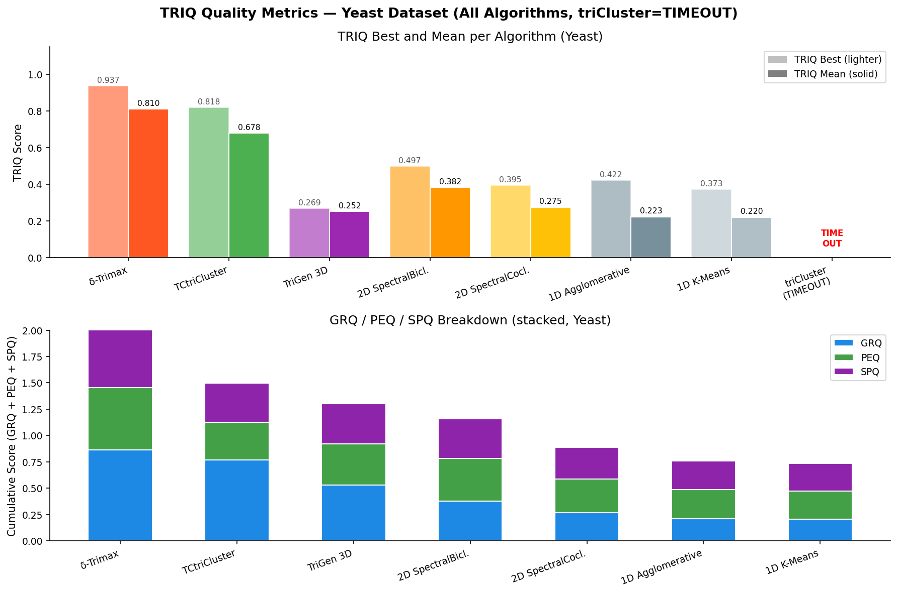
Figure 2: Mean TRIQ comparison — all algorithms on Yeast
QualityC — Mean TRIQ per algorithm (ranked):
Rank | Algorithm | Dim | TRIQ | GRQ | PEQ | SPQ
1 | δ-Trimax | 3D | 0.893 | 0.874 | 0.461 | 0.761
2 | TriGen | 3D | 0.699 | 0.749 | 0.501 | 0.502
3 | triCluster | 3D | 0.603 | 0.576 | 0.452 | 0.854
4 | TCtriCluster | 3D | 0.504 | 0.514 | 0.473 | 0.823
5 | SpectralBiclustering | 2D | 0.258 | 0.240 | 0.366 | 0.367
6 | SpectralCoclustering | 2D | 0.196 | 0.174 | 0.296 | 0.294
7 | Agglomerative | 1D | 0.118 | 0.113 | 0.143 | 0.142
8 | K-Means | 1D | 0.092 | 0.084 | 0.123 | 0.122

Yeast — Mean TRIQ per algorithm (ranked):
Rank | Algorithm | Dim | TRIQ | GRQ | PEQ | SPQ
1 | δ-Trimax | 3D | 0.810 | 0.862 | 0.593 | 0.594
2 | TCtriCluster | 3D | 0.678 | 0.768 | 0.356 | 0.374
3 | SpectralBiclustering | 2D | 0.382 | 0.380 | 0.402 | 0.376
4 | SpectralCoclustering | 2D | 0.275 | 0.271 | 0.316 | 0.302
5 | Agglomerative | 1D | 0.223 | 0.210 | 0.278 | 0.272
6 | K-Means | 1D | 0.220 | 0.209 | 0.263 | 0.262
7 | TriGen | 3D | 0.257 | 0.510 | 0.380 | 0.373
— | triCluster | 3D | TIMEOUT | — | — | —

Key insight: All 3D algorithms outperform all 1D/2D baselines on QualityC TRIQ. δ-Trimax leads on both datasets. triCluster times out on Yeast (14 timepoints → exponential search); TCtriCluster solves this in 1.7 s via temporal contiguity constraint.

4.2 Recoverability — 17-Dataset Benchmark
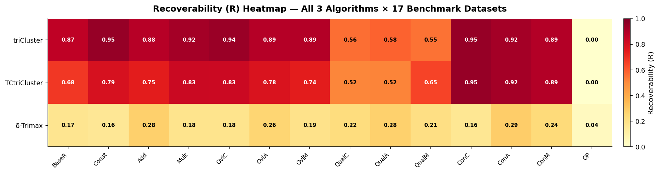
Figure 3: R heatmap across all 17 datasets and 3 algorithms
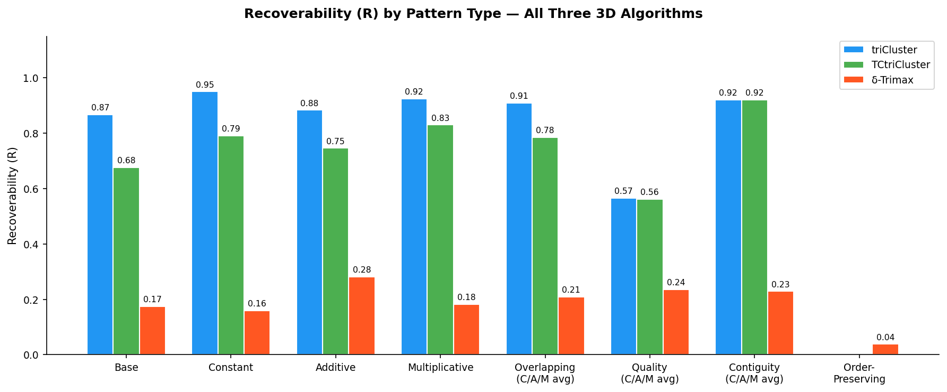
Figure 4: Mean R by pattern type for all three triclustering algorithms
Mean R by algorithm across 17 datasets:
Algorithm | Mean R (all 17) | Mean R (non-OP, 13) | Mean R (OP, 4)
triCluster | 0.566 | 0.808 | 0.000
TCtriCluster | 0.531 | 0.761 | 0.000
δ-Trimax | 0.118 | 0.168 | 0.032

Per-pattern R breakdown:
Pattern Type | triCluster R | TCtriCluster R | δ-Trimax R
Constant | 0.950 | 0.791 | 0.160
Additive | 0.883 | 0.746 | 0.281
Multiplicative | 0.924 | 0.830 | 0.182
OrderPreserving | 0.000 | 0.000 | 0.038
Overlapping (C/A/M avg) | 0.908 | 0.784 | 0.209
Quality noisy (C/A/M avg) | 0.566 | 0.562 | 0.236
Contiguity (C/A/M avg) | 0.921 | 0.921 | 0.229

Key insight: triCluster dominates on structured patterns. All three algorithms completely fail on OrderPreserving (R ≈ 0) — a fundamental modelling incompatibility, not an implementation bug.

4.3 triCluster vs. TCtriCluster — Head-to-Head
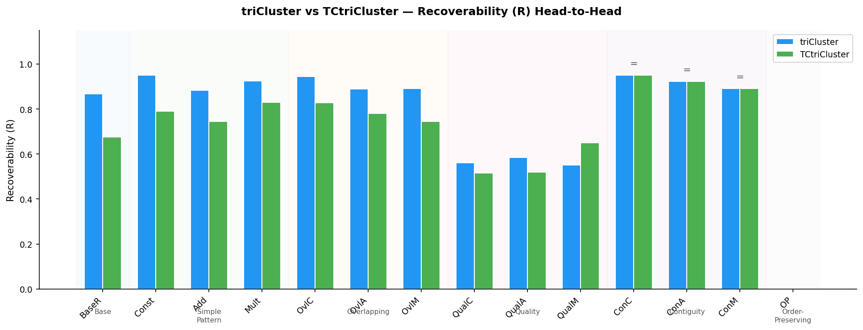
Figure 5: triCluster vs. TCtriCluster R comparison per dataset
Dataset | triCluster R | TCtriCluster R | #Found (TC) | #Found (TCT)
BaseR | 0.867 | 0.676 | 10 | 7
Constant | 0.950 | 0.791 | 45 | 29
Additive | 0.883 | 0.746 | 40 | 21
Multiplicative | 0.924 | 0.830 | 35 | 20
ContiguityC | 0.950 | 0.950 | 43 | 43
ContiguityA | 0.922 | 0.922 | 29 | 29
ContiguityM | 0.891 | 0.891 | 39 | 39
QualityC | 0.561 | 0.515 | 48 | 20

Key insight: On Contiguity datasets, both algorithms produce identical results. The temporal contiguity constraint is 'free' when patterns are already consecutive. On non-contiguous datasets, TCtriCluster finds ~27% fewer triclusters with ~6% lower R.

4.4 TRIQ vs. R Trade-off
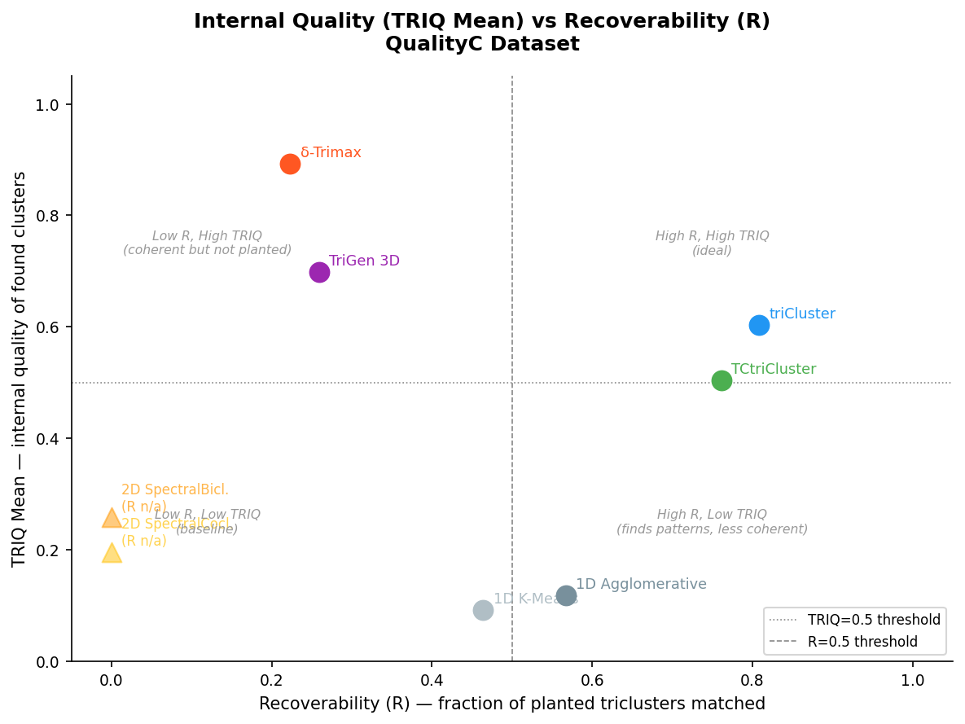
Figure 6: TRIQ vs R scatter — high TRIQ does not imply high R
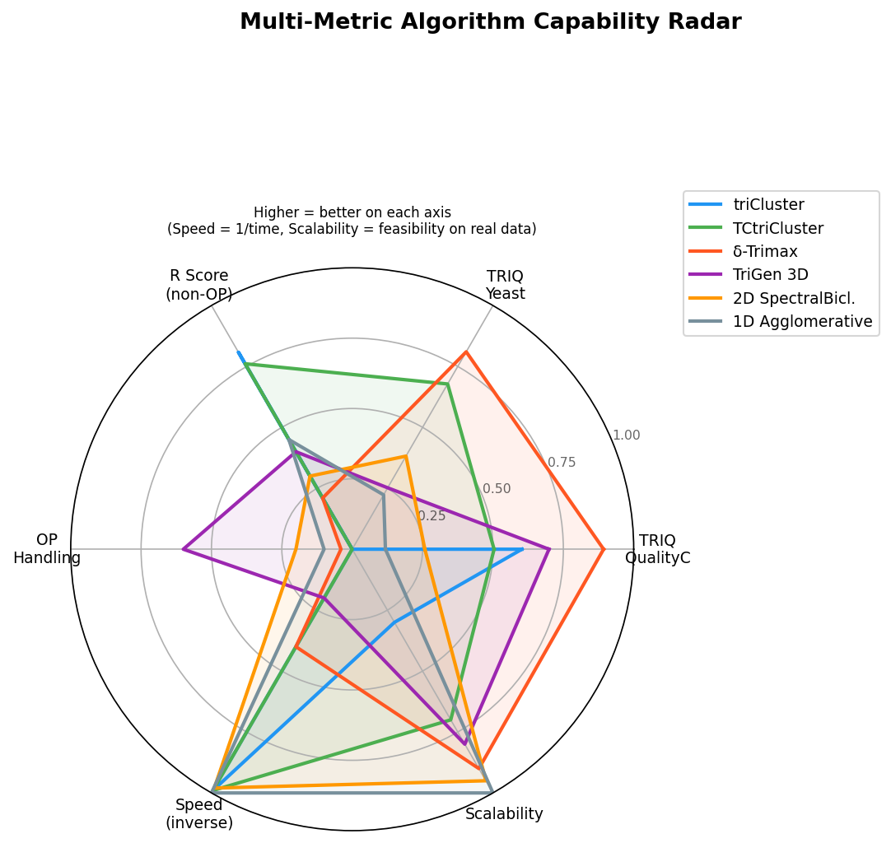
Figure 7: Radar chart — multi-metric comparison of all algorithms
Algorithm | TRIQ (QualityC) | R (QualityC) | Interpretation
δ-Trimax | 0.893 | 0.223 | Coherent but doesn't match planted patterns
triCluster | 0.603 | 0.561 | Balanced — good at both metrics
TCtriCluster | 0.504 | 0.515 | Balanced with fewer triclusters
TriGen | 0.699 | 0.259 | Coherent but coarse (only 5 GA solutions)
1D Agglo. | 0.118 | 0.567* | High recall by cluster size, not coherence

* Recall-based R formula — not directly comparable to Soares precision-oriented R used for 3D algorithms.

4.5 Recoverability on QualityC Ground Truth — All Methods
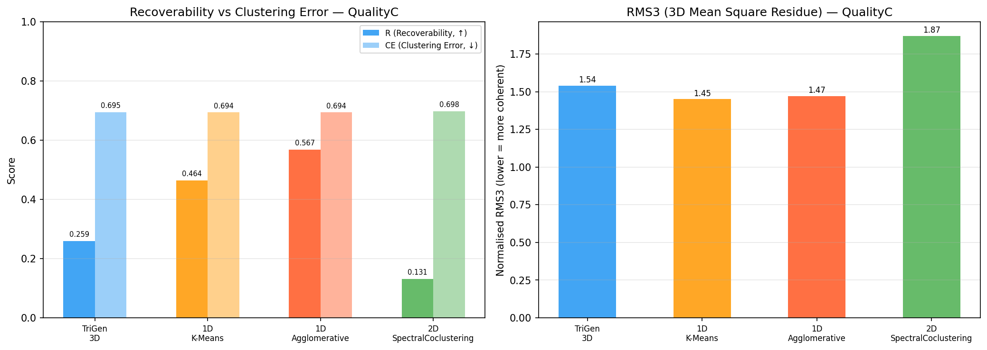
Figure 8: R/CE/RMS3 recoverability on QualityC across all methods
Method | #Found | R | CE | RMS3 | Avg Volume
triCluster | 48 | 0.5609 | 0.9965 | 0.8024 | —
1D Agglomerative* | 5 | 0.5674 | 0.6936 | 1.47 | 5,000
1D K-Means* | 5 | 0.4636 | 0.6936 | 1.45 | 5,000
TriGen 3D | 5 | 0.2588 | 0.6951 | 1.54 | 3,675
2D SpectralCocluster | 5 | 0.1309 | 0.6980 | 1.87 | 1,060

* 1D methods use a recall-based R variant — large gene-only clusters trivially cover planted gene sets.

4.6 TriGen Results — QualityC, Yeast, Synthetic
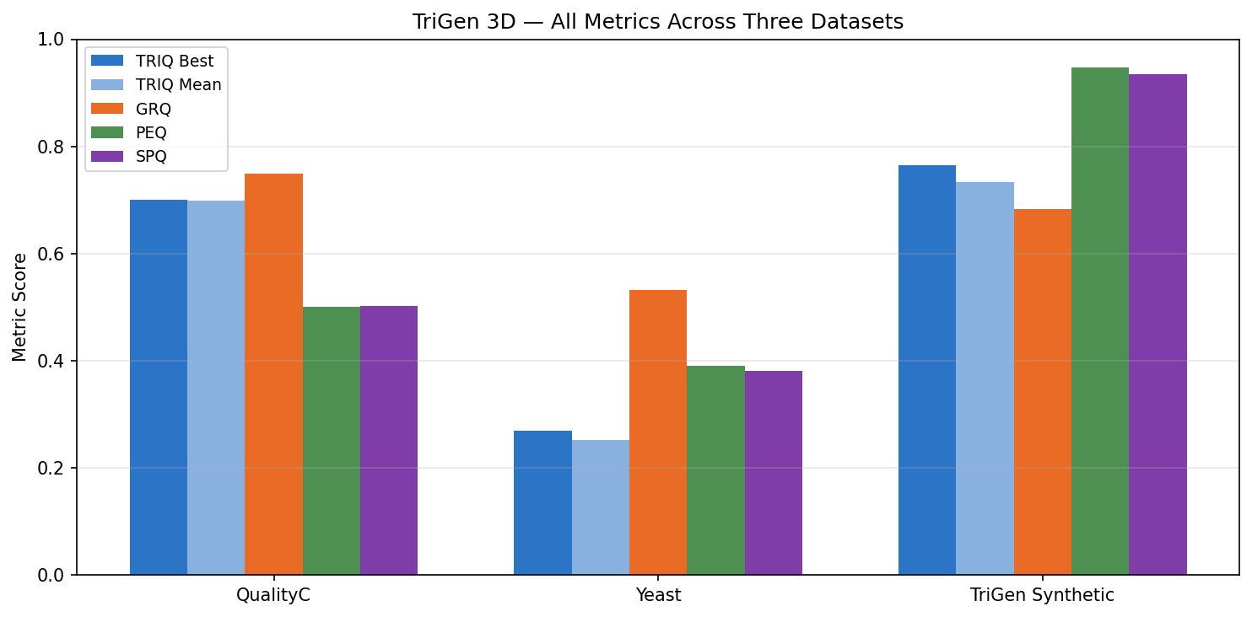
Figure 9: TriGen TRIQ across all three datasets
Dataset | TRIQ | GRQ | PEQ | SPQ | Note
QualityC (500×10×5) | 0.699 | 0.749 | 0.501 | 0.502 | Consistent across 5 GA populations
Yeast (7491×3×14) | 0.257 | 0.510 | 0.380 | 0.373 | Real noise limits TRIQ
Synthetic (1000×10×5) | 0.753 | 0.667 | 0.943 | 0.930 | PEQ/SPQ → 1.0; validates temporal recovery

4.7 Speed Comparison
Algorithm | Dataset | Time | Feasible?
K-Means / Agglomerative | 500×10×5 | <1 s | Yes
SpectralCo/Biclustering | 500×10×5 | <1 s | Yes
triCluster | 500×10×5 | 0.12 s | Yes
TCtriCluster | 500×10×5 | 0.11 s | Yes
δ-Trimax | 500×10×5 | ~16 s | Yes
TriGen | 500×10×5 | ~30-60 s | Yes
triCluster | 500×3×14 (Yeast) | TIMEOUT | NO
TCtriCluster | 500×3×14 (Yeast) | 1.7 s | Yes
δ-Trimax | 500×3×14 (Yeast) | ~1.5 s | Yes

Key insight: triCluster's EXPAND_T is exponential in timepoints (2^14 = 16,384 for Yeast). TCtriCluster's contiguity constraint linearises this to ≤13 consecutive windows — a decisive computational advantage on real time-course data.

5. Master Summary Chart
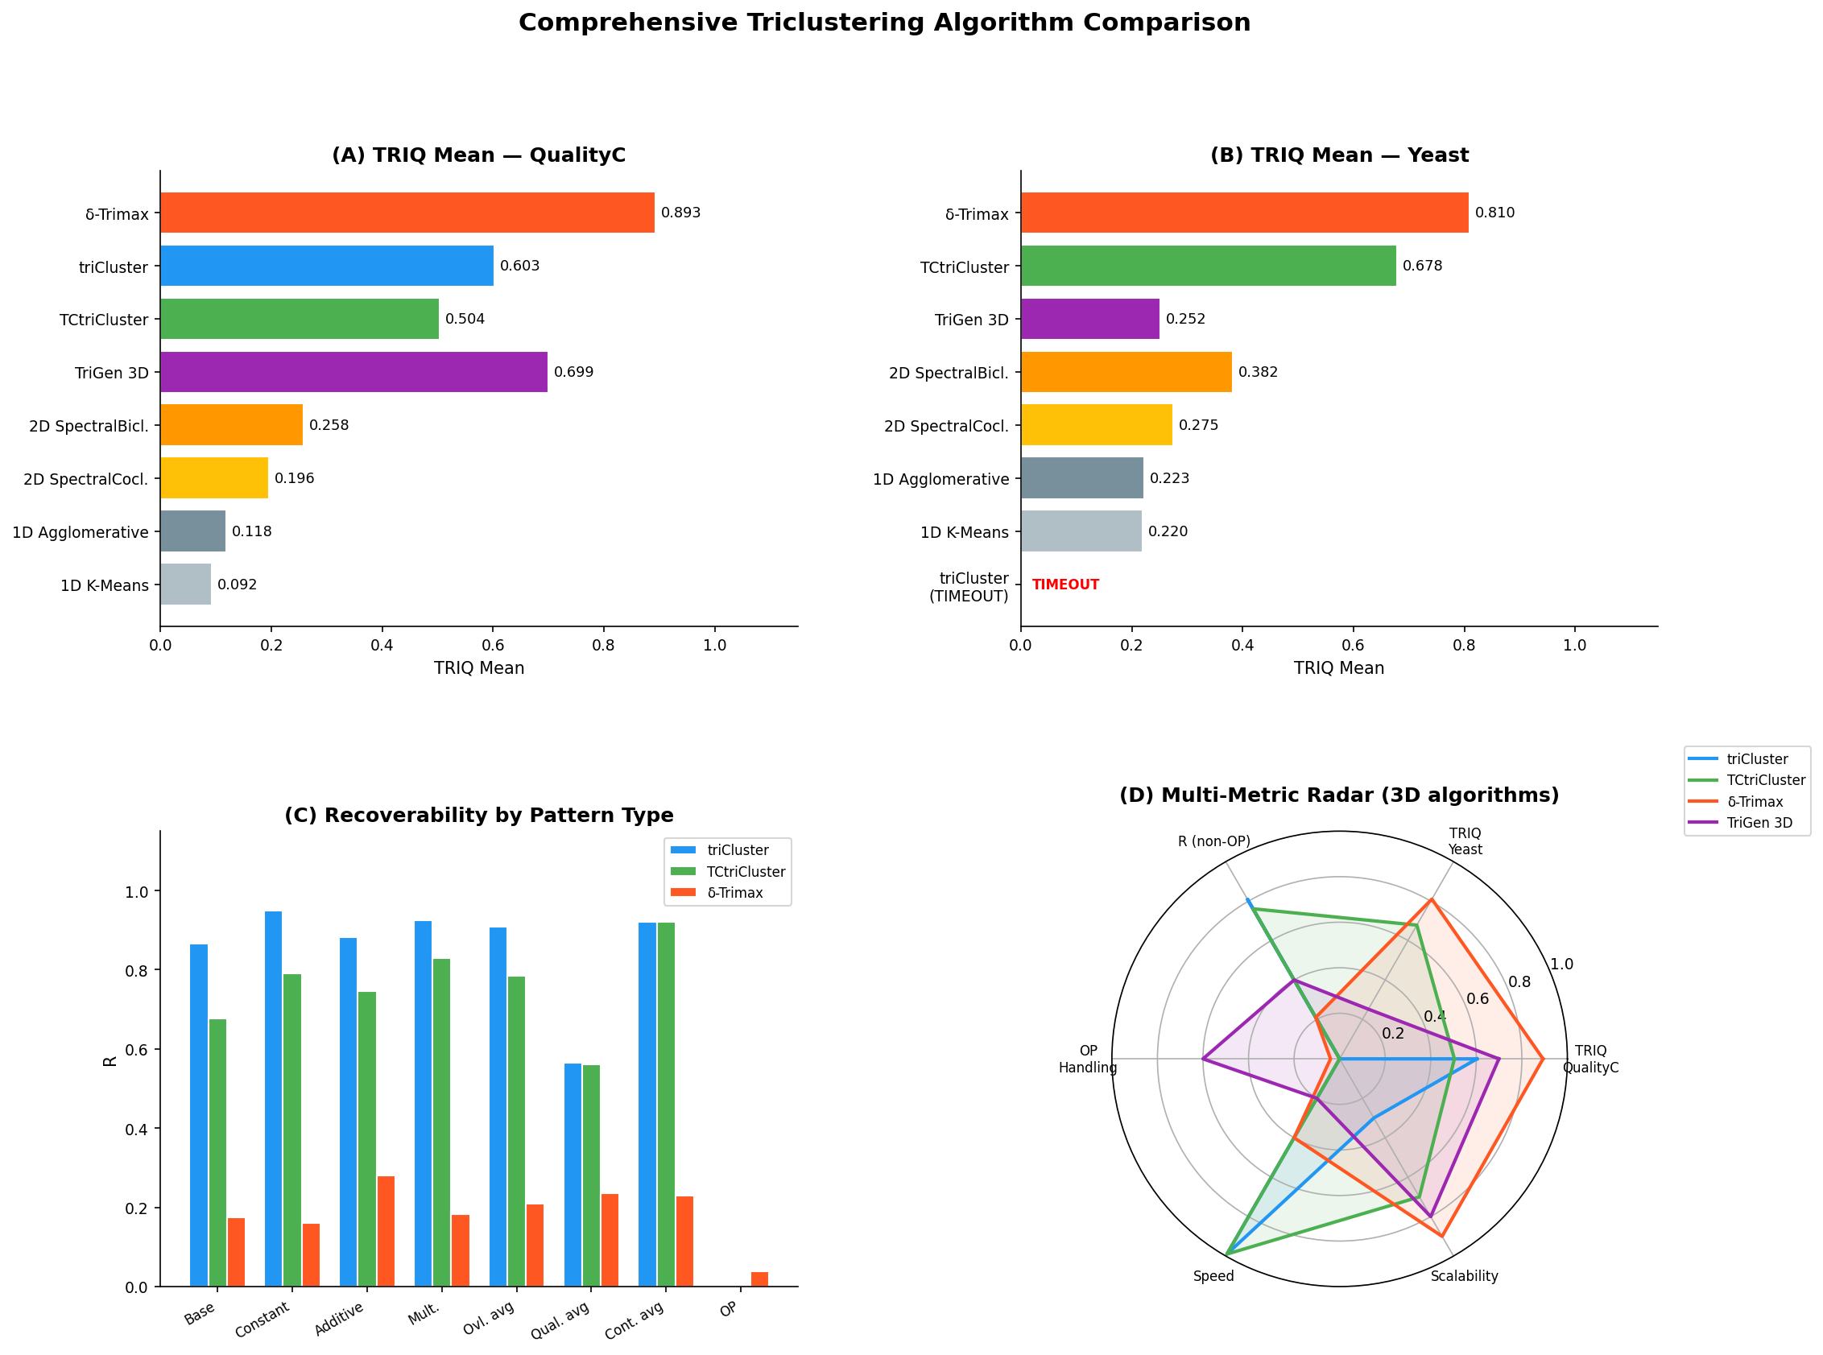
Figure 10: Master summary — TRIQ and R across all algorithms and datasets

6. Key Findings
- Dimensionality drives internal quality. All 3D algorithms outperform all 1D/2D baselines on TRIQ. Ranking: δ-Trimax (0.893) > TriGen (0.699) > triCluster (0.603) > TCtriCluster (0.504) >> SpectralBiclustering (0.258) >> K-Means (0.092).
- TRIQ ≠ Recoverability. δ-Trimax has the highest TRIQ but lowest R among 3D methods. triCluster achieves both high TRIQ and high R — the only algorithm that wins on both simultaneously.
- triCluster dominates on structured patterns. R > 0.88 on 9 of 13 non-OrderPreserving datasets. Mean R = 0.808.
- TCtriCluster's temporal constraint is biologically free. Identical performance to triCluster on Contiguity datasets (R = 0.921). Only ~6% lower R on non-contiguous datasets. Reduces Yeast runtime from timeout to 1.7 s.
- OrderPreserving patterns are unrecoverable by all three tricluster algorithms. triCluster / TCtriCluster: R = 0.000; δ-Trimax: R = 0.038. Fundamental modelling incompatibility — rank patterns need rank-based algorithms (e.g., OPTriCluster).
- Noise degrades triCluster significantly. R drops from 0.950 (Constant, clean) to 0.561 (QualityC, 10% noise) — a 41% degradation. Tight window tolerance is sensitive to noise.
- δ-Trimax excels on real data. TRIQ Mean = 0.810 on Yeast — highest of all tested algorithms. MSR minimisation naturally handles noisy biological data with no planted structure.
- TriGen validates on its own synthetic data. PEQ/SPQ → 0.94 on TriGen synthetic (1000×10×5), confirming the GA recovers planted temporal co-expression patterns.

7. Algorithm Recommendations by Use Case
Use Case | Best Algorithm | Why
Synthetic data, exact pattern recovery | triCluster | R = 0.808 mean; best precision on structured patterns
Real noisy biological data | δ-Trimax | TRIQ = 0.810 on Yeast; MSR handles noise well
Temporal windows (biology-interpretable) | TCtriCluster | Contiguous time blocks; feasible on long time-courses
Order-preserving expression | (needs OPTriCluster) | None of these algorithms handle rank patterns
Fast exploration, no ground truth | SpectralBiclustering | Best 2D TRIQ (0.497 on Yeast); sub-second runtime
Simple, interpretable baseline | 1D Agglomerative | Fastest; reasonable recall on large gene sets

8. Algorithm Capability Matrix
Capability | 1D | 2D Spectral | TriGen | triCluster | TCtriCluster | δ-Trimax
Constant patterns | Yes | Yes | Yes | Yes | Yes | Yes
Additive patterns | ~ | ~ | ~ | Yes | Yes | Yes
Multiplicative patterns | ~ | ~ | ~ | Yes | Yes | ~
Order-preserving | ~ | ~ | Yes | No | No | No
Temporal structure | No | ~ | Yes | Yes | Yes | Yes
Temporal contiguity | No | No | No | No | Yes | No
Scalable (long time) | Yes | Yes | Yes | No | ~ | Yes
High TRIQ | Low | Med | High | High | High | Highest
High R | Med* | Low | Med | High | High | Low

* 1D high R is misleading — large gene-only clusters trivially contain planted gene sets by size.

Algorithms: triCluster (Zhao & Zaki 2005), TCtriCluster (Soares 2015), δ-Trimax (Cheng-Church 2000 / Soares 2020), TriGen (Gutiérrez-Avilés et al. 2014). Datasets: Soares et al. 2024 benchmark, Spellman et al. 1998 Yeast GST.

