XenevaOS Post-Quantum Cryptography Benchmarks
This document contains the finalized data extractions from the cryptographic simulation experiments for XenevaOS. All benchmarks were run natively in C++ using OpenSSL 3.5.5.

System Configuration
- Compiler: g++ (Ubuntu 15.2.0-16ubuntu1) 15.2.0
- Openssl: OpenSSL 3.5.5 27 Jan 2026
- Cpu: AMD Ryzen 7 5800H with Radeon Graphics
- Kernel: Linux 6.18.33.2-microsoft-standard-WSL2
- Ram: 7.4Gi
- Timestamp: 2026-07-18 20:30:44 UTC

1. ECDH P-256 vs ML-KEM-768 (Key Establishment)
Compares the latency of generating keys and establishing shared secrets.
Algorithm | Operation | Mean Latency (µs) | Ops/sec | Slowdown (x)
ECDH-P256 | Key Generation | 14.48 | 69058.88 | 1.00
ECDH-P256 | Shared Secret | 46.17 | 21660.49 | 1.00
ECDH-P256 | Full Key Exchange | 77.29 | 12937.64 | 1.00
ML-KEM-768 | Key Generation | 39.82 | 25111.62 | 2.75
ML-KEM-768 | Encapsulation | 28.87 | 34643.94 | 1.00
ML-KEM-768 | Decapsulation | 42.63 | 23458.35 | 1.00
ML-KEM-768 | Full Key Exchange | 110.50 | 9049.75 | 1.43
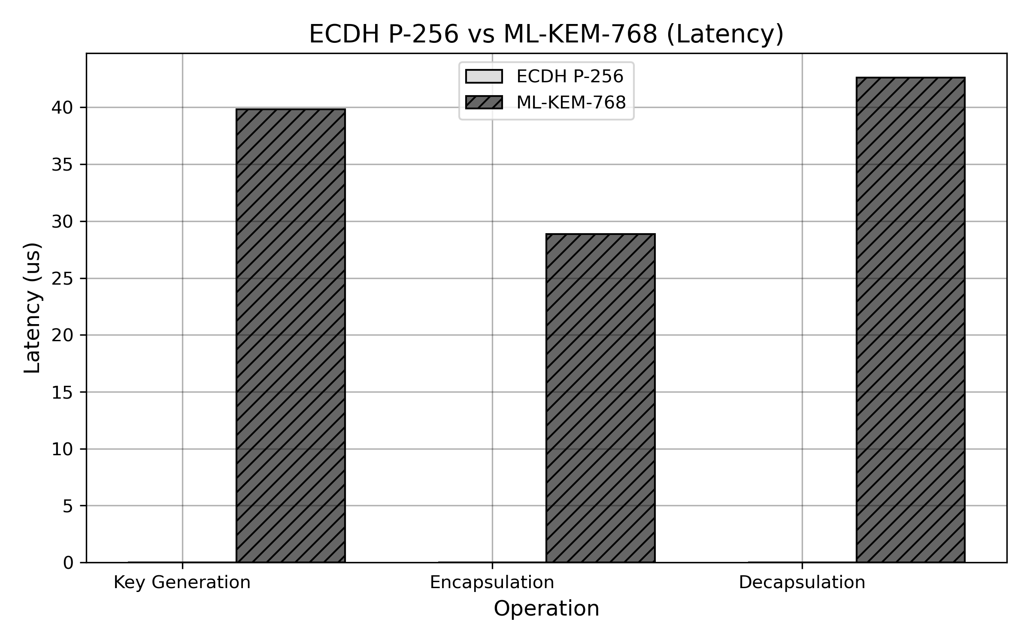

2. RSA-2048 vs ML-DSA-65 (Digital Signatures)
Compares standard key/signature generation and verification. Includes a 256-byte payload.
Algorithm | Operation | Mean Latency (µs) | Ops/sec | Slowdown (x)
RSA-2048 | Key Generation | 51827.59 | 19.29 | 1.00
RSA-2048 | Sign | 690.24 | 1448.76 | 1.00
RSA-2048 | Verify | 22.51 | 44420.50 | 1.00
ML-DSA-65 | Key Generation | 212.29 | 4710.47 | 0.00
ML-DSA-65 | Sign | 1141.11 | 876.34 | 1.65
ML-DSA-65 | Verify | 208.24 | 4802.11 | 9.25
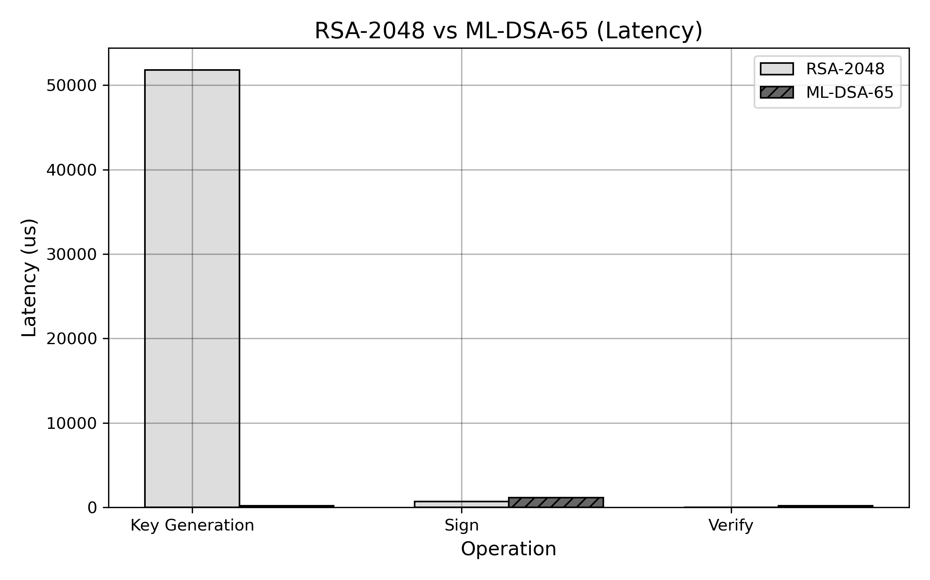

3. Secure Boot Simulation (Kernel Integrity)
Simulates the impact of signature verification on OS boot times using a synthetic 4MB kernel image payload.
Algorithm | Operation | Mean Latency (µs) | Ops/sec | Slowdown (x)
RSA-2048 | Boot Verification | 2015.79 | 496.08 | 1.00
ML-DSA-65 | Boot Verification | 8223.87 | 121.60 | 4.08
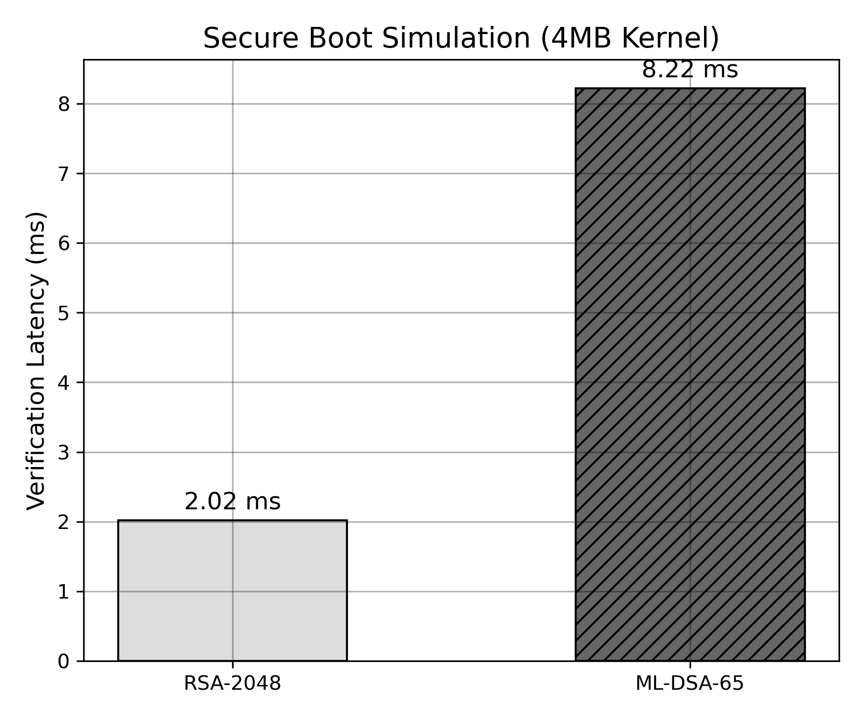

4. Package Verification (Software Supply Chain)
Simulates verifying batches of 1MB system packages (100, 500, and 1000 packages per batch).
No data available.

5. Secure IPC Simulation (Process Isolation)
Simulates a full inter-process communication handshake: KeyGen -> KeyDerivation -> Encrypt/Decrypt (AES-256-GCM) on a 4KB payload.
Algorithm | Operation | Mean Latency (µs) | Ops/sec | Slowdown (x)
Classical (ECDH+AES) | IPC Roundtrip | 126.88 | 7881.27 | 1.00
PQ (ML-KEM+AES) | IPC Roundtrip | 114.98 | 8697.13 | 0.91
