Gaussian Naive Bayes – Breast Cancer Dataset

# 📘 Dataset Summary

- Dataset: Breast Cancer Wisconsin (Diagnostic)  
- Features: 30 continuous variables (e.g., mean radius, texture, perimeter, etc.)  
- Target: Binary classification  
 - 0 = Malignant  
 - 1 = Benign  
- Split: 80% training, 20% test

# 📊 Performance Summary

- Accuracy: ~97.37%  
- Classification Report:  
 - Precision (Malignant): 1.00  
 - Recall (Malignant): 0.93  
 - F1 Score (Malignant): 0.96  
 - Precision (Benign): 0.96  
 - Recall (Benign): 1.00  
 - F1 Score (Benign): 0.98

# 📉 Confusion Matrix

Predicted: Malignant Predicted: Benign  
Actual Malignant 40 3  
Actual Benign 0 71

# 🧠 Interpretation

- The model performs very well overall with high accuracy.  
- It misclassified 3 malignant cases as benign (false negatives), which could be critical in medical diagnosis.  
- However, it had no false positives (no benign cases misclassified as malignant).  
- Gaussian Naive Bayes is suitable here due to the continuous and normally distributed features.

# 📸 Output Visualization

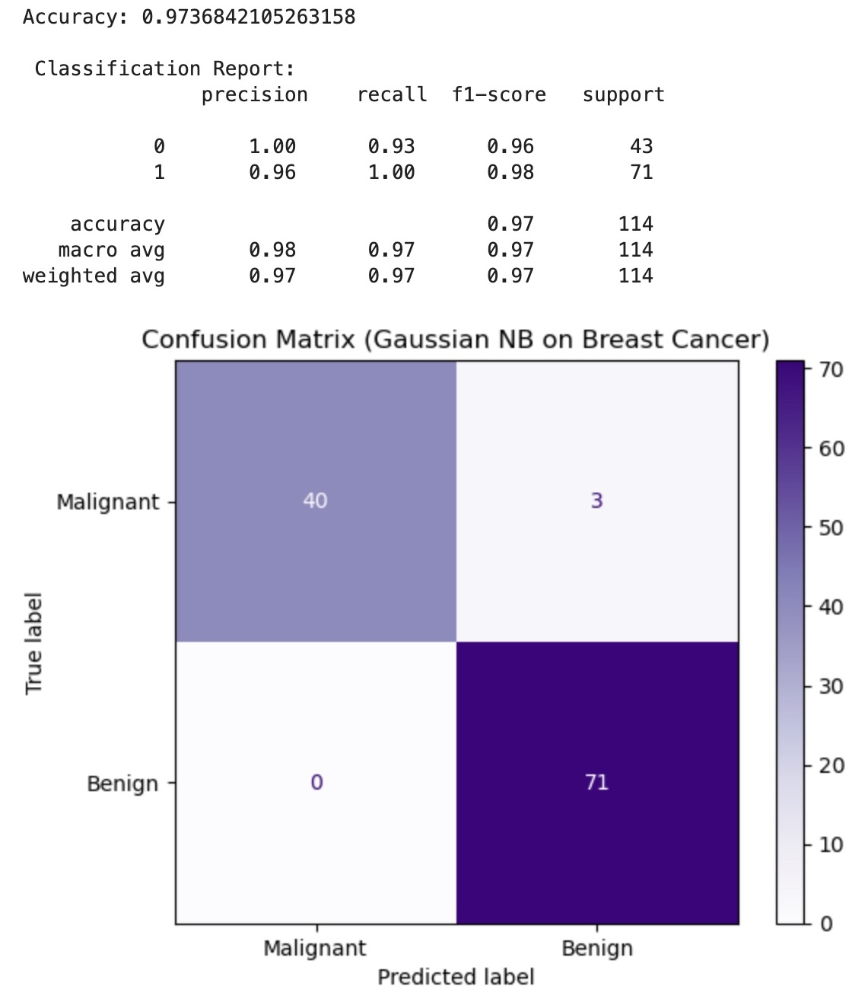

Confusion Matrix for Gaussian Naive Bayes on Breast Cancer Dataset