SVM Hyperparameter Tuning – MNIST Classification

# 🎯 What is Hyperparameter Tuning?

Hyperparameter tuning is the process of selecting the optimal combination of parameters for a machine learning model to maximize its performance.   
For Support Vector Machines (SVMs), the most important hyperparameters are:  
- C: Regularization parameter controlling the trade-off between margin width and misclassification.  
- gamma: Defines how far the influence of a single training example reaches (used in RBF, Poly, Sigmoid kernels).  
- kernel: Specifies the type of kernel to use (e.g., linear, rbf, poly, sigmoid).  
  
We use GridSearchCV to test different combinations of these parameters using cross-validation.

# 🧪 Grid Search on MNIST Dataset (RBF Kernel)

We ran GridSearchCV on a subset of the MNIST handwritten digit dataset using the RBF kernel.   
The grid included combinations of C = [1, 5, 10] and gamma = [0.001, 0.01, 0.1].   
To manage compute, training was done on 5,000 samples and testing on 1,000 samples.

## 🔍 Best Parameters Found

- C: 5  
- gamma: 0.01  
- kernel: rbf

## 📈 Performance Metrics (Test Set – 1000 Samples)

- Accuracy: 94%  
- Macro Avg F1 Score: 0.94  
- Weighted Avg F1 Score: 0.94  
  
Class-wise precision and recall were strong, especially for digits 0, 1, and 6. Minor drops in performance were observed for digits 8 and 9, likely due to visual similarity.

## 📸 Classification Report Output

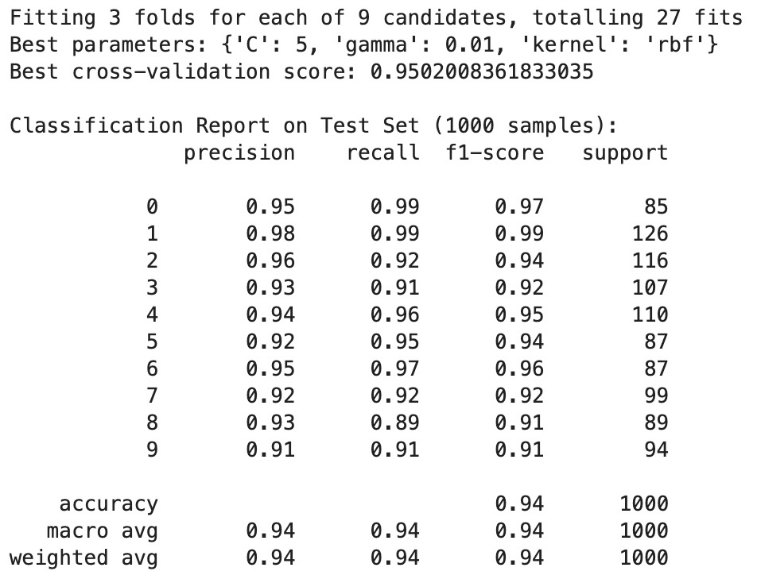

Figure: Classification report showing precision, recall, and F1-scores for each digit class after hyperparameter tuning with GridSearchCV.