Social Media Sentiment Analysis: OnePlus 13 vs Samsung S25

# *1. Introduction*

This project aims to explore and compare public perception, sentiment, and buzz around two flagship smartphones: the OnePlus 13 and the Samsung S25. These devices have generated significant interest since their respective launches, and I wanted to investigate how each was received across multiple public channels.  
  
The focus is to understand the differences in launch buzz, public opinion, media coverage, and sentiment using techniques from Natural Language Processing (NLP), text mining, and data visualization.

# *2. Problem Statement*

The primary research objective is to compare the OnePlus 13 and Samsung S25 based on:  
- Public sentiment and social media buzz  
- Perception trends post-launch  
- Coverage in news and YouTube  
- Frequently discussed topics and themes  
  
This aligns with the broader theme of 'Launch Buzz vs. Long-Term Satisfaction' and supports informed product analysis.

# *3. Data Sources and Tools*

To ensure diversity and richness in the analysis, I collected data from:  
- Reddit: Organic conversations, opinions, and discussions  
- News Articles: Professional reviews and announcements  
- YouTube Comments: Viewer reactions on real-time product reviews  
  
Tools and Libraries:  
Python, PRAW, GNews API, youtube-comment-downloader, pandas, matplotlib, wordcloud, spaCy, gensim, transformers, nltk.

# *4. Data Collection and Preprocessing*

I collected over 300 Reddit posts, 50+ news articles, and nearly 400 YouTube comments. The text was cleaned by:  
- Removing links, punctuation, and special characters  
- Converting to lowercase and removing stopwords  
- Lemmatizing where needed (especially for topic modeling)  
  
This preprocessing was essential to ensure clean and uniform input for sentiment models and topic modeling algorithms.

# *5. Sentiment Analysis and Interpretation*

I used three sentiment analysis methods to capture different perspectives:  
- VADER: Best for social media, gives compound score  
- TextBlob: Provides polarity-based sentiment (positive, negative, neutral)  
- BERT: Deep learning model offering contextual understanding  
  
This multi-model approach ensures cross-validation of sentiment outcomes.

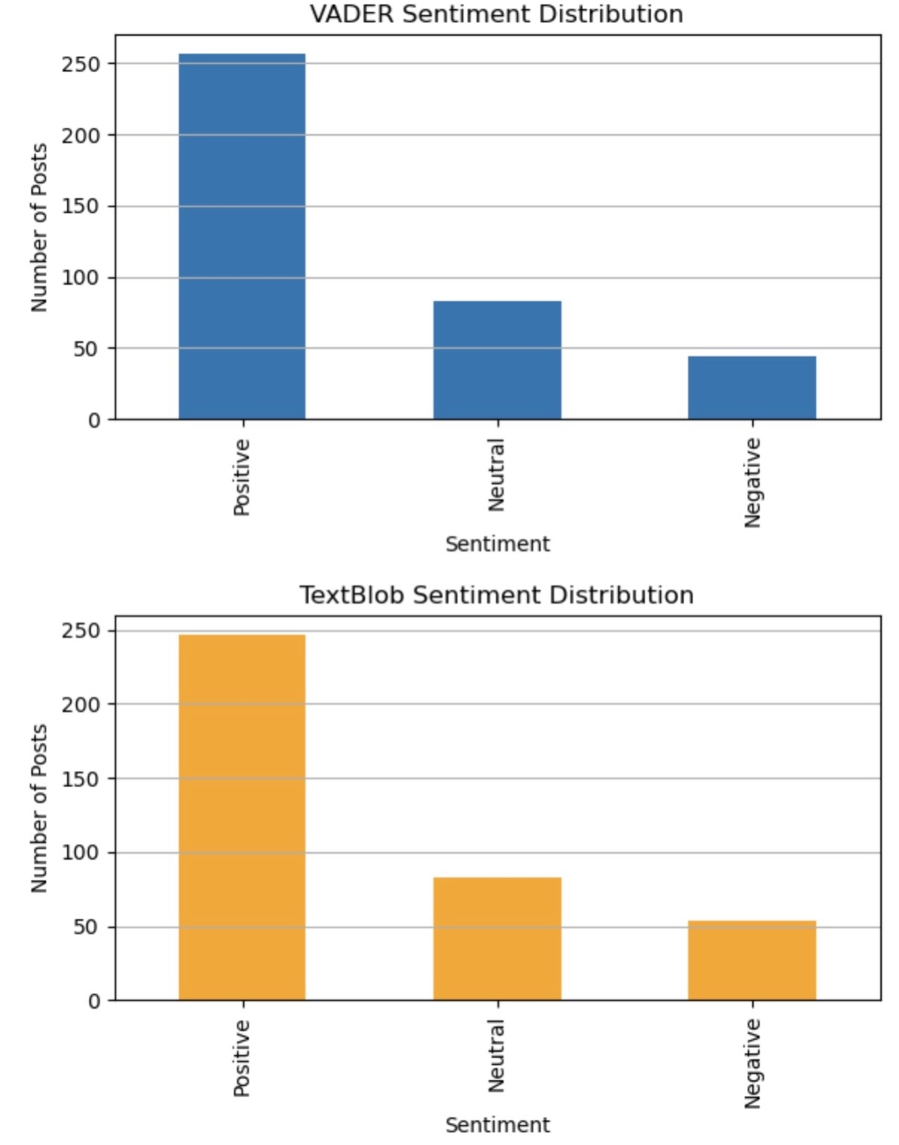

Both VADER and TextBlob show a strong tilt towards positive sentiment, confirming an overall favorable perception in Reddit discussions. VADER detects more positivity than TextBlob, which is expected due to its tuning for informal text.

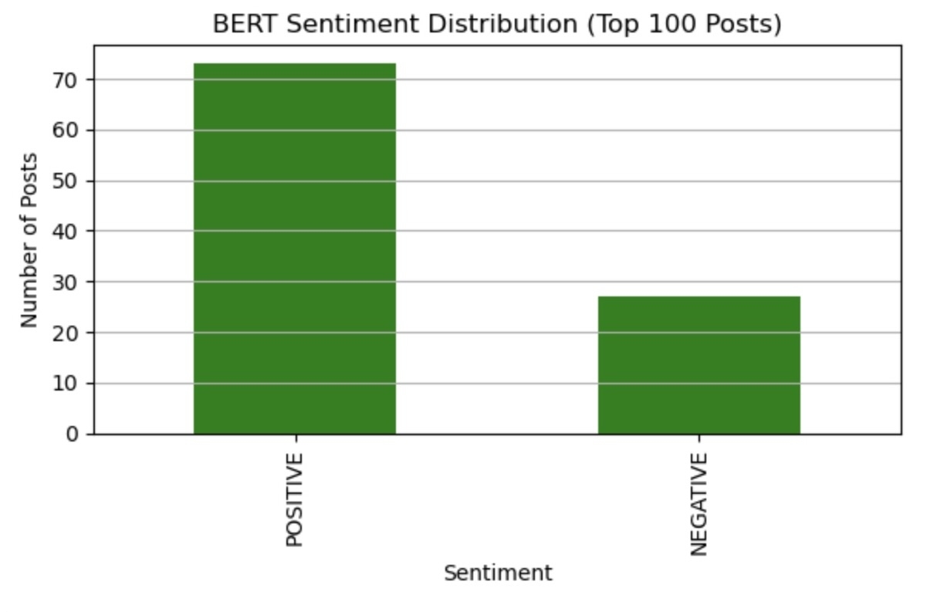

BERT, applied to the top 100 comments for efficiency, shows over 70% of them were labeled as POSITIVE, further confirming that social sentiment leans favorably towards both phones, especially the OnePlus 13.

# *6. Word Cloud Analysis*

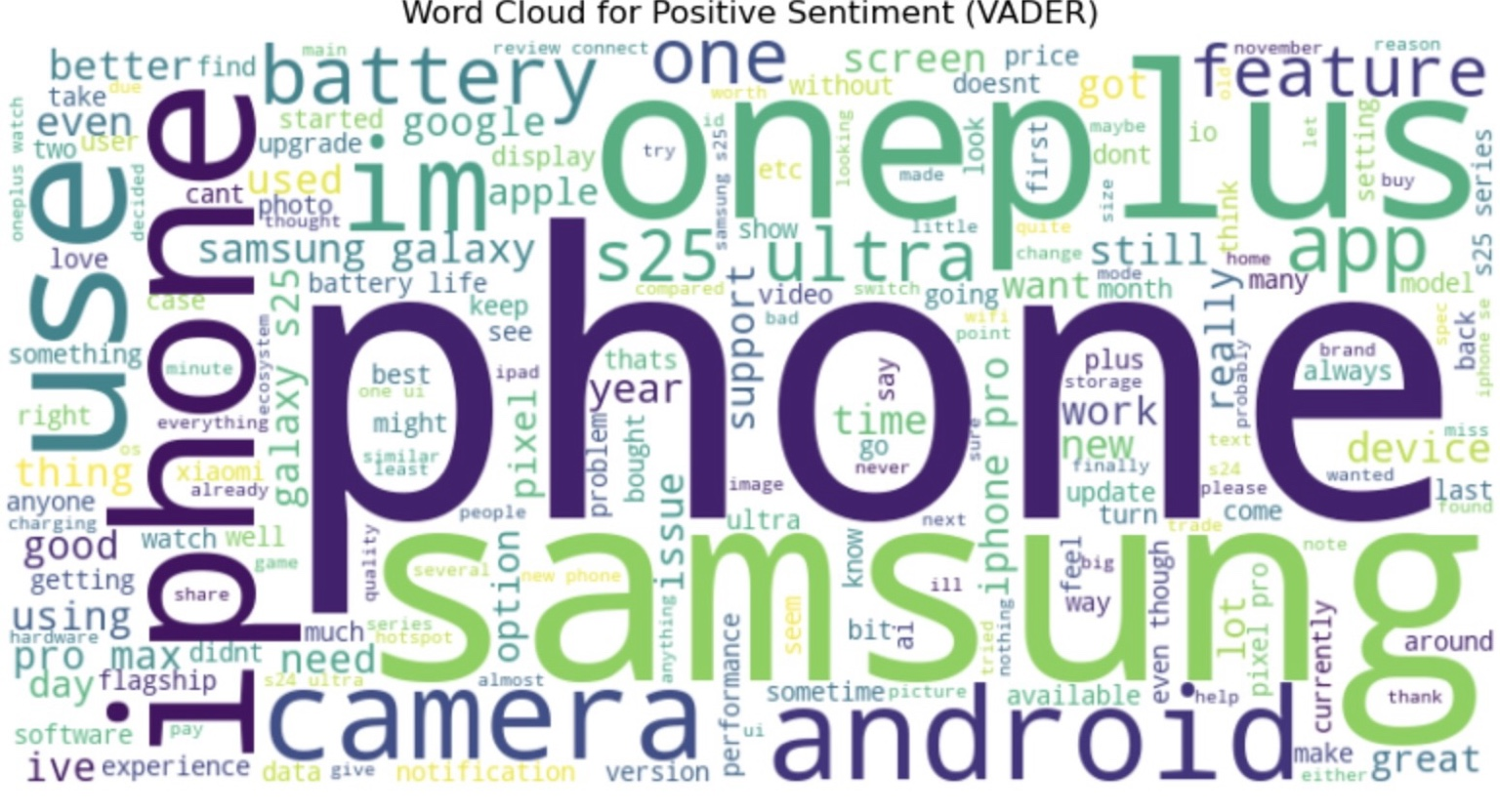

This word cloud visualizes the most frequent terms in positive sentiment Reddit posts. Dominant terms include 'phone', 'oneplus', 'samsung', 'battery', and 'camera'. These reflect user priorities and highlight the popularity of discussions around performance, battery life, and design features.

# *7. Sentiment Trend Over Time*

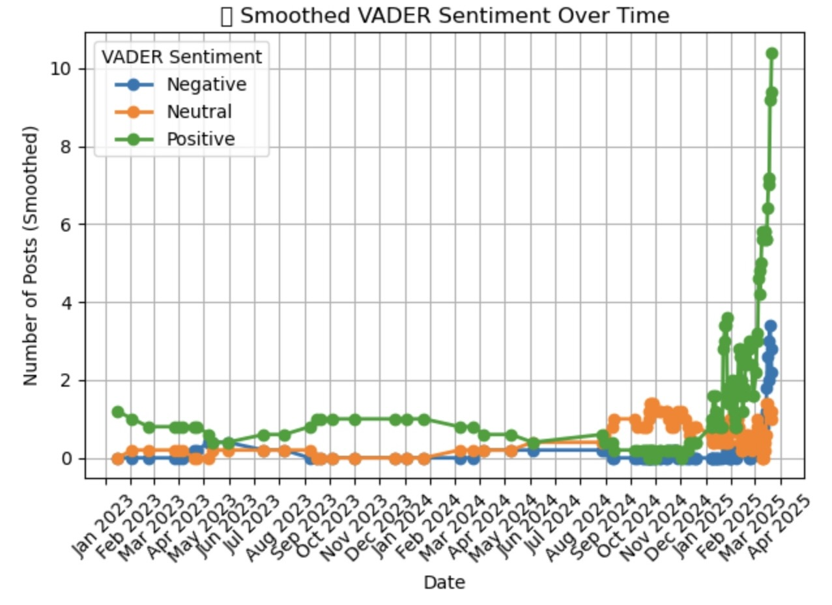

This time-series chart shows sentiment evolution over the months. A sharp rise in positive sentiment from February 2025 onward aligns with the official product launch timelines, indicating a buzz spike post-announcement and early impressions.

# *8. News Article Sentiment*

News sentiment analysis via VADER revealed OnePlus 13 received more positive articles than Samsung S25. Samsung S25 had a more neutral distribution, suggesting either balanced reviews or cautious enthusiasm from the media.

# *9. Average Sentiment Score Comparison*

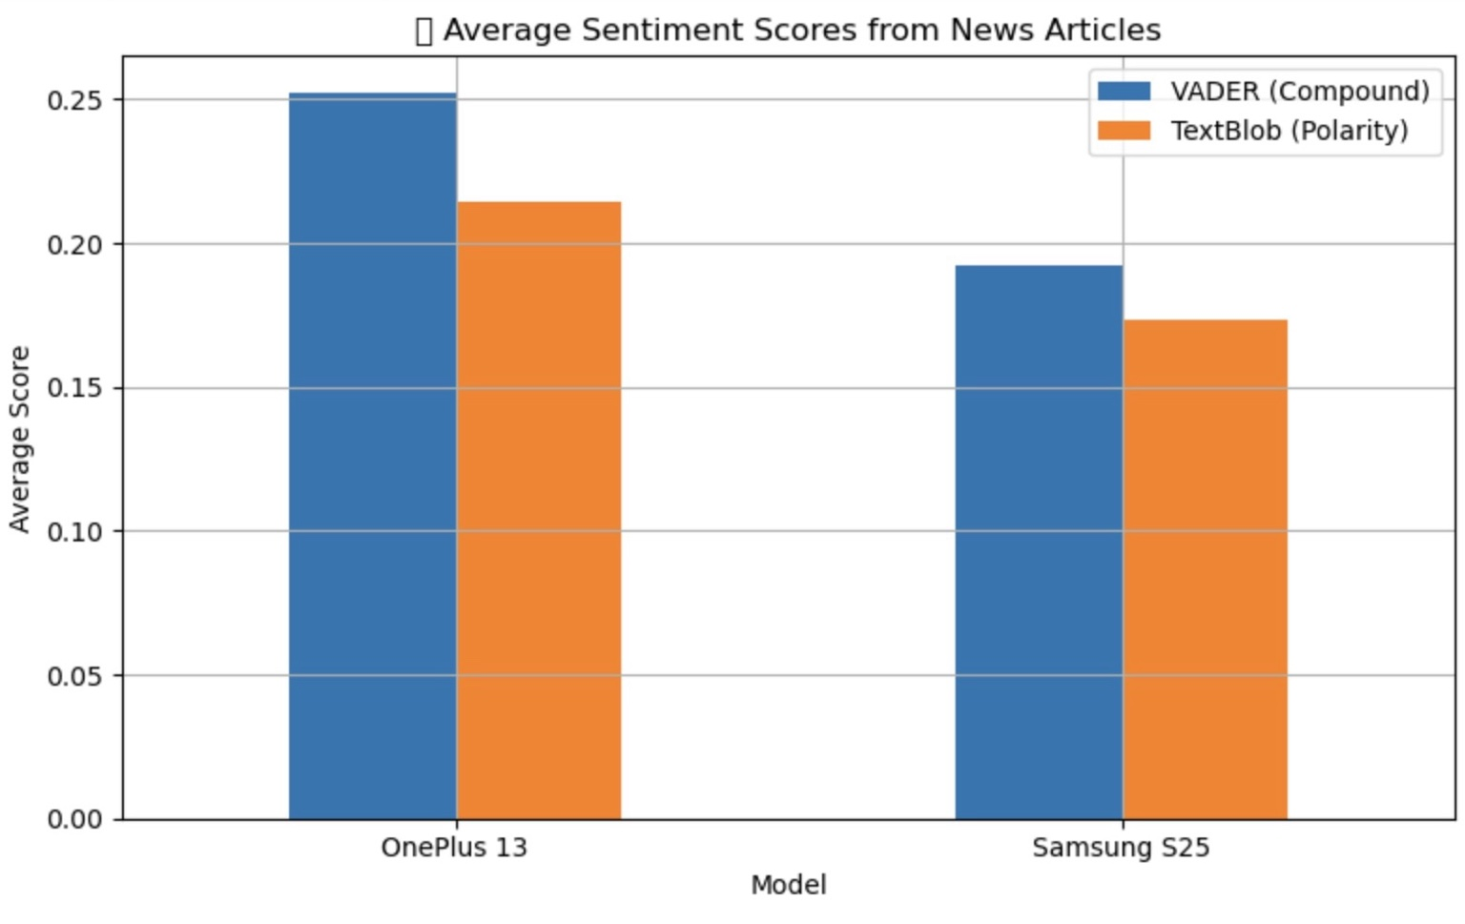

The bar chart shows average sentiment scores from both VADER and TextBlob. OnePlus 13 clearly scores higher on both metrics, indicating more favorable coverage and perception than the Samsung S25 in editorial content.

This chart compares the average sentiment scores of news articles written about OnePlus 13 and Samsung S25 — basically, it tells us how positively or negatively news websites talked about each phone.

# *10. WordCloud*

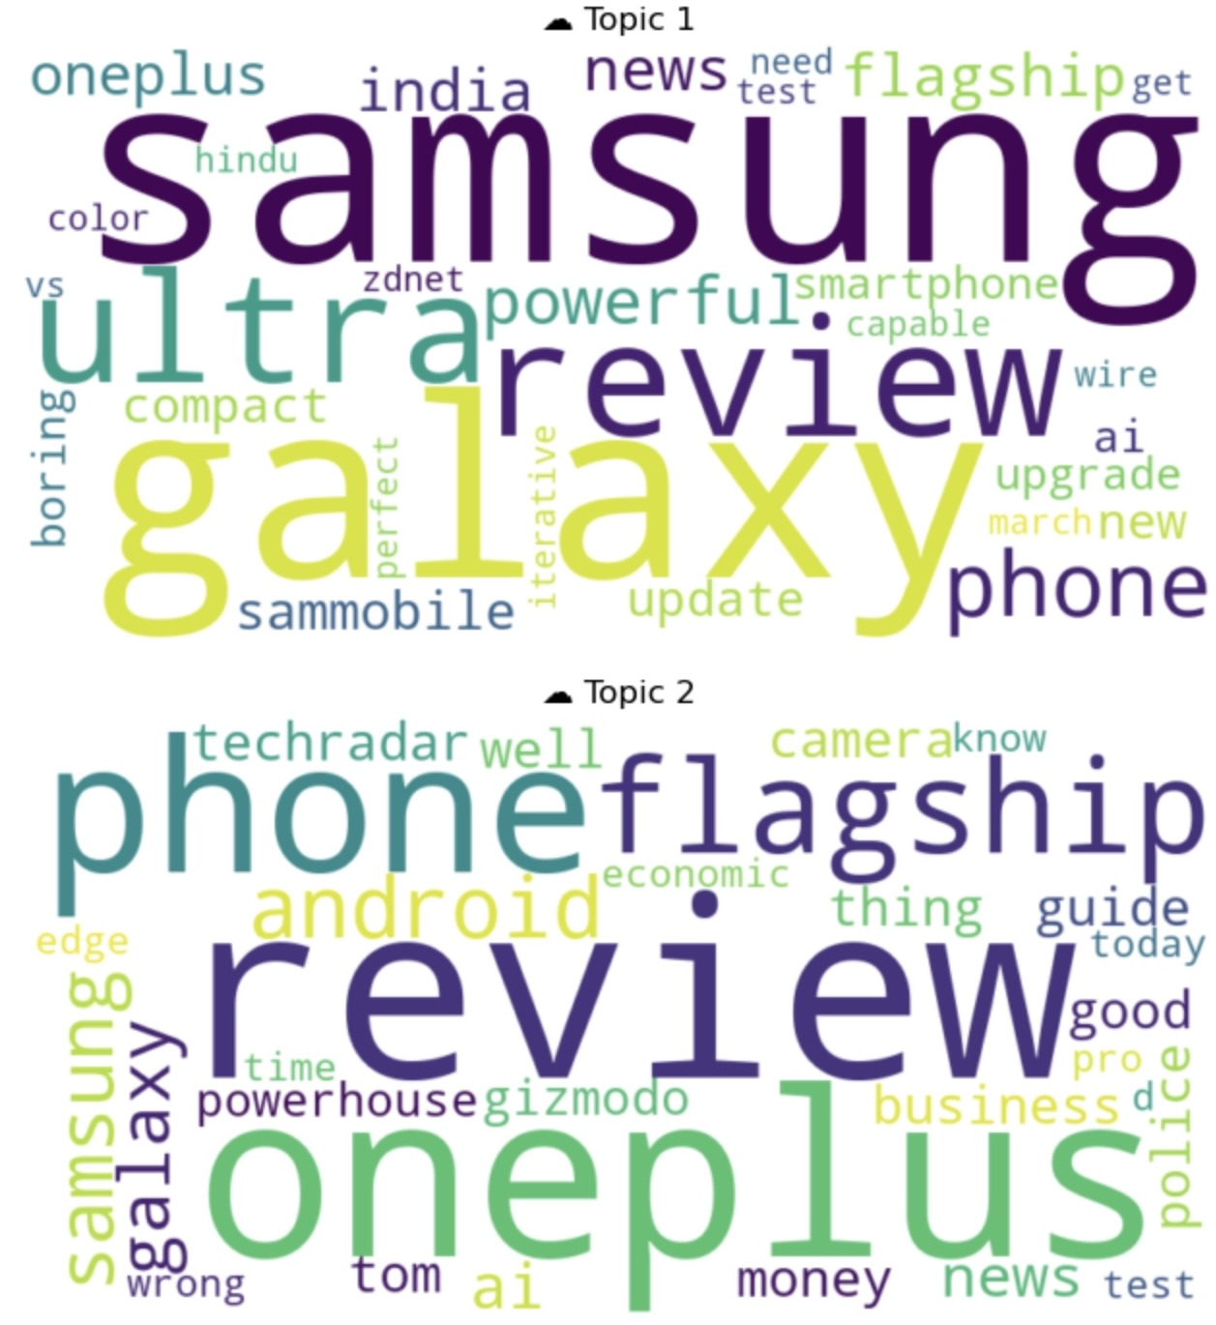

Word clouds of news headlines show common themes like 'flagship', 'review', 'galaxy', and 'oneplus'. This suggests both devices were covered similarly in media, but the context and tone varied as shown in sentiment breakdown.

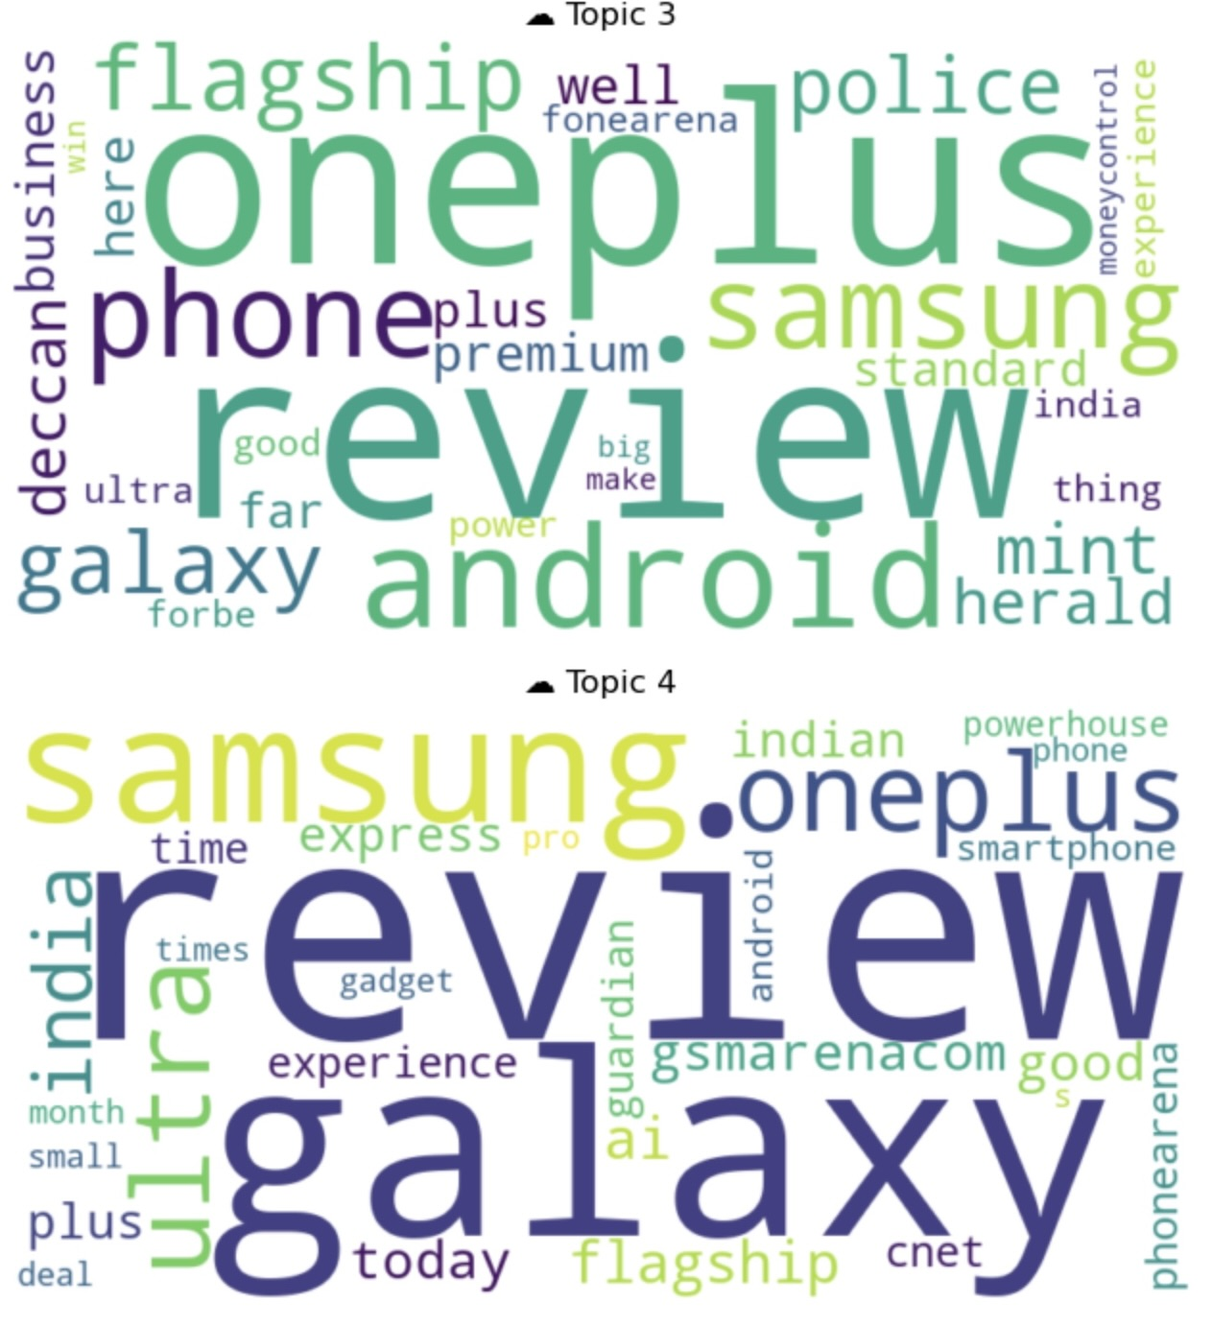

Topic modeling using LDA revealed repeated keywords across articles. Words like 'flagship', 'galaxy', 'review', 'powerful', and 'android' point to recurring themes about performance, design, and competitive positioning.

# *12. YouTube Sentiment Analysis*

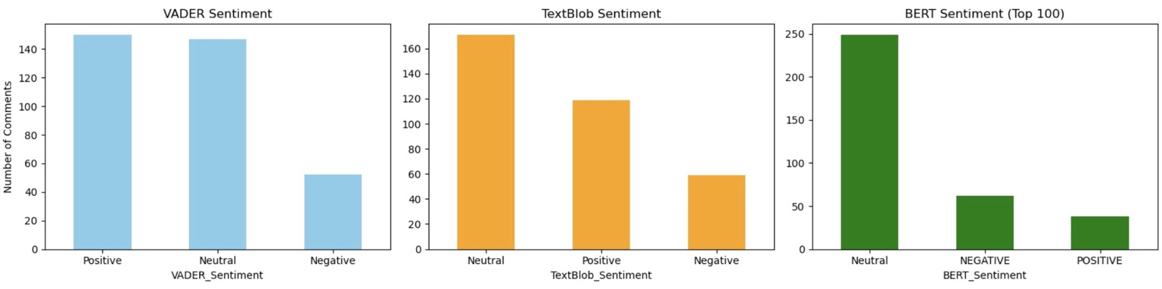

YouTube sentiment results show a mostly neutral to positive response. BERT detected the most neutrality, while VADER found a slightly higher number of positive comments. This suggests that although viewers acknowledge the strengths, they are also being cautious or balanced in their feedback.

# *13. Conclusion*

Across Reddit, news, and YouTube, OnePlus 13 maintained a more positive sentiment profile compared to the Samsung S25. This was supported consistently across all three sentiment models (VADER, TextBlob, BERT). News media was slightly more neutral for Samsung, while Reddit and YouTube were significantly favorable towards OnePlus.  
  
The analysis captured both launch buzz and early satisfaction effectively. With diverse data sources and rigorous NLP techniques, this study fulfills the intended scope of understanding public reaction across platforms.