Trump News & Social Media Analysis Report

# *1. Introduction*

In this project, I aimed to understand the relationship between public sentiment around Donald Trump and trends in online media. This involved analyzing tweet sentiments, news article sentiments, Google search interest, and the topics being discussed over time. I wanted to know whether what people are searching for, reading, and tweeting about aligns with how they feel about him.

# *2. Topic Modeling and Sentiment Analysis*

To understand what people were talking about in the news, I used two machine learning techniques called LDA and BERTopic. These models automatically grouped the news summaries into different ‘topics’ by looking at patterns in word usage.

Imagine going through hundreds of news summaries and trying to figure out the main themes or topics—it's exhausting. Topic modeling helped me do just that, but automatically. This is important because it shows what themes were being emphasized in the media.

Next, I analyzed the *sentiment* of each news article—whether it felt positive, negative, or neutral. Then, I grouped those articles by topic to see which topics were generally associated with negative or positive emotions. This helped me understand not just what people were talking about, but how they felt about those topics.

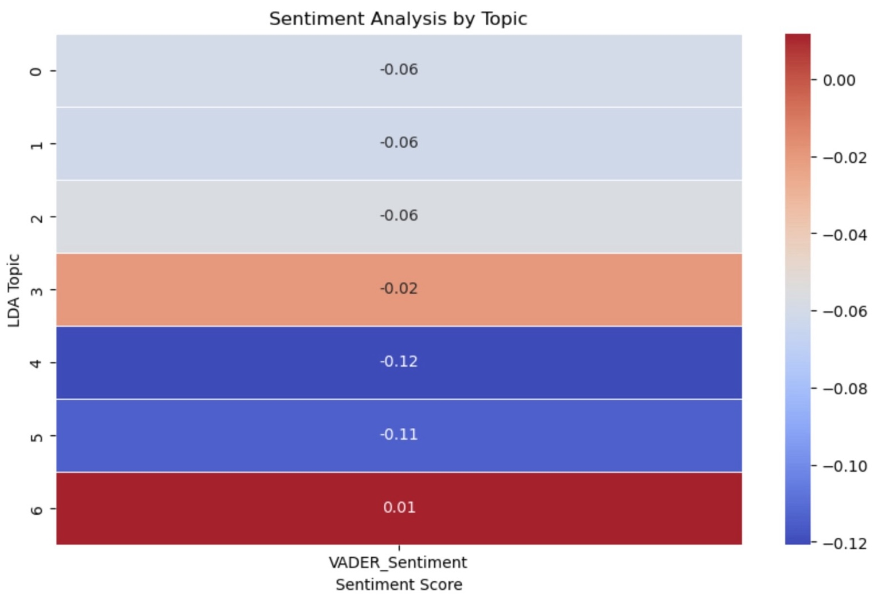

🖼️ Sentiment Analysis by Topic (VADER): Shows how each topic is generally perceived emotionally.

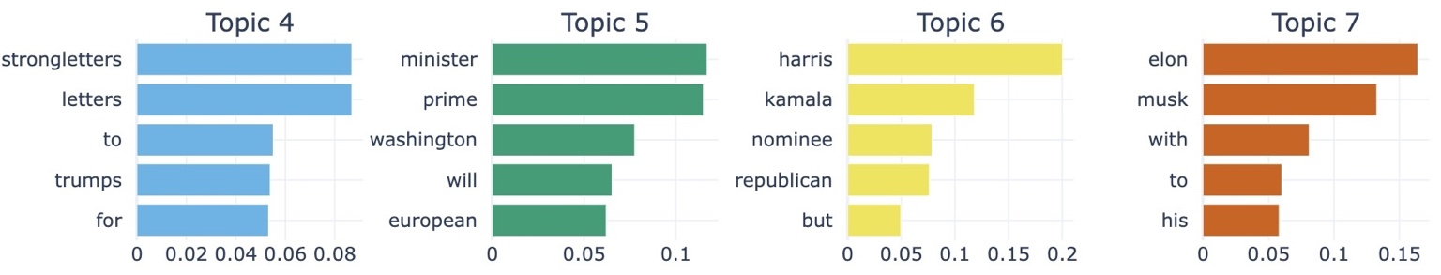

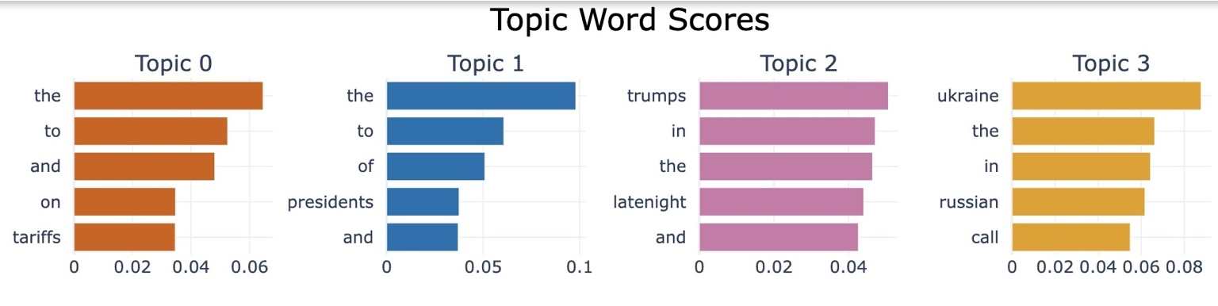

🖼️ Word distributions from topic modeling: These visuals help interpret the main keywords in each topic.

# *3. Correlation with Google Search Trends*

To check if public interest (as seen in Google searches) is linked to the way Trump is talked about on social media, I compared sentiment scores from tweets with Google search trends. I scaled both metrics to make them visually comparable on the same plot.

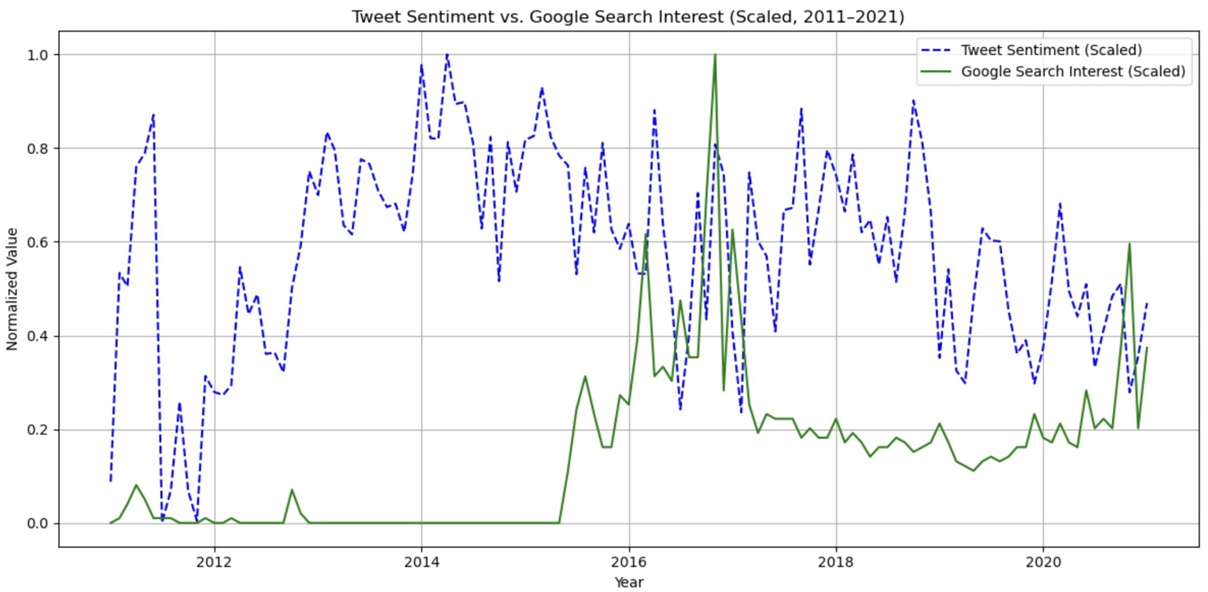

🖼️ Scaled Tweet Sentiment vs Google Search Interest (2011–2021): We observe a few peaks aligning with known events.

# *4. Sentiment Tools Comparison (VADER vs RoBERTa)*

To ensure accuracy, I compared two sentiment analysis tools: VADER and RoBERTa. Both are popular models, but they differ in how they interpret language. I noticed that while they often agreed on the trend, RoBERTa was more sensitive and showed more extreme values for negative sentiment.

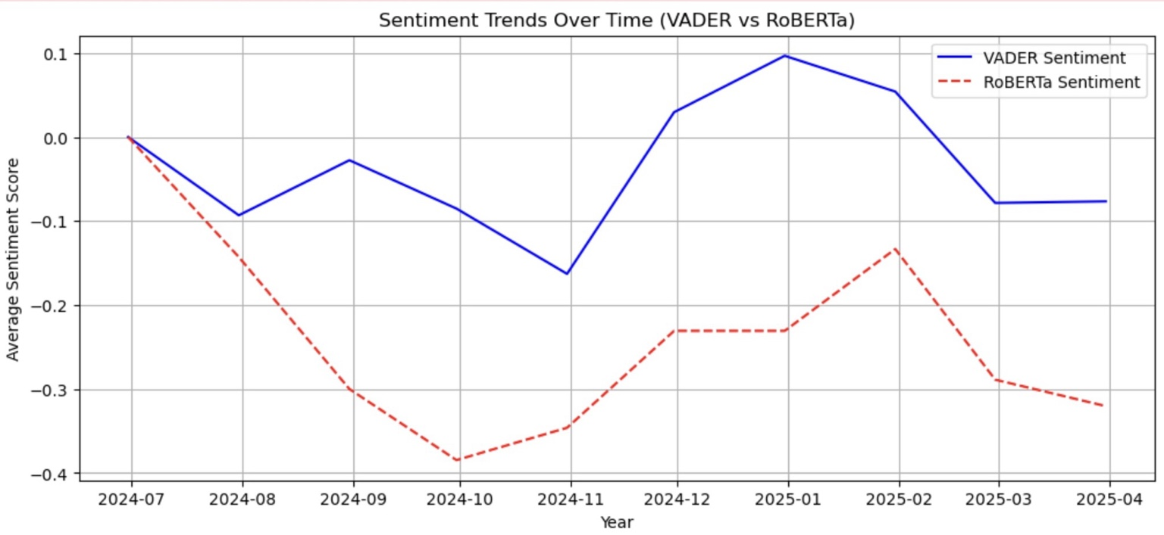

🖼️ Sentiment comparison over time using VADER and RoBERTa.

# *5. Challenges Faced*

Throughout this analysis, I ran into several issues. First, there were mismatches between date formats in datasets, which led to merging problems. I also faced Google Trends API restrictions (error 429) that prevented me from downloading long-term data, so I had to reduce the timeframe. Lastly, I had to reprocess and clean the data multiple times due to inconsistencies or missing values.

# *6. Key Takeaways*

- Topic modeling revealed common themes like foreign policy, politicians, and Elon Musk.  
- Sentiment was largely neutral to negative across topics, with a few exceptions.  
- Google search interest did not always align with tweet sentiment, indicating differing public behaviors.  
- Different sentiment models can yield different interpretations, emphasizing the need for model comparison.