Name : Anirudh Prakash Sharma
Branch : CSE
Section : A
Roll No : 202401100200051

Github Repository URL :- https://github.com/AnirudhSharma-code/github-skills-challenge
Pull Request :- https://github.com/AnirudhSharma-code/github-skills-challenge/pull/2
https://github.com/AnirudhSharma-code/github-skills-challenge/pull/1
Github Actions ScreenShot:
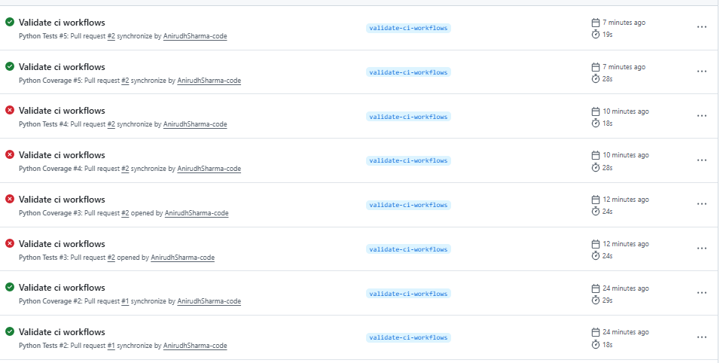
Test WorkFlow Execution :
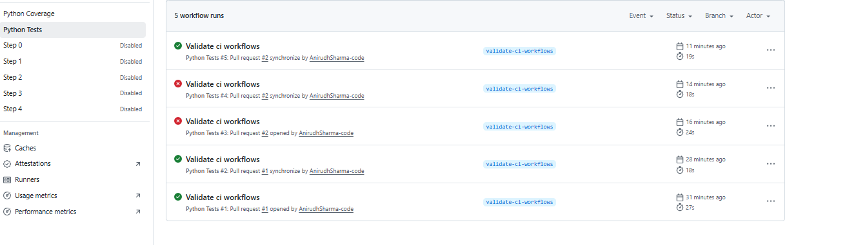
Coverage Workflow Execution :
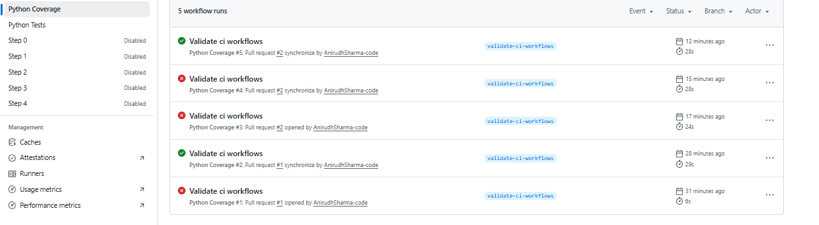
Workflow files :
