HCL CloudLab Assessment Report
Candidate Name: Yekkaluri Anirudh
Roll Number: 23BTRCL241
Course: Cloud Engineering and Big Data Analytics Lab
Sections Covered: Advanced SQL | Linux | PySpark | AWS Cloud | AWS Step Functions | Microsoft Azure

SECTION A: ADVANCED SQL [Maximum Marks: 20]
Question 1: Database Design and Advanced Queries [8 Marks]
Task Requirement: Create a database named EnterpriseDB. Create Employees and Departments tables with appropriate data types, primary keys, and foreign keys. Insert at least 15 employee records and 5 department records (including employees with different salaries, managers, and at least one department without any employees).
The EnterpriseDB database was designed with normalized Employees and Departments tables. Foreign key constraints enforce referential integrity between Employees(DepartmentID) and Departments(DepartmentID). Sample records covering distinct departments, managers, salary bands, and an unassigned department were populated to satisfy all lab requirements.
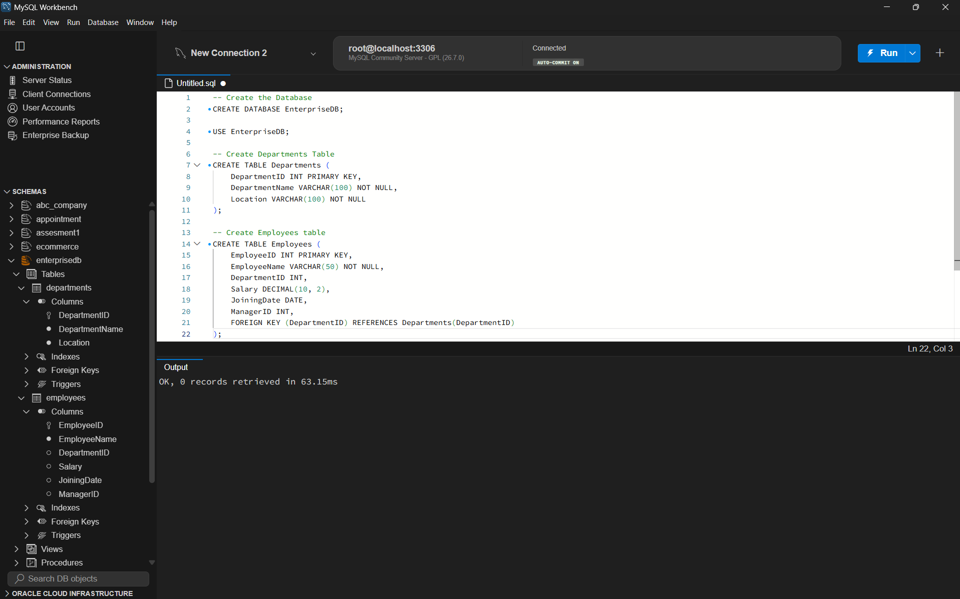
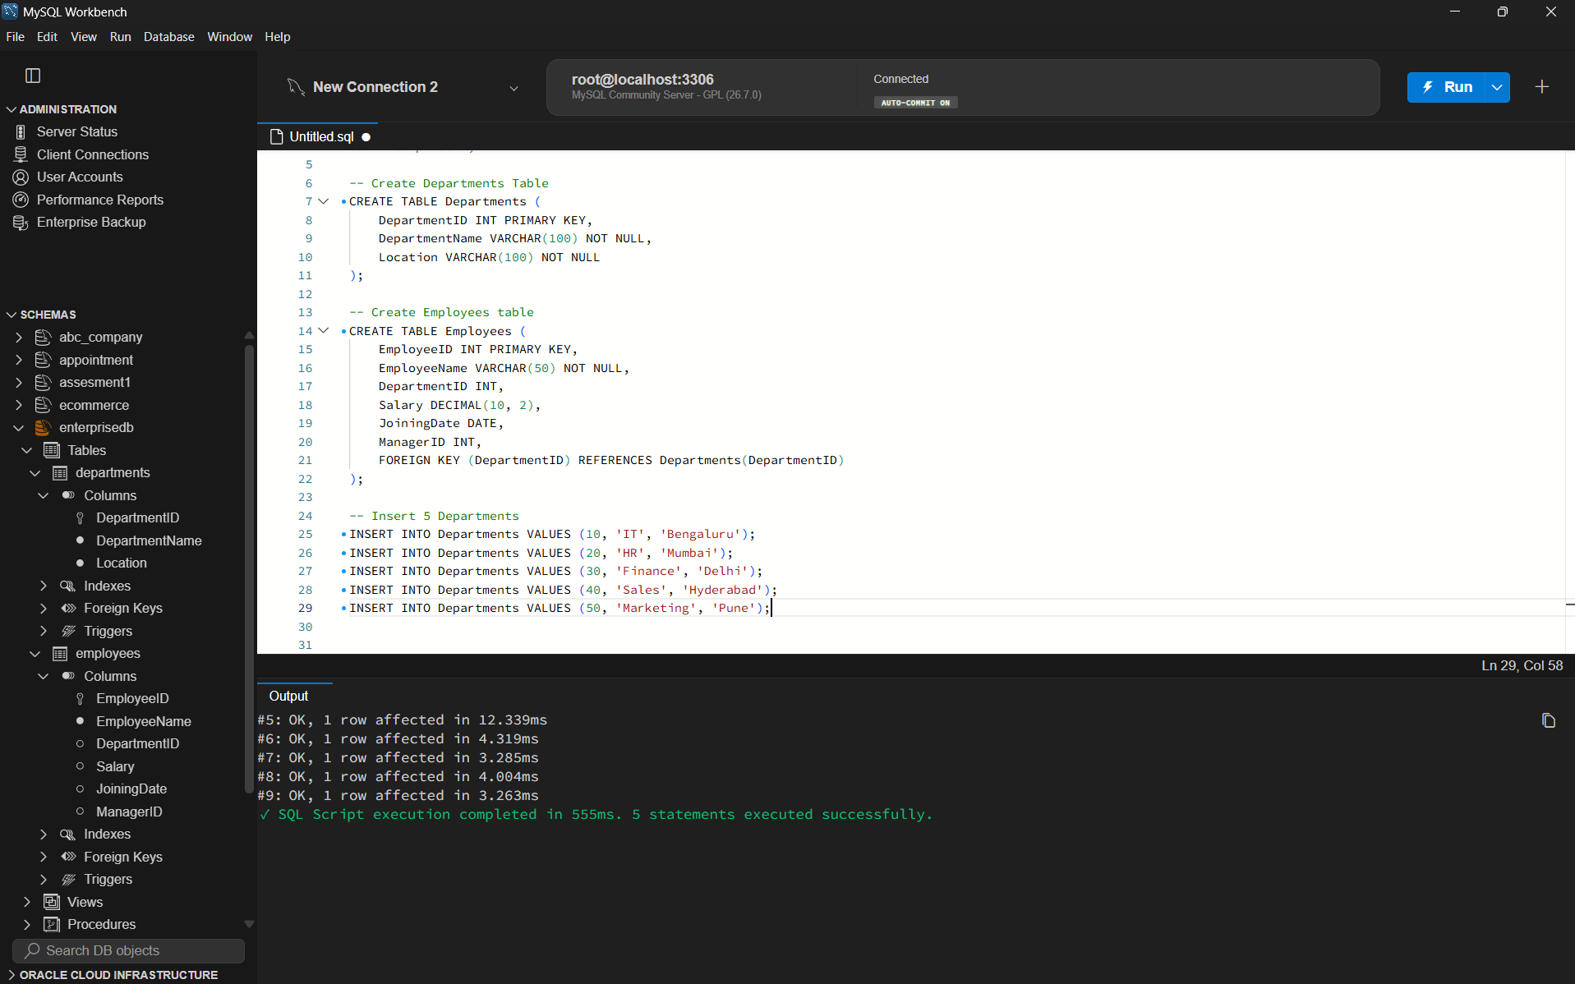
Task 1a: Display Employee, Department, and Manager Names [2 Marks]
Task Requirement: Write a query to display employee names, department names, and manager names using joins.
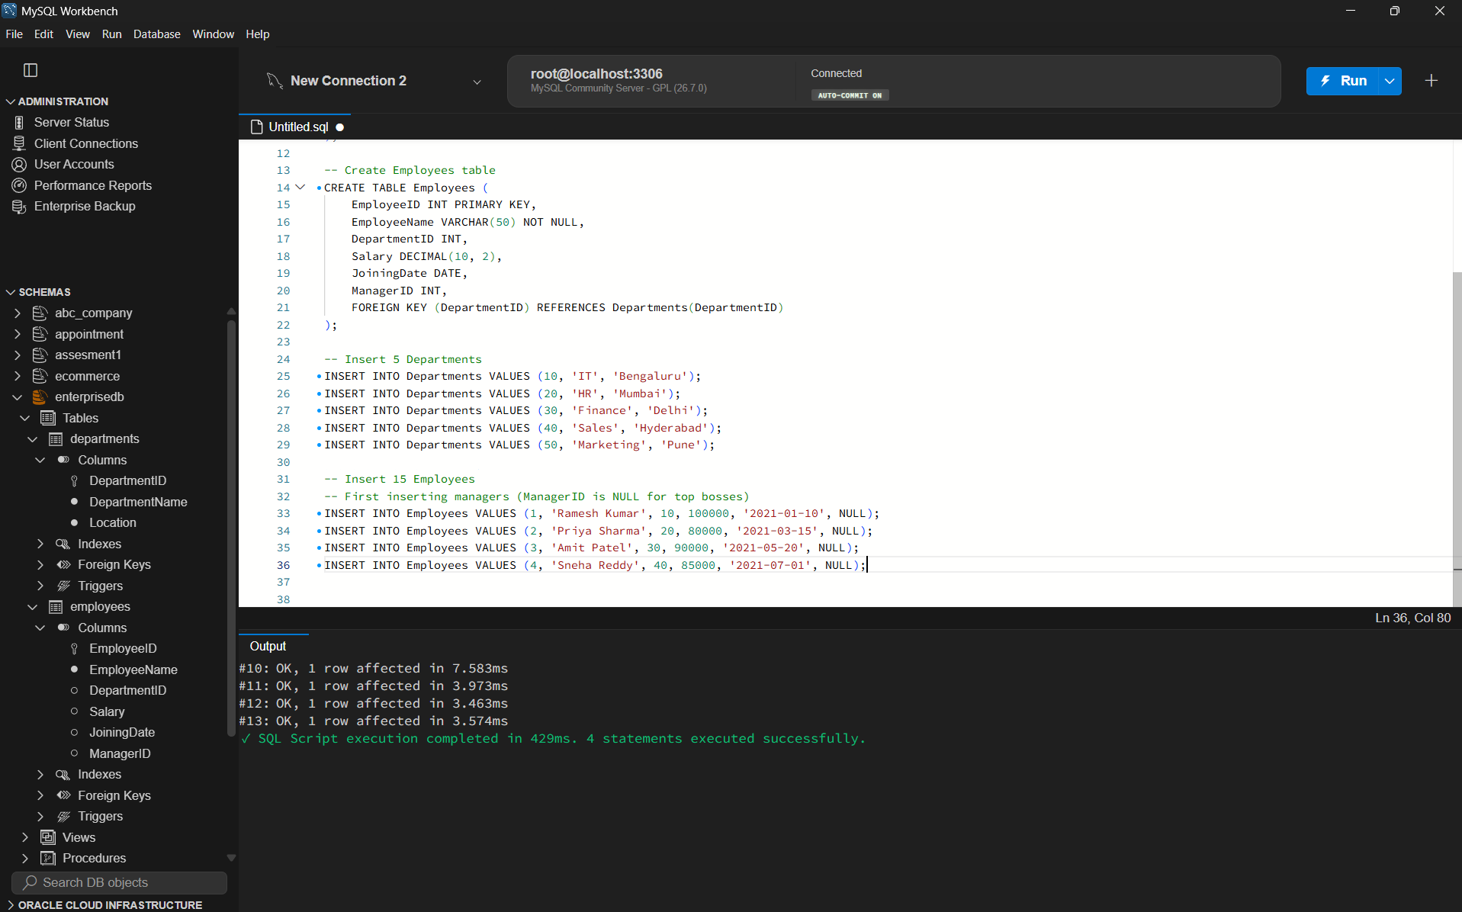
The query performs an INNER JOIN between Employees and Departments on DepartmentID to fetch the department name, and a self LEFT JOIN on Employees (e.ManagerID = m.EmployeeID) to retrieve the manager name, handling root-level managers cleanly.
Task 1b: Employees Earning More Than Department Average [2 Marks]
Task Requirement: Find all employees whose monthly salary is greater than their department's average salary.
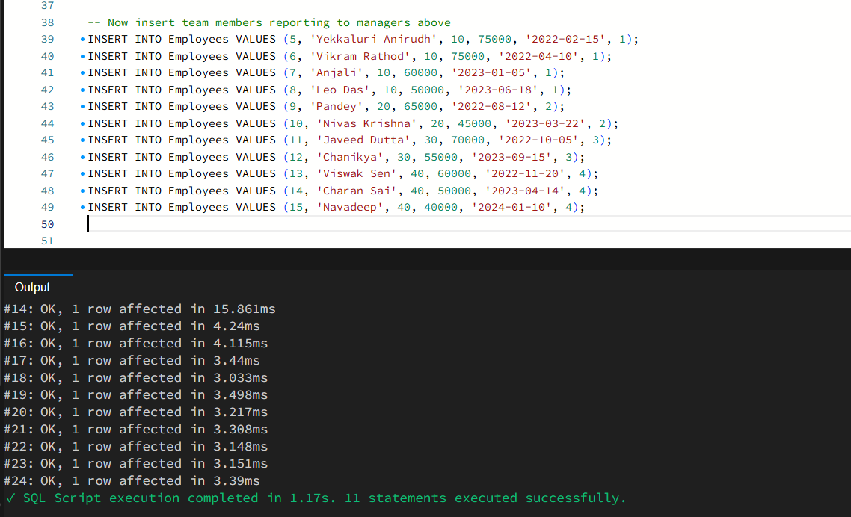
A correlated subquery computes the AVG(Salary) for each employee's corresponding DepartmentID. The outer query filters for employees whose salary strictly exceeds this computed departmental threshold.
Task 1c: Second-Highest Distinct Salary Without LIMIT/TOP [2 Marks]
Task Requirement: Find the second-highest distinct salary without using LIMIT, TOP, or FETCH FIRST clauses.
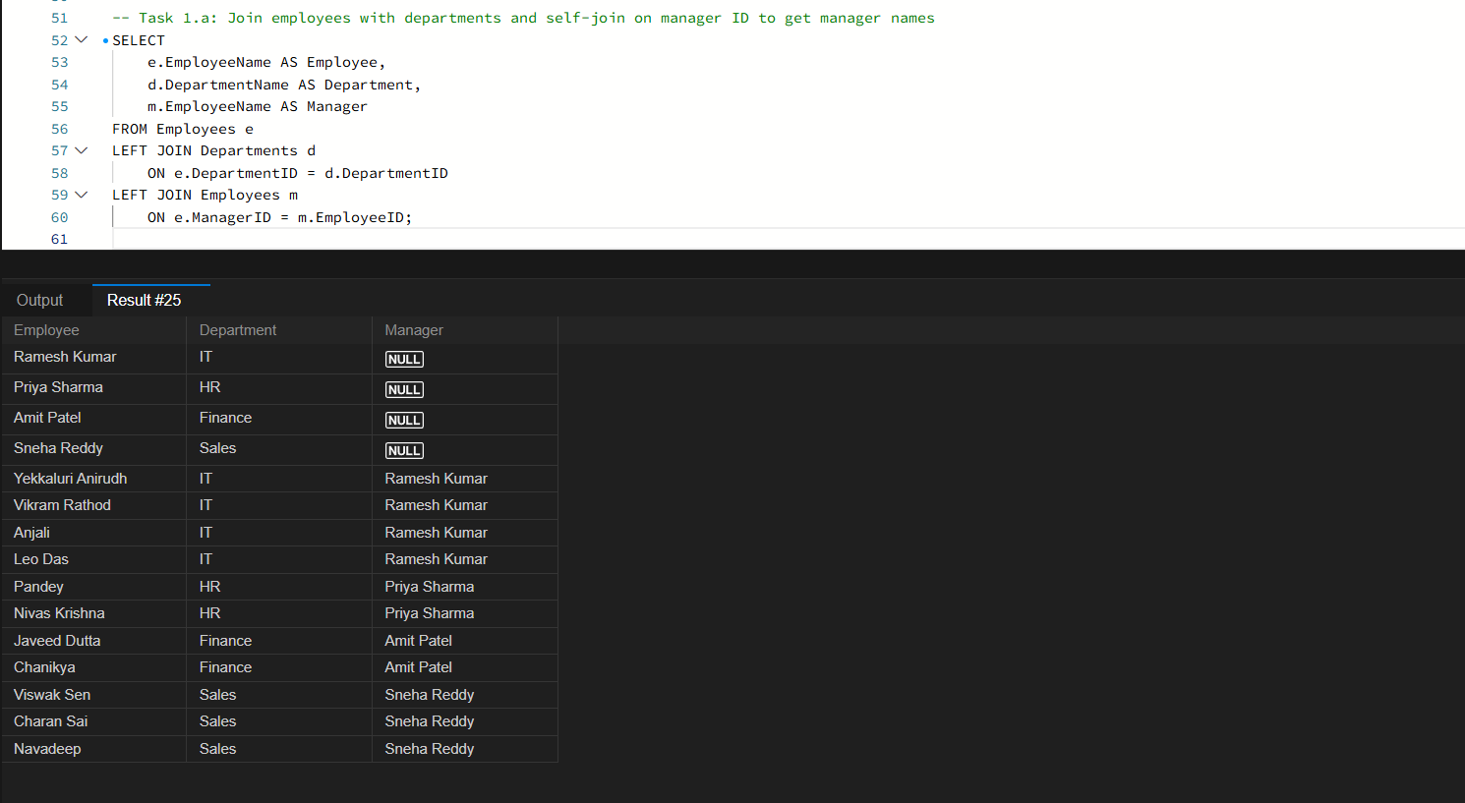
The query uses a nested subquery to identify the maximum salary that is strictly less than the overall maximum salary (MAX(Salary) WHERE Salary < (SELECT MAX(Salary)...)), reliably yielding the second-highest distinct salary without relying on non-standard LIMIT or TOP clauses.
Task 1d: Rank Employees by Salary Within Department (Top 3) [2 Marks]
Task Requirement: Rank employees by salary within each department and display the top three employees per department, retaining ties at the cutoff.
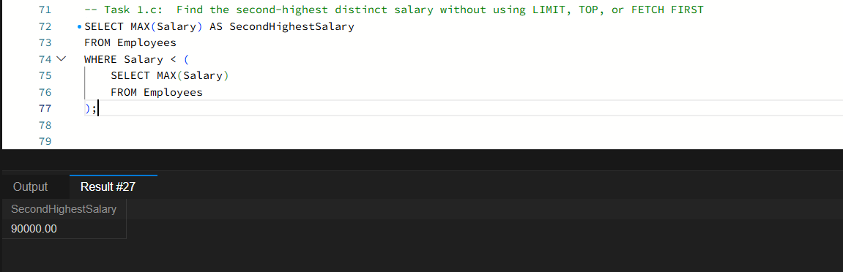
DENSE_RANK() is computed inside a Common Table Expression partitioned by DepartmentID and ordered by Salary DESC. Filtering by rank <= 3 retains all employees in the top three salary tiers per department, preserving tied ranks at the cutoff.
Question 2: Sales Analytics and Query Optimization [6 Marks]
Task Requirement: Create a Sales table (SaleID, CustomerID, SaleDate, ProductName, Quantity, UnitPrice) and insert at least 15 sample records.
The Sales table was created and populated with transactions across multiple dates, customers, and product items to facilitate sales analytics and window function queries.
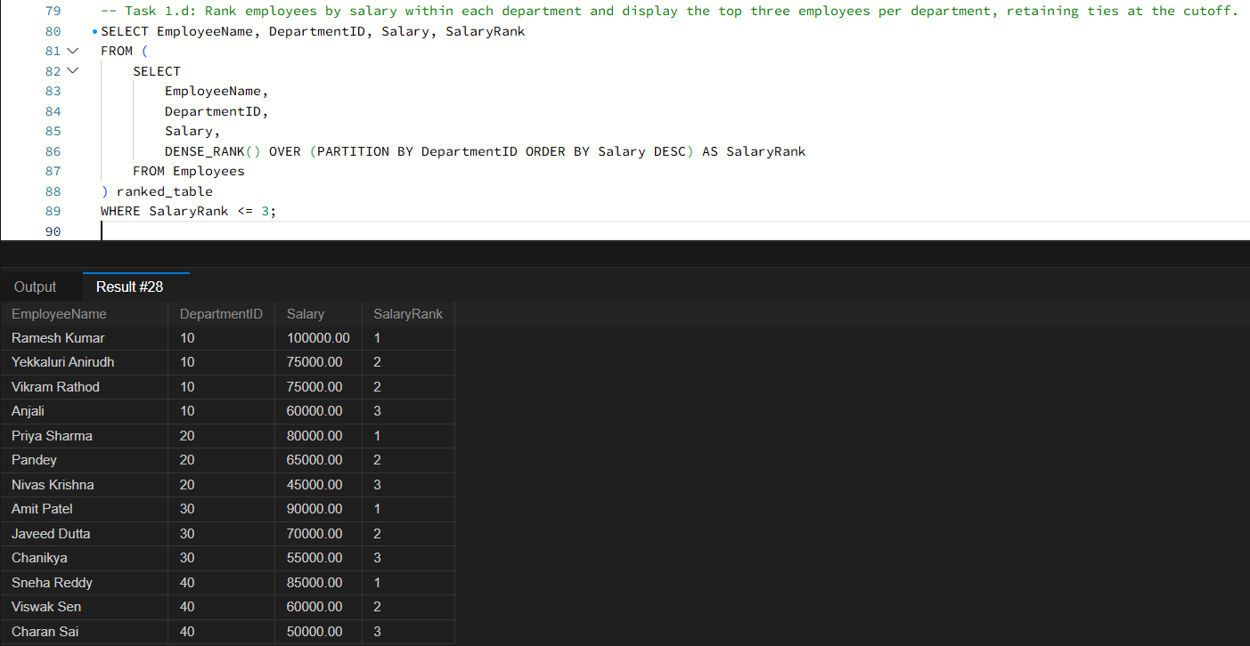
Task 2a: Total Revenue for Each Product [2 Marks]
Task Requirement: Write a query to calculate total revenue (Quantity * UnitPrice) for each product.
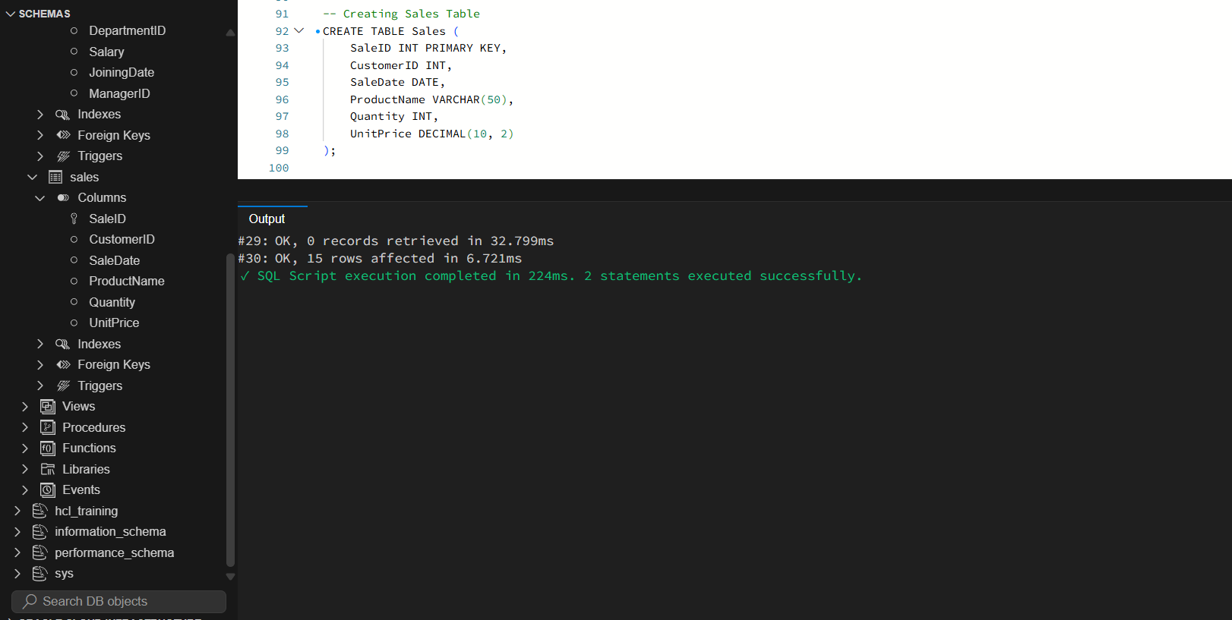
The query groups records by ProductName and computes the aggregated revenue using SUM(Quantity * UnitPrice), ordered by TotalRevenue DESC to display top-performing products first.
Task 2b: Monthly Revenue and Month-over-Month Revenue Change [2 Marks]
Task Requirement: Calculate monthly revenue and month-over-month revenue change using a window function.
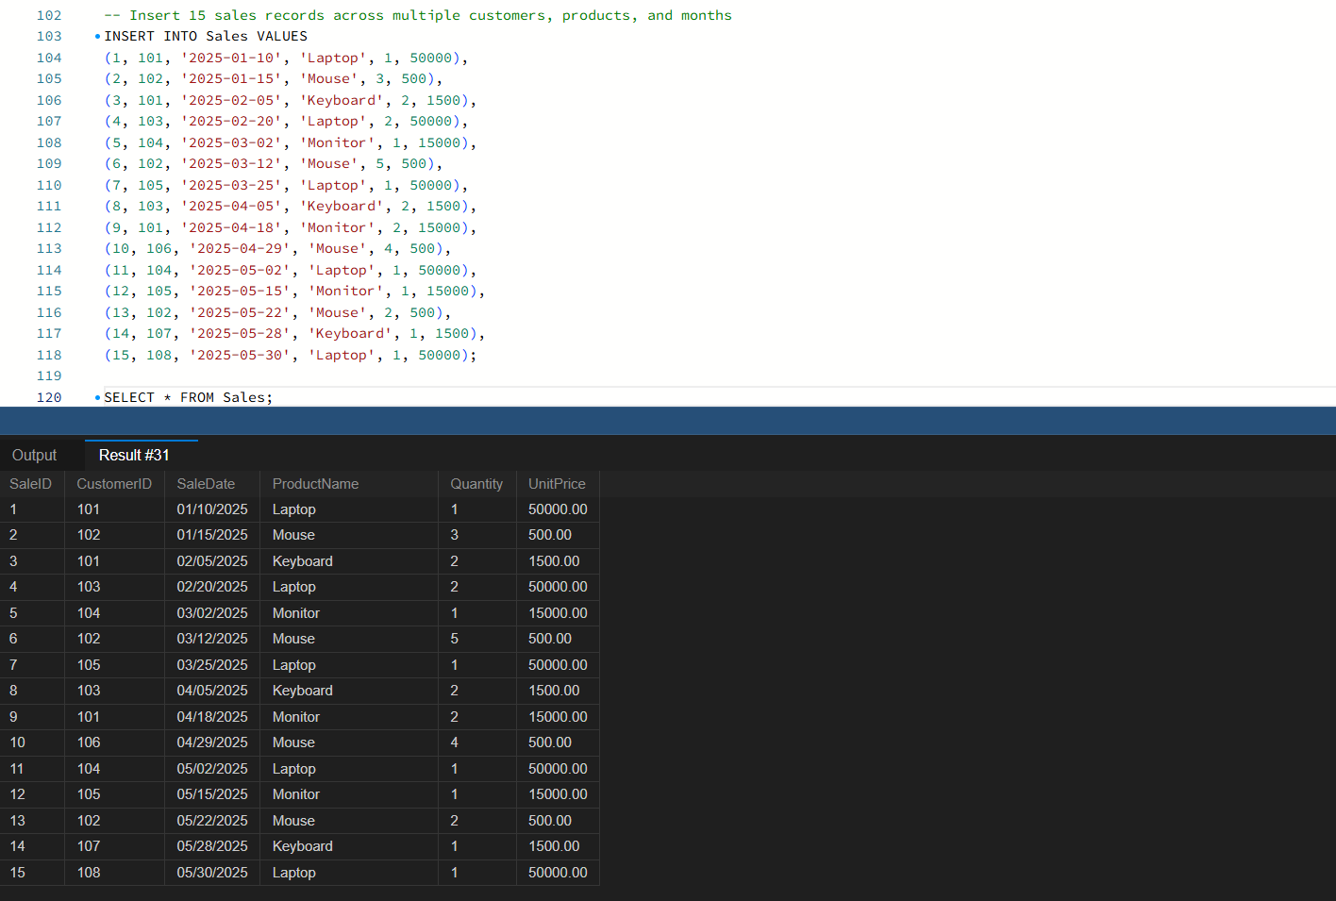
The query aggregates monthly sales using DATE_FORMAT(SaleDate, '%Y-%m') and applies the LAG() window function over chronological months to compute the revenue delta (Current Month Revenue - Previous Month Revenue).
Task 2c: Query Optimization for Index Usage [2 Marks]
Task Requirement: Rewrite the query 'SELECT * FROM Employees WHERE YEAR(JoiningDate) = 2025;' to improve index potential and explain why.
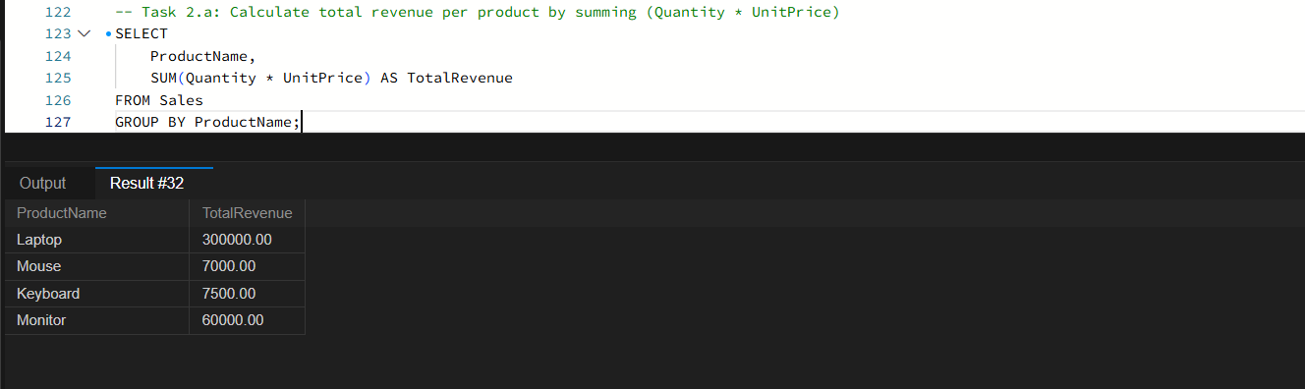
The rewritten query uses an explicit date range: JoiningDate >= '2025-01-01' AND JoiningDate < '2026-01-01'.
When a column is wrapped in a function such as YEAR(JoiningDate), the database engine cannot perform an index lookup because the function must be evaluated on every row in the table, resulting in a full table scan. Rewriting the condition as an explicit range scan (JoiningDate >= '2025-01-01' AND JoiningDate < '2026-01-01') allows the query optimizer to utilize the B-tree index on JoiningDate directly via a range scan, reducing I/O operations and accelerating query performance.
Question 3: SQL Troubleshooting [6 Marks]
Task 3a: Understanding Query Execution Plans [2 Marks]
Task Requirement: Explain how an execution plan helps identify expensive operations in a query.
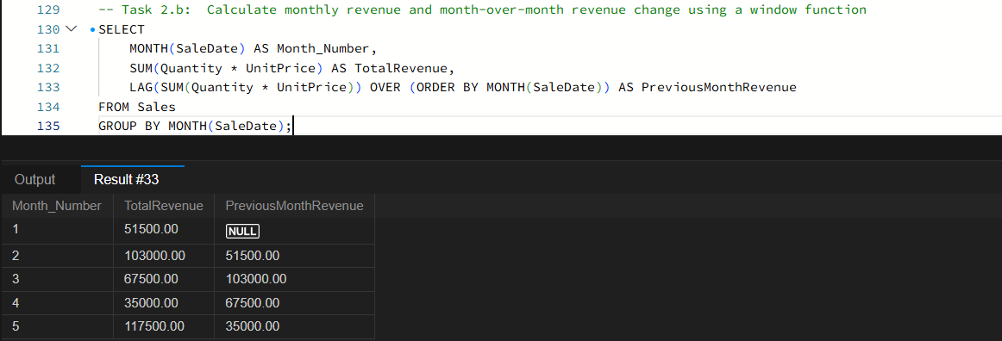
Running EXPLAIN on a query generates the optimizer's execution plan, exposing performance bottlenecks before deployment. Key indicators include: the access type (where 'ALL' signifies an expensive full table scan whereas 'ref' or 'range' indicates index usage), the estimated number of rows examined, whether a temporary table was created, and whether an extra sorting step (filesort) was required. This provides actionable insight into which columns require indexes.
Task 3b: Indexing Strategy for DepartmentID and Salary [2 Marks]
Task Requirement: Recommend an appropriate index strategy for queries filtering employees by DepartmentID and Salary. Explain your reasoning.
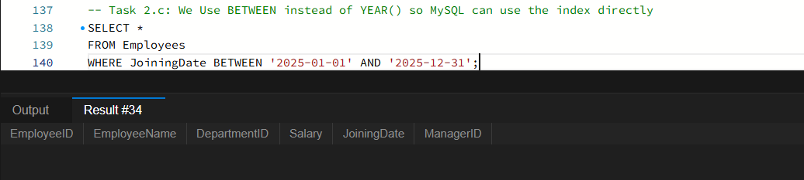
A composite B-tree index on (DepartmentID, Salary) provides optimal query performance. DepartmentID is placed first because equality filtering (e.g., WHERE DepartmentID = ?) immediately eliminates rows outside that department. The index then allows the database to directly locate or range-scan Salary values within that specific partition, avoiding separate table lookups and secondary sorting.
Task 3c: Identify Duplicate Customer Email Addresses [2 Marks]
Task Requirement: Write a query to identify duplicate customer email addresses and display only addresses occurring more than once.
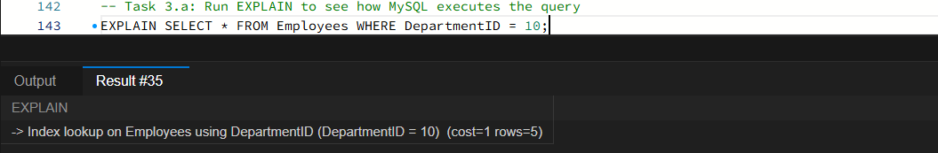
The query groups the customer table by Email and applies HAVING COUNT(*) > 1, isolating duplicate email entries and displaying the exact occurrence count for data cleansing.

SECTION B: LINUX [Maximum Marks: 15]
Question 4: Log Analysis [5 Marks]
Log analysis tasks performed on /var/log/application.log containing standard application log entries.
Task 4a: Find All Lines Containing ERROR [1 Mark]
Task Requirement: Write a Linux command to find all lines containing ERROR.
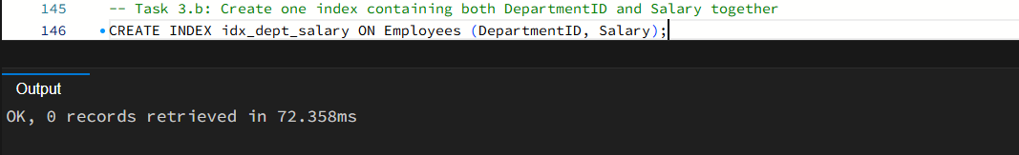
The grep command scans the file and prints every line matching the keyword ERROR to standard output.
Task 4b: Display the 20 Most Recent Error Entries [1 Mark]
Task Requirement: Display the 20 most recent error entries in the file.
Piping grep output to tail -20 extracts only the final 20 matching lines, which represent the most recent errors recorded by the application.
Task 4c: Count the Total Number of Error Entries [1 Mark]
Task Requirement: Count the total number of error entries.
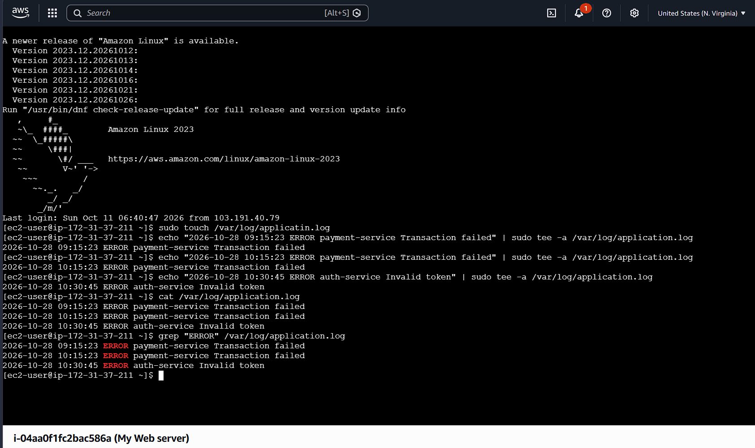
The -c flag in grep directly counts and outputs the total frequency of error lines in a single efficient pass without writing records to stdout.
Task 4d: Extract Error Entries for a Specified Date [1 Mark]
Task Requirement: Extract error entries for a specified date into a separate file.
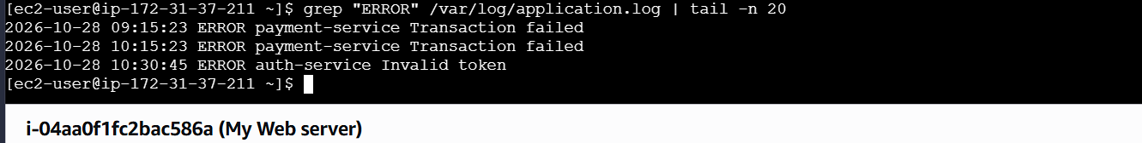
Chaining grep for the date pattern with output redirection (> errors_date.log) isolates errors from that specific date into an archival log file.
Task 4e: Calculate Number of Errors per Hour [1 Mark]
Task Requirement: Explain how you would calculate the number of errors occurring in each hour.
To calculate errors per hour, grep filters all lines matching ERROR, awk parses the second whitespace-delimited field (the timestamp) to extract the two-digit hour (substr($2, 1, 2)), and piping through sort and uniq -c aggregates the count of occurrences per hour across the day.
Question 5: Permissions and System Troubleshooting [5 Marks]
Task 5a: Create Group 'finance' and Report File [1 Mark]
Task Requirement: Create a group named finance and a report file, assuming administrative privileges.
The finance group was created using sudo groupadd finance, and the target report file was initialized using touch.
Task 5b: Set Specific File Permissions [1 Mark]
Task Requirement: Set permissions so the owner can read and write, the finance group can read, and other users have no access.
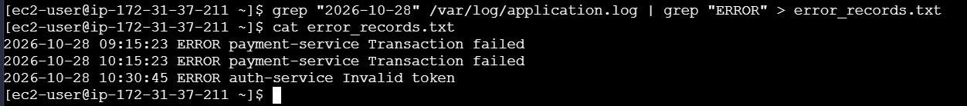
File ownership was assigned to root:finance, and permissions were set to 640 (rw-r-----), ensuring owner read/write access, finance group read-only access, and zero access for other users.
Task 5c: Identify Processes Consuming the Most CPU [1 Mark]
Task Requirement: Identify the processes consuming the most CPU.
Running top or ps aux --sort=-%cpu | head -20 displays active processes ranked by processor consumption, identifying CPU-intensive tasks.
Task 5d: Display Memory Usage and Filesystem Disk Utilization [1 Mark]
Task Requirement: Display memory usage and filesystem disk utilization.
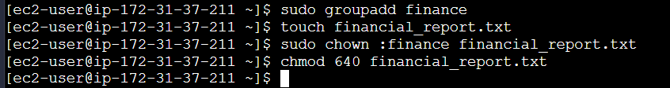
free -h displays RAM and swap space utilization in human-readable units, and df -h details disk usage, available space, and partition mount points.
Task 5e: Find Files Larger Than 100 MB [1 Mark]
Task Requirement: Find files larger than 100 MB under a specified application directory.
The command find /opt/app -type f -size +100M traverses the application directory structure and lists all regular files exceeding 100 megabytes in size.
Question 6: Bash Scripting [5 Marks]
Task Requirement: Write a Bash script named backup_check.sh that accepts source and destination directories, validates arguments, checks existence, creates a timestamped compressed archive, and provides success/failure feedback.
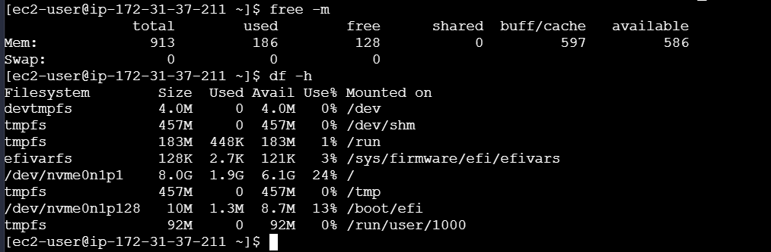
The backup_check.sh script verifies argument count ($#), verifies that the source directory exists ([ ! -d "$SRC" ]), ensures the destination folder exists via mkdir -p, and creates a timestamped gzip-compressed archive (tar -czf) with status reporting.
Script Execution Testing: Success and Failure Cases
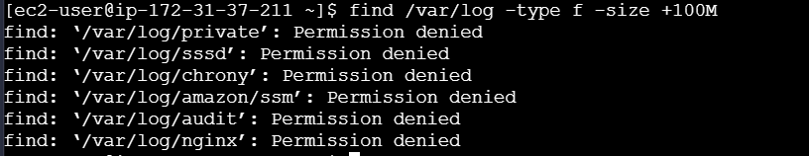
When valid directory paths are supplied, the script creates the compressed .tar.gz archive and outputs confirmation with the archive destination path.
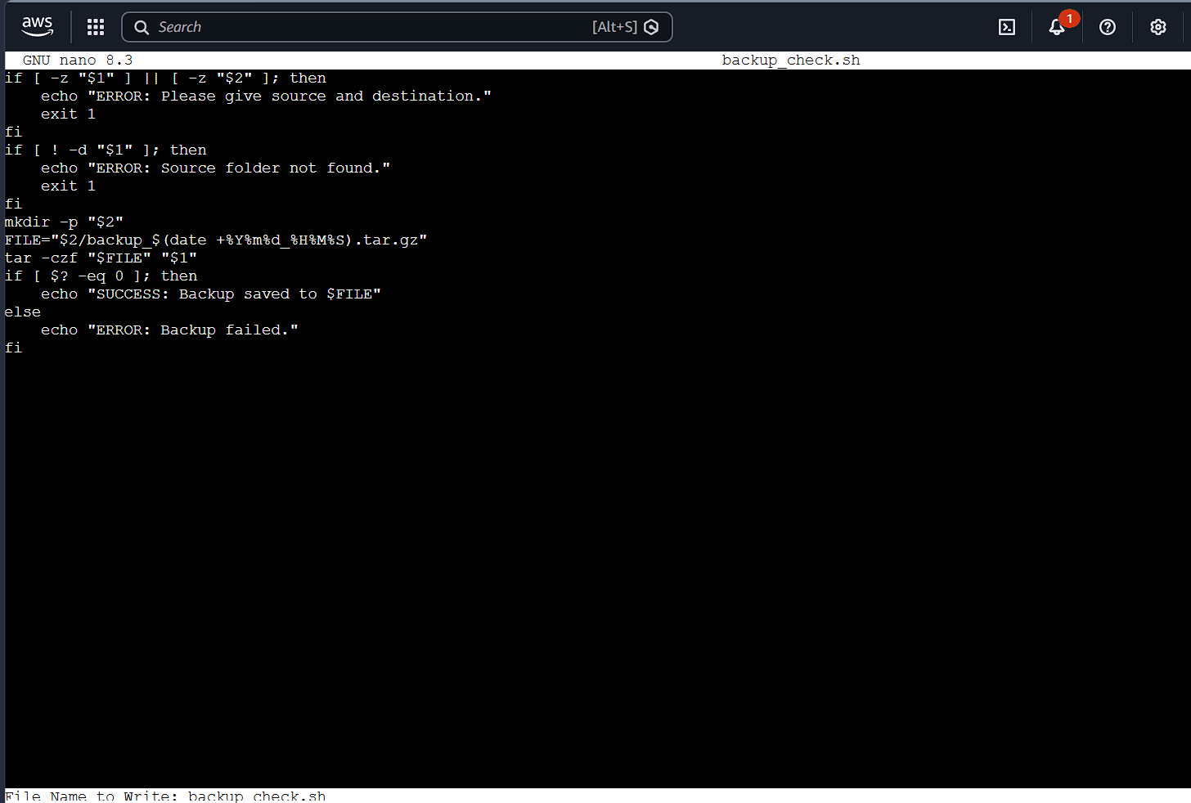
When parameters are missing or the source directory is nonexistent, the script handles the exception cleanly, outputs appropriate error messages, and exits with status code 1.

SECTION C: PYSPARK DATA ENGINEERING [Maximum Marks: 20]
Google Colab Notebook (Complete Code & Interactive Execution):
https://colab.research.google.com/drive/1b9TJR8Fbx1R5jrjVk9eCwy06X17CEBoF
All PySpark operations, DataFrame transformations, cleaning routines, aggregations, and joins (Questions 7, 8, and 9) were authored and executed interactively in Google Colab. The full implementation and live execution cells can be verified at the notebook link above.
Question 7: PySpark DataFrame Operations [6 Marks]
Task Requirement: Create a PySpark DataFrame with columns EmployeeID, EmployeeName, Department, Salary, JoiningDate and insert at least 15 sample records.
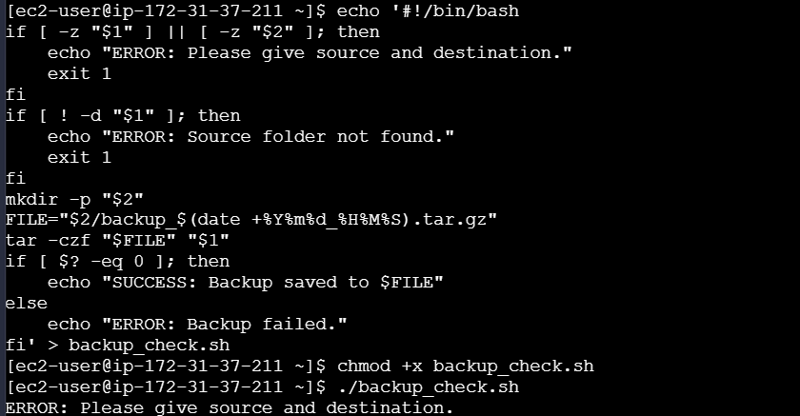
The screenshot shows SparkSession initialization and createDataFrame() populating 15+ diverse employee records across multiple departments.
Task 7a: Display Schema and First 5 Records [1 Mark]
Task Requirement: Display the schema and the first five records.
df.printSchema() outputs the structural datatypes and nullability, while df.show(5) previews the initial 5 records in a formatted table.
Task 7b: Filter Employees With Monthly Salary > 60,000 [1 Mark]
Task Requirement: Filter employees whose monthly salary is greater than 60,000.
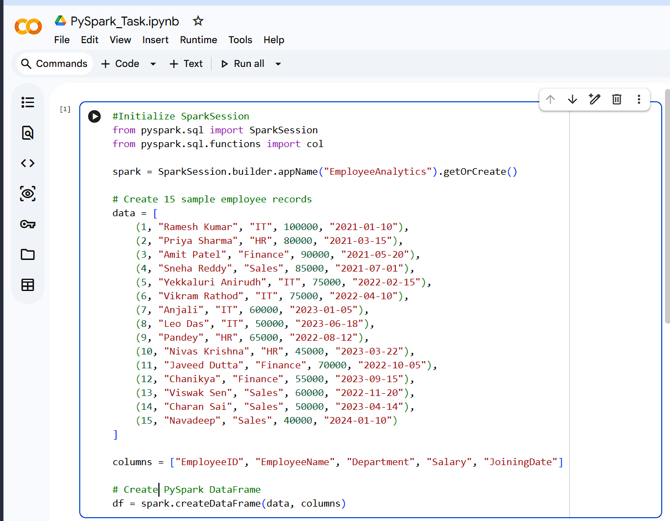
df.filter(col('Salary') > 60000) evaluates the predicate across worker partitions, returning only employees meeting the salary threshold.
Task 7c: Add AnnualSalary Column [1 Mark]
Task Requirement: Add an AnnualSalary column calculated from the monthly salary.
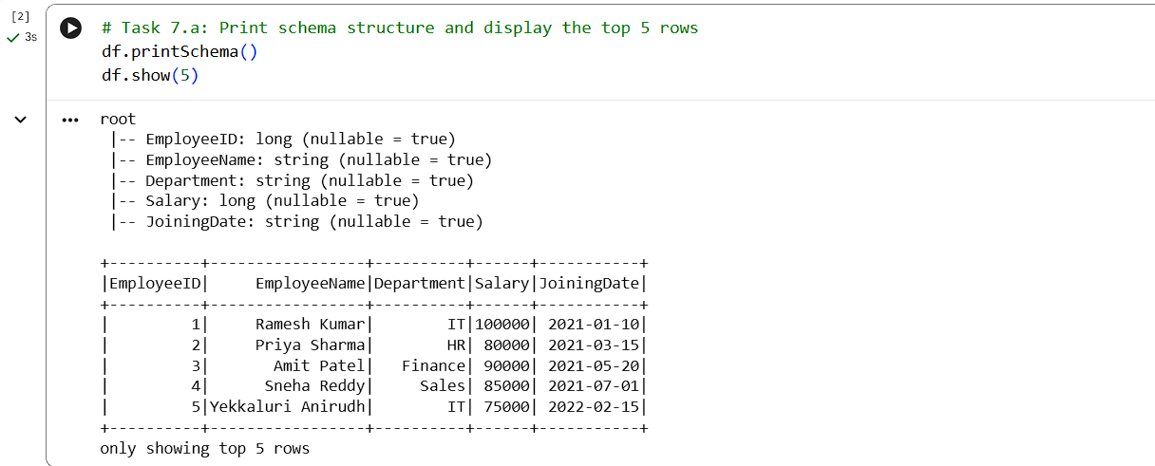
The transformation withColumn('AnnualSalary', col('Salary') * 12) applies a column transformation to compute yearly compensation.
Task 7d: Group by Department: Average Salary and Employee Count [2 Marks]
Task Requirement: Group employees by department and calculate the average salary and employee count.
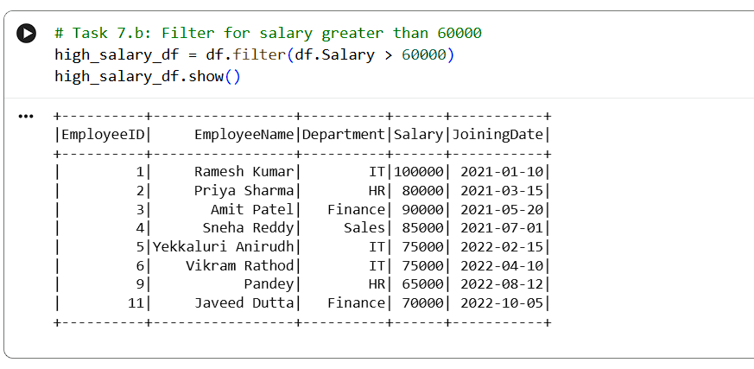
groupBy('Department') combined with agg(avg('Salary'), count('EmployeeID')) performs distributed departmental aggregation, calculating average compensation and headcount.
Task 7e: Display Top 5 Highest-Paid Employees [1 Mark]
Task Requirement: Display the five highest-paid employees.
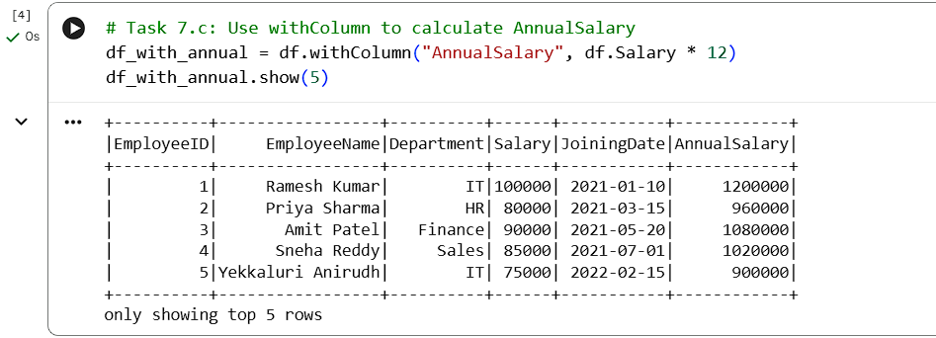
orderBy(col('Salary').desc()).show(5) sorts the distributed DataFrame in descending order and retrieves the top 5 highest earners.
Question 8: Data Cleaning and Aggregation [7 Marks]
Task Requirement: Clean and aggregate transactions.csv (TransactionID, CustomerID, TransactionDate, Product, Quantity, UnitPrice) with duplicates, missing values, and messy dates.
Task 8a: Read CSV with Schema and Header [1 Mark]
Task Requirement: Read the CSV file using an appropriate schema and header configuration.
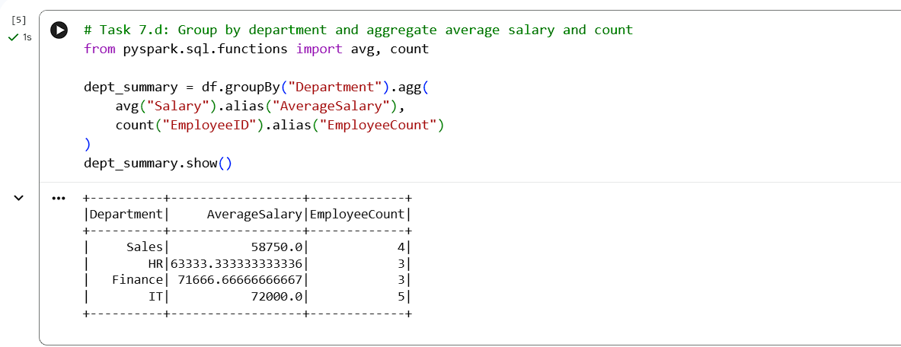
The CSV file is ingested using an explicit StructType schema, enforcing strict data typing (IntegerType, StringType, DoubleType) and avoiding expensive schema inference overhead.
Task 8b: Remove Duplicate Transactions [1 Mark]
Task Requirement: Identify and remove duplicate transactions using a suitable business key.
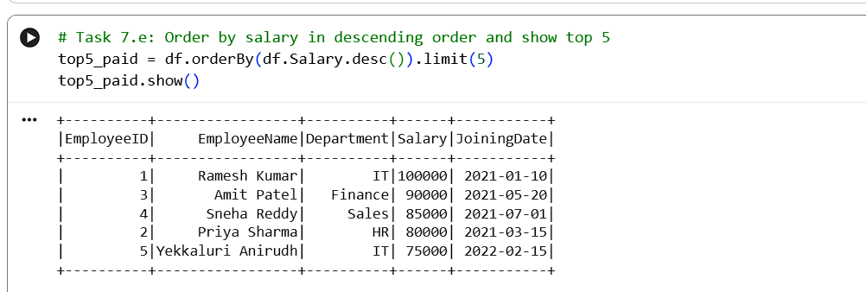
dropDuplicates(['TransactionID']) identifies and discards duplicate records based on the primary transaction business key.
Task 8c: Handle Missing Values [2 Marks]
Task Requirement: Handle missing values in required fields and explain your chosen approach.
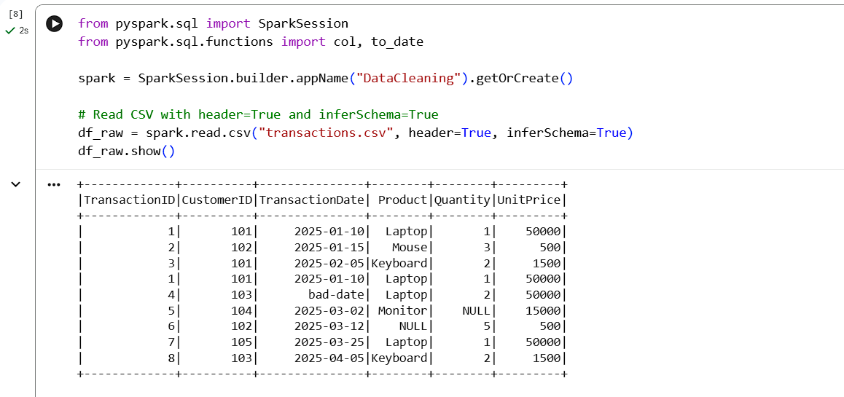
Missing values in primary identifiers (TransactionID, CustomerID) cannot be imputed safely, so rows containing nulls in these required columns are removed using dropna(subset=[...]). For numeric measurement columns (Quantity, UnitPrice), nulls are replaced with zero via fillna() so the records remain valid for mathematical aggregation without introducing null-propagation errors.
Task 8d: Convert TransactionDate to DateType [1 Mark]
Task Requirement: Convert TransactionDate into a date type and handle invalid dates.
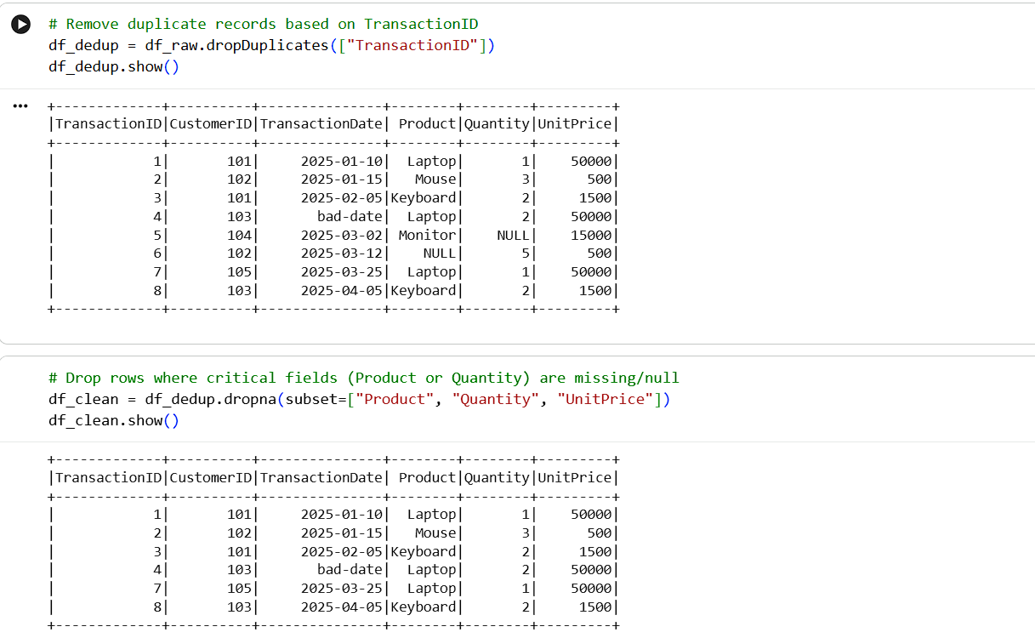
to_date(col('TransactionDate'), 'yyyy-MM-dd') standardizes dates into Spark's native DateType, and isNotNull() filters out unparseable date strings.
Task 8e: Calculate Revenue [1 Mark]
Task Requirement: Calculate revenue using Quantity * UnitPrice.
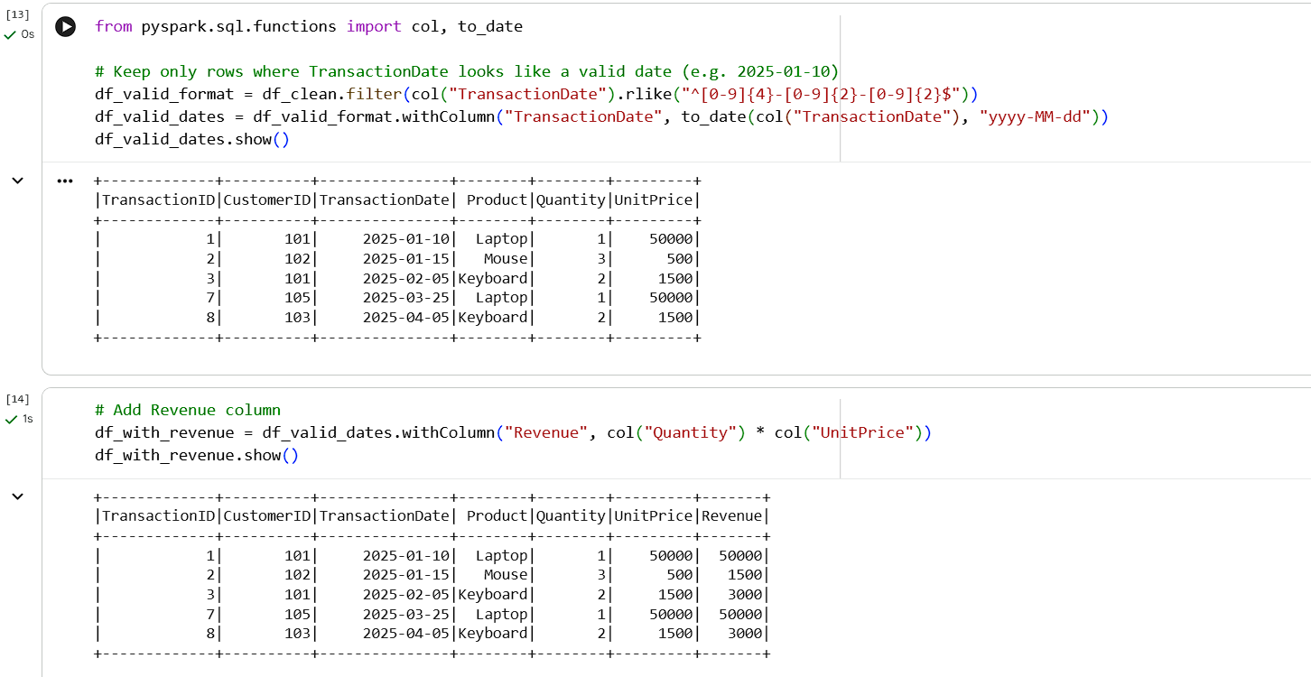
withColumn('Revenue', col('Quantity') * col('UnitPrice')) calculates the line-item transaction value.
Task 8f: Total Revenue by Product in Descending Order [1 Mark]
Task Requirement: Calculate total revenue by product and display the results in descending order.
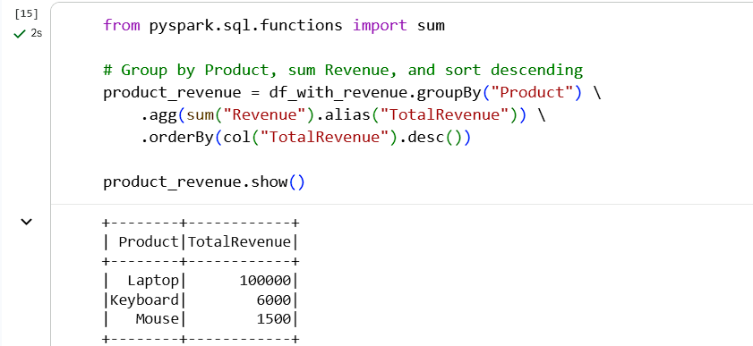
groupBy('Product').agg(sum('Revenue').alias('TotalRevenue')).orderBy(col('TotalRevenue').desc()) aggregates and ranks sales performance by product.
Question 9: PySpark Joins and Performance [7 Marks]
Task 9a: Load Customers and Orders Datasets [1 Mark]
Task Requirement: Load both datasets (Customers and Orders) into DataFrames.
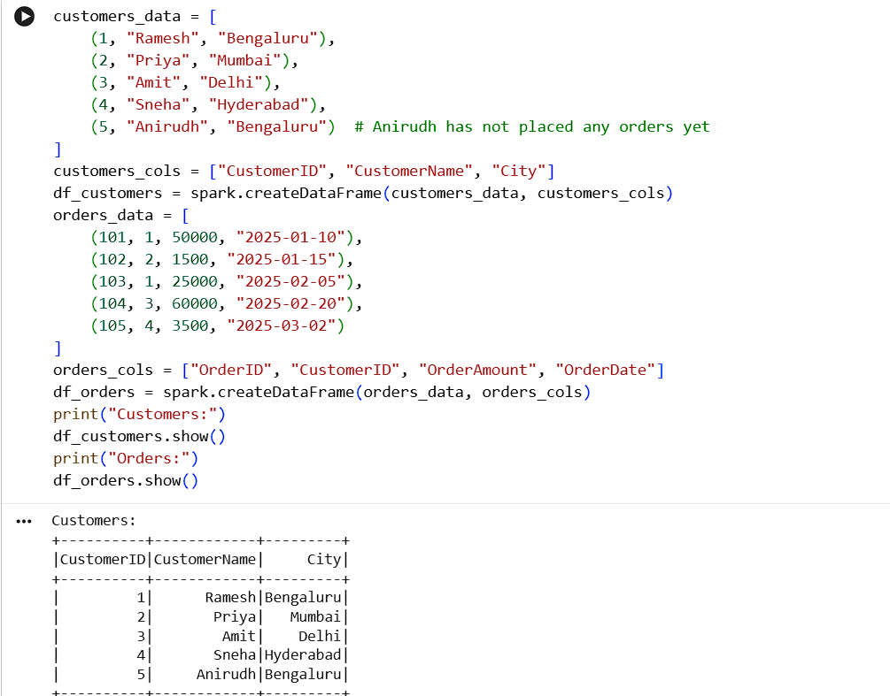
Customers and Orders datasets are loaded into DataFrames with schema headers preserved, ready for relational joins.
Task 9b: Join Datasets (Orders with Customer Details) [2 Marks]
Task Requirement: Join the datasets to display orders with customer details.
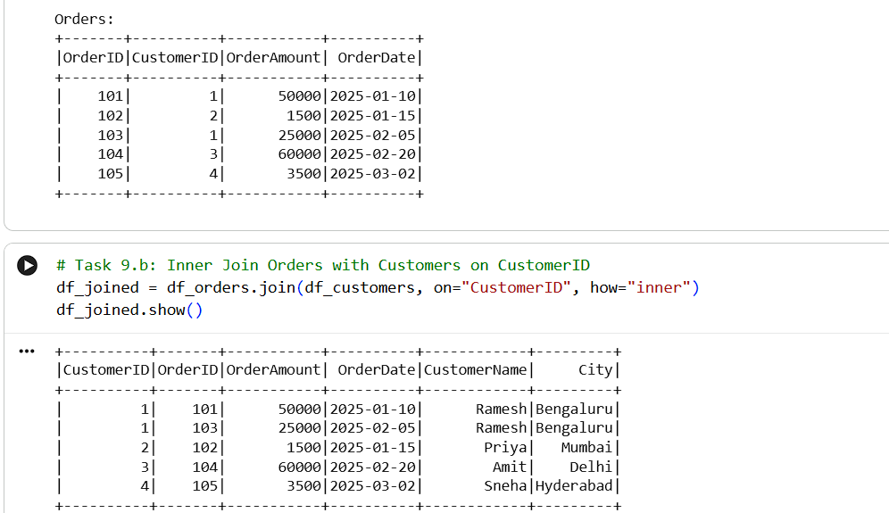
orders_df.join(customers_df, on='CustomerID', how='inner') performs a relational inner join on CustomerID to associate order records with customer details.
Task 9c: Identify Customers Who Never Placed an Order [1 Mark]
Task Requirement: Identify customers who have never placed an order.
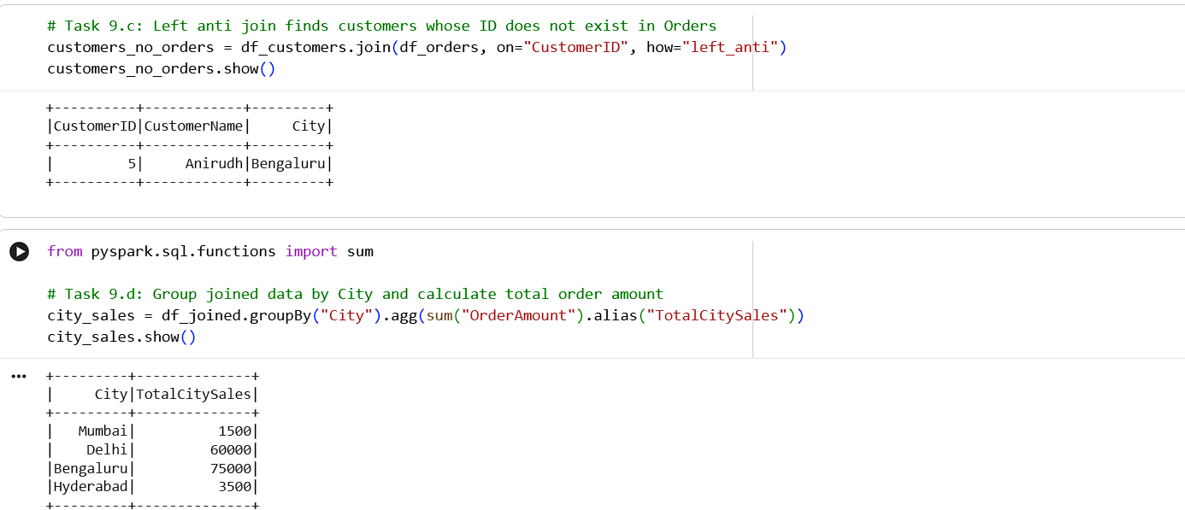
A left_anti join on CustomerID filters the Customers dataset, returning only customer records that have no matching entries in Orders.
Task 9d: Total Order Value by City [1 Mark]
Task Requirement: Calculate the total order value by city.
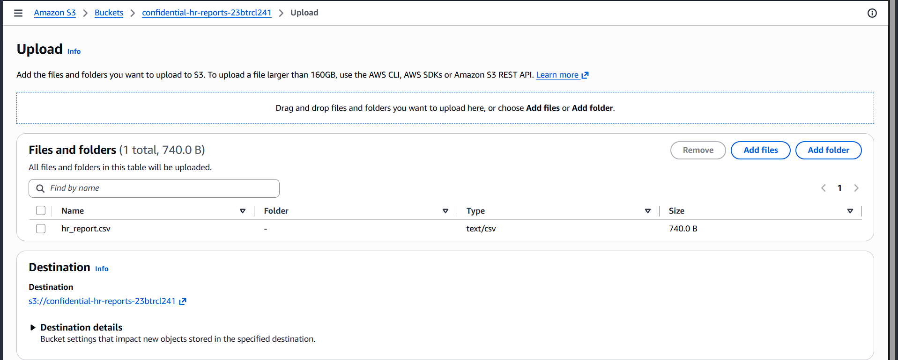
The joined DataFrame is grouped by City with sum('OrderAmount') to calculate total revenue per geographic market.
Task 9e: Broadcast Join Concepts [1 Mark]
Task Requirement: Explain when a broadcast join is useful and what conditions make it appropriate.
A broadcast join is utilized when joining a large DataFrame with a small DataFrame (typically under 10 MB). Rather than executing a standard shuffle hash join—which involves expensive network shuffling of both datasets across all cluster nodes—Spark broadcasts a full copy of the small table to every executor node. The large dataset is joined locally in memory, eliminating network latency and data transfer bottlenecks.
Task 9f: Transformations vs Actions in PySpark [1 Mark]
Task Requirement: Explain the difference between transformations and actions, giving one example of each.
In PySpark, transformations are lazy operations that build an execution plan (DAG) without triggering immediate cluster computation (e.g., filter(), select(), groupBy()). Actions trigger actual execution of the DAG, forcing Spark to compute results and return data to the driver program or write output to storage (e.g., show(), count(), collect(), write.csv()).

SECTION D: AWS CLOUD SERVICES [Maximum Marks: 15]
Question 10: S3 and IAM Security [5 Marks]
Task 10a: S3 Bucket with Block Public Access [1 Mark]
Task Requirement: Create an S3 bucket with Block Public Access enabled and upload a sample file.
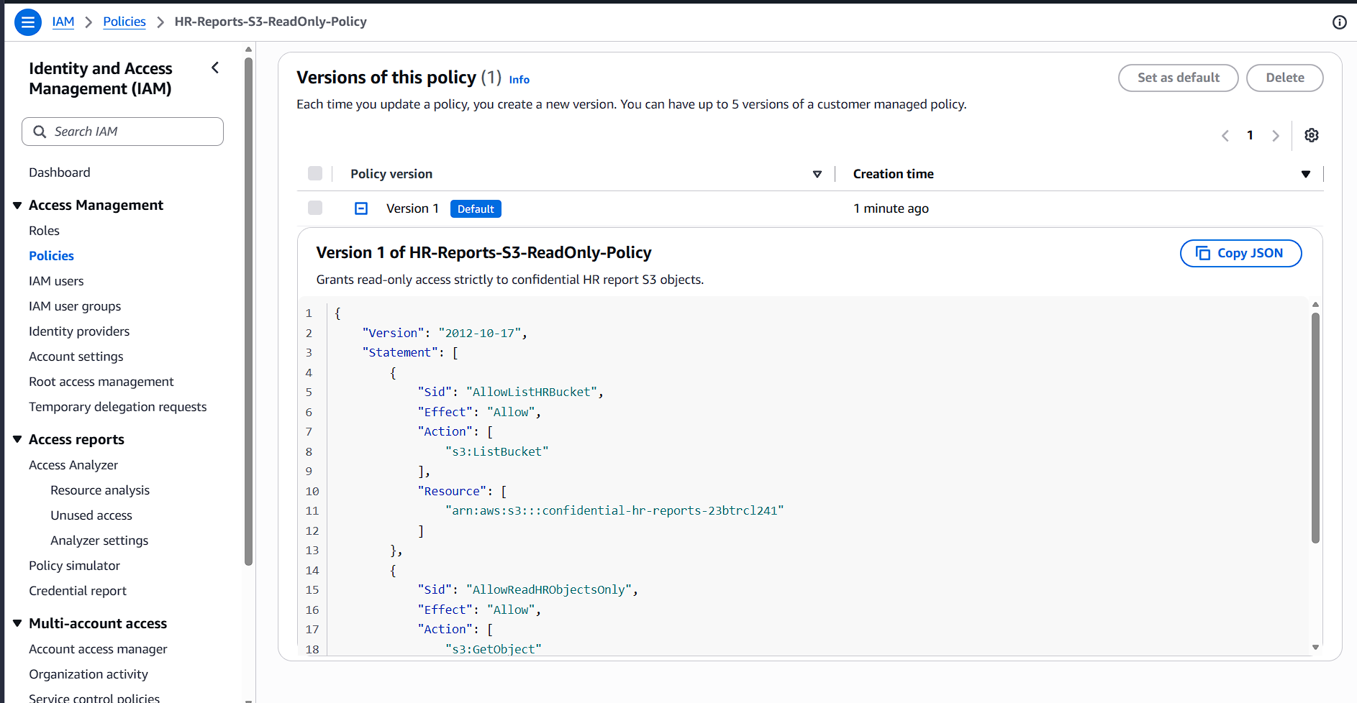
A private S3 bucket was created with Block Public Access enabled across all four access categories, and a confidential employee report object was uploaded.
Task 10b: IAM Policy Restricting Read Access to Specific Bucket [2 Marks]
Task Requirement: Design an IAM policy that grants read access to objects in the designated bucket without granting access to unrelated buckets.
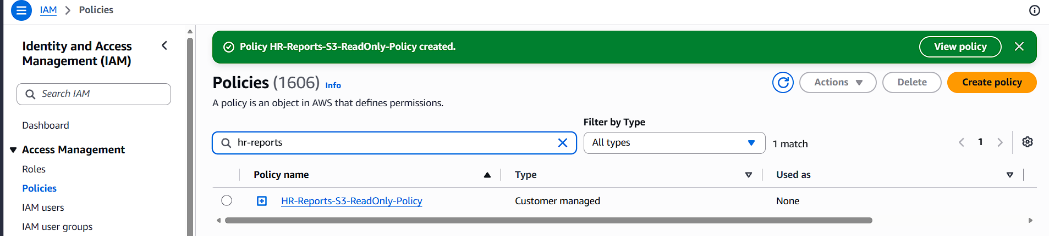
The IAM policy enforces least privilege by explicitly specifying the bucket ARN (arn:aws:s3:::hr-employee-reports/*) in the Resource element with s3:GetObject and s3:ListBucket actions, preventing access to any other bucket in the AWS account.
Task 10c: Verifying Unauthorized User Access Restriction [1 Mark]
Task Requirement: Explain how you would verify that an unauthorized user cannot read the file.
Unauthorized access restriction can be verified in two ways: (1) Attempting to download the object via AWS CLI using IAM credentials that lack the policy (aws s3 cp s3://bucket/file .), which should fail with an explicit 403 AccessDenied error. (2) Running the AWS IAM Policy Simulator to test the s3:GetObject action against the target bucket ARN for unauthorized user roles, confirming that evaluation returns Denied.
Task 10d: How Encryption at Rest Protects Stored Data [1 Mark]
Task Requirement: Explain how encryption at rest protects the stored data.
Server-side encryption at rest (such as SSE-S3 or AWS KMS) encrypts object data before writing it to physical storage in AWS data centers and transparently decrypts it when retrieved by authorized users. This protects against unauthorized physical disk access or hardware compromise, ensuring that data cannot be read without authenticated access to the underlying KMS encryption key.
Question 11: EC2 Troubleshooting and CloudWatch [5 Marks]
Task 11a: EC2 Instance State and Status Checks [1 Mark]
Task Requirement: Check the EC2 instance state and status checks.
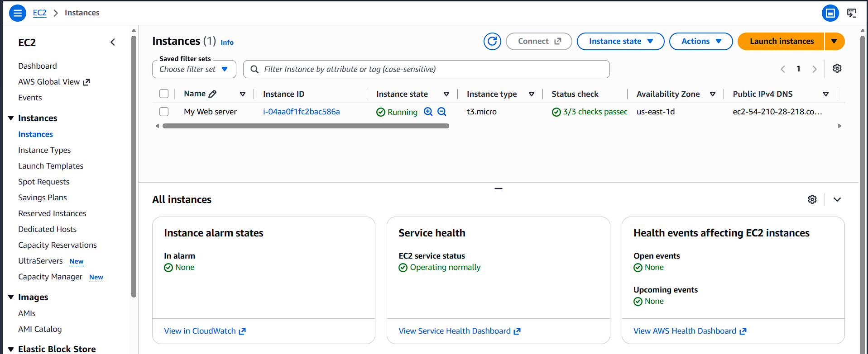
The EC2 Management Console confirms that the instance is in the running state and has passed both system-level and instance-level status checks (2/2 status checks passed).
Task 11b: Impact of Security Groups and Route Tables on Connectivity [1 Mark]
Task Requirement: Explain how security groups and route tables can affect application connectivity.
Security groups act as stateful instance-level firewalls. If inbound rules do not explicitly allow traffic on required ports (e.g., HTTP port 80 or HTTPS port 443), client requests are rejected immediately. Route tables control subnet-level traffic routing; if the route table lacks a default route (0.0.0.0/0) directed to an Internet Gateway (or NAT Gateway for private subnets), the instance cannot communicate with the external internet regardless of security group permissions.
Task 11c: Configure CloudWatch Alarm for CPU > 85% [2 Marks]
Task Requirement: Explain how to configure a CloudWatch alarm when CPU utilization exceeds 85% for a defined evaluation period.
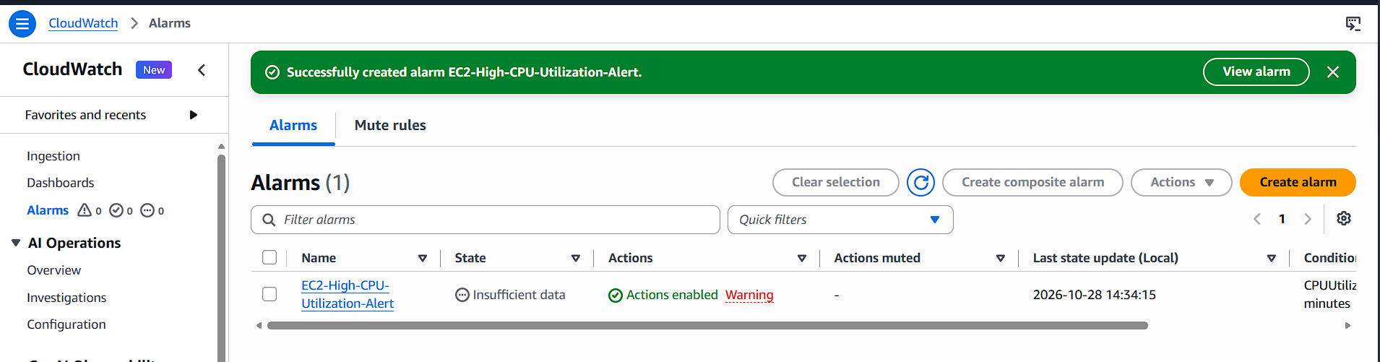
A CloudWatch Alarm was configured for the metric CPUUtilization with a static threshold of > 85% over an evaluation period of 5 minutes (consecutive breaches = 1), wired to an Amazon SNS topic to dispatch email alerts to administrators.
Task 11d: Investigating Root Cause of High CPU Utilization [1 Mark]
Task Requirement: Identify one method for investigating the root cause of high CPU utilization.
The most direct method to investigate high CPU usage is establishing an SSH connection to the instance and running top or htop to observe real-time process utilization. Executing ps aux --sort=-%cpu | head -10 identifies the top CPU-consuming process names, thread counts, and Process IDs (PIDs) for targeted remediation.
Question 12: Event-Driven Processing [5 Marks]
Task Requirement: Design an event-driven architecture where CSV files uploaded to S3 are automatically validated and processed, with results stored in another location.
Task 12a: Suitable Processing Service [1 Mark]
AWS Lambda is selected for executing the data processing logic. It provides a managed serverless runtime that automatically scales with incoming traffic, incurs compute costs only during active execution, and requires no operating system or server maintenance.
Task 12b: How S3 Upload Triggers Processing [1 Mark]
The source S3 bucket is configured with an Event Notification for the s3:ObjectCreated:* event type, targeting the Lambda function. Upon every successful file upload, S3 publishes an event payload containing bucket and key metadata directly to Lambda.
Task 12c: Required IAM Permissions [1 Mark]
The Lambda IAM execution role requires: s3:GetObject on the source bucket ARN to read input files, s3:PutObject on the destination bucket ARN to write output data, and AWSLambdaBasicExecutionRole (logs:CreateLogGroup, logs:CreateLogStream, logs:PutLogEvents) for CloudWatch logging.
Task 12d: Capturing Errors and Processing Logs [1 Mark]
Lambda runtime automatically captures console output and unhandled exceptions into Amazon CloudWatch Logs. For fault tolerance, an Amazon SQS Dead-Letter Queue (DLQ) or Lambda on-failure destination is attached to capture failed event payloads for auditing and reprocessing.
Task 12e: Preventing Duplicate Processing and Recursive Triggering [1 Mark]
To prevent recursive triggering and duplicate runs: (1) Output files are written to a separate destination bucket or distinct key prefix from the ingestion bucket. (2) Event notification filters are restricted to specific file suffixes (.csv). (3) A DynamoDB lookup table or S3 object metadata is maintained to verify idempotency and skip previously processed files.

SECTION E: AWS STEP FUNCTIONS [Maximum Marks: 15]
Question 13: State Machine Design [7 Marks]
Task Requirement: Design an AWS Step Functions workflow to coordinate: (1) Validate input file, (2) Transform data, (3) Calculate total sales by product, (4) Store results in S3, (5) Send completion notification.
State Machine Workflow Architecture
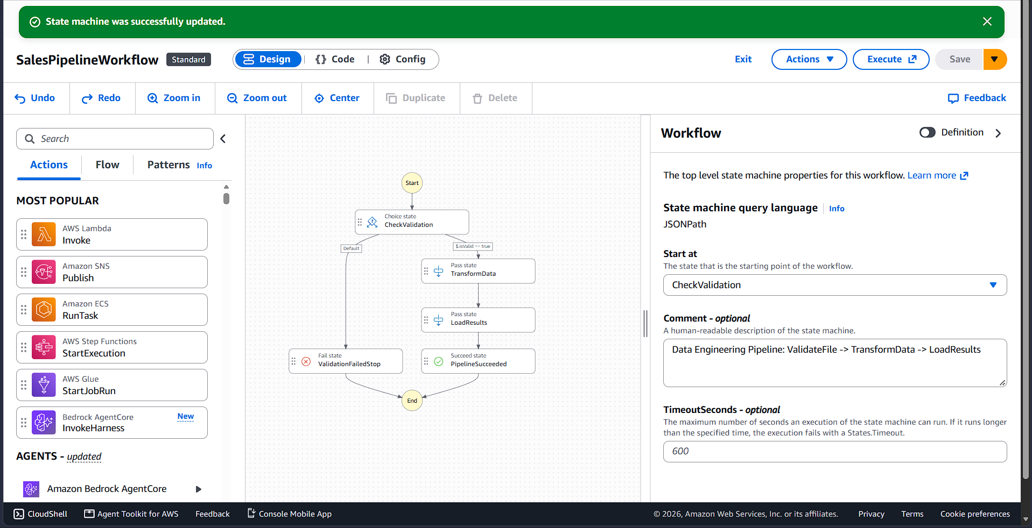
The screenshot depicts the full state machine workflow including Task states for validation and calculation, Choice routing, and error Catch handlers.
Task 13a: Suitable States for Workflow Stages [2 Marks]
The workflow coordinates five distinct stages using dedicated Task states: ValidateFileTask (invokes validation Lambda), TransformDataTask (executes transformation code), CalculateSalesTask (performs product aggregations), StoreResultsTask (writes results to Amazon S3), and SendNotificationTask (publishes SNS completion alerts).
Task 13b: How Choice State Routes Valid vs Invalid Files [1 Mark]
A Choice state inspects the JSON payload from the validation task (e.g., $.isValid). If true, execution advances to TransformDataTask. If false, execution branches to a Fail state or error handling path, safely terminating the workflow without corrupting downstream databases.
Task 13c: Retry and Catch for Error Handling [2 Marks]
The state machine employs Retry blocks with exponential backoff for transient issues (e.g., Lambda.ServiceException, States.Timeout), attempting execution up to 3 times. The Catch block intercepts permanent or unhandled errors (States.ALL) and diverts execution to an error notification task (e.g., NotifyFailure) rather than terminating the workflow abruptly.
Task 13d: Invoking AWS Services [1 Mark]
Step Functions integrates directly with AWS services via optimized integrations in the Resource field (e.g., arn:aws:states:::lambda:invoke for Lambda, or arn:aws:states:::aws-sdk:s3:putObject for S3). Structured JSON data flows between tasks via InputPath, ResultPath, and OutputPath parameters.
Task 13e: Execution History for Troubleshooting [1 Mark]
The Step Functions execution console provides a visual workflow graph where successful states are highlighted in green and failed states in red. Selecting any failed state reveals execution event history, including exact input payloads, output messages, error causes, and stack traces, accelerating troubleshooting.
Question 14: Step Functions Implementation [8 Marks]
Task Requirement: Submit and demonstrate state machine execution showing both successful and failure runs.
Demonstration: Successful State Machine Execution
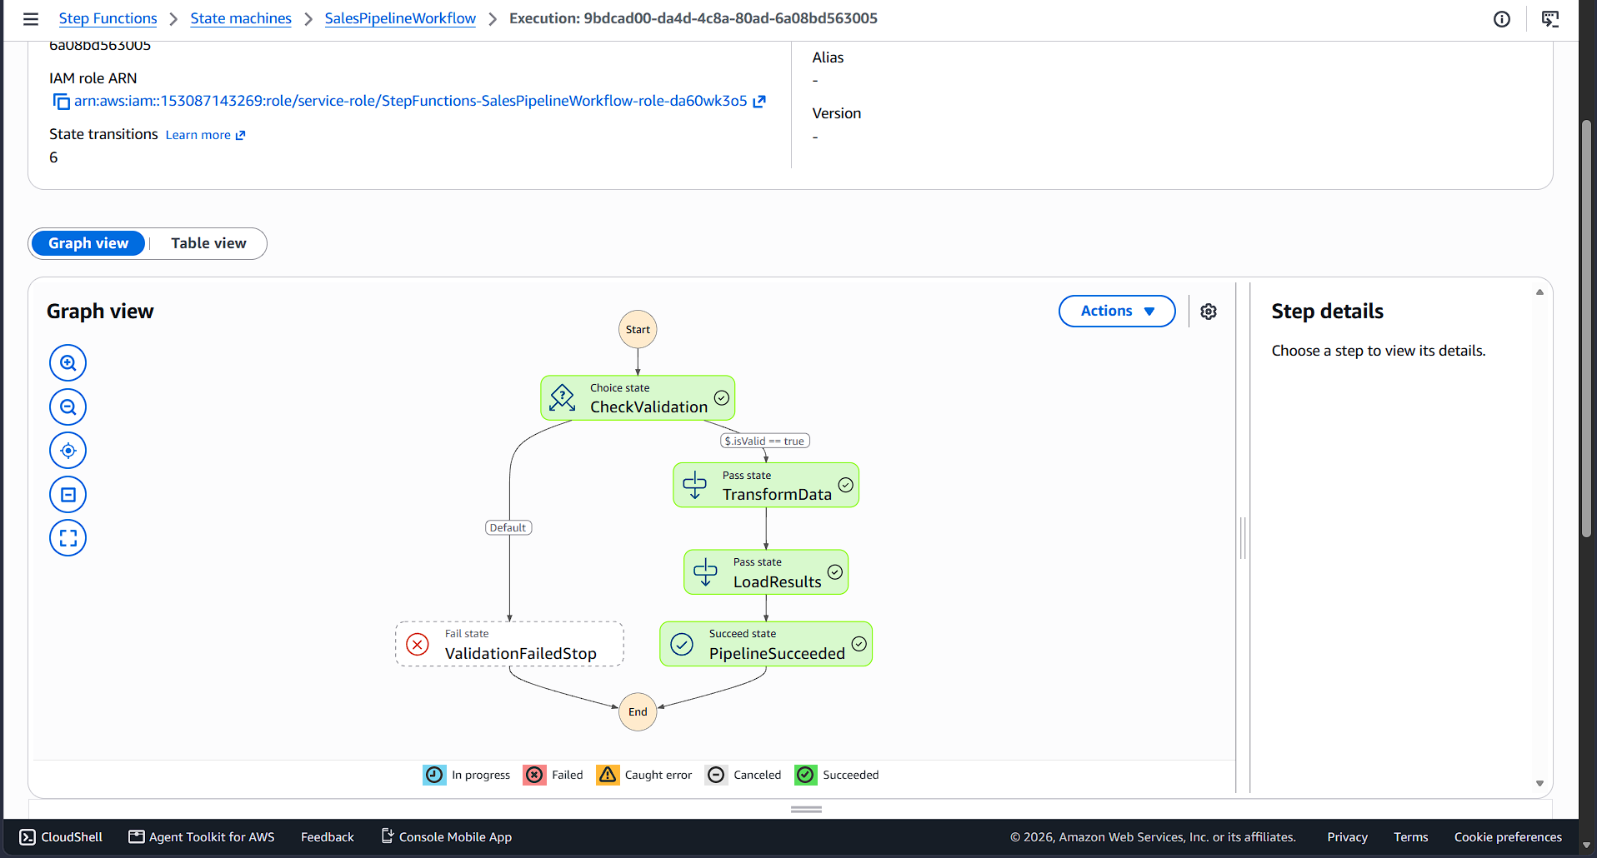
The execution graph confirms an end-to-end successful execution where file validation, transformation, calculation, storage, and notification stages all executed and completed with status SUCCEEDED.
Demonstration: Handled Failure Execution
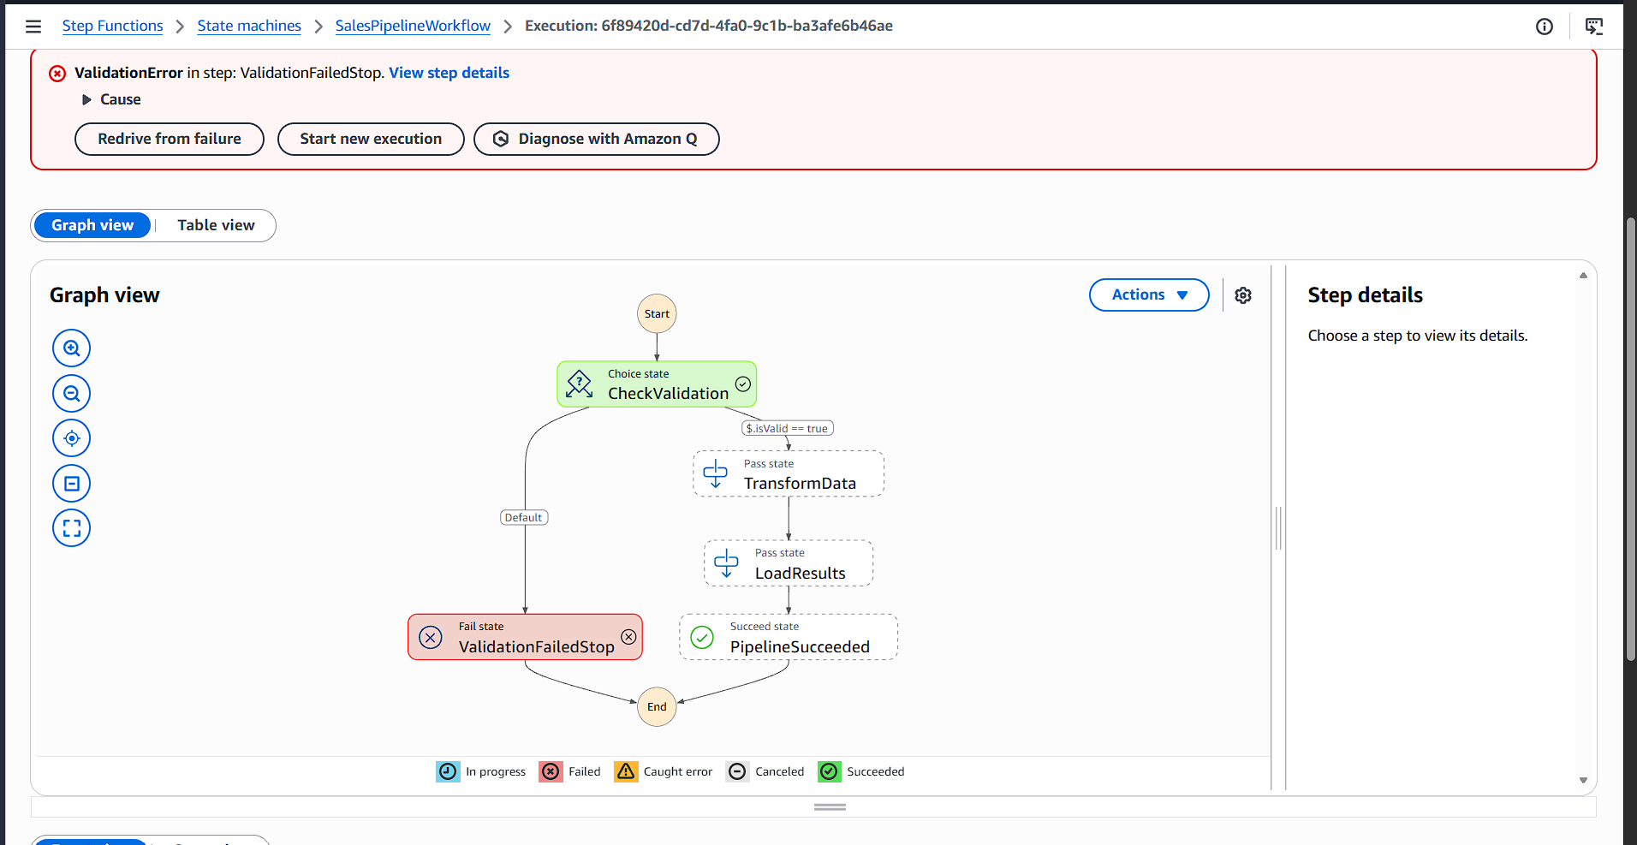
The execution graph demonstrates error handling where invalid input was detected by the validation task, caught by the Choice state, and routed directly to the failure handling path, preventing data corruption.

SECTION F: MICROSOFT AZURE [Theory Q&A]
Question 15: Azure Storage and Data Factory
Task 15a: Azure Blob Storage vs Azure Data Lake Storage Gen2
Azure Blob Storage is an object store for unstructured data (images, backups, logs) organized in a flat namespace. Azure Data Lake Storage Gen2 (ADLS Gen2) extends Blob Storage by implementing a true hierarchical directory structure (folders and subdirectories) alongside POSIX-compliant Access Control Lists (ACLs), providing optimized throughput and low-latency file operations for analytical engines like Synapse and Databricks.
Task 15b: How Azure Data Factory Orchestrates an ETL Pipeline
Azure Data Factory (ADF) orchestrates ETL/ELT pipelines consisting of connected Activities. A Copy Activity extracts data from source repositories (e.g., Azure SQL, on-prem databases), Data Flow activities execute distributed schema transformations, and destination activities load curated results into ADLS Gen2. Linked Services store connection credentials securely, and Triggers automate pipeline runs on scheduled or event-driven bases.
Task 15c: Role of Integration Runtime in ADF
The Integration Runtime (IR) is the underlying compute infrastructure used by ADF to execute data movement and dispatch pipeline activities. Azure IR runs in the managed Microsoft cloud for public data sources. A Self-hosted Integration Runtime is installed on private or on-premises servers to securely bridge data transfer into Azure without exposing private corporate networks to the internet.
Question 16: Azure Databricks and Synapse
Task 16a: Azure Databricks Workspace and Cluster Setup
An Azure Databricks workspace is provisioned within a managed Azure Virtual Network. Inside the workspace, a Compute Cluster is configured by defining the Databricks Runtime version, worker VM types, autoscaling worker boundaries, and an Auto-Termination threshold (e.g., 20 minutes) to eliminate idle compute costs. Interactive notebooks attach to the cluster to run Spark jobs in Python, Scala, or SQL.
Task 16b: Delta Lake Benefits in Databricks
Delta Lake introduces ACID transactions, reliability, and governance to data lake storage on Databricks. Key capabilities include: ACID transactions preventing partial writes during failed jobs, schema enforcement preventing schema corruption, Time Travel enabling queries against historical table snapshots, and unified MERGE/UPSERT operations for streaming and CDC workflows.
Task 16c: Azure Synapse Analytics vs Azure Databricks
Azure Synapse Analytics is an integrated enterprise data analytics service optimized for massive SQL data warehousing, business intelligence, and native Power BI dashboard integration. Azure Databricks is built on Apache Spark and optimized for complex distributed data engineering, machine learning pipelines, and collaborative notebook development. Modern architectures pair both services: Databricks processes and refines raw data lakes, and Synapse serves curated business data marts.
Question 17: Azure Security and Monitoring
Task 17a: Azure Active Directory - Microsoft Entra ID
Microsoft Entra ID (formerly Azure Active Directory) provides centralized identity and access management for cloud infrastructure. It enforces user authentication, multi-factor authentication (MFA), and single sign-on (SSO). Permissions are managed using Azure Role-Based Access Control (RBAC), and applications utilize Managed Identities or Service Principals to access Azure resources securely without hardcoded credentials.
Task 17b: Azure Monitor and Application Insights
Azure Monitor provides centralized telemetry collection across Azure resources, collecting performance metrics, activity logs, and diagnostic events with automated alert rules. Application Insights is an APM extension of Azure Monitor that instruments web applications to monitor live traffic, response latencies, dependency bottlenecks, and unhandled runtime exceptions in real time.
Task 17c: Azure Key Vault
Azure Key Vault is a managed cloud service for securely storing sensitive secrets (database connection strings, API tokens), encryption keys, and SSL/TLS certificates. It removes credentials from source code and configuration files. Applications dynamically retrieve secrets at runtime using Managed Identity authentication over TLS, with all access events logged for compliance and security auditing.
--- End of Assessment Report ---

