Research Assistant Agent
AI Solution Direction & Workflow Proposal
Version 1.0 | July 16, 2026
From literature discovery to a submission-ready, faculty-approved draft.

Summary
Faculty research work spans literature discovery, identifying gaps, drafting papers or proposals, citation and formatting compliance, tracking funding/journal deadlines, and coordinating with co-authors — largely done manually and repeated for every paper or proposal.
This document proposes a Research Assistant Agent: faculty state a research question or draft goal, and the agent coordinates discovery, gap analysis, drafting, citation compliance, and collaboration, always stopping at faculty sign-off before anything is submitted.

What the Agent Means in This Document
- Coordinator, not an autonomous author: the agent drafts and assembles; faculty own every claim, argument, and submission decision.
- Grounded in real sources: literature and citations come from scholarly databases, never invented references.
- Deadline-aware: journal and funding deadlines are tracked and surfaced proactively, not just on request.
- Collaboration-ready: supports multi-author workflows with clear ownership of sections and edits.

How to Use This Document
- Start with the problem domain closest to the current research need (survey, proposal, or paper draft).
- Use the prompt command to launch or relaunch the workflow for a specific paper/proposal.
- Assign agents to student research-assistant roles where applicable.
- Use the hybrid methodology table to see what can run in parallel.

Problem Statement
Faculty problem cluster: literature survey and gap discovery are slow; drafting and citation formatting for different venues is repetitive; tracking journal/funding deadlines is manual; validating a draft's originality and citation accuracy is time-consuming.

Problems heard
- Literature search across scholarly databases for a new problem area takes significant manual effort.
- Identifying what is genuinely novel (the gap) versus already published is hard to confirm quickly.
- Drafting is fine, but citation formatting and compliance with a specific venue's template is repetitive.
- New journals, calls for papers, and funding deadlines are often discovered late, by chance web searches.
- Coordinating drafts and edits across multiple co-authors is currently ad hoc (email, shared docs).

Research Inputs and Data Model
The agent works from a small set of structured inputs per research task, plus faculty-maintained reference material:
Input | Description
Research question / topic | The problem area, keywords, and scope for the current task.
Target venue | Journal, conference, or funding call, with its citation style and page/word limits.
Prior work library | Faculty's own past papers, proposals, and citation library for style and self-citation consistency.
Collaborator list | Co-authors and their section ownership, if the draft is multi-author.
Deadline | Submission or funding-call deadline to track and alert against.

AI Solution Direction
Build a Research Assistant that treats each task as: discover → analyze → draft → check → track, always pausing at faculty review before anything leaves the system. Literature discovery uses scholarly metadata sources (not general web search) and returns ranked, summarized results with links, not fabricated citations. Gap analysis compares the discovered literature against the stated research question and flags where the idea is genuinely under-explored versus already covered.
Drafting produces outline-first content in the target venue's structure; citation and compliance checking verifies formatting, reference completeness, and self-consistency before faculty sees a “ready” draft. A funding/journal radar agent runs continuously in the background, independent of any single paper, to surface upcoming deadlines relevant to faculty's stated interests.
Prompt command for faculty to reuse:
/research-agent start-workflow \
--topic "edge AI hardware porting frameworks" \
--venue "IEEE conference, IMRAD, 6-page limit" \
--collaborators "self, co-author" \
--deadline "2026-09-15" \
--outputs "ranked reading list, gap summary, outline, draft, citation check" \
--constraints "faculty approval before submission, no fabricated citations, audit log"

Recommended Workflow
- Faculty states the research question, target venue, collaborators, and deadline.
- The Literature Discovery Agent searches scholarly metadata sources and returns a ranked reading list with summaries.
- The Gap & Idea Analysis Agent compares the stated question against discovered literature and flags what is genuinely novel.
- The Drafting & Writing Agent produces an outline first, then a full draft only after faculty confirms the outline.
- The Citation & Compliance Agent checks formatting, reference completeness, and venue-specific requirements.
- The Funding/Journal Radar Agent runs independently, surfacing upcoming deadlines relevant to faculty's interests.
- The Collaboration Agent tracks section ownership and consolidates co-author edits into one version.
- Faculty reviews, approves, or requests revisions before anything is exported or submitted.
- The Export & Repository Agent produces the final formatted document and logs it to the research tracker.

Agentic Execution Node Graph
Execution blueprint: each node can be built, tested, and demoed independently before wiring into the full coordinator.
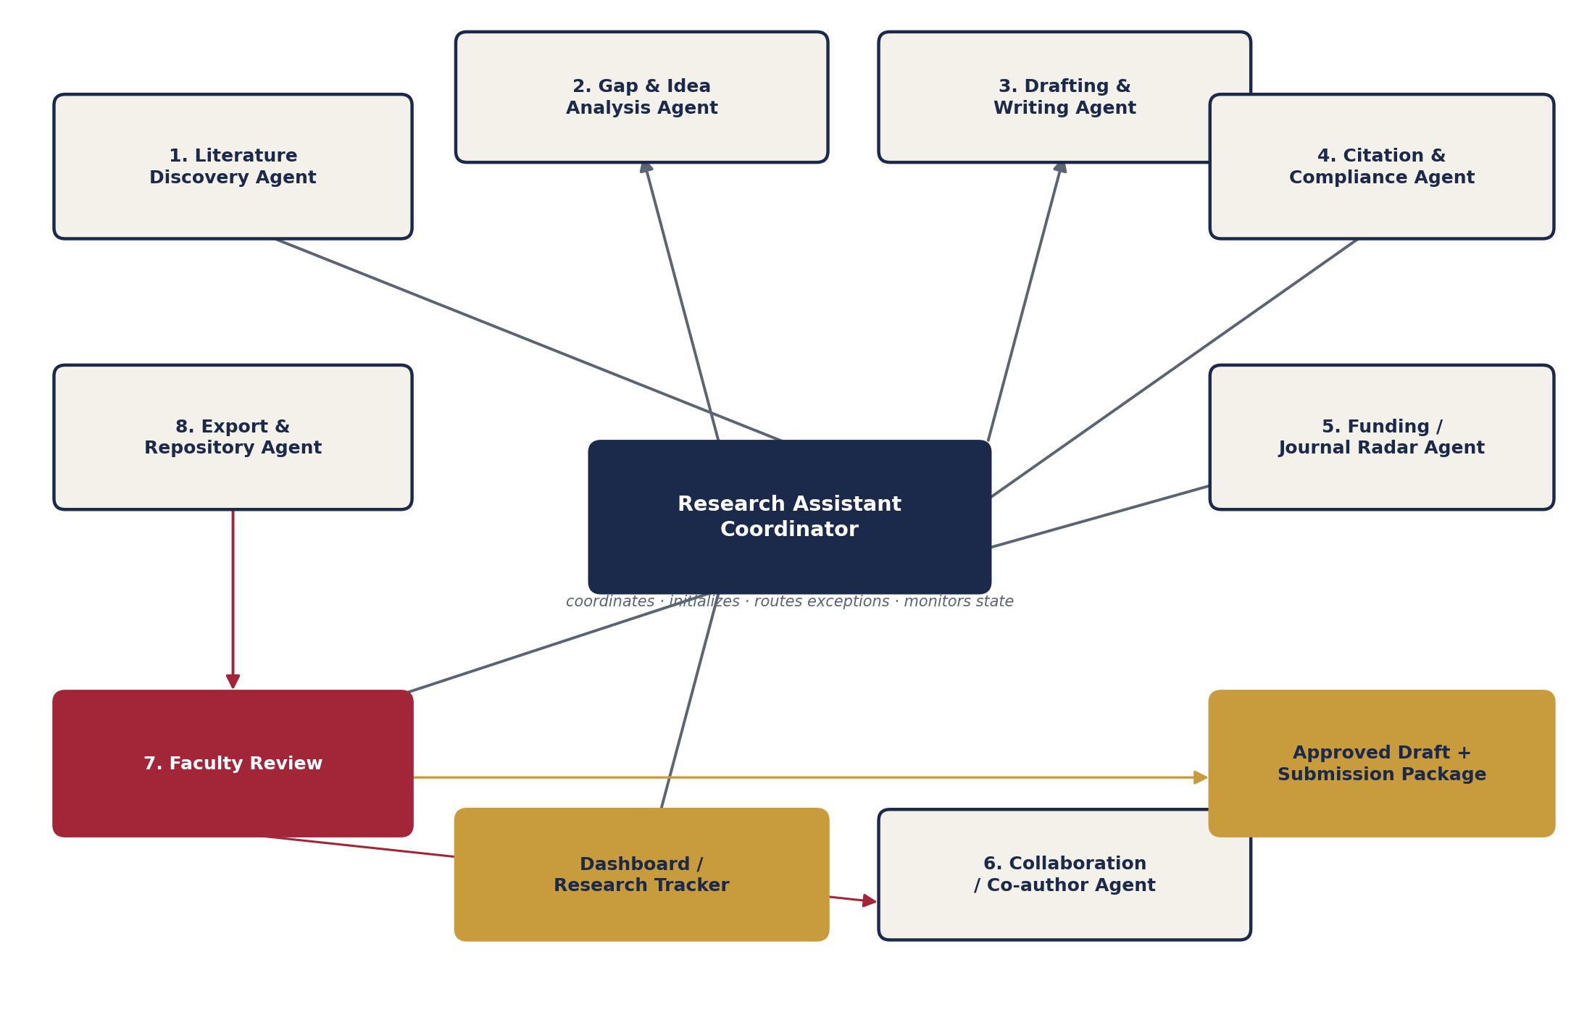
Research Assistant Coordinator and its agents.

Agent Roles, Communication Order, and Guardrails
The Research Assistant Coordinator receives the faculty request, initializes agents with scoped instructions, collects outputs, routes exceptions to faculty, and publishes only approved artifacts.
Order | Agent | Role and communication | Guardrails
0 | Coordinator | Receives the research request, creates the run plan, initializes agents with scoped instructions, monitors state. | Never bypass faculty approval; enforce source citation and audit logging.
1 | Literature Discovery Agent | Searches scholarly metadata sources and returns a ranked, summarized reading list. | Use only verifiable scholarly sources; never fabricate a citation or abstract.
2 | Gap & Idea Analysis Agent | Compares the research question against discovered literature and flags novelty versus overlap. | State uncertainty explicitly rather than asserting novelty it cannot verify.
3 | Drafting & Writing Agent | Produces an outline, then a full draft in the target venue's structure. | Draft only; mark AI-authored text clearly; no submission without faculty approval.
4 | Citation & Compliance Agent | Checks formatting, reference completeness, and venue-specific requirements. | Flag missing or inconsistent citations rather than inventing a reference.
5 | Funding / Journal Radar Agent | Continuously surfaces relevant journals, calls for papers, and funding deadlines. | Only report from verifiable sources; timestamp every alert.
6 | Collaboration Agent | Tracks co-author section ownership and consolidates edits into one version. | Preserve individual author attribution; never silently overwrite a co-author's edit.
7 | Faculty Review | Reviews exceptions, approves drafts, requests corrections or scope changes. | Faculty decision is final authority for all submissions.
8 | Export & Repository Agent | Produces the final formatted document and logs it in the research tracker. | Keep version history and source links; label draft versus approved status.

Hybrid Execution Methodology
Independent agents run in parallel to save time, while drafting, compliance checks, and faculty approval remain sequential gates.
Stage | Execution mode and coordinator behavior
Gate 1: intent and venue | Sequential — drafting starts only after faculty confirms topic, venue, and deadline.
Parallel discovery | Parallel — the Literature Discovery Agent and Funding/Journal Radar Agent run independently of each other.
Join and drafting | Sequential — the Drafting Agent starts only once the gap analysis is available.
Parallel compliance | Parallel — the Citation & Compliance Agent and Collaboration Agent both work once a draft exists.
Faculty approval | Sequential — faculty approves before export or submission.
Export and tracking | Parallel after approval — export and repository logging run together.

Pilot Artifacts and Guardrails

Pilot artifacts
- A ranked reading list and gap summary for one active research question.
- One outline-to-draft cycle in a specific target venue's format.
- A citation/compliance check report against that venue's requirements.
- A running funding/journal deadline digest for the faculty's stated interests.

Guardrails
- Never fabricate a citation, abstract, or claimed result.
- Never submit or share a draft without explicit faculty approval.
- Always preserve co-author attribution; never silently overwrite another author's edits.
- Always keep source links and version history for every draft.
- Flag uncertainty about novelty rather than asserting it.

Suggested MVP Roadmap
Order | Agent | Role and communication | Guardrails
1 | Literature discovery | Ranked reading list with summaries for a stated topic. | Coordinator, Literature Discovery Agent.
2 | Gap analysis | Compare topic against discovered literature; flag novelty. | Gap & Idea Analysis Agent.
3 | Outline-to-draft | Outline first, full draft after confirmation, in target venue format. | Drafting & Writing Agent.
4 | Citation compliance | Formatting and reference completeness check. | Citation & Compliance Agent.
5 | Funding/journal radar | Continuous deadline digest. | Funding / Journal Radar Agent.
6 | Multi-author collaboration | Section ownership and edit consolidation. | Collaboration Agent.

Reference Architecture
- Data capture: research question intake, venue templates, faculty's prior-work library.
- Data layer: canonical schema for papers, citations, deadlines, and collaborator roles.
- AI layer: retrieval-augmented literature search, gap analysis, drafting, and compliance checking.
- Workflow layer: faculty review queue, deadline alerts, version history, collaboration tracking.
- Governance layer: source citation requirements, audit logs, authorship attribution, approval gates.

