SQL Assignment – 7
Summarizing Data with Aggregate Functions.

1) Write a query that counts all orders October 3.

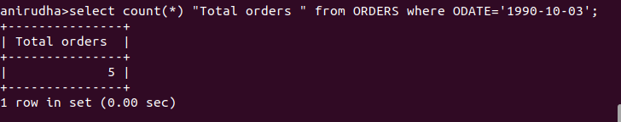

2) Write a query that counts the number of different non-NULL city values in the Customers table.


3) Write a query that selects each customer’s
smallest order.

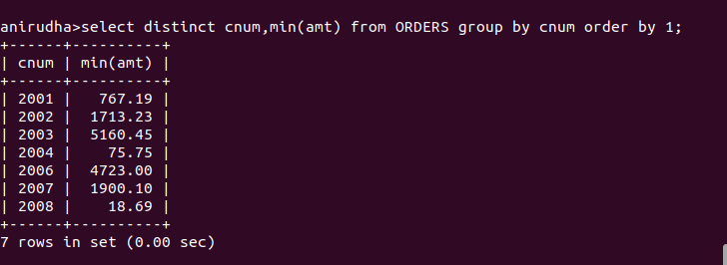

4) Write a query that selects the first customer,
in alphabetical order, whose name begins with G.

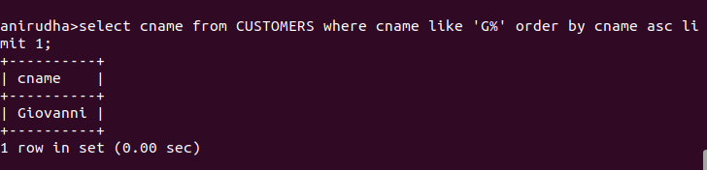

5) Write a query that selects the highest rating
in each city.

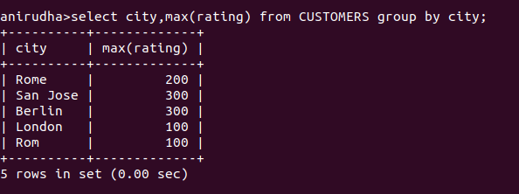
6) Write a query that counts the number of
salespeople registering orders for each day. (Ifa
salesperson has more than one order on a givenday,
he or she should be counted only once.

