1) Write a query that lists each order number
followed by the name of the customer who made the
order.
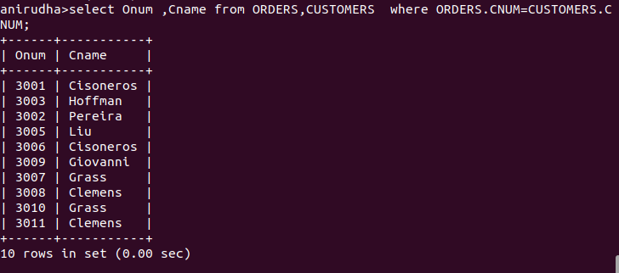
2) Write a query that gives the names of both the salesperson and the customer for each order along with the order number.
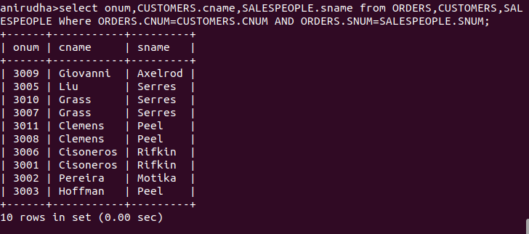

3) Write a query that calculates the amount of the salesperson’s commission on each order by a customer with a rating above 100.

