TELECOMMUNICATIONS NETWORK OPERATIONS, CUSTOMER EXPERIENCE & SERVICE ASSURANCE ANALYTICS PLATFORM
Capstone Project Report
Snowflake | Informatica IDMC | Snowpark Python | Streamlit | Cortex Analyst
Prepared by
Anirudha Sanjay Ojha
Ananya Vaishnav
Dhanavarshini V R
Jovitha Rajendran
Sagala Guru Santhosh
Telecommunications Data Engineering Capstone | Five-Day Sprint | November 2026

Table of Contents
No. | Heading
1 | Execution Summary
2 | Problem Statement
3 | Project Objectives
4 | Business Understanding
5 | Source Data & Data Understanding
6 | End-to-End Architecture
7 | IDMC ETL & Data Quality Layer
8 | Data Cleansing & Transformation Logic
9 | Snowflake Architecture & Implementation
10 | Medallion Architecture
11 | Data Warehouse / Dimension Modelling
12 | Important SQL & Transformation Logic
13 | Telecom Usage, Incident, Ticket Delay & Network Reliability Analysis
14 | Network Risk Analytics
15 | KPI Framework
16 | Cortex Analyst Semantic Layer – Project USP
17 | Automated Critical Incident Alerting – Project USP
18 | Snowpark Network-Risk Scoring – Project USP
19 | Streamlit Dashboard
20 | Technical Flow End-to-End
21 | Data Quality & Validation
22 | Security & Governance
23 | Performance & Scalability
24 | Error Handling & Edge Cases
25 | Challenges & Solutions
26 | Sprint Execution & Project Management
27 | Deliverables Achieved
28 | Overall Project Assessment
 | – Strengths
 | – Areas for Future Iteration
 | – Future Enhancements

1. Execution Summary
The project delivers a governed telecom analytics platform that unifies seven operational datasets across customer, subscription, usage, network, incident, ticket and event domains. IDMC performs upstream profiling and cleansing, Snowflake implements the medallion warehouse, Snowpark calculates explainable rule-based risk, and Streamlit presents operational and analytical views.
Outcome | Verified implementation
Scale | 6,900 source rows across 7 datasets; 6,886 rows accepted after IDMC routing.
Warehouse | 4 dimensions, 4 facts, 4 core marts, 10 KPI views and 6 Cortex semantic views.
Incremental flow | 10-row Usage file with 8 new IDs and 2 changed IDs processed through Stream, procedure, SCD Type 2 and Gold MERGE.
Operational analytics | Main Streamlit dashboard, explainable risk view and a second telecom CRM dashboard.
Security | Three business roles, customer-data masking and secure reporting views.
Project delivery | Five-day sprint with 13 of 13 planned tasks completed by Day 5.

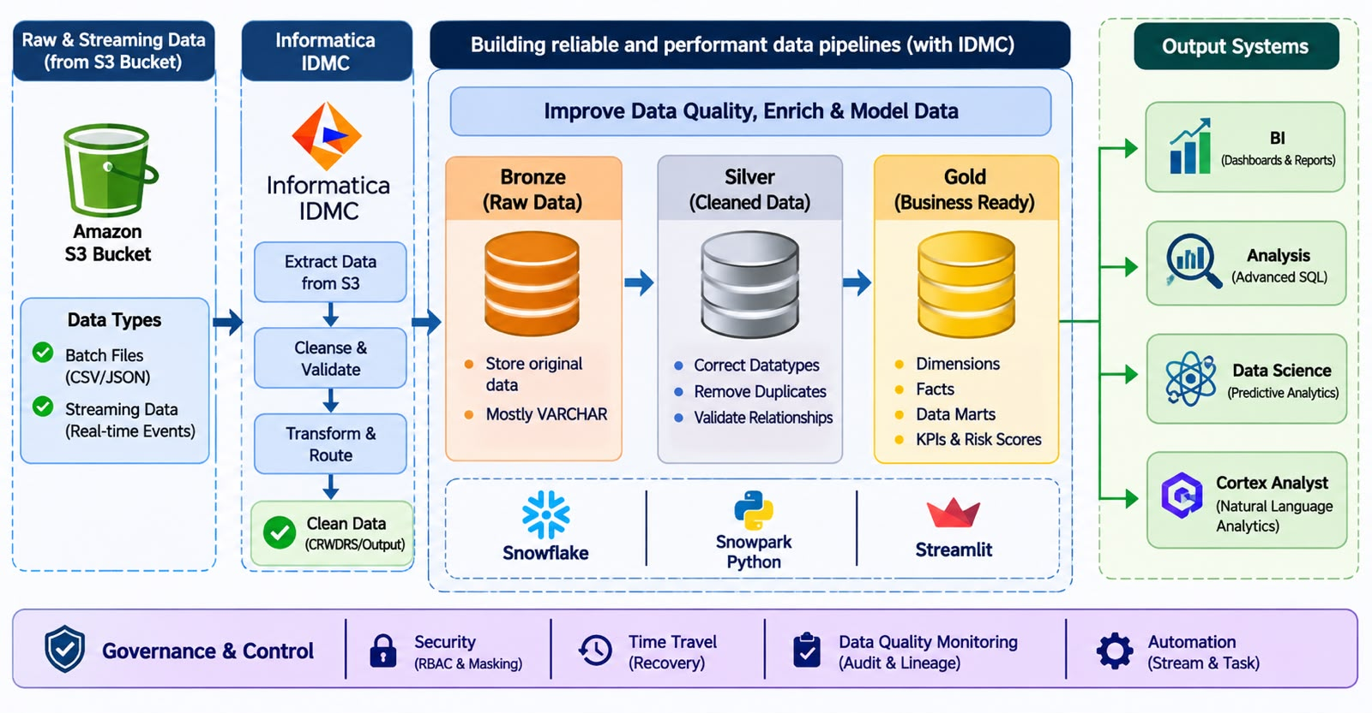
Fig. 1.1: Implemented platform architecture from source delivery to governed consumption

2. Problem Statement
Telecom operations data was distributed across seven source files, preventing teams from tracing a service problem from a network event through incident impact, ticket handling and customer usage. The data also included controlled nulls, duplicates, impossible timestamp sequences, outliers and mixed date formats. Without a governed model, KPI definitions, operational triage and customer-impact analysis were inconsistent.
- No single analytical path connected network elements, events, incidents, tickets, subscriptions and customers.
- Raw records could not be trusted without explicit profiling, exception routing and count reconciliation.
- Operational staff needed proactive alerting and investigation views, while business users needed curated, masked consumption views.
- The solution had to preserve incremental Usage history without double-counting historical versions.

3. Project Objectives
The objectives combine the trainer guide requirements with the implementation evidenced in the final presentation.
Category | Objectives
Data integration | Ingest six CSV sources and one JSON event source; preserve source metadata and reconcile counts.
Data quality | Profile, standardise, deduplicate, validate business sequences and route invalid records.
Warehouse | Implement Bronze, Silver and Gold layers with conformed dimensions, facts and marts.
Incremental processing | Process a second Usage file through COPY INTO, Stream, SCD Type 2 and Gold MERGE.
Analytics | Measure usage, incident duration, customer impact, MTTR, ticket resolution, SLA and alarms.
AI and risk | Provide six Cortex semantic views and an explainable Snowpark network-risk score.
Security | Apply RBAC, masking policies and secure views.
Presentation | Deliver Streamlit dashboards for KPI, risk, exception and alert-triage use cases.

4. Business Understanding
The platform supports multiple telecom operating perspectives while retaining common definitions and shared conformed dimensions.
Team | Meaning in the Project
Network Engineering | Investigates raw and conformed events, incidents, latency, packet loss, CPU and traffic metrics.
Service Assurance | Monitors reliability, open alarms, incident impact, ticket queues and SLA compliance.
Customer Operations | Uses customer, subscription and ticket context to understand service impact.
Telecom Management | Consumes curated KPI and risk views without direct raw-table access.
Data Engineering | Maintains ingestion, data quality, medallion transformations, incremental loads and recovery.
Analytics Users | Use dashboards and Cortex Analyst to ask governed business questions without writing SQL.

5. Source Data & Data Understanding
The source package contains seven datasets and 6,900 records. Each dataset was assigned an explicit business grain and downstream purpose before transformation.
Source | Business Purpose | Grain | Key Columns
customers.csv | Customer identity and segmentation | One row per customer | customer_id, region, segment, contact fields
subscriptions.csv | Service ownership and status | One row per subscription | subscription_id, customer_id, service_type, dates
network_elements.csv | Physical/logical network inventory | One row per network element | network_element_id, parent_element_id, type, region
usage_transactions.csv | Voice, SMS, data and charge activity | One row per usage transaction | usage_transaction_id, subscription_id, usage_ts, measures
trouble_tickets.csv | Customer-reported service work | One row per ticket | ticket_id, network_incident_id, priority, SLA
network_incidents.csv | Service-impacting incidents | One row per incident | network_incident_id, primary_element_id, severity, timestamps
network_events.json | NMS alarms and telemetry context | One row per event | event_id, network_element_id, severity, metric_context

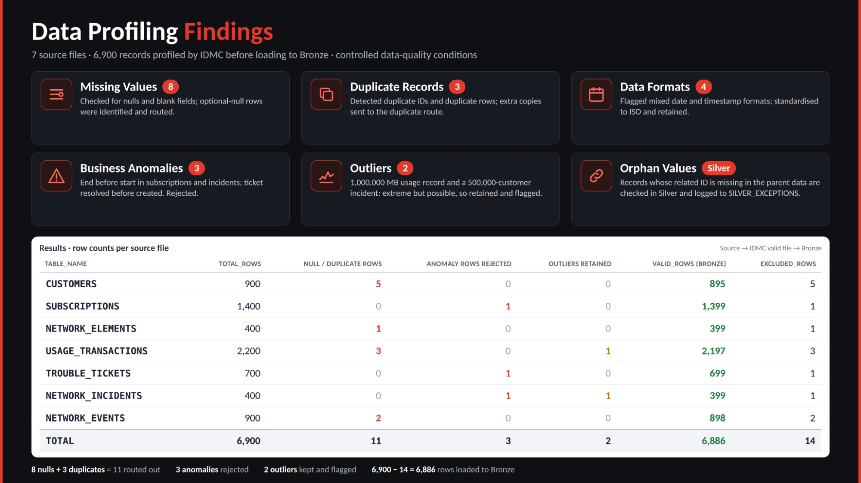
Fig. 5.1: IDMC profiling results and source-to-Bronze row reconciliation

6. End-to-End Architecture
The implemented journey is S3 to IDMC, named Snowflake stage, Bronze, Silver, Gold, Consumption and Streamlit. A separate incremental Usage path appends a second file to Bronze and consumes only new rows through a Stream. CONTROL holds procedures, tasks, exceptions and masking policies, while SEMANTIC holds the Cortex Analyst semantic views.
Fig. 6.1: End-to-end architecture and governance controls

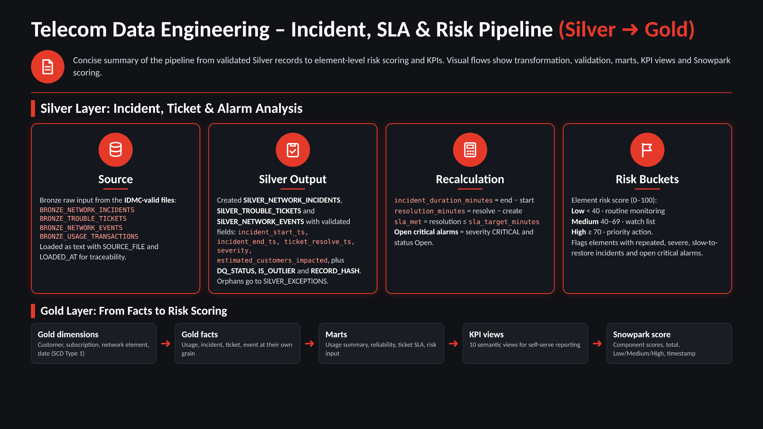
Fig. 6.2: Validated Silver records transformed into Gold marts, KPIs and risk scores

7. IDMC ETL & Data Quality Layer
IDMC is the authoritative upstream profiling and cleansing layer. Separate mappings were created for the seven datasets, with clean outputs routed for Snowflake loading and invalid or duplicate rows retained as quality evidence.
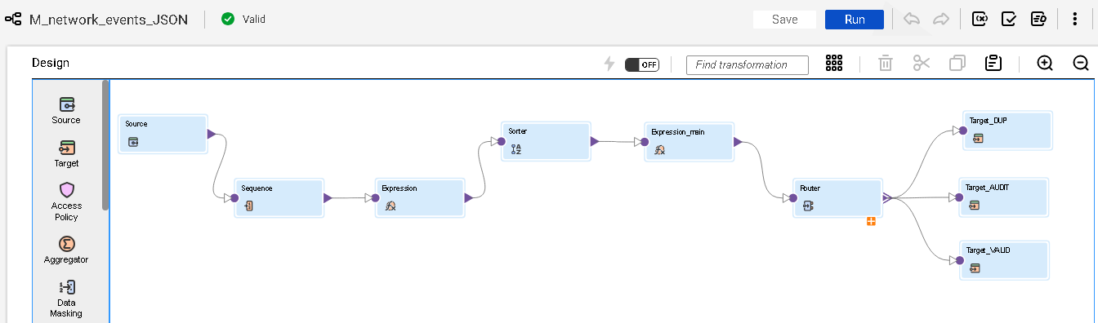
Fig. 7.1: IDMC mapping for JSON network events

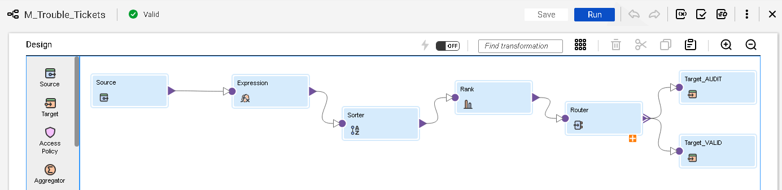
Fig. 7.2: IDMC mapping for trouble-ticket validation

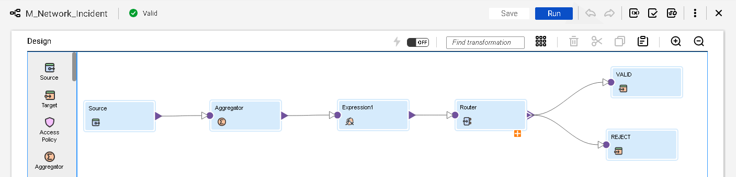
Fig. 7.3: IDMC mapping for network-incident validation

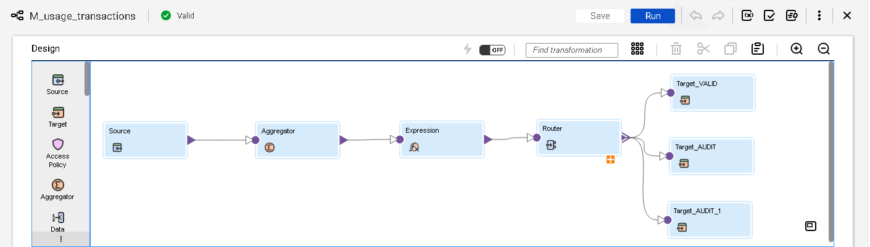
Fig. 7.4: IDMC mapping for usage-transaction validation

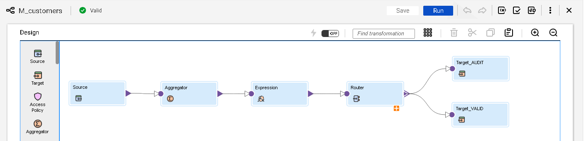
Fig. 7.5: IDMC customer cleansing and valid-record route
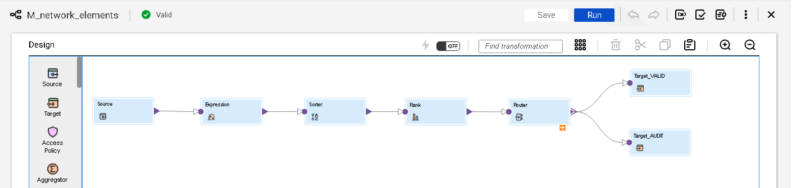
Fig. 7.6: IDMC network-element cleansing and valid-record route

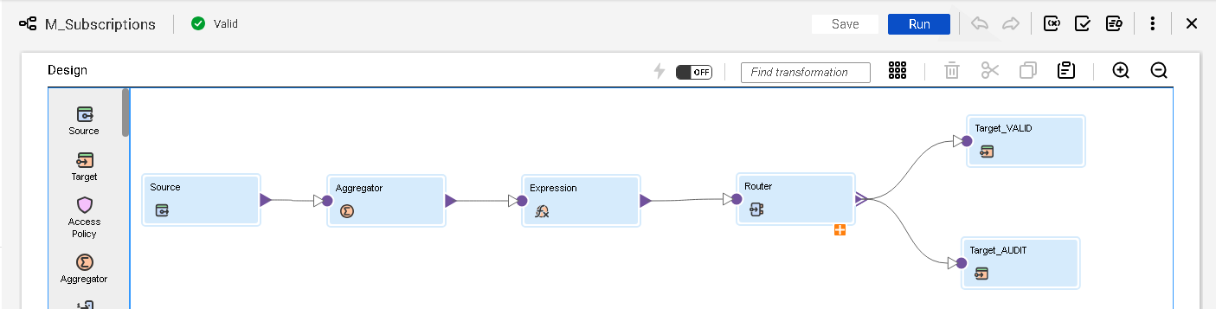
Fig. 7.7: IDMC subscription cleansing and valid-record route

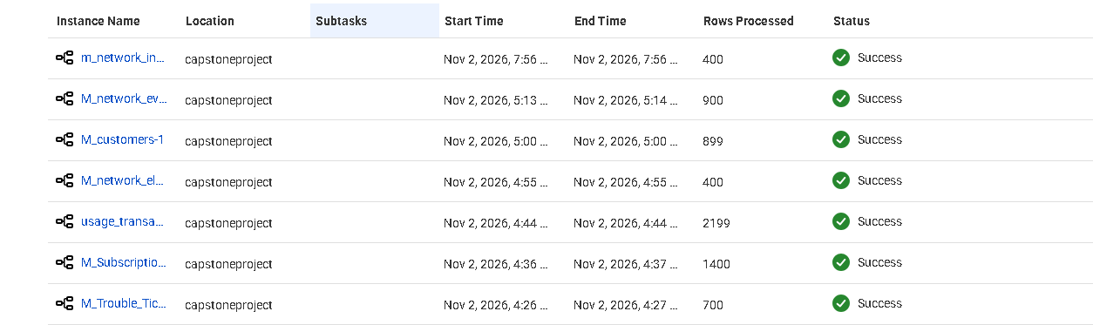
Fig. 7.8: Successful IDMC mapping executions and processed-row evidence

8. Data Cleansing & Transformation Logic
Cleansing rules were designed around correctness, explainability and controlled routing. Correctable formats were standardised and retained; duplicates and impossible sequences were excluded; extreme but possible values were retained with an outlier flag. Silver then performed datatype conformance, relationship checks and JSON extraction.

Condition | Handling | Reason
Mandatory key is null | Reject or exception route | A record without its business key cannot be reconciled.
Duplicate business key or duplicate row | Duplicate route | Prevents unintended double counting.
Date or timestamp format variation | Standardise | Preserves valid business meaning.
End before start / resolve before create | Reject | Business sequence is impossible.
Extreme but possible measure | Retain and flag | Keeps legitimate rare events visible.
Missing parent or foreign key | Silver exception | Protects dimensional and hierarchy integrity.
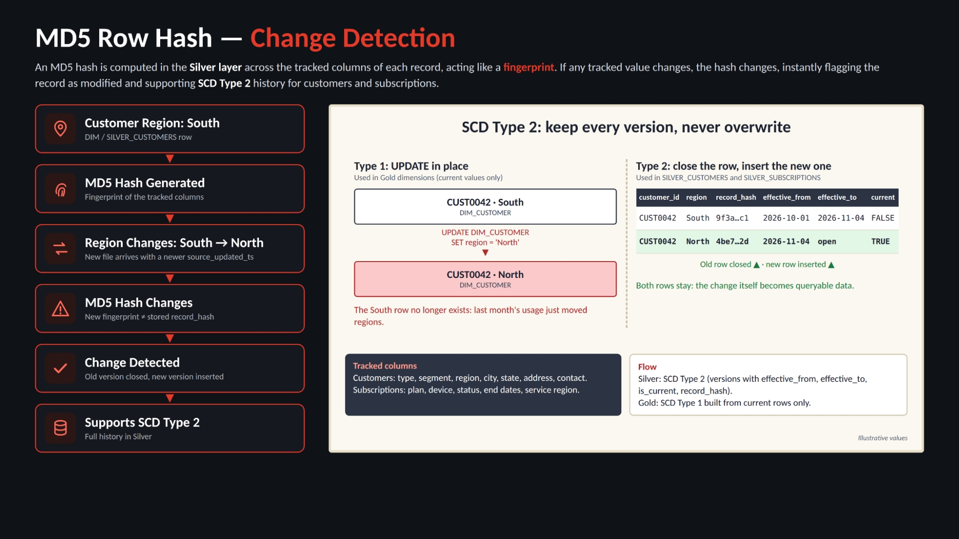
Fig. 8.1: MD5 row-hash change detection and historisation concept

9. Snowflake Architecture & Implementation
TELECOM_DB separates responsibilities into BRONZE, SILVER, GOLD, SEMANTIC, CONSUMPTION and CONTROL schemas. Raw files are loaded with source metadata. Silver tables apply typed business structures and preserve the Usage history. Gold tables use surrogate keys and conformed dimensions. Consumption exposes reporting-safe objects, while Control isolates operational logic.

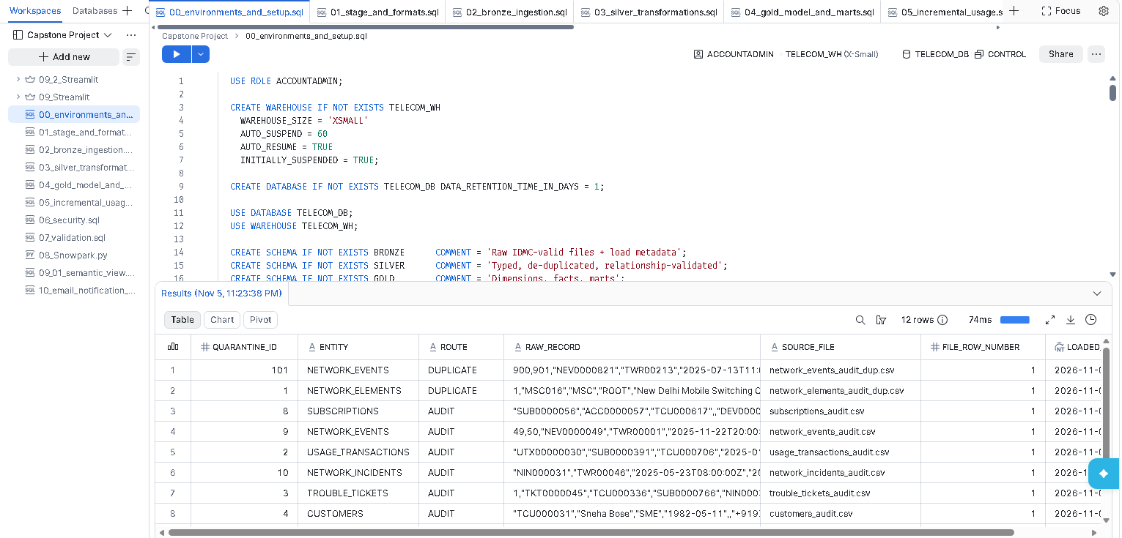
Fig. 9.1: Snowflake project scripts and schema-oriented implementation workspace
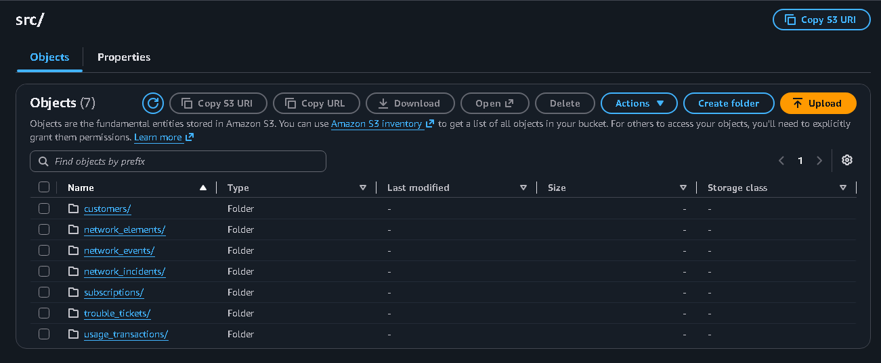
Fig. 9.2: Snowflake object and script management evidence

10. Medallion Architecture
The medallion pattern provides progressive quality and usability. Bronze stays source-aligned for traceability. Silver contains typed, deduplicated and relationship-validated records. Gold applies dimensional modelling and business calculations. The project deliberately keeps IDMC as the primary cleansing layer to avoid duplicating business-quality logic inside Snowflake.

Layer | Purpose | Representative objects
Bronze | Raw landing plus SOURCE_FILE and LOADED_AT | BRONZE_CUSTOMERS, BRONZE_USAGE_TRANSACTIONS, BRONZE_NETWORK_EVENTS
Silver | Typed and conformed records, JSON extraction and exceptions | SILVER_CUSTOMERS, SILVER_USAGE_TRANSACTIONS, SILVER_EXCEPTIONS
Gold | Dimensions, facts, marts and KPIs | DIM_CUSTOMER, FACT_USAGE, MART_NETWORK_RELIABILITY
Semantic | Business-friendly model for Cortex Analyst | Six TELECOM_*_SV semantic views
Consumption | Secure reporting boundary and persisted Snowpark output | V_USAGE_KPI, V_TICKET_SLA, NETWORK_RISK_SNOWPARK

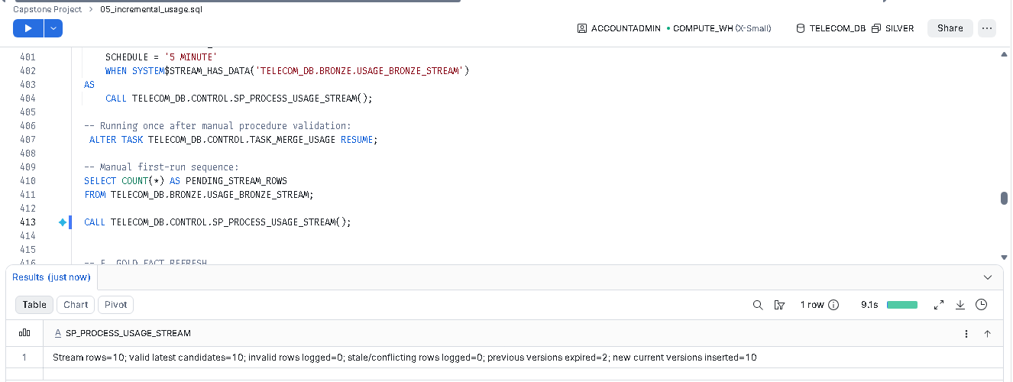
Fig. 10.1: Telecom warehouse flow from Silver through transformation tasks to Gold

11. Data Warehouse / Dimension Modelling
The implemented warehouse is a galaxy schema: four fact tables share four conformed dimensions. This structure supports cross-process analysis while preserving the natural grain of usage, incidents, tickets and events. DIM_DATE is role-playing for usage, incident start/end and ticket creation/resolution dates.

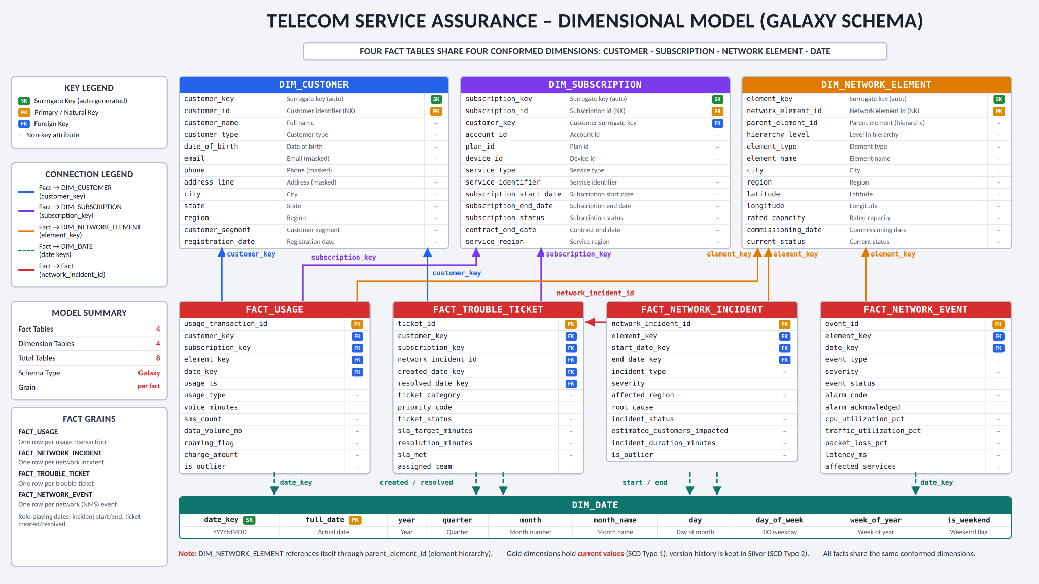
Fig. 11.1: Galaxy schema with four facts and four conformed dimensions

Fact | Declared grain | Primary analytical use
FACT_USAGE | One row per current usage transaction | Voice, SMS, data, roaming and charges
FACT_NETWORK_INCIDENT | One row per network incident | Frequency, severity, duration and impact
FACT_TROUBLE_TICKET | One row per trouble ticket | Resolution time, status and SLA
FACT_NETWORK_EVENT | One row per NMS event | Alarm, utilisation, packet loss and latency

12. Important SQL & Transformation Logic
The implementation uses Snowflake-native patterns that are safe to rerun and easy to validate: TRY_TO_* conversions, ROW_NUMBER-based deduplication, HASH/MD5 fingerprints, MERGE, Streams, Tasks, secure views and transactional stored procedures.
TRY_TO_TIMESTAMP(raw_usage_ts) AS usage_ts
ROW_NUMBER() OVER (PARTITION BY business_key ORDER BY version_ts DESC) AS rn
SYSTEM$STREAM_HAS_DATA('TELECOM_DB.BRONZE.USAGE_BRONZE_STREAM')
MERGE INTO GOLD.FACT_USAGE USING SILVER.VW_USAGE_TRANSACTIONS_CURRENT
The report intentionally provides representative patterns rather than inventing complete scripts. Exact SQL should be taken from the project repository and executed against the target account. The critical alert procedure additionally uses LISTAGG to assemble one context-rich report block per qualifying event.
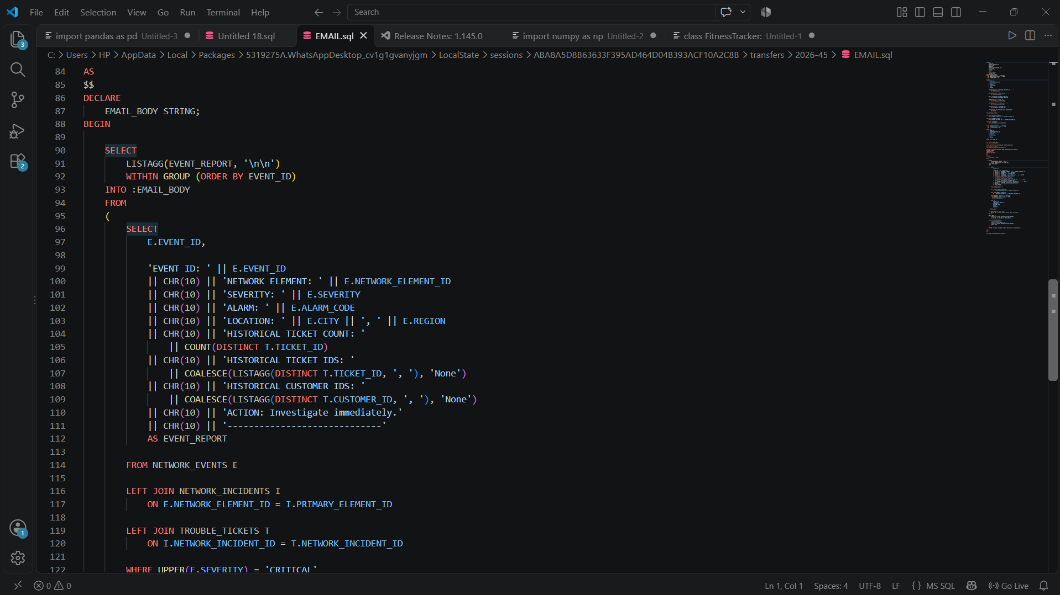
Fig. 12.1: SQL logic that composes enriched critical-event email content

13. Telecom Usage, Incident, Ticket Delay & Network Reliability Analysis
The analytical layer exposes a connected view of usage, incident burden, event telemetry and ticket resolution. Dashboard values are snapshots from the demonstrated run and should not be interpreted as fixed production benchmarks.

Analytical area | Demonstrated result
Usage | 2,072 current usage transactions, 24,818 voice minutes, 9,570 SMS and 3,674.7 GB data in the presentation snapshot.
Incidents | 378 network incidents in the illustrated dashboard snapshot.
Network events | 898 events available to the CRM dashboard.
Ticket SLA | 31.9% compliance against a configured 95% target in the demonstrated filter state.
Packet loss | 2.0% average against a 5% dashboard limit.
Critical alarms | 89 in the main dashboard snapshot; CRM home separately shows 94 critical events under its own view/filter context.

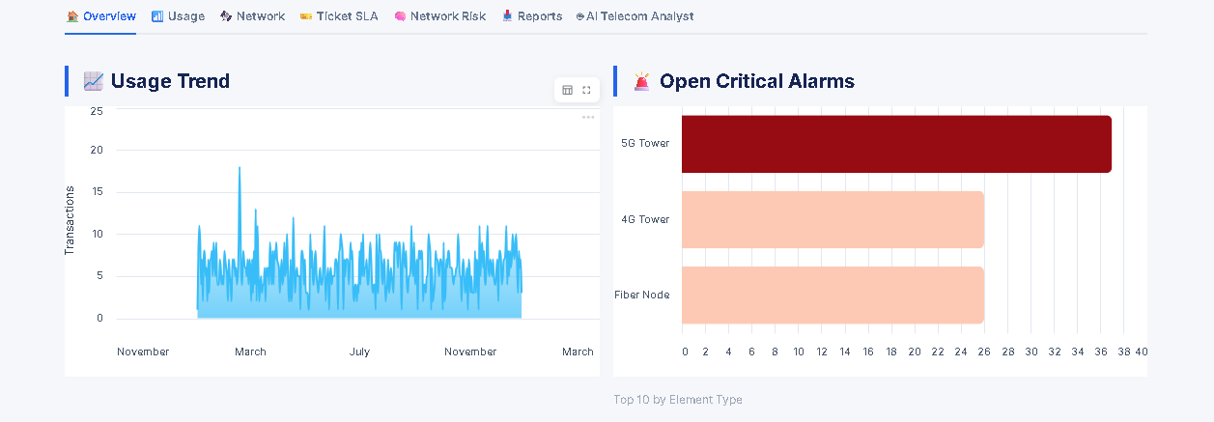
Fig. 13.1: Streamlit overview dashboard with telecom usage and operations KPIs
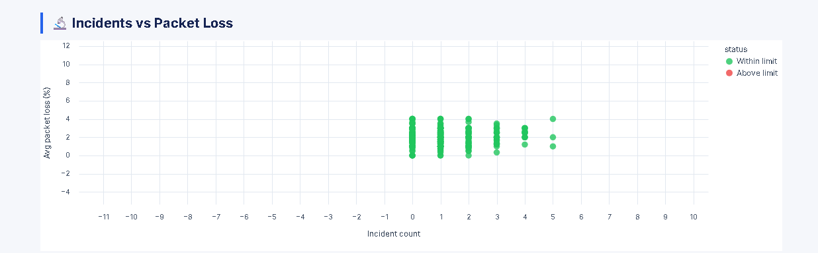
Fig. 13.2: Incident and packet-loss reliability analysis

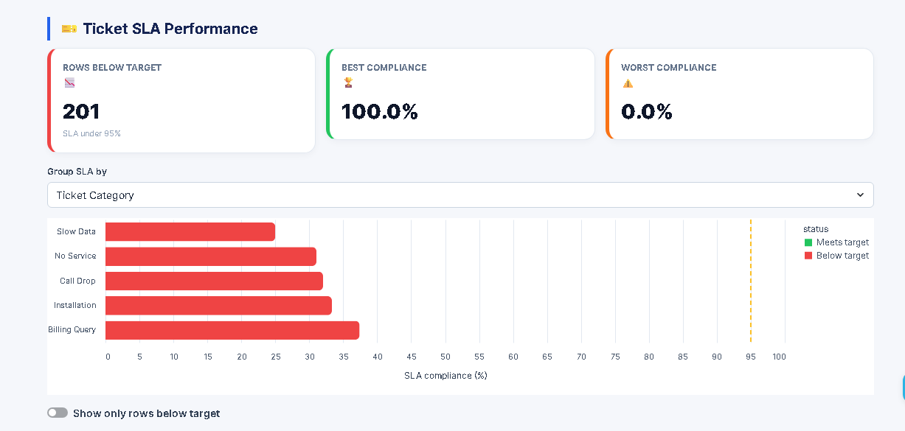
Fig. 13.3: Ticket SLA performance and rows below target

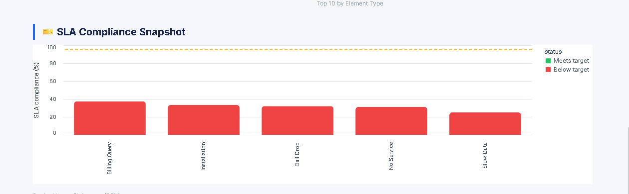
Fig. 13.4: SLA compliance snapshot and category analysis

14. Network Risk Analytics
Network risk is calculated per network element from operational evidence. The canonical implemented design documented in the Gold model uses incident frequency, severity, restore time, open critical alarms and customer-experience impact. A separate dashboard screenshot confirms 361 scored elements, 11 medium-risk elements, no high-risk elements and an average score of 18.8 under the 40/70 presentation bands.
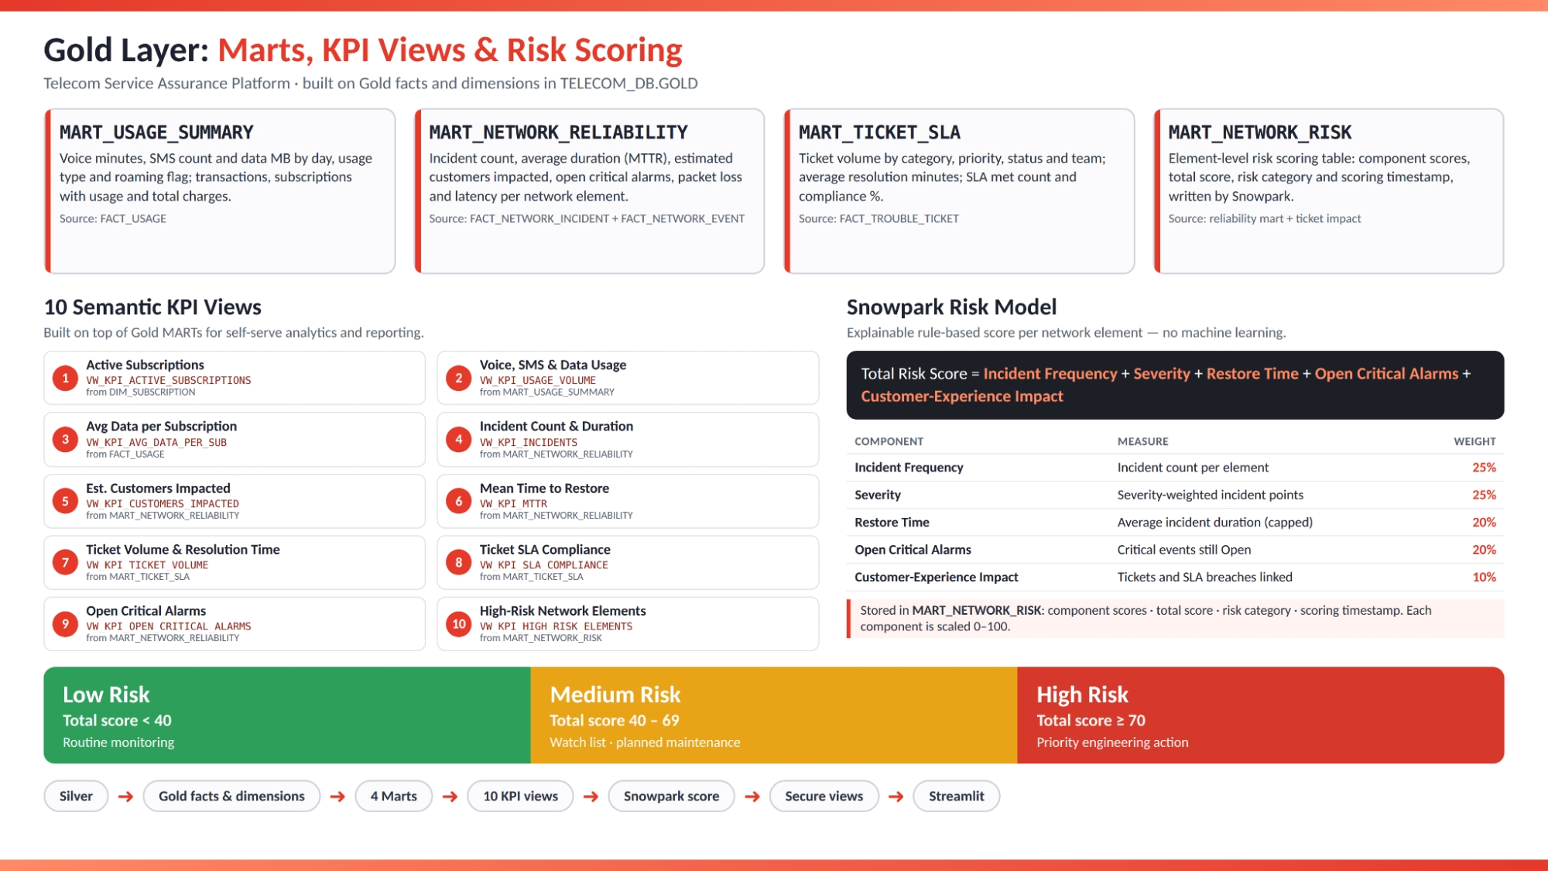
Fig. 14.1: Gold marts, KPI views and explainable network-risk model

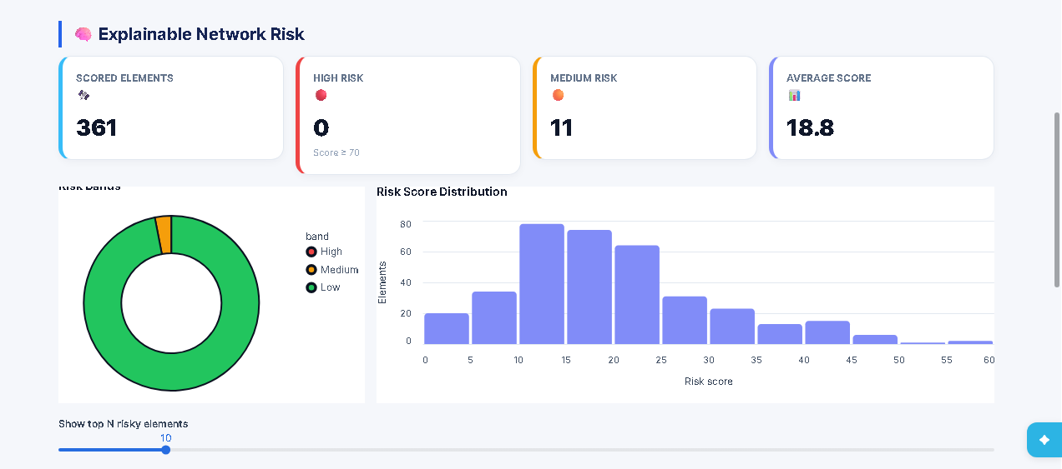
Fig. 14.2: Explainable network-risk distribution and score-band summary

15. KPI Framework
The KPI framework connects business definitions to governed Gold objects. Ten semantic KPI views cover subscriptions, usage, incidents, customer impact, MTTR, tickets, SLA, alarms and high-risk elements.

KPI | Business meaning | Primary source
Active subscriptions | Current active service base | DIM_SUBSCRIPTION
Usage volume | Voice, SMS and data consumption | MART_USAGE_SUMMARY
Average data per subscription | Normalised data usage | FACT_USAGE
Incident count and duration | Operational disruption | MART_NETWORK_RELIABILITY
Estimated customers impacted | Potential service impact | MART_NETWORK_RELIABILITY
MTTR | Average time to restore service | MART_NETWORK_RELIABILITY
Ticket resolution | Volume and time to resolve | MART_TICKET_SLA
SLA compliance | Share of tickets meeting target | MART_TICKET_SLA
Open critical alarms | Urgent unclosed events | MART_NETWORK_RELIABILITY
High-risk elements | Elements exceeding risk threshold | MART_NETWORK_RISK

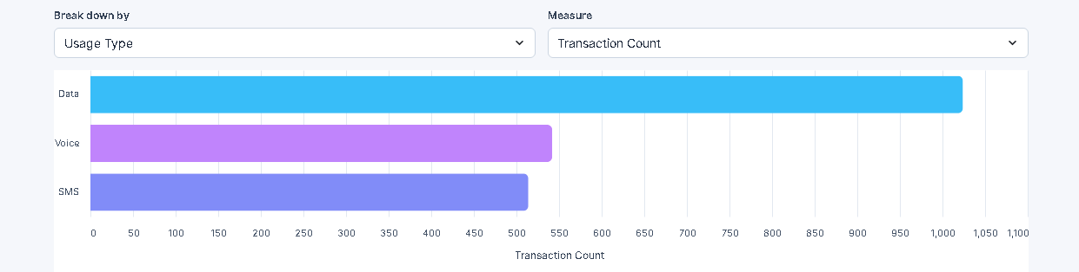
Fig. 15.1: Usage metric breakdown and transaction analysis

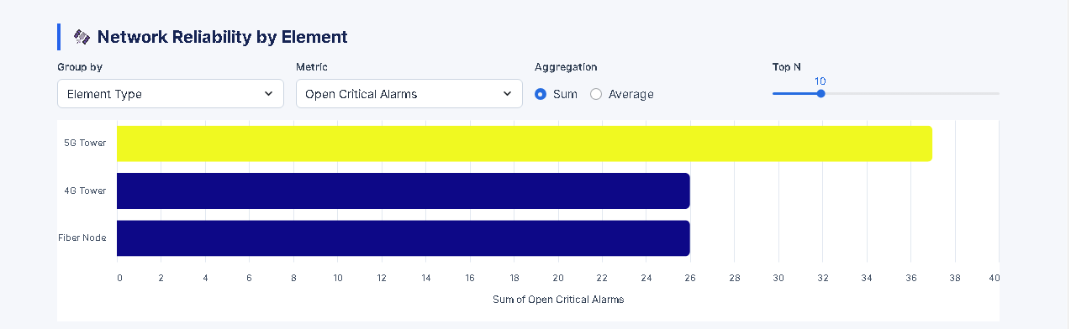
Fig. 15.2: Network reliability analysis by element grouping

16. Cortex Analyst Semantic Layer – Project USP
Six semantic views were implemented in TELECOM_DB.SEMANTIC: customer experience, incidents, network events, network reliability, network risk and usage. Cortex Analyst translates a natural-language question into SQL against these governed semantic definitions, and the AI Telecom Analyst tab returns live Snowflake results.

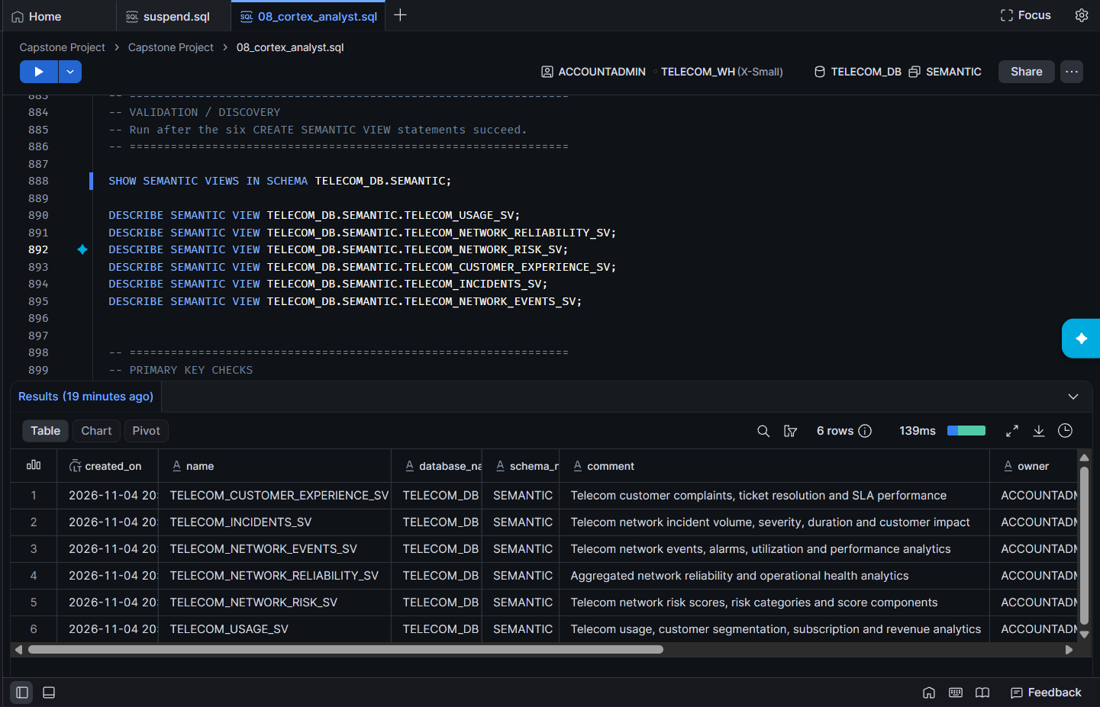
Fig. 16.1: Six semantic views created and validated in the SEMANTIC schema
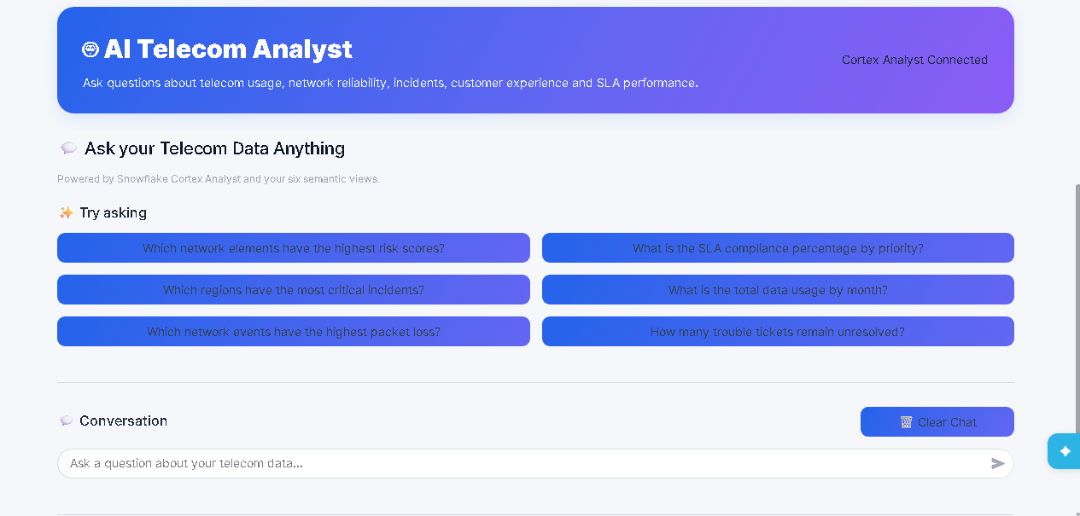
Fig. 16.2: AI Telecom Analyst start screen with suggested telecom questions

17. Automated Critical Incident Alerting – Project USP
The platform does not wait for someone to open a dashboard: it detects unattended critical events and emails the on-call team with full context. The alert runs natively in Snowflake and turns the analytics layer into an operational action within one alert cycle.
Stage | What happens | Detail
1. Detect | Snowflake Alert checks NETWORK_EVENTS every 30 minutes | SEVERITY = CRITICAL, EVENT_STATUS = OPEN, ACKNOWLEDGED = 0
2. Enrich | Joins each event to incidents and trouble tickets | Incident IDs, root cause, customers impacted, past tickets and customers
3. Compose | SEND_TELECOM_CRITICAL_EMAIL builds one block per event | Element, alarm, location, ticket history and recommended action
4. Notify | SYSTEM$SEND_EMAIL via TELECOM_EMAIL_INT | Delivered only to verified, allow-listed recipients

Why it stands out:
- Proactive: turns analytics into action within one alert cycle.
- Context-rich: engineers see ticket and customer history up front.
- No noise: no critical events means no email is sent.
- Native to Snowflake: no external scheduler or mail server is needed.
Each email carries one block per critical event, listing the event ID, network element, severity, alarm code, location, historical ticket count, historical ticket and customer IDs, and the action “Investigate immediately.”

Component | Purpose
TELECOM_EMAIL_INT | Email notification integration with an allow-listed recipient
Verified recipient user | USERADMIN creates the user; email verification is started
SEND_TELECOM_CRITICAL_EMAIL() | SQL procedure (EXECUTE AS OWNER) builds and sends the report
TELECOM_CRITICAL_ALERT | Runs on COMPUTE_WH every 30 minutes when critical events exist
The alerting was tested in three steps: a SYSTEM$SEND_EMAIL test message confirmed delivery; a query listed the critical, open, unacknowledged events; and the alert was run on demand with ALTER ALERT … RESUME followed by EXECUTE ALERT.
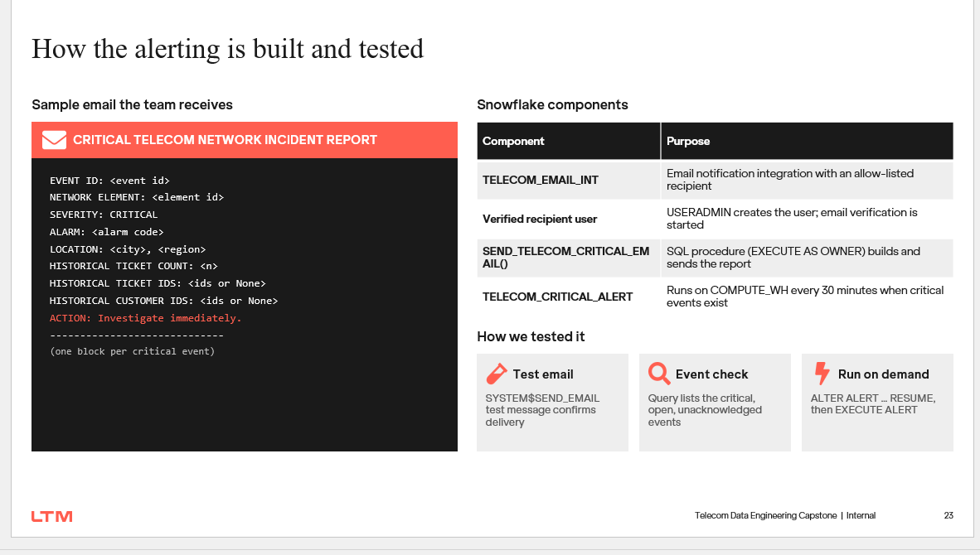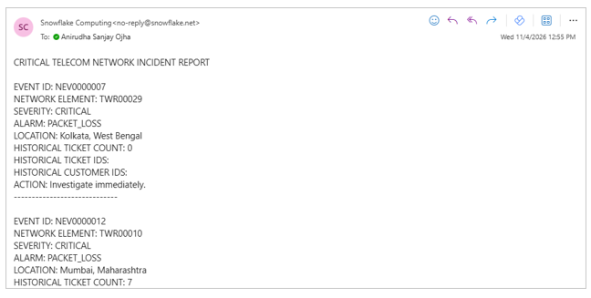
Fig. 17.2: Sample alert email and critical alert emails delivered from Snowflake

The delivered output confirmed the design. All three emails (test message, scheduled alert notice and enriched incident report) arrived from Snowflake on 4 November 2026. The report lists each critical event with its element, alarm and location, and the ticket history adds context, for example seven past tickets for TWR00010 in Mumbai. The team is informed without any manual checking.

18. Snowpark Network-Risk Scoring – Project USP
Snowpark performs transparent rule-based scoring inside Snowflake. The implementation is not a trained machine-learning model. Each component is calculated from domain measures, capped or scaled, combined into a total score, assigned a risk category and written with a scoring timestamp.
Component | Implemented rationale | Model weight in Gold design
Incident frequency | Repeated incidents indicate unstable elements | 25%
Severity | Higher-severity incidents receive more weight | 25%
Restore time | Slow restoration increases operational exposure | 20%
Open critical alarms | Unresolved critical events require immediate attention | 20%
Customer-experience impact | Tickets and SLA breaches connect network health to customers | 10%
Threshold note: the final evidence includes two historical configurations. The earlier Snowpark slide shows Low below 35, Medium 35 to below 65 and High at 65 or above. The later Gold model and final dashboard use Low below 40, Medium 40–69 and High at 70 or above. This report treats 40/70 as the final presentation configuration and records 35/65 as an earlier implementation variant.

19. Streamlit Dashboard
The primary Streamlit application reads persisted calculations through secure views. SQL and Snowpark own transformations; Streamlit is responsible for filters, KPI cards, charts, tables and drill-down presentation. A second CRM dashboard supports operational alert triage.
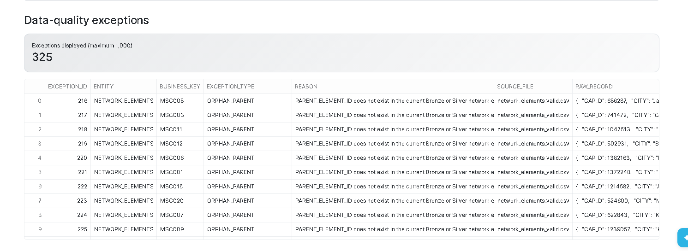
Fig. 19.1: Data-quality exception register displayed in Streamlit

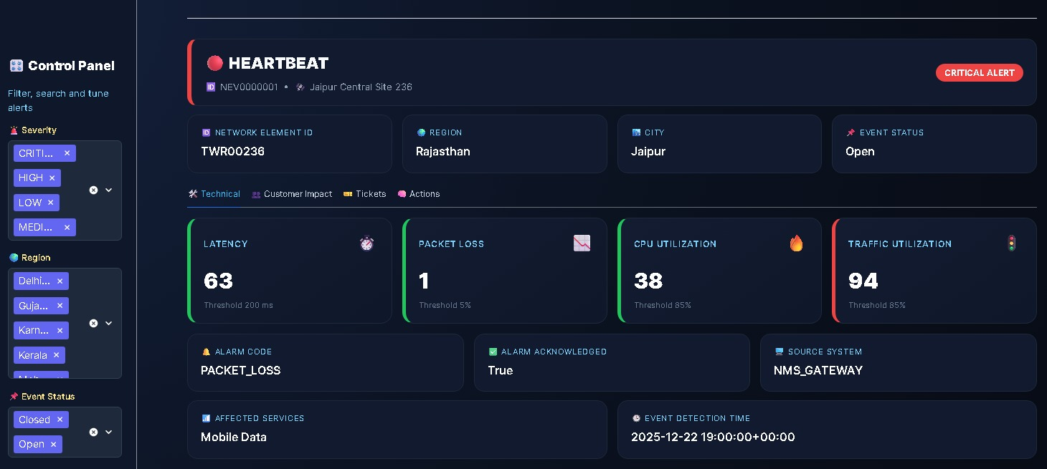
Fig. 19.2: Critical alert investigator with technical thresholds

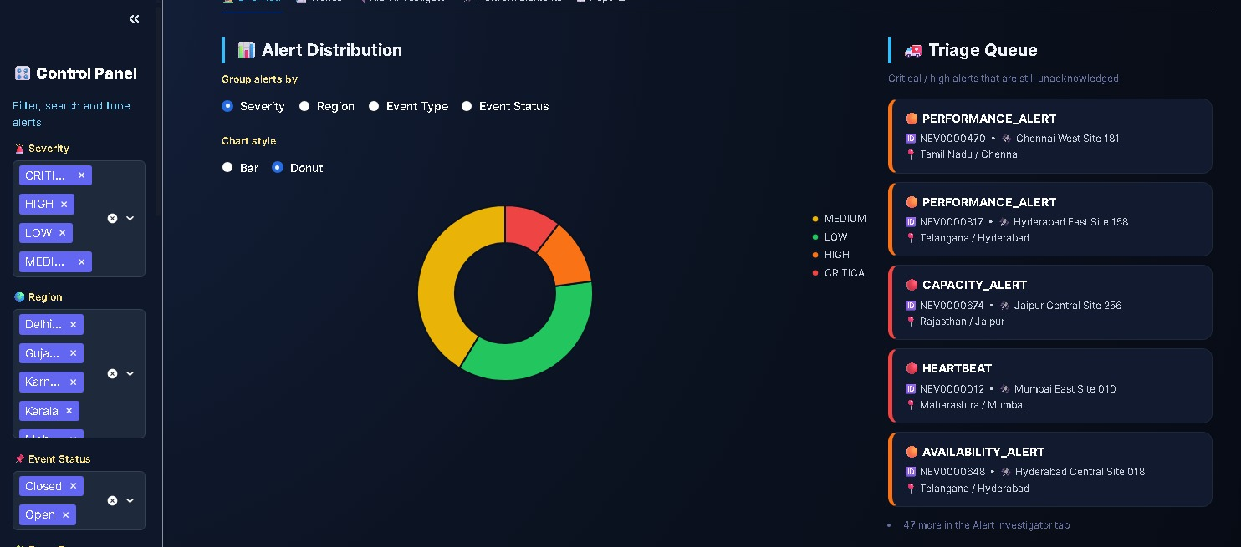
Fig. 19.3: Alert distribution donut and operational triage queue

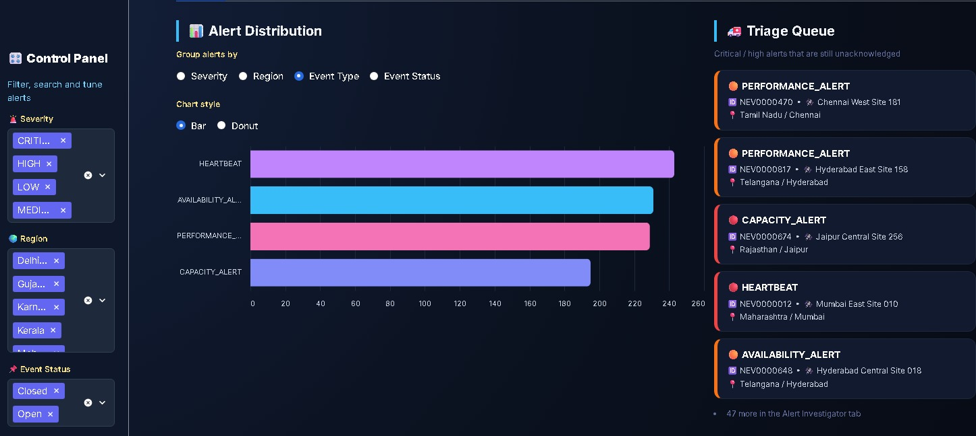
Fig. 19.4: Alert distribution bar chart and triage queue

20. Technical Flow End-to-End
The runtime sequence begins with delivery of source files to S3, continues through IDMC cleansing and routing, then loads clean files to Snowflake Bronze. Silver enforces typed structures and relationships, Gold applies dimensional logic, and Consumption presents secure outputs. The incremental path separately processes a 10-row Usage file through a Stream and stored procedure before refreshing Gold.
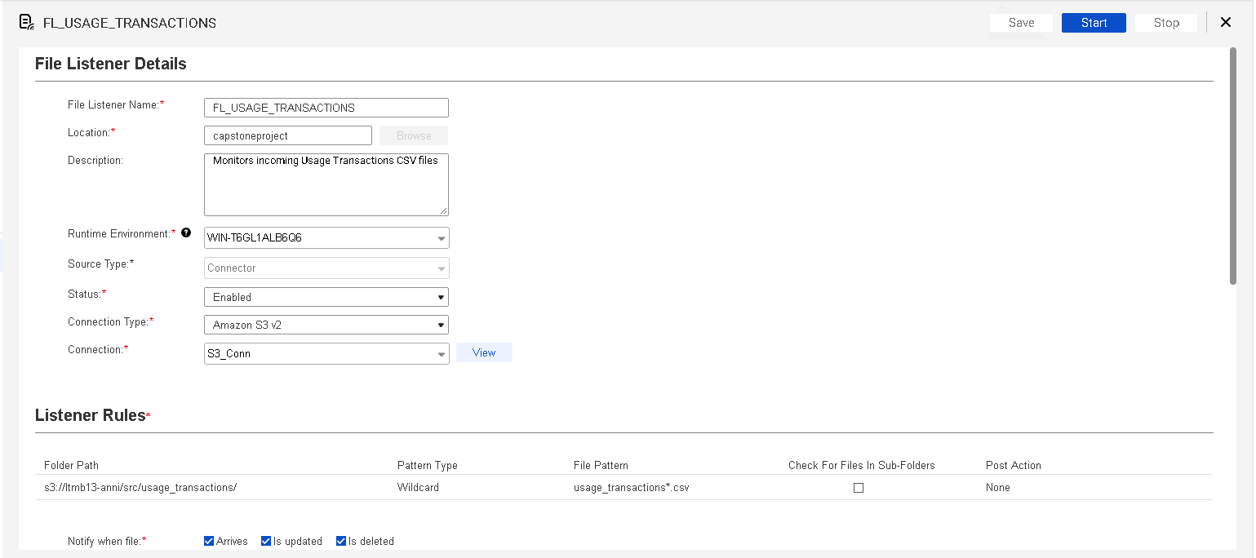
Fig. 20.1: IDMC file listener for incremental usage transactions
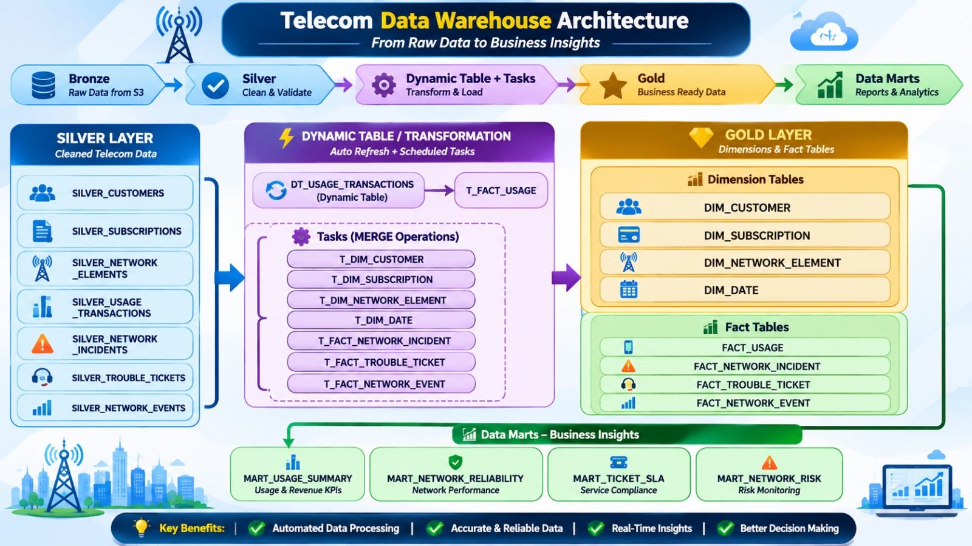
Fig. 20.2: Task and stored-procedure execution for incremental Usage processing

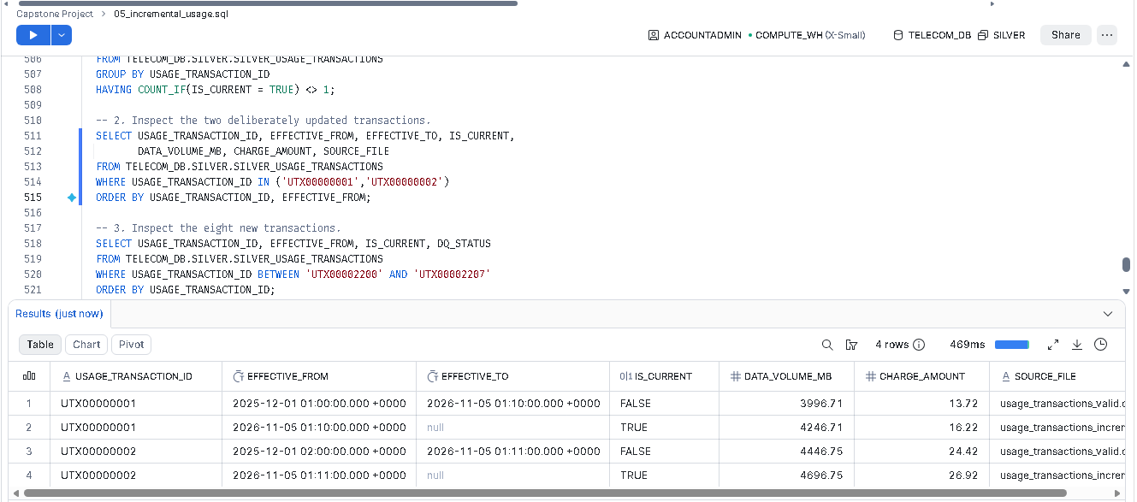
Fig. 20.3: Snowflake warehouse transformation and mart flow

21. Data Quality & Validation
Validation covers load status, source-to-layer counts, controlled data-quality signatures, duplicate keys, referential integrity, SCD Type 2 uniqueness, KPI plausibility, risk-score ranges, dashboard reconciliation, role tests and recovery. The screenshot evidence reports 325 Silver exceptions in the displayed view, largely orphan-parent checks for network elements.
Validation | Expected control
Initial reconciliation | 6,900 source rows; 6,886 accepted; 14 excluded upstream.
SCD Type 2 | Exactly one IS_CURRENT = TRUE row per usage_transaction_id.
Risk scores | Populated, explainable and bounded.
Referential integrity | No orphan Gold fact-to-dimension surrogate keys.
Replay | Unchanged replay does not add a duplicate current version.
Dashboard | Displayed totals reconcile to the underlying Gold or Consumption object for the same filter state.
Fig. 21.1: Silver data-quality exceptions with reason and source-file traceability

Fig. 21.2: Successful project execution and processed-row validation

22. Security & Governance
The security model applies least privilege through role separation, masking policies and secure views. NETWORK_ENGINEER_ROLE focuses on operational engineering access; SERVICE_ASSURANCE_ROLE consumes masked analytical outputs; TELECOM_MANAGER_ROLE receives curated visibility. Customer email, phone and address are protected by role-aware masking.
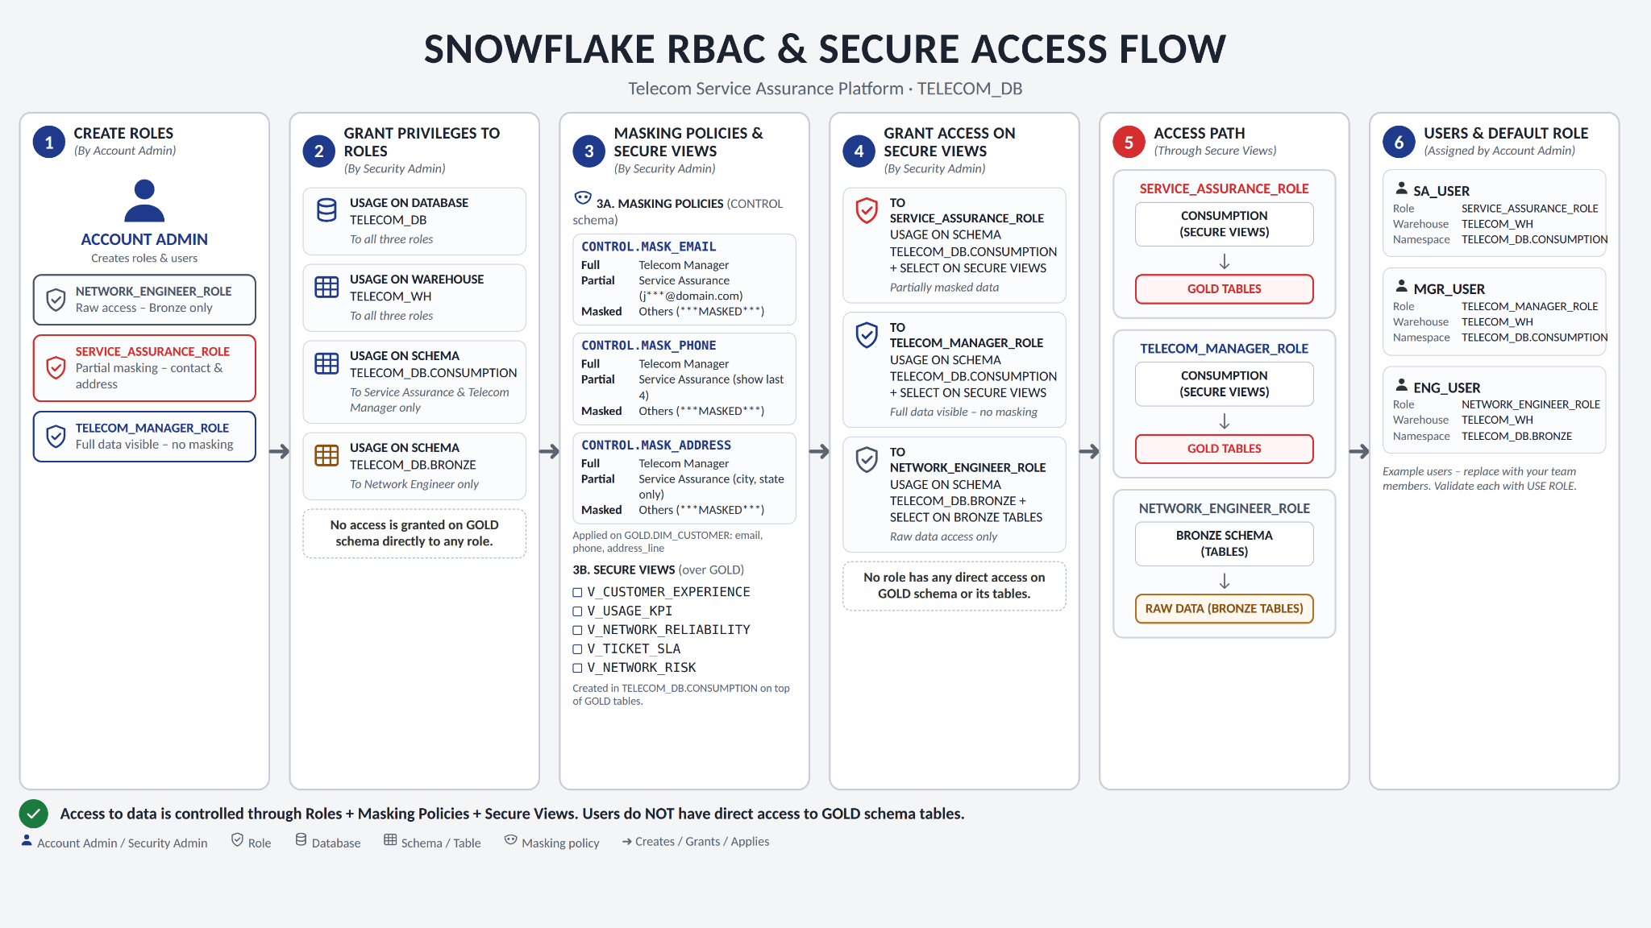
Fig. 22.1: Snowflake RBAC, masking policies, secure views and user access flow
Governance controls include source metadata, exception logging, object ownership, secure reporting boundaries, Time Travel or CLONE recovery, and explicit USE ROLE tests. A future production hardening step is to replace broad Consumption grants with object-specific grants required by each application.

23. Performance & Scalability
The project uses design choices that scale beyond the capstone volume: append-only Streams isolate changed rows, Tasks run only when a Stream contains data, MERGE avoids rebuilds, views propagate refreshed facts to marts, and calculations remain inside Snowflake. Warehouse sizing in screenshots is X-Small, suitable for the demonstrated volume but not a capacity recommendation for production.
- Use query profiles before changing warehouse size or clustering.
- Retain selective projections in secure views to reduce scanned columns.
- Schedule Tasks with SYSTEM$STREAM_HAS_DATA to prevent empty runs.
- Partition operational responsibility: Snowpark calculates risk; Streamlit only reads persisted results.
- For production, retain score history in an append-only fact rather than overwriting the latest snapshot.

24. Error Handling & Edge Cases
The stored-procedure design protects good rows from bad-row failures. TRY_TO_* functions convert parsing failures to NULL for routing. Missing keys, bad timestamps and orphan relationships are written to the exception register. Transactions ensure that COMMIT advances a successful batch, while ROLLBACK preserves the Stream offset for retry.
Edge case | Response
Same unchanged record replayed | No additional SCD version.
Existing ID with changed payload | Close old version and insert new current version.
Older incoming version | Log as stale and leave current row unchanged.
Missing parent network element | Write an ORPHAN_PARENT exception.
No qualifying critical events | Do not send an email.
Task created before manual validation | Keep suspended until the procedure has been exercised successfully.

25. Challenges & Solutions
The implementation addressed both technical and delivery constraints within a five-day sprint.
Challenge | Solution | Residual consideration
Seven heterogeneous sources | IDMC mappings with dataset-specific rules and common routing | Automate regression profiling when source contracts change.
Historical Usage corrections | Stream plus row hash and SCD Type 2 procedure | Keep one current row and validate replay continuously.
Conflicting risk thresholds | Document final 40/70 bands and preserve earlier 35/65 as history | Centralise thresholds in a configuration table.
Sensitive customer fields | Masking policies and secure views | Tighten grants to exact objects.
Operational alert overload | Filter to critical, open, unacknowledged events and enrich context | Add suppression and escalation windows.
Dashboard count differences | Treat screenshots as filter-state snapshots and reconcile to source views | Display “as of” timestamp and active filters prominently.

26. Sprint Execution & Project Management
The project was managed as a five-day sprint using a Kanban board and a burndown chart. Work moved from profiling and IDMC ingestion through Snowflake layers, incrementals, analytics, security and final demonstration. Task ownership was visible on the board, while the burndown tracked remaining work against an ideal trajectory.
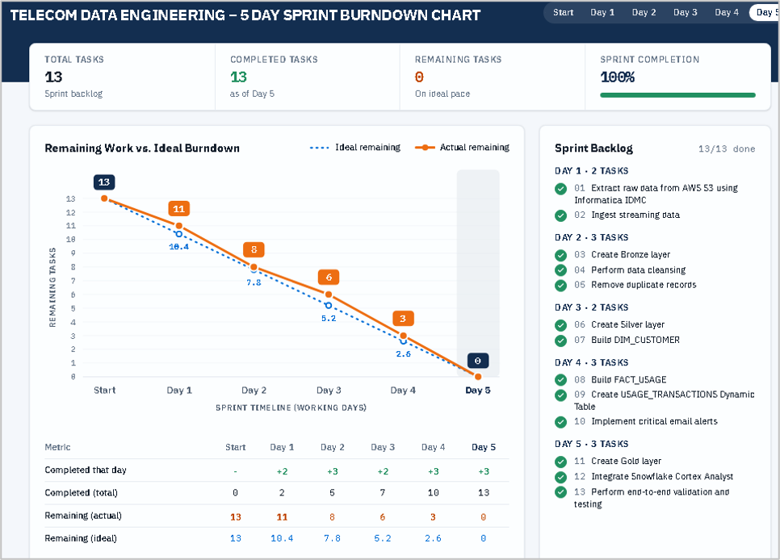
Fig. 26.1: Five-day sprint burndown with 13 of 13 tasks completed

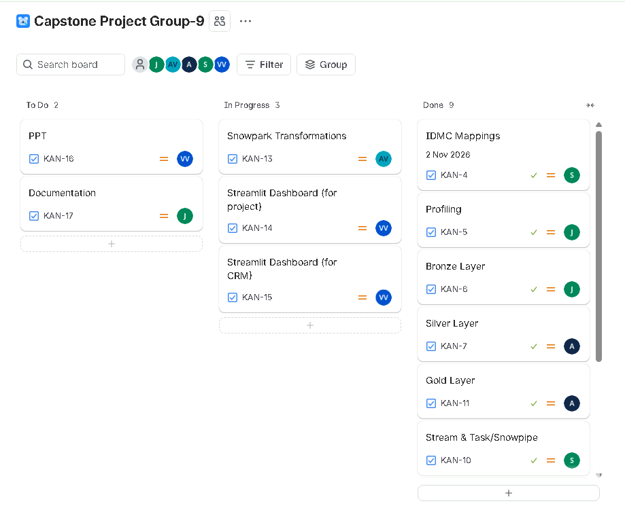
Fig. 26.2: Capstone Project Group-9 Kanban board and task status

Day | Execution focus | Progress evidence
Day 1 | Domain discovery, architecture, source profiling and mapping design | 2 tasks completed; 11 remaining.
Day 2 | Bronze creation, cleansing and duplicate handling | 3 tasks completed; 8 remaining.
Day 3 | Silver layer and initial dimensional work | 2 tasks completed; 6 remaining.
Day 4 | Gold facts, incremental processing and critical alerting | 3 tasks completed; 3 remaining.
Day 5 | Gold completion, Cortex Analyst, validation and testing | 3 tasks completed; 0 remaining; 100%.

27. Deliverables Achieved
The delivered solution exceeds the original baseline in several areas while staying within the telecom domain.
- Seven-source profiling and IDMC cleansing/routing evidence.
- Snowflake Bronze, Silver, Gold, Control, Consumption and Semantic implementation.
- Four dimensions, four facts, four core analytical marts and ten KPI views.
- Incremental Usage pipeline with Stream, Task, stored procedure, SCD Type 2 and Gold MERGE.
- Explainable Snowpark network-risk scoring.
- Main Streamlit analytics application and dedicated Telecom CRM alert dashboard.
- Six Cortex Analyst semantic views and embedded AI Telecom Analyst experience.
- RBAC, masking policies, secure views, exception handling and recovery approach.
- Native critical-event email alert workflow and execution evidence.

28. Overall Project Assessment
The project is technically coherent and demonstrable: data-quality responsibilities are separated, the warehouse model has explicit grains, incremental processing preserves history safely, risk is explainable, and consumption is governed. The strongest differentiators are the Cortex Analyst layer, native critical-event alerting and the operational CRM dashboard.

Strengths
- Clear separation between initial batch ingestion and incremental Usage processing.
- Strong traceability from source files through exceptions and Gold outputs.
- Rule-based risk is transparent and appropriate for a capstone without labelled training data.
- Operational alerting converts analytics into action rather than relying only on dashboards.

Areas for Future Iteration
- Centralise thresholds and KPI targets in governed configuration tables.
- Retain historical risk snapshots rather than replacing the latest score table.
- Automate DIM_DATE extension and production deployment pipelines.
- Tighten object grants and complete repeatable role-test automation.

Future Enhancements
- Continuous event ingestion using Snowpipe Streaming or an approved event platform.
- Alert suppression, deduplication and escalation policies.
- Historical trend analysis for risk movement and SLA recovery.
- Production monitoring for Task failures, Stream lag, query cost and dashboard freshness.
- published test results were fabricated.

