.join() function
Used to join String using separator in a List, Tuple
Ex: "#".join(myTuple)

time.time()
is used to get current time in minute and seconds
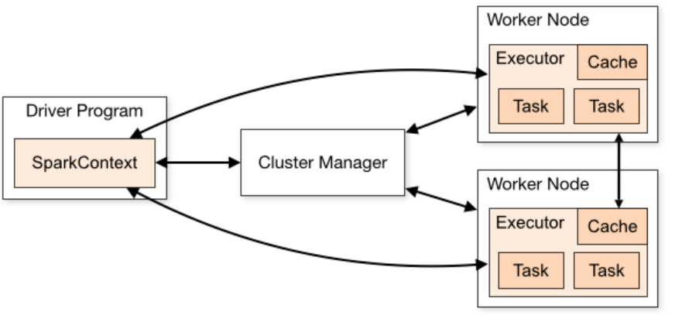
SparkConf()
• SparkConf is a class in PySpark used to set Spark application configurations programmatically before initializing the Spark session.
• It is typically passed to SparkContext or SparkSession.builder.config() to apply configurations.

.setMaster("local[*]")
• Defines where the Spark application will run.
• "local[*]" means:
- Run Spark locally using all available CPU cores (*).
- Useful for development and testing.
• Other possible values:
- "local[2]" → Run locally with 2 cores.
- "yarn" → Run on Hadoop YARN cluster.
- "spark://<host>:7077" → Run on a standalone cluster.

.set(“spark.sql.debug.maxToStringFields”,1000)
Debugging - Max Number of Fields in Output
- Controls how many fields are displayed when converting a DataFrame to a string.
- Default is 25, which truncates output when printing large DataFrames.
- Increasing it to 1000 allows more fields to be displayed.

.set("spark.executor.heartbeatInterval", 200000)
- Specifies how often (in milliseconds) executors send heartbeats to the driver.
- Helps detect lost executors.
- Default: 10s (10000ms) /Executor Heartbeat Interval
- Here, it is increased to 200s (200000ms) to prevent timeout issues in large workloads.
.set("spark.network.timeout", 300000)
- Defines the network timeout (in milliseconds) for communication between nodes.
- Default: 120s (120000ms)
- Here, it is increased to 5 minutes (300000ms) to prevent executors from timing out in case of slow network conditions.

.set("spark.sql.execution.arrow.pyspark.enabled", "true")
Enable Apache Arrow for PySpark Optimization
- Enables Apache Arrow, which optimizes data transfer between Spark and Pandas.
- Helps improve performance when using .toPandas().
- Should be enabled for faster PySpark-Pandas conversion

.set("spark.jars", jdbc_driver_path)
To Adding External JARs
- Used to specify external JAR files needed for Spark.
- Example: JDBC drivers for connecting to databases.
- jdbc_driver_path should be the full path to the JDBC JAR file.

.set("spark.ui.port", 4040)
Web UI Port Configuration
- Specifies the port for the Spark Web UI.
- Default: 4040.
- If multiple applications run simultaneously, use different ports (e.g., 4041, 4042).
. .set("spark.driver.cores", "5")
- Allocates 5 CPU cores to the Spark driver.
- Affects how many tasks the driver can handle in parallel.
- Typically useful for workloads involving heavy computations on driver (e.g., aggregations, broadcasting).

.set("spark.executor.cores", "5")
- Executor Cores
- Specifies 5 CPU cores per executor.
- More cores allow executors to process multiple tasks in parallel.
- Should be optimized based on cluster hardware.

.set("spark.driver.memory", "1G")
- Driver Memory
- Allocates 1GB of memory to the driver.
- Higher values are needed when dealing with large DataFrames.

.set("spark.executor.memory", "1G")
- Allocates 1GB of memory per executor.
- More memory prevents OutOfMemory (OOM) errors in large workloads.

.set("spark.executor.instances", "2")
- Specifies the number of executors for the application.
- If using a YARN or Standalone cluster, this defines how many executors are launched.
- More executors improve parallelism

.setAppName("PYSPARK_MSSQL")
- Sets the name of the Spark application.
- Displayed in Spark UI and YARN Resource Manager.
- "PYSPARK_MSSQL" suggests that this application is related to PySpark and Microsoft SQL Server.

spark = SparkSession.builder.config(conf=conf).getOrCreate()

•SparkSession.builder
- This is the entry point to create a SparkSession.
- It is required to work with DataFrames, SQL, and Hive tables in Spark.
• .config(conf=conf)
- This applies the configuration settings stored in the conf object (which is created using SparkConf() earlier).
- This configuration includes settings like the number of executors, memory limits, and other Spark parameters.
• .getOrCreate()
- This creates a new Spark session if one doesn’t exist.
- If a session already exists, it retrieves the existing session instead of creating a new one.
- This ensures that we don't create multiple Spark sessions in the same application.

SparkContext
A SparkContext is a connection to a Spark cluster that allows an application to access Spark's components

sc = spark.sparkContext
- Extracts the SparkContext from the SparkSession.
- The SparkContext (sc) is the core entry point for low-level RDD-based operations in Spark.
- Even though SparkSession is the new standard in Spark 2.x+, SparkContext is still used internally for job execution

sc.setLogLevel("WARN")
- Purpose: Controls how much log information is displayed in the console.
- setLogLevel("WARN") means:
  - Show only WARNING, ERROR, and FATAL messages.
  - INFO and DEBUG messages are hidden.
  - This helps reduce clutter in logs when running Spark jobs.
✔️ Final Output: Only warnings and errors are displayed in the logs, making debugging easier.

driver = "com.microsoft.sqlserver.jdbc.SQLServerDriver"
jdbc_url = "jdbc:sqlserver://{};databaseName={};integratedSecurity=true;".format(db_ip, db_name)

Where we are Stores the path to the Windows Authentication DLL. For by providing “mssql-jdbc_auth.dll"
Then we are providing auth_library_path to ensure Ensures that JVM can find the DLL for authentication.
And making sure that integratedSecurity=true; it will connect automatically instead of providing user and password in jdbc_url

main_query = f"(SELECT * FROM {table_name}) as my_table"
// we write sql queries and run
data = spark.read \
.format("jdbc") \
.option("url",jdbc_url) \
.option("driver", driver) \
.option("dbtable", main_query) \
.load()

data.show()

• spark.read: This starts a read operation in Spark.
• .format("jdbc"): Specifies that we are reading data using JDBC (Java Database Connectivity).
• "url": Specifies the JDBC connection URL for the database.
• jdbc_url: This variable contains the database connection string.
• "driver": Specifies the JDBC driver class required for the database connection.
• driver: This is a variable that stores the Java class name of the JDBC driver.
• "dbtable": This tells Spark which table or query to fetch data from.
• main_query: This contains the SQL query ("(SELECT * FROM {table_name}) as my_table").
• Loads the data into a PySpark DataFrame.
• Spark executes the JDBC query and retrieves the results in a distributed manner.

spark.hadoop.*

Allows setting Hadoop-specific configurations. Replace * with the desired property (e.g., fs.defaultFS).
Possible Values
· Any valid Hadoop configuration value, e.g., hdfs://namenode:8020.

spark.eventLog.enabled
Description
Enables or disables event logging for tracking Spark application metrics.
Possible Values
· true: Enables event logging.
· false: Disables event logging.
Setting the Logs location
.config("spark.eventLog.dir", "file:///tmp/spark-logs")

spark.sql.adaptive.enabled
Description
This configuration enables Adaptive Query Execution (AQE), a feature in Spark that dynamically optimizes query execution plans based on runtime statistics.
Possible Values
· true: Enables adaptive query execution.
· false: Disables adaptive query execution.

spark.sql.autoBroadcastJoinThreshold
Description
Configures the maximum size (in bytes) for a table to be broadcasted in a join. Broadcast join is used when one of the tables which is being used for JOINS is small. Rather than mixing up all the data from the small table to each partition, which will make the process complex, it sends the entire table to all of its partitions so that the JOINS can happen quick and easy. The threshold here refers to the size of the small tables. If the table is smaller than this threshold, it sends the entire table to all the partitions, if it exceeds the threshold then it performs the joins normally.
Possible Values
Any integer representing size in bytes, e.g., 10485760 (10MB), 52428800 (50MB).

General File Based Options

spark.sql.shuffle.partitions
Description
This configuration controls the default number of partitions that are used for shuffle operations in Spark SQL queries. Greater the number of partitions, easier the parallelism. Default value is 200, but we can increase the number of the partitions if we are working with a huge chunk of data.
Possible Values
· Any positive integer, e.g., 200, 500.

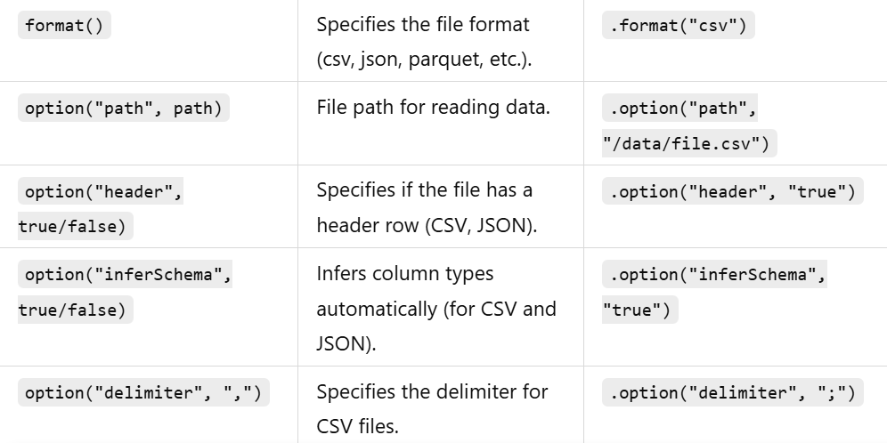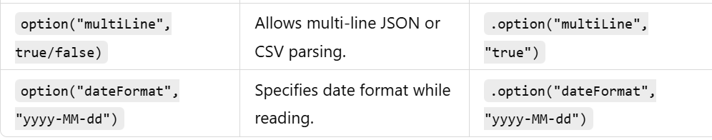

JDBC Read options
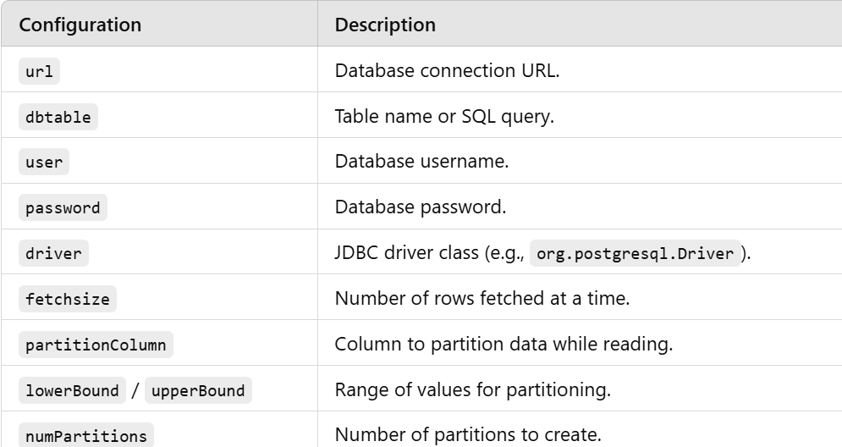

Writing Datframe Configurations
