**PROJECT:**

1. **Retrieve the book title, category, and rental price of all available books.**

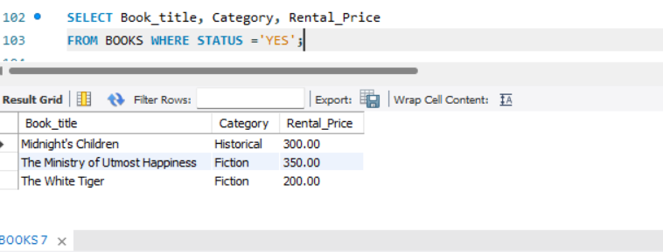

1. **List the employee names and their respective salaries in descending order of salary.**

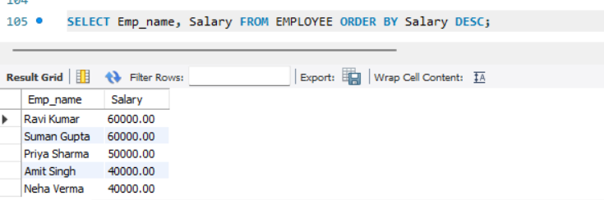

1. **Retrieve the book titles and the corresponding customers who have issued those books.**

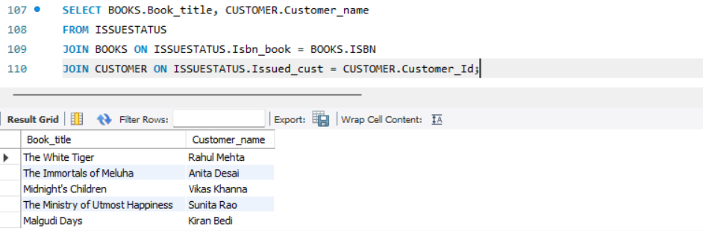

1. **Display the total count of books in each category.**

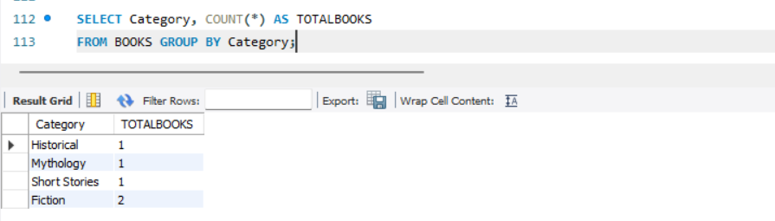

1. **Retrieve the employee names and their positions for the employees whose salaries are above Rs.50,000.**

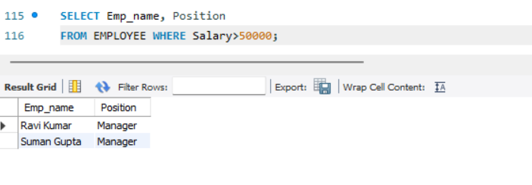

1. **List the customer names who registered before 2022-01-01 and have not issued any books ye**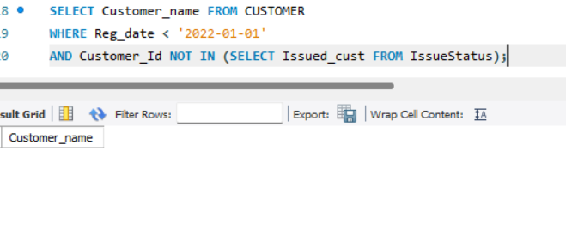
2. **Display the branch numbers and the total count of employees in each branch.**

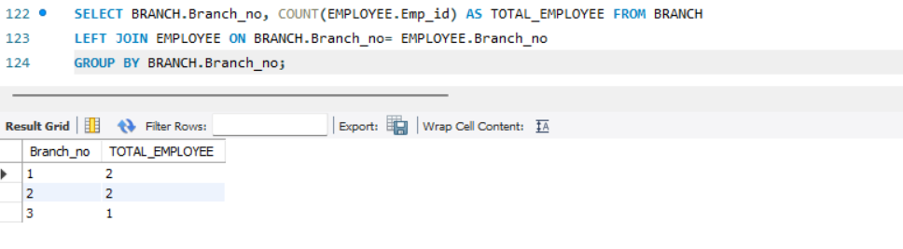

1. **Display the names of customers who have issued books in the month of June 2023.**

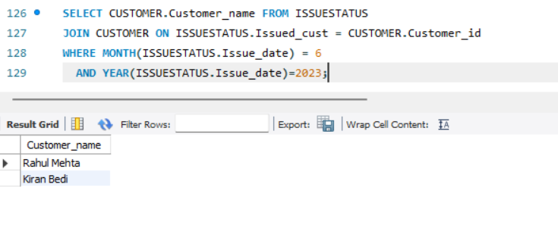

1. **Retrieve book_title from book table containing history.**

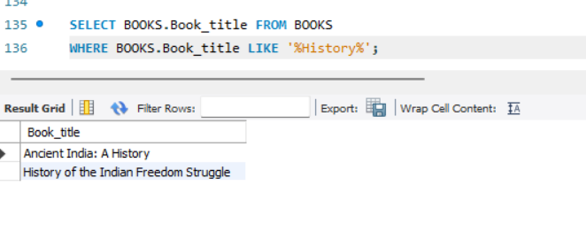

**10.Retrieve the branch numbers along with the count of employees for branches having more than 5 employees**

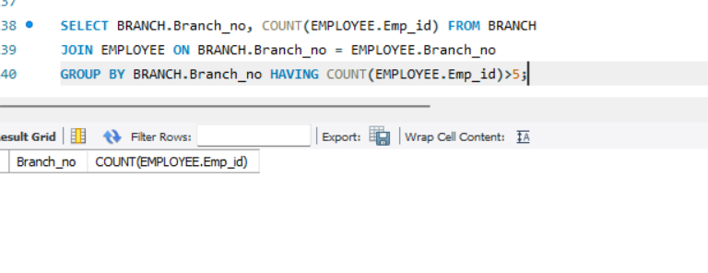

1. **Retrieve the names of employees who manage branches and their respective branch addresses.**

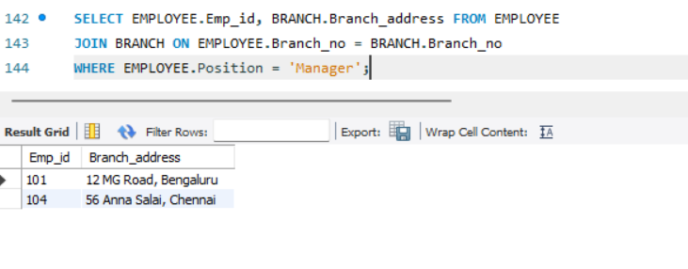

1. **Display the names of customers who have issued books with a rental price higher than Rs. 25.**

