**Business Analytics with Excel- Final Assessment**

**Project: Designing a Sales dashboard in Excel**

**Histogram:**

|  |  |
| --- | --- |
| Bins | Max of each bin |
| 0-1 | 1 |
| 2-5 | 5 |
| 5-10 | 10 |
| >10 |  |

* A histogram was created to understand the order distribution based on its aging.
* The Above bins were used to create the histogram for the Aging data available in Column D of the of the “Sales Data” sheet.
* The following parameters were used to create the histogram-

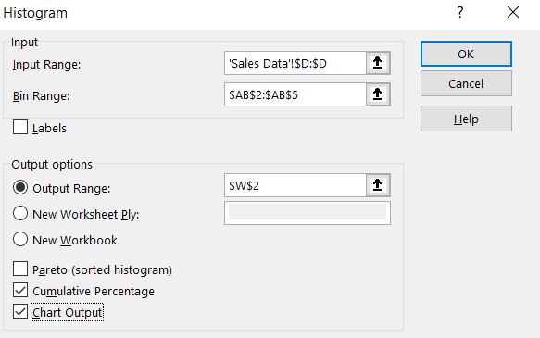

* This resulted in the below histogram-

This indicates that all the orders were delivered within a period of 10 days from the time they were placed. Among the orders, 52% were delivered within the first 5 days, while the remaining 48% were delivered within the following 5-10 days.  
  
**Month/ region based Sales and profit for different Product Categories:**

• A combo chart was created to represent different product categories

• The OFFSET function was utilized to retrieve the category name in cell T3, based on the cell link value in T2

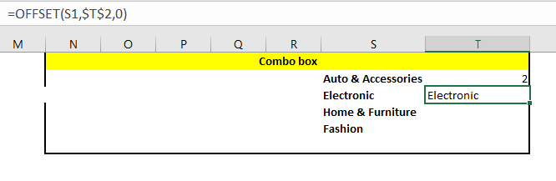

• Two tables were created, as illustrated below, which are linked to the sales data and combo chart.

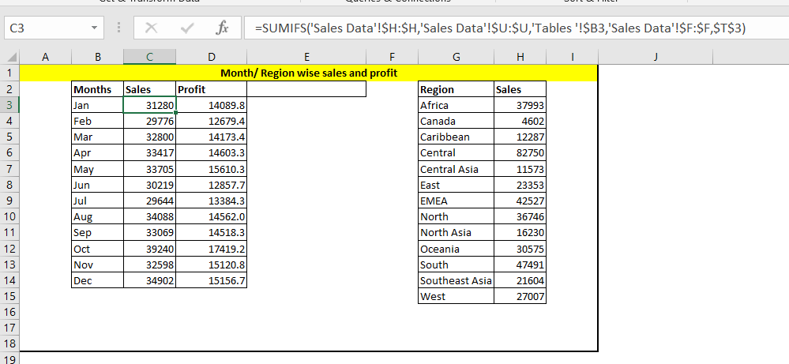

The tables were employed to construct the following dashboard. The graphs on the left-hand side dynamically adjust based on the selected product category.



