**EE49001: Control and Electronic System Design**

**Assignment-1**

Submitted By: Group-43

21EE30001: Aditya Kumar

21EE30004: Anirvan Krishna

# Representing an inductor as a block with TF of $sL$ and a capacitor as a block with TF of $\frac{1}{sC}$, obtain a block diagram representation of a series RLC circuit excited by a voltage source $v\left(t\right)$.

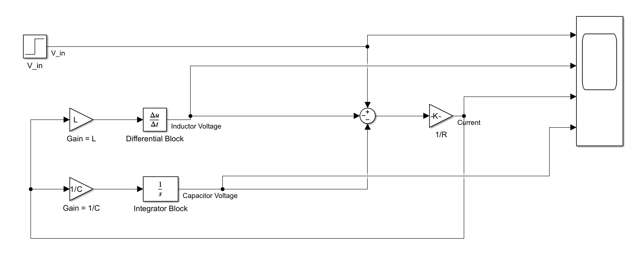

The Transfer function: $G\left(s\right)=\frac{I\left(s\right)}{V\left(s\right)}=\frac{1}{R+sL+\frac{1}{sC}}$

The same transfer function $G\left(s\right)$ can be realised in two mathematically equivalent forms.

$$G\left(s\right)=\frac{\frac{1}{R}}{1+\frac{1}{R}\left(sL+\frac{1}{sC}\right)} = \frac{\frac{1}{sL}}{1+\frac{1}{sL}\left(R+\frac{1}{sC}\right)}$$

# Using MATLAB-SIMULINK, obtain the voltage responses $v_{L}\left(t\right),$ $v_{C}\left(t\right)$ and the current $i\left(t\right)$ when $v\left(t\right)$ is the unit step input, $R = 40 Ω$, $L = 10 mH, C = 1µF$

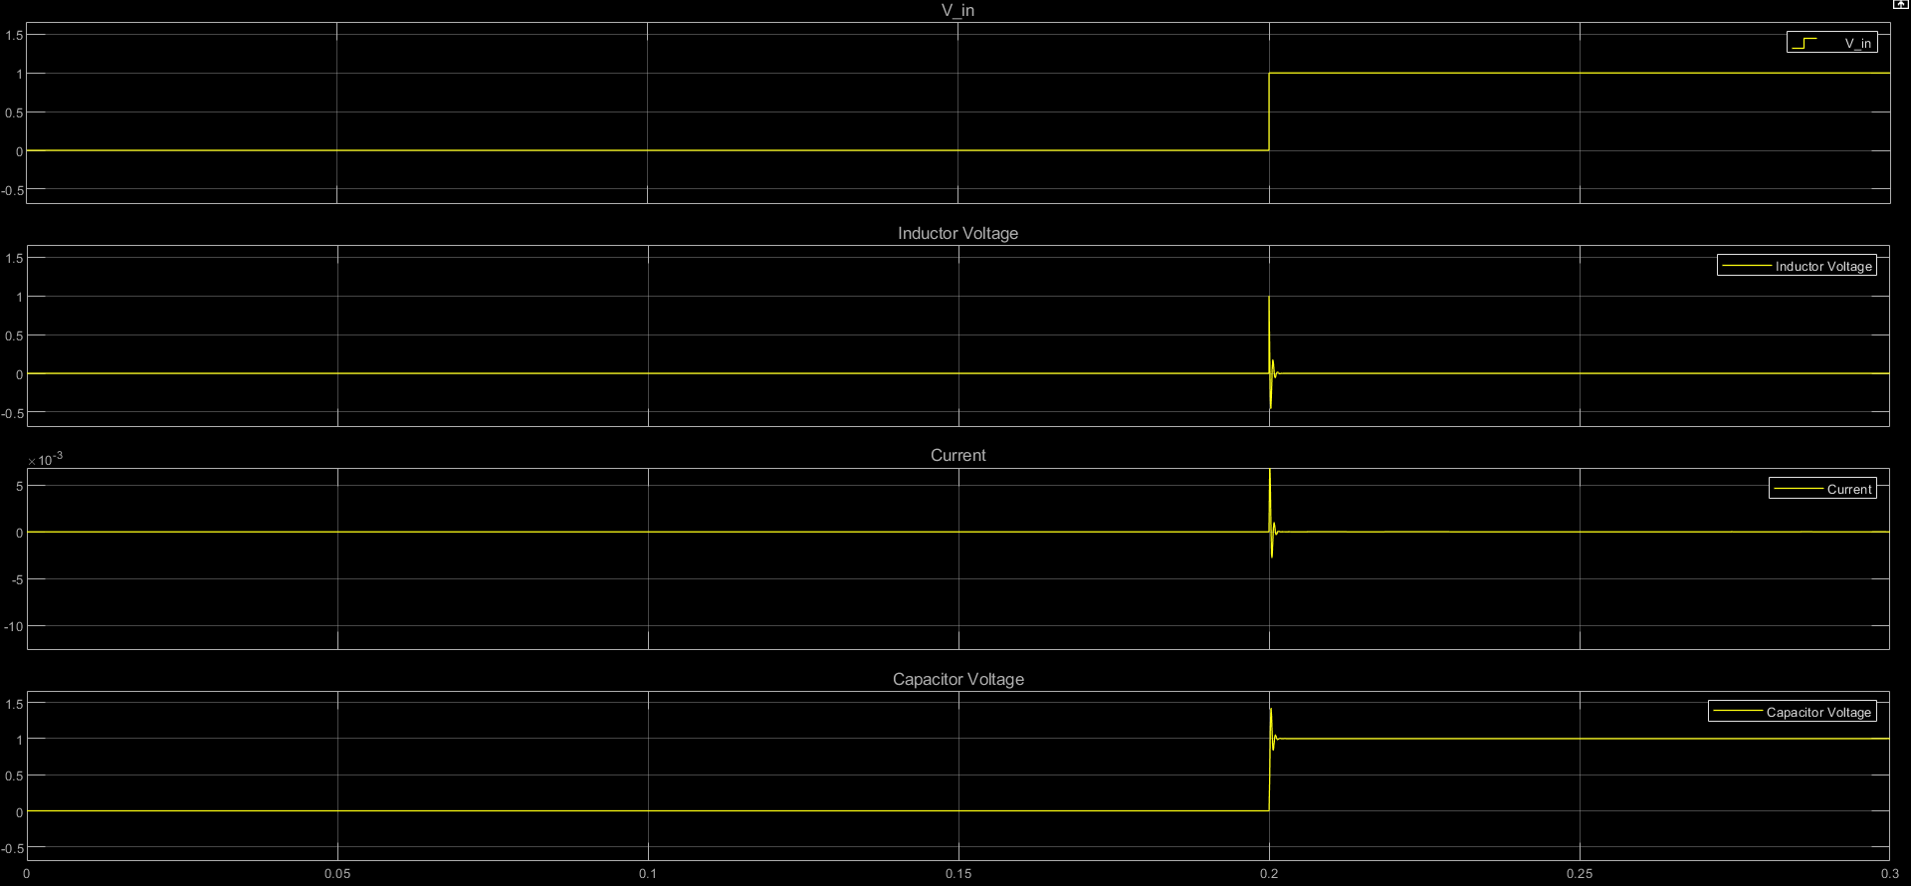

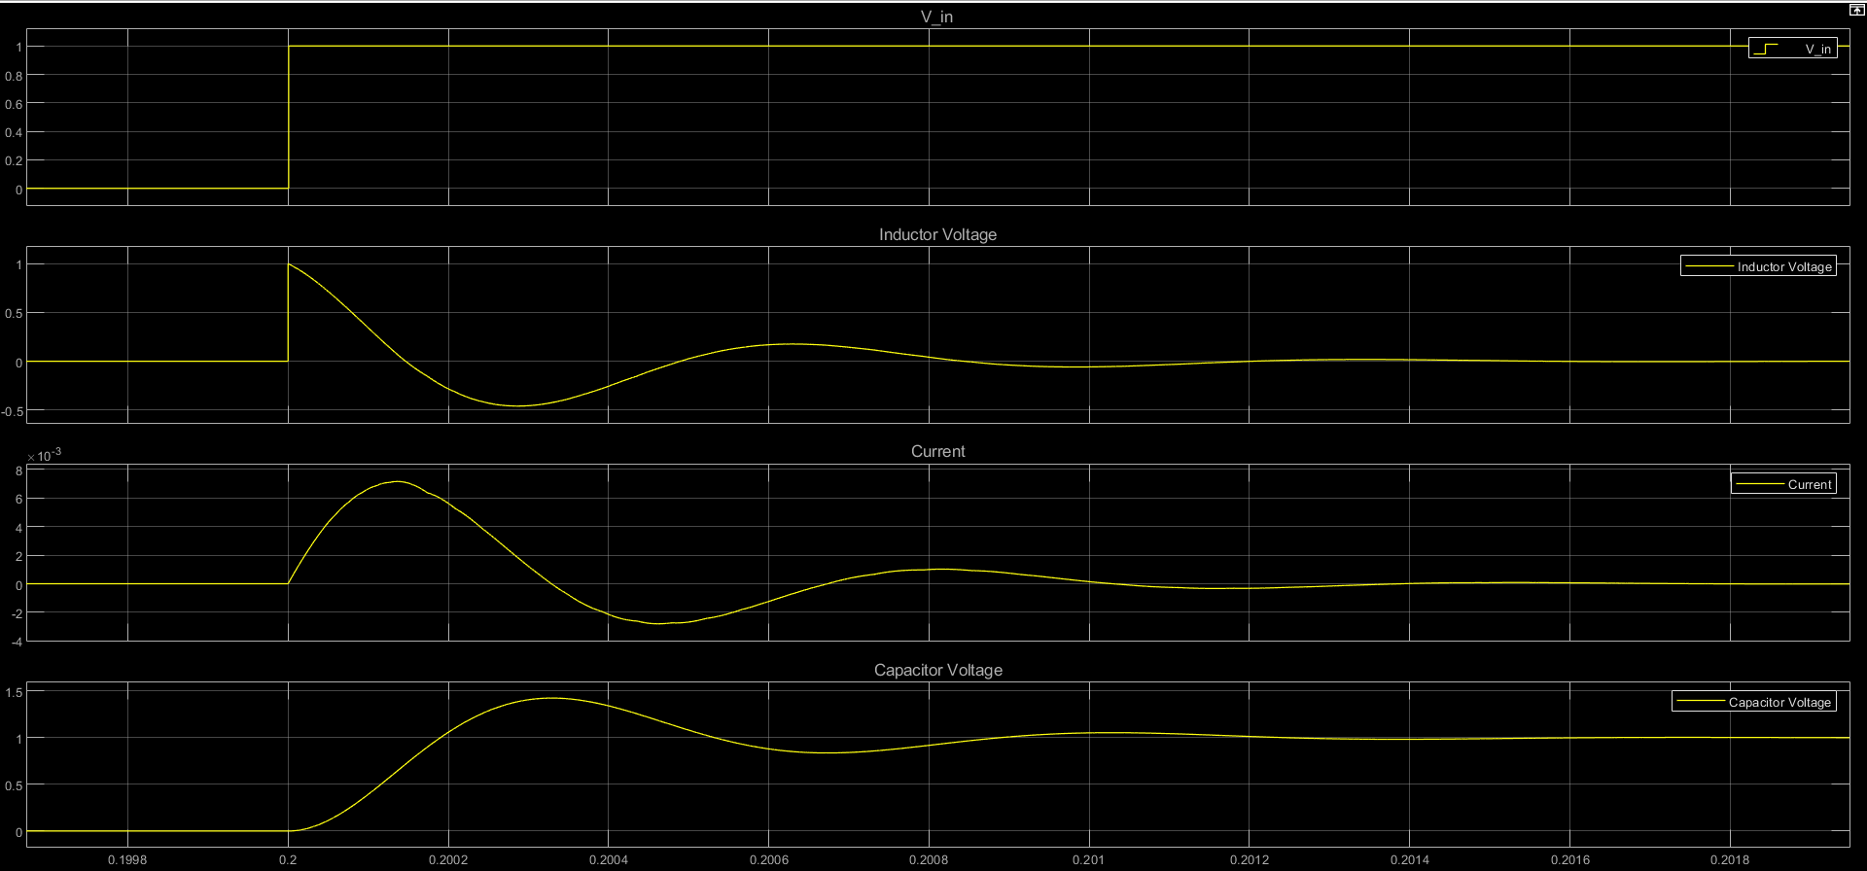

Fig: Simulink Plot for configuration-1

Here, we use the transfer function:

$$G\left(s\right)=\frac{\frac{1}{R}}{1+\frac{1}{R}\left(sL+\frac{1}{sC}\right)}$$

# Repeat the above considering the TF of inductor as $\frac{1}{sL}$ and capacitor as $\frac{1}{sC}$.

For this part of experiment, we are taking the inductor impedance as $\frac{1}{sL}$. Therefore, the transfer function $G\left(s\right)=\frac{I\left(s\right)}{V\left(s\right)}$ is given by:

$$G\left(s\right)=\frac{\frac{1}{sL}}{1+\frac{1}{sL}\left(R+\frac{1}{sC}\right)}$$

For the given conditions, the MATLAB-Simulink Block Diagram is given as:

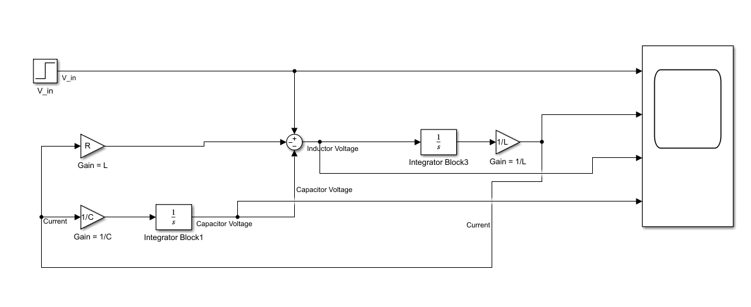

Fig. MATLAB-Simulink Block Diagram

On execution, we get the following waveform for $i\left(t\right),V_{L}\left(t\right) \&$ $V_{C}\left(t\right)$

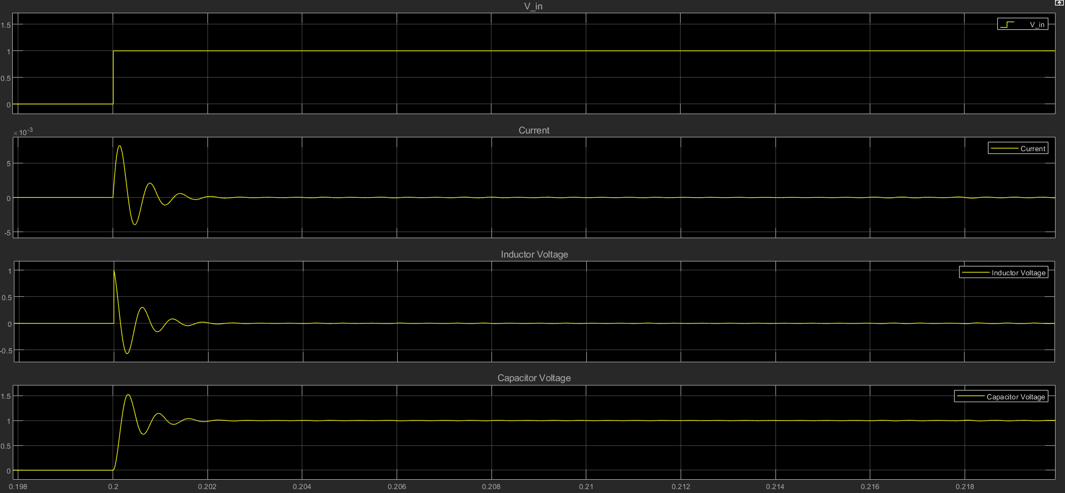

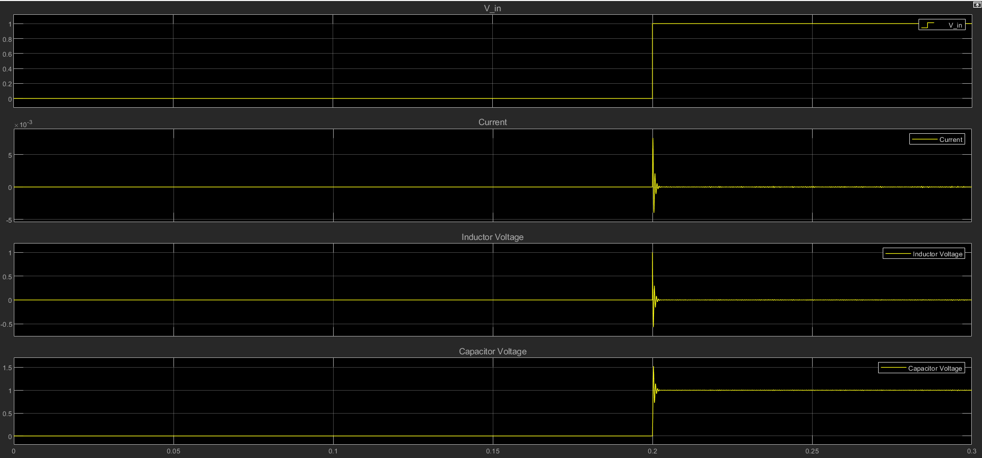

Fig. Plots for configuration-2

# Are the responses obtained in (1) and (2) identical? If not, explain the reason behind the difference and explain which of the above representations is more appropriate.

|  |  |  |
| --- | --- | --- |
|  | Response in Configuration-1 | Response in Configuration-2 |
| $$i\left(t\right)$$ | Jump of 0.025 A at t=0, past t=0, a damped oscillation | Continuous at t=0 and then damped oscillation |
| $$V_{L}$$ | At t=0, $V_{L}=0$ and at $t=0^{+},V_{L} is a decreasing function$ | Jump of 1 V at t=0 and later a damped oscillation |
| $$V_{c}$$ | %overshoot is > 100% $$V_{c,peak}>2V_{c}\left(∞\right)$$ | %overshoot is around 50% $$V_{C,peak}≈1.5V_{C}$$ |

Both the configurations show different behaviour, as $sL$ is an improper transfer function, non-causal and hence, physically unrealizable. This is because, it involves a derivative. Since, the computation of derivatives needs information about the future. Also, derivative amplifies noise and distorts the output at input discontinuities. But this effect is removed in case of $\frac{1}{sL}$ as it’s a proper transfer function and hence, more appropriate.