**EE49001: Control and Electronic System Design**

Assignment-10: Effect of Disturbance

Submitted By:

21EE30004: Anirvan Krishna | 21EE30001: Aditya Kumar

# System Without Disturbance

$$x\left(t+1\right)=\left(\begin{matrix}1.5 & 0 \\ 1 & -1.5\end{matrix}\right) x\left(t\right) +\left(\begin{matrix}1 \\ 0\end{matrix}\right) u\left(t\right)$$

Considering a system:

$$x\left(t+1\right)=Ax\left(t\right)+Bu\left(t\right)$$

We have:

|  |  |
| --- | --- |
| $$A = \left(\begin{matrix}1.5 & 0 \\ 1 & -1.5\end{matrix}\right)$$ | $$B =\left(\begin{matrix}1 \\ 0\end{matrix}\right)$$ |

## Open Loop Stability:

Eigen values of the matrix $A=\{-1.5,1.5\}$. Since, one eigen value of matrix $A$. Therefore, the system is open loop unstable.

## System Controllability:

For system controllability, the rank of the controllability matrix must be equal to $n$. Controllability Matrix, $C$ is defined as:

$$C=\left[\begin{matrix}B & AB & A^{2}B & … & A^{n-1}B\end{matrix}\right]$$

Where: $n$ denotes the size of the state-space. Here, $n=2$

$$C=\left[\begin{matrix}B & AB\end{matrix}\right]$$

Controllability Matrix (calculated using MATLAB):

$$C = \left(\begin{matrix}1 & 1.5 \\ 0 & 0\end{matrix}\right)$$

Rank of the matrix $=$ $1$. Therefore, system is uncontrollable.

## Determination of ${\left(x\left(t\right)\right)}_{0}^{T}$ for $T = 10$ for different initialization

For determining the values of ${\left(x\left(t\right)\right)}_{0}^{T}$ using values of $x\left(0\right)$ and $u(0)$ can be done by running the following MATLAB script. We take different initializations for $x(0)$ and $u\left(t\right)$ based on the allowable range. The script runs for various initializations of $x\left(0\right)$ and different values $u\left(t\right)$ at different time steps and display the results which satisfy the constraint:

$$\left(\begin{matrix}-10 \\ -10\end{matrix}\right)≤\left(\begin{matrix}x_{1}\left(t\right) \\ x_{2}\left(t\right)\end{matrix}\right)≤\left(\begin{matrix}+10 \\ +10\end{matrix}\right)$$

**MATLAB**

|  |
| --- |
| % Define time horizon  T = 10;  % Define state and input constraints  x_min = -10;  x_max = 10;  u_min = -5;  u_max = 5;  satisfying_combinations = [];  % Iterate through all combinations of x0 and u  for x0_1 = x_min:x_max  for x0_2 = x_min:x_max  for u = u_min:u_max  % Initialize x  x = zeros(2, T+1);  x(:,1) = [x0_1; x0_2];    % Iterate to compute x(t) for t = 1 to T  for t = 1:T  x(:,t+1) = A*x(:,t) + B*u;  end    % Check if condition is satisfied for all time steps  if all(x(:) >= -10) && all(x(:) <= 10)  satisfying_combinations = [satisfying_combinations; [x0_1, x0_2, u]];  end  end  end  end  % Display satisfying combinations  disp('Combinations satisfying the condition:');  disp(satisfying_combinations); |

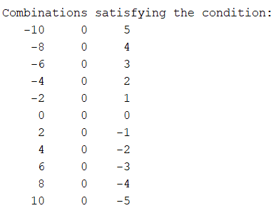

**Fig.** Output format $\left(x_{1}\left(0\right),x_{2}\left(0\right),u\right)$