**EE49001: Control and Electronic System Design**

Assignment-2: Inverted Pendulum, Part:1

Submitted By:

21EE30004: Anirvan Krishna | 21EE30001: Aditya Kumar

# A pendulum consisting of a mass-less rod of length $l = 0.36m$ and a bob of mass $m = 0.26kg$ is attached to a cart of mass $M = 2.4kg$ moving on a rail. Let the position of the cart on the rail be denoted by $x$ and the angle of the rod with respect to the upward vertical by $θ$. The cart is propelled by a horizontal force of $u$ along the rail.

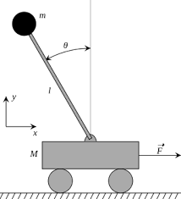

Fig: Diagram for Inverted Pendulum Setup

For the following system, we have 4 states: $z=\left[x,\dot{x},θ,\dot{θ}\right]$, where:

$\dot{x}=v ≡$ Translational velocity of the cart along $x-$ direction

$\dot{θ}=ω$ Angular velocity of the rod, $F = u ≡$ Horizontal force on the cart

## Represent the nonlinear dynamics of the plant in the form $\dot{z}=f\left(z,u\right)$ where $z$ denotes the states and $u$ denotes the input

We can, using Newton’s Laws of Motion, say that:

$$\dot{x}=v$$

$$\dot{θ}=$$

$$\left(m+M\right)\ddot{x}+ml\ddot{θ}\cos{θ}-ml{\dot{θ}}^{2}\sin{θ}=u$$

$$ml^{2}\ddot{θ}=mglsinθ-ml\ddot{x}cos$$

Considering the state space, $z=\left[ \begin{matrix}x \\ v \\ θ \\ ω\end{matrix} \right]$

$$\dot{x}=f_{1}=v$$

$$\dot{v}=f_{2}=\frac{u+mlω^{2}\sin{θ}-mg\sin{θ}\cos{θ}}{m\sin^{2}{θ}+M}$$

$$\dot{θ}=f_{3}= ω$$

$$\dot{ω}=f_{4}=\frac{g\left(m+M\right)\sin{θ}-u\cos{θ}-mlω^{2}\sin{θ}\cos{θ}}{\left(m\sin^{2}{θ}+M\right)l}$$

## Determine the equilibrium points of the above dynamical system.

The system is at equilibrium, means $\sum{{\vec{F}}_{system}}=0$ and $\sum{{\vec{τ}}_{system}}=0$. It means, $\ddot{x}=\ddot{θ}=0$. Putting these values in the non-linear dynamics’ equations, we get: $θ∈\{0,π\}$. For equilibrium we have $\dot{z}=0$. That is: $\dot{x}=\ddot{x}=\dot{θ}=\ddot{θ}=0$.

## Linearize the above nonlinear dynamics around the unstable equilibrium point which has $θ = 0$, and obtain the linearized dynamics of the form: $\dot{z}=Az+Bu$ for suitable matrices $A$ and $B.$ Determine the dimensions of $A$ and $B$.

For Linearization of the given state equations in the neighbourhood of $θ= 0$ i.e. $θ= Δθ$ where $Δθ→0 °$, we can assume the small angle approximations to be valid. Therefore, we have $sinθ≈ θ$ and $cosθ≈ 1$.

Hence, we can write:

$$ml^{2}\ddot{θ}=mgl θ-ml\ddot{x}$$

$$\left(m+M\right)\ddot{x}+ml\ddot{θ}=u$$

For small $θ$, assuming ${\dot{θ}}^{2}≈0$

These are the linearized dynamics equations in the neighbourhood of $θ= 0°$

The 4 nonlinear equations can be linearised in the form $\dot{z}=Az+Bu$, where the matrices are defined as follows:

$$\left[A_{ij}\right]={\left[\frac{∂f_{i}}{∂z_{j}}\right]}_{z_{0}} \text{and}\left[B_{i}\right]={\left[\frac{∂f_{i}}{∂u}\right]}_{z_{0}}$$

$z_{0}$ is the unstable equilibrium point, $z_{0}=0$

Dimensionally, $A ≡4×4$ and $B ≡4×1$

$z_{0}$ is the unstable equilibrium point $z_{0}=0$

$$A=\left[\begin{matrix}0 & 1 & 0 & 0 \\ 0 & 0 & -\frac{mg}{M} & 0 \\ 0 & 0 & 0 & 1 \\ 0 & 0 & \frac{\left(m+M\right)g}{Ml} & 0\end{matrix}\right]\text{\backslash \backslash and }B=\left[\begin{matrix}0 \\ \frac{1}{M} \\ 0 \\ -\frac{1}{Ml}\end{matrix}\right]$$

## Obtain the transfer functions $\frac{Θ\left(s\right)}{U\left(s\right)}$ and $\frac{X\left(s\right)}{U\left(s\right)}$ assuming θ to be close to zero.

Taking Laplace Transform we get

$$\left(m+M\right)s^{2}X+mls^{2}Θ=U\backslash {bigmmls}^{2}Θ-mgΘ+ms^{2}X=0$$

Where,

$$X=X\left(s\right)=L\left\{x\left(t\right)\right\}║1Θ=Θ\left(s\right)=L\left\{θ\left(t\right)\right\}\backslash bigmU=U\left(s\right)=L\left\{u\left(t\right)\right\}$$

On solving and simplifying we get,

$$\frac{X\left(s\right)}{U\left(s\right)}=\frac{\frac{1}{M}\left(s^{2}-\frac{g}{l}\right)}{s^{2}\left(s^{2}-\frac{\left(M+m\right)g}{Ml}\right)}$$

$$\frac{Θ\left(s\right)}{U\left(s\right)}=-\frac{\frac{1}{Ml}}{s^{2}-\frac{\left(M+m\right)g}{Ml}}$$

Numerical Values of transfer function:

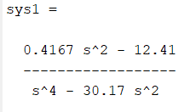 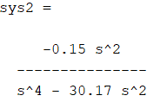

Fig: Transfer function $\frac{X\left(s\right)}{U\left(s\right)}$ Fig: Transfer function $\frac{Θ\left(s\right)}{U\left(s\right)}$

## The pendulum is to be balanced in the inverted position with the cart being within the rail by applying a suitable $u$. Explain if the pendulum can be balanced using only $θ$ or only $x$ feedback. In other words, determine if the system is controllable when the input u is equal to either $θ$ or $x$.

For $G\left(s\right)=\frac{Θ\left(s\right)}{U\left(s\right)}$: There is a pole-zero cancellation for the pole at $s=0$

$H\left(s\right)=\frac{X\left(s\right)}{U\left(s\right)}$: Though, theoretically, there is no pole-zero cancellation, but pole and zero are very close. Therefore, for all practical purposes, pole-zero cancellation can be considered for the system.

Though it is theoretically possible to control the system by only providing feedback of $x$, it is not practically possible.

Hence, the system is not controllable by providing feedback of only $θ$ or $x$

# Create a model of the nonlinear dynamical system in SIMULINK

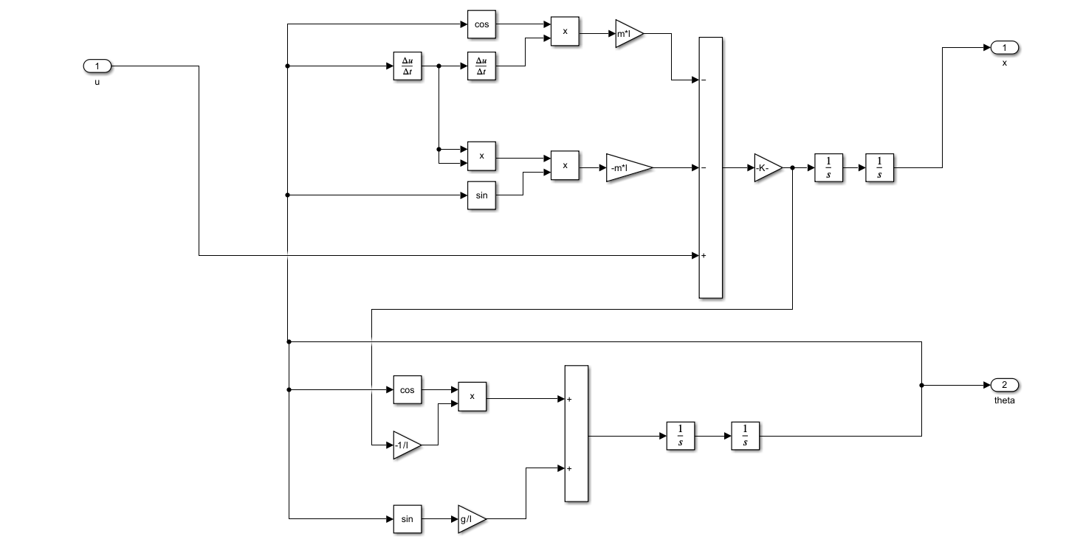

# Create a model of the linearized system in SIMULINK.

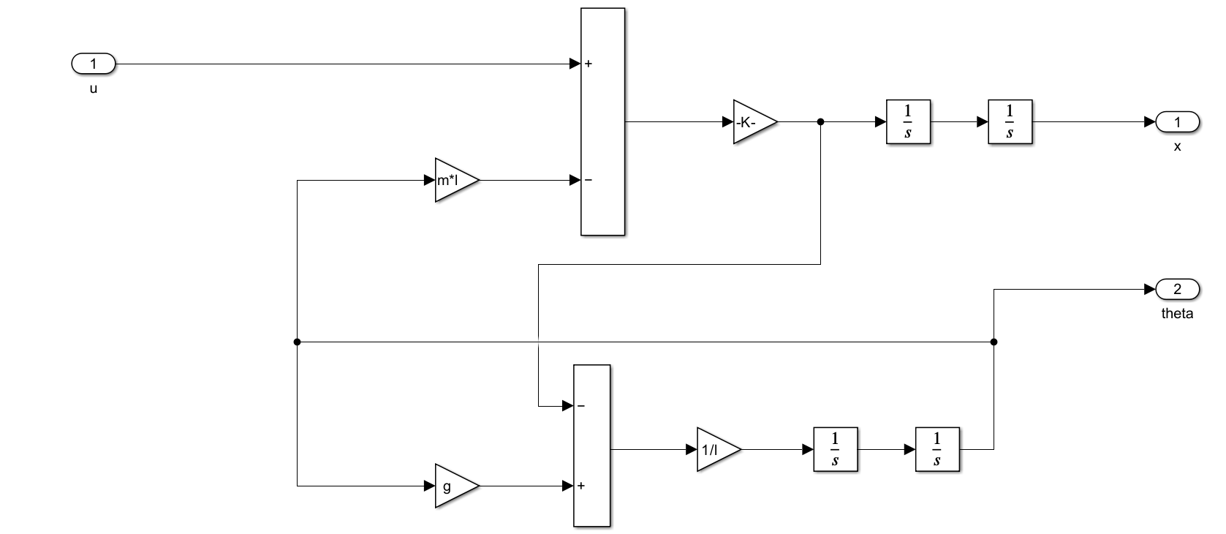

# Plots for $x$ and $θ$

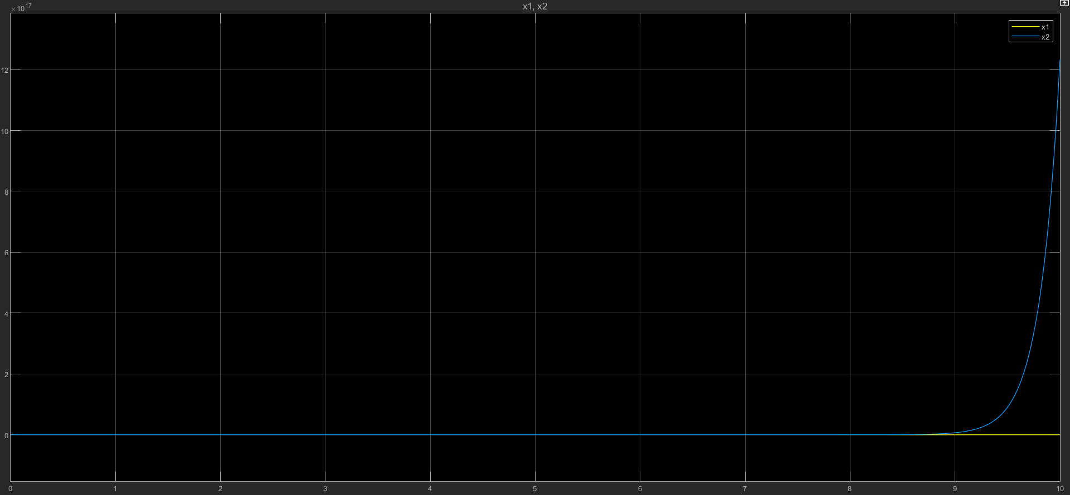

Fig. Comparison between $x_{1}$ (non-linear) and $x_{2}$ (linear)

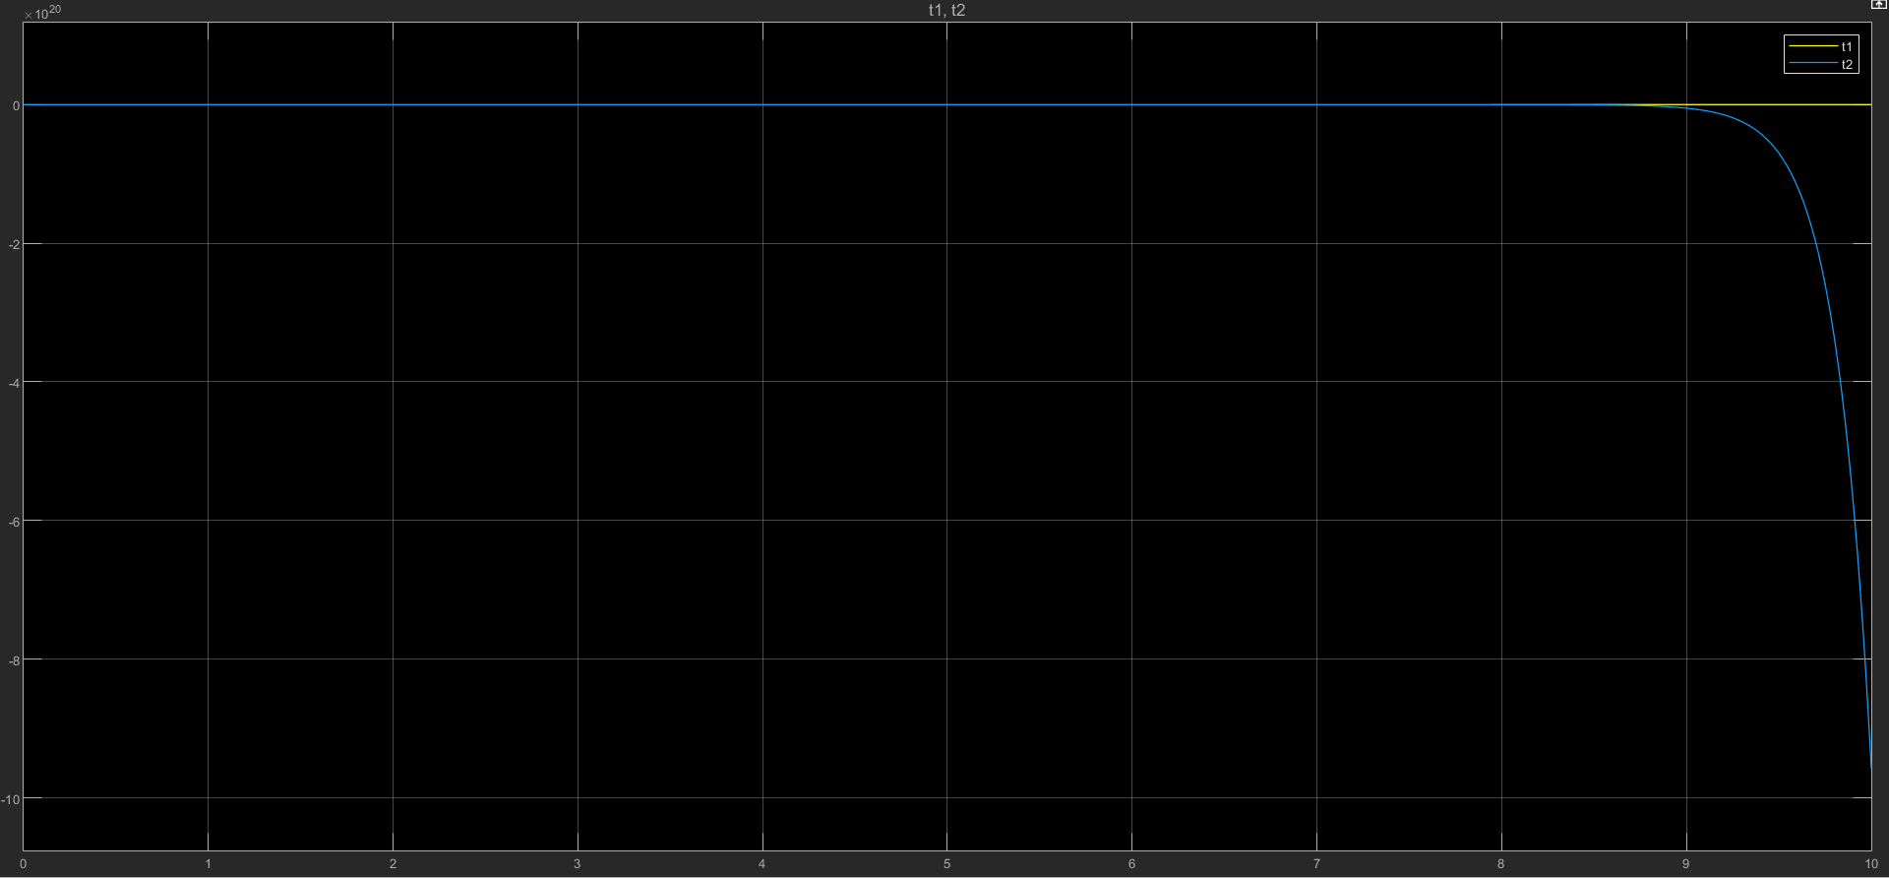

Fig. Comparison between $θ_{1}$ (non-linear) and $θ_{2}$ (linear)