**EE49001: Control and Electronic System Design**

Assignment-3: Lead-Lag Compensator Design

Submitted By:

21EE30004: Anirvan Krishna | 21EE30001: Aditya Kumar

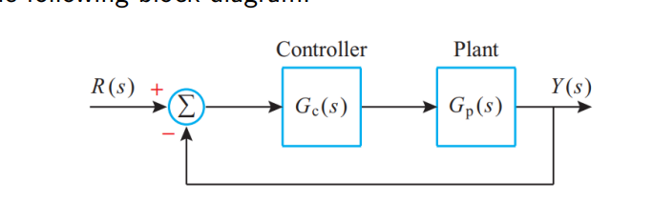

In the above block diagram,

$$G_{p}=\frac{10}{s\left(s+10\right)}$$

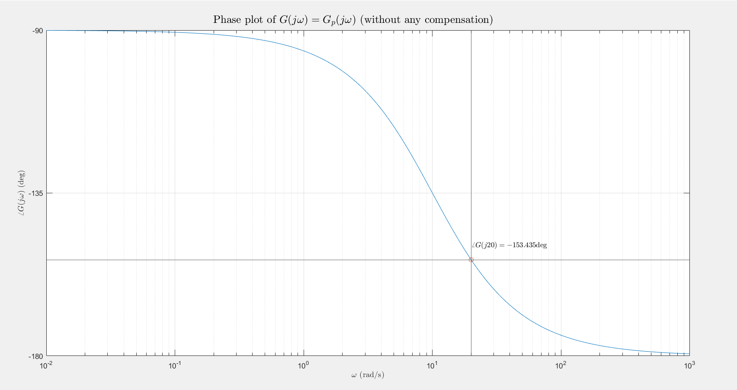

# Design of Lead Compensator

For a lead compensator the controller is assumed to be of form

$$G_{c1}=\frac{K\left(Ts+1\right)}{βTs+1}$$

Where, $K>0, T>0 \text{and} 0<β<1$

$$ω_{c}=0.995 \text{rad/s}$$

From the above plot it can be observed that, uncompensated phase margin is $PM_{u}=∠G\left(j20\right)+180°=26.565°$

Therefore, the controller parameters are

|  |  |  |
| --- | --- | --- |
| $$ϕ_{m}=PM-PM_{u} \\ =33.435°$$ | $$β=\frac{1-\sin{ϕ_{m}}}{1+\sin{ϕ_{m}}} \\ ≈0.2895$$ | $$T=\frac{1}{ω_{c}\sqrt{β}} \\ ≈0.093$$ |

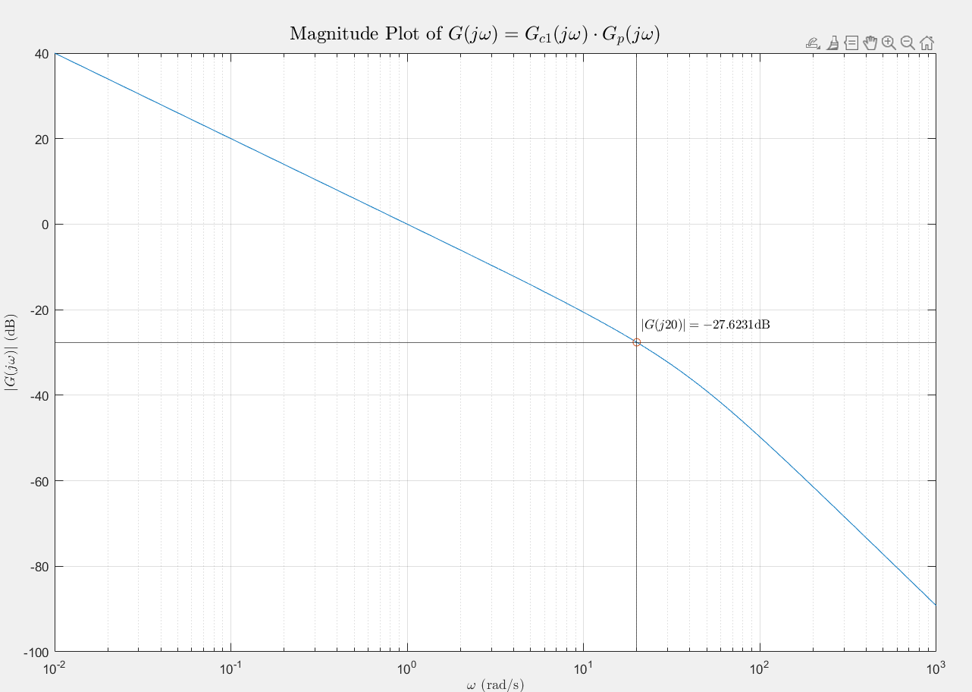

From the graph it can be observed that $20\log\left|G_{c1}⋅G_{p}\left(j20\right)\right|=-27.6231\text{dB}$. Hence to make $\left|G_{c1}⋅G_{p}\left(j20\right)\right|=1$, the magnitude plot needs to be brought up by $27.6231\text{dB}$. Therefore, our required DC gain is

|  |
| --- |
| $$K={10}^{\frac{27.6231}{20}}≈24.0522$$ |

# Design of Lag Compensator

For a lag compensator the controlled is assumed to be of form

$$G_{c2}=\frac{α\left(T_{1}s+1\right)}{αT_{1}s+1}$$

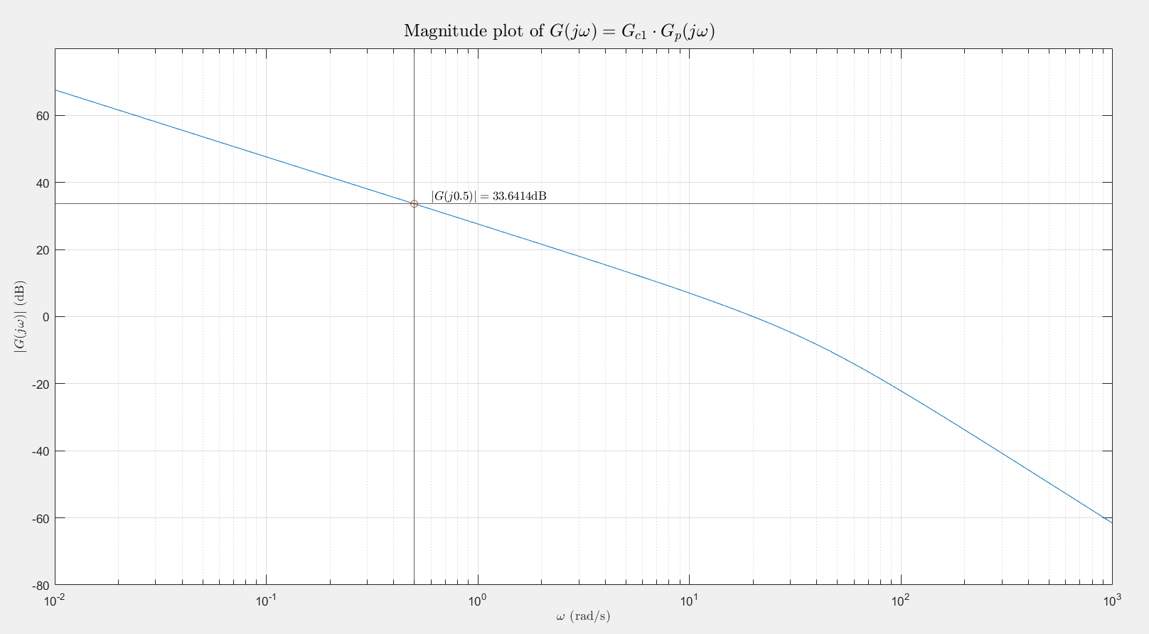

Where, $T_{1}>0, α>1$

Here,

|  |
| --- |
| $$T_{1}=\frac{7}{ω_{c}}≈0.35$$ |

And from the above plot is observed that $20\log\left|G_{c1}⋅G_{p}\left(j0.5\right)\right|=33.6414$. Therefore,

Thus, the controller parameters are

|  |  |
| --- | --- |
|  |  |

# Verification

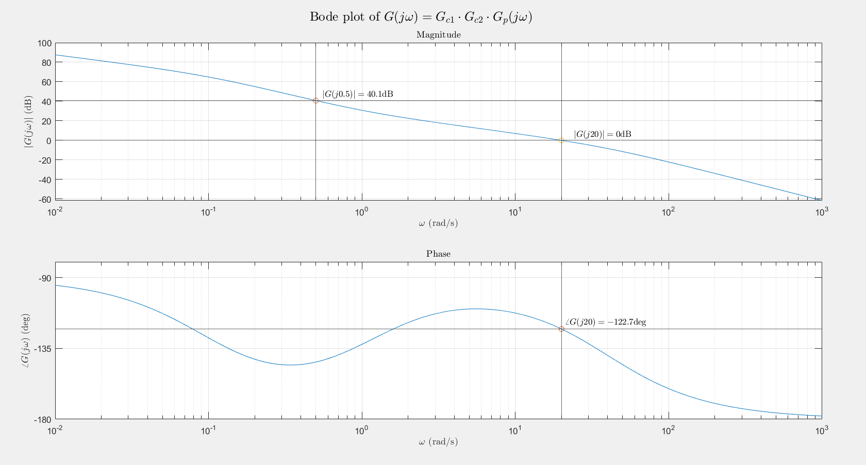

The compensated system is $G\left(s\right)=G_{c1}⋅G_{c2}⋅G_{p}(s)$ and from the above plot it can observed that the gain crossover frequency is $20\text{rad/s}$ and the corresponding phase margin is $∠G\left(j20\right)+180=57.3\text{deg}$. Also loop gain at $ω∈\left[0,0.5\right]≥100 (40\text{dB})$ as $\left|G\left(jω\right)\right|$ is decreasing in the lower frequencies and $20\log{|G\left(j0.5\right)|}=40.1\text{dB}$.

Thus, the desired specifications are met.