EE49001: Control and Electronic System Design Assignment-5

Submitted By:

21EE30004: Anirvan Krishna | 21EE30001: Aditya Kumar

# SECTION - I

Networked Control Systems (NCSs):-

1. Consider an NCS whose plant is a discrete- me linear system

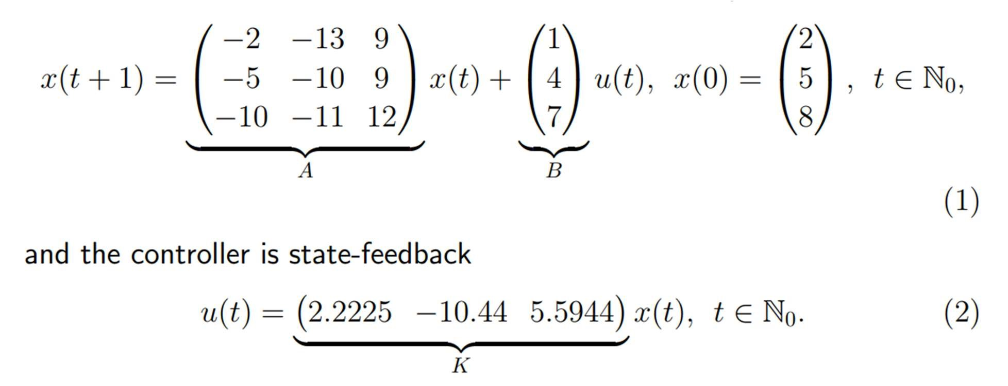

Plot the state trajectory of system using equa ons (1)-(2) un l t = 15 units of me, i.e. 𝑥(𝑡) .

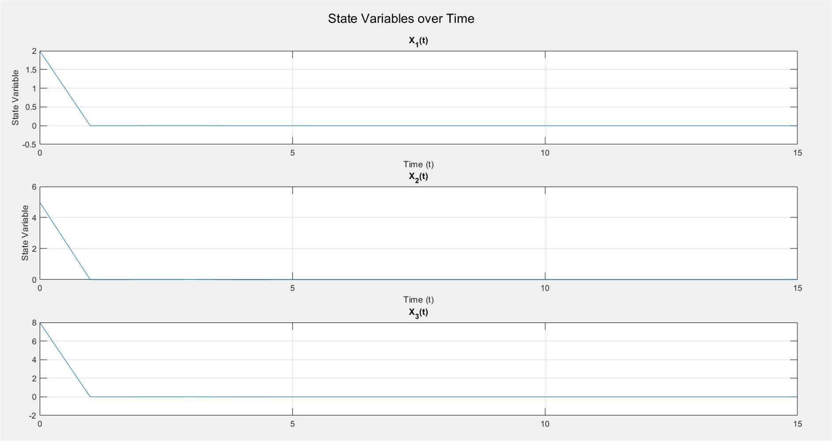

Fig: Plot of Trajectories over me t = 0 to 15

## Data Losses Trajectory

Communica on channels from the controller to the plant are prone to data losses. As a result, control input u may be lost in the network intermi ently. Let κ : N0→ {0, 1} denote the data loss signal, defined as follows: if κ(t) = 0, then the control input u(t) is lost in the network at me t and if κ(t) = 1, then the control input u(t) is received by the plant at me t, t ∈ N0.

k = [0, 0, 1, 0, 0, 0, 1, 0, 1, 0, 0, 1, 0, 0, 0];

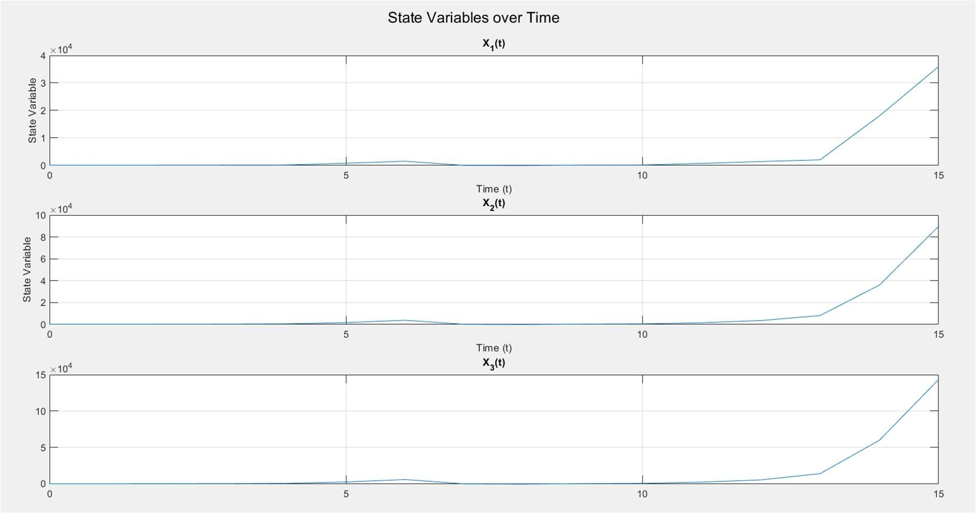

Fig: - Plot of Trajectories with Losses

(C). Observa on :- Without Communica on losses the system se les down to it’s equilibrium point which is [0, 0, 0] that is it has se led down. But with communica on losses the system diverges and goes to instability.

## (D) Probability :-

With Changing values of P, generate the K = [], such that the state trajectory can be made with data losses dependent on probability.

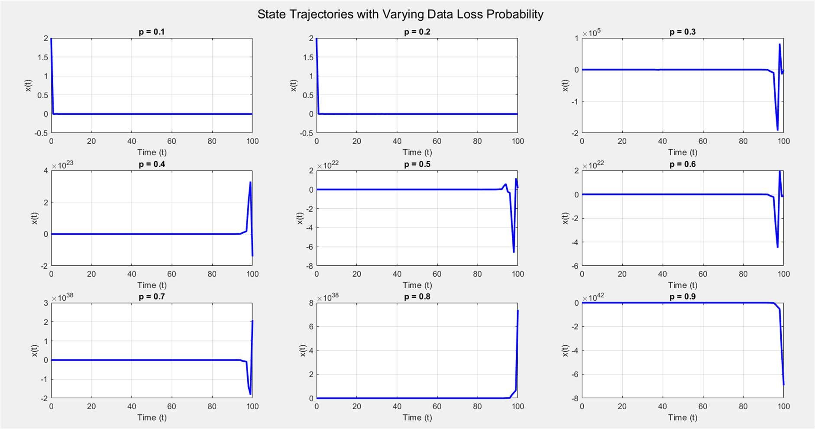

Fig : - State Trajectory with Varying Probability

## (D)Range of P :-

FOR,

0

𝑋(15)=0 0

range of probability = 0.1 to 0.3 .

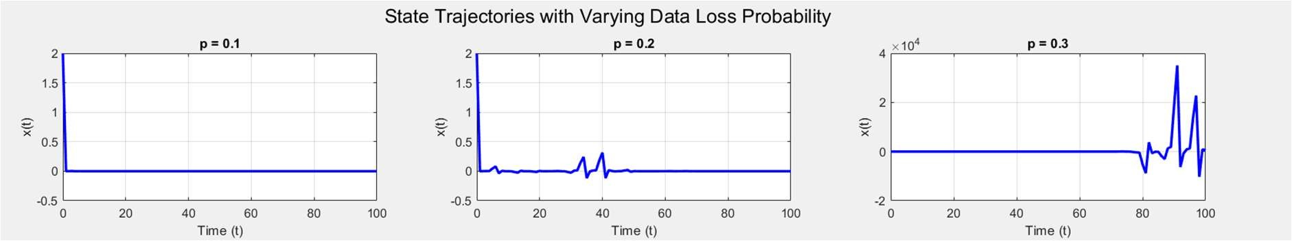

Fig:- Trajectories for X(15) = [0,0,0]

## Sec on - II

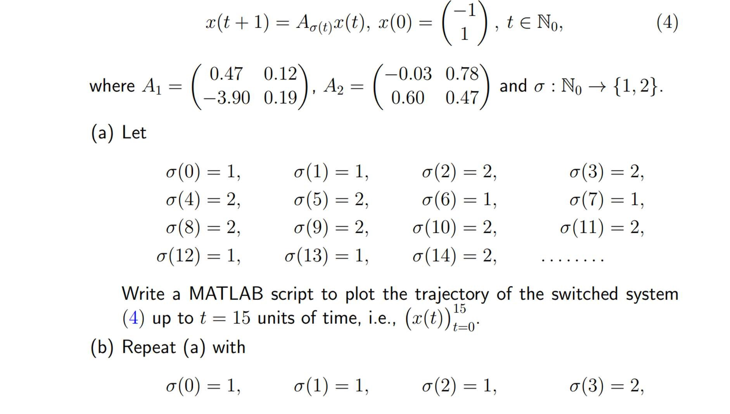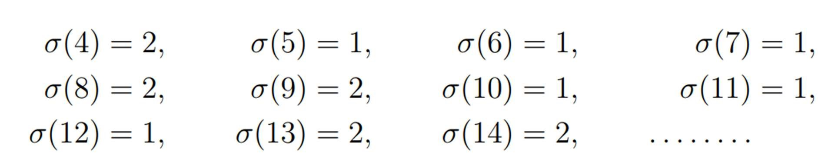

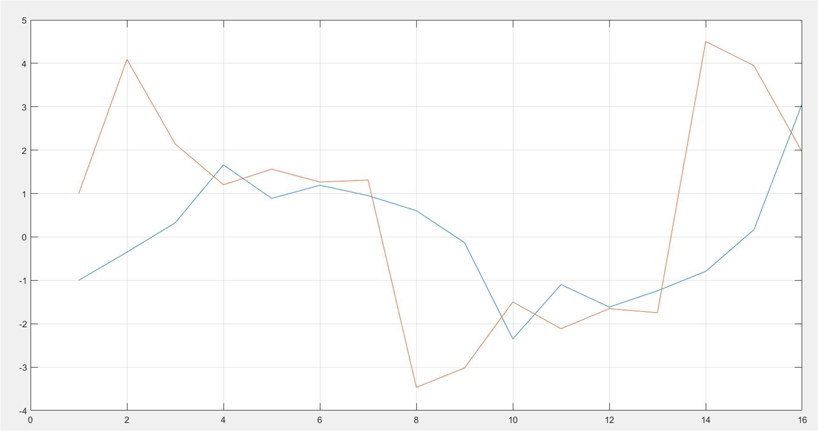

Fig:- Trajectory For First set of Sigma

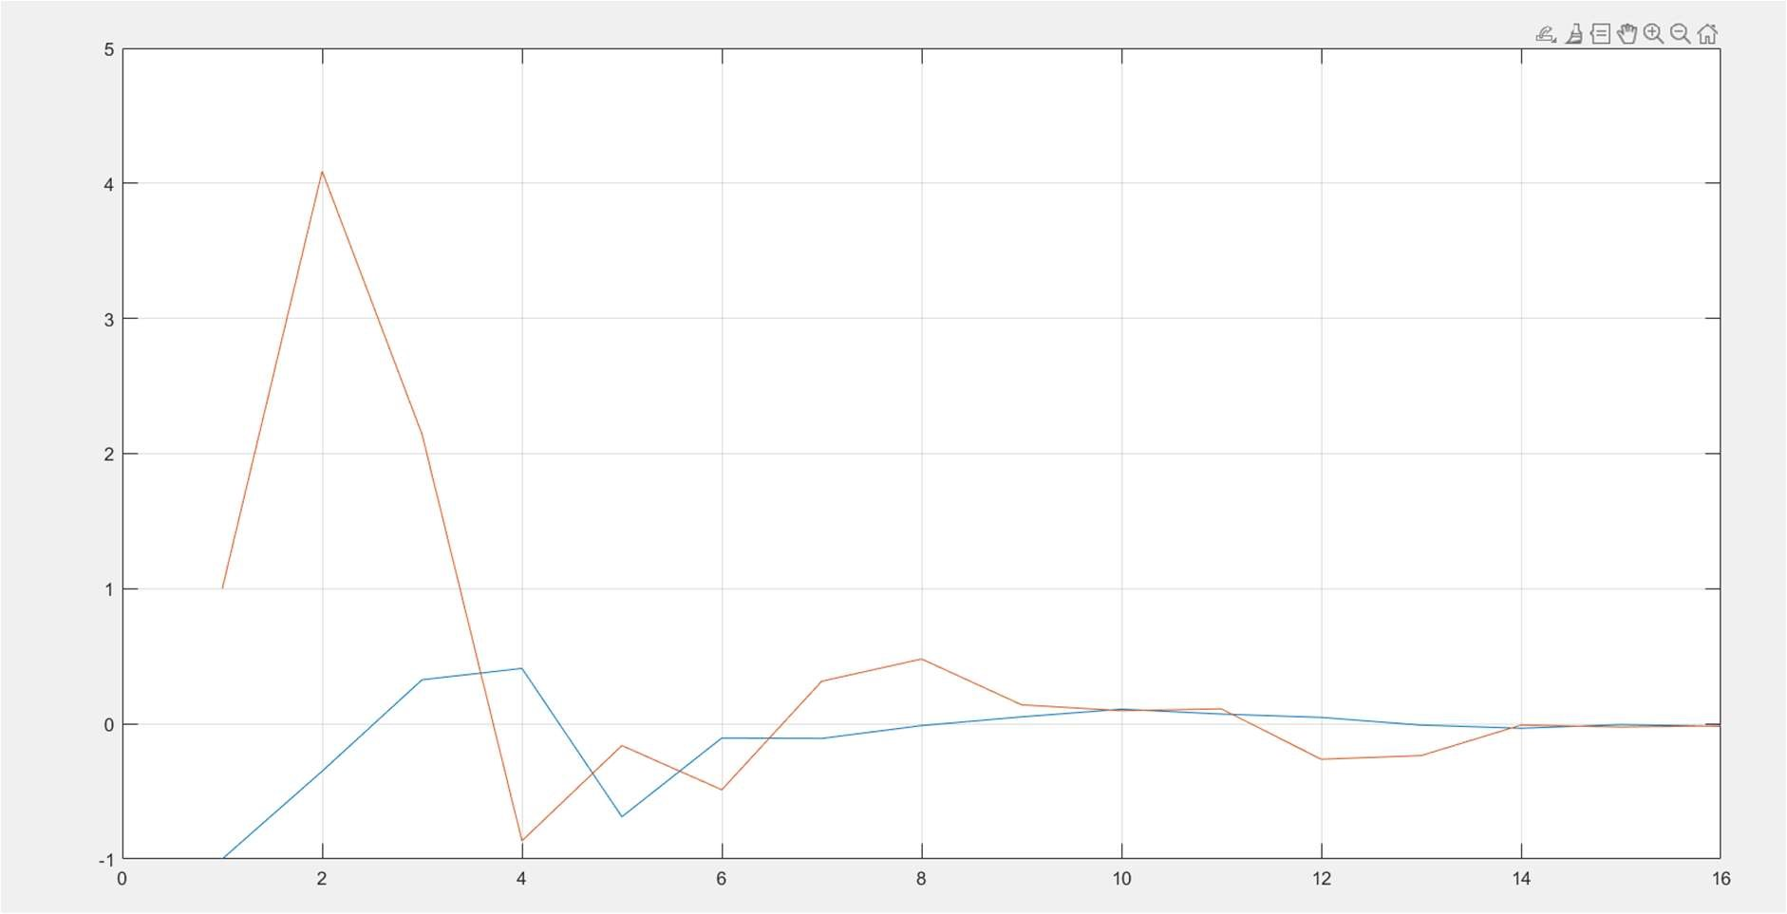

Fig:- Trajectory For Second Set of Sigma

(C).Based on experiments (a) and (b) comment on the following: “Switching between stable subsystems arbitrarily leads to a stable switched system” :-

The First set of sigma give unstable while the second is a stable one. A1 and A2 are stable as eigenvalues lies within unit circle. But if the system is switched then stability is decided by the switching. Stability depends on states and switching signal σ(t).