**EE49001: Control and Electronic System Design**

Assignment-5 (Compensatory)

Submitted By:

21EE30004: Anirvan Krishna

**Section-I: Networked Control Systems**

# Plotting State Trajectory for Lossless transmission

An NCS plant is characterized by the following linear discrete time system

$$x\left(t+1\right)=Ax\left(t\right)+Bu\left(t\right),x\left(0\right)={\left[\begin{matrix}2 & 5 & 8\end{matrix}\right]}^{T} \\ u\left(t\right)=Kx\left(t\right)$$

|  |  |  |
| --- | --- | --- |
| $$A=\left[\begin{matrix}-2 & -13 & 9 \\ -5 & -10 & 9 \\ -10 & -11 & 12\end{matrix}\right]$$ | $$B=\left[\begin{matrix}1 \\ 4 \\ 7\end{matrix}\right]$$ | $$K=\left[\begin{matrix}2.2225 & -10.44 & 5.5944\end{matrix}\right]$$ |

The system is simulated for 15-time units (following script) the system trajectory is plotted.

**MATLAB Code**

|  |
| --- |
| 1. clc; clear; close all; 2. A = [ 3. -2 -13 9; 4. -5 -10 9 5. -10 -11 12; 6. ]; 7. B = [1;4;7]; 8. K = [2.2225 -10.44 5.5944]; 9. x0 = [2; 5; 8]; 10. t = 0:15; 11. xt = zeros(3,16); xt(:,1) = x0; 12. ut = zeros(1,16); ut(1) = K*x0; 13. for i = 2:16 14. xt(:,i) = A*xt(:,i-1) + B*ut(i-1); 15. ut(i) = K*xt(:,i); 16. end 17. xt = gen_xt(15,A,B,K,x0,0); 18. fig = figure; fig.Position(3) = 1000; fig.Position(4) = 1000; movegui('center'); 19. sgtitle('State Trajectory', Interpreter='latex'); 20. hold on; 21. plot(t,xt(1,:)); 22. plot(t,xt(2,:)); 23. plot(t,xt(3,:)); 24. hold off; 25. xlabel('$t$', Interpreter='latex'); 26. ylabel('$x(t)$', Interpreter='latex'); 27. legend('$x_1$', '$x_2$', '$x_3$',Interpreter='latex'); |

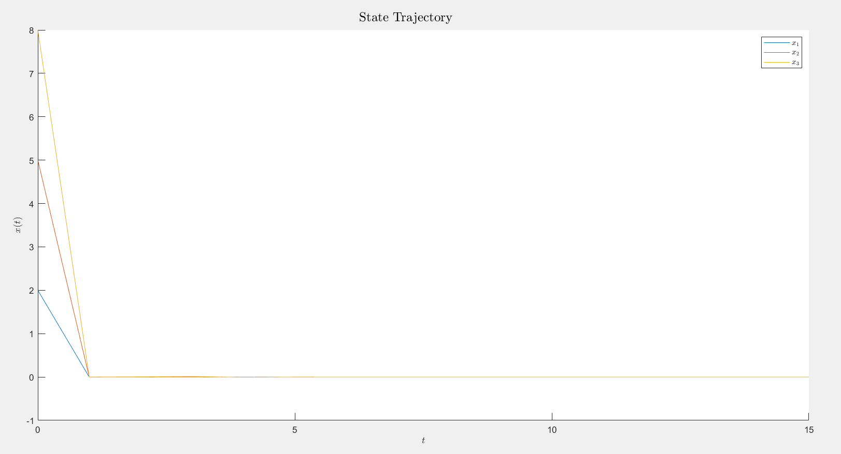

**Fig.** Trajectory of States $x_{1},x_{2}$ and $x_{3}$

# Lossy Transmission (Fixed Loss $κ$)

Let the loss signal $κ\left(t\right)$ be given as:

$$κ\left(t\right)=\{0,0,1,0,0,0,1,0,1,0,0,1,0,0,0,0\}$$

After the losses, the input: $u\left(t\right)≔κ\left(t\right)⋅u\left(t\right)$

**MATLAB Code**

|  |
| --- |
| clc; clear; close all;  A = [  -2 -13 9;  -5 -10 9  -10 -11 12;  ];  B = [1;4;7;];  K = [2.2225 -10.44 5.5944];  k = [0 0 1 0 0 0 1 0 1 0 0 1 0 0 0 0];  x0 = [2; 5; 8]; t = 0:15;  xt = zeros(3,16); xt(:,1) = x0;  ut = zeros(1,16); ut(1) = K*x0*k(1);  for i = 2:16  xt(:,i) = A*xt(:,i-1) + B*ut(i-1);  ut(i) = K*xt(:,i)*k(i);  end  fig = figure; fig.Position(3) = 1000; fig.Position(4) = 500; movegui('center');  sgtitle('State Trajectory', Interpreter='latex');  hold on;  plot(t,xt(1,:));  plot(t,xt(2,:));  plot(t,xt(3,:));  hold off;  xlabel('$t$', Interpreter='latex');  ylabel('$x(t)$', Interpreter='latex');  legend('$x_1$', '$x_2$', '$x_3$',Interpreter='latex'); |

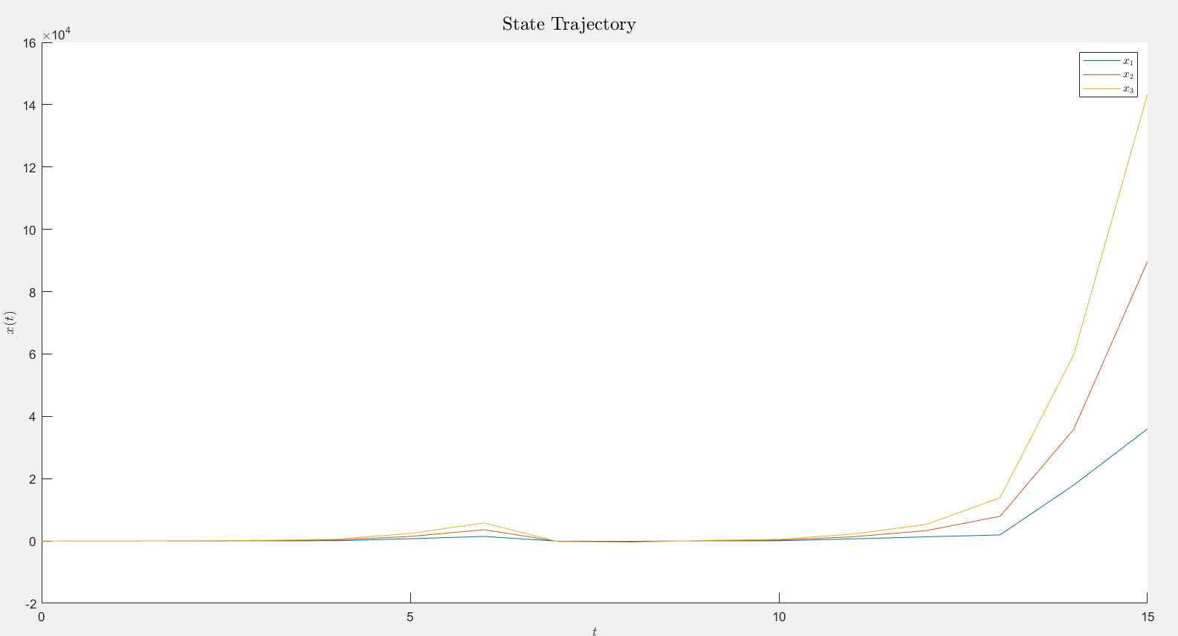

**Fig.** State trajectories with given values of $κ\left(t\right)$

In the lossy medium, we observe that the state trajectories start from $0$ and then start increasing. Meanwhile in the lossless medium, the states are observed to decrease from some initial value to $0,$ As the time increased

# Lossy Medium (Random Loss)

The same NCS plant is simulated for 100 units time (script following), this time the data loss signal is generated randomly.

$$κ\left(t\right)=\left\{\begin{aligned}0, &\text{with probability} p \\ 1, &\text{with probability} 1-p\end{aligned}\right.$$

**MATLAB Code**

|  |
| --- |
| 1. clc; clear; close all; 2. A = [ 3. -2 -13 9; 4. -5 -10 9 5. -10 -11 12; 6. ]; 7. B = [1;4;7;]; 8. K = [2.2225 -10.44 5.5944]; 9. for p = 1:9 10. xt = gen_xt(100,A,B,K,x0,p/10); t = 0:100; 11. fig = figure; fig.Position(3) = 1000; fig.Position(4) = 500; movegui('center'); 12. sgtitle(['State Trajectory for $p=',num2str(p/10),'$'], Interpreter='latex'); 13. hold on; 14. plot(t,xt(1,:)); 15. plot(t,xt(2,:)); 16. plot(t,xt(3,:)); 17. xline(15); text(15,1,['$x(15)=(',num2str(xt(1,16)),',',num2str(xt(2,16)),',',num2str(xt(3,16)),')$'], Interpreter='latex') 18. hold off; 19. xlabel('$t$', Interpreter='latex'); 20. ylabel('$x(t)$', Interpreter='latex'); 21. legend('$x_1$', '$x_2$', '$x_3$',Interpreter='latex'); 22. end |
| 1. function xt = gen_xt(n, A, B, K, x0, p) 2. xt = zeros(length(x0),n+1); ut = zeros(height(K),n+1); 3. k = (rand(1,n+1)>p); 4. xt(:,1) = x0; ut(:,1) = K*x0*k(1); 5. for i = 2:n+1 6. xt(:,i) = A*xt(:,i-1) + B*ut(:,i-1); 7. ut(:,i) = K*xt(:,i)*k(i); 8. end 9. end |

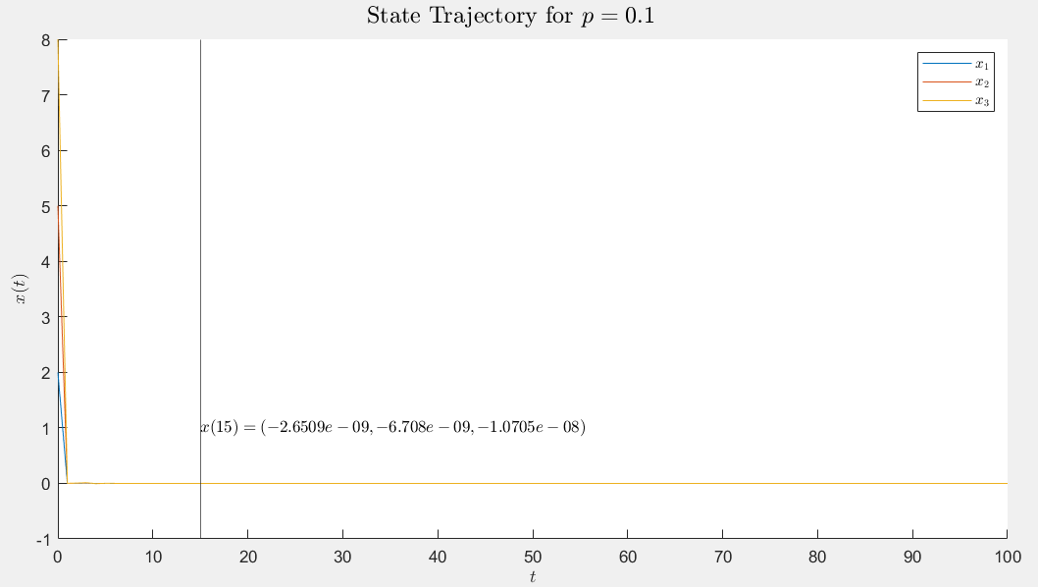

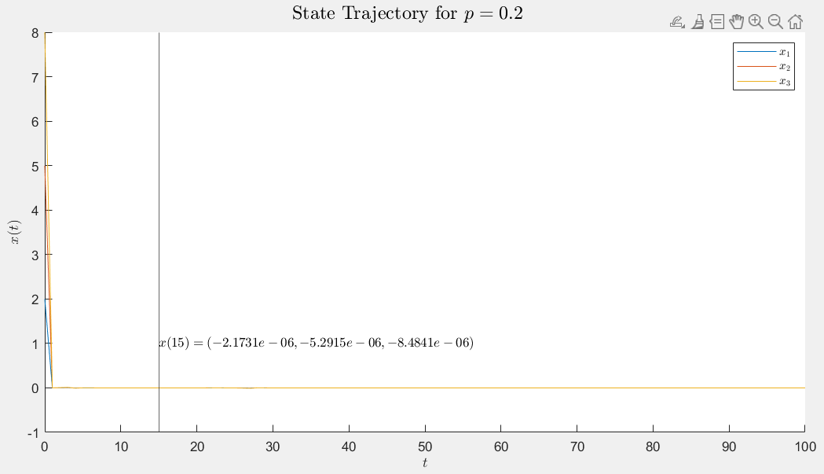

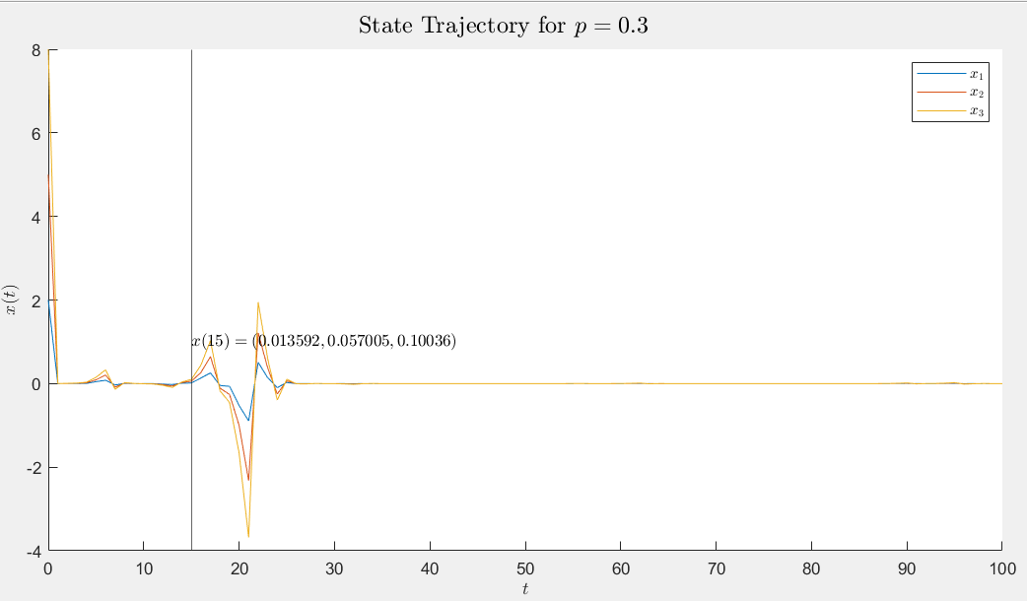

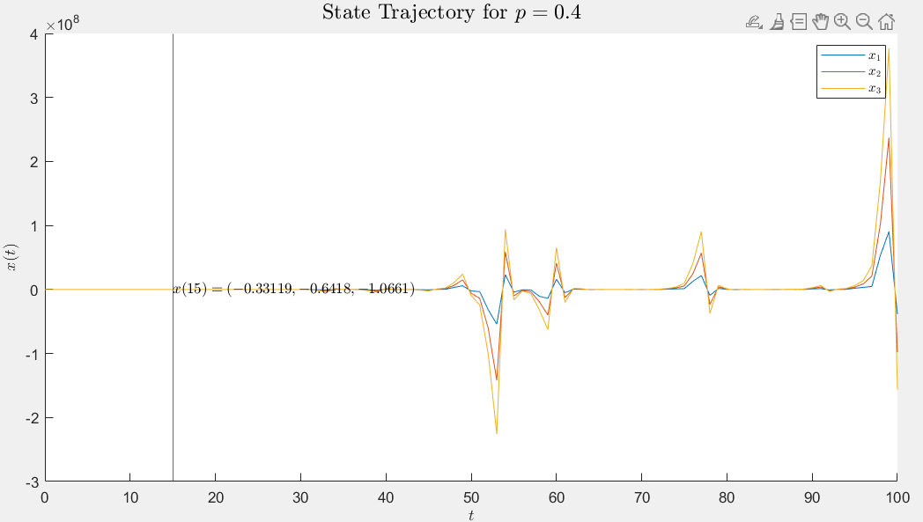

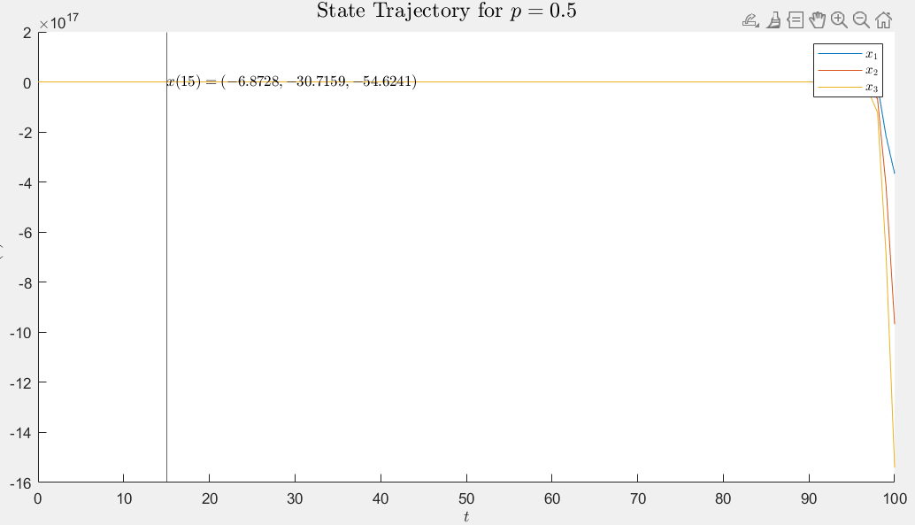

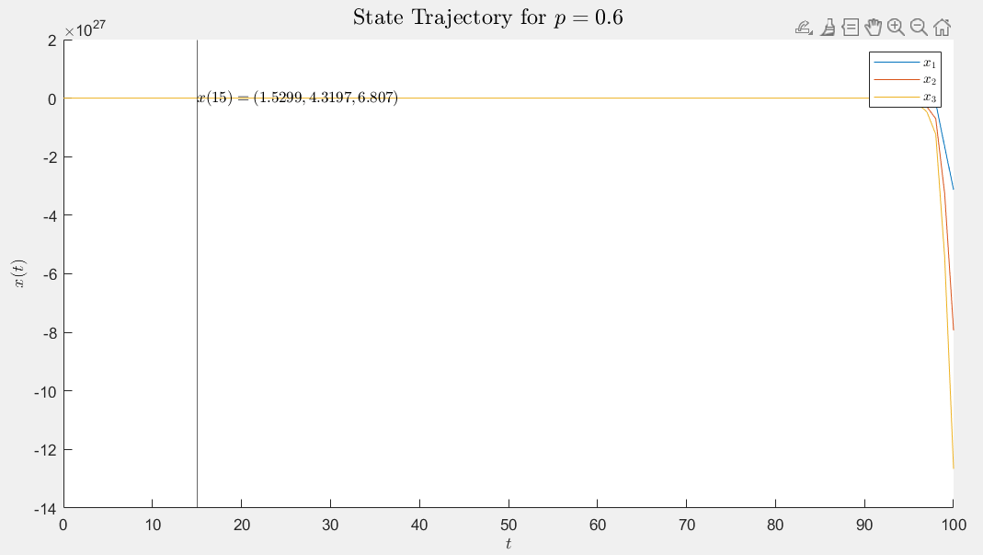

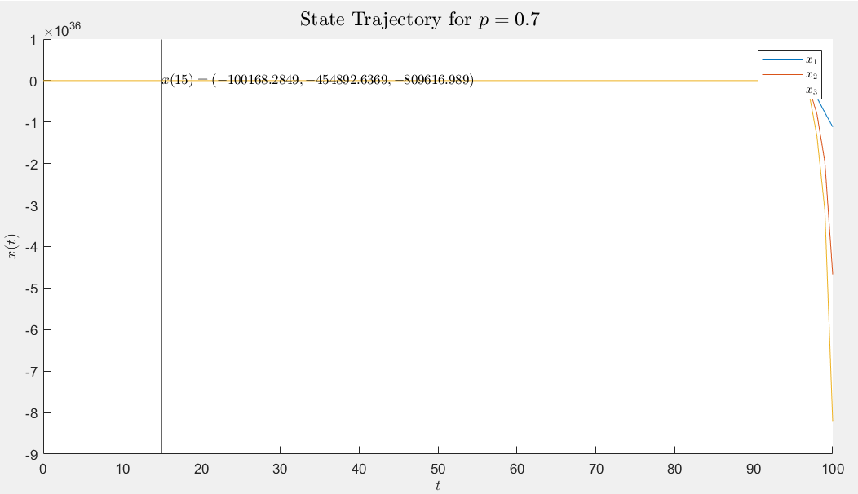

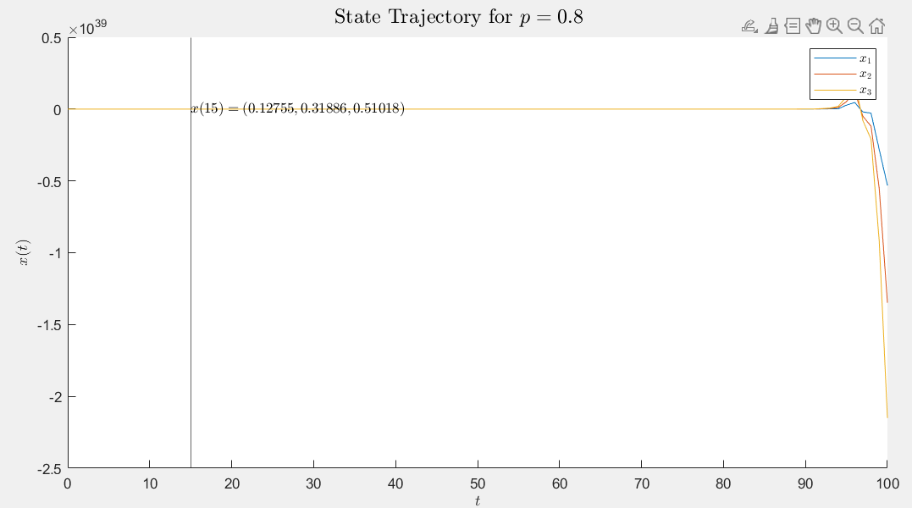

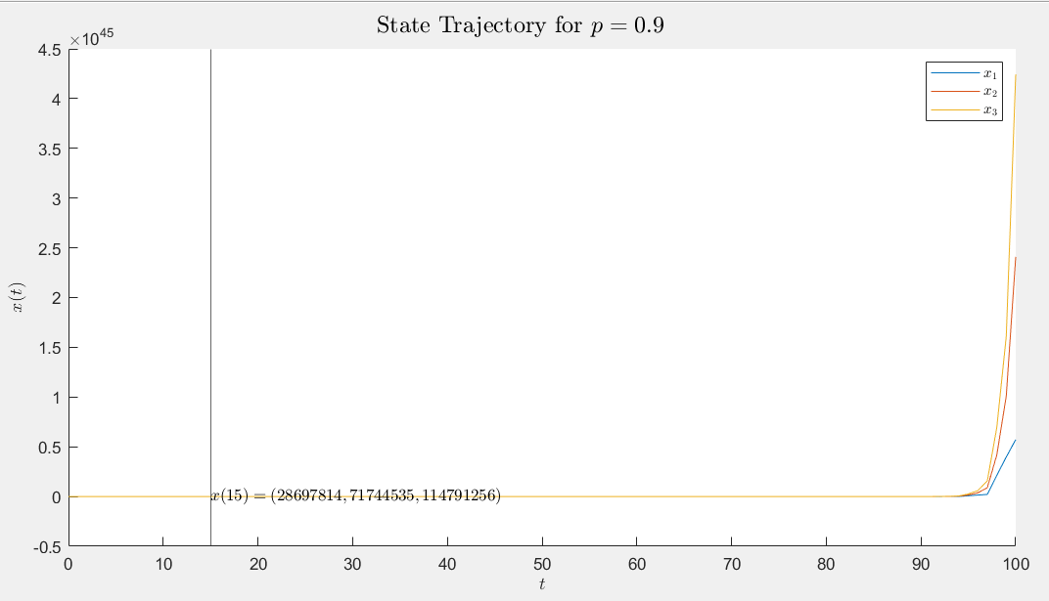

**Fig.** Lossy Media with different probabilities for losses

As can be observed $x\left(15\right)≈0$ for $p≤0.3$.

**Section-II: Switched Systems**

# Trajectory of the Switched Systems

A switched system is characterized by

$$x\left(t+1\right)=A_{σ\left(t\right)}x\left(t\right), x\left(0\right)={\left[\begin{matrix}-1 & 1\end{matrix}\right]}^{T}$$

Where,

|  |  |
| --- | --- |
| $$A_{1}=\left[\begin{matrix}0.47 & 0.12 \\ -3.90 & 0.19\end{matrix}\right]$$ | $$A_{2}=\left[\begin{matrix}-0.03 & 0.78 \\ 0.60 & 0.47\end{matrix}\right]$$ |

We have: $σ_{1}\left(t\right) = \{1, 1, 2, 2, 2, 2, 1, 1, 2, 2, 2, 2,1, 1, 2\}$

$σ_{2}\left(t\right) = \{1, 1, 1, 2, 2,1,1,1, 2,2,1,1,1,2, 2\}$

The system is simulated for 15 time units (following script) for two different random noise signal and the response is plotted.

**MATLAB Code**

|  |
| --- |
| 1. clear; close all; clc; 2. A1 = [ 3. 0.47, 0.12; 4. -3.90, 0.19 5. ]; 6. A2 = [ 7. -0.03, 0.78; 8. 0.60, 0.47; 9. ]; 10. A = zeros(2,2,2); 11. A(:,:,1) = A1; 12. A(:,:,2) = A2; 13. x0 = [-1;1]; 14. s1 = [1,1,2,2,2,2,1,1,2,2,2,2,1,1,2]; 15. s2 = [1,1,1,2,2,1,1,1,2,2,1,1,1,2,2]; 16. n=15; 17. xt = zeros(length(x0), n+1); 18. xt(:,1) = x0; 19. for i = 1:n 20. xt(:,i+1) = A(:,:,s1(i))*xt(:,i); 21. end 22. t = 0:15; 23. xt1 = gen_xt1(15,A,s1,x0); 24. xt2 = gen_xt1(15,A,s2,x0); 25. fig = figure; fig.Position(3) = 2000; fig.Position(4) = 1000; movegui('center'); 26. sgtitle('State Trajectory', Interpreter='latex'); 27. subplot(1,2,1); 28. hold on; 29. plot(t,xt1(1,:)); 30. plot(t,xt1(2,:)); 31. hold off; 32. xlabel('$t$', Interpreter='latex'); 33. ylabel('$x^{(1)}(t)$', Interpreter='latex'); 34. legend('$x_1$', '$x_2$',Interpreter='latex'); 35. subplot(1,2,2); 36. hold on; 37. plot(t,xt2(1,:)); 38. plot(t,xt2(2,:)); 39. hold off; 40. xlabel('$t$', Interpreter='latex'); 41. ylabel('$x^{(2)}(t)$', Interpreter='latex'); 42. legend('$x_1$', '$x_2$',Interpreter='latex'); |
| 1. function xt = gen_xt1(n,A,s,x0) 2. xt = zeros(length(x0), n+1); 3. xt(:,1) = x0; 4. for i = 1:n    1. xt(:,i+1) = A(:,:,s(i))*xt(:,i); 5. end 6. end |

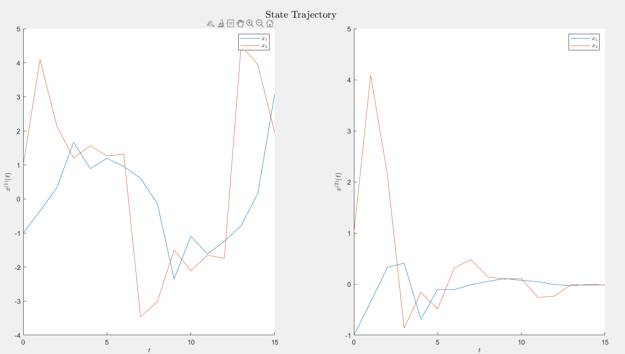

**Fig.** State trajectories corresponding to different values of $σ\left(t\right)$

As can be seen that the second system is stable. Thus, random switching doesn’t always result in a stable response.