**EE49001: Control and Electronic System Design**

Assignment-7: RLC Circuit Control

Submitted By:

21EE30004: Anirvan Krishna | 21EE30001: Aditya Kumar

# State-Space Representation and Controllability

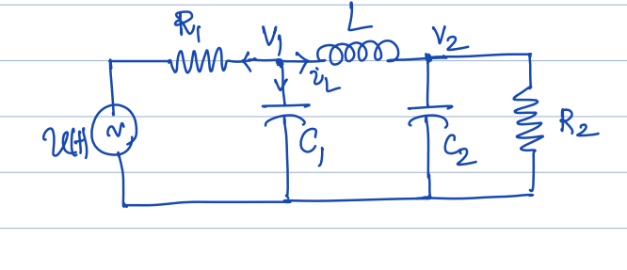

**Fig.** Circuit Diagram

We have the circuit parameters as follows: $R_{1}=1kΩ,R_{2}=2kΩ,C_{1}=1mF,C_{2}=4mF,L=0.5H$. The states for the state space considered are: $v_{1}, { v}_{2}, i_{L}$.

The state space: $X = \left[\begin{matrix}i_{L} \\ v_{1} \\ v_{2}\end{matrix}\right]$

Therefore, we can write the equations as follows:

$$\dot{X\left(t\right)}=AX\left(t\right)+Bu\left(t\right)$$

Here, $A = \left[\begin{matrix}0 & \frac{1}{L} & \frac{-1}{L} \\ \frac{-1}{C_{1}} & \frac{-1}{C_{1}R_{1}} & 0 \\ \frac{-1}{C_{2}} & 0 & \frac{1}{C_{2}R_{2}}\end{matrix}\right]$, $B = \left[\begin{matrix}0 \\ \frac{1}{C_{1}R_{1}} \\ 0\end{matrix}\right]$

Controllability check is executed in MATLAB using the following snippet.

**MATLAB Code**

|  |
| --- |
| clear; close all; clc;  R1 = 1e3; C1 = 1e-3;  R2 = 2e3; C2 = 4e-3;  L = 0.5;  A = [  -1/(R1*C1), 0, -1/C1;  0, -1/(R2*C2), 1/C2;  1/L, -1/L, 0;  ];  B = [1/(R1*C1); 0; 0];  D = 0;  Co = ctrb(A,B);  disp("Rank of the controllability matrix is: "+rank(Co)); |

On executing the above code, we get the rank of the controllability matrix $= 3$. Hence, the system is controllable.

# Estimation of Observability

We need to find if the system is observable for the following choice of outputs:

$v_{1}≔$ voltage across $C_{1}$

$v_{2}≔$ voltage across $C_{2}$

$i_{1}≔$ current across $L$

For different output states, we have different vectors $C$. We can write output $y$ as:

$$y=CX+Du\left(t\right)$$

Since $D = 0$. We have matrix $C$ for each case as follows:

$$C_{1} = \left[\begin{matrix}0 & 1 & 0\end{matrix}\right]$$

$$C_{2} = \left[\begin{matrix}0 & 0 & 1\end{matrix}\right]$$

$$C_{3} = \left[\begin{matrix}1 & 0 & 0\end{matrix}\right]$$

For all the three cases, the rank of the observability matrix is calculated by running the following script:

**MATLAB Code**

|  |
| --- |
| clear; close all; clc;  R1 = 1e3; C1 = 1e-3;  R2 = 2e3; C2 = 4e-3;  L = 0.5;  A = [  -1/(R1*C1), 0, -1/C1;  0, -1/(R2*C2), 1/C2;  1/L, -1/L, 0;  ];  B = [1/(R1*C1); 0; 0];  D = 0;  Co = ctrb(A,B);  disp("Rank of the controllability matrix is: "+rank(Co));  C11 = [1, 0,0]; Ob1 = obsv(A,C11);  C12 = [0, 1,0]; Ob2 = obsv(A,C12);  C13 = [1,-1,0]; Ob3 = obsv(A,C13);  disp("Rank of the observability matrix when output is v1: "+rank(Ob1));  disp("Rank of the observability matrix when output is v2: "+rank(Ob2));  disp("Rank of the observability matrix when output is iL: "+rank(Ob3)); |

From the MATLAB output, we find that the rank of observability matrix in all the three cases: $3.$ Therefore, we can infer that the system is observable with these output variables.

# Simulink Implementation

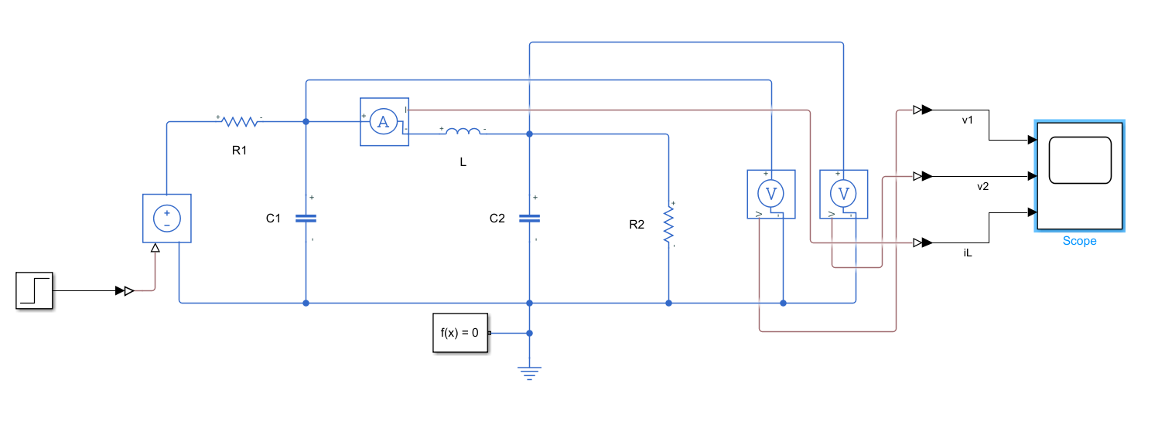

**Fig:** Simulink Model implementation

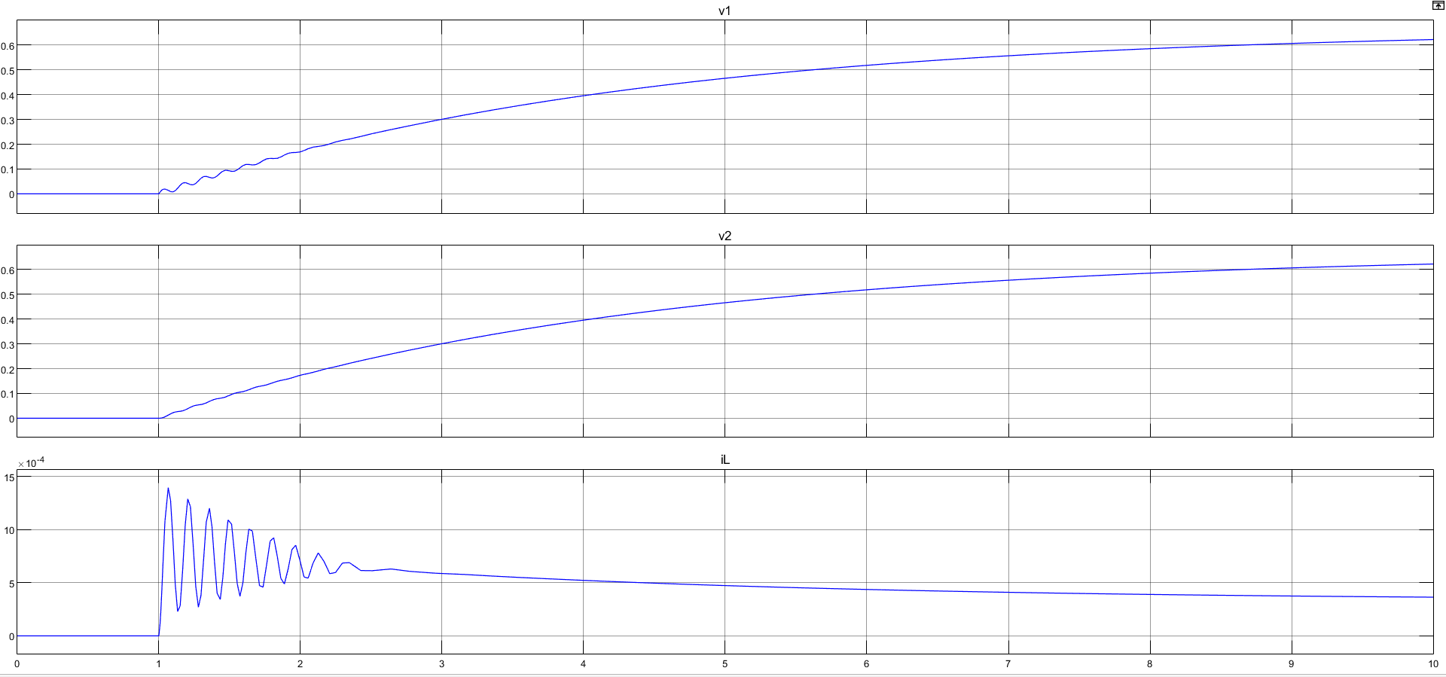

**Fig:** Output Voltages at steady state across $L,C_{1},C_{2}$

# Design of State-Feedback Controller

We are required to implement a state feedback controller to regulate the voltage $v_{2}=10V$ when the voltage across $C_{1}$ i.e. $v_{1}$ is known after being sampled at $1 kHZ$.

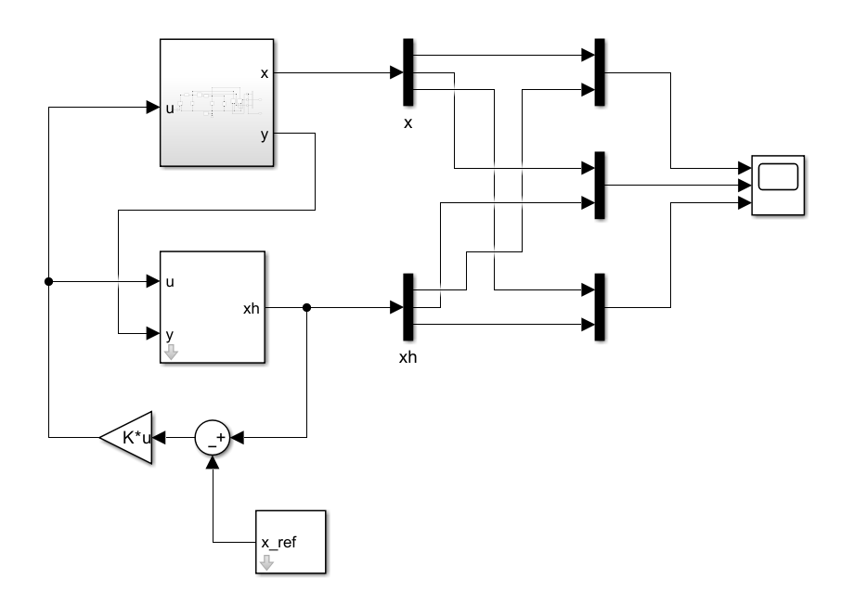

**Fig.** State Feedback Controller Design

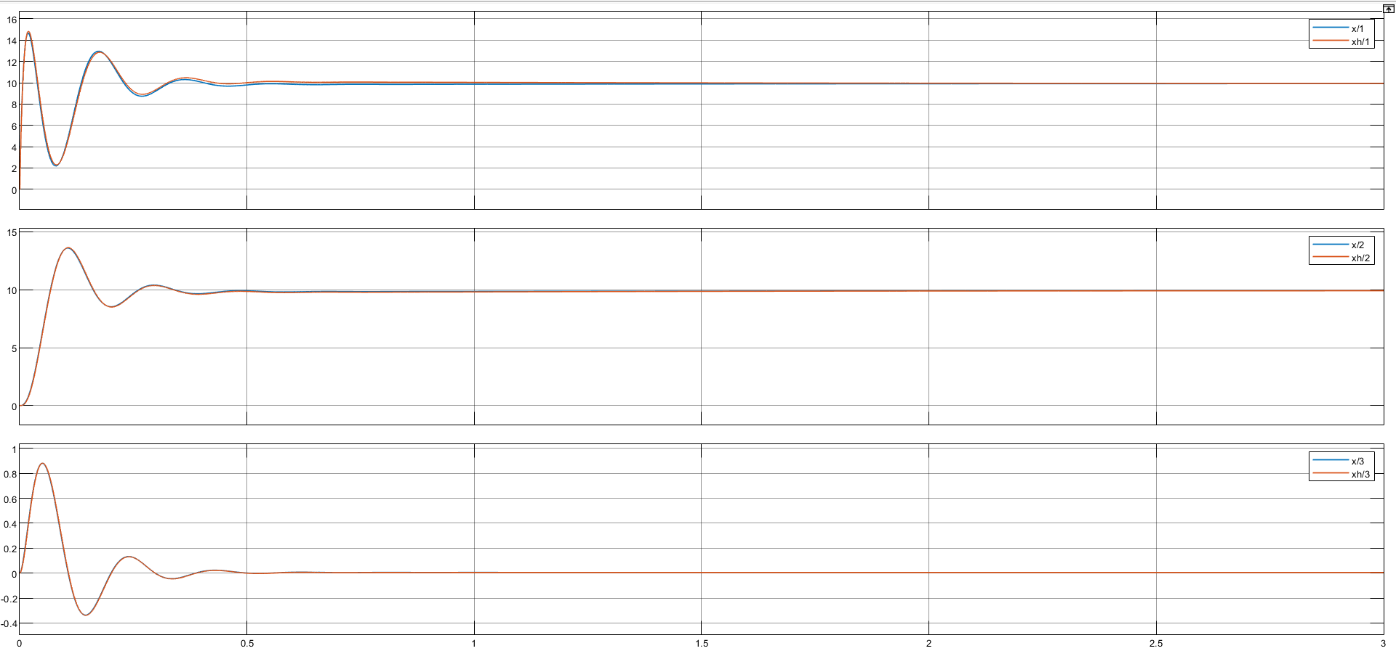

**Fig.** Trajectory of the three states after application of state feedback controller

We observe that the voltage $v_{2}$ finally settles to the required value i.e. $10 V$.

# Estimator for estimating the value of $R_{1}$

We need to estimate the value of $R_{1}$ using the control input and the three estimators i.e. $v_{1},v_{2},i_{L}$.

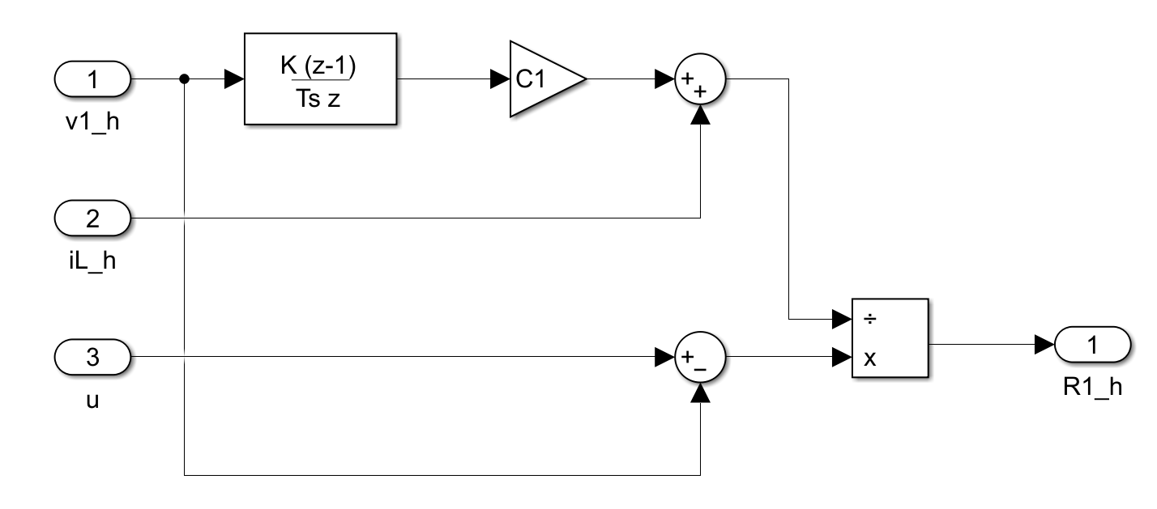

**Fig.** Estimator Subsystem

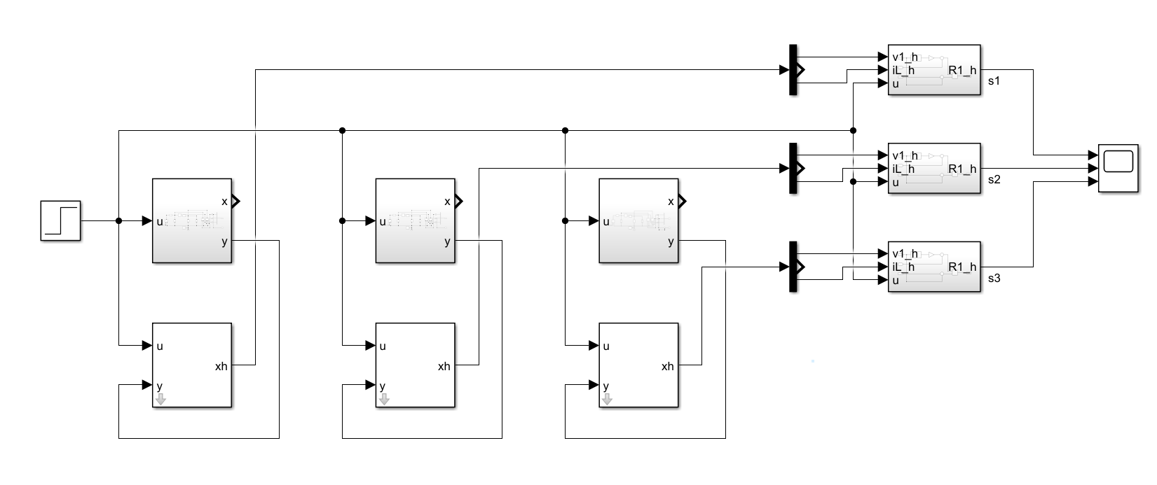

**Fig.** Estimator Model with different observer for observing different outputs

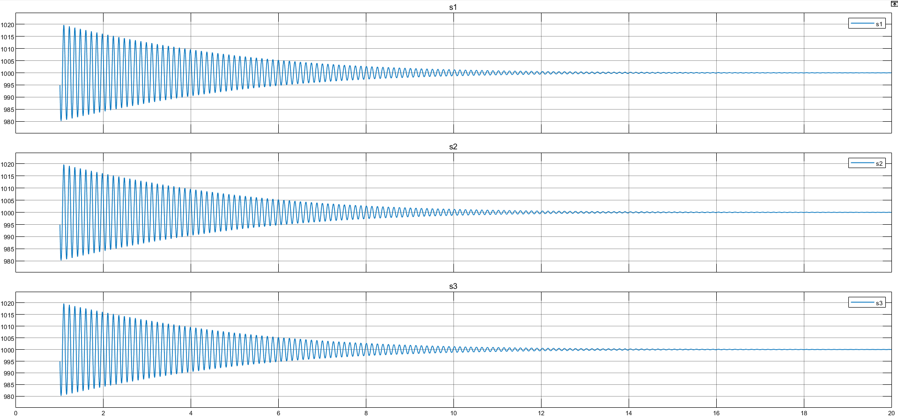

**Fig.** Estimated value of $R_{1}$ from different observed quantities

In all the three cases, i.e. by observing the states $v_{1},v_{2},i_{L}$, we can see the variation in the estimated value of $R_{1}$. As evident from the three plots attached above, the value of $R_{1}$ oscillates and finally settles to its actual value i.e. $1 KΩ$.