**EE49001: Control and Electronic System Design**

Assignment-7: Transfer Function Estimation

Submitted By:

21EE30004: Anirvan Krishna | 21EE30001: Aditya Kumar

# Simulink Model of RLC Series Circuit and Step Response

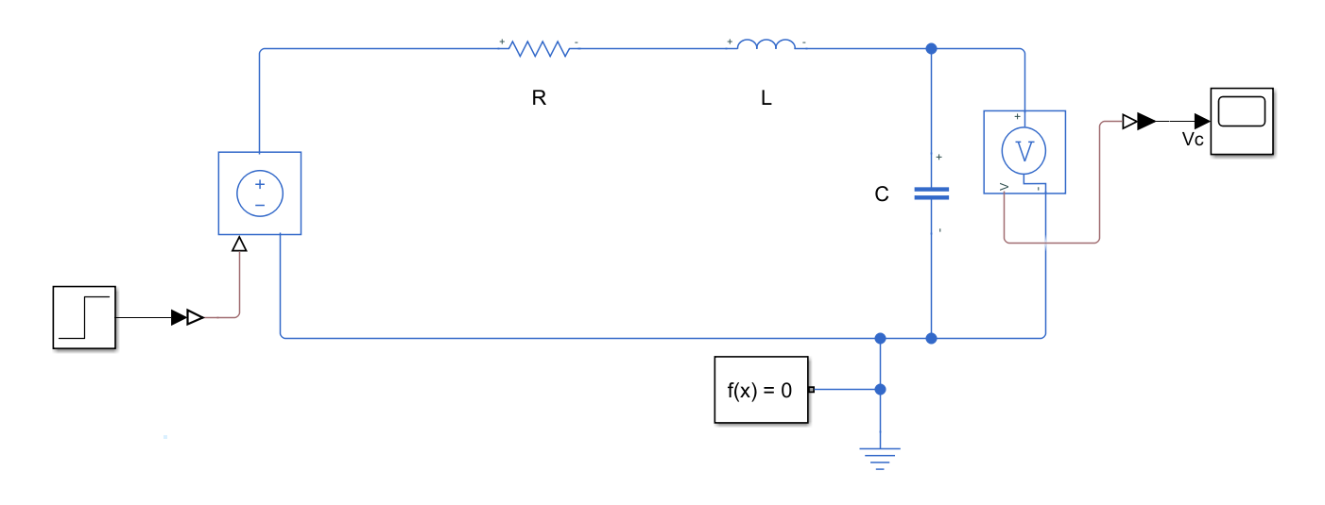

**Fig.** RLC Series Circuit Simulink Model

Here, we have: $R = 3Ω; L = 2H; C = 0.5F$

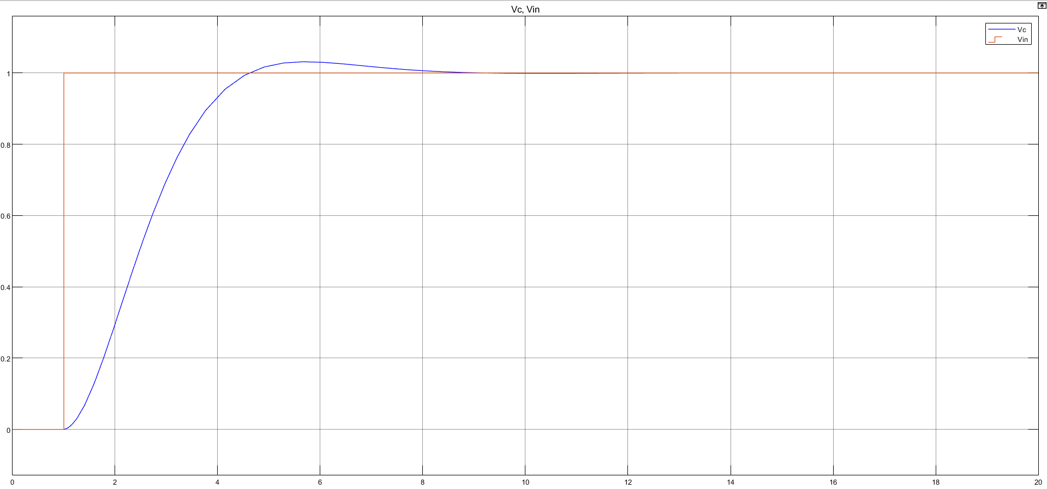

**Fig.** Input $\left(V_{in}\right)$ and Output $\left(V_{c}\right)$ vs. Time

From the system response, we can observe that the system is underdamped.

# Transfer Function computation from step response

# Response to Sinusoidal Input

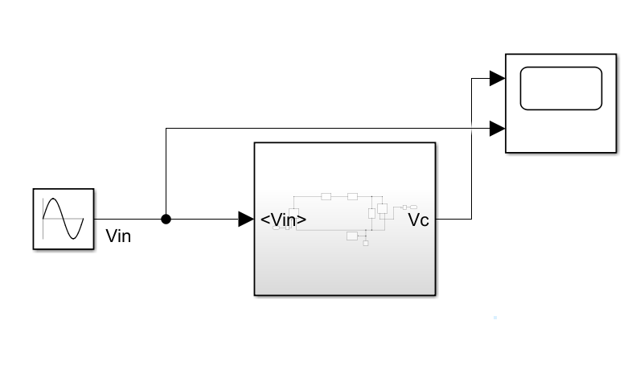

**Fig.** Application of Sinusoidal Input to the system

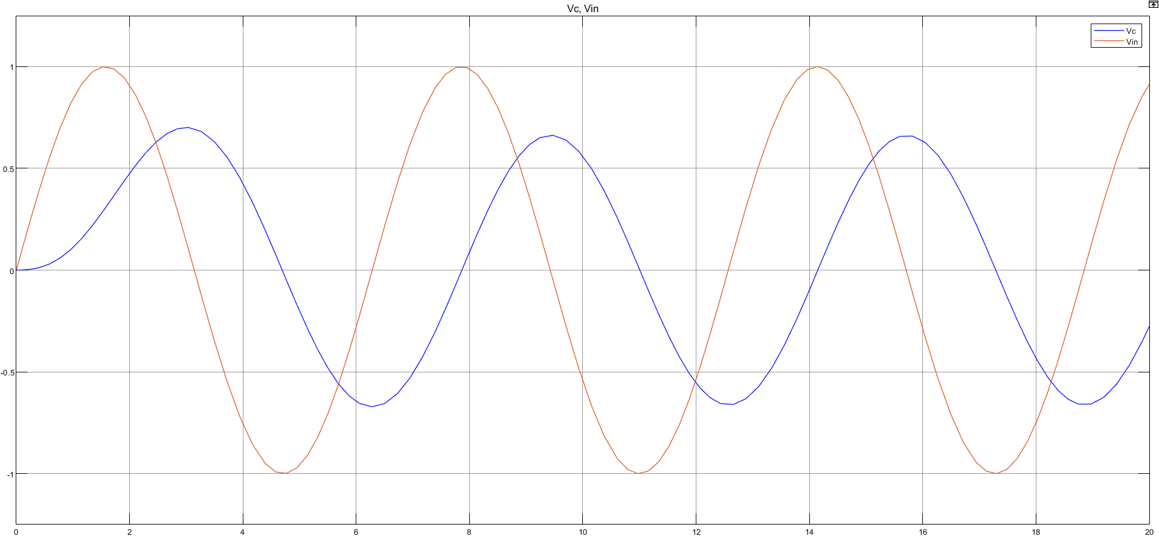

**Fig.** System response corresponding to sinusoidal input

# Analytical Derivation of the Transfer Function

For an RLC Series circuit, total impedance, in Laplace domain can be written as:

$$Z\left(s\right)=R+sL+\frac{1}{sC}$$

$$V_{c}\left(s\right)=\frac{V_{in}\left(s\right)}{Z}⋅\frac{1}{sC}=\frac{V_{in}}{LCs^{2}+RCs+1}$$

Therefore, the transfer function $G\left(s\right)$ is given as:

$$G\left(s\right)=\frac{V_{c}\left(s\right)}{V_{in}\left(s\right)}=\frac{1}{LCs^{2}+RCs+1}=\frac{1}{s^{2}+0.5s+1}$$