PSET 3 OPERATING SYSTEMS 29017 ANIS

Q1
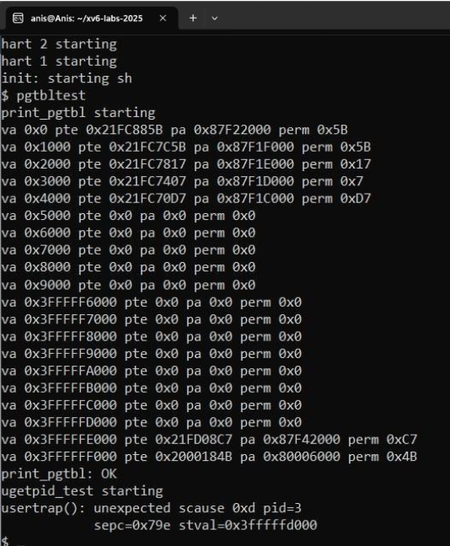

Each page table entry (PTE) maps a 4KB virtual page to a physical frame and includes permission bits controlling access. Lower addresses map to user code/data pages with full RWX user permissions, while the highest addresses map to kernel-only pages (trampoline and kernel mappings) without the User bit set. Unmapped addresses have zeroed entries.

Q2
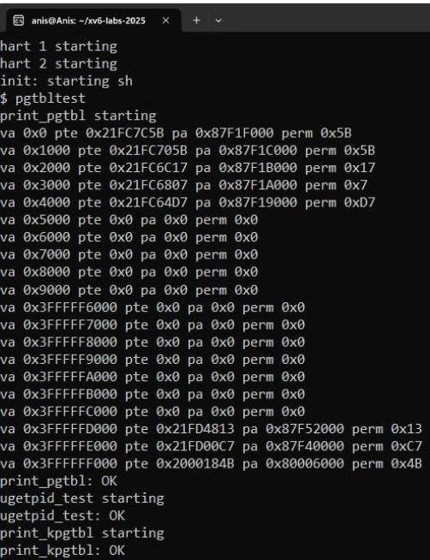
Any system call that only reads static or slowly changing kernel data (like process IDs, uptime, user ID, or system time) can be sped up using the same read-only shared memory page technique.
This avoids expensive kernel crossings and improves performance for frequently called functions.
uptime()
- What it does: Returns the number of clock ticks since the system started.
- How it can be sped up:
The kernel can maintain a read-only counter in the shared page that is periodically updated by the timer interrupt handler.
User programs can directly read the current tick count from this shared page, avoiding a syscall trap.

Grade test
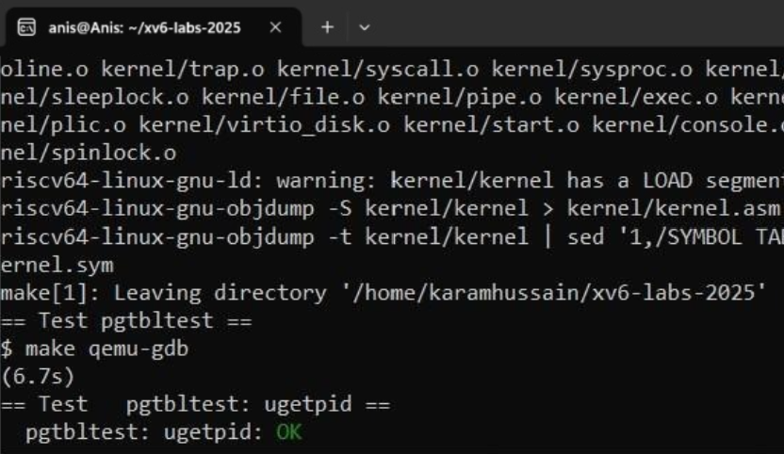
Q3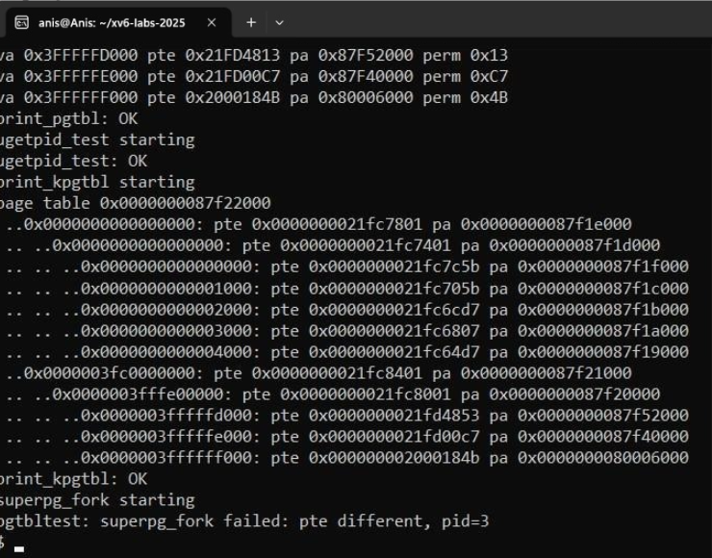

The leaf entries in vmprint() show the same virtual pages and permissions as in print_pgtbl(), while higher levels show how those pages are connected in xv6’s 3-level RISC-V page table hierarchy. Leaf pages are real mappings; non-leaf pages are table pointers.

Grade test
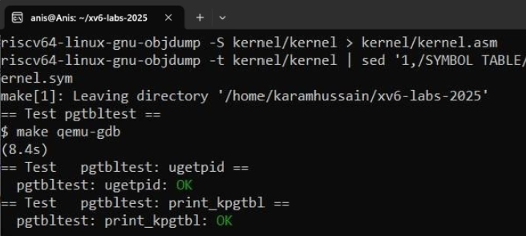

Q4
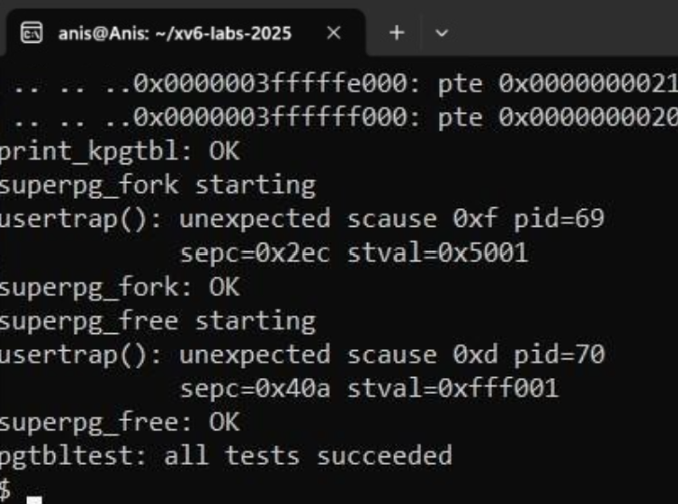

MAKE GRADE
