PSET 2 OPERATING SYSTEMS
NAME: Anis
ERP: 29017
Date:4-10-2025

Using GDB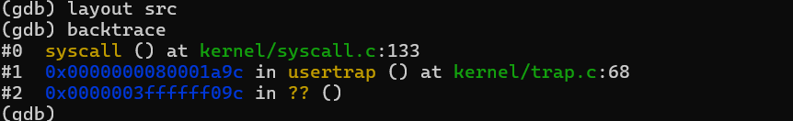

Pointers and address a7 value
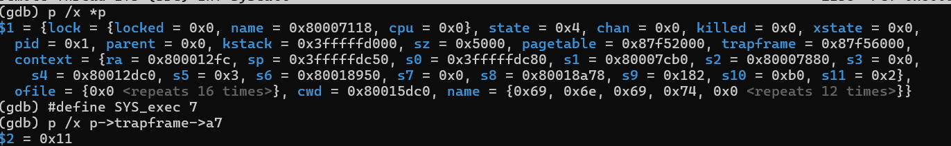

Proof of existence: 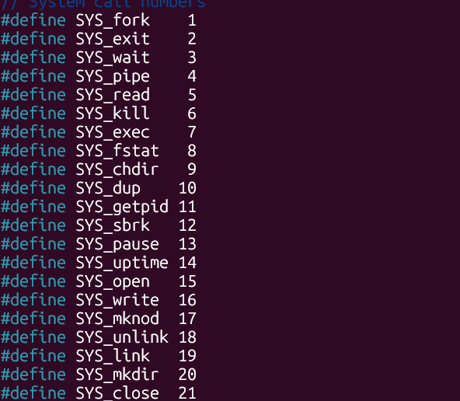

Running command for question 3
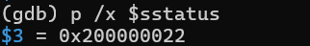

Proof of kernel trap when make qemu
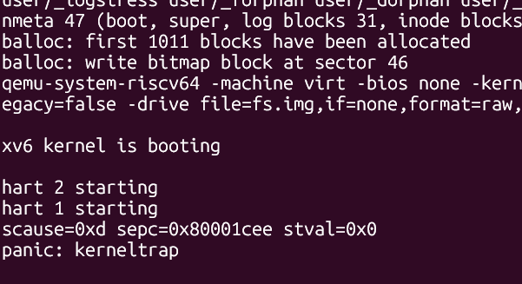

Proof of assembly instruction:

