**PC Lint (version 9.0) integration with SDK Eclipse**

Some of the steps you need to follow in order get PC Lint working:

* Run PClint9.exe from PC_lint Setup folder

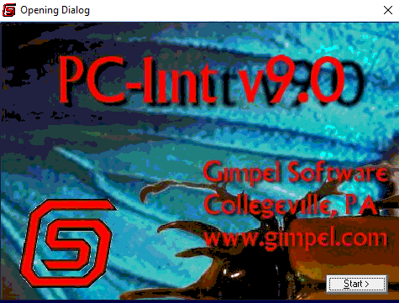

Figure 1

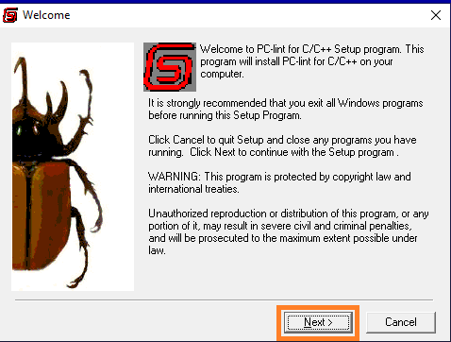

Figure 2

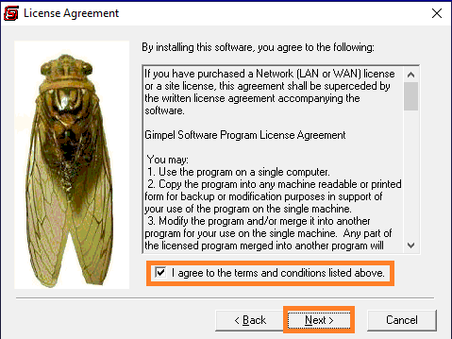

Figure 3

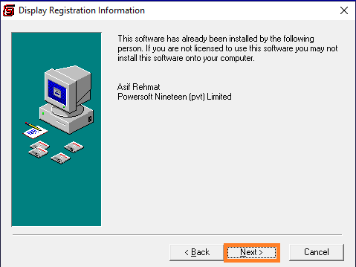

Figure 4

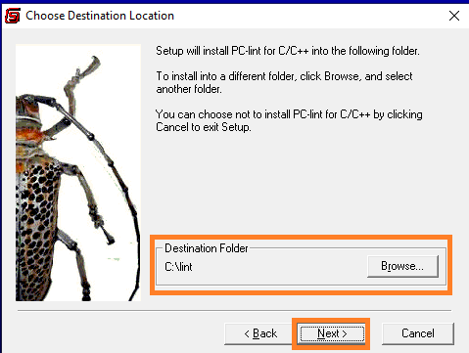

Figure 5

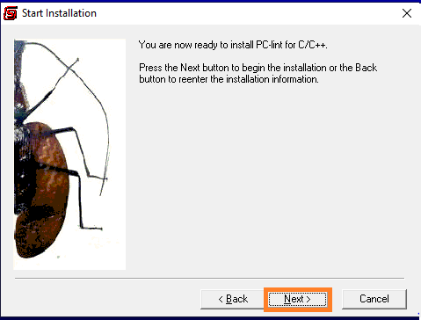

Figure 6

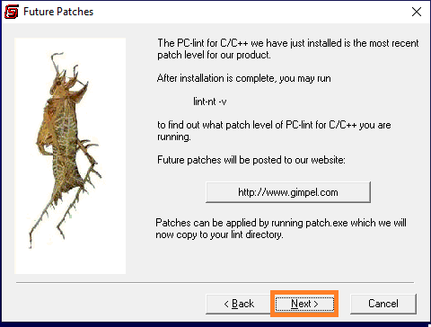

Figure 7

* Before Finish installing, uncheck the dialog box as shown in figure below;

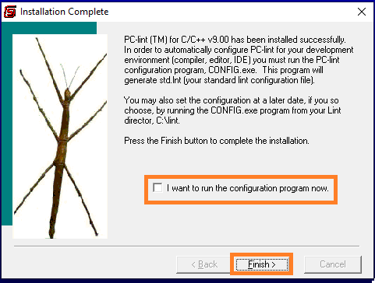

Figure 8

* Copy all Patch files from PC_lint Crack to the installed directory i.e. C:\lint

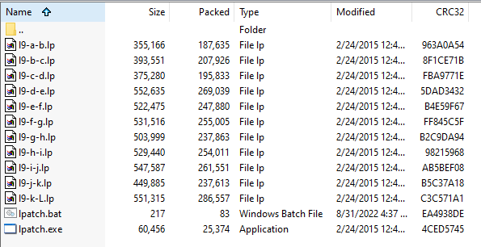

Figure 9

* Run **lpatch.bat** file (copied to installed directory) to apply Patches on PC lint

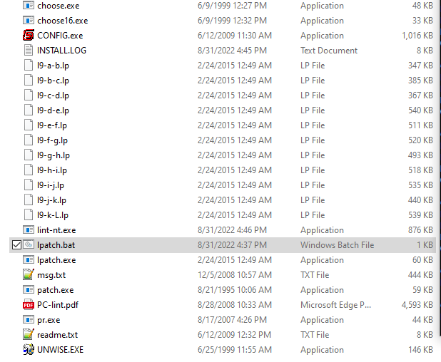

Figure 10

* Check PC-lint version 9.00L and then press enter

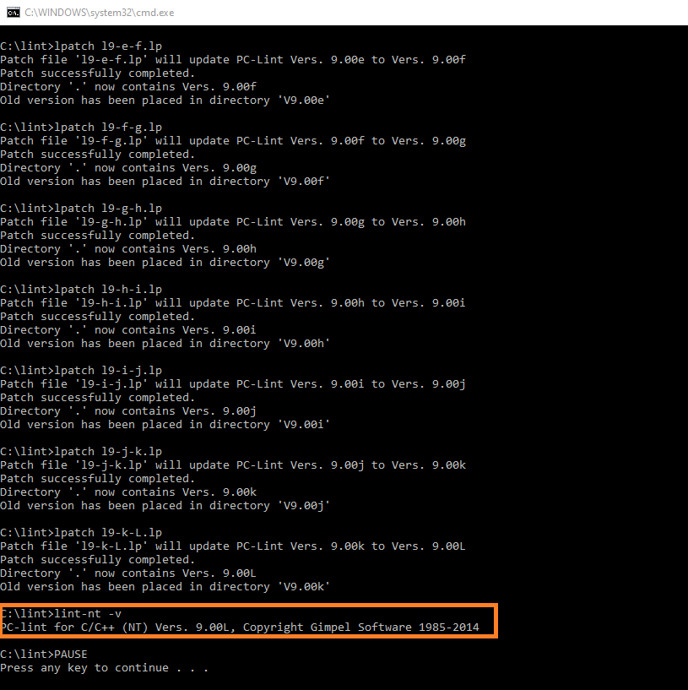

Figure 11

* Open SDK with any project
* Then after that you need to install **linticator** plugin into your SDK by clicking Install new software  
  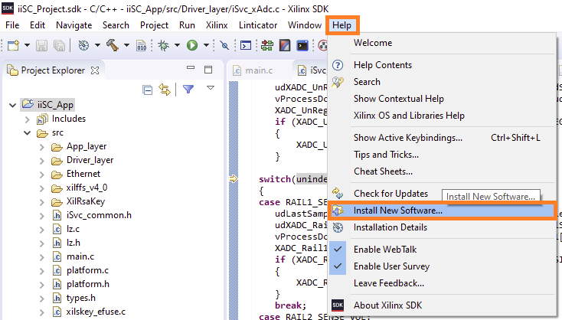

Figure 12

* Paste URL <https://eclipse-update-sites.s3.eu-central-1.amazonaws.com/linticator> .Click add in order to download the plugin.

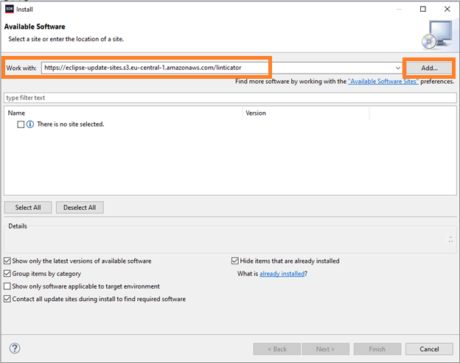

Figure 13

* Click Ok as shown below;

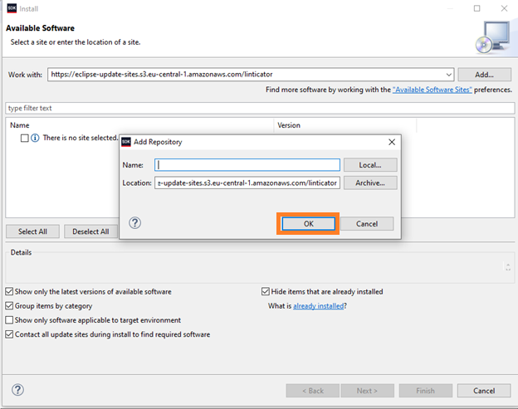

Figure 14

* Uncheck Linticator Quickfixes and hit next

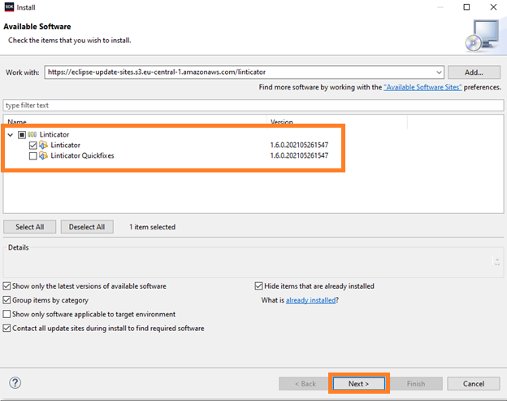

Figure 15

* Click next as shown in Figure 16

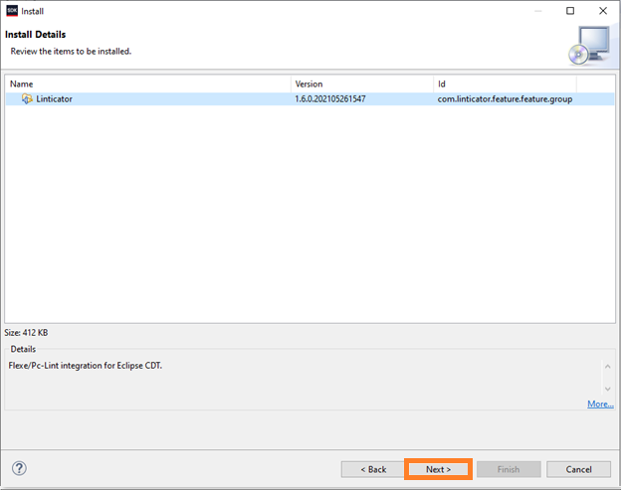

Figure 16

* Checkmark terms & conditions of license agreement and hit finish.

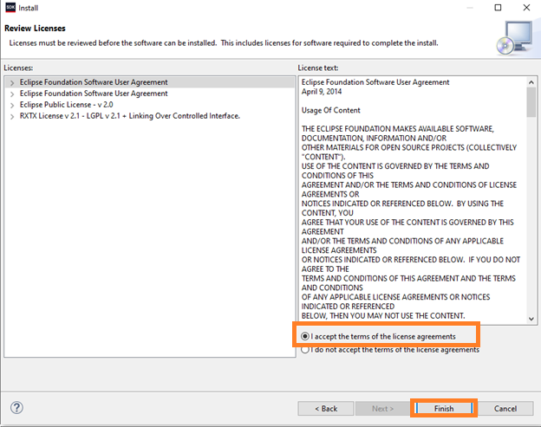

Figure 17

* Reboot SDK after installing plugin

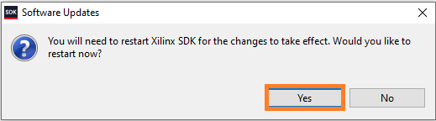

Figure 18

* Click Enable Linticator

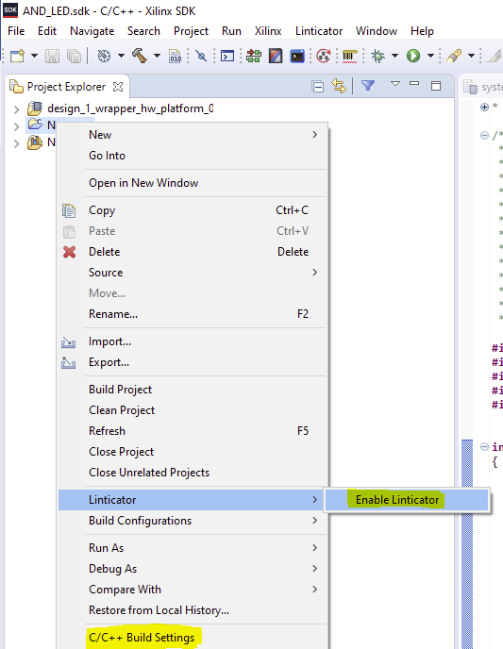

Figure 19

* **Optional step:** If you want to lint your project automatically after build then click configure linticator

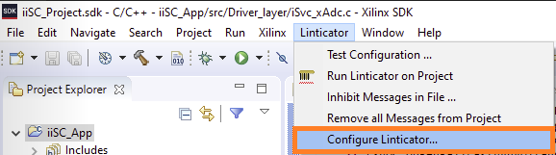

Figure 20

* Checkmark if you want to lint your project automatically.

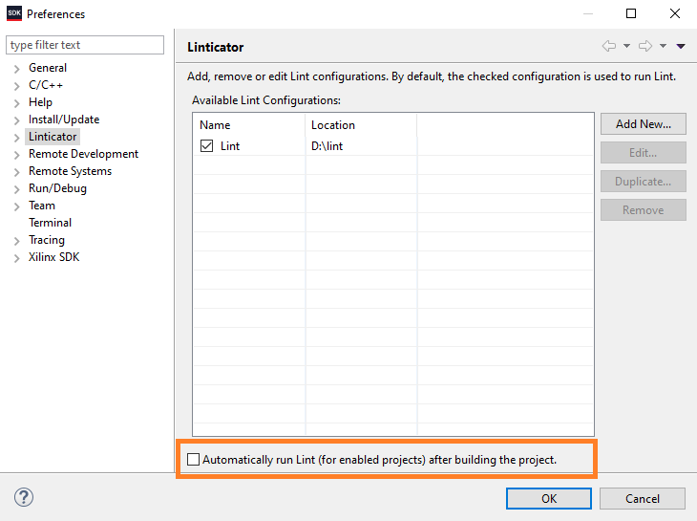

Figure 21

* Run Linticator on Project

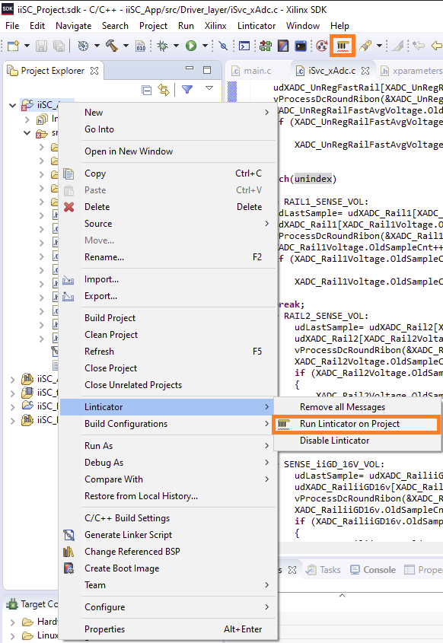

Figure 22

* Remove limit of Problems from configure contents menu;

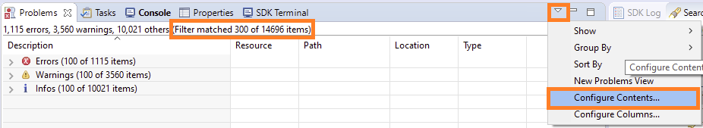

Figure 23

* Uncheck Use item limits and hit OK

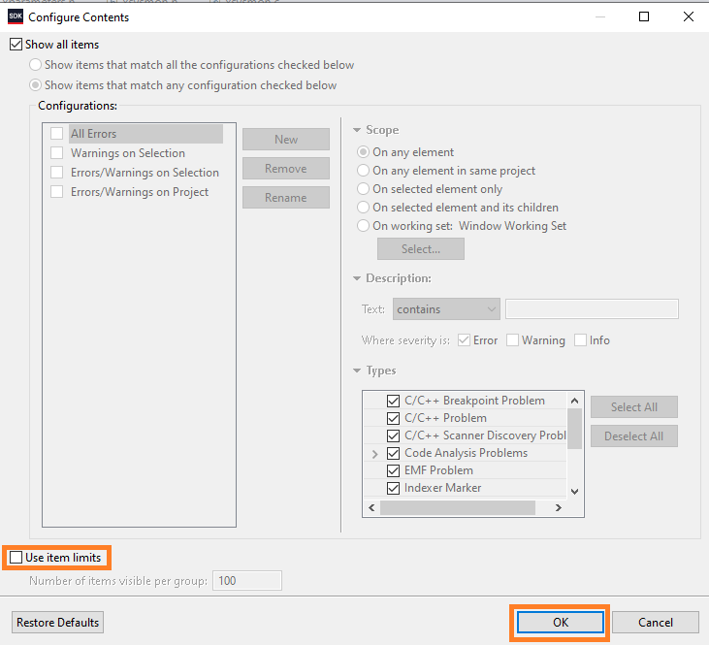

Figure 24

* Documentation View show the problem of error and possible solution

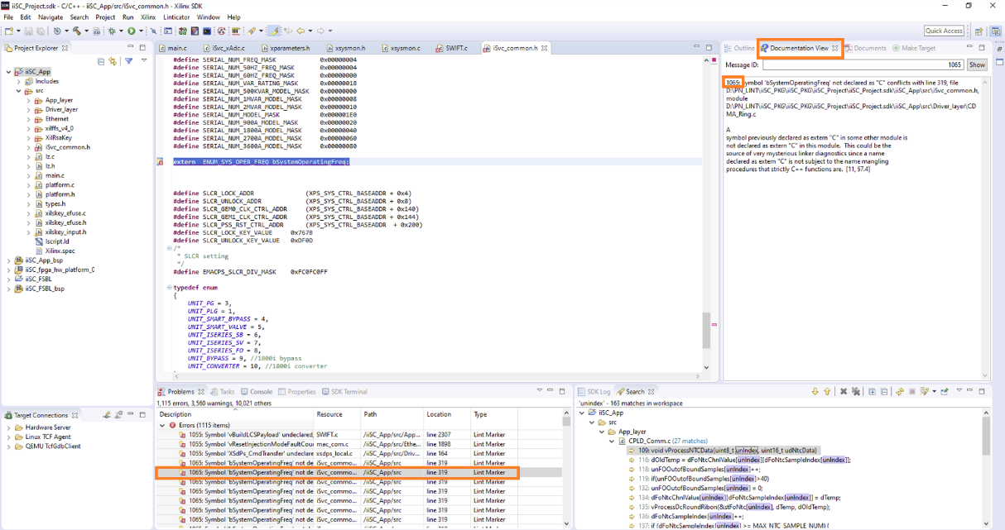

Figure 25

* Happy Linting with PC-Lint on eclipse

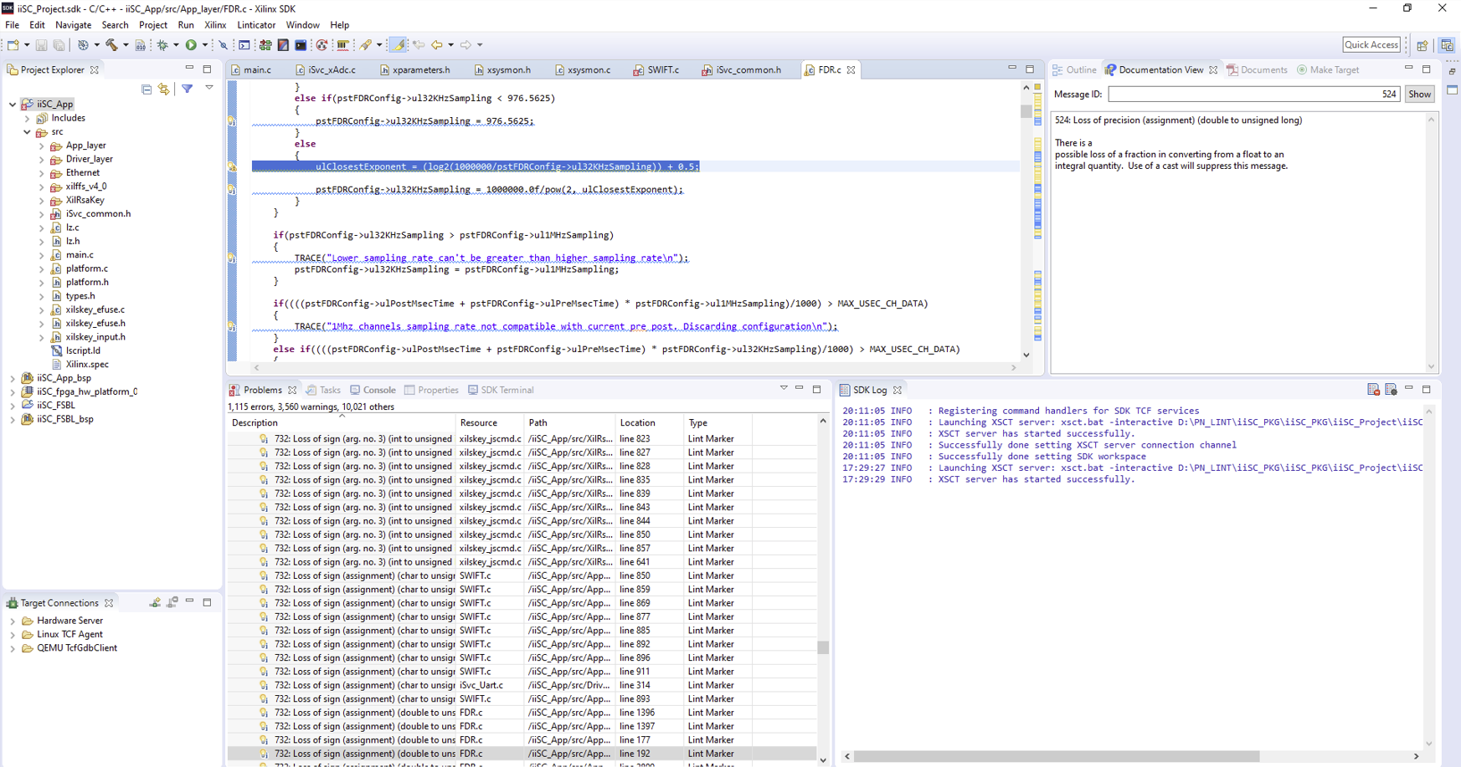

Figure 26