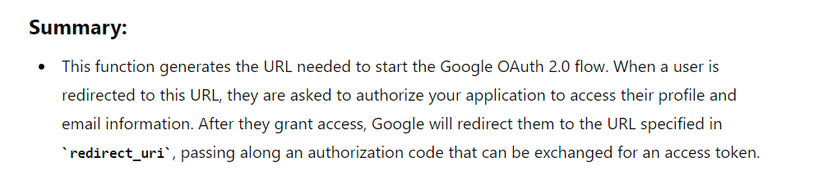

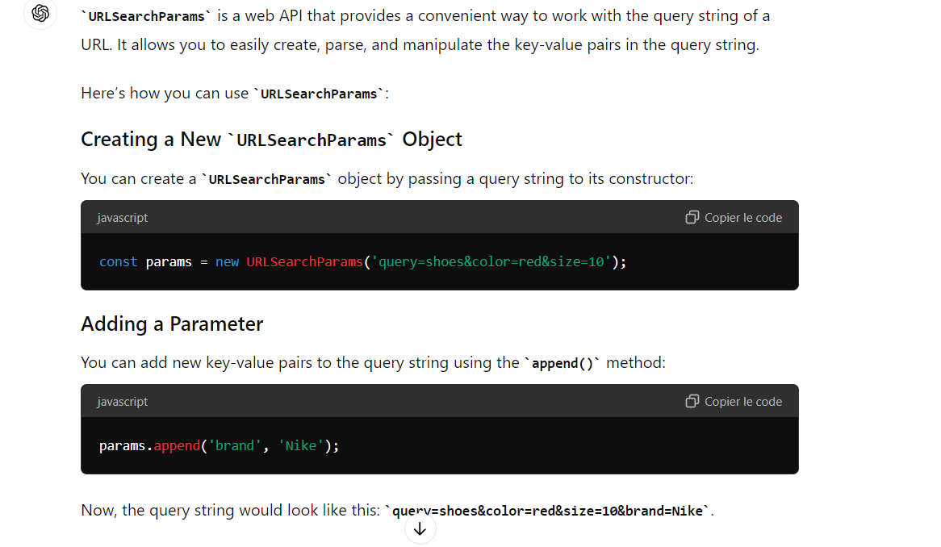

Microervice ;

This approach ensures that you're not creating posts for non-existent users. However, keep in mind a few considerations:

1. This introduces a dependency between your post service and user service. If the user service is down, you won't be able to create posts.
2. There's a slight performance hit as you're making an additional HTTP request for each post creation.
3. In a high-scale system, you might want to consider eventual consistency and allow post creation even if the user service is temporarily unavailable. You could then have a background job that periodically checks and cleans up any posts with invalid author IDs.
4. For even better performance and reliability, you could implement a caching layer or use a message queue system to keep a local copy of valid user IDs in the post service.

**http** :

HTTP (Hypertext Transfer Protocol) is the foundation of data communication on the web. It's a protocol used by web browsers and servers to communicate, allowing the transfer of information such as web pages, images, and other types of files. Here's an overview of how it works:

**1. Client-Server Model**

HTTP operates on a client-server model:

* **Client**: Typically a web browser or application making requests for resources.
* **Server**: Hosts the resources and responds to client requests, usually a web server.

**2. Requests and Responses**

Communication happens through HTTP **requests** and **responses**.

**HTTP Request:**

A client sends a request to the server, consisting of:

* **Request Line**: Includes the HTTP method, the resource URL, and the HTTP version (e.g., GET /index.html HTTP/1.1).
* **Headers**: Additional information (metadata) such as the client’s browser type, authentication tokens, content type, etc.
* **Body** (optional): Data sent to the server, usually with POST or PUT methods (e.g., form data or JSON payload).

**HTTP Response:**

The server replies with a response that includes:

* **Status Line**: Consists of the HTTP version, a status code, and a status message (e.g., HTTP/1.1 200 OK).
* **Headers**: Information about the server, content type, caching, etc.
* **Body** (optional): The actual content (e.g., HTML, JSON) requested by the client.

**3. HTTP Methods**

There are several methods used in HTTP requests to indicate the desired action:

* **GET**: Retrieve data from the server (e.g., loading a web page).
* **POST**: Send data to the server (e.g., submitting a form).
* **PUT**: Update or replace a resource.
* **DELETE**: Remove a resource from the server.
* **PATCH**: Partially update a resource.
* **HEAD**: Similar to GET, but only retrieves the headers, no body.
* **OPTIONS**: Describes the communication options available for the target resource.

**4. HTTP Status Codes**

Responses from the server include a status code indicating the result of the request:

* **2xx Success**: Request was successful (e.g., 200 OK).
* **3xx Redirection**: The client needs to take additional actions (e.g., 301 Moved Permanently).
* **4xx Client Errors**: There was an error in the request (e.g., 404 Not Found, 400 Bad Request).
* **5xx Server Errors**: The server encountered an error (e.g., 500 Internal Server Error).

**5. Statelessness**

HTTP is a **stateless** protocol, meaning each request is independent. The server does not store information about previous requests, which ensures scalability but requires mechanisms like **cookies** or **tokens** to maintain session information (state) between requests.

**6. HTTP Versions**

* **HTTP/1.1**: The most widely used version, introducing features like persistent connections (allowing multiple requests to be sent over the same connection).
* **HTTP/2**: Improves performance by multiplexing requests, allowing multiple requests to be processed simultaneously on the same connection.
* **HTTP/3**: Further enhances speed and security, using a different transport protocol called QUIC instead of TCP.

**7. Security (HTTPS)**

When security is needed, HTTP can be combined with **SSL/TLS** to form HTTPS (Hypertext Transfer Protocol Secure). This encrypts data between the client and server, protecting it from eavesdropping and tampering.

WEBSOCKET :

WebSocket is a communication protocol that provides full-duplex, bidirectional communication between a client (usually a browser) and a server over a single, long-lived connection. It’s designed to overcome the limitations of HTTP, which is inherently request-response-based, by allowing real-time, low-latency data transfer.

**Key Concepts of WebSockets**

1. **Full-Duplex Communication**
   * Unlike HTTP, where communication is initiated by the client, WebSocket allows both the client and the server to send messages to each other at any time. This is called full-duplex communication.
2. **Persistent Connection**
   * After the initial handshake, WebSocket creates a single TCP connection that remains open, allowing continuous communication between the client and server without the need to repeatedly open new connections.
3. **Real-Time Communication**
   * WebSocket is ideal for scenarios that require real-time data, such as chat applications, stock price updates, online gaming, and collaborative tools (e.g., Google Docs).
4. **Protocol Upgrade**
   * WebSocket connections start as standard HTTP requests. During the initial handshake, the protocol switches from HTTP to WebSocket, using the Upgrade header in the HTTP request/response. Once established, the WebSocket connection operates over a TCP connection without the overhead of HTTP headers for each message.

**How WebSocket Works**

1. **Client Initiates Handshake (Upgrade Request)**
   * The client starts by sending an HTTP request to the server, asking to upgrade the connection from HTTP to WebSocket using the Upgrade header.

1. **Server Responds with Upgrade Confirmation**
   * If the server supports WebSocket, it responds with an HTTP 101 status code (Switching Protocols), agreeing to switch the protocol.

1. **WebSocket Connection Established**
   * Once the handshake is complete, the WebSocket connection is open, and both the client and server can send and receive data freely.
   * Data is transmitted in small frames with minimal overhead, unlike HTTP requests that carry a significant amount of metadata (headers).
2. **Data Transmission**
   * WebSocket messages can be sent as **text** or **binary** data. The frames sent over the WebSocket protocol include information on the payload type and the actual data.
   * Messages are sent asynchronously, meaning either side can send data at any time without waiting for a response.
3. **Closing the Connection**
   * Either the client or server can close the connection by sending a close frame. Once the connection is closed, the client and server can no longer exchange messages unless a new WebSocket connection is established.

**Advantages of WebSocket**

* **Low Latency**: WebSocket allows real-time communication with minimal latency since it avoids the overhead of setting up new HTTP connections for every request-response cycle.
* **Efficient**: Once established, WebSocket communication avoids the repetitive sending of HTTP headers, making the data transmission lightweight and efficient.
* **Bidirectional**: Both client and server can push data to each other whenever necessary, which is crucial for applications like chat systems, live notifications, and collaborative platforms.
* **Scalability**: WebSocket connections can handle a large number of concurrent users, making them ideal for applications like multiplayer games, real-time data analytics, or financial trading platforms.

**Use Cases of WebSockets**

* **Chat Applications**: WebSocket is often used in real-time messaging systems like Slack or WhatsApp Web to maintain a live connection between the users and the server.
* **Live Feeds/Notifications**: Platforms that display real-time updates, such as stock tickers or live sports scores, use WebSocket for instant data delivery.
* **Collaborative Tools**: Applications like Google Docs or Figma that require live collaboration between users use WebSocket to synchronize changes in real-time.
* **Online Gaming**: Multiplayer games use WebSocket to send frequent updates to and from the server, ensuring a smooth experience for all players.

**WebSocket vs. HTTP/2 vs. Long Polling**

* **WebSocket**: Full-duplex, persistent connection that allows both the server and client to send messages at any time.
* **HTTP/2**: Multiplexing allows for multiple HTTP requests to be sent over a single connection, improving the efficiency of the HTTP protocol but still relying on a request-response model.
* **Long Polling**: A technique where the client repeatedly requests the server for updates. This can be inefficient compared to WebSocket because each new update requires a new HTTP request.

**Socket.IO :**

**Socket.IO** is a popular JavaScript library that makes working with **WebSockets** simpler and more robust by providing additional features like automatic reconnection, broadcasting, and the ability to fall back to other communication protocols (such as HTTP long polling) if WebSocket is not supported.

**How Socket.IO Works**

Socket.IO consists of two parts:

1. **Server-side**: A Node.js module (socket.io) that listens for incoming socket connections.
2. **Client-side**: A JavaScript library that is included in the browser or other clients and communicates with the server over WebSocket (or another protocol).

Unlike plain WebSocket, Socket.IO is designed to handle real-world issues such as:

* **Automatic reconnections**: If the client gets disconnected, Socket.IO will automatically attempt to reconnect.
* **Fallback options**: If WebSockets are unavailable (due to firewalls, proxies, etc.), Socket.IO can fall back to other protocols like HTTP long polling.
* **Event-based communication**: You can define and emit custom events between the client and server, making the API more flexible and readable.

**Basic Concepts in Socket.IO**

1. **Connection Event**: When a client connects to the server, both the client and server can listen for the connection event to start communication.
2. Une image contenant texte, capture d’écran, logiciel, Logiciel multimédia

   Description générée automatiquement

**Namespace** :

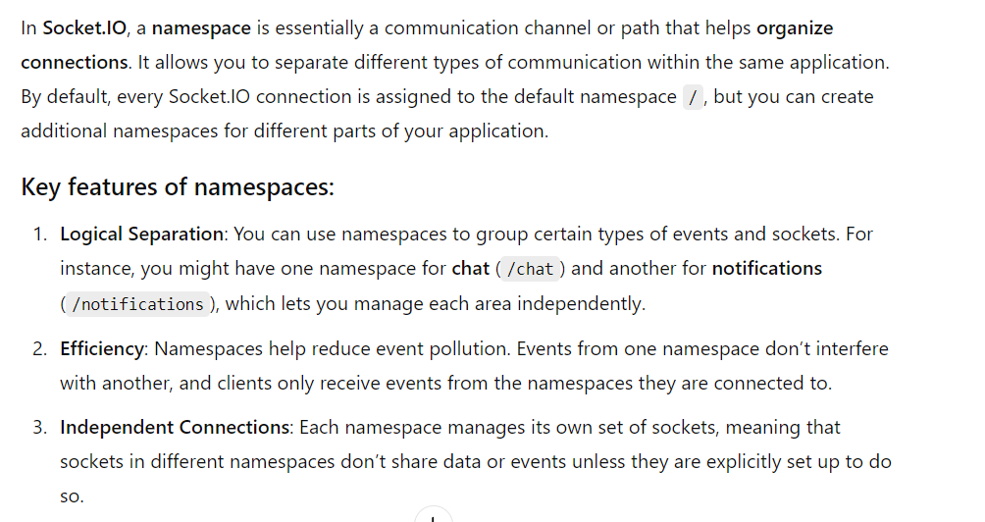

**ASYNC FUNCTION AND PROMISE :**

