What is an Agentic Browser and its use cases?
- SA Herdev Anish (1RVU23CSE385)

1. Shopping Assistant
When we do shopping online we usually start checking Amazon, Flipkart, Myntra, and Zepto just to find the best price for a whatever we are looking to buy.

The Problem: You spend 20 minutes jumping between apps, calculating delivery fees, and checking if your UPI discount applies.

The Agentic Use Case: You tell your browser, "Find me the best price for a boAt soundbar under ₹5,000, including shipping to Bangalore." The agent opens all those tabs in the background, finds the cheapest one, applies any "NEW50" coupons it finds, and stops at the payment page waiting for you to scan the QR code. It’s like having a friend who is a pro at finding deals.

2. Handling Government and College Forms
We all know that filling out government portals or college registration forms can be a nightmare. The websites are often slow, and the forms are miles long.

The Problem: You have to manually type your Name, Aadhaar number, Address, and CGPA into ten different boxes on five different pages.

The Agentic Use Case: You give the browser your Resume or a "Profile" file. When you go to a site like the Passport Seva or a job portal, you just say "Fill this." The agent recognizes the labels (even if the website is badly designed) and puts the right info in the right boxes. It’s like a smart "Autofill" that actually understands what it’s reading.

3. Planning Trips and Outings
Planning a trip from Bangalore to Goa involves more than just booking a flight. You need a hotel near the beach, a scooty rental, and a list of cafes that aren't "tourist traps."

The Problem: You end up with 20 tabs open and a massive headache trying to coordinate times and locations.

The Agentic Use Case: You tell the browser, "Plan a 3-day trip to Goa for ₹15,000 total. Book a hostel with good Wi-Fi and find me a flight that leaves after my Friday lab." The browser looks at flights on Indigo, checks ratings on Zomato for food, and maps everything out. It turns a 2-hour research project into a 2-minute conversation.

4. Smart Research for Students
When we’re studying for exams or working on a project, we usually search on Google, click a link, realize it’s useless, go back, and try again.

The Problem: Most of our time is wasted filtering through ads and "clickbait" articles to find the one actual code snippet or explanation we need.

The Agentic Use Case: You ask, "Explain the difference between Dijkstra’s and A* algorithm using a simple Indian road traffic example." The agent doesn't just give you links; it visits five different educational sites, reads them, and writes a custom explanation for you with a diagram. It’s like a tutor who reads the whole library so you don’t have to.

5. Automated "Work" Tasks
If you’re doing an internship, you might have tasks like "Find 50 startups in Mumbai and get their HR’s LinkedIn profile."

The Problem: This is "donkey work." It’s just clicking, copying, and pasting for hours.

The Agentic Use Case: You tell the browser, "Go to LinkedIn, search for startups in Mumbai, and put their names and website links into an Excel sheet." The agent does the all the clicking while we can work so something else. It treats the browser like a tool it can use just as well as a human can.

Autonomous vehicles and what made them happen
- S A Herdev Anish

1. A Quick History:
The dream of a car that drives itself is actually a century old. It evolved in three major waves:

- The Radio Wave (1920s-1930s): In 1925, a car called the "American Wonder" was driven through New York City via radio signals from a car following behind. People thought it was magic, but it was a giant remote-controlled toy.
- The "Smart Road" Wave (1950s-1960s): Engineers thought the secret was in the roads, not the cars. They built test tracks with magnetic cables buried under the asphalt. The car would "feel" the cable and follow it. This failed because you can't rebuild every road in the world just to fit a car.
- The "Vision" Wave (1980s-2000s): This is where it gets interesting for us. In 1986, Carnegie Mellon built Navlab 1, a van stuffed with a supercomputer. By 1995, their "No Hands Across America" project drove 4,500 km across the US, staying autonomous for 98% of the trip. The hardware was finally catching up to the vision.

2. What’s Available in the World Now?
Fast forward to 2026, and we are no longer in the "testing" phase; we are in the "scaling" phase.

- Waymo (The Gold Standard): Owned by Google’s parent company, Waymo is the leader. In cities like Phoenix, San Francisco, and Los Angeles, you can download an app and call a Waymo "Robotaxi." There is no human in the driver’s seat. It is a Level 4 autonomous vehicle, meaning it can handle everything within a specific city.
- Tesla (Full Self-Driving): Unlike Waymo, Tesla sells its cars to regular people. Their "FSD" (Full Self-Driving) software is Level 2/3, meaning it does the driving, but a human must stay alert. Tesla’s big bet is on "Vision Only"-using only cameras and no LiDAR to keep costs low.
- Zoox & Cruise: These are "purpose-built" vehicles. Zoox (owned by Amazon) doesn't even have a front or back; it looks like a carriage where passengers face each other. No steering wheel, no pedals, just a carriage on wheels.

3. How it Actually Works: The "Sense-Solve-Go" Loop
Whether it’s a Waymo or a Tesla, they all follow a similar logic loop that repeats every millisecond.

Step 1: Perception (Sense)
The car uses a "Sensor Fusion" to build a 3D model of the world.
- LiDAR: Shoots lasers to measure distances down to the centimeter.
- Cameras: Identify if a light is Red or Green and read "Stop" signs.
- Radar: Sees through rain and fog to track the speed of the car ahead.

Step 2: Prediction & Planning (Solve)
This is where the Deep Learning happens. The car's computer (the "Brain") doesn't just see a cyclist; it predicts where that cyclist will be in 3 seconds. It runs thousands of simulations in a heartbeat: "If I turn left now, will I hit that rickshaw? If I brake, will the car behind hit me?" It chooses the path with the highest safety score.

Step 3: Actuation (Go)
Finally, the "Brain" sends a signal to the Actuators. These are electric motors that physically move the steering rack, push the brake pads, or spin the wheels. In modern cars, this is all "Drive-by-Wire," meaning there is no physical cable- just bits and bytes turning into physical force.

Conclusion: Why now?
The reason we didn't have Waymo in 2010 is simple: Processing Power. We needed GPUs that could handle trillions of operations per second (TOPS) while fitting inside a car's trunk. Today, a single chip in a Waymo has more "thinking power" than all the computers used to put a man on the moon.

Number of parameters in AlexNet
AlexNet is a deep convolutional neural network introduced in 2012 by Alex Krizhevsky, Ilya Sutskever, and Geoffrey Hinton that dramatically advanced the field of computer vision. Designed for image classification, it won the ImageNet Large Scale Visual Recognition Challenge by a huge margin, cutting the error rate nearly in half compared to previous methods. What made AlexNet revolutionary was not just its depth eight learned layers was considered massive at the time but how it successfully combined key ideas like convolutional layers, ReLU activations, dropout for regularization, and training on GPUs to make deep learning practical at scale. Its success showed that neural networks could outperform traditional handcrafted features when given enough data and compute, sparking the modern deep learning boom and influencing almost every major vision model that followed.
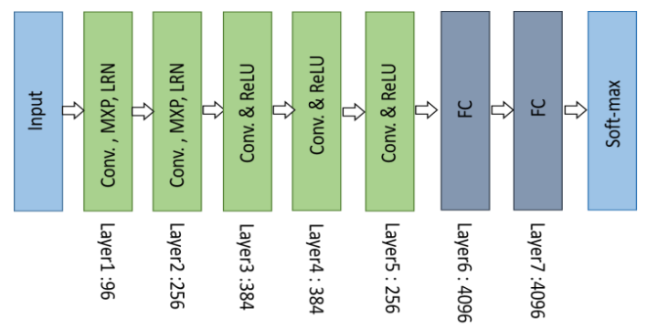
Architecture of AlexNet

Layer Type | Parameters | Calculation Details
Conv 1 | 34,944 | (121 * 3 + 1) * 96
Conv 2 | 614,656 | (25 * 96 + 1) * 256
Conv 3 | 885,120 | (9 * 256 + 1) * 384
Conv 4 | 1,327,488 | (9 * 384 + 1) * 384
Conv 5 | 884,992 | (9 * 384 + 1) * 256
FC 6 | 37,752,832 | (9216 + 1) * 4096
FC 7 | 16,781,312 | (4096 + 1) * 4096
Output | 4,097,000 | (4096 + 1) * 1000
TOTAL | 62,378,344 | ~62 Million

