Email:
Prompt:
Assume you are a head of marketing, i want you to draft an email for an upcoming college fest at RVU on Jan 14th and 15th, this is open to all of the students, we are going to have singers arjith singht and raghu dixit performing toghter, i want this to be the highlight for attracting people to come, i want you to also specify
Target audience: Undergraduate Engineering students.
Include:
- Date, time, and place (RVU campus)
- Registration details (form link)
- Contact information of the head Herdev ph number 1231235845
Tone: Energetic and enthusiasm
Word limit: 180–200 words, so short and sweet

Output:
Subject: Patang 2026 at RVU 🪁 | Arijit Singh & Raghu Dixit Live!
Hey RVU fam!
Get ready to lift off because PATANG 2026, RV University’s annual college fest, is happening on January 14th & 15th, and the campus is about to come alive like never before.
🎤 The biggest highlight?
Two iconic artists. One unforgettable stage.
Arijit Singh and Raghu Dixit performing LIVE together at RVU. From soulful melodies to high-energy beats, this performance alone makes Patang a must-attend.
But that’s not all 🚀
Patang 2026 brings you a power-packed lineup of exciting events, competitive hackathons, fun activities, games, and experiences spread across both days. Whether you’re into tech, creativity, or just vibing with friends, there’s something here for everyone.
📍 Venue: RV University Campus
📅 Dates: January 14 & 15, 2026
⏰ Time: Events all day, main performances in the evening
🎓 Open to: All Undergraduate Engineering students
📝 Register here:
👉 [Registration Form Link]
📞 Contact:
Herdev (Head, Marketing) — 1231235845
Come fly high with us at PATANG 2026 🪁
See you there! 🎉
— Team Patang, RVU

Image:
Prompt:
A minimal yet festive event poster for a college cultural festival called “PATANG 2026”.

The words “PATANG 2026” are written inside a colorful kite, forming the actual body of the kite, with elegant hand-painted typography.

The kite is flying in the sky with soft strings flowing naturally.

Background has a Holi-inspired vibe — gentle clouds of powdered colors (pink, yellow, blue, orange) blending softly, not overwhelming.

Clean white-to-pastel sky background, bright daylight.

Subtle festive Indian elements like tiny kites in the distance and faint confetti.

Modern, youthful, college-fest aesthetic.

Flat illustration style with slight depth, smooth gradients, high resolution, poster-friendly layout.

No clutter, no crowd, simple composition, joyful and energetic mood.

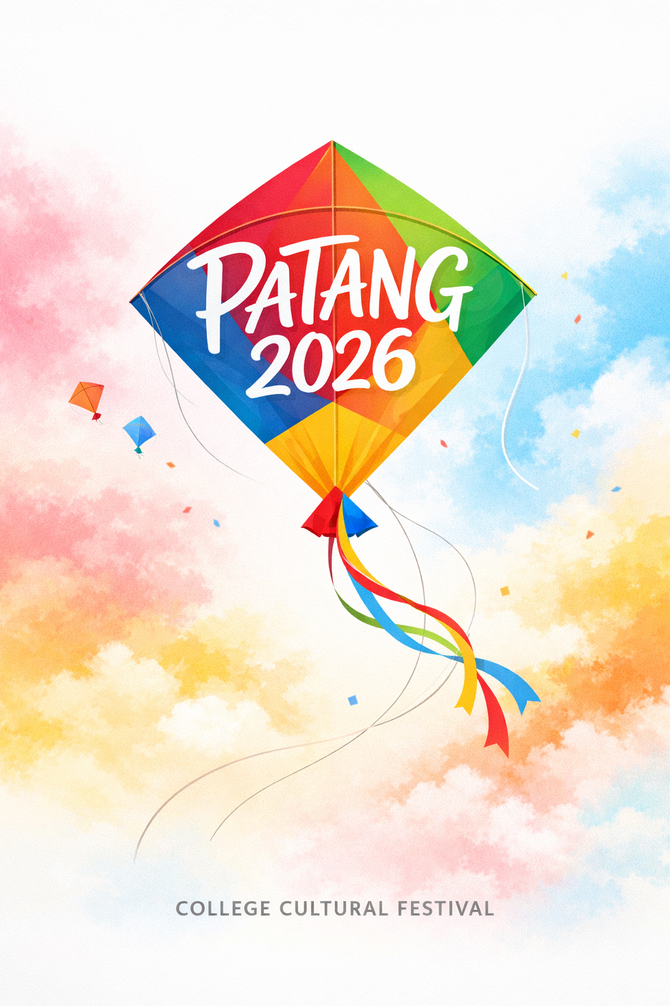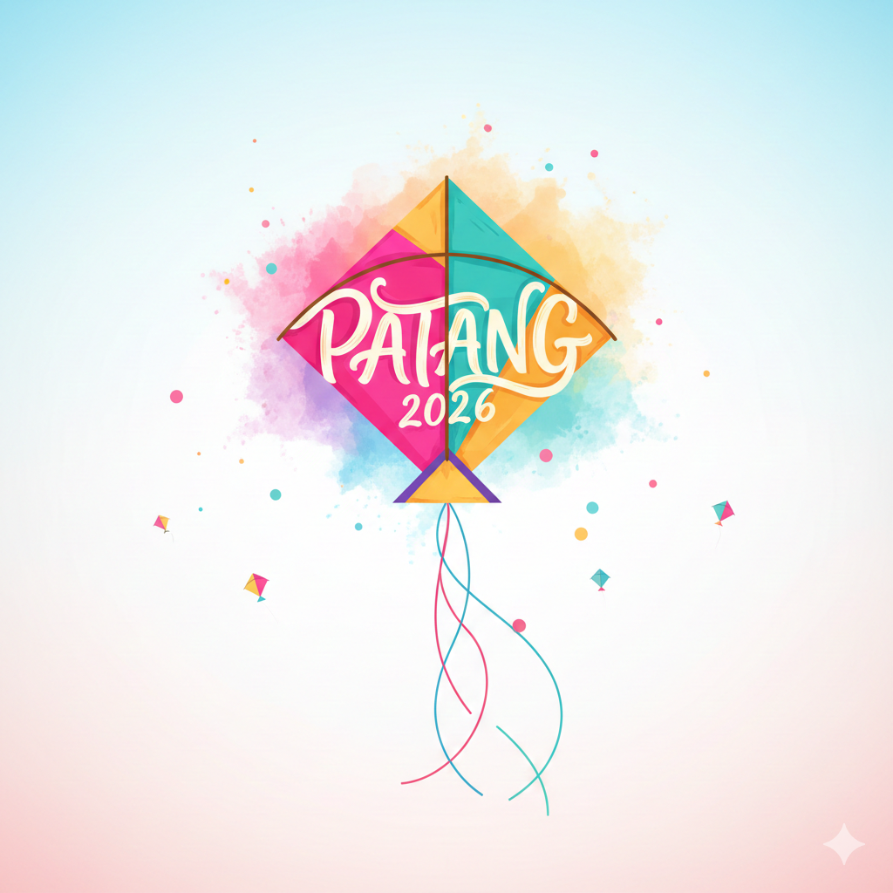
Prompt:
A modern tri-fold style brochure design for a university cultural and tech fest called “PATANG 2026”.
Bright, festive yet clean layout inspired by kites and Holi colors.
Background uses soft pastel color splashes (pink, yellow, blue, green) with a light sky texture.

Top section:
A colorful kite graphic with the title “PATANG 2026” integrated into the kite design.

Middle sections (clearly divided panels):
Clean icon-based sections with headings and short descriptions:

Hackathon (All Night) – moon & laptop icon, night sky gradient

Ideathon – lightbulb & brainstorm icon

Social Experiments – people interaction icon

Guinness World Record Attempt – large group forming a Rubik’s Cube mosaic portrait, top-down view illustration

Each event has simple timing labels like:
“Overnight Challenge”
“Daytime Event”
“Evening Highlight”

Bottom section:
Event details displayed neatly:
Dates: January 14–15, 2026
Venue: RV University Campus
Evening: Live Music Performances
Minimal text, strong visual hierarchy, easy-to-read typography, modern college fest aesthetic.
Flat illustration style with soft shadows, smooth gradients, brochure-ready layout, high resolution.
🧠 Optional Timing Emphasis Add-On
Add this line if you want time flow to be visually clear:

Include a subtle timeline design flowing left to right or top to bottom, with sun and moon icons indicating day and night events.

🎨 Style Control (Optional)

Use rounded shapes, friendly icons, bold section headers, and plenty of white space.
Color palette inspired by Indian festivals but toned down for readability.

🚫 Negative Prompt

Avoid realistic people, avoid cluttered text, avoid dark backgrounds, avoid excessive fonts, no logos, no watermarks, no photo-realism.
Ensure the tri-fold brochure uses all three panels fully, with no empty or blank areas. Each panel should be visually balanced and completely filled with relevant design elements, illustrations, or sections.

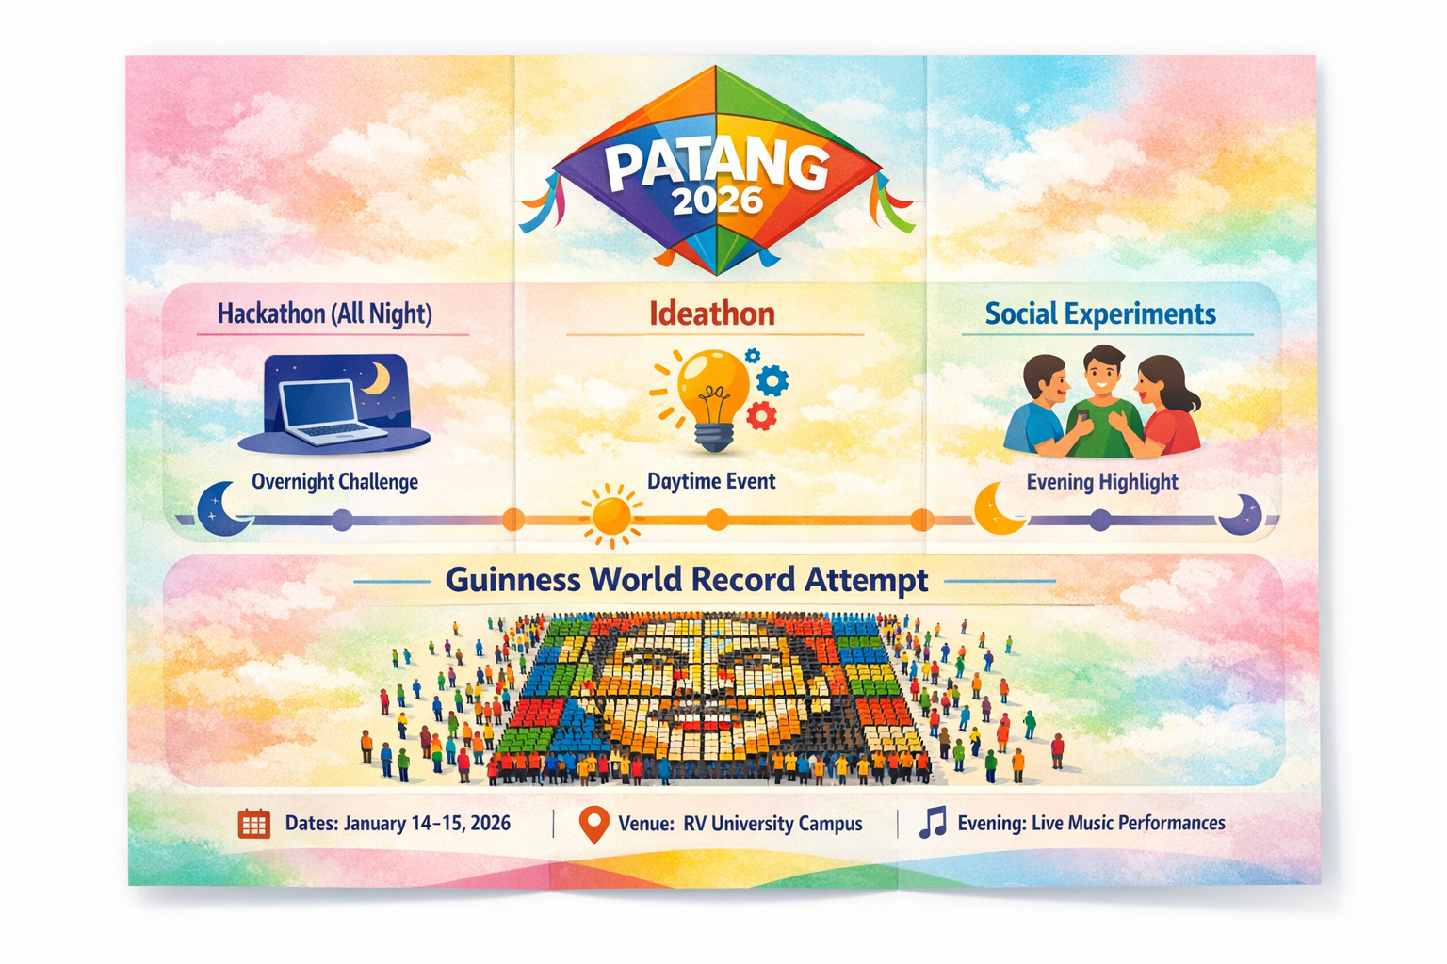
Audio:
Prompt:
Create a groovy, upbeat college fest anthem for “Patang 2026”.
Energetic, joyful, festival vibe.
Indie pop + desi funk with light EDM beats and Indian percussion.
Medium-fast tempo, danceable groove.
Lyrics about flying kites, colors, college life, late nights, hackathons, ideas, crowds, and togetherness.
Catchy chorus repeating “Patang 2026”, easy to sing along.
Youthful vocals, English with light Hindi words.

Video:
Prompt:
Create a 30–40 second vertical Instagram video promoting a college fest called “PATANG 2026”.
Hook (first 3 seconds):
Start with fast cuts of colorful kites flying and Holi color bursts, bold on-screen text:
“RVU, are you ready to fly?”
Upbeat groovy music starts immediately.
Main Content:
Show animated scenes of:
- All-night Hackathon (laptops, night sky)
- Ideathon & Social Experiments (ideas, people interaction)
- Guinness World Record attempt with a crowd forming a Rubik’s Cube portrait
Highlight Text Overlays:
- 2 Days. Endless Energy.
- January 14–15, 2026 | RV University
  - Big Events. Bigger Vibes.
Ending:
Festive kite flying into the sky with text:
“PATANG 2026 🪁 Don’t Miss It.”
Add a quick “Register Now” call-to-action.
Style:
Bright, clean, Holi-inspired colors, smooth transitions, modern college-fest vibe.

