

Heat exchanger AL
Report date | Mar 23, 2026, 1:32:24 AM

Contents
1. Global Definitions
1.1. Shared Properties
2. Component 1
2.1. Definitions
2.2. Geometry 1
2.3. Materials
2.4. Heat Transfer in Fluids
2.5. Turbulent Flow, k-ω
2.6. Multiphysics
2.7. Mesh 1
3. Study 1
3.1. Wall Distance Initialization
3.2. Stationary
3.3. Solver Configurations
4. Results
4.1. Datasets
4.2. Plot Groups

Global Definitions
Date | Mar 11, 2025, 6:41:37 PM

Global settings
Name | Heat exchanger AL.mph
Path | C:\Users\TL\Desktop\Heat exchanger\heat exchanger AL.mph
Version | COMSOL Multiphysics 6.2 (Build: 339)
Unit system | SI

Used products
COMSOL Multiphysics
CFD Module
CAD Import Module

Computer information
CPU | 12th Gen Intel(R) Core(TM) i5-1235U, 6 cores, 15.64 GB RAM
Operating system | Windows 11

Shared Properties

Default Model Inputs
Tag | cminpt

Component 1
Date | Mar 7, 2025, 1:56:10 AM

Settings
Description | Value
Unit system | Same as global system (SI)
Geometry shape function | Automatic

Spatial frame coordinates
First | Second | Third
x | y | z

Material frame coordinates
First | Second | Third
X | Y | Z

Geometry frame coordinates
First | Second | Third
Xg | Yg | Zg

Mesh frame coordinates
First | Second | Third
Xm | Ym | Zm

Definitions

Coordinate Systems

Boundary System 1
Coordinate system type | Boundary system
Tag | sys1

Coordinate names
First | Second | Third
t1 | t2 | n

Geometry 1
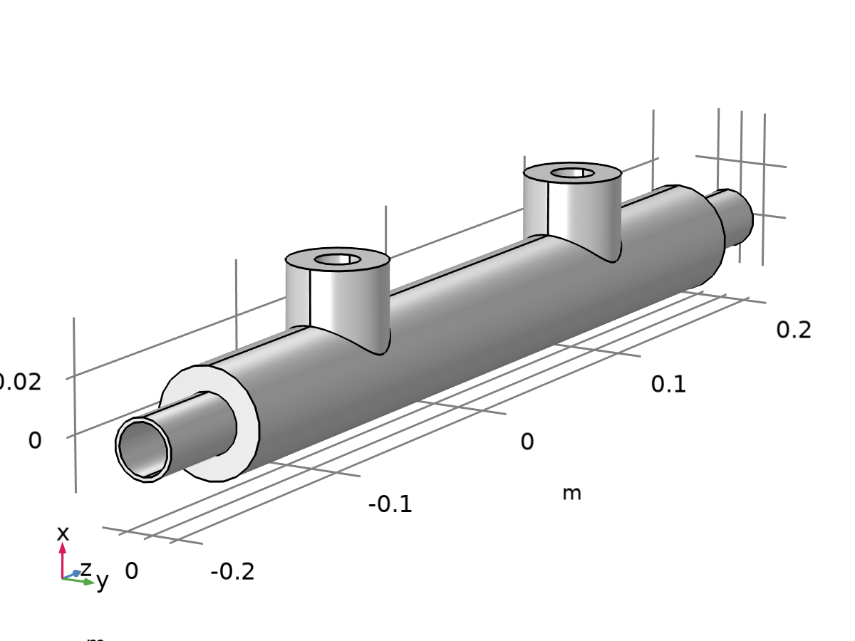
Geometry 1
Units
Length unit | m
Angular unit | deg

Geometry statistics
Description | Value
Space dimension | 3
Number of domains | 1
Number of boundaries | 22
Number of edges | 52
Number of vertices | 32

Import 1 (imp1)
Object selections
Description | Value
Source | 3D CAD file

Settings
Description | Value
Filename | C:\Users\TL\Downloads\Part11.SLDPRT

Boundary selections
Name | Keep | Physics | Contribute to
Boundary color 1 | off | On | none

Information
Description | Value
Details | Imported 1 solid object from C:\Users\TL\Downloads\Part11.SLDPRT.
Last build time | < 1 second
Built with | COMSOL 6.2.0.339 (win64), Mar 7, 2025, 2:02:07 AM

Form Union (fin)
Information
Description | Value
Details | {Formed union of 1 solid object., Union has 1 domain, 22 boundaries, 52 edges, and 32 vertices.}
Last build time | < 1 second
Built with | COMSOL 6.2.0.339 (win64), Mar 7, 2025, 2:02:28 AM

Materials

Aluminum [solid,bulk]
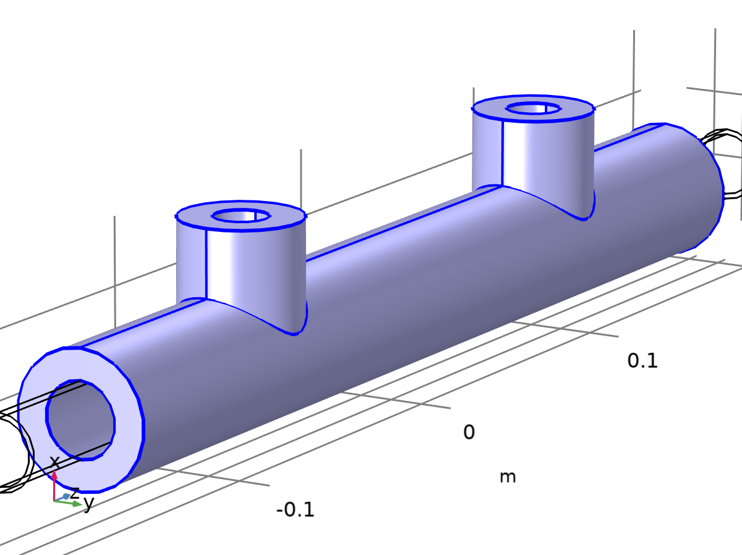
Aluminum [solid,bulk]
Selection
Geometric entity level | Boundary
Selection | Geometry geom1: Dimension 2: Boundaries 1–4, 13–22

Basic
Description | Value | Unit
Thermal conductivity | k_solid_bulk_1(T) | W/(m·K)
Resistivity | res_solid_1(T) | Ω·m
Coefficient of thermal expansion | (alpha_solid_1(T) + (-293 + Tempref)*if(abs(T - Tempref)>0.001, (alpha_solid_1(T) - alpha_solid_1(Tempref))/(T - Tempref), d(alpha_solid_1(T), T)))/(1 + alpha_solid_1(Tempref)*(-293 + Tempref)) | 1/K
Heat capacity at constant pressure | C_solid_1(T) | J/(kg·K)
Electrical conductivity | sigma_solid_1(T) | S/m
HC | HC_solid_1(T)
VP | VP_solid_1(T)
Density | rho_solid_1(T) | kg/m³
TD | TD_solid_bulk_1(T)

Functions
Function name | Type
k_solid_bulk_1 | Piecewise
res_solid_1 | Piecewise
alpha_solid_1 | Piecewise
C_solid_1 | Piecewise
sigma_solid_1 | Piecewise
HC_solid_1 | Piecewise
VP_solid_1 | Piecewise
rho_solid_1 | Piecewise
TD_solid_bulk_1 | Piecewise

Piecewise
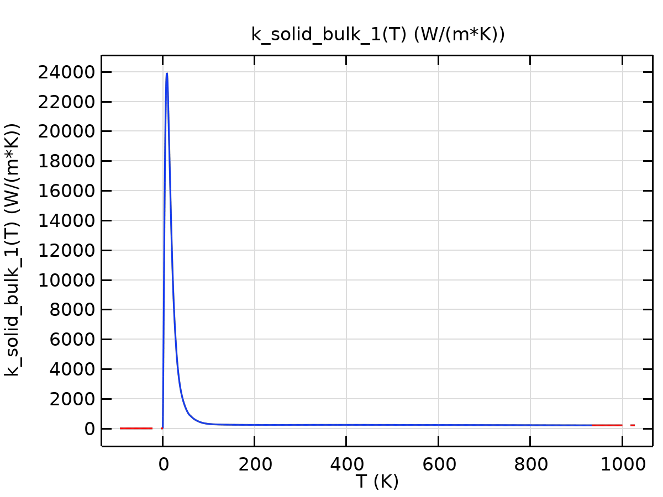
k_solid_bulk_1

Piecewise 1
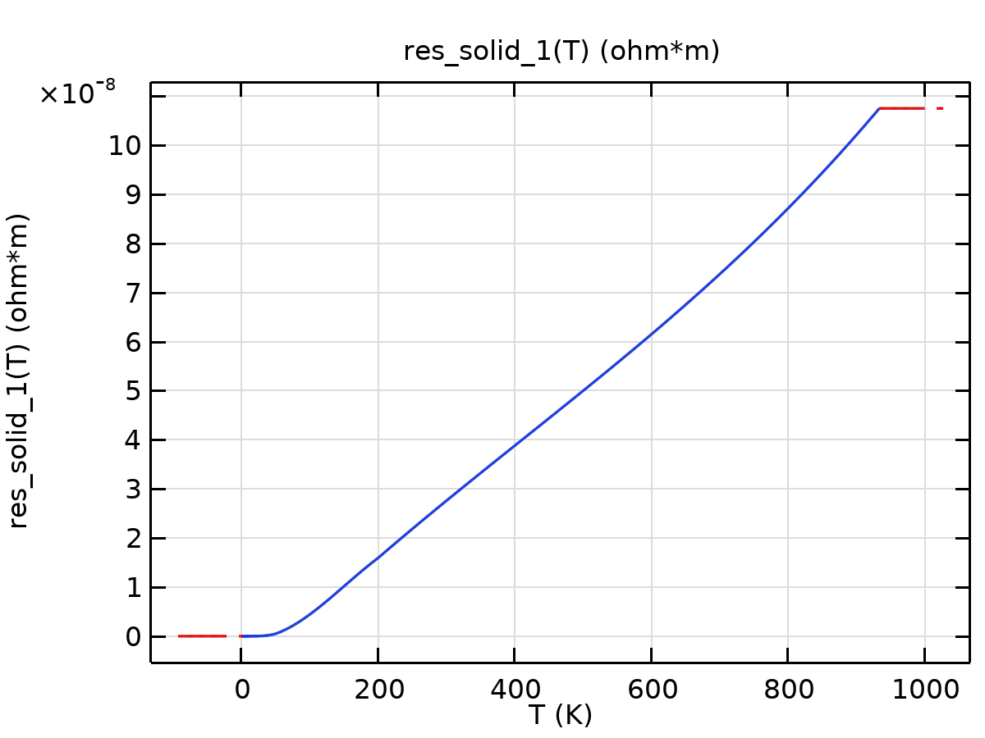
res_solid_1

Piecewise 2
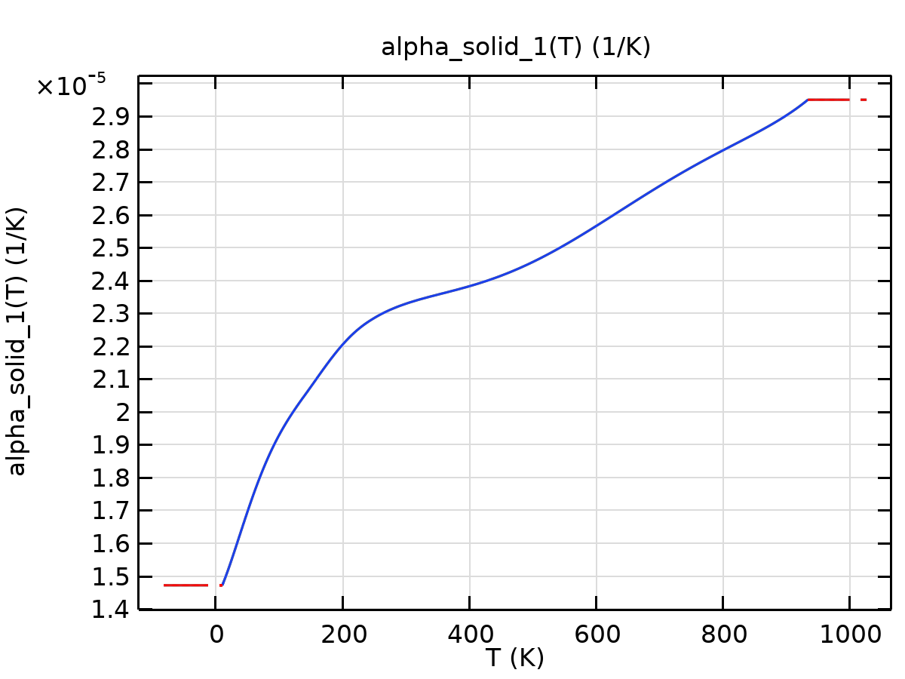
alpha_solid_1

Piecewise 3
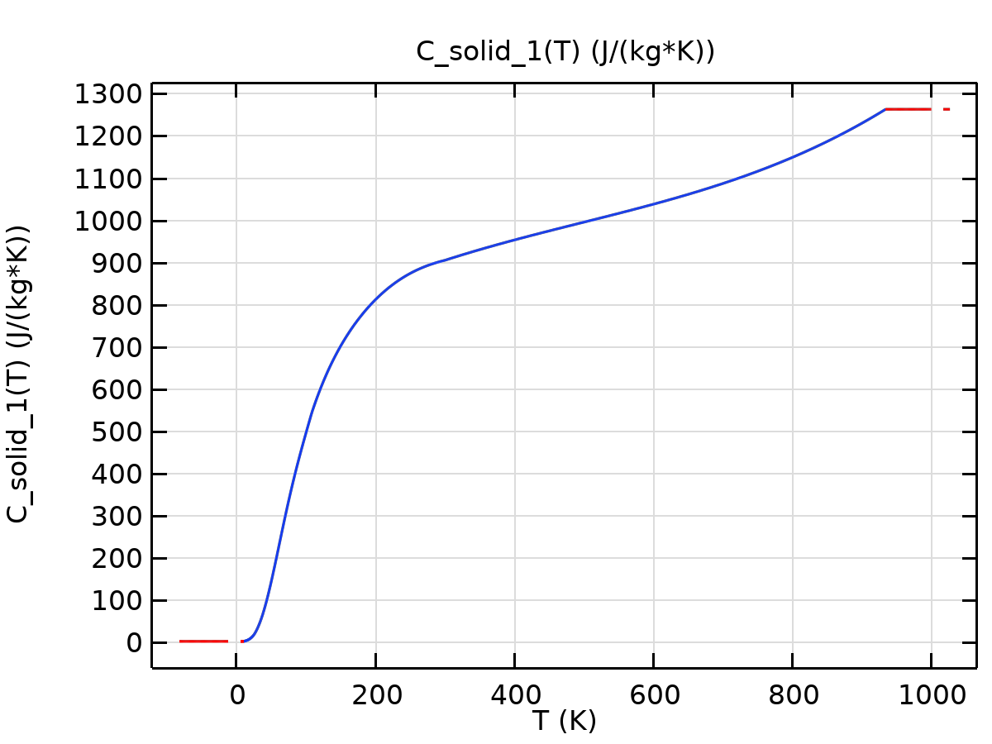
C_solid_1

Piecewise 4
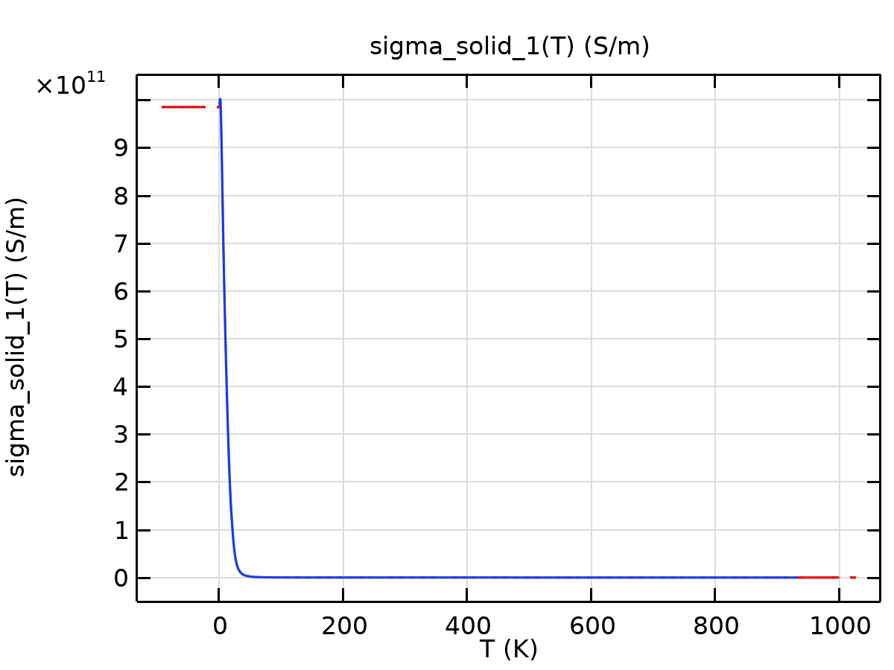
sigma_solid_1

Piecewise 5
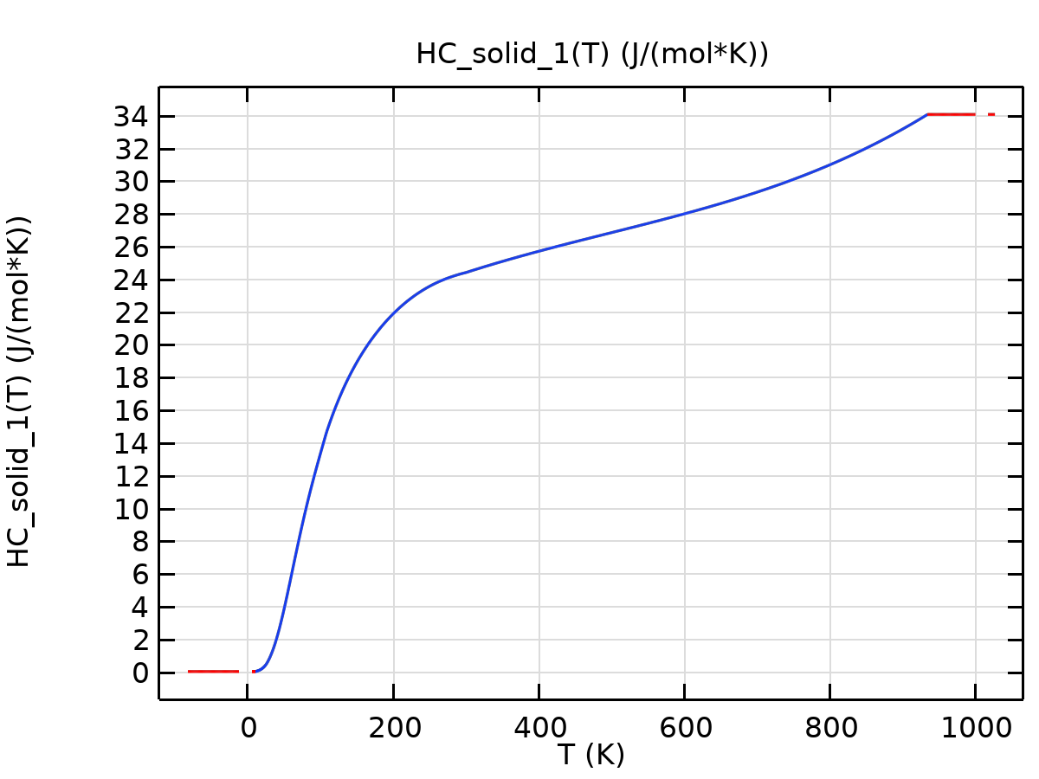
HC_solid_1

Piecewise 6
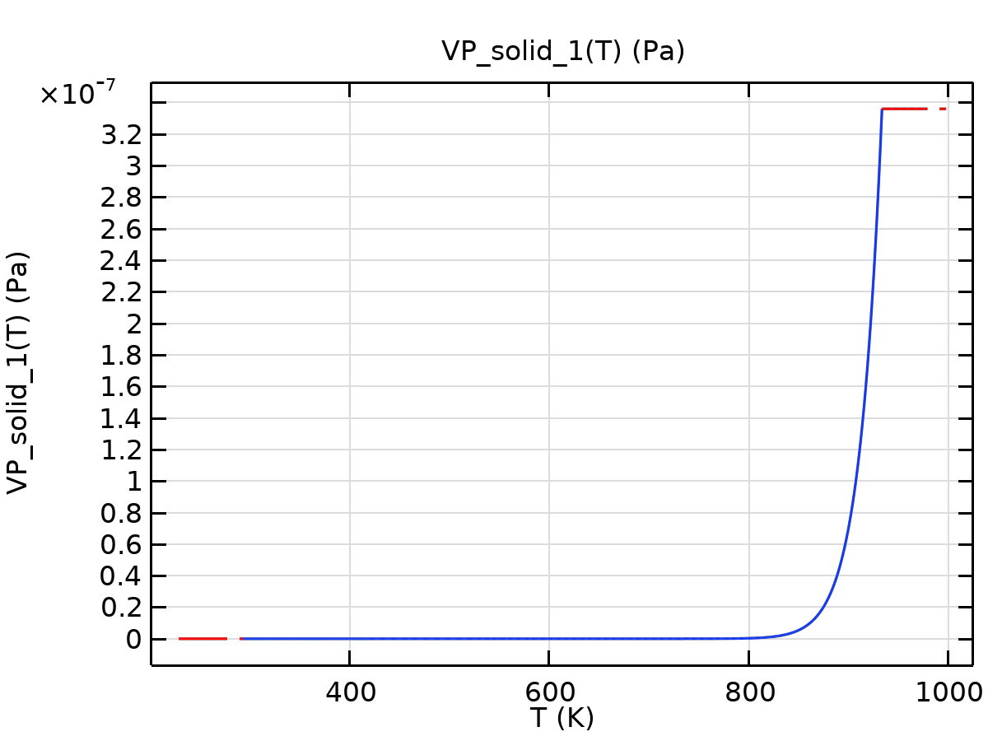
VP_solid_1

Piecewise 7
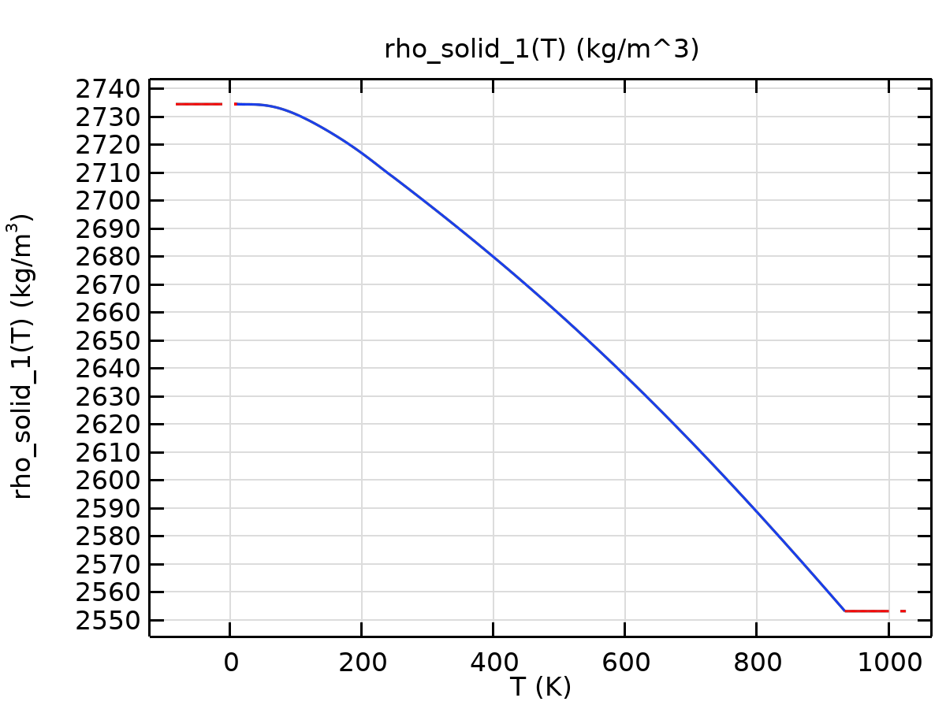
rho_solid_1

Piecewise 8
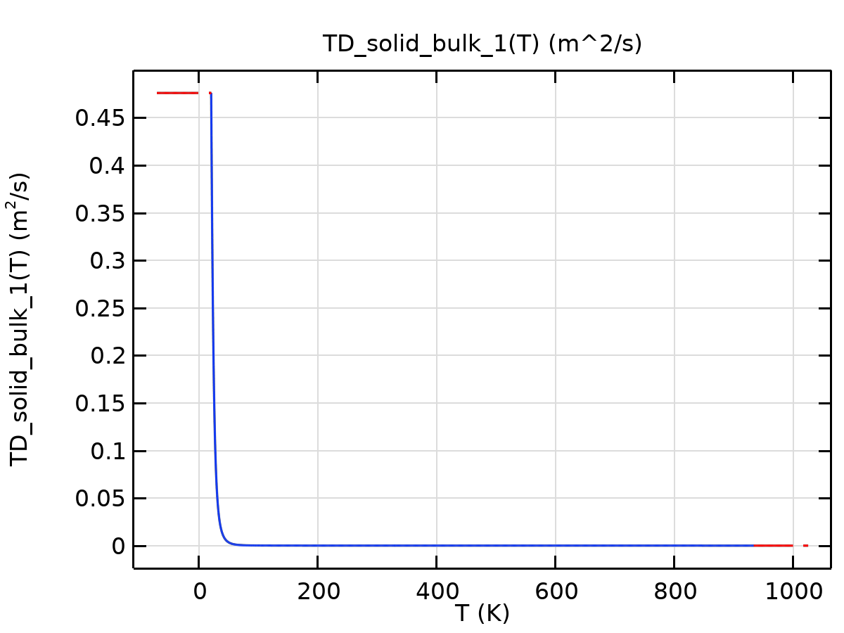
TD_solid_bulk_1
Thermal expansion
Description | Value | Unit
Tangent coefficient of thermal expansion | CTE_solid_1(T) | 1/K
Thermal strain | (dL_solid_1(T) - dL_solid_1(Tempref))/(1 + dL_solid_1(Tempref)) | 1

Functions
Function name | Type
dL_solid_1 | Piecewise
CTE_solid_1 | Piecewise

Piecewise
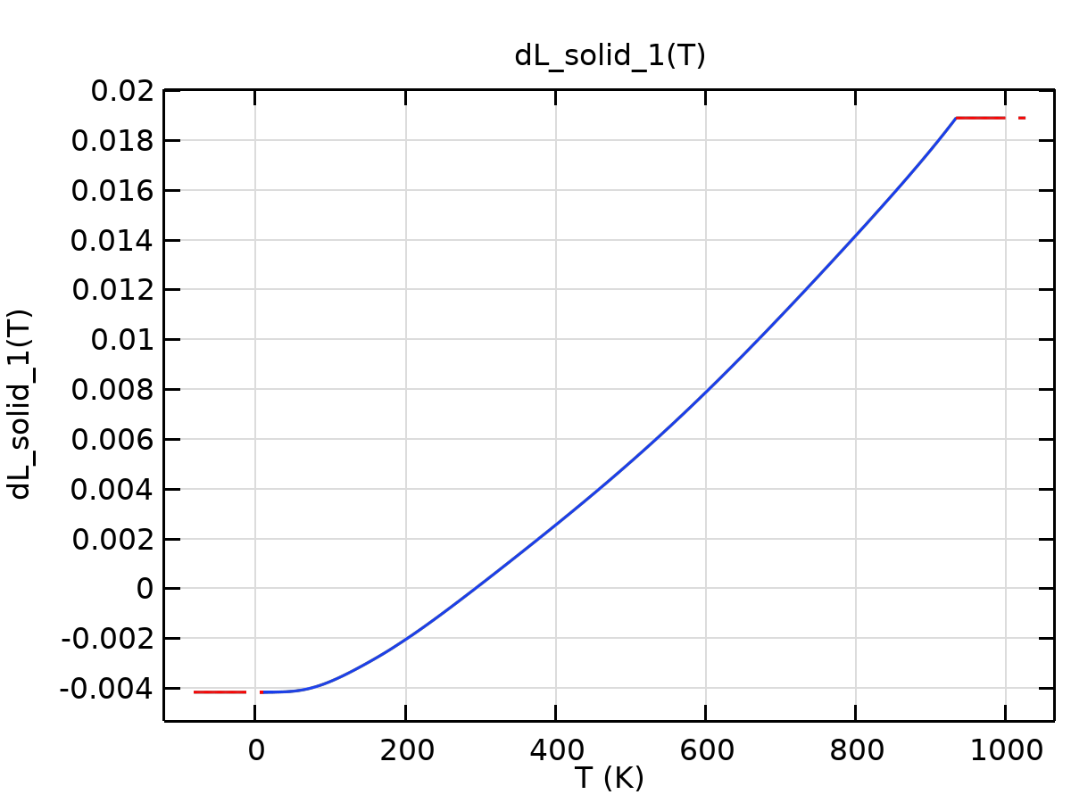
dL_solid_1

Piecewise 1
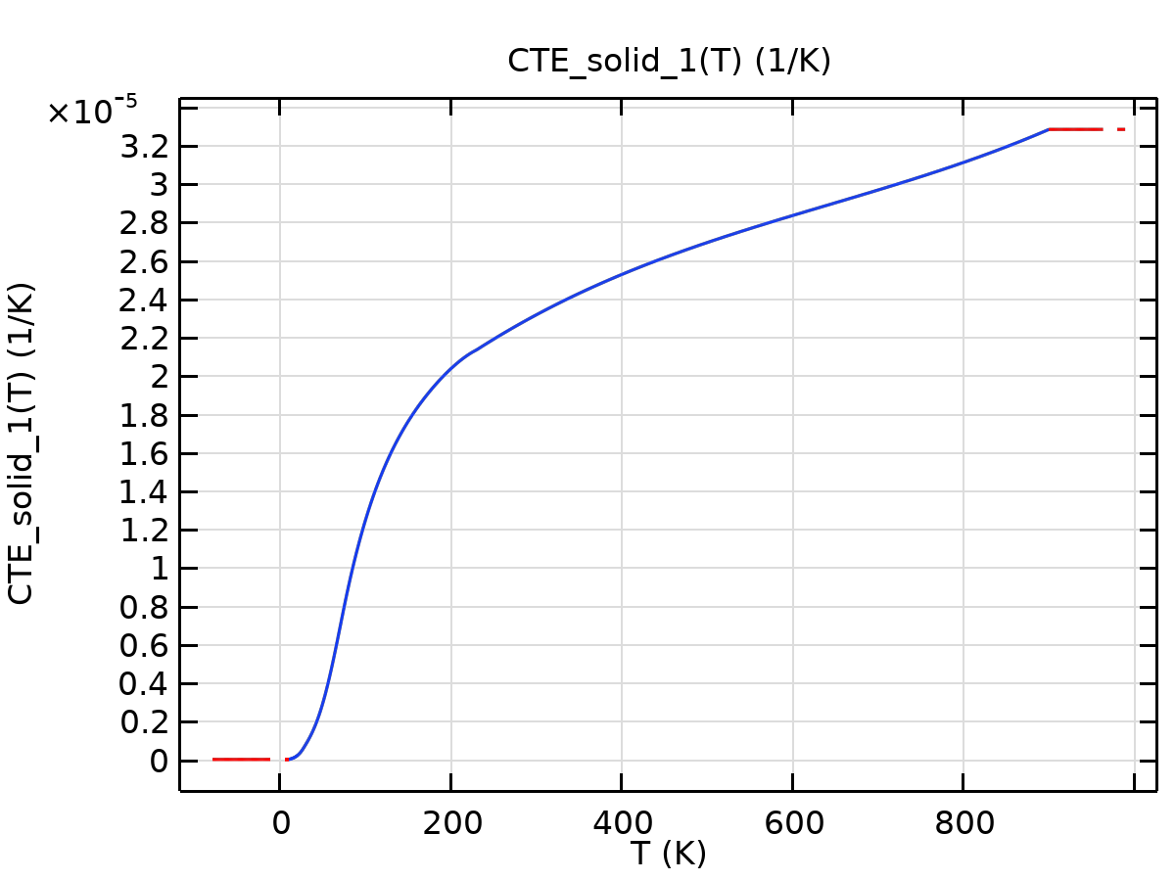
CTE_solid_1
Young's modulus and Poisson's ratio
Description | Value | Unit
Young's modulus | E(T) | Pa
Poisson's ratio | nu(T) | 1

Functions
Function name | Type
E | Piecewise
nu | Piecewise

Piecewise
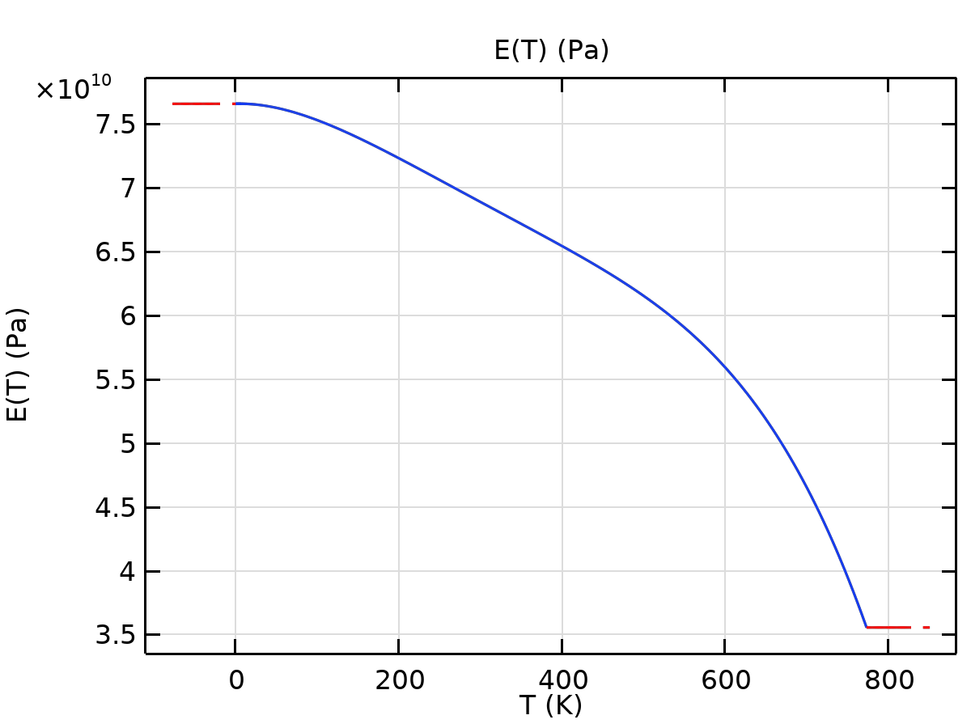
E

Piecewise 1
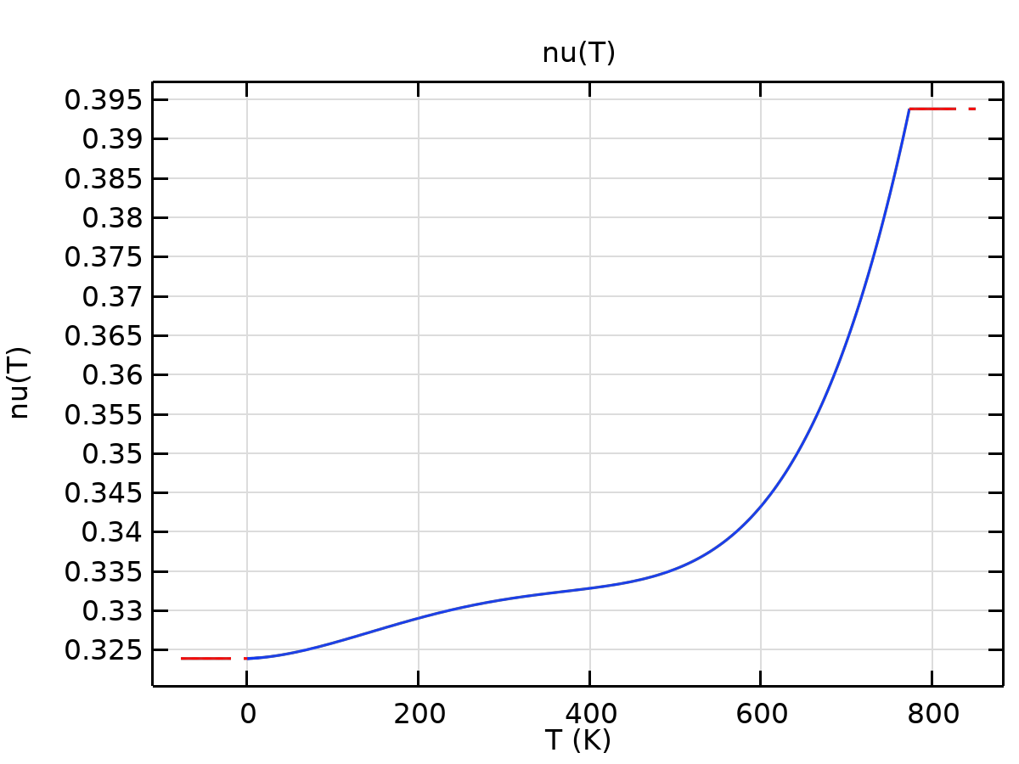
nu
Bulk modulus and shear modulus
Description | Value | Unit
Bulk modulus | kappa(T) | N/m²
Shear modulus | mu(T) | N/m²

Functions
Function name | Type
mu | Piecewise
kappa | Piecewise

Piecewise
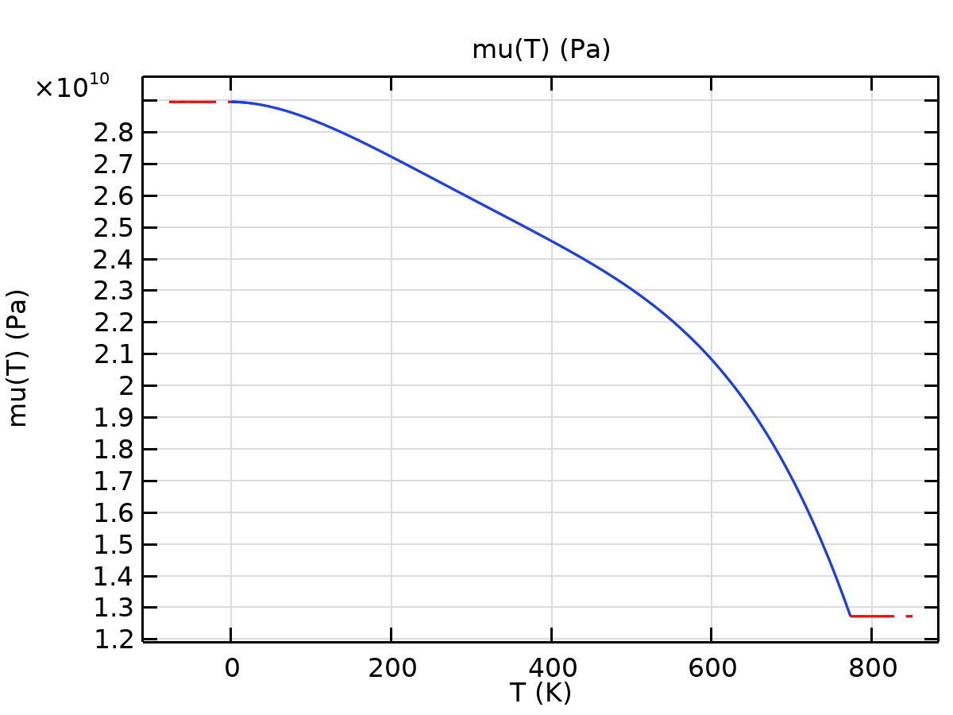
mu

Piecewise 1
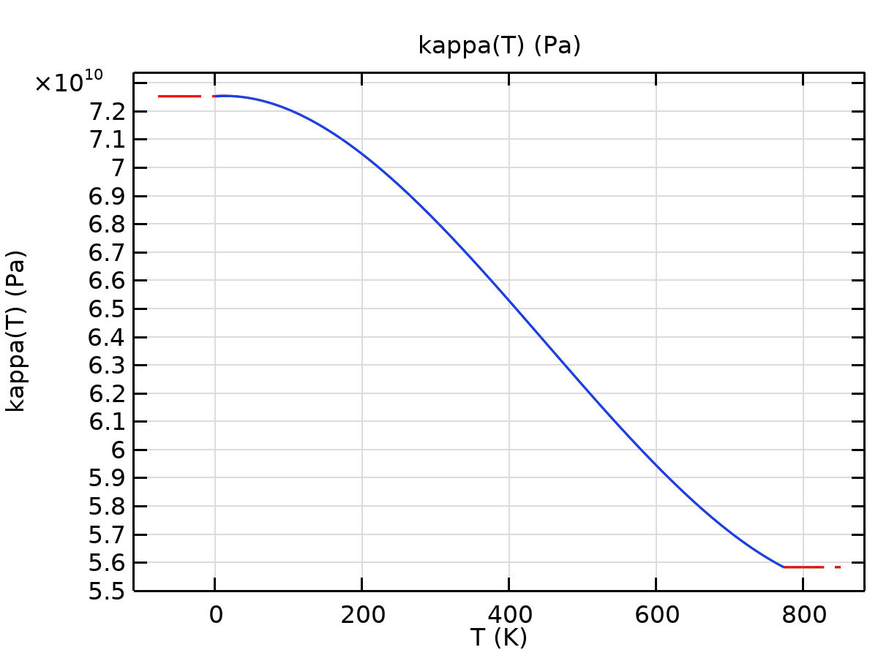
kappa

Copper [solid,oxidized]
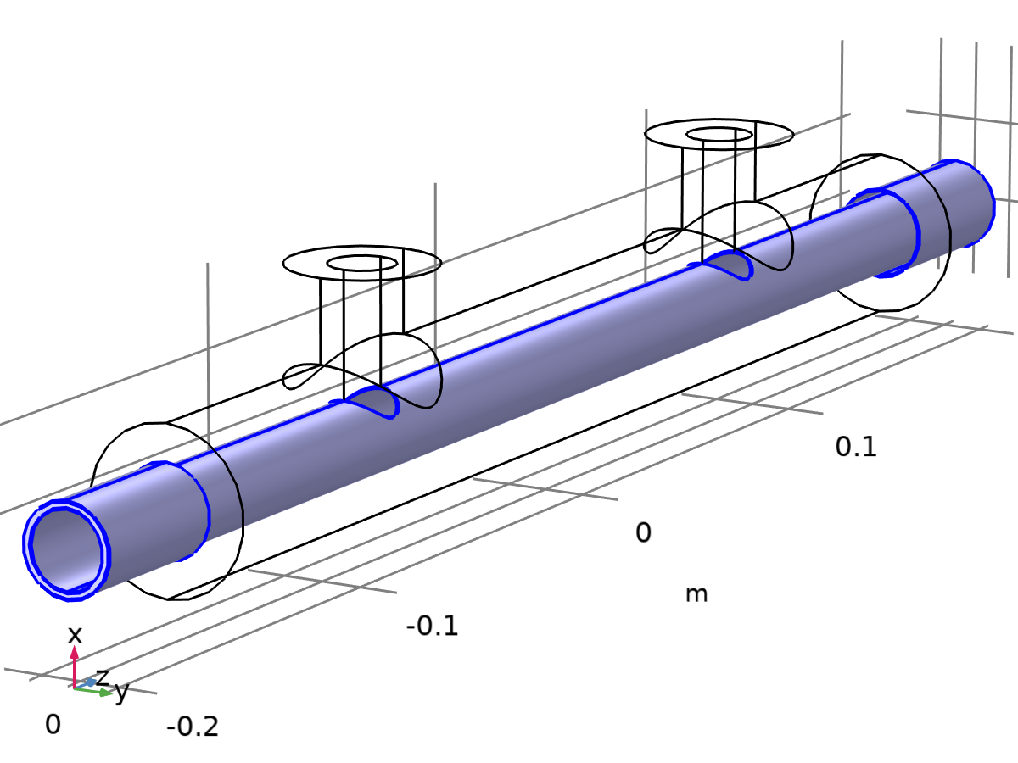
Copper [solid,oxidized]
Selection
Geometric entity level | Boundary
Selection | Geometry geom1: Dimension 2: Boundaries 5–9, 11–12

Basic
Description | Value | Unit
Coefficient of thermal expansion | (alpha_solid_1(T) + (-293 + Tempref)*if(abs(T - Tempref)>0.001, (alpha_solid_1(T) - alpha_solid_1(Tempref))/(T - Tempref), d(alpha_solid_1(T), T)))/(1 + alpha_solid_1(Tempref)*(-293 + Tempref)) | 1/K
Heat capacity at constant pressure | C_solid_1(T) | J/(kg·K)
HC | HC_solid_1(T)
VP | VP_solid_1(T)
Surface emissivity | epsilon_solid_oxidized_1(T) | 1
Density | rho_solid_1(T) | kg/m³
nemiss | nemiss(T)

Functions
Function name | Type
alpha_solid_1 | Piecewise
C_solid_1 | Piecewise
HC_solid_1 | Piecewise
VP_solid_1 | Piecewise
epsilon_solid_oxidized_1 | Piecewise
rho_solid_1 | Piecewise
nemiss | Piecewise

Piecewise
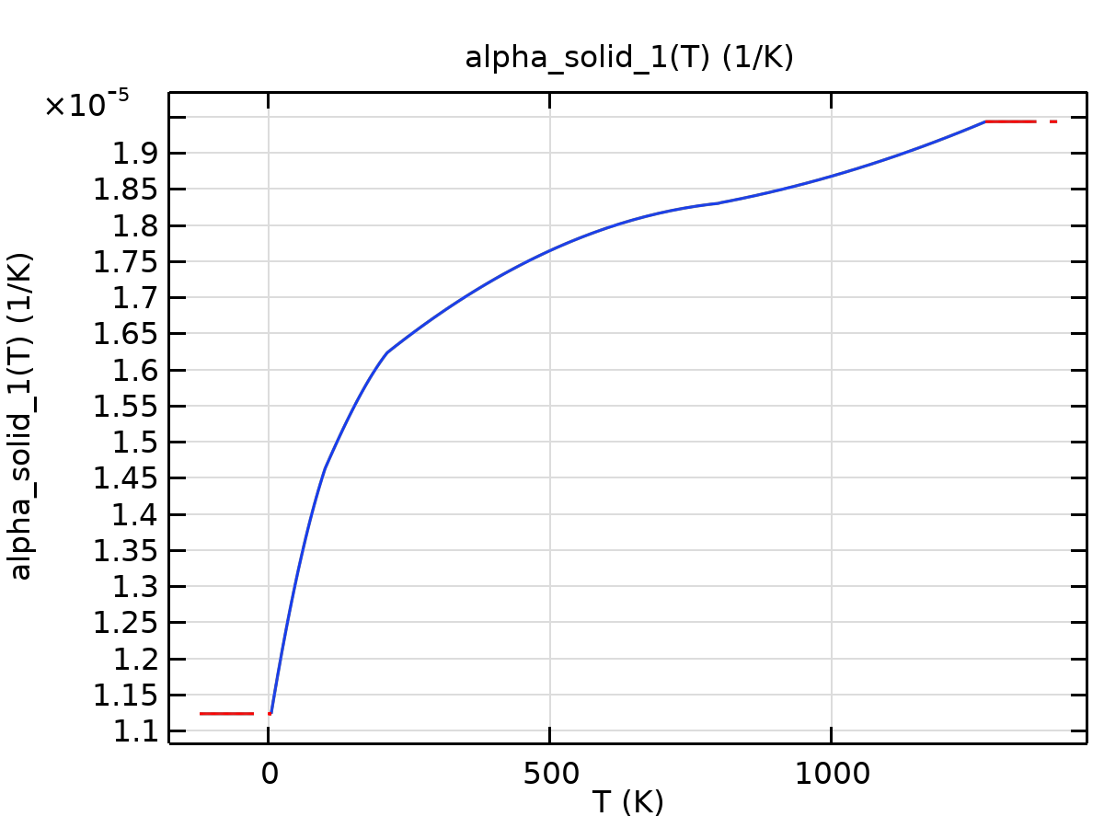
alpha_solid_1

Piecewise 1
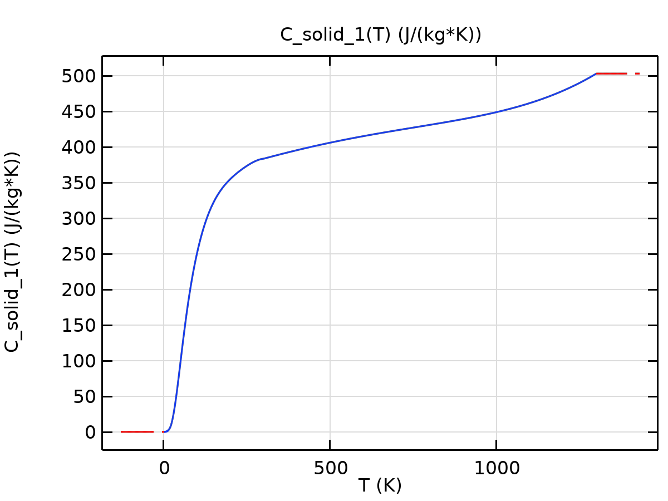
C_solid_1

Piecewise 2
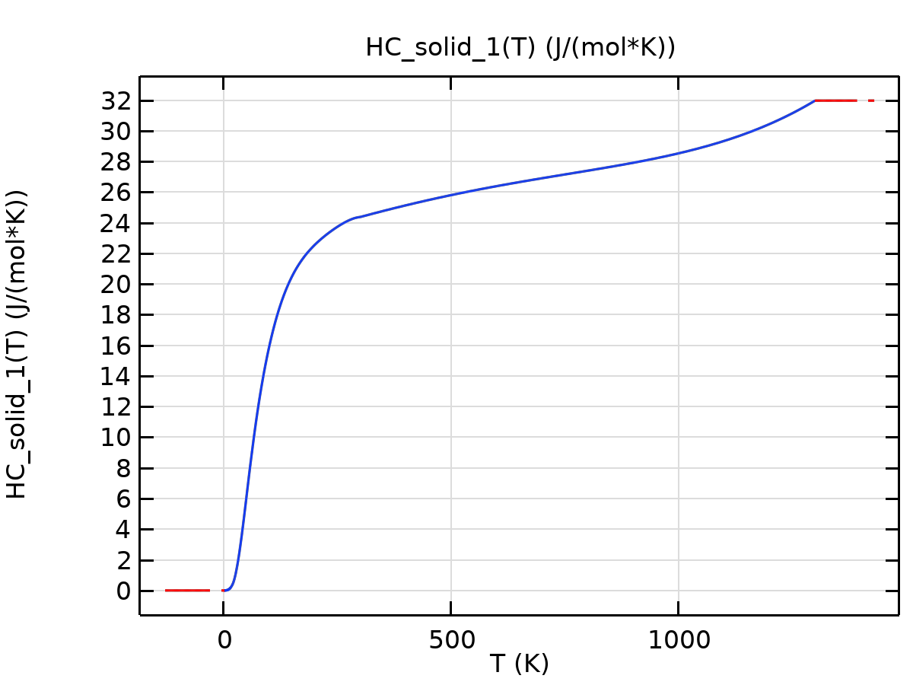
HC_solid_1

Piecewise 3
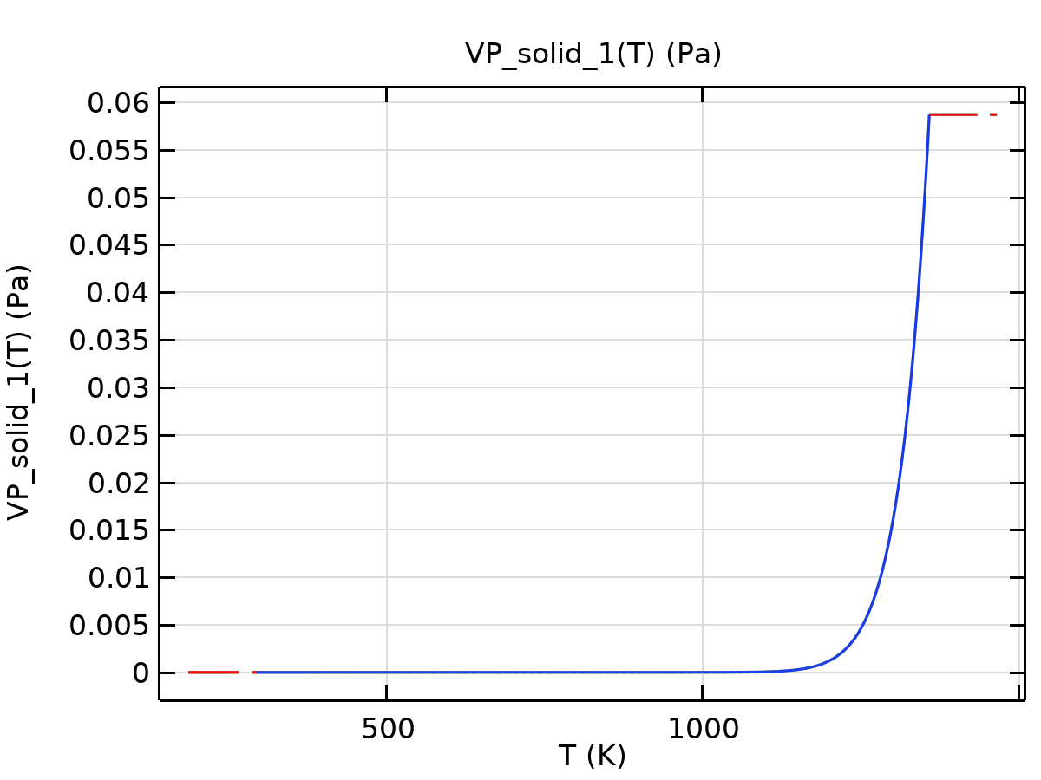
VP_solid_1

Piecewise 4
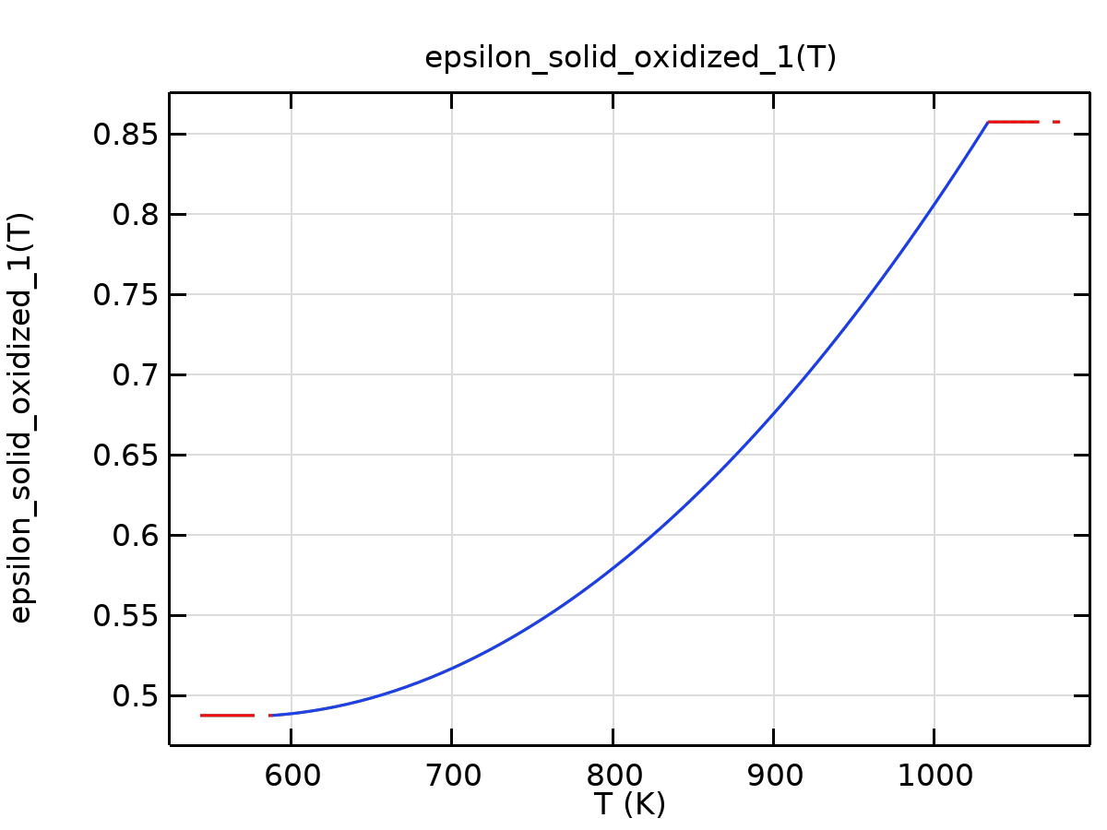
epsilon_solid_oxidized_1

Piecewise 5
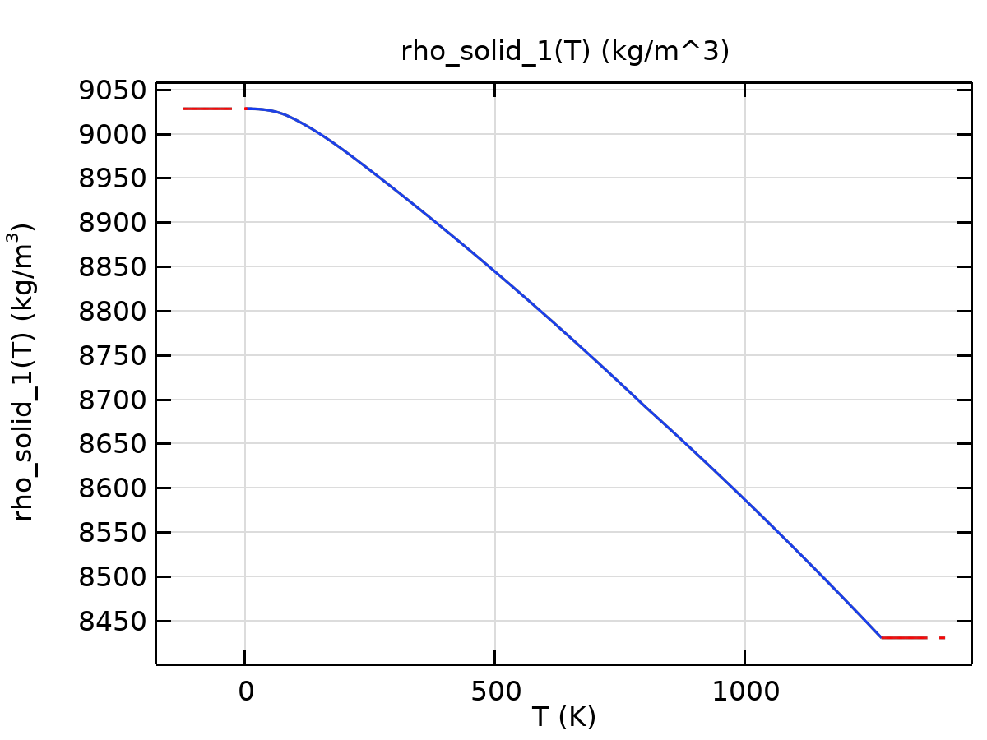
rho_solid_1

Piecewise 6
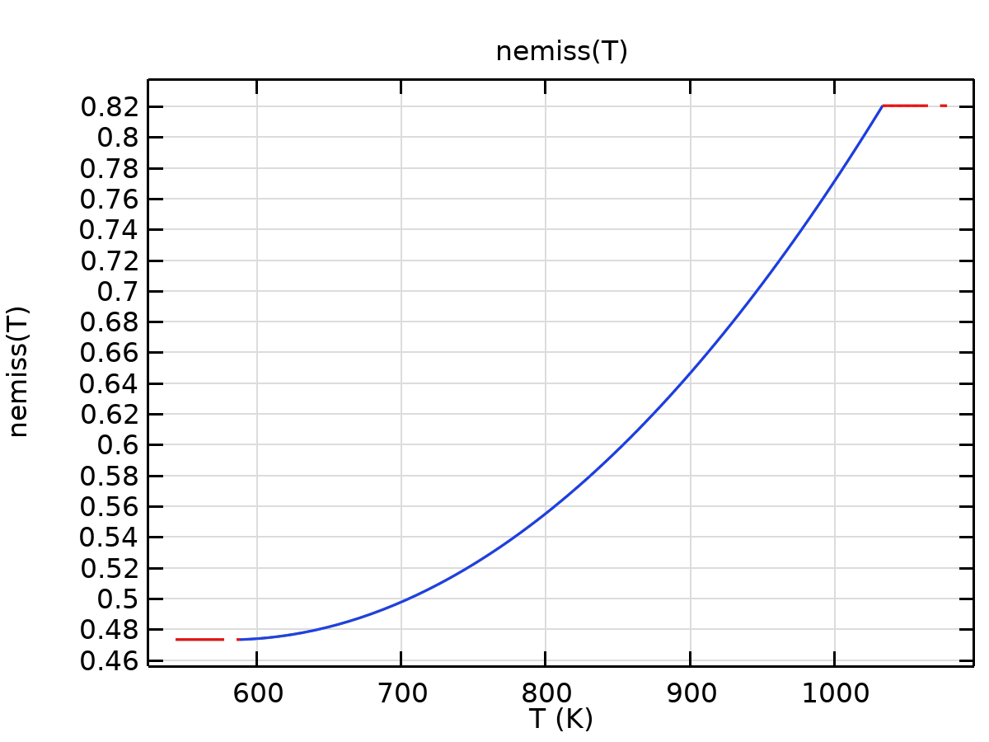
nemiss
Thermal expansion
Description | Value | Unit
Tangent coefficient of thermal expansion | CTE_solid_1(T) | 1/K
Thermal strain | (dL_solid_1(T) - dL_solid_1(Tempref))/(1 + dL_solid_1(Tempref)) | 1

Functions
Function name | Type
dL_solid_1 | Piecewise
CTE_solid_1 | Piecewise

Piecewise
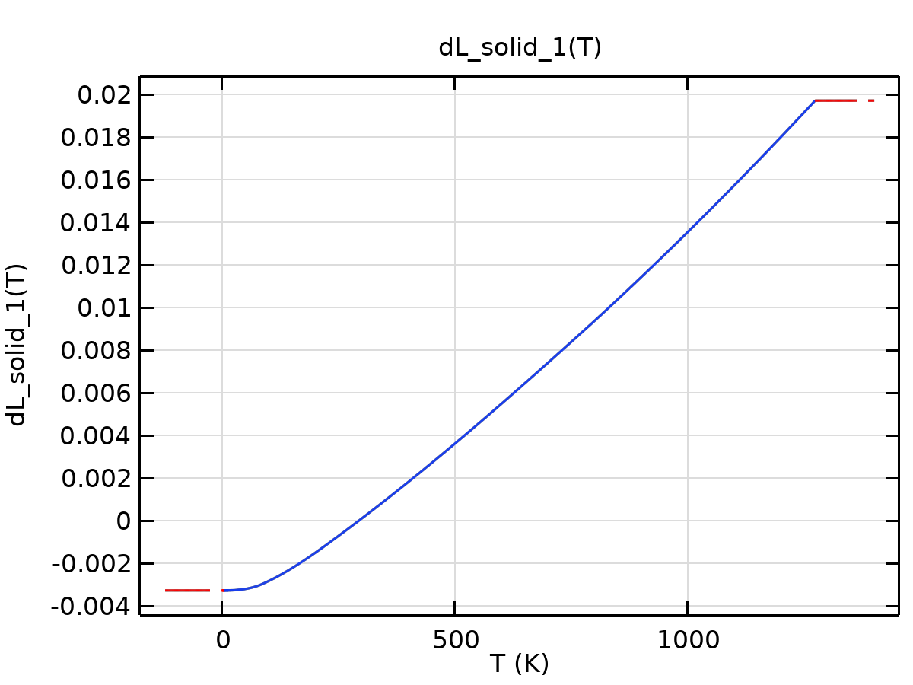
dL_solid_1

Piecewise 1
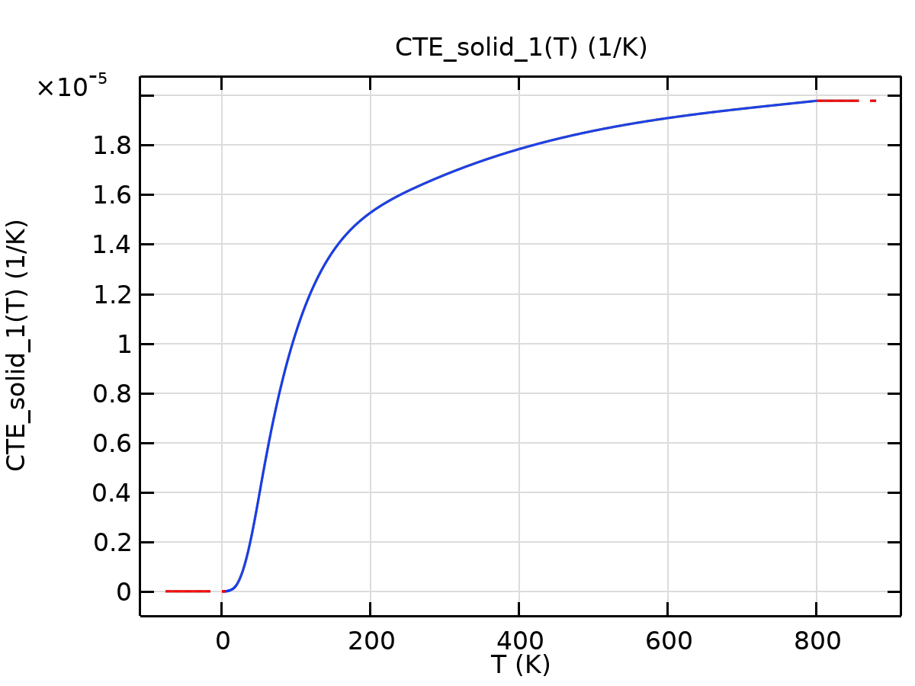
CTE_solid_1
Young's modulus and Poisson's ratio
Description | Value | Unit
Young's modulus | E_solid_1(T) | Pa
Poisson's ratio | nu(T) | 1

Functions
Function name | Type
E_solid_1 | Piecewise
nu | Piecewise

Piecewise
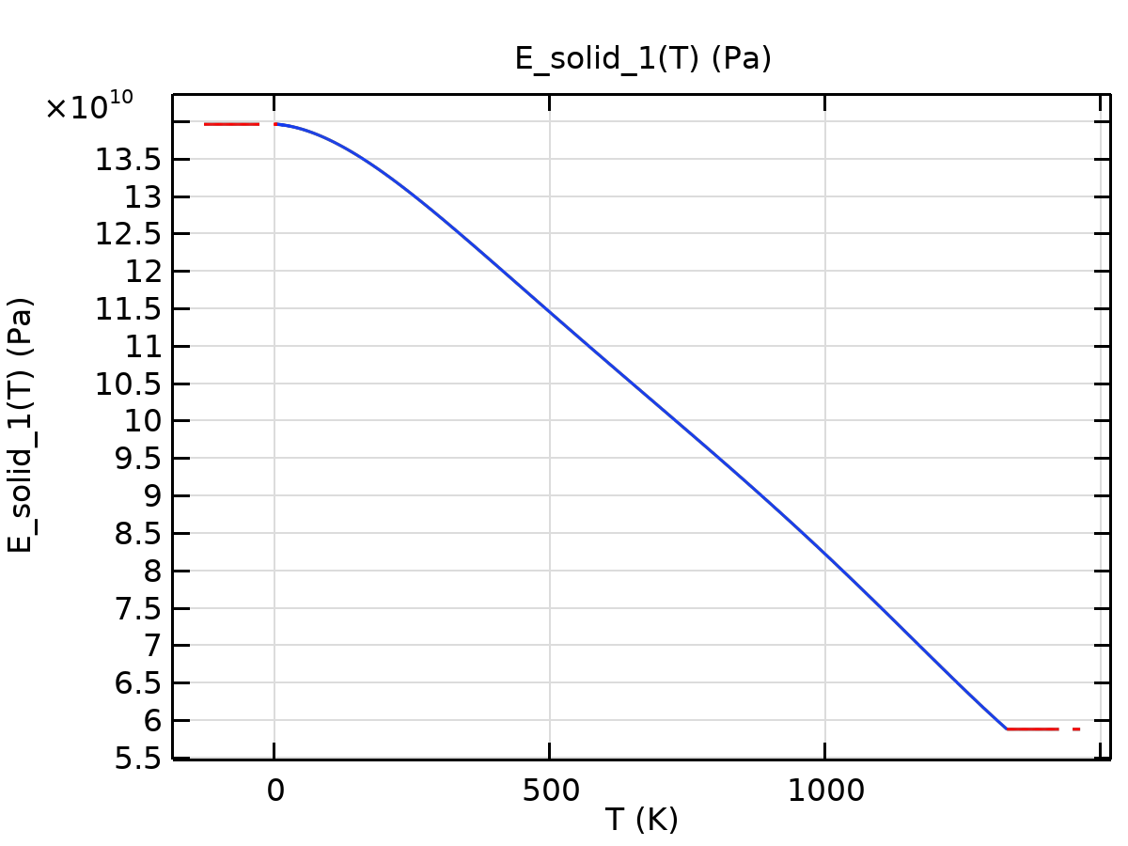
E_solid_1

Piecewise 1
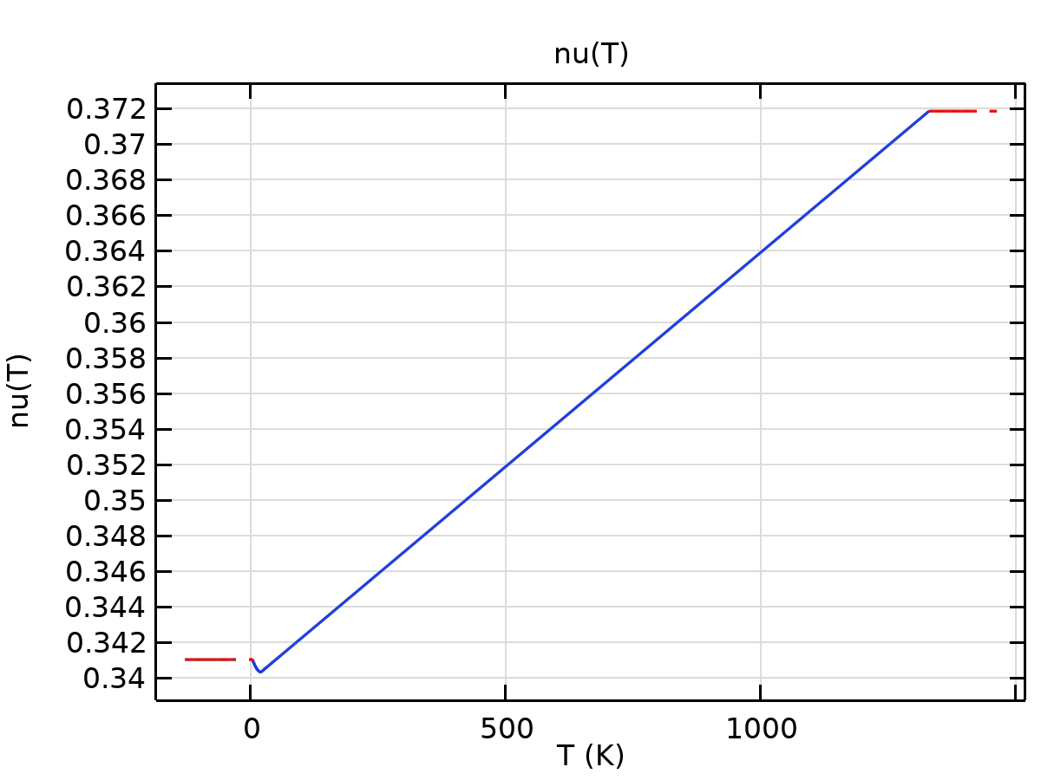
nu
Bulk modulus and shear modulus
Description | Value | Unit
Bulk modulus | kappa(T) | N/m²
Shear modulus | mu(T) | N/m²

Functions
Function name | Type
mu | Piecewise
kappa | Piecewise

Piecewise
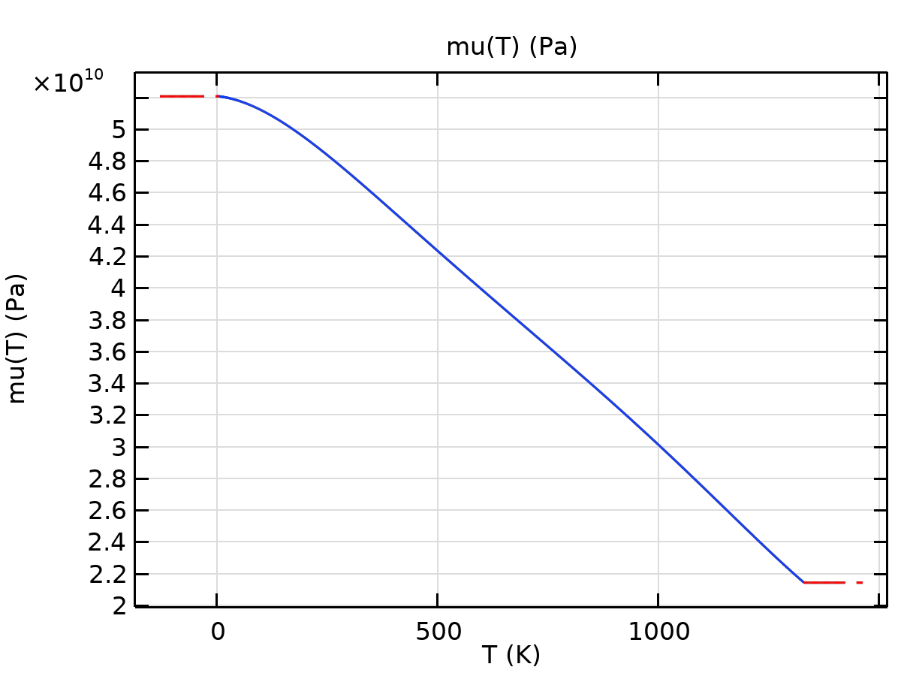
mu

Piecewise 1
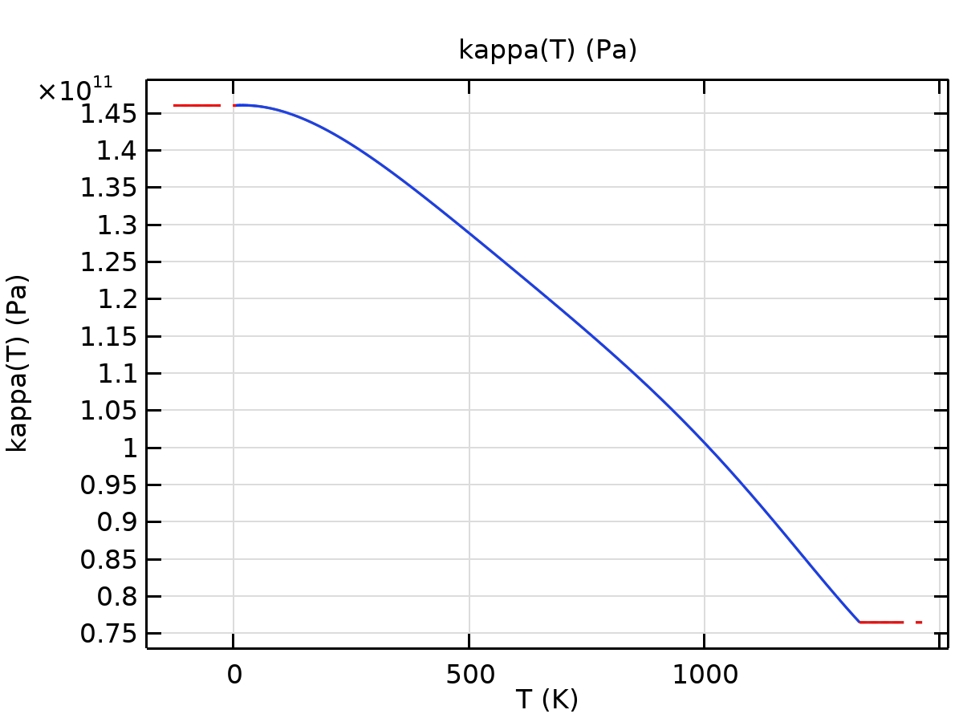
kappa

H2O (water) [liquid]
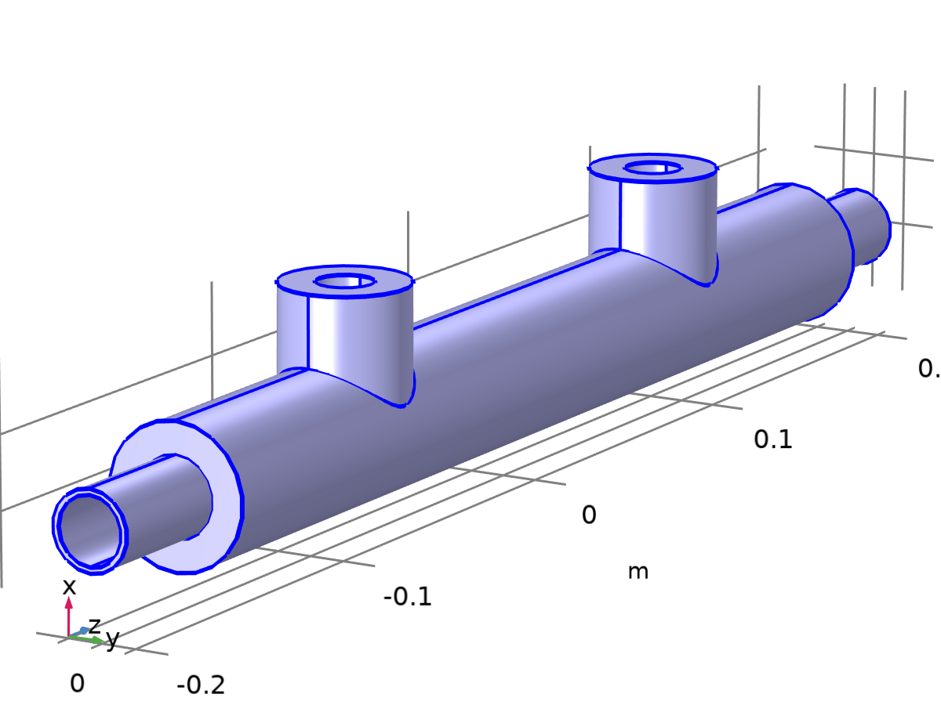
H2O (water) [liquid]
Selection
Geometric entity level | Domain
Selection | Geometry geom1: Dimension 3: All domains

Material parameters
Name | Value | Unit | Property group
Thermal conductivity | k_liquid_2(T) | W/(m·K) | Basic
Heat capacity at constant pressure | C_liquid_2(T) | J/(kg·K) | Basic
Density | rho_liquid_2(T) | kg/m³ | Basic
Dynamic viscosity | eta_liquid_1(T) | Pa·s | Basic

Basic
Description | Value | Unit
Thermal conductivity | k_liquid_2(T) | W/(m·K)
Heat capacity at constant pressure | C_liquid_2(T) | J/(kg·K)
Density | rho_liquid_2(T) | kg/m³
Dynamic viscosity | eta_liquid_1(T) | Pa·s

Functions
Function name | Type
k_liquid_2 | Piecewise
alpha_liquid_2 | Piecewise
C_liquid_2 | Piecewise
HC_liquid_2 | Piecewise
VP_liquid_2 | Piecewise
rho_liquid_2 | Piecewise
TD_liquid_2 | Piecewise
eta_liquid_1 | Piecewise
SurfF | Piecewise

Piecewise
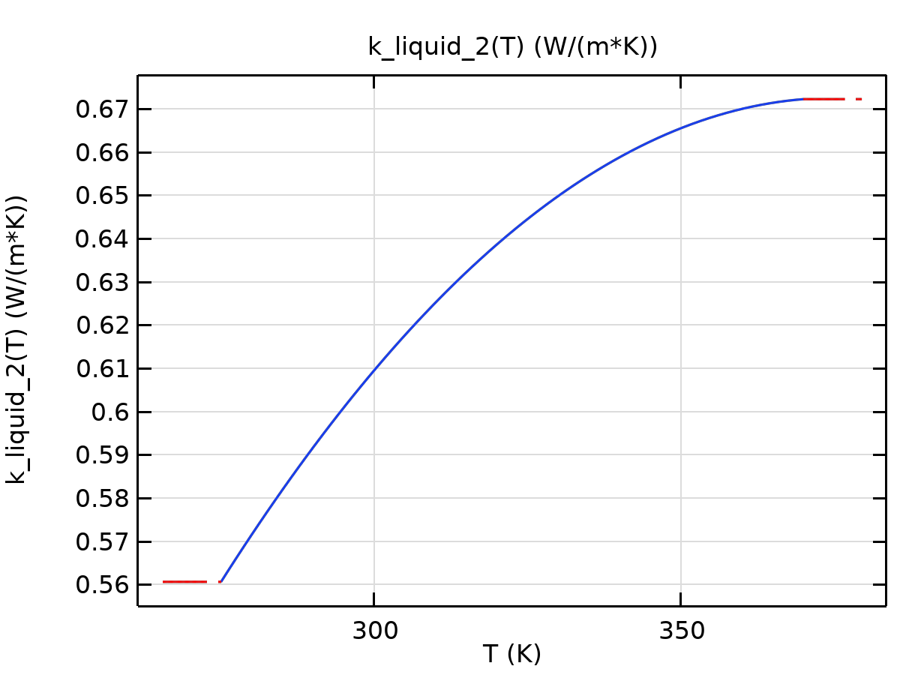
k_liquid_2

Piecewise 1
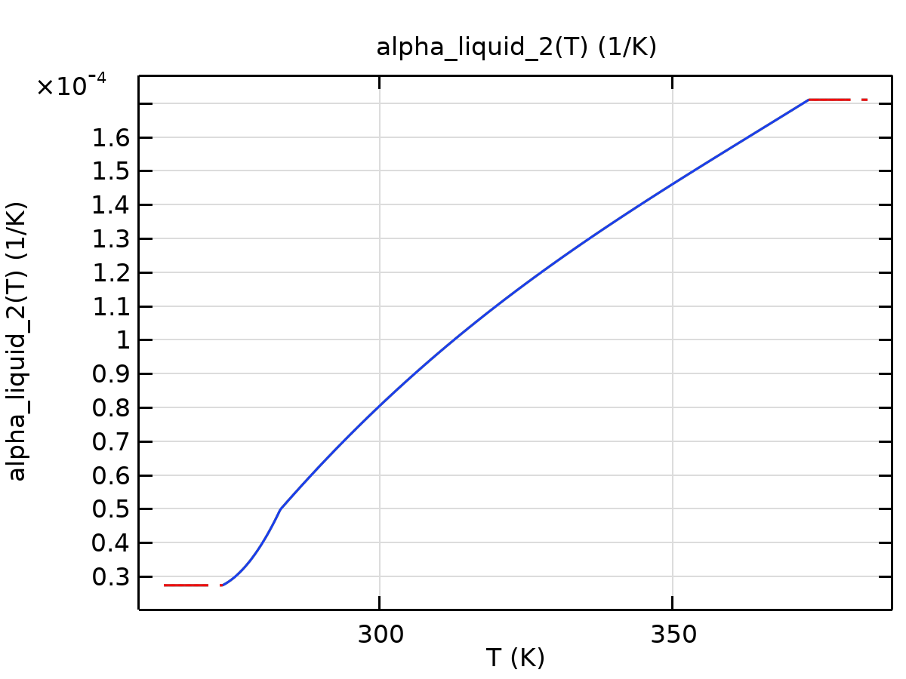
alpha_liquid_2

Piecewise 2
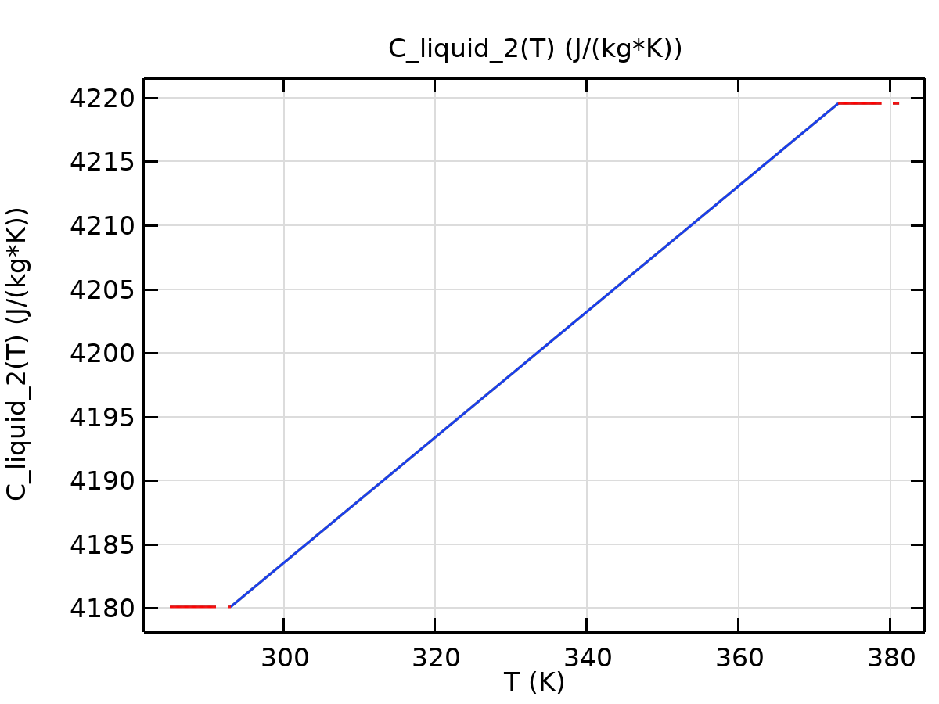
C_liquid_2

Piecewise 3
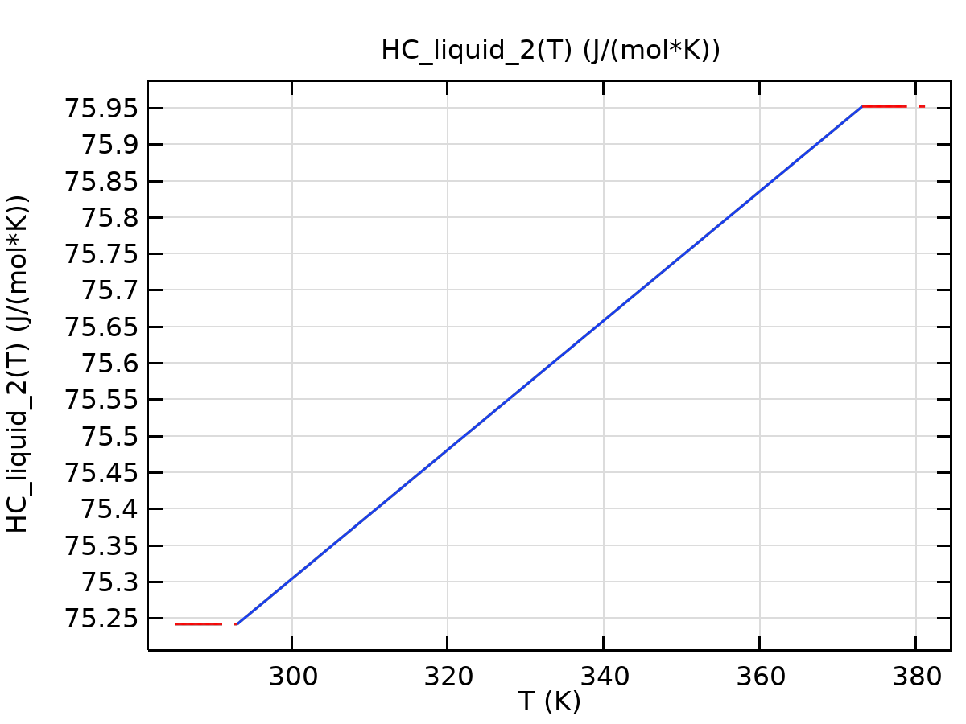
HC_liquid_2

Piecewise 4
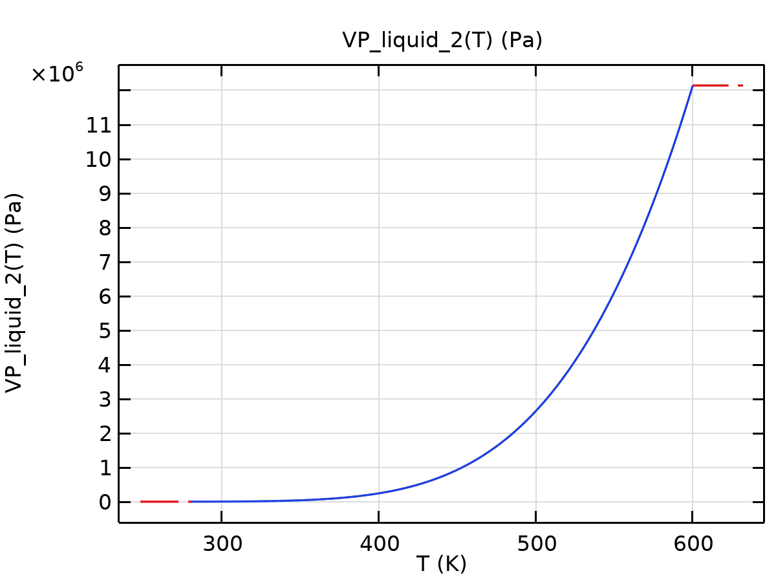
VP_liquid_2

Piecewise 5
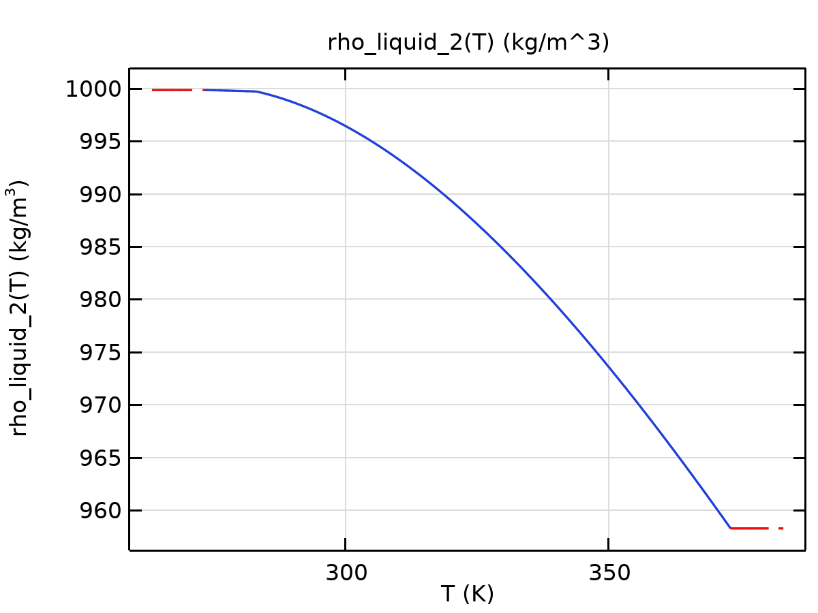
rho_liquid_2

Piecewise 6
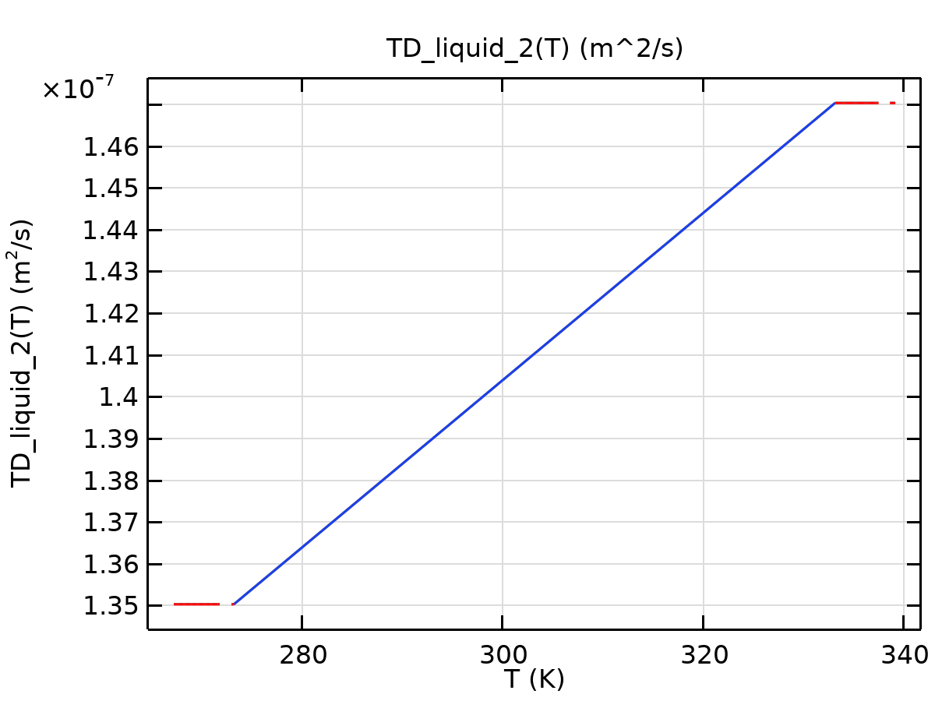
TD_liquid_2

Piecewise 7
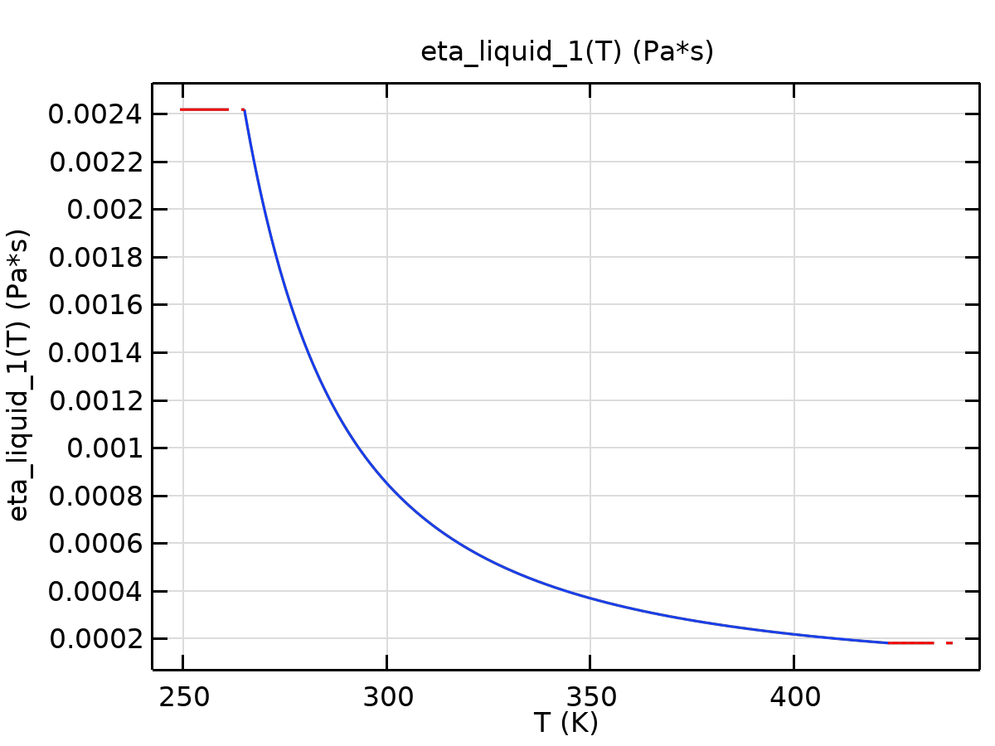
eta_liquid_1

Piecewise 8
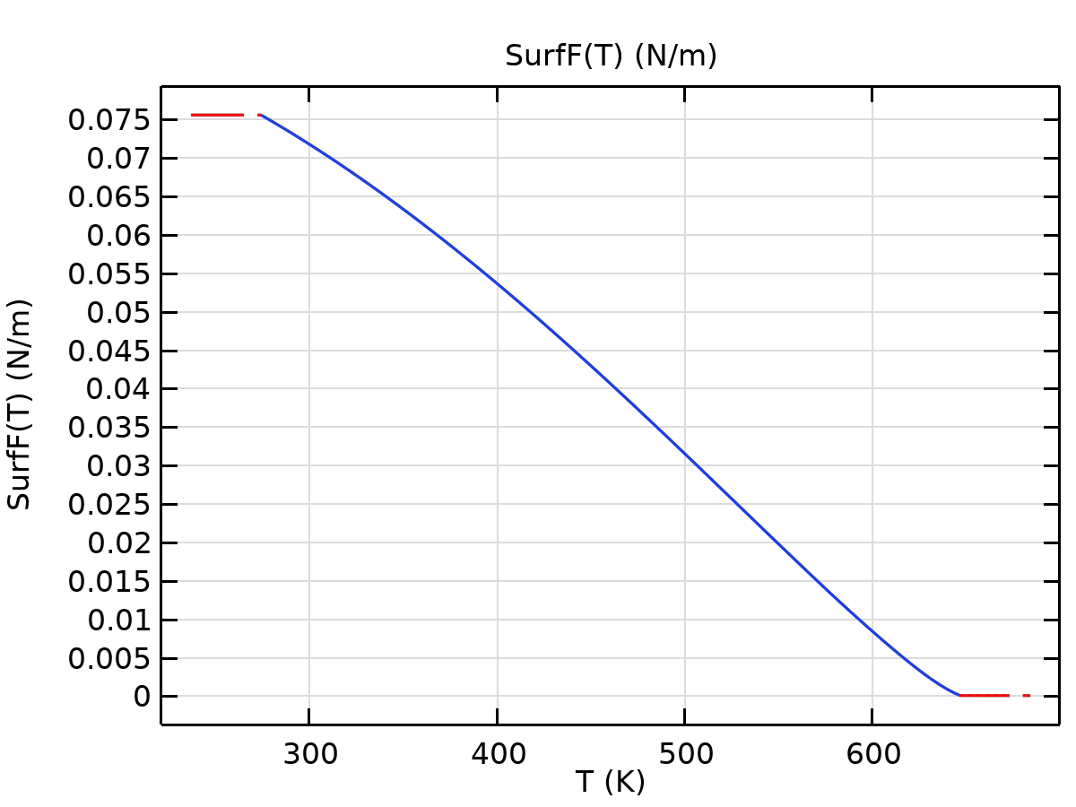
SurfF
Functions
Function name | Type
dL_liquid_2 | Piecewise
CTE_liquid_2 | Piecewise

Piecewise
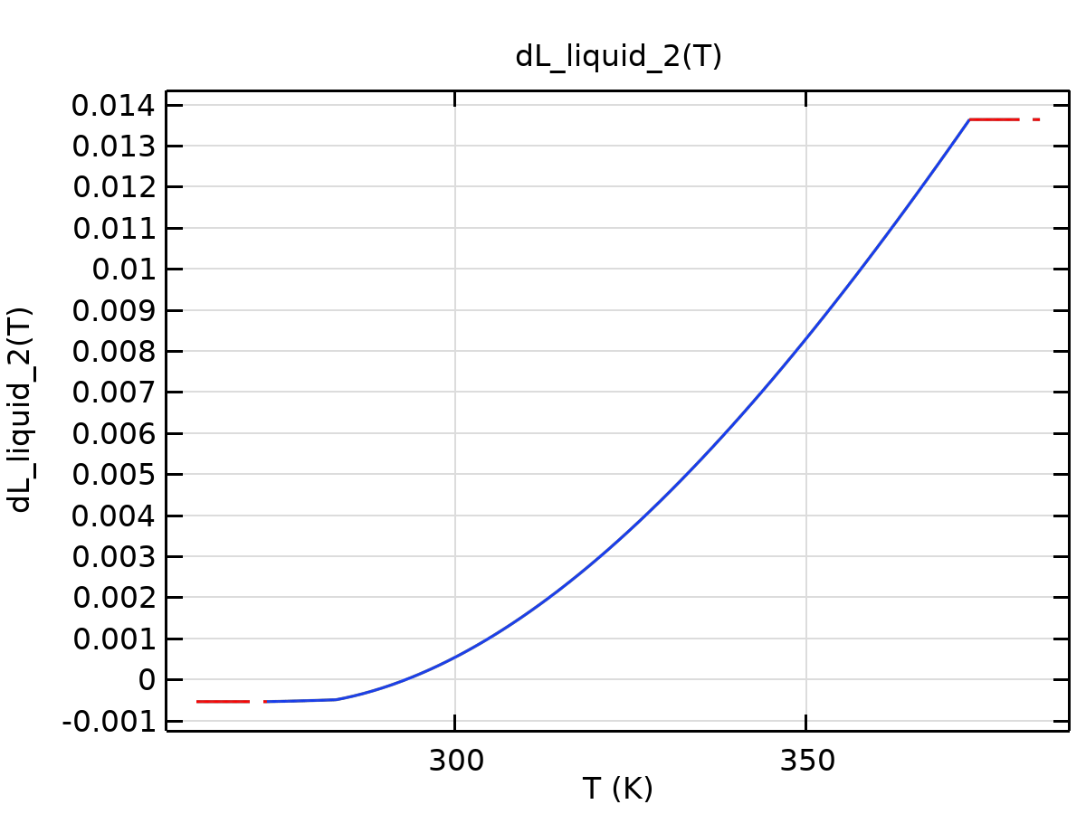
dL_liquid_2

Piecewise 1
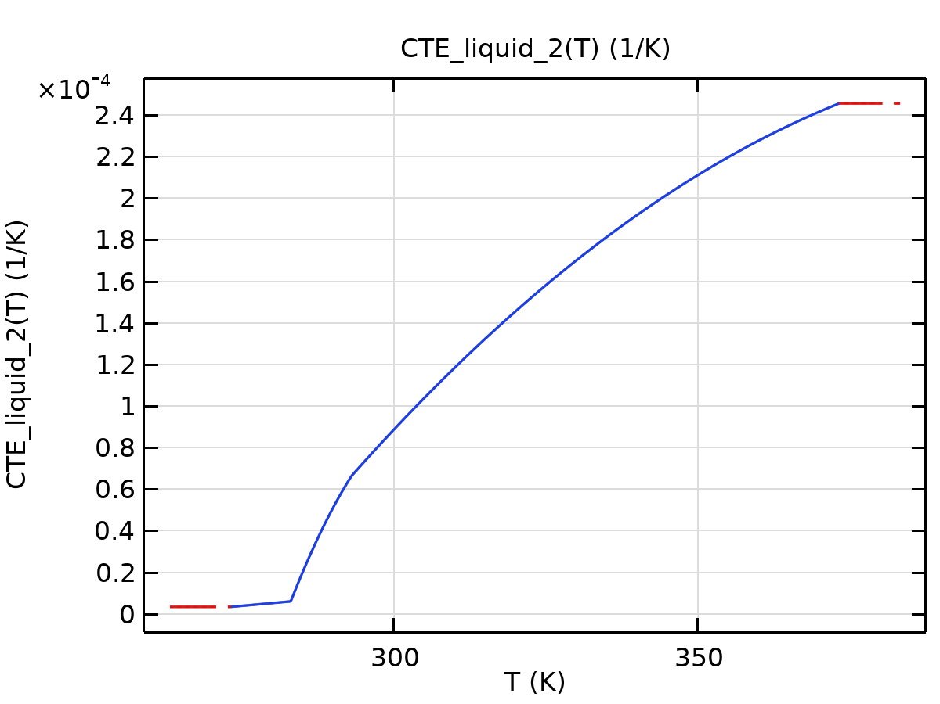
CTE_liquid_2

Heat Transfer in Fluids
Used products
COMSOL Multiphysics
CFD Module


Heat Transfer in Fluids
Selection
Geometric entity level | Domain
Selection | Geometry geom1: Dimension 3: All domains

Equations
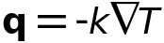

Interface Settings

Discretization
Settings
Description | Value
Temperature | Linear

Settings
Description | Value
Equation form | Study controlled

Physical Model
Settings
Description | Value | Unit
Reference temperature | User defined
Reference temperature | 293.15 | K

Variables
Name | Expression | Unit | Description | Selection | Details
ht.Tvar | T | K | Temperature | Domain 1
ht.Tvar | T | K | Temperature | Boundaries 1–22
ht.Tvar | T | K | Temperature | Edges 1–52
ht.Tvar | T | K | Temperature | Points 1–32
ht.TextFace | 0 | K | External temperature | Domain 1 | + operation
ht.chiT | 0 | 1/Pa | Isothermal compressibility coefficient | Domain 1
ht.alphap | 0 | 1/K | Isobaric compressibility coefficient | Domain 1
ht.Ek | 0 | J/kg | Kinetic energy | Domain 1 | + operation
ht.Tu | T | K | Temperature | Boundaries 1–22
ht.Td | T | K | Temperature | Boundaries 1–22
ht.TuIsDown | 0 | 1 | Help variable | Boundaries 1–22
ht.TdIsUp | 0 | 1 | Help variable | Boundaries 1–22
ht.Tref | model.input.Tref | K | Reference temperature | Global | Meta
ht.C_effExt | 0 | J/(m³·K) | Effective volumetric heat capacity | Domain 1 | + operation
ht.EMatExt | 0 | Pa | Young's modulus | Domain 1 | + operation
ht.nknExt | 0 | W/(m·K) | Help variable | Domain 1 | + operation
ht.nuMatExt | 0 | 1 | Poisson's ratio | Domain 1 | + operation
ht.d | 1 | 1 | Thickness | Domain 1
ht.HRef | 0 | J/kg | Reference enthalpy | Domain 1
ht.DeltaH | ht.DeltaH_add | J/kg | Sensible enthalpy | Domain 1
ht.DeltaH_cst | ht.DeltaH_add_cst | J/kg | Sensible enthalpy, constant material properties | Domain 1
ht.DeltaH_add | 0 | J/kg | Sensible enthalpy | Domain 1 | + operation
ht.DeltaH_add_cst | 0 | J/kg | Sensible enthalpy, constant material properties | Domain 1 | + operation
ht.H | 0 | J/kg | Enthalpy | Domain 1 | + operation
ht.H_cst | 0 | J/kg | Enthalpy, constant material properties | Domain 1 | + operation
ht.H0 | ht.H+ht.Ek | J/kg | Total enthalpy | Domain 1
ht.H0_cst | ht.H_cst+ht.Ek | J/kg | Total enthalpy, constant material properties | Domain 1
ht.Ei | 0 | J/kg | Internal energy | Domain 1 | + operation
ht.Ei_cst | 0 | J/kg | Internal energy, constant material properties | Domain 1 | + operation
ht.Ei0 | ht.Ei+ht.Ek | J/kg | Total internal energy | Domain 1
ht.Ei0_cst | ht.Ei_cst+ht.Ek | J/kg | Total internal energy, constant material properties | Domain 1
ht.dfluxx | 0 | W/m² | Conductive heat flux, x-component | Domain 1 | + operation
ht.dfluxy | 0 | W/m² | Conductive heat flux, y-component | Domain 1 | + operation
ht.dfluxz | 0 | W/m² | Conductive heat flux, z-component | Domain 1 | + operation
ht.dfluxx | mean(ht.dfluxx) | W/m² | Conductive heat flux, x-component | Boundaries 1–22 | + operation
ht.dfluxy | mean(ht.dfluxy) | W/m² | Conductive heat flux, y-component | Boundaries 1–22 | + operation
ht.dfluxz | mean(ht.dfluxz) | W/m² | Conductive heat flux, z-component | Boundaries 1–22 | + operation
ht.dfluxtestx | 0 | W/m² | Conductive heat flux, x-component | Domain 1 | + operation
ht.dfluxtesty | 0 | W/m² | Conductive heat flux, y-component | Domain 1 | + operation
ht.dfluxtestz | 0 | W/m² | Conductive heat flux, z-component | Domain 1 | + operation
ht.dfluxtestx | mean(ht.dfluxtestx) | W/m² | Conductive heat flux, x-component | Boundaries 1–22 | + operation
ht.dfluxtesty | mean(ht.dfluxtesty) | W/m² | Conductive heat flux, y-component | Boundaries 1–22 | + operation
ht.dfluxtestz | mean(ht.dfluxtestz) | W/m² | Conductive heat flux, z-component | Boundaries 1–22 | + operation
ht.dfluxMag | sqrt(ht.dfluxx^2+ht.dfluxy^2+ht.dfluxz^2) | W/m² | Conductive heat flux magnitude | Domain 1
ht.cfluxx | 0 | W/m² | Convective heat flux, x-component | Domain 1 | + operation
ht.cfluxy | 0 | W/m² | Convective heat flux, y-component | Domain 1 | + operation
ht.cfluxz | 0 | W/m² | Convective heat flux, z-component | Domain 1 | + operation
ht.cfluxMag | sqrt(ht.cfluxx^2+ht.cfluxy^2+ht.cfluxz^2) | W/m² | Convective heat flux magnitude | Domain 1
ht.tfluxx | ht.dfluxx+ht.cfluxx | W/m² | Total heat flux, x-component | Domain 1
ht.tfluxy | ht.dfluxy+ht.cfluxy | W/m² | Total heat flux, y-component | Domain 1
ht.tfluxz | ht.dfluxz+ht.cfluxz | W/m² | Total heat flux, z-component | Domain 1
ht.tfluxMag | sqrt(ht.tfluxx^2+ht.tfluxy^2+ht.tfluxz^2) | W/m² | Total heat flux magnitude | Domain 1
ht.tefluxx | 0 | W/m² | Total energy flux, x-component | Domain 1 | + operation
ht.tefluxy | 0 | W/m² | Total energy flux, y-component | Domain 1 | + operation
ht.tefluxz | 0 | W/m² | Total energy flux, z-component | Domain 1 | + operation
ht.teflux_cstx | 0 | W/m² | Total energy flux, constant material properties, x-component | Domain 1 | + operation
ht.teflux_csty | 0 | W/m² | Total energy flux, constant material properties, y-component | Domain 1 | + operation
ht.teflux_cstz | 0 | W/m² | Total energy flux, constant material properties, z-component | Domain 1 | + operation
ht.tefluxMag | sqrt(ht.tefluxx^2+ht.tefluxy^2+ht.tefluxz^2) | W/m² | Total energy flux magnitude | Domain 1
ht.thfluxx | 0 | W/m² | Total enthalpy flux, x-component | Domain 1 | + operation
ht.thfluxy | 0 | W/m² | Total enthalpy flux, y-component | Domain 1 | + operation
ht.thfluxz | 0 | W/m² | Total enthalpy flux, z-component | Domain 1 | + operation
ht.thflux_cstx | 0 | W/m² | Total enthalpy flux, constant material properties, x-component | Domain 1 | + operation
ht.thflux_csty | 0 | W/m² | Total enthalpy flux, constant material properties, y-component | Domain 1 | + operation
ht.thflux_cstz | 0 | W/m² | Total enthalpy flux, constant material properties, z-component | Domain 1 | + operation
ht.thfluxMag | sqrt(ht.thfluxx^2+ht.thfluxy^2+ht.thfluxz^2) | W/m² | Total enthalpy flux magnitude | Domain 1
ht.dflux_ux | up(ht.dfluxx) | W/m² | Conductive heat flux, x-component | Boundaries 1–22
ht.dflux_uy | up(ht.dfluxy) | W/m² | Conductive heat flux, y-component | Boundaries 1–22
ht.dflux_uz | up(ht.dfluxz) | W/m² | Conductive heat flux, z-component | Boundaries 1–22
ht.dflux_dx | down(ht.dfluxx) | W/m² | Conductive heat flux, x-component | Boundaries 1–22
ht.dflux_dy | down(ht.dfluxy) | W/m² | Conductive heat flux, y-component | Boundaries 1–22
ht.dflux_dz | down(ht.dfluxz) | W/m² | Conductive heat flux, z-component | Boundaries 1–22
ht.dfluxtest_ux | up(ht.dfluxtestx) | W/m² | Conductive heat flux, x-component | Boundaries 1–22
ht.dfluxtest_uy | up(ht.dfluxtesty) | W/m² | Conductive heat flux, y-component | Boundaries 1–22
ht.dfluxtest_uz | up(ht.dfluxtestz) | W/m² | Conductive heat flux, z-component | Boundaries 1–22
ht.dfluxtest_dx | down(ht.dfluxtestx) | W/m² | Conductive heat flux, x-component | Boundaries 1–22
ht.dfluxtest_dy | down(ht.dfluxtesty) | W/m² | Conductive heat flux, y-component | Boundaries 1–22
ht.dfluxtest_dz | down(ht.dfluxtestz) | W/m² | Conductive heat flux, z-component | Boundaries 1–22
ht.rflux | 0 | W/m² | Radiative heat flux | Boundaries 1–22 | + operation
ht.ncflux | mean(ht.cfluxx)*ht.nxmesh+mean(ht.cfluxy)*ht.nymesh+mean(ht.cfluxz)*ht.nzmesh | W/m² | Normal convective heat flux | Boundaries 1–22
ht.ncflux_u | up(ht.cfluxx)*ht.unxmesh+up(ht.cfluxy)*ht.unymesh+up(ht.cfluxz)*ht.unzmesh | W/m² | Internal normal convective heat flux, upside | Boundaries 1–22
ht.ncflux_d | down(ht.cfluxx)*ht.dnxmesh+down(ht.cfluxy)*ht.dnymesh+down(ht.cfluxz)*ht.dnzmesh | W/m² | Internal normal convective heat flux, downside | Boundaries 1–22
ht.ndflux | 0.5*(ht.ndflux_d-ht.ndflux_u) | W/m² | Normal conductive heat flux | Boundaries 1–22 | + operation
ht.ndflux_u | -ht.ndflux_d | W/m² | Internal normal conductive heat flux, upside | Boundaries 1–22 | + operation
ht.ndflux_d | 0 | W/m² | Internal normal conductive heat flux, downside | Boundaries 1–22 | + operation
ht.ntflux | ht.ndflux+ht.ncflux | W/m² | Normal total heat flux | Boundaries 1–22
ht.ntflux_cst | ht.ndflux+ht.ncflux | W/m² | Normal total heat flux, constant material properties | Boundaries 1–22
ht.ntflux_u | ht.ndflux_u+ht.ncflux_u | W/m² | Internal normal total flux, upside | Boundaries 1–22
ht.ntflux_cst_u | ht.ndflux_u+ht.ncflux_u | W/m² | Internal normal total heat flux, constant material properties, upside | Boundaries 1–22
ht.ntflux_d | ht.ndflux_d+ht.ncflux_d | W/m² | Internal normal total flux, downside | Boundaries 1–22
ht.ntflux_cst_d | ht.ndflux_d+ht.ncflux_d | W/m² | Internal normal total heat flux, constant material properties, downside | Boundaries 1–22
ht.nteflux | mean(ht.tefluxx)*ht.nxmesh+mean(ht.tefluxy)*ht.nymesh+mean(ht.tefluxz)*ht.nzmesh-mean(ht.dfluxx)*ht.nxmesh-mean(ht.dfluxy)*ht.nymesh-mean(ht.dfluxz)*ht.nzmesh+ht.ndflux | W/m² | Normal total energy flux | Boundaries 1–22
ht.nteflux_cst | mean(ht.teflux_cstx)*ht.nxmesh+mean(ht.teflux_csty)*ht.nymesh+mean(ht.teflux_cstz)*ht.nzmesh-mean(ht.dfluxx)*ht.nxmesh-mean(ht.dfluxy)*ht.nymesh-mean(ht.dfluxz)*ht.nzmesh+ht.ndflux | W/m² | Normal total energy flux, constant material properties | Boundaries 1–22
ht.nteflux_u | up(ht.tefluxx)*ht.unxmesh+up(ht.tefluxy)*ht.unymesh+up(ht.tefluxz)*ht.unzmesh-up(ht.dfluxx)*ht.unxmesh-up(ht.dfluxy)*ht.unymesh-up(ht.dfluxz)*ht.unzmesh+ht.ndflux_u | W/m² | Internal normal total energy flux, upside | Boundaries 1–22
ht.nteflux_cst_u | up(ht.teflux_cstx)*ht.unxmesh+up(ht.teflux_csty)*ht.unymesh+up(ht.teflux_cstz)*ht.unzmesh-up(ht.dfluxx)*ht.unxmesh-up(ht.dfluxy)*ht.unymesh-up(ht.dfluxz)*ht.unzmesh+ht.ndflux_u | W/m² | Internal normal total energy flux, constant material properties, upside | Boundaries 1–22
ht.nteflux_d | down(ht.tefluxx)*ht.dnxmesh+down(ht.tefluxy)*ht.dnymesh+down(ht.tefluxz)*ht.dnzmesh-down(ht.dfluxx)*ht.dnxmesh-down(ht.dfluxy)*ht.dnymesh-down(ht.dfluxz)*ht.dnzmesh+ht.ndflux_d | W/m² | Internal normal total energy flux, downside | Boundaries 1–22
ht.nteflux_cst_d | down(ht.teflux_cstx)*ht.dnxmesh+down(ht.teflux_csty)*ht.dnymesh+down(ht.teflux_cstz)*ht.dnzmesh-down(ht.dfluxx)*ht.dnxmesh-down(ht.dfluxy)*ht.dnymesh-down(ht.dfluxz)*ht.dnzmesh+ht.ndflux_d | W/m² | Internal normal total energy flux, constant material properties, downside | Boundaries 1–22
ht.nthflux | mean(ht.thfluxx)*ht.nxmesh+mean(ht.thfluxy)*ht.nymesh+mean(ht.thfluxz)*ht.nzmesh | W/m² | Normal total enthalpy flux | Boundaries 1–22
ht.nthflux_cst | mean(ht.thflux_cstx)*ht.nxmesh+mean(ht.thflux_csty)*ht.nymesh+mean(ht.thflux_cstz)*ht.nzmesh | W/m² | Normal total enthalpy flux, constant material properties | Boundaries 1–22
ht.nthflux_u | up(ht.thfluxx)*ht.unxmesh+up(ht.thfluxy)*ht.unymesh+up(ht.thfluxz)*ht.unzmesh | W/m² | Internal normal total enthalpy flux, upside | Boundaries 1–22
ht.nthflux_cst_u | up(ht.thflux_cstx)*ht.unxmesh+up(ht.thflux_csty)*ht.unymesh+up(ht.thflux_cstz)*ht.unzmesh | W/m² | Internal normal total enthalpy flux, constant material properties, upside | Boundaries 1–22
ht.nthflux_d | down(ht.thfluxx)*ht.dnxmesh+down(ht.thfluxy)*ht.dnymesh+down(ht.thfluxz)*ht.dnzmesh | W/m² | Internal normal total enthalpy flux, downside | Boundaries 1–22
ht.nthflux_cst_d | down(ht.thflux_cstx)*ht.dnxmesh+down(ht.thflux_csty)*ht.dnymesh+down(ht.thflux_cstz)*ht.dnzmesh | W/m² | Internal normal total enthalpy flux, constant material properties, downside | Boundaries 1–22
ht.Q | 0 | W/m³ | Heat source | Domain 1 | + operation
ht.Qoop | 0 | W/m³ | Out-of-plane heat source | Domain 1 | + operation
ht.Qtot | 0 | W/m³ | Total heat source | Domain 1 | + operation
ht.Qbtot | 0 | W/m² | Total boundary heat source | Boundaries 1–22 | + operation
ht.ntflux_contrib | 0 | W/m² | Boundary sources and fluxes contribution | Domain 1 | + operation
ht.Qitot | 0 | W/m² | Total interface source | Domain 1 | + operation
ht.qs | 0 | W/(m³·K) | Production/absorption coefficient | Domain 1 | + operation
ht.qs_oop | 0 | W/(m³·K) | Out-of-plane production/absorption coefficient | Domain 1 | + operation
ht.Qltot | 0 | W/m | Total line heat source | Edges 1–52 | + operation
ht.Qlrtot | 0 | W/m | Total line heat source with radius | Edges 1–52 | + operation
ht.Qptot | 0 | W | Total point heat source | Points 1–32 | + operation
ht.Qprtot | 0 | W | Total point heat source with radius | Points 1–32 | + operation
ht.q0 | 0 | W/m² | Inward heat flux | Boundaries 1–22 | + operation
ht.du | ht.d | 1 | Thickness | Boundaries 1–22
ht.dd | ht.d | 1 | Thickness | Boundaries 1–22
ht.nx | dnx | 1 | Normal vector, x-component | Boundaries 1–22
ht.ny | dny | 1 | Normal vector, y-component | Boundaries 1–22
ht.nz | dnz | 1 | Normal vector, z-component | Boundaries 1–22
ht.nxmesh | dnxmesh | 1 | Normal vector (mesh), x-component | Boundaries 1–22
ht.nymesh | dnymesh | 1 | Normal vector (mesh), y-component | Boundaries 1–22
ht.nzmesh | dnzmesh | 1 | Normal vector (mesh), z-component | Boundaries 1–22
ht.dnx | dnx | 1 | Normal vector down direction, x-component | Boundaries 1–22
ht.dny | dny | 1 | Normal vector down direction, y-component | Boundaries 1–22
ht.dnz | dnz | 1 | Normal vector down direction, z-component | Boundaries 1–22
ht.dnxmesh | dnxmesh | 1 | Normal vector down direction (mesh), x-component | Boundaries 1–22
ht.dnymesh | dnymesh | 1 | Normal vector down direction (mesh), y-component | Boundaries 1–22
ht.dnzmesh | dnzmesh | 1 | Normal vector down direction (mesh), z-component | Boundaries 1–22
ht.unx | unx | 1 | Normal vector up direction, x-component | Boundaries 1–22
ht.uny | uny | 1 | Normal vector up direction, y-component | Boundaries 1–22
ht.unz | unz | 1 | Normal vector up direction, z-component | Boundaries 1–22
ht.unxmesh | unxmesh | 1 | Normal vector up direction (mesh), x-component | Boundaries 1–22
ht.unymesh | unymesh | 1 | Normal vector up direction (mesh), y-component | Boundaries 1–22
ht.unzmesh | unzmesh | 1 | Normal vector up direction (mesh), z-component | Boundaries 1–22
ht.dEiInt | 0 | W | Total accumulated heat rate | Global | + operation
ht.dEiInt_cst | 0 | W | Total accumulated heat rate, constant material properties | Global | + operation
ht.dEi0Int | 0 | W | Total accumulated energy rate | Global | + operation
ht.dEi0Int_cst | 0 | W | Total accumulated energy rate, constant material properties | Global | + operation
ht.ntfluxInt | ht.intExtBnd(ht.ntflux*ht.varIntSpa)+ht.intIntBnd(ht.ncflux_u*up(ht.varIntSpa)+ht.ncflux_d*down(ht.varIntSpa)) | W | Total net heat rate | Global
ht.ntfluxInt_cst | ht.intExtBnd(ht.ntflux_cst*ht.varIntSpa)+ht.intIntBnd(ht.ncflux_u*up(ht.varIntSpa)+ht.ncflux_d*down(ht.varIntSpa)) | W | Total net heat rate, constant material properties | Global
ht.ntefluxInt | ht.intExtBnd(ht.nteflux*ht.varIntSpa)+ht.intIntBnd(ht.nthflux_u*up(ht.varIntSpa)+ht.nthflux_d*down(ht.varIntSpa)) | W | Total net energy rate | Global
ht.ntefluxInt_cst | ht.intExtBnd(ht.nteflux_cst*ht.varIntSpa)+ht.intIntBnd(ht.nthflux_cst_u*up(ht.varIntSpa)+ht.nthflux_cst_d*down(ht.varIntSpa)) | W | Total net energy rate, constant material properties | Global
ht.QInt | ht.intDom(ht.Qtot*ht.varIntSpa)+ht.intIntLine(ht.Qltot*ht.varIntSpa)+ht.intLine(ht.Qlrtot*ht.varIntSpa)+ht.intIntPnt(ht.Qptot)+ht.intPnt(ht.Qprtot)-ht.intIntBnd(ht.ndflux_u*up(ht.varIntSpa)+ht.ndflux_d*down(ht.varIntSpa)) | W | Total heat source | Global
ht.QInt_cst | ht.intDom(ht.Qtot*ht.varIntSpa)+ht.intIntLine(ht.Qltot*ht.varIntSpa)+ht.intLine(ht.Qlrtot*ht.varIntSpa)+ht.intIntPnt(ht.Qptot)+ht.intPnt(ht.Qprtot)-ht.intIntBnd(ht.ndflux_u*up(ht.varIntSpa)+ht.ndflux_d*down(ht.varIntSpa)) | W | Total heat source, constant material properties | Global
ht.Wstr | 0 | W/m³ | Total stress power | Domain 1 | + operation
ht.WstrInt | 0 | W | Total stress power | Global | + operation
ht.WstrInt_cst | 0 | W | Total stress power, constant material properties | Global | + operation
ht.Wtot | 0 | W/m³ | Total work source | Domain 1 | + operation
ht.WBndTot_d | 0 | W/m² | Total work source, downside | Boundaries 1–22 | + operation
ht.WInt | 0 | W | Total work source | Global | + operation
ht.WInt_cst | 0 | W | Total work source, constant material properties | Global | + operation
ht.heatBalance | ht.dEiInt+ht.ntfluxInt+ht.WstrInt-ht.QInt | W | Heat balance | Global
ht.heatBalance_cst | ht.dEiInt_cst+ht.ntfluxInt_cst+ht.WstrInt_cst-ht.QInt_cst | W | Heat balance, constant material properties | Global
ht.energyBalance | ht.dEi0Int+ht.ntefluxInt-ht.WInt-ht.QInt | W | Energy balance | Global
ht.energyBalance_cst | ht.dEi0Int_cst+ht.ntefluxInt_cst-ht.WInt_cst-ht.QInt_cst | W | Energy balance, constant material properties | Global
ht.id | 1 | 1 | Physics indicator | Domain 1
ht.varIntSpa | ht.d | 1 | Intermediate variable | Domain 1 | Meta

Fluid 1

Fluid 1
Selection
Geometric entity level | Domain
Selection | Geometry geom1: Dimension 3: All domains

Equations
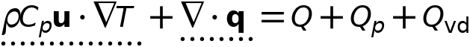
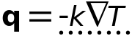
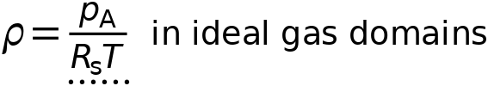

Heat Conduction, Fluid
Settings
Description | Value
Thermal conductivity | From material

Thermodynamics, Fluid
Settings
Description | Value
Fluid type | From material

Coordinate System Selection
Settings
Description | Value
Coordinate system | Global coordinate system

Model Input
Settings
Description | Value | Unit
Volume reference temperature | User defined
Volume reference temperature | 293.15 | K

Used products
COMSOL Multiphysics

Properties from material
Property | Material | Property group
Heat capacity at constant pressure | H2O (water) [liquid] | Basic
Thermal conductivity | H2O (water) [liquid] | Basic
Density | H2O (water) [liquid] | Basic

Variables
Name | Expression | Unit | Description | Selection | Details
ht.chiT | d(ht.rho,ht.prho)/max(ht.rho,eps) | 1/Pa | Isothermal compressibility coefficient | Domain 1
ht.alphap | -d(ht.rho,T)/max(ht.rho,eps) | 1/K | Isobaric compressibility coefficient | Domain 1
ht.Ek | 0.5*(ht.ux^2+ht.uy^2+ht.uz^2) | J/kg | Kinetic energy | Domain 1 | + operation
ht.k_effxx | ht.kxx | W/(m·K) | Effective thermal conductivity, xx-component | Domain 1
ht.k_effyx | ht.kyx | W/(m·K) | Effective thermal conductivity, yx-component | Domain 1
ht.k_effzx | ht.kzx | W/(m·K) | Effective thermal conductivity, zx-component | Domain 1
ht.k_effxy | ht.kxy | W/(m·K) | Effective thermal conductivity, xy-component | Domain 1
ht.k_effyy | ht.kyy | W/(m·K) | Effective thermal conductivity, yy-component | Domain 1
ht.k_effzy | ht.kzy | W/(m·K) | Effective thermal conductivity, zy-component | Domain 1
ht.k_effxz | ht.kxz | W/(m·K) | Effective thermal conductivity, xz-component | Domain 1
ht.k_effyz | ht.kyz | W/(m·K) | Effective thermal conductivity, yz-component | Domain 1
ht.k_effzz | ht.kzz | W/(m·K) | Effective thermal conductivity, zz-component | Domain 1
ht.kappaTxx | 0 | W/(m·K) | Turbulent thermal conductivity, xx-component | Domain 1
ht.kappaTyx | 0 | W/(m·K) | Turbulent thermal conductivity, yx-component | Domain 1
ht.kappaTzx | 0 | W/(m·K) | Turbulent thermal conductivity, zx-component | Domain 1
ht.kappaTxy | 0 | W/(m·K) | Turbulent thermal conductivity, xy-component | Domain 1
ht.kappaTyy | 0 | W/(m·K) | Turbulent thermal conductivity, yy-component | Domain 1
ht.kappaTzy | 0 | W/(m·K) | Turbulent thermal conductivity, zy-component | Domain 1
ht.kappaTxz | 0 | W/(m·K) | Turbulent thermal conductivity, xz-component | Domain 1
ht.kappaTyz | 0 | W/(m·K) | Turbulent thermal conductivity, yz-component | Domain 1
ht.kappaTzz | 0 | W/(m·K) | Turbulent thermal conductivity, zz-component | Domain 1
ht.pref | ht.fluid1.pref | Pa | Reference pressure level | Domain 1
ht.chiT_ref | d(ht.rhoref,ht.pref)/max(ht.rhoref,eps) | 1/Pa | Reference isothermal compressibility coefficient | Domain 1
ht.alphap_ref | -d(ht.rhoref,ht.Tref)/max(ht.rhoref,eps) | 1/K | Reference isobaric compressibility coefficient | Domain 1
ht.alphapT | ht.alphap*T | 1 | Help variable | Domain 1
ht.kxx | ht.kmatxx | W/(m·K) | Thermal conductivity, xx-component | Domain 1
ht.kyx | ht.kmatyx | W/(m·K) | Thermal conductivity, yx-component | Domain 1
ht.kzx | ht.kmatzx | W/(m·K) | Thermal conductivity, zx-component | Domain 1
ht.kxy | ht.kmatxy | W/(m·K) | Thermal conductivity, xy-component | Domain 1
ht.kyy | ht.kmatyy | W/(m·K) | Thermal conductivity, yy-component | Domain 1
ht.kzy | ht.kmatzy | W/(m·K) | Thermal conductivity, zy-component | Domain 1
ht.kxz | ht.kmatxz | W/(m·K) | Thermal conductivity, xz-component | Domain 1
ht.kyz | ht.kmatyz | W/(m·K) | Thermal conductivity, yz-component | Domain 1
ht.kzz | ht.kmatzz | W/(m·K) | Thermal conductivity, zz-component | Domain 1
ht.kmatxx | material.k11 | W/(m·K) | Thermal conductivity, xx-component | Domain 1 | Meta
ht.kmatyx | material.k21 | W/(m·K) | Thermal conductivity, yx-component | Domain 1 | Meta
ht.kmatzx | material.k31 | W/(m·K) | Thermal conductivity, zx-component | Domain 1 | Meta
ht.kmatxy | material.k12 | W/(m·K) | Thermal conductivity, xy-component | Domain 1 | Meta
ht.kmatyy | material.k22 | W/(m·K) | Thermal conductivity, yy-component | Domain 1 | Meta
ht.kmatzy | material.k32 | W/(m·K) | Thermal conductivity, zy-component | Domain 1 | Meta
ht.kmatxz | material.k13 | W/(m·K) | Thermal conductivity, xz-component | Domain 1 | Meta
ht.kmatyz | material.k23 | W/(m·K) | Thermal conductivity, yz-component | Domain 1 | Meta
ht.kmatzz | material.k33 | W/(m·K) | Thermal conductivity, zz-component | Domain 1 | Meta
ht.rho | subst(material.rho_from_mat,ht.fluid1.minput_pressure,ht.prho) | kg/m³ | Density | Domain 1 | Meta
ht.Cp | ht.Cpmat | J/(kg·K) | Heat capacity at constant pressure | Domain 1
ht.Cpmat | material.Cp_from_mat | J/(kg·K) | Heat capacity at constant pressure | Domain 1 | Meta
ht.gamma | if(abs(ht.chiT)<eps,1,ht.rho*ht.Cp*ht.chiT/(ht.rho*ht.Cp*ht.chiT-T*ht.alphap^2)) | 1 | Ratio of specific heats | Domain 1
ht.prho | ht.fluid1.minput_pressure | Pa | Pressure for the evaluation of density | Domain 1
ht.Trho | ht.fluid1.minput_temperature | K | Temperature for density evaluation | Domain 1
domflux.Tx | ht.dfluxx*ht.d | W/m² | Domain flux, x-component | Domain 1
domflux.Ty | ht.dfluxy*ht.d | W/m² | Domain flux, y-component | Domain 1
domflux.Tz | ht.dfluxz*ht.d | W/m² | Domain flux, z-component | Domain 1
ht.DeltaH_add | integrate(ht.CpInt,ht.TInt,ht.DeltaH_Tlow,T)+integrate(ht.dHdp,ht.fluid1.minput_pressure,ht.DeltaH_plow,ht.pA) | J/kg | Sensible enthalpy | Domain 1 | + operation
ht.DeltaH_add_cst | ht.Cp*(T-ht.DeltaH_Tlow)+ht.dHdp*(ht.pA-ht.DeltaH_plow) | J/kg | Sensible enthalpy, constant material properties | Domain 1 | + operation
ht.H | ht.HRef+ht.DeltaH | J/kg | Enthalpy | Domain 1 | + operation
ht.H_cst | ht.HRef+ht.DeltaH_cst | J/kg | Enthalpy, constant material properties | Domain 1 | + operation
ht.Ei | ht.H-ht.pA/ht.rho | J/kg | Internal energy | Domain 1 | + operation
ht.Ei_cst | ht.H_cst-ht.pA/ht.rho | J/kg | Internal energy, constant material properties | Domain 1 | + operation
ht.dfluxx | -ht.k_effxx*Tx-ht.k_effxy*Ty-ht.k_effxz*Tz | W/m² | Conductive heat flux, x-component | Domain 1 | + operation
ht.dfluxy | -ht.k_effyx*Tx-ht.k_effyy*Ty-ht.k_effyz*Tz | W/m² | Conductive heat flux, y-component | Domain 1 | + operation
ht.dfluxz | -ht.k_effzx*Tx-ht.k_effzy*Ty-ht.k_effzz*Tz | W/m² | Conductive heat flux, z-component | Domain 1 | + operation
ht.dfluxtestx | -ht.k_effxx*test(Tx)-ht.k_effxy*test(Ty)-ht.k_effxz*test(Tz) | W/m² | Conductive heat flux, x-component | Domain 1 | + operation
ht.dfluxtesty | -ht.k_effyx*test(Tx)-ht.k_effyy*test(Ty)-ht.k_effyz*test(Tz) | W/m² | Conductive heat flux, y-component | Domain 1 | + operation
ht.dfluxtestz | -ht.k_effzx*test(Tx)-ht.k_effzy*test(Ty)-ht.k_effzz*test(Tz) | W/m² | Conductive heat flux, z-component | Domain 1 | + operation
ht.cfluxx | ht.rho*ht.ux*ht.Ei | W/m² | Convective heat flux, x-component | Domain 1 | + operation
ht.cfluxy | ht.rho*ht.uy*ht.Ei | W/m² | Convective heat flux, y-component | Domain 1 | + operation
ht.cfluxz | ht.rho*ht.uz*ht.Ei | W/m² | Convective heat flux, z-component | Domain 1 | + operation
ht.tefluxx | ht.dfluxx+ht.thfluxx | W/m² | Total energy flux, x-component | Domain 1 | + operation
ht.tefluxy | ht.dfluxy+ht.thfluxy | W/m² | Total energy flux, y-component | Domain 1 | + operation
ht.tefluxz | ht.dfluxz+ht.thfluxz | W/m² | Total energy flux, z-component | Domain 1 | + operation
ht.teflux_cstx | ht.dfluxx+ht.thflux_cstx | W/m² | Total energy flux, constant material properties, x-component | Domain 1 | + operation
ht.teflux_csty | ht.dfluxy+ht.thflux_csty | W/m² | Total energy flux, constant material properties, y-component | Domain 1 | + operation
ht.teflux_cstz | ht.dfluxz+ht.thflux_cstz | W/m² | Total energy flux, constant material properties, z-component | Domain 1 | + operation
ht.thfluxx | ht.rho*ht.ux*ht.H0 | W/m² | Total enthalpy flux, x-component | Domain 1 | + operation
ht.thfluxy | ht.rho*ht.uy*ht.H0 | W/m² | Total enthalpy flux, y-component | Domain 1 | + operation
ht.thfluxz | ht.rho*ht.uz*ht.H0 | W/m² | Total enthalpy flux, z-component | Domain 1 | + operation
ht.thflux_cstx | ht.rho*ht.ux*ht.H0_cst | W/m² | Total enthalpy flux, constant material properties, x-component | Domain 1 | + operation
ht.thflux_csty | ht.rho*ht.uy*ht.H0_cst | W/m² | Total enthalpy flux, constant material properties, y-component | Domain 1 | + operation
ht.thflux_cstz | ht.rho*ht.uz*ht.H0_cst | W/m² | Total enthalpy flux, constant material properties, z-component | Domain 1 | + operation
ht.ndflux_d | -dflux_spatial(T)/down(ht.varIntSpa) | W/m² | Internal normal conductive heat flux, downside | Boundaries 1–22 | + operation
ht.dEiInt | ht.fluid1.dEiInt | W | Total accumulated heat rate | Global | + operation
ht.dEiInt_cst | ht.fluid1.dEiInt_cst | W | Total accumulated heat rate, constant material properties | Global | + operation
ht.dEi0Int | ht.fluid1.dEi0Int | W | Total accumulated energy rate | Global | + operation
ht.dEi0Int_cst | ht.fluid1.dEi0Int_cst | W | Total accumulated energy rate, constant material properties | Global | + operation
ht.Wstr | ht.pA*(d(ht.ux,x)+d(ht.uy,y)+d(ht.uz,z)) | W/m³ | Total stress power | Domain 1 | + operation
ht.WstrInt | ht.fluid1.WstrInt | W | Total stress power | Global | + operation
ht.WstrInt_cst | ht.fluid1.WstrInt_cst | W | Total stress power, constant material properties | Global | + operation
ht.WInt | ht.fluid1.WInt | W | Total work source | Global | + operation
ht.WInt_cst | ht.fluid1.WInt_cst | W | Total work source, constant material properties | Global | + operation
ht.Cp_from_mat | material.Cp_from_mat | J/(kg·K) | Heat capacity at constant pressure | Domain 1 | Meta
ht.fluid1.pref | model.input.pref | Pa | Reference pressure level | Domain 1 | Meta
ht.res_T | -ht.k_effxx*Txx-ht.k_effxy*Txy-ht.k_effxz*Txz-ht.k_effyx*Tyx-ht.k_effyy*Tyy-ht.k_effyz*Tyz-ht.k_effzx*Tzx-ht.k_effzy*Tzy-ht.k_effzz*Tzz-(ht.qs+ht.qs_oop)*T+ht.C_eff*(ht.ux*Tx+ht.uy*Ty+ht.uz*Tz)-ht.D_Hx*Tx-ht.D_Hy*Ty-ht.D_Hz*Tz-ht.Q-ht.Qoop | W/m³ | Equation residual | Domain 1 | + operation
ht.pA | ht.fluid1.minput_pressure | Pa | Absolute pressure | Domain 1
ht.C_eff | ht.rho*ht.Cp | J/(m³·K) | Effective volumetric heat capacity | Domain 1
ht.cellPe | 0.5*ht.rho*ht.Cp*h*sqrt(ht.ux^2+ht.uy^2+ht.uz^2)/ht.kmean | 1 | Cell Péclet number | Domain 1
ht.ux | ht.u_inputx | m/s | Velocity field, x-component | Domain 1 | + operation
ht.uy | ht.u_inputy | m/s | Velocity field, y-component | Domain 1 | + operation
ht.uz | ht.u_inputz | m/s | Velocity field, z-component | Domain 1 | + operation
ht.Qmet | 0 | W/m³ | Metabolic heat source | Domain 1 | + operation
ht.rhoInit | subst(ht.rho,T,ht.Tinit,minput.pA,ht.pref) | kg/m³ | Initial density | Domain 1
ht.rho_eff | ht.rho | kg/m³ | Effective density | Domain 1
ht.kmean | (ht.k_effxx+ht.k_effyy+ht.k_effzz)/3 | W/(m·K) | Mean effective thermal conductivity | Domain 1
ht.alphaTdxx | ht.k_effxx/ht.C_eff | m²/s | Thermal diffusivity, xx-component | Domain 1
ht.alphaTdyx | ht.k_effyx/ht.C_eff | m²/s | Thermal diffusivity, yx-component | Domain 1
ht.alphaTdzx | ht.k_effzx/ht.C_eff | m²/s | Thermal diffusivity, zx-component | Domain 1
ht.alphaTdxy | ht.k_effxy/ht.C_eff | m²/s | Thermal diffusivity, xy-component | Domain 1
ht.alphaTdyy | ht.k_effyy/ht.C_eff | m²/s | Thermal diffusivity, yy-component | Domain 1
ht.alphaTdzy | ht.k_effzy/ht.C_eff | m²/s | Thermal diffusivity, zy-component | Domain 1
ht.alphaTdxz | ht.k_effxz/ht.C_eff | m²/s | Thermal diffusivity, xz-component | Domain 1
ht.alphaTdyz | ht.k_effyz/ht.C_eff | m²/s | Thermal diffusivity, yz-component | Domain 1
ht.alphaTdzz | ht.k_effzz/ht.C_eff | m²/s | Thermal diffusivity, zz-component | Domain 1
ht.alphaTdMean | ht.kmean/ht.C_eff | m²/s | Mean thermal diffusivity | Domain 1
ht.gradTx | Tx | K/m | Temperature gradient, x-component | Domain 1
ht.gradTy | Ty | K/m | Temperature gradient, y-component | Domain 1
ht.gradTz | Tz | K/m | Temperature gradient, z-component | Domain 1
ht.gradTmag | sqrt(ht.gradTx^2+ht.gradTy^2+ht.gradTz^2) | K/m | Temperature gradient magnitude | Domain 1
ht.DeltaH_Tlow | ht.Tref | K | Temperature lower bound for enthalpy evaluation | Domain 1
ht.DeltaH_plow | ht.pref | Pa | Pressure lower bound for enthalpy evaluation | Domain 1
ht.dHdp | (1-ht.alphap*T)/max(ht.rho,eps) | m³/kg | Intermediate variable | Domain 1
ht.mujtT | -ht.dHdp/ht.Cp | K/Pa | Isothermal Joule-Thomson coefficient | Domain 1
ht.dEi | 0 | W/m³ | Total accumulated heat rate density | Domain 1
ht.dEi_cst | 0 | W/m³ | Total accumulated heat rate density, constant material properties | Domain 1
ht.dEi0 | 0 | W/m³ | Total accumulated energy rate density | Domain 1
ht.dEi0_cst | 0 | W/m³ | Total accumulated energy rate density, constant material properties | Domain 1
ht.fluid1.dEiInt | ht.fluid1.intDom((ht.dEi-ht.Qm*ht.Ei)*ht.varIntSpa) | W | Total accumulated heat rate | Global
ht.fluid1.dEiInt_cst | ht.fluid1.intDom((ht.dEi_cst-ht.Qm*ht.Ei_cst)*ht.varIntSpa) | W | Total accumulated heat rate, constant material properties | Global
ht.fluid1.dEi0Int | ht.fluid1.intDom((ht.dEi0-ht.Qm*ht.H)*ht.varIntSpa) | W | Total accumulated energy rate | Global
ht.fluid1.dEi0Int_cst | ht.fluid1.intDom((ht.dEi0_cst-ht.Qm*ht.H_cst)*ht.varIntSpa) | W | Total accumulated energy rate, constant material properties | Global
ht.fluid1.QInt | ht.fluid1.intDom(ht.Qtot*ht.varIntSpa)+ht.fluid1.intIntLine(ht.Qltot*ht.varIntSpa)+ht.intLine(subst(ht.Qlrtot,ht.id,isdefined(ht.fluid1.id))*ht.varIntSpa)+ht.fluid1.intIntPnt(ht.Qptot)+ht.intPnt(subst(ht.Qprtot,ht.id,isdefined(ht.fluid1.id)))-ht.fluid1.intIntBnd(ht.ndflux_u*up(ht.varIntSpa)+ht.ndflux_d*down(ht.varIntSpa)) | W | Total heat source | Global
ht.fluid1.QInt_cst | ht.fluid1.intDom(ht.Qtot*ht.varIntSpa)+ht.fluid1.intIntLine(ht.Qltot*ht.varIntSpa)+ht.intLine(subst(ht.Qlrtot,ht.id,isdefined(ht.fluid1.id))*ht.varIntSpa)+ht.fluid1.intIntPnt(ht.Qptot)+ht.intPnt(subst(ht.Qprtot,ht.id,isdefined(ht.fluid1.id)))-ht.fluid1.intIntBnd(ht.ndflux_u*up(ht.varIntSpa)+ht.ndflux_d*down(ht.varIntSpa)) | W | Total heat source, constant material properties | Global
ht.fluid1.WstrInt | ht.fluid1.intDom(ht.Wstr*ht.varIntSpa) | W | Total stress power | Global
ht.fluid1.WstrInt_cst | ht.fluid1.intDom(ht.Wstr*ht.varIntSpa) | W | Total stress power, constant material properties | Global
ht.fluid1.WInt | ht.fluid1.intDom(ht.Wtot*ht.varIntSpa)+ht.fluid1.intBndUp(ht.WBndTot_u*up(ht.varIntSpa))+ht.fluid1.intBndDown(ht.WBndTot_d*down(ht.varIntSpa)) | W | Total work source | Global
ht.fluid1.WInt_cst | ht.fluid1.intDom(ht.Wtot*ht.varIntSpa)+ht.fluid1.intBndUp(ht.WBndTot_u*up(ht.varIntSpa))+ht.fluid1.intBndDown(ht.WBndTot_d*down(ht.varIntSpa)) | W | Total work source, constant material properties | Global
ht.fluid1.ntfluxInt | ht.fluid1.intExtBnd(ht.ntflux*ht.varIntSpa)+ht.fluid1.intExtBndUp(ht.ntflux_u*up(ht.varIntSpa))+ht.fluid1.intExtBndDown(ht.ntflux_d*down(ht.varIntSpa))+ht.fluid1.intIntBnd(ht.ncflux_u*up(ht.varIntSpa)+ht.ncflux_d*down(ht.varIntSpa)) | W | Total net heat rate | Global
ht.fluid1.ntfluxInt_cst | ht.fluid1.intExtBnd(ht.ntflux_cst*ht.varIntSpa)+ht.fluid1.intExtBndUp(ht.ntflux_cst_u*up(ht.varIntSpa))+ht.fluid1.intExtBndDown(ht.ntflux_cst_d*down(ht.varIntSpa))+ht.fluid1.intIntBnd(ht.ncflux_u*up(ht.varIntSpa)+ht.ncflux_d*down(ht.varIntSpa)) | W | Total net heat rate, constant material properties | Global
ht.fluid1.ntefluxInt | ht.fluid1.intExtBnd(ht.nteflux*ht.varIntSpa)+ht.fluid1.intExtBndUp(ht.nteflux_u*up(ht.varIntSpa))+ht.fluid1.intExtBndDown(ht.nteflux_d*down(ht.varIntSpa))+ht.fluid1.intIntBnd(ht.nthflux_u*up(ht.varIntSpa)+ht.nthflux_d*down(ht.varIntSpa)) | W | Total net energy rate | Global
ht.fluid1.ntefluxInt_cst | ht.fluid1.intExtBnd(ht.nteflux_cst*ht.varIntSpa)+ht.fluid1.intExtBndUp(ht.nteflux_cst_u*up(ht.varIntSpa))+ht.fluid1.intExtBndDown(ht.nteflux_cst_d*down(ht.varIntSpa))+ht.fluid1.intIntBnd(ht.nthflux_cst_u*up(ht.varIntSpa)+ht.nthflux_cst_d*down(ht.varIntSpa)) | W | Total net energy rate, constant material properties | Global
ht.fluid1.heatBalance | ht.fluid1.dEiInt+ht.fluid1.ntfluxInt+ht.fluid1.WstrInt-ht.fluid1.QInt | W | Heat balance | Global
ht.fluid1.heatBalance_cst | ht.fluid1.dEiInt_cst+ht.fluid1.ntfluxInt_cst+ht.fluid1.WstrInt_cst-ht.fluid1.QInt_cst | W | Heat balance, constant material properties | Global
ht.fluid1.energyBalance | ht.fluid1.dEi0Int+ht.fluid1.ntefluxInt-ht.fluid1.WInt-ht.fluid1.QInt | W | Energy balance | Global
ht.fluid1.energyBalance_cst | ht.fluid1.dEi0Int_cst+ht.fluid1.ntefluxInt_cst-ht.fluid1.WInt_cst-ht.fluid1.QInt_cst | W | Energy balance, constant material properties | Global
ht.Tradu | ht.Tu | K | Upside temperature | Domain 1
ht.Tradu | ht.Tu | K | Upside temperature | Boundaries 1–22
ht.Tradd | ht.Td | K | Downside temperature | Domain 1
ht.Tradd | ht.Td | K | Downside temperature | Boundaries 1–22
ht.rhoref | subst(material.rho_from_mat,ht.fluid1.minput_pressure,ht.pref,ht.fluid1.minput_temperature,ht.Tref) | kg/m³ | Reference density | Domain 1 | Meta
ht.CpInt | subst(material.Cp_from_mat,ht.fluid1.minput_pressure,ht.pref,ht.fluid1.minput_temperature,ht.TInt) | J/(kg·K) | Specific heat capacity for integration | Domain 1 | Meta
ht.Cp_ref | subst(material.Cp_from_mat,ht.fluid1.minput_pressure,ht.pref,ht.fluid1.minput_temperature,ht.Tref) | J/(kg·K) | Reference heat capacity | Domain 1 | Meta
ht.gamma_ref | if(abs(ht.chiT_ref)<eps,1,ht.rhoref*ht.Cp_ref*ht.chiT_ref/(ht.rhoref*ht.Cp_ref*ht.chiT_ref-ht.Tref*ht.alphap_ref^2)) | 1 | Reference ratio of specific heats | Domain 1
ht.c_s | sqrt((-1+ht.gamma)*ht.Cp/(ht.Trho*ht.alphap^2)) | m/s | Speed of sound | Domain 1
ht.Ma | sqrt(model.input.u1^2+model.input.u2^2+model.input.u3^2)/ht.c_s | 1 | Mach number | Domain 1 | Meta
ht.T | ht.fluid1.minput_temperature | K | Temperature | Domain 1
ht.timeDerivative | 0 | K/s | Temperature, first time derivative | Domain 1
ht.helem | h_spatial | m | Element size | Domain 1

Shape functions
Name | Shape function | Unit | Description | Shape frame | Selection
T | Lagrange (Linear) | K | Temperature | Spatial | Domain 1
T | Lagrange (Linear) | K | Temperature | Material | Domain 1
T | Lagrange (Linear) | K | Temperature | Geometry | Domain 1
T | Lagrange (Linear) | K | Temperature | Mesh | Domain 1

Initial Values 1

Initial Values 1
Selection
Geometric entity level | Domain
Selection | Geometry geom1: Dimension 3: All domains

Initial Values
Settings
Description | Value | Unit
Temperature | User defined
Temperature | 293.15 | K

Used products
COMSOL Multiphysics

Variables
Name | Expression | Unit | Description | Selection
ht.Tinit | 293.15[K] | K | Initial temperature | Domain 1

Thermal Insulation 1
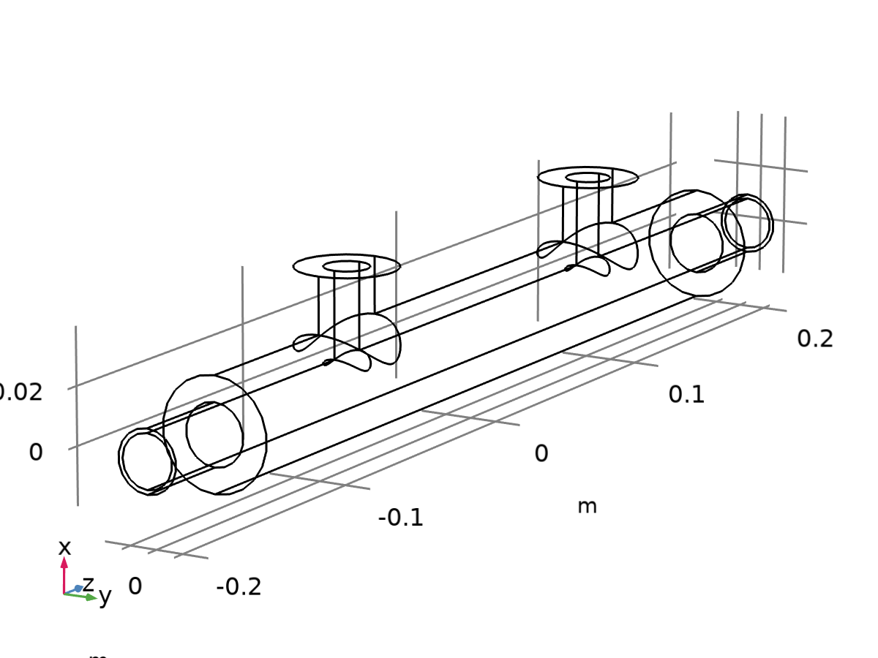
Thermal Insulation 1
Selection
Geometric entity level | Boundary
Selection | Geometry geom1: Dimension 2: All boundaries

Equations
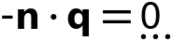
Used products
COMSOL Multiphysics

Shape functions
Name | Shape function | Unit | Description | Shape frame | Selection | Details
T | Lagrange (Linear) | K | Temperature | Spatial | No boundaries | Slit
T | Lagrange (Linear) | K | Temperature | Material | No boundaries | Slit
T | Lagrange (Linear) | K | Temperature | Geometry | No boundaries | Slit
T | Lagrange (Linear) | K | Temperature | Mesh | No boundaries | Slit

Thermal Insulation 2

Thermal Insulation 2
Selection
Geometric entity level | Boundary
Selection | Geometry geom1: Dimension 2: All boundaries

Equations

Used products
COMSOL Multiphysics

Shape functions
Name | Shape function | Unit | Description | Shape frame | Selection | Details
T | Lagrange (Linear) | K | Temperature | Spatial | No boundaries | Slit
T | Lagrange (Linear) | K | Temperature | Material | No boundaries | Slit
T | Lagrange (Linear) | K | Temperature | Geometry | No boundaries | Slit
T | Lagrange (Linear) | K | Temperature | Mesh | No boundaries | Slit

Symmetry 1

Symmetry 1
Selection
Geometric entity level | Boundary
Selection | Geometry geom1: Dimension 2: All boundaries

Equations

Used products
COMSOL Multiphysics

Open Boundary 1
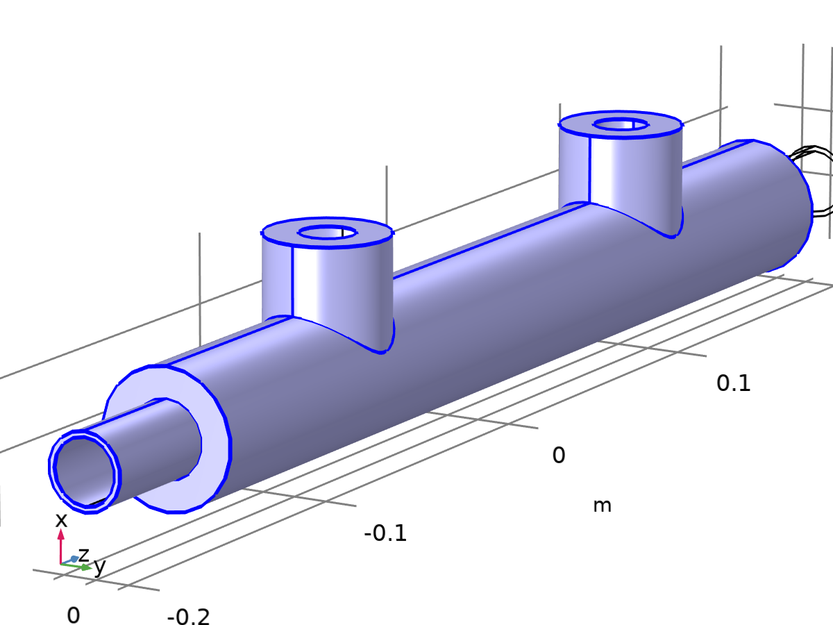
Open Boundary 1
Selection
Geometric entity level | Boundary
Selection | Geometry geom1: Dimension 2: All boundaries

Equations
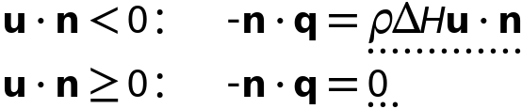
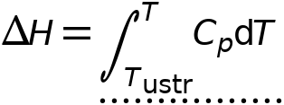

Upstream Properties
Settings
Description | Value | Unit
Upstream temperature | User defined
Upstream temperature | 293.15 | K

Inflow Condition
Settings
Description | Value
Inflow condition | Flux (Danckwerts)

Variables
Name | Expression | Unit | Description | Selection
ht.open1.Tustr | 293.15[K] | K | Upstream temperature | Boundaries 1–7, 15–22
ht.open1.ntfluxInt | ht.open1.intExtBnd(ht.ntflux*ht.varIntSpa)+ht.open1.intIntBnd(ht.ncflux_u*up(ht.varIntSpa)+ht.ncflux_d*down(ht.varIntSpa)) | W | Total net heat rate | Global
ht.open1.ntfluxInt_cst | ht.open1.intExtBnd(ht.ntflux*ht.varIntSpa)+ht.open1.intIntBnd(ht.ncflux_u*up(ht.varIntSpa)+ht.ncflux_d*down(ht.varIntSpa)) | W | Total net heat rate, constant material properties | Global
ht.open1.ntefluxInt | ht.open1.intExtBnd(ht.nteflux*ht.varIntSpa)+ht.open1.intIntBnd(ht.nthflux_u*up(ht.varIntSpa)+ht.nthflux_d*down(ht.varIntSpa)) | W | Total net energy rate | Global
ht.open1.ntefluxInt_cst | ht.open1.intExtBnd(ht.nteflux_cst*ht.varIntSpa)+ht.open1.intIntBnd(ht.nthflux_cst_u*up(ht.varIntSpa)+ht.nthflux_cst_d*down(ht.varIntSpa)) | W | Total net energy rate, constant material properties | Global
ht.open1.ntfluxInt_u | ht.open1.intIntBnd(ht.ntflux_u*up(ht.varIntSpa)) | W | Total net heat rate, upside | Global
ht.open1.ntfluxInt_cst_u | ht.open1.intIntBnd(ht.ntflux_u*up(ht.varIntSpa)) | W | Total net heat rate, constant material properties, upside | Global
ht.open1.ntefluxInt_u | ht.open1.intIntBnd(ht.nteflux_u*up(ht.varIntSpa)) | W | Total net energy rate, upside | Global
ht.open1.ntefluxInt_cst_u | ht.open1.intIntBnd(ht.nteflux_cst_u*up(ht.varIntSpa)) | W | Total net energy rate, constant material properties, upside | Global
ht.open1.ntfluxInt_d | ht.open1.intIntBnd(ht.ntflux_d*down(ht.varIntSpa)) | W | Total net heat rate, downside | Global
ht.open1.ntfluxInt_cst_d | ht.open1.intIntBnd(ht.ntflux_d*down(ht.varIntSpa)) | W | Total net heat rate, constant material properties, downside | Global
ht.open1.ntefluxInt_d | ht.open1.intIntBnd(ht.nteflux_d*down(ht.varIntSpa)) | W | Total net energy rate, downside | Global
ht.open1.ntefluxInt_cst_d | ht.open1.intIntBnd(ht.nteflux_cst_d*down(ht.varIntSpa)) | W | Total net energy rate, constant material properties, downside | Global
ht.open1.Tave | nojac(ht.open1.intBnd(ht.varIntSpa*ht.rho*ht.Cp*T*max(abs(ht.ux*ht.nxmesh+ht.uy*ht.nymesh+ht.uz*ht.nzmesh),eps)))/nojac(ht.open1.intBnd(ht.varIntSpa*ht.rho*ht.Cp*max(abs(ht.ux*ht.nxmesh+ht.uy*ht.nymesh+ht.uz*ht.nzmesh),eps))) | K | Weighted average temperature | Global
ht.open1.pustr | ht.pA | Pa | Upstream absolute pressure | Boundaries 1–7, 15–22

Inflow 1
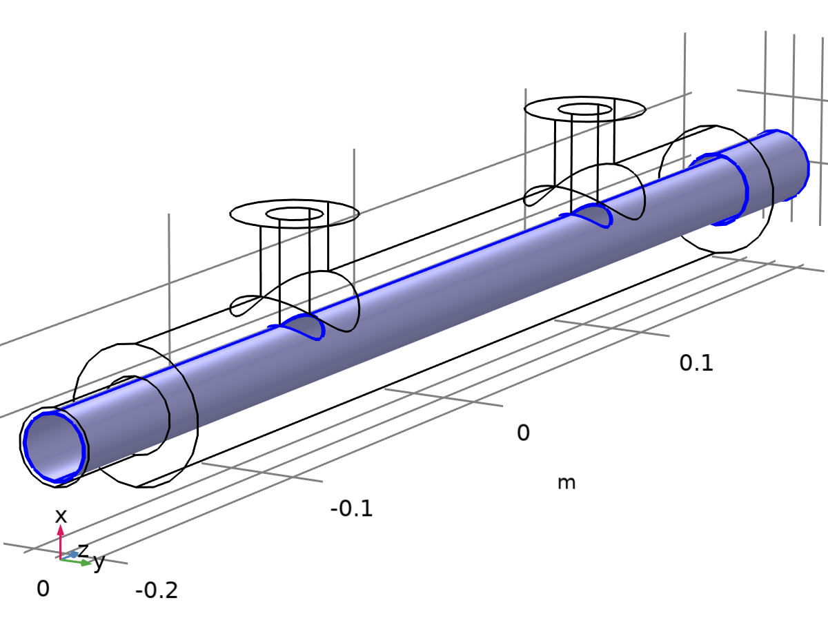
Inflow 1
Selection
Geometric entity level | Boundary
Selection | Geometry geom1: Dimension 2: Boundaries 8–12

Equations
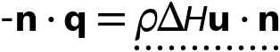


Upstream Properties
Settings
Description | Value | Unit
Upstream temperature | User defined
Upstream temperature | 303 | K
Specify upstream absolute pressure | Off

Variables
Name | Expression | Unit | Description | Selection
ht.ifl1.Tustr | 303[K] | K | Upstream temperature | Boundaries 8–12
ht.ifl1.ntfluxInt | ht.ifl1.intExtBnd(ht.ntflux*ht.varIntSpa)+ht.ifl1.intIntBnd(ht.ncflux_u*up(ht.varIntSpa)+ht.ncflux_d*down(ht.varIntSpa)) | W | Total net heat rate | Global
ht.ifl1.ntfluxInt_cst | ht.ifl1.intExtBnd(ht.ntflux*ht.varIntSpa)+ht.ifl1.intIntBnd(ht.ncflux_u*up(ht.varIntSpa)+ht.ncflux_d*down(ht.varIntSpa)) | W | Total net heat rate, constant material properties | Global
ht.ifl1.ntefluxInt | ht.ifl1.intExtBnd(ht.nteflux*ht.varIntSpa)+ht.ifl1.intIntBnd(ht.nthflux_u*up(ht.varIntSpa)+ht.nthflux_d*down(ht.varIntSpa)) | W | Total net energy rate | Global
ht.ifl1.ntefluxInt_cst | ht.ifl1.intExtBnd(ht.nteflux_cst*ht.varIntSpa)+ht.ifl1.intIntBnd(ht.nthflux_cst_u*up(ht.varIntSpa)+ht.nthflux_cst_d*down(ht.varIntSpa)) | W | Total net energy rate, constant material properties | Global
ht.ifl1.ntfluxInt_u | ht.ifl1.intIntBnd(ht.ntflux_u*up(ht.varIntSpa)) | W | Total net heat rate, upside | Global
ht.ifl1.ntfluxInt_cst_u | ht.ifl1.intIntBnd(ht.ntflux_u*up(ht.varIntSpa)) | W | Total net heat rate, constant material properties, upside | Global
ht.ifl1.ntefluxInt_u | ht.ifl1.intIntBnd(ht.nteflux_u*up(ht.varIntSpa)) | W | Total net energy rate, upside | Global
ht.ifl1.ntefluxInt_cst_u | ht.ifl1.intIntBnd(ht.nteflux_cst_u*up(ht.varIntSpa)) | W | Total net energy rate, constant material properties, upside | Global
ht.ifl1.ntfluxInt_d | ht.ifl1.intIntBnd(ht.ntflux_d*down(ht.varIntSpa)) | W | Total net heat rate, downside | Global
ht.ifl1.ntfluxInt_cst_d | ht.ifl1.intIntBnd(ht.ntflux_d*down(ht.varIntSpa)) | W | Total net heat rate, constant material properties, downside | Global
ht.ifl1.ntefluxInt_d | ht.ifl1.intIntBnd(ht.nteflux_d*down(ht.varIntSpa)) | W | Total net energy rate, downside | Global
ht.ifl1.ntefluxInt_cst_d | ht.ifl1.intIntBnd(ht.nteflux_cst_d*down(ht.varIntSpa)) | W | Total net energy rate, constant material properties, downside | Global
ht.ifl1.Tave | nojac(ht.ifl1.intBnd(ht.varIntSpa*ht.rho*ht.Cp*T*max(abs(ht.ux*ht.nxmesh+ht.uy*ht.nymesh+ht.uz*ht.nzmesh),eps)))/nojac(ht.ifl1.intBnd(ht.varIntSpa*ht.rho*ht.Cp*max(abs(ht.ux*ht.nxmesh+ht.uy*ht.nymesh+ht.uz*ht.nzmesh),eps))) | K | Weighted average temperature | Global
ht.ifl1.pustr | ht.pA | Pa | Upstream absolute pressure | Boundaries 8–12

Inflow 2
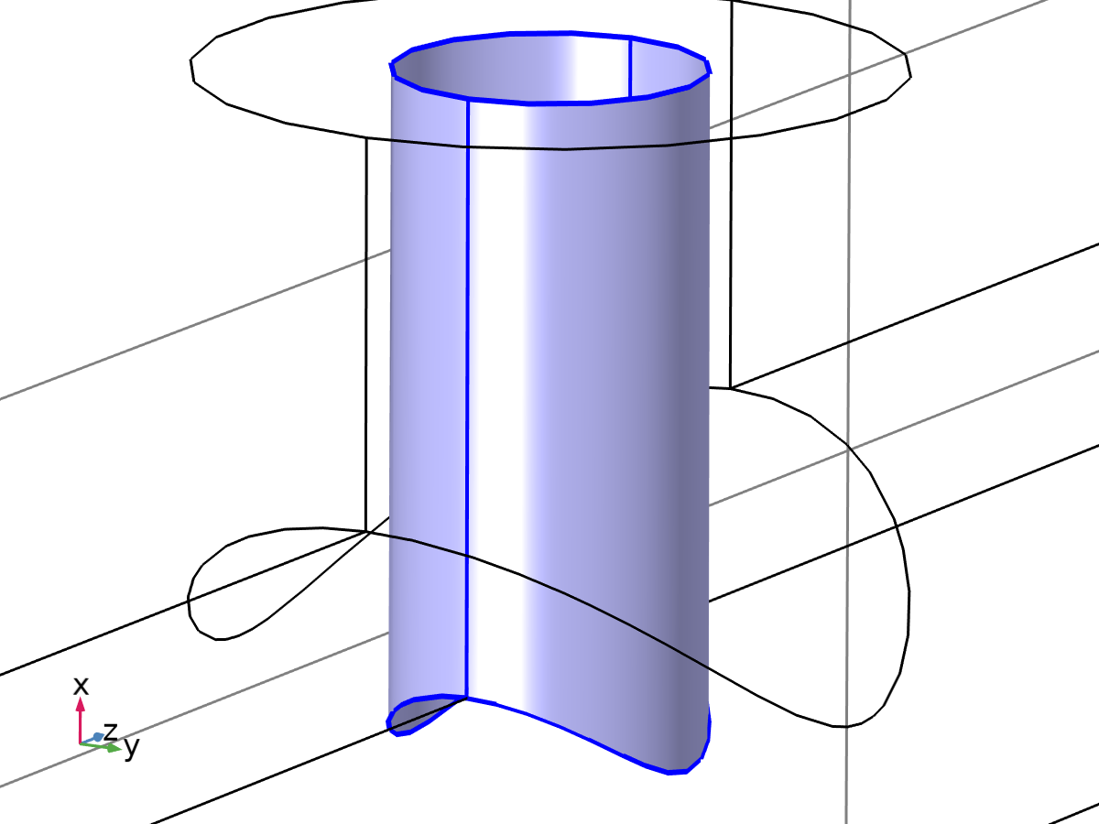
Inflow 2
Selection
Geometric entity level | Boundary
Selection | Geometry geom1: Dimension 2: Boundaries 13–14

Equations



Upstream Properties
Settings
Description | Value | Unit
Upstream temperature | User defined
Upstream temperature | 277 | K
Specify upstream absolute pressure | Off

Variables
Name | Expression | Unit | Description | Selection
ht.ifl2.Tustr | 277[K] | K | Upstream temperature | Boundaries 13–14
ht.ifl2.ntfluxInt | ht.ifl2.intExtBnd(ht.ntflux*ht.varIntSpa)+ht.ifl2.intIntBnd(ht.ncflux_u*up(ht.varIntSpa)+ht.ncflux_d*down(ht.varIntSpa)) | W | Total net heat rate | Global
ht.ifl2.ntfluxInt_cst | ht.ifl2.intExtBnd(ht.ntflux*ht.varIntSpa)+ht.ifl2.intIntBnd(ht.ncflux_u*up(ht.varIntSpa)+ht.ncflux_d*down(ht.varIntSpa)) | W | Total net heat rate, constant material properties | Global
ht.ifl2.ntefluxInt | ht.ifl2.intExtBnd(ht.nteflux*ht.varIntSpa)+ht.ifl2.intIntBnd(ht.nthflux_u*up(ht.varIntSpa)+ht.nthflux_d*down(ht.varIntSpa)) | W | Total net energy rate | Global
ht.ifl2.ntefluxInt_cst | ht.ifl2.intExtBnd(ht.nteflux_cst*ht.varIntSpa)+ht.ifl2.intIntBnd(ht.nthflux_cst_u*up(ht.varIntSpa)+ht.nthflux_cst_d*down(ht.varIntSpa)) | W | Total net energy rate, constant material properties | Global
ht.ifl2.ntfluxInt_u | ht.ifl2.intIntBnd(ht.ntflux_u*up(ht.varIntSpa)) | W | Total net heat rate, upside | Global
ht.ifl2.ntfluxInt_cst_u | ht.ifl2.intIntBnd(ht.ntflux_u*up(ht.varIntSpa)) | W | Total net heat rate, constant material properties, upside | Global
ht.ifl2.ntefluxInt_u | ht.ifl2.intIntBnd(ht.nteflux_u*up(ht.varIntSpa)) | W | Total net energy rate, upside | Global
ht.ifl2.ntefluxInt_cst_u | ht.ifl2.intIntBnd(ht.nteflux_cst_u*up(ht.varIntSpa)) | W | Total net energy rate, constant material properties, upside | Global
ht.ifl2.ntfluxInt_d | ht.ifl2.intIntBnd(ht.ntflux_d*down(ht.varIntSpa)) | W | Total net heat rate, downside | Global
ht.ifl2.ntfluxInt_cst_d | ht.ifl2.intIntBnd(ht.ntflux_d*down(ht.varIntSpa)) | W | Total net heat rate, constant material properties, downside | Global
ht.ifl2.ntefluxInt_d | ht.ifl2.intIntBnd(ht.nteflux_d*down(ht.varIntSpa)) | W | Total net energy rate, downside | Global
ht.ifl2.ntefluxInt_cst_d | ht.ifl2.intIntBnd(ht.nteflux_cst_d*down(ht.varIntSpa)) | W | Total net energy rate, constant material properties, downside | Global
ht.ifl2.Tave | nojac(ht.ifl2.intBnd(ht.varIntSpa*ht.rho*ht.Cp*T*max(abs(ht.ux*ht.nxmesh+ht.uy*ht.nymesh+ht.uz*ht.nzmesh),eps)))/nojac(ht.ifl2.intBnd(ht.varIntSpa*ht.rho*ht.Cp*max(abs(ht.ux*ht.nxmesh+ht.uy*ht.nymesh+ht.uz*ht.nzmesh),eps))) | K | Weighted average temperature | Global
ht.ifl2.pustr | ht.pA | Pa | Upstream absolute pressure | Boundaries 13–14

Turbulent Flow, k-ω
Used products
COMSOL Multiphysics
CFD Module


Turbulent Flow, k-ω
Selection
Geometric entity level | Domain
Selection | Geometry geom1: Dimension 3: All domains

Equations
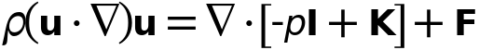
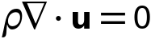
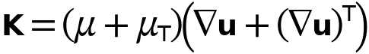
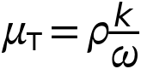
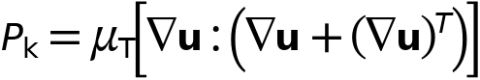

Interface Settings

Discretization
Settings
Description | Value
Discretization of fluids | P1 + P1

Settings
Description | Value
Equation form | Study controlled

Physical Model
Settings
Description | Value | Unit
Compressibility | Incompressible flow
Enable porous media domains | Off
Include gravity | Off
Reference pressure level | 1.0133E5 | Pa

Turbulence
Settings
Description | Value
Turbulence model | k - ω
Wall treatment | Automatic
Edit turbulence model parameters | Off
Turbulence model type | RANS

Advanced Settings
Settings
Description | Value | Unit
Use pseudo time stepping for stationary equation form | Automatic from physics
CFL number expression | Automatic
Velocity scale | 1 | m/s
Length scale factor | 0.035 | 1
Use Block Navier-Stokes preconditioner | Off

Variables
Name | Expression | Unit | Description | Selection | Details
spf.kappav | 0.41 | 1 | Turbulence model parameter | Domain 1
spf.B | 5.2 | 1 | Law of the wall constant | Domain 1
spf.Tref | model.input.Tref | K | Reference temperature | Global | Meta
spf.dz | 1 | m | Thickness | Domain 1
spf.pref | 1[atm] | Pa | Reference pressure level | Domain 1
spf.pA | p+spf.pref | Pa | Absolute pressure | Domain 1
spf.hasWF | 0 |  | Help variable | Boundaries 1–22
spf.dt_CFL | 1/max(spf.maxop(sqrt(emetric_spatial(u-d(x,TIME),v-d(y,TIME),w-d(z,TIME)))),eps) | s | Time step, CFL=1 | Global
spf.Qvd_tot | spf.intop(spf.Qvd) | W | Total viscous dissipation | Global
spf.K_stressx | spf.K_stress_tensorxx*spf.nxmesh+spf.K_stress_tensorxy*spf.nymesh+spf.K_stress_tensorxz*spf.nzmesh | N/m² | Viscous stress, exterior boundaries, x-component | Boundaries 1–22
spf.K_stressy | spf.K_stress_tensoryx*spf.nxmesh+spf.K_stress_tensoryy*spf.nymesh+spf.K_stress_tensoryz*spf.nzmesh | N/m² | Viscous stress, exterior boundaries, y-component | Boundaries 1–22
spf.K_stressz | spf.K_stress_tensorzx*spf.nxmesh+spf.K_stress_tensorzy*spf.nymesh+spf.K_stress_tensorzz*spf.nzmesh | N/m² | Viscous stress, exterior boundaries, z-component | Boundaries 1–22
spf.T_stressx | spf.T_stress_tensorxx*spf.nxmesh+spf.T_stress_tensorxy*spf.nymesh+spf.T_stress_tensorxz*spf.nzmesh | N/m² | Total traction, exterior boundaries, x-component | Boundaries 1–22
spf.T_stressy | spf.T_stress_tensoryx*spf.nxmesh+spf.T_stress_tensoryy*spf.nymesh+spf.T_stress_tensoryz*spf.nzmesh | N/m² | Total traction, exterior boundaries, y-component | Boundaries 1–22
spf.T_stressz | spf.T_stress_tensorzx*spf.nxmesh+spf.T_stress_tensorzy*spf.nymesh+spf.T_stress_tensorzz*spf.nzmesh | N/m² | Total traction, exterior boundaries, z-component | Boundaries 1–22
spf.K_stress_dx | down(spf.K_stress_tensorxx)*spf.dnxmesh+down(spf.K_stress_tensorxy)*spf.dnymesh+down(spf.K_stress_tensorxz)*spf.dnzmesh | N/m² | Viscous stress, interior boundaries, downside, x-component | Boundaries 1–22
spf.K_stress_dy | down(spf.K_stress_tensoryx)*spf.dnxmesh+down(spf.K_stress_tensoryy)*spf.dnymesh+down(spf.K_stress_tensoryz)*spf.dnzmesh | N/m² | Viscous stress, interior boundaries, downside, y-component | Boundaries 1–22
spf.K_stress_dz | down(spf.K_stress_tensorzx)*spf.dnxmesh+down(spf.K_stress_tensorzy)*spf.dnymesh+down(spf.K_stress_tensorzz)*spf.dnzmesh | N/m² | Viscous stress, interior boundaries, downside, z-component | Boundaries 1–22
spf.T_stress_dx | down(spf.T_stress_tensorxx)*spf.dnxmesh+down(spf.T_stress_tensorxy)*spf.dnymesh+down(spf.T_stress_tensorxz)*spf.dnzmesh | N/m² | Total traction, interior boundaries, downside, x-component | Boundaries 1–22
spf.T_stress_dy | down(spf.T_stress_tensoryx)*spf.dnxmesh+down(spf.T_stress_tensoryy)*spf.dnymesh+down(spf.T_stress_tensoryz)*spf.dnzmesh | N/m² | Total traction, interior boundaries, downside, y-component | Boundaries 1–22
spf.T_stress_dz | down(spf.T_stress_tensorzx)*spf.dnxmesh+down(spf.T_stress_tensorzy)*spf.dnymesh+down(spf.T_stress_tensorzz)*spf.dnzmesh | N/m² | Total traction, interior boundaries, downside, z-component | Boundaries 1–22
spf.sigmaw | 0.2 | 1 | Smoothing parameter | Domain 1
spf.alphakom | 0.52 | 1 | Turbulence model parameter | Domain 1
spf.sigmaks | 0.5 | 1 | Turbulence model parameter | Domain 1
spf.sigmaom | 0.5 | 1 | Turbulence model parameter | Domain 1
spf.beta0 | 0.072 | 1 | Turbulence model parameter | Domain 1
spf.beta0s | 0.09 | 1 | Turbulence model parameter | Domain 1
spf.usePseudoTimeStepping | 1 | 1 | Help variable | Global
spf.localCFLvalue | 3+if(niterCMP>=15,1.3^min(-15+niterCMP,7),0)+if(niterCMP>=40,9*1.3^min(-40+niterCMP,9),0)+if(niterCMP>=70,90*1.3^min(-70+niterCMP,9),0) |  | Local CFL number | Domain 1
spf.locCFL | max(CFLCMP,sqrt(eps)) | 1 | Local CFL number | Global
spf.geometryLengthScale | 0.01 | m | Geometry length scale | Domain 1
spf.time_step_inv | max(sqrt(emetric_spatial(u,v,w)*2^gmg_level^2),spf.nu/spf.geometryLengthScale^2) | Hz | Inverse time step | Domain 1
spf.tsti | nojac(spf.time_step_inv/spf.locCFL) | 1/s | Help variable | Domain 1
spf.nx | dnx | 1 | Normal vector, x-component | Boundaries 1–22
spf.ny | dny | 1 | Normal vector, y-component | Boundaries 1–22
spf.nz | dnz | 1 | Normal vector, z-component | Boundaries 1–22
spf.nxmesh | dnxmesh | 1 | Normal vector, x-component | Boundaries 1–22
spf.nymesh | dnymesh | 1 | Normal vector, y-component | Boundaries 1–22
spf.nzmesh | dnzmesh | 1 | Normal vector, z-component | Boundaries 1–22

Fluid Properties 1

Fluid Properties 1
Selection
Geometric entity level | Domain
Selection | Geometry geom1: Dimension 3: All domains

Equations
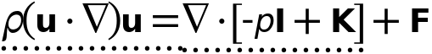
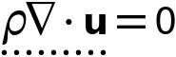

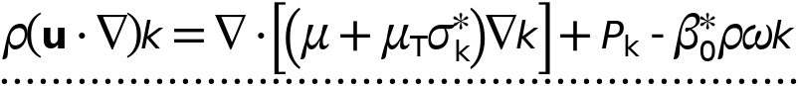

Fluid Properties
Settings
Description | Value | Unit
Density | User defined
Density | 1000 | kg/m³
Constitutive relation | Specify dynamic viscosity
Dynamic viscosity | From material

Mixing Length Limit
Settings
Description | Value
Mixing length limit | Automatic

Model Input
Settings
Description | Value | Unit
Temperature | Temperature (ht)
Absolute pressure | User defined
Absolute pressure | 1.0133E5 | Pa
Volume reference temperature | User defined
Volume reference temperature | 293.15 | K

Properties from material
Property | Material | Property group
Dynamic viscosity | H2O (water) [liquid] | Basic

Variables
Name | Expression | Unit | Description | Selection | Details
spf.mu | material.mu | Pa·s | Dynamic viscosity | Domain 1 | Meta
spf.rho | 1000[kg/m^3] | kg/m³ | Density | Domain 1
spf.rhoref | subst(1000[kg/m^3],minput.T,spf.Tref,minput.pA,spf.pref) | kg/m³ | Reference density | Domain 1
spf.muinit | subst(material.mu,spf.fp1.minput_temperature,spf.Tref,spf.fp1.minput_pressure,spf.pref) | Pa·s | Dynamic viscosity | Domain 1 | Meta
spf.rhoinit | spf.rho | kg/m³ | Density | Domain 1
spf.geometryLengthScale | 0.25*spf.l_mix_lim | m | Geometry length scale | Domain 1
spf.Trho | spf.fp1.minput_temperature | K | Temperature for density evaluation | Domain 1
spf.prho | spf.fp1.minput_pressure | Pa | Pressure for the evaluation of density | Domain 1
spf.mumat | material.mu | Pa·s | Dynamic viscosity | Domain 1 | Meta
spf.srijxx | ux | 1/s | Strain rate tensor, xx-component | Domain 1
spf.srijyx | 0.5*(vx+uy) | 1/s | Strain rate tensor, yx-component | Domain 1
spf.srijzx | 0.5*(wx+uz) | 1/s | Strain rate tensor, zx-component | Domain 1
spf.srijxy | 0.5*(uy+vx) | 1/s | Strain rate tensor, xy-component | Domain 1
spf.srijyy | vy | 1/s | Strain rate tensor, yy-component | Domain 1
spf.srijzy | 0.5*(wy+vz) | 1/s | Strain rate tensor, zy-component | Domain 1
spf.srijxz | 0.5*(uz+wx) | 1/s | Strain rate tensor, xz-component | Domain 1
spf.srijyz | 0.5*(vz+wy) | 1/s | Strain rate tensor, yz-component | Domain 1
spf.srijzz | wz | 1/s | Strain rate tensor, zz-component | Domain 1
spf.rrijxx | 0 | 1/s | Rotation rate tensor, xx-component | Domain 1
spf.rrijyx | 0.5*(vx-uy) | 1/s | Rotation rate tensor, yx-component | Domain 1
spf.rrijzx | 0.5*(wx-uz) | 1/s | Rotation rate tensor, zx-component | Domain 1
spf.rrijxy | 0.5*(uy-vx) | 1/s | Rotation rate tensor, xy-component | Domain 1
spf.rrijyy | 0 | 1/s | Rotation rate tensor, yy-component | Domain 1
spf.rrijzy | 0.5*(wy-vz) | 1/s | Rotation rate tensor, zy-component | Domain 1
spf.rrijxz | 0.5*(uz-wx) | 1/s | Rotation rate tensor, xz-component | Domain 1
spf.rrijyz | 0.5*(vz-wy) | 1/s | Rotation rate tensor, yz-component | Domain 1
spf.rrijzz | 0 | 1/s | Rotation rate tensor, zz-component | Domain 1
spf.sr | sqrt(2*spf.srijxx^2+2*spf.srijxy^2+2*spf.srijxz^2+2*spf.srijyx^2+2*spf.srijyy^2+2*spf.srijyz^2+2*spf.srijzx^2+2*spf.srijzy^2+2*spf.srijzz^2+eps) | 1/s | Shear rate | Domain 1
spf.rr | sqrt(2*spf.rrijxx^2+2*spf.rrijxy^2+2*spf.rrijxz^2+2*spf.rrijyx^2+2*spf.rrijyy^2+2*spf.rrijyz^2+2*spf.rrijzx^2+2*spf.rrijzy^2+2*spf.rrijzz^2+eps) | 1/s | Rotation rate | Domain 1
spf.divu | ux+vy+wz | 1/s | Divergence of velocity field | Domain 1
spf.Fx | 0 | N/m³ | Volume force, x-component | Domain 1 | + operation
spf.Fy | 0 | N/m³ | Volume force, y-component | Domain 1 | + operation
spf.Fz | 0 | N/m³ | Volume force, z-component | Domain 1 | + operation
spf.U | sqrt(u^2+v^2+w^2) | m/s | Velocity magnitude | Domain 1
spf.vorticityx | wy-vz | 1/s | Vorticity field, x-component | Domain 1
spf.vorticityy | -wx+uz | 1/s | Vorticity field, y-component | Domain 1
spf.vorticityz | vx-uy | 1/s | Vorticity field, z-component | Domain 1
spf.vort_magn | sqrt(spf.vorticityx^2+spf.vorticityy^2+spf.vorticityz^2) | 1/s | Vorticity magnitude | Domain 1
spf.cellRe | 0.25*spf.rho*sqrt(emetric_spatial(u-d(x,TIME),v-d(y,TIME),w-d(z,TIME))/emetric2_spatial)/spf.mu | 1 | Cell Reynolds number | Domain 1
spf.nu | spf.mu/spf.rho | m²/s | Kinematic viscosity | Domain 1
spf.betaT | 0 | 1/Pa | Isothermal compressibility coefficient | Domain 1
spf.Qm | 0 | kg/(m³·s) | Source term | Domain 1 | + operation
spf.Fgtotx | 0 | N/m³ | Gravity force, x-component | Domain 1 | + operation
spf.Fgtoty | 0 | N/m³ | Gravity force, y-component | Domain 1 | + operation
spf.Fgtotz | 0 | N/m³ | Gravity force, z-component | Domain 1 | + operation
spf.Qm_aco | 0 | kg/(m³·s) | Acoustic mass source | Domain 1
spf.F_acox | 0 | N/m³ | Acoustic volume force, x-component | Domain 1
spf.F_acoy | 0 | N/m³ | Acoustic volume force, y-component | Domain 1
spf.F_acoz | 0 | N/m³ | Acoustic volume force, z-component | Domain 1
spf.gamma_sr | sqrt(2*spf.srijxx^2+2*spf.srijxy^2+2*spf.srijxz^2+2*spf.srijyx^2+2*spf.srijyy^2+2*spf.srijyz^2+2*spf.srijzx^2+2*spf.srijzy^2+2*spf.srijzz^2+eps) | 1/s | Shear rate | Domain 1
spf.mu_eff | spf.mu+spf.muT | Pa·s | Effective dynamic viscosity | Domain 1
spf.muT | nojac(spf.rho*spf.lsubstar*sqrt(spf.k_nn)) | Pa·s | Turbulent dynamic viscosity | Domain 1 | + operation
spf.T_stress_tensorxx | spf.K_stress_tensorxx-p | N/m² | Total stress tensor, xx-component | Domain 1 | + operation
spf.T_stress_tensoryx | spf.K_stress_tensoryx | N/m² | Total stress tensor, yx-component | Domain 1 | + operation
spf.T_stress_tensorzx | spf.K_stress_tensorzx | N/m² | Total stress tensor, zx-component | Domain 1 | + operation
spf.T_stress_tensorxy | spf.K_stress_tensorxy | N/m² | Total stress tensor, xy-component | Domain 1 | + operation
spf.T_stress_tensoryy | spf.K_stress_tensoryy-p | N/m² | Total stress tensor, yy-component | Domain 1 | + operation
spf.T_stress_tensorzy | spf.K_stress_tensorzy | N/m² | Total stress tensor, zy-component | Domain 1 | + operation
spf.T_stress_tensorxz | spf.K_stress_tensorxz | N/m² | Total stress tensor, xz-component | Domain 1 | + operation
spf.T_stress_tensoryz | spf.K_stress_tensoryz | N/m² | Total stress tensor, yz-component | Domain 1 | + operation
spf.T_stress_tensorzz | spf.K_stress_tensorzz-p | N/m² | Total stress tensor, zz-component | Domain 1 | + operation
spf.K_stress_tensorxx | 2*spf.mu_eff*ux | N/m² | Viscous stress tensor, xx-component | Domain 1 | + operation
spf.K_stress_tensoryx | spf.mu_eff*(vx+uy) | N/m² | Viscous stress tensor, yx-component | Domain 1 | + operation
spf.K_stress_tensorzx | spf.mu_eff*(wx+uz) | N/m² | Viscous stress tensor, zx-component | Domain 1 | + operation
spf.K_stress_tensorxy | spf.mu_eff*(uy+vx) | N/m² | Viscous stress tensor, xy-component | Domain 1 | + operation
spf.K_stress_tensoryy | 2*spf.mu_eff*vy | N/m² | Viscous stress tensor, yy-component | Domain 1 | + operation
spf.K_stress_tensorzy | spf.mu_eff*(wy+vz) | N/m² | Viscous stress tensor, zy-component | Domain 1 | + operation
spf.K_stress_tensorxz | spf.mu_eff*(uz+wx) | N/m² | Viscous stress tensor, xz-component | Domain 1 | + operation
spf.K_stress_tensoryz | spf.mu_eff*(vz+wy) | N/m² | Viscous stress tensor, yz-component | Domain 1 | + operation
spf.K_stress_tensorzz | 2*spf.mu_eff*wz | N/m² | Viscous stress tensor, zz-component | Domain 1 | + operation
spf.K_stress_tensor_testxx | 2*spf.mu_eff*test(ux) | N/m² | Viscous stress tensor test, xx-component | Domain 1 | + operation
spf.K_stress_tensor_testyx | spf.mu_eff*(test(vx)+test(uy)) | N/m² | Viscous stress tensor test, yx-component | Domain 1 | + operation
spf.K_stress_tensor_testzx | spf.mu_eff*(test(wx)+test(uz)) | N/m² | Viscous stress tensor test, zx-component | Domain 1 | + operation
spf.K_stress_tensor_testxy | spf.mu_eff*(test(uy)+test(vx)) | N/m² | Viscous stress tensor test, xy-component | Domain 1 | + operation
spf.K_stress_tensor_testyy | 2*spf.mu_eff*test(vy) | N/m² | Viscous stress tensor test, yy-component | Domain 1 | + operation
spf.K_stress_tensor_testzy | spf.mu_eff*(test(wy)+test(vz)) | N/m² | Viscous stress tensor test, zy-component | Domain 1 | + operation
spf.K_stress_tensor_testxz | spf.mu_eff*(test(uz)+test(wx)) | N/m² | Viscous stress tensor test, xz-component | Domain 1 | + operation
spf.K_stress_tensor_testyz | spf.mu_eff*(test(vz)+test(wy)) | N/m² | Viscous stress tensor test, yz-component | Domain 1 | + operation
spf.K_stress_tensor_testzz | 2*spf.mu_eff*test(wz) | N/m² | Viscous stress tensor test, zz-component | Domain 1 | + operation
spf.upwind_helpx | u-d(x,TIME) | m/s | Upwind term, x-component | Domain 1 | + operation
spf.upwind_helpy | v-d(y,TIME) | m/s | Upwind term, y-component | Domain 1 | + operation
spf.upwind_helpz | w-d(z,TIME) | m/s | Upwind term, z-component | Domain 1 | + operation
spf.continuityEquation | spf.rho*spf.divu | kg/(m³·s) | Continuity equation | Domain 1
spf.contCoeff | spf.rho | kg/m³ | Help variable | Domain 1
spf.om_global | om | 1/s | Specific dissipation rate, (all cells) | Domain 1
spf.l_mix_lim | 2*spf.lref | m | Mixing length limit | Domain 1
spf.k_nn | max(k,0) | m²/s² | Regularized turbulent kinetic energy | Domain 1
spf.k_pos | spf.k_nn+eps | m²/s² | Regularized turbulent kinetic energy | Domain 1
spf.om_nn | max(spf.om_global,0) | 1/s | Regularized turbulent dissipation rate | Domain 1
spf.om_pos | spf.om_nn+eps | 1/s |  | Domain 1
spf.Sxx | ux | 1/s | Strain rate, xx-component | Domain 1 | + operation
spf.Syx | 0.5*(vx+uy) | 1/s | Strain rate, yx-component | Domain 1 | + operation
spf.Szx | 0.5*(wx+uz) | 1/s | Strain rate, zx-component | Domain 1 | + operation
spf.Sxy | 0.5*(uy+vx) | 1/s | Strain rate, xy-component | Domain 1 | + operation
spf.Syy | vy | 1/s | Strain rate, yy-component | Domain 1 | + operation
spf.Szy | 0.5*(wy+vz) | 1/s | Strain rate, zy-component | Domain 1 | + operation
spf.Sxz | 0.5*(uz+wx) | 1/s | Strain rate, xz-component | Domain 1 | + operation
spf.Syz | 0.5*(vz+wy) | 1/s | Strain rate, yz-component | Domain 1 | + operation
spf.Szz | wz | 1/s | Strain rate, zz-component | Domain 1 | + operation
spf.AbsS | sqrt(max(spf.Sxx^2+spf.Sxy^2+spf.Sxz^2+spf.Syx^2+spf.Syy^2+spf.Syz^2+spf.Szx^2+spf.Szy^2+spf.Szz^2,0)) | 1/s | Absolute strain rate | Domain 1
spf.rF | sqrt(1/6)/max(spf.AbsS,eps) | s | Help variable | Domain 1
spf.rFInv | sqrt(6)*spf.AbsS | 1/s | Help variable | Domain 1
spf.lcore | min(sqrt(spf.k_nn)/spf.om_pos,sqrt(spf.k_nn)*spf.rF) | m | Help variable | Domain 1
spf.lsubstar | nojac(min(spf.lcore,spf.l_mix_lim)) | m | Limited mixing length | Domain 1
spf.nuT | spf.muT/spf.rho | m²/s | Turbulent kinematic viscosity | Domain 1
spf.linSCk | nojac(-spf.rho*(spf.om_nn*spf.betaStar-min(spf.Pkb_mul,0)/max(spf.rho,eps))) | kg/(m³·s) | Linear source term coefficient, k-equation | Domain 1
spf.linSCom | nojac(-spf.rho*(spf.betaom*spf.om_nn-min(spf.Pomb_mul,0)/max(spf.rho,eps))) | kg/(m³·s) | Linear source term coefficient | Domain 1
spf.PCore | 2*(spf.Sxx^2+spf.Sxy^2+spf.Sxz^2+spf.Syx^2+spf.Syy^2+spf.Syz^2+spf.Szx^2+spf.Szy^2+spf.Szz^2) | 1/s² | Turbulent kinetic energy source term | Domain 1
spf.Pk | nojac(max(spf.muT*spf.PCore,0))+nojac(max(spf.Pkb_mul,0)*k) | W/m³ | Turbulent kinetic energy source term | Domain 1
spf.Pom | nojac(max(spf.alphakom*spf.rho*spf.PCore,0))+nojac(max(spf.Pomb_mul,0)*om) | kg/(m³·s²) | Turbulence help variable | Domain 1
spf.kinit | (100*spf.muinit/(spf.rhoinit*spf.l_mix_lim))^2 | m²/s² | Turbulent kinetic energy | Domain 1
spf.omInit | 10*spf.kinit^0.5/spf.l_mix_lim | 1/s | Turbulent dissipation rate | Domain 1
spf.Omxx | 0 | 1/s | Rotation rate tensor, xx-component | Domain 1 | + operation
spf.Omyx | 0.5*(vx-uy) | 1/s | Rotation rate tensor, yx-component | Domain 1 | + operation
spf.Omzx | 0.5*(wx-uz) | 1/s | Rotation rate tensor, zx-component | Domain 1 | + operation
spf.Omxy | 0.5*(uy-vx) | 1/s | Rotation rate tensor, xy-component | Domain 1 | + operation
spf.Omyy | 0 | 1/s | Rotation rate tensor, yy-component | Domain 1 | + operation
spf.Omzy | 0.5*(wy-vz) | 1/s | Rotation rate tensor, zy-component | Domain 1 | + operation
spf.Omxz | 0.5*(uz-wx) | 1/s | Rotation rate tensor, xz-component | Domain 1 | + operation
spf.Omyz | 0.5*(vz-wy) | 1/s | Rotation rate tensor, yz-component | Domain 1 | + operation
spf.Omzz | 0 | 1/s | Rotation rate tensor, zz-component | Domain 1 | + operation
spf.Xiom | abs(spf.Omxx*(spf.Omxx*spf.Sxx+spf.Omxy*spf.Syx+spf.Omxz*spf.Szx)+spf.Omxy*(spf.Omyx*spf.Sxx+spf.Omyy*spf.Syx+spf.Omyz*spf.Szx)+spf.Omxz*(spf.Omzx*spf.Sxx+spf.Omzy*spf.Syx+spf.Omzz*spf.Szx)+spf.Omyx*(spf.Omxx*spf.Sxy+spf.Omxy*spf.Syy+spf.Omxz*spf.Szy)+spf.Omyy*(spf.Omyx*spf.Sxy+spf.Omyy*spf.Syy+spf.Omyz*spf.Szy)+spf.Omyz*(spf.Omzx*spf.Sxy+spf.Omzy*spf.Syy+spf.Omzz*spf.Szy)+spf.Omzx*(spf.Omxx*spf.Sxz+spf.Omxy*spf.Syz+spf.Omxz*spf.Szz)+spf.Omzy*(spf.Omyx*spf.Sxz+spf.Omyy*spf.Syz+spf.Omyz*spf.Szz)+spf.Omzz*(spf.Omzx*spf.Sxz+spf.Omzy*spf.Syz+spf.Omzz*spf.Szz))/(spf.beta0s*spf.om_pos)^3 | 1 | Turbulence help variable | Domain 1
spf.betaom | nojac(spf.beta0*(1+70*spf.Xiom)/(1+80*spf.Xiom)) | 1 | Damping function | Domain 1
spf.Xik | (kx*d(log(spf.om_pos),x)+ky*d(log(spf.om_pos),y)+kz*d(log(spf.om_pos),z))/spf.om_pos^2 | 1 | Turbulence help variable | Domain 1
spf.betaStar | nojac(spf.beta0s*if(spf.Xik<0,1,(1+680*spf.Xik^2)/(1+400*spf.Xik^2))) | 1 | Damping function | Domain 1
spf.gammaT | nojac(spf.betaStar*max(spf.om_nn,spf.rFInv)) | 1/s | Turbulence help variable | Domain 1
spf.tauT | 1/nojac(spf.betaStar*max(spf.om_pos,spf.rFInv)) | s | Turbulence time scale | Domain 1
spf.Pkb | spf.Pkb_mul*k | W/m³ | Buoyancy-induced production of turbulence kinetic energy | Domain 1 | + operation
spf.Pkb_mul | 0 | kg/(m³·s) | Help variable | Domain 1 | + operation
spf.Pomb_mul | 0 | kg/(m³·s) | Help variable | Domain 1 | + operation
spf.mu_k | spf.mu+spf.muT*spf.sigmaks | Pa·s | Effective viscosity of turbulence variable | Domain 1
spf.D_flux_kx | spf.mu_k*kx | W/m² | Turbulence variable diffusion flux, x-component | Domain 1
spf.D_flux_ky | spf.mu_k*ky | W/m² | Turbulence variable diffusion flux, y-component | Domain 1
spf.D_flux_kz | spf.mu_k*kz | W/m² | Turbulence variable diffusion flux, z-component | Domain 1
spf.D_flux_k_testx | spf.mu_k*test(kx) | W/m² | Turbulence variable diffusion flux test, x-component | Domain 1
spf.D_flux_k_testy | spf.mu_k*test(ky) | W/m² | Turbulence variable diffusion flux test, y-component | Domain 1
spf.D_flux_k_testz | spf.mu_k*test(kz) | W/m² | Turbulence variable diffusion flux test, z-component | Domain 1
spf.mu_om | spf.mu+spf.muT*spf.sigmaom | Pa·s | Effective viscosity of turbulence variable | Domain 1
spf.D_flux_omx | spf.mu_om*omx | N/m³ | Turbulence variable diffusion flux, x-component | Domain 1
spf.D_flux_omy | spf.mu_om*omy | N/m³ | Turbulence variable diffusion flux, y-component | Domain 1
spf.D_flux_omz | spf.mu_om*omz | N/m³ | Turbulence variable diffusion flux, z-component | Domain 1
spf.D_flux_om_testx | spf.mu_om*test(omx) | N/m³ | Turbulence variable diffusion flux test, x-component | Domain 1
spf.D_flux_om_testy | spf.mu_om*test(omy) | N/m³ | Turbulence variable diffusion flux test, y-component | Domain 1
spf.D_flux_om_testz | spf.mu_om*test(omz) | N/m³ | Turbulence variable diffusion flux test, z-component | Domain 1
spf.ep | spf.betaStar*k*spf.om_global | m²/s³ | Turbulent dissipation rate | Domain 1
spf.tau_vdxx | 2*spf.srijxx*(spf.mu+spf.muT) | Pa | Viscous stress tensor, xx-component | Domain 1 | + operation
spf.tau_vdyx | 2*spf.srijyx*(spf.mu+spf.muT) | Pa | Viscous stress tensor, yx-component | Domain 1 | + operation
spf.tau_vdzx | 2*spf.srijzx*(spf.mu+spf.muT) | Pa | Viscous stress tensor, zx-component | Domain 1 | + operation
spf.tau_vdxy | 2*spf.srijxy*(spf.mu+spf.muT) | Pa | Viscous stress tensor, xy-component | Domain 1 | + operation
spf.tau_vdyy | 2*spf.srijyy*(spf.mu+spf.muT) | Pa | Viscous stress tensor, yy-component | Domain 1 | + operation
spf.tau_vdzy | 2*spf.srijzy*(spf.mu+spf.muT) | Pa | Viscous stress tensor, zy-component | Domain 1 | + operation
spf.tau_vdxz | 2*spf.srijxz*(spf.mu+spf.muT) | Pa | Viscous stress tensor, xz-component | Domain 1 | + operation
spf.tau_vdyz | 2*spf.srijyz*(spf.mu+spf.muT) | Pa | Viscous stress tensor, yz-component | Domain 1 | + operation
spf.tau_vdzz | 2*spf.srijzz*(spf.mu+spf.muT) | Pa | Viscous stress tensor, zz-component | Domain 1 | + operation
spf.Qvd | spf.tau_vdxx*ux+spf.tau_vdxy*uy+spf.tau_vdxz*uz+spf.tau_vdyx*vx+spf.tau_vdyy*vy+spf.tau_vdyz*vz+spf.tau_vdzx*wx+spf.tau_vdzy*wy+spf.tau_vdzz*wz | W/m³ | Viscous dissipation | Domain 1 | + operation
spf.epsilon_p | 1 | 1 | Porosity | Domain 1
spf.epsilon_p_pos | 1 | 1 | Positive porosity | Domain 1
spf.Fst_tensorxx | 0 | N/m² | Surface tension force, xx-component | Domain 1 | + operation
spf.Fst_tensoryx | 0 | N/m² | Surface tension force, yx-component | Domain 1 | + operation
spf.Fst_tensorzx | 0 | N/m² | Surface tension force, zx-component | Domain 1 | + operation
spf.Fst_tensorxy | 0 | N/m² | Surface tension force, xy-component | Domain 1 | + operation
spf.Fst_tensoryy | 0 | N/m² | Surface tension force, yy-component | Domain 1 | + operation
spf.Fst_tensorzy | 0 | N/m² | Surface tension force, zy-component | Domain 1 | + operation
spf.Fst_tensorxz | 0 | N/m² | Surface tension force, xz-component | Domain 1 | + operation
spf.Fst_tensoryz | 0 | N/m² | Surface tension force, yz-component | Domain 1 | + operation
spf.Fst_tensorzz | 0 | N/m² | Surface tension force, zz-component | Domain 1 | + operation
spf.lref | 0.02 | m | Reference length | Domain 1
spf.res_k | spf.rho*u*d(k,x)+spf.rho*v*d(k,y)+spf.rho*w*d(k,z)-d(spf.mu_k*kx,x)-d(spf.mu_k*ky,y)-d(spf.mu_k*kz,z)-spf.linSCk*k-spf.Pk | W/m³ | Turbulent kinetic energy equation residual | Domain 1
spf.res_om | spf.rho*u*omx+spf.rho*v*omy+spf.rho*w*omz-d(spf.mu_om*omx,x)-d(spf.mu_om*omy,y)-d(spf.mu_om*omz,z)-spf.linSCom*om-spf.Pom | kg/(m³·s²) | Specific dissipation rate equation residual | Domain 1
spf.res_u | px+spf.rho*u*ux+spf.rho*v*uy+spf.rho*w*uz-(d(2*ux,x)+d(uy+vx,y)+d(uz+wx,z))*(spf.mu+spf.muT)-spf.Fx | N/m³ | Equation residual | Domain 1
spf.res_v | spf.rho*u*vx+py+spf.rho*v*vy+spf.rho*w*vz-(d(vx+uy,x)+d(2*vy,y)+d(vz+wy,z))*(spf.mu+spf.muT)-spf.Fy | N/m³ | Equation residual | Domain 1
spf.res_w | spf.rho*u*wx+spf.rho*v*wy+pz+spf.rho*w*wz-(d(wx+uz,x)+d(wy+vz,y)+d(2*wz,z))*(spf.mu+spf.muT)-spf.Fz | N/m³ | Equation residual | Domain 1
spf.res_p | spf.rho*spf.divu | kg/(m³·s) | Pressure equation residual | Domain 1

Shape functions
Name | Shape function | Unit | Description | Shape frame | Selection
u | Lagrange (Linear) | m/s | Velocity field, x-component | Spatial | Domain 1
v | Lagrange (Linear) | m/s | Velocity field, y-component | Spatial | Domain 1
w | Lagrange (Linear) | m/s | Velocity field, z-component | Spatial | Domain 1
p | Lagrange (Linear) | Pa | Pressure | Spatial | Domain 1
k | Lagrange (Linear) | m²/s² | Turbulent kinetic energy | Spatial | Domain 1
om | Lagrange (Linear) | 1/s | Specific dissipation rate | Spatial | Domain 1

Weak Expressions
Weak expression | Integration order | Integration frame | Selection
(p-spf.K_stress_tensorxx)*test(ux)-spf.K_stress_tensorxy*test(uy)-spf.K_stress_tensorxz*test(uz)-spf.K_stress_tensoryx*test(vx)+(p-spf.K_stress_tensoryy)*test(vy)-spf.K_stress_tensoryz*test(vz)-spf.K_stress_tensorzx*test(wx)-spf.K_stress_tensorzy*test(wy)+(p-spf.K_stress_tensorzz)*test(wz) | 2 | Spatial | Domain 1
spf.Fx*test(u)+spf.Fy*test(v)+spf.Fz*test(w) | 2 | Spatial | Domain 1
spf.rho*(-(d(u,x)*u+d(u,y)*v+d(u,z)*w)*test(u)-(d(v,x)*u+d(v,y)*v+d(v,z)*w)*test(v)-(d(w,x)*u+d(w,y)*v+d(w,z)*w)*test(w)) | 2 | Spatial | Domain 1
-spf.continuityEquation*test(p) | 2 | Spatial | Domain 1
-test(kx)*spf.D_flux_kx-test(ky)*spf.D_flux_ky-test(kz)*spf.D_flux_kz-spf.rho*(u*d(k,x)+v*d(k,y)+w*d(k,z))*test(k)+spf.Pk*test(k)+spf.linSCk*k*test(k) | 2 | Spatial | Domain 1
-test(omx)*spf.D_flux_omx-test(omy)*spf.D_flux_omy-test(omz)*spf.D_flux_omz-spf.rho*(u*d(om,x)+v*d(om,y)+w*d(om,z))*test(om)+spf.Pom*test(om)+spf.linSCom*om*test(om) | 2 | Spatial | Domain 1
spf.streamlinek | 2 | Spatial | Domain 1
spf.streamlineom | 2 | Spatial | Domain 1
spf.crosswindk | 2 | Spatial | Domain 1
spf.crosswindom | 2 | Spatial | Domain 1
spf.streamlinens | 2 | Spatial | Domain 1
spf.crosswindns | 2 | Spatial | Domain 1

Initial Values 1

Initial Values 1
Selection
Geometric entity level | Domain
Selection | Geometry geom1: Dimension 3: All domains

Initial Values
Settings
Description | Value | Unit
Velocity field, x-component | 0 | m/s
Velocity field, y-component | 0 | m/s
Velocity field, z-component | 0 | m/s
Pressure | 0 | Pa
Turbulent kinetic energy | spf.kinit | m²/s²
Specific dissipation rate | spf.omInit | 1/s

Coordinate System Selection
Settings
Description | Value
Coordinate system | Global coordinate system

Variables
Name | Expression | Unit | Description | Selection
spf.u_initx | 0 | m/s | Velocity field, x-component | Domain 1
spf.u_inity | 0 | m/s | Velocity field, y-component | Domain 1
spf.u_initz | 0 | m/s | Velocity field, z-component | Domain 1
spf.p_init | 0 | Pa | Pressure | Domain 1
spf.k_init | spf.kinit | m²/s² | Turbulent kinetic energy | Domain 1
spf.om_init | spf.omInit | 1/s | Specific dissipation rate | Domain 1

Wall 1
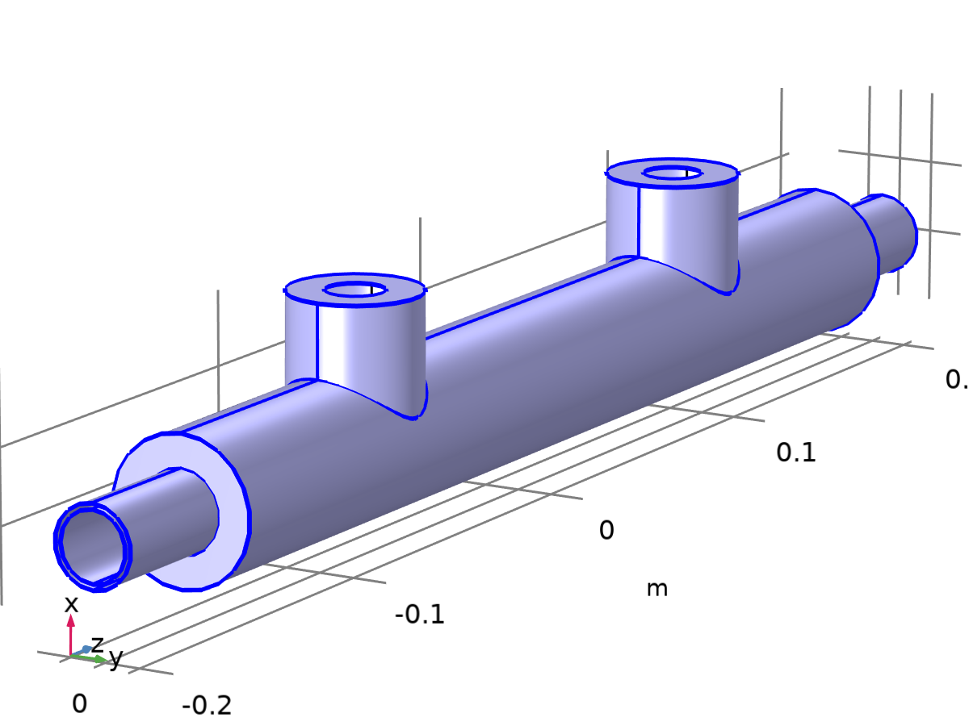
Wall 1
Selection
Geometric entity level | Boundary
Selection | Geometry geom1: Dimension 2: All boundaries

Equations
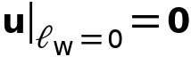
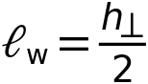
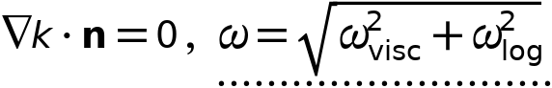

Boundary Condition
Settings
Description | Value
Wall condition | No slip

Wall Movement
Settings
Description | Value
Translational velocity | Automatic from frame
Sliding wall | Off

Constraint Settings
Settings
Description | Value
Constraint | Automatic
Apply reaction terms on | Individual dependent variables
Constraint method | Elemental

Variables
Name | Expression | Unit | Description | Selection | Details
spf.hasWF | 1 |  | Help variable | Boundaries 1–6, 8–9, 11–12, 17–22
spf.ubndx | spf.utrx+spf.usx | m/s | Velocity at boundary, x-component | Boundaries 1–6, 8–9, 11–12, 17–22
spf.ubndy | spf.utry+spf.usy | m/s | Velocity at boundary, y-component | Boundaries 1–6, 8–9, 11–12, 17–22
spf.ubndz | spf.utrz+spf.usz | m/s | Velocity at boundary, z-component | Boundaries 1–6, 8–9, 11–12, 17–22
spf.rhoFace | down(spf.rho) | kg/m³ | Density face value | Boundaries 1–6, 8–9, 11–12, 17–22
spf.meshVol | meshvol | m² |  | Boundaries 1–6, 8–9, 11–12, 17–22
spf.meshVolInt | down(meshvol) | m³ | Volume of interior mesh element | Boundaries 1–6, 8–9, 11–12, 17–22
spf.umxTnFace | (spf.upwind_helpx*spf.nxmesh+spf.upwind_helpy*spf.nymesh+spf.upwind_helpz*spf.nzmesh<0)*(spf.upwind_helpx*spf.nxmesh+spf.upwind_helpy*spf.nymesh+spf.upwind_helpz*spf.nzmesh) | m/s | Relative velocity on face | Boundaries 1–6, 8–9, 11–12, 17–22
spf.usx | 0 | m/s | Velocity of sliding wall, x-component | Boundaries 1–6, 8–9, 11–12, 17–22
spf.usy | 0 | m/s | Velocity of sliding wall, y-component | Boundaries 1–6, 8–9, 11–12, 17–22
spf.usz | 0 | m/s | Velocity of sliding wall, z-component | Boundaries 1–6, 8–9, 11–12, 17–22
spf.utrx | 0 | m/s | Velocity of moving wall, x-component | Boundaries 1–6, 8–9, 11–12, 17–22
spf.utry | 0 | m/s | Velocity of moving wall, y-component | Boundaries 1–6, 8–9, 11–12, 17–22
spf.utrz | 0 | m/s | Velocity of moving wall, z-component | Boundaries 1–6, 8–9, 11–12, 17–22
spf.uLeakagex | 0 | m/s | Leakage velocity, x-component | Boundaries 1–6, 8–9, 11–12, 17–22 | + operation
spf.uLeakagey | 0 | m/s | Leakage velocity, y-component | Boundaries 1–6, 8–9, 11–12, 17–22 | + operation
spf.uLeakagez | 0 | m/s | Leakage velocity, z-component | Boundaries 1–6, 8–9, 11–12, 17–22 | + operation
spf.noSlipWall | 1 | 1 | Help variable | Boundaries 1–6, 8–9, 11–12, 17–22
spf.delta_w | 0.5/sqrt(down(tremetric_spatial)) | m | Wall lift-off | Boundaries 1–6, 8–9, 11–12, 17–22
spf.un_here | u*nojac(spf.nxmesh)+v*nojac(spf.nymesh)+w*nojac(spf.nzmesh) | m/s | Intermediate variable | Boundaries 1–6, 8–9, 11–12, 17–22
spf.u_herex | spf.un_here*nojac(spf.nxmesh) | m/s | Intermediate variable, x-component | Boundaries 1–6, 8–9, 11–12, 17–22
spf.u_herey | spf.un_here*nojac(spf.nymesh) | m/s | Intermediate variable, y-component | Boundaries 1–6, 8–9, 11–12, 17–22
spf.u_herez | spf.un_here*nojac(spf.nzmesh) | m/s | Intermediate variable, z-component | Boundaries 1–6, 8–9, 11–12, 17–22
spf.un_there | (spf.ubndx+spf.uLeakagex)*nojac(spf.nxmesh)+(spf.ubndy+spf.uLeakagey)*nojac(spf.nymesh)+(spf.ubndz+spf.uLeakagez)*nojac(spf.nzmesh) | m/s | Intermediate variable | Boundaries 1–6, 8–9, 11–12, 17–22
spf.u_therex | spf.un_there*nojac(spf.nxmesh) | m/s | Intermediate variable, x-component | Boundaries 1–6, 8–9, 11–12, 17–22
spf.u_therey | spf.un_there*nojac(spf.nymesh) | m/s | Intermediate variable, y-component | Boundaries 1–6, 8–9, 11–12, 17–22
spf.u_therez | spf.un_there*nojac(spf.nzmesh) | m/s | Intermediate variable, z-component | Boundaries 1–6, 8–9, 11–12, 17–22
spf.unJump | spf.un_here-spf.un_there | m/s | Jump in normal velocity | Boundaries 1–6, 8–9, 11–12, 17–22
spf.KStressn_avx | spf.K_stress_tensorxx*spf.nxmesh+spf.K_stress_tensorxy*spf.nymesh+spf.K_stress_tensorxz*spf.nzmesh | N/m² | Average viscous stress, x-component | Boundaries 1–6, 8–9, 11–12, 17–22
spf.KStressn_avy | spf.K_stress_tensoryx*spf.nxmesh+spf.K_stress_tensoryy*spf.nymesh+spf.K_stress_tensoryz*spf.nzmesh | N/m² | Average viscous stress, y-component | Boundaries 1–6, 8–9, 11–12, 17–22
spf.KStressn_avz | spf.K_stress_tensorzx*spf.nxmesh+spf.K_stress_tensorzy*spf.nymesh+spf.K_stress_tensorzz*spf.nzmesh | N/m² | Average viscous stress, z-component | Boundaries 1–6, 8–9, 11–12, 17–22
spf.KStressTestn_avx | spf.K_stress_tensor_testxx*spf.nxmesh+spf.K_stress_tensor_testxy*spf.nymesh+spf.K_stress_tensor_testxz*spf.nzmesh | N/m² | Average viscous stress, x-component | Boundaries 1–6, 8–9, 11–12, 17–22
spf.KStressTestn_avy | spf.K_stress_tensor_testyx*spf.nxmesh+spf.K_stress_tensor_testyy*spf.nymesh+spf.K_stress_tensor_testyz*spf.nzmesh | N/m² | Average viscous stress, y-component | Boundaries 1–6, 8–9, 11–12, 17–22
spf.KStressTestn_avz | spf.K_stress_tensor_testzx*spf.nxmesh+spf.K_stress_tensor_testzy*spf.nymesh+spf.K_stress_tensor_testzz*spf.nzmesh | N/m² | Average viscous stress, z-component | Boundaries 1–6, 8–9, 11–12, 17–22
spf.ujumpx | spf.u_herex-spf.u_therex | m/s | Velocity jump, x-component | Boundaries 1–6, 8–9, 11–12, 17–22
spf.ujumpy | spf.u_herey-spf.u_therey | m/s | Velocity jump, y-component | Boundaries 1–6, 8–9, 11–12, 17–22
spf.ujumpz | spf.u_herez-spf.u_therez | m/s | Velocity jump, z-component | Boundaries 1–6, 8–9, 11–12, 17–22
spf.contCoeffFace | down(spf.contCoeff) | kg/m³ | Help variable | Boundaries 1–6, 8–9, 11–12, 17–22
spf.c_here | 36*nojac(down(spf.mu+spf.muT)/down(1))*spf.meshVol/spf.meshVolInt | Pa·s/m | Intermediate variable | Boundaries 1–6, 8–9, 11–12, 17–22
spf.sigma_dg_ns | 4*spf.c_here | Pa·s/m |  | Boundaries 1–6, 8–9, 11–12, 17–22
spf.upwind_ns | spf.rhoFace*spf.umxTnFace*spf.unJump*test(spf.un_here)/down(1)^2 | W/m² | Upwind term | Boundaries 1–6, 8–9, 11–12, 17–22
spf.upwindCont | spf.contCoeffFace*spf.unJump*test(p) | kg²/(m³·s³) | Upwind term for continuity equation | Boundaries 1–6, 8–9, 11–12, 17–22
spf.pFace | p | Pa | Pressure face value | Boundaries 1–6, 8–9, 11–12, 17–22
spf.consFlux | -spf.pFace*test(spf.un_here) | W/m² | Conservative flux | Boundaries 1–6, 8–9, 11–12, 17–22 | + operation
spf.u_tangx | u-spf.ubndx-spf.nxmesh*((u-spf.ubndx)*spf.nxmesh+(v-spf.ubndy)*spf.nymesh+(w-spf.ubndz)*spf.nzmesh) | m/s | Velocity field, x-component | Boundaries 1–6, 8–9, 11–12, 17–22
spf.u_tangy | v-spf.ubndy-spf.nymesh*((u-spf.ubndx)*spf.nxmesh+(v-spf.ubndy)*spf.nymesh+(w-spf.ubndz)*spf.nzmesh) | m/s | Velocity field, y-component | Boundaries 1–6, 8–9, 11–12, 17–22
spf.u_tangz | w-spf.ubndz-spf.nzmesh*((u-spf.ubndx)*spf.nxmesh+(v-spf.ubndy)*spf.nymesh+(w-spf.ubndz)*spf.nzmesh) | m/s | Velocity field, z-component | Boundaries 1–6, 8–9, 11–12, 17–22
spf.omVisc | 6*down(spf.nu)/(spf.beta0*spf.delta_w^2) | 1/s | Specific dissipation rate | Boundaries 1–6, 8–9, 11–12, 17–22
spf.omLog | spf.uStar/(sqrt(spf.beta0s)*spf.kappav*spf.delta_w) | 1/s | Specific dissipation rate | Boundaries 1–6, 8–9, 11–12, 17–22
spf.om_w | sqrt(spf.omVisc^2+spf.omLog^2) | 1/s | Specific dissipation rate | Boundaries 1–6, 8–9, 11–12, 17–22
spf.uStarLog | sqrt(sqrt(spf.beta0s)*max(k,eps)) | m/s | Friction velocity | Boundaries 1–6, 8–9, 11–12, 17–22
spf.uTauVisc | sqrt(down(spf.nu)*sqrt(spf.u_tangx^2+spf.u_tangy^2+spf.u_tangz^2+eps)/spf.delta_w) | m/s | Friction velocity, viscous formulation | Boundaries 1–6, 8–9, 11–12, 17–22
spf.uStar | sqrt(sqrt(spf.uTauVisc^4+spf.uStarLog^4)) | m/s | Friction velocity | Boundaries 1–6, 8–9, 11–12, 17–22
spf.d_w_plus | spf.uStar*spf.delta_w/down(spf.nu) | 1 | Wall lift-off in viscous units | Boundaries 1–6, 8–9, 11–12, 17–22
spf.uTauLog | sqrt(spf.u_tangx^2+spf.u_tangy^2+spf.u_tangz^2+eps)/(log(max(spf.d_w_plus,1))/spf.kappav+spf.B) | m/s | Friction velocity | Boundaries 1–6, 8–9, 11–12, 17–22
spf.u_tau | sqrt(sqrt(spf.uTauVisc^4+spf.uTauLog^4)) | m/s | Friction velocity | Boundaries 1–6, 8–9, 11–12, 17–22
spf.uPlus | sqrt(spf.u_tangx^2+spf.u_tangy^2+spf.u_tangz^2+eps)/max(spf.u_tau,eps) | 1 | Friction velocity in viscous units | Boundaries 1–6, 8–9, 11–12, 17–22
spf.u_tauWall | sqrt(spf.u_tau*spf.uStar) | m/s | Wall friction velocity | Boundaries 1–6, 8–9, 11–12, 17–22
spf.Delta_wPlus | spf.u_tauWall*spf.delta_w/down(spf.nu) | 1 | Wall resolution in viscous units | Boundaries 1–6, 8–9, 11–12, 17–22
spf.WRHeightExpr | spf.Delta_wPlus | 1 | Wall resolution height expression | Boundaries 1–6, 8–9, 11–12, 17–22

Weak Expressions
Weak expression | Integration order | Integration frame | Selection
spf.KStressn_avx*test(spf.u_herex)+spf.KStressn_avy*test(spf.u_herey)+spf.KStressn_avz*test(spf.u_herez)+spf.KStressTestn_avx*spf.ujumpx+spf.KStressTestn_avy*spf.ujumpy+spf.KStressTestn_avz*spf.ujumpz-spf.sigma_dg_ns*spf.unJump*test(spf.un_here)+spf.upwind_ns+spf.upwindCont+spf.consFlux | 2 | Spatial | Boundaries 1–6, 8–9, 11–12, 17–22
down(spf.rho)*spf.u_tau*spf.uStar*(-spf.u_tangx*test(u)-spf.u_tangy*test(v)-spf.u_tangz*test(w))/sqrt(spf.u_tangx^2+spf.u_tangy^2+spf.u_tangz^2+eps) | 2 | Spatial | Boundaries 1–6, 8–9, 11–12, 17–22

Constraints
Constraint | Constraint force | Shape function | Selection | Details
-om+spf.om_w | test(-om) | Lagrange (Linear) | Boundaries 1–6, 8–9, 11–12, 17–22 | Elemental

Inlet 1
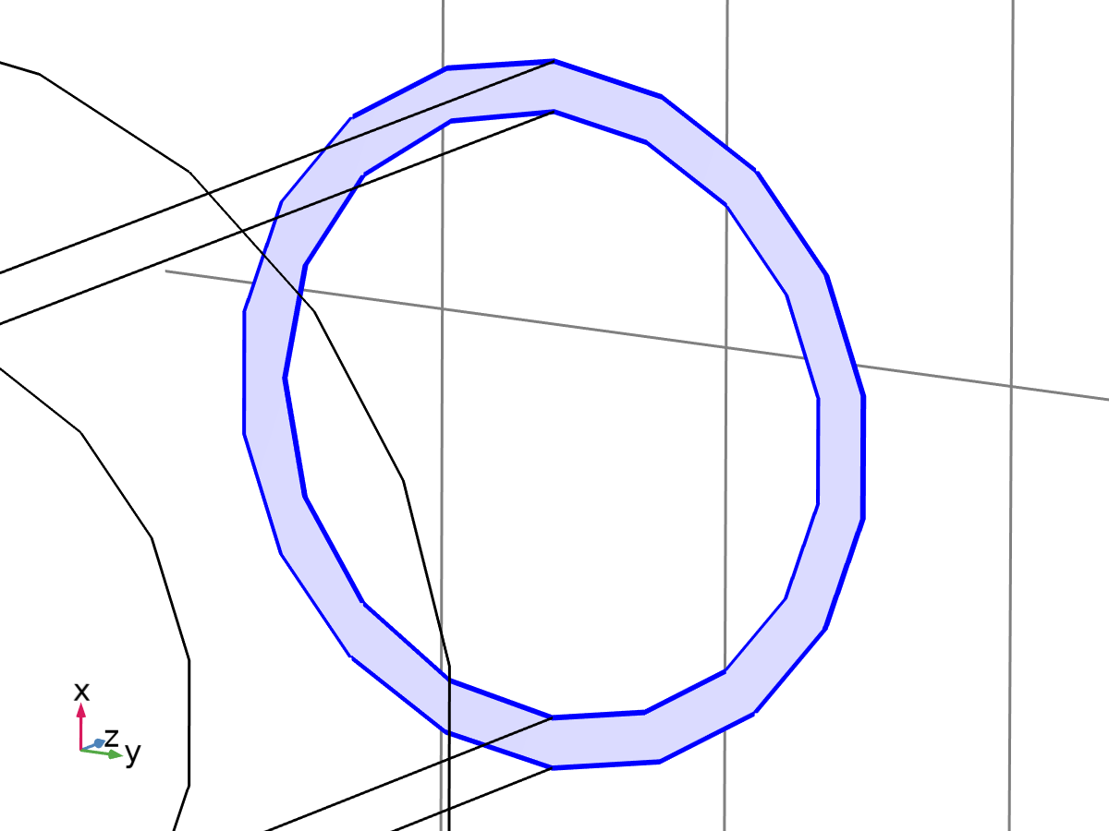
Inlet 1
Selection
Geometric entity level | Boundary
Selection | Geometry geom1: Dimension 2: Boundary 10

Equations
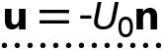
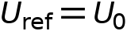
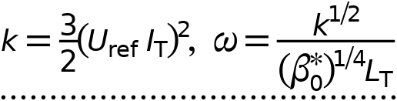

Boundary Condition
Settings
Description | Value
Boundary condition | Velocity

Velocity
Settings
Description | Value | Unit
Velocity field componentwise | Normal inflow velocity
Normal inflow velocity | 1 | m/s

Turbulence Conditions
Settings
Description | Value
 | Specify turbulent length scale and intensity
Turbulent intensity | Medium (0.05)
Turbulence length scale | Geometry based

Constraint Settings
Settings
Description | Value
Constraint | Pointwise constraints
Apply reaction terms on | Individual dependent variables
Constraint method | Elemental

Variables
Name | Expression | Unit | Description | Selection
spf.ubndx | -nojac(spf.nxmesh)*spf.U0in | m/s | Velocity at boundary, x-component | Boundary 10
spf.ubndy | -nojac(spf.nymesh)*spf.U0in | m/s | Velocity at boundary, y-component | Boundary 10
spf.ubndz | -nojac(spf.nzmesh)*spf.U0in | m/s | Velocity at boundary, z-component | Boundary 10
spf.U0in | 1 | m/s | Normal inflow velocity | Boundary 10
spf.IT | 0.05 | 1 | Turbulent intensity | Boundary 10
spf.zeta0_init | 2/3 | 1 | Turbulent relative fluctuations | Boundary 10
spf.alpha0_init | 1 | 1 | Elliptic blending function | Boundary 10
spf.LT | spf.inl1.LT | m | Turbulence length scale | Boundary 10
spf.k0 | 1.5*(spf.IT*spf.U0in)^2 | m²/s² | Turbulent kinetic energy | Boundary 10
spf.om0 | sqrt(spf.k0)/(spf.beta0s^0.25*spf.LT) | 1/s | Specific dissipation rate | Boundary 10
spf.inl1.dz | spf.dz | m | Channel thickness | Boundary 10
spf.inl1.volumeFlowRate | spf.inl1.intop(u*spf.nxmesh+v*spf.nymesh+w*spf.nzmesh) | m³/s | Outward volume flow rate across feature selection | Global
spf.inl1.massFlowRate | spf.inl1.intop(spf.rho*(u*spf.nxmesh+v*spf.nymesh+w*spf.nzmesh)) | kg/s | Outward mass flow rate across feature selection | Global
spf.inl1.pAverage | spf.inl1.aveop(p) | Pa | Pressure average over feature selection | Global
spf.inl1.LT | 0.28*spf.inl1.intop(1)/spf.inl1.intopLine(1) | m | Turbulence length scale | Global

Constraints
Constraint | Constraint force | Shape function | Selection | Details
-u+spf.ubndx | test(-u) | Lagrange (Linear) | Boundary 10 | Elemental
-v+spf.ubndy | test(-v) | Lagrange (Linear) | Boundary 10 | Elemental
-w+spf.ubndz | test(-w) | Lagrange (Linear) | Boundary 10 | Elemental
-k+spf.k0 | -test(k) | Lagrange (Linear) | Boundary 10 | Elemental
-om+spf.om0 | -test(om) | Lagrange (Linear) | Boundary 10 | Elemental

Inlet 2

Inlet 2
Selection
Geometric entity level | Boundary
Selection | Geometry geom1: Dimension 2: Boundaries 13–14

Equations




Boundary Condition
Settings
Description | Value
Boundary condition | Velocity

Velocity
Settings
Description | Value | Unit
Velocity field componentwise | Normal inflow velocity
Normal inflow velocity | 1 | m/s

Turbulence Conditions
Settings
Description | Value
 | Specify turbulent length scale and intensity
Turbulent intensity | Medium (0.05)
Turbulence length scale | Geometry based

Constraint Settings
Settings
Description | Value
Constraint | Pointwise constraints
Apply reaction terms on | Individual dependent variables
Constraint method | Elemental

Variables
Name | Expression | Unit | Description | Selection
spf.ubndx | -nojac(spf.nxmesh)*spf.U0in | m/s | Velocity at boundary, x-component | Boundaries 13–14
spf.ubndy | -nojac(spf.nymesh)*spf.U0in | m/s | Velocity at boundary, y-component | Boundaries 13–14
spf.ubndz | -nojac(spf.nzmesh)*spf.U0in | m/s | Velocity at boundary, z-component | Boundaries 13–14
spf.U0in | 1 | m/s | Normal inflow velocity | Boundaries 13–14
spf.IT | 0.05 | 1 | Turbulent intensity | Boundaries 13–14
spf.zeta0_init | 2/3 | 1 | Turbulent relative fluctuations | Boundaries 13–14
spf.alpha0_init | 1 | 1 | Elliptic blending function | Boundaries 13–14
spf.LT | spf.inl2.LT | m | Turbulence length scale | Boundaries 13–14
spf.k0 | 1.5*(spf.IT*spf.U0in)^2 | m²/s² | Turbulent kinetic energy | Boundaries 13–14
spf.om0 | sqrt(spf.k0)/(spf.beta0s^0.25*spf.LT) | 1/s | Specific dissipation rate | Boundaries 13–14
spf.inl2.dz | spf.dz | m | Channel thickness | Boundaries 13–14
spf.inl2.volumeFlowRate | spf.inl2.intop(u*spf.nxmesh+v*spf.nymesh+w*spf.nzmesh) | m³/s | Outward volume flow rate across feature selection | Global
spf.inl2.massFlowRate | spf.inl2.intop(spf.rho*(u*spf.nxmesh+v*spf.nymesh+w*spf.nzmesh)) | kg/s | Outward mass flow rate across feature selection | Global
spf.inl2.pAverage | spf.inl2.aveop(p) | Pa | Pressure average over feature selection | Global
spf.inl2.LT | 0.28*spf.inl2.intop(1)/spf.inl2.intopLine(1) | m | Turbulence length scale | Global

Constraints
Constraint | Constraint force | Shape function | Selection | Details
-u+spf.ubndx | test(-u) | Lagrange (Linear) | Boundaries 13–14 | Elemental
-v+spf.ubndy | test(-v) | Lagrange (Linear) | Boundaries 13–14 | Elemental
-w+spf.ubndz | test(-w) | Lagrange (Linear) | Boundaries 13–14 | Elemental
-k+spf.k0 | -test(k) | Lagrange (Linear) | Boundaries 13–14 | Elemental
-om+spf.om0 | -test(om) | Lagrange (Linear) | Boundaries 13–14 | Elemental

Outlet 1
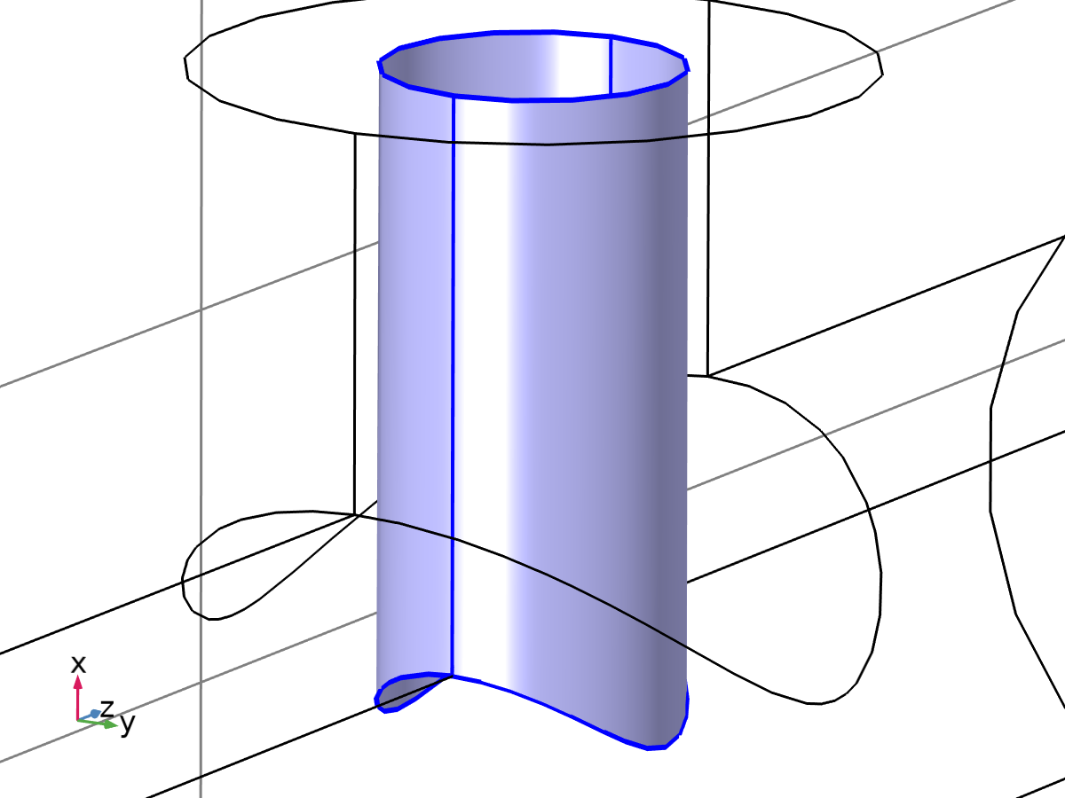
Outlet 1
Selection
Geometric entity level | Boundary
Selection | Geometry geom1: Dimension 2: Boundaries 15–16

Equations
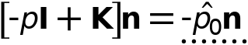
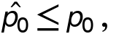
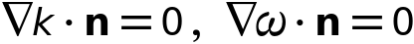

Boundary Condition
Settings
Description | Value
Boundary condition | Pressure

Pressure Conditions
Settings
Description | Value | Unit
Pressure | Static
Pressure | 0 | Pa
Normal flow | Off
Suppress backflow | On

Constraint Settings
Settings
Description | Value
Constraint | Pointwise constraints
Apply reaction terms on | Individual dependent variables
Constraint method | Elemental

Variables
Name | Expression | Unit | Description | Selection
spf.rhoFace | down(spf.rho) | kg/m³ | Density face value | Boundaries 15–16
spf.meshVol | meshvol_spatial | m² |  | Boundaries 15–16
spf.meshVolInt | down(meshvol_spatial) | m³ | Volume of interior mesh element | Boundaries 15–16
spf.umxTnFace | spf.upwind_helpx*spf.nxmesh+spf.upwind_helpy*spf.nymesh+spf.upwind_helpz*spf.nzmesh | m/s | Relative velocity on face | Boundaries 15–16
spf.p0 | 0 | Pa | Pressure | Boundaries 15–16
spf.f0 | spf.p0+spf.uNormal*(spf.backflowPenaltyDiff-spf.backflowPenaltyConv)*(spf.uNormal<0) | N/m² | Normal stress | Boundaries 15–16
spf.uNormal | u*nojac(spf.nxmesh)+v*nojac(spf.nymesh)+w*nojac(spf.nzmesh) | m/s | Normal velocity | Boundaries 15–16
spf.backflowPenaltyDiff | spf.out1.c_here*min((down(spf.mu)+spf.muT)*spf.meshVol/spf.meshVolInt,down(spf.rho)*abs(spf.uNormal)/down(spf.epsilon_p)) | Pa·s/m | Backflow penalty parameter, diffusive contribution | Boundaries 15–16
spf.backflowPenaltyConv | spf.rhoFace*spf.umxTnFace/spf.epsilon_p^2 | kg/(m²·s) | Backflow penalty parameter, convective contribution | Boundaries 15–16
spf.out1.Uav | 0 | m/s | Average velocity | Global
spf.out1.p0avfdf | 0 | Pa | Average pressure | Global
spf.out1.dz | spf.dz | m | Channel thickness | Boundaries 15–16
spf.out1.Mflow | spf.out1.massFlowRate | kg/s | Mass flow | Global
spf.out1.c_here | 144/spf.epsilon_p | 1 | Intermediate variable | Boundaries 15–16
spf.out1.upwind_ns | spf.backflowPenaltyConv*spf.uNormal | Pa | Upwind term | Boundaries 15–16
spf.out1.volumeFlowRate | spf.out1.intop(u*spf.nxmesh+v*spf.nymesh+w*spf.nzmesh) | m³/s | Outward volume flow rate across feature selection | Global
spf.out1.massFlowRate | spf.out1.intop(spf.rho*(u*spf.nxmesh+v*spf.nymesh+w*spf.nzmesh)) | kg/s | Outward mass flow rate across feature selection | Global
spf.out1.pAverage | spf.out1.aveop(p) | Pa | Pressure average over feature selection | Global

Weak Expressions
Weak expression | Integration order | Integration frame | Selection
-spf.f0*(test(u)*spf.nxmesh+test(v)*spf.nymesh+test(w)*spf.nzmesh) | 2 | Spatial | Boundaries 15–16

Outlet 2
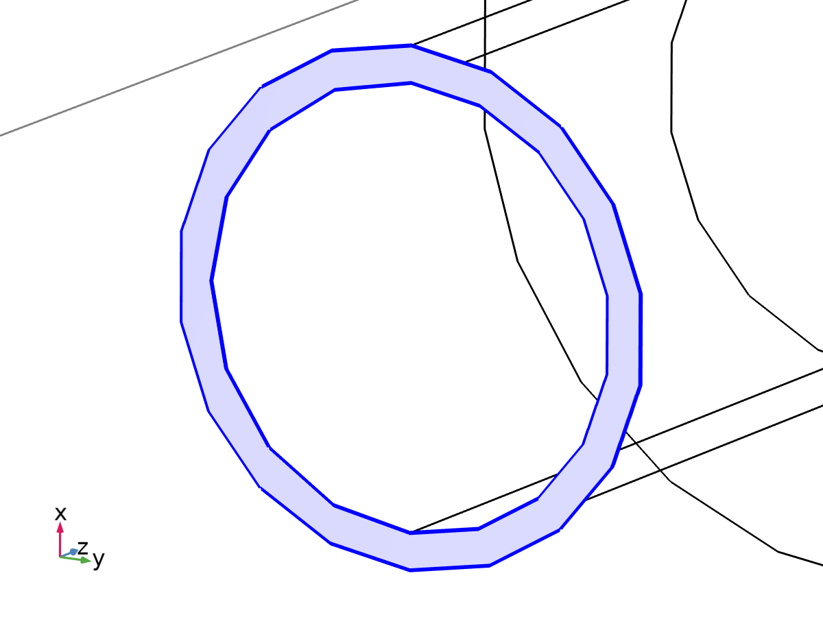
Outlet 2
Selection
Geometric entity level | Boundary
Selection | Geometry geom1: Dimension 2: Boundary 7

Equations




Boundary Condition
Settings
Description | Value
Boundary condition | Pressure

Pressure Conditions
Settings
Description | Value | Unit
Pressure | Static
Pressure | 0 | Pa
Normal flow | Off
Suppress backflow | On

Constraint Settings
Settings
Description | Value
Constraint | Pointwise constraints
Apply reaction terms on | Individual dependent variables
Constraint method | Elemental

Variables
Name | Expression | Unit | Description | Selection
spf.rhoFace | down(spf.rho) | kg/m³ | Density face value | Boundary 7
spf.meshVol | meshvol_spatial | m² |  | Boundary 7
spf.meshVolInt | down(meshvol_spatial) | m³ | Volume of interior mesh element | Boundary 7
spf.umxTnFace | spf.upwind_helpx*spf.nxmesh+spf.upwind_helpy*spf.nymesh+spf.upwind_helpz*spf.nzmesh | m/s | Relative velocity on face | Boundary 7
spf.p0 | 0 | Pa | Pressure | Boundary 7
spf.f0 | spf.p0+spf.uNormal*(spf.backflowPenaltyDiff-spf.backflowPenaltyConv)*(spf.uNormal<0) | N/m² | Normal stress | Boundary 7
spf.uNormal | u*nojac(spf.nxmesh)+v*nojac(spf.nymesh)+w*nojac(spf.nzmesh) | m/s | Normal velocity | Boundary 7
spf.backflowPenaltyDiff | spf.out2.c_here*min((down(spf.mu)+spf.muT)*spf.meshVol/spf.meshVolInt,down(spf.rho)*abs(spf.uNormal)/down(spf.epsilon_p)) | Pa·s/m | Backflow penalty parameter, diffusive contribution | Boundary 7
spf.backflowPenaltyConv | spf.rhoFace*spf.umxTnFace/spf.epsilon_p^2 | kg/(m²·s) | Backflow penalty parameter, convective contribution | Boundary 7
spf.out2.Uav | 0 | m/s | Average velocity | Global
spf.out2.p0avfdf | 0 | Pa | Average pressure | Global
spf.out2.dz | spf.dz | m | Channel thickness | Boundary 7
spf.out2.Mflow | spf.out2.massFlowRate | kg/s | Mass flow | Global
spf.out2.c_here | 144/spf.epsilon_p | 1 | Intermediate variable | Boundary 7
spf.out2.upwind_ns | spf.backflowPenaltyConv*spf.uNormal | Pa | Upwind term | Boundary 7
spf.out2.volumeFlowRate | spf.out2.intop(u*spf.nxmesh+v*spf.nymesh+w*spf.nzmesh) | m³/s | Outward volume flow rate across feature selection | Global
spf.out2.massFlowRate | spf.out2.intop(spf.rho*(u*spf.nxmesh+v*spf.nymesh+w*spf.nzmesh)) | kg/s | Outward mass flow rate across feature selection | Global
spf.out2.pAverage | spf.out2.aveop(p) | Pa | Pressure average over feature selection | Global

Weak Expressions
Weak expression | Integration order | Integration frame | Selection
-spf.f0*(test(u)*spf.nxmesh+test(v)*spf.nymesh+test(w)*spf.nzmesh) | 2 | Spatial | Boundary 7

Multiphysics

Nonisothermal Flow 1
Used products
COMSOL Multiphysics


Nonisothermal Flow 1
Selection
Geometric entity level | Domain
Selection | Geometry geom1: Dimension 3: All domains

Equations
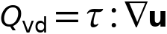
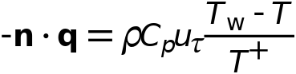
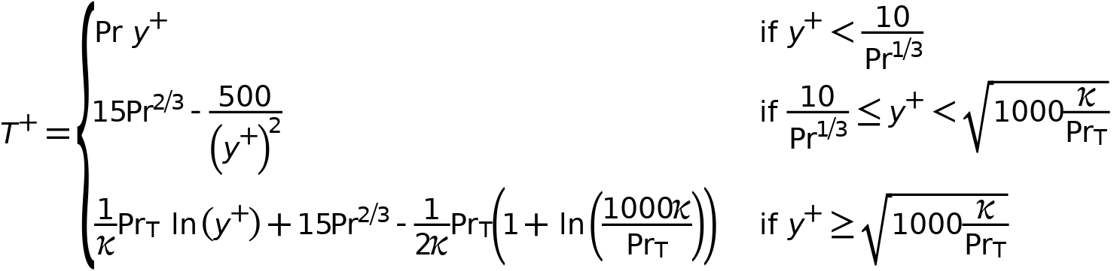

Heat Transfer Turbulence
Settings
Description | Value
Heat transport turbulence model | Kays - Crawford
Thermal wall function | Standard

Material Properties
Settings
Description | Value
Boussinesq approximation | Off
Specify density | From heat transfer interface
Specify reference temperature | From heat transfer interface

Energy Balance
Settings
Description | Value
Include viscous dissipation | On
Include kinetic energy | Off

Coupled Interfaces
Settings
Description | Value
Fluid flow | Turbulent Flow, k - ω (spf)
Heat transfer | Heat Transfer in Fluids (ht)

Variables
Name | Expression | Unit | Description | Selection | Details
ht.Tvar | 0.5*(ht.Tu+ht.Td) | K | Temperature | Boundaries 1–22
ht.Tvar | 0.5*(ht.Tu+ht.Td) | K | Temperature | Edges 1–52
ht.Tvar | 0.5*(ht.Tu+ht.Td) | K | Temperature | Points 1–32
ht.chiT | ht.chiT_ref | 1/Pa | Isothermal compressibility coefficient | Domain 1
ht.alphap | ht.alphap_ref | 1/K | Isobaric compressibility coefficient | Domain 1
ht.Ek | k | J/kg | Kinetic energy | Domain 1 | + operation
ht.Tu | nitf1.TWall_d | K | Temperature | Boundaries 1–6, 8–9, 11–12, 17–22
ht.Td | nitf1.TWall_d | K | Temperature | Boundaries 1–6, 8–9, 11–12, 17–22
ht.TuIsDown | 0 | 1 | Help variable | Boundaries 1–6, 8–9, 11–12, 17–22
ht.TdIsUp | 0 | 1 | Help variable | Boundaries 1–6, 8–9, 11–12, 17–22
ht.k_effxx | ht.kxx+ht.kappaTxx | W/(m·K) | Effective thermal conductivity, xx-component | Domain 1
ht.k_effyx | ht.kyx+ht.kappaTyx | W/(m·K) | Effective thermal conductivity, yx-component | Domain 1
ht.k_effzx | ht.kzx+ht.kappaTzx | W/(m·K) | Effective thermal conductivity, zx-component | Domain 1
ht.k_effxy | ht.kxy+ht.kappaTxy | W/(m·K) | Effective thermal conductivity, xy-component | Domain 1
ht.k_effyy | ht.kyy+ht.kappaTyy | W/(m·K) | Effective thermal conductivity, yy-component | Domain 1
ht.k_effzy | ht.kzy+ht.kappaTzy | W/(m·K) | Effective thermal conductivity, zy-component | Domain 1
ht.k_effxz | ht.kxz+ht.kappaTxz | W/(m·K) | Effective thermal conductivity, xz-component | Domain 1
ht.k_effyz | ht.kyz+ht.kappaTyz | W/(m·K) | Effective thermal conductivity, yz-component | Domain 1
ht.k_effzz | ht.kzz+ht.kappaTzz | W/(m·K) | Effective thermal conductivity, zz-component | Domain 1
ht.kappaTxx | ht.C_eff*spf.nuT/nitf1.Prt | W/(m·K) | Turbulent thermal conductivity, xx-component | Domain 1
ht.kappaTyx | 0 | W/(m·K) | Turbulent thermal conductivity, yx-component | Domain 1
ht.kappaTzx | 0 | W/(m·K) | Turbulent thermal conductivity, zx-component | Domain 1
ht.kappaTxy | 0 | W/(m·K) | Turbulent thermal conductivity, xy-component | Domain 1
ht.kappaTyy | ht.C_eff*spf.nuT/nitf1.Prt | W/(m·K) | Turbulent thermal conductivity, yy-component | Domain 1
ht.kappaTzy | 0 | W/(m·K) | Turbulent thermal conductivity, zy-component | Domain 1
ht.kappaTxz | 0 | W/(m·K) | Turbulent thermal conductivity, xz-component | Domain 1
ht.kappaTyz | 0 | W/(m·K) | Turbulent thermal conductivity, yz-component | Domain 1
ht.kappaTzz | ht.C_eff*spf.nuT/nitf1.Prt | W/(m·K) | Turbulent thermal conductivity, zz-component | Domain 1
ht.pref | spf.pref | Pa | Reference pressure level | Domain 1
ht.kxx | ht.kmatxx | W/(m·K) | Thermal conductivity, xx-component | Domain 1
ht.kyx | ht.kmatyx | W/(m·K) | Thermal conductivity, yx-component | Domain 1
ht.kzx | ht.kmatzx | W/(m·K) | Thermal conductivity, zx-component | Domain 1
ht.kxy | ht.kmatxy | W/(m·K) | Thermal conductivity, xy-component | Domain 1
ht.kyy | ht.kmatyy | W/(m·K) | Thermal conductivity, yy-component | Domain 1
ht.kzy | ht.kmatzy | W/(m·K) | Thermal conductivity, zy-component | Domain 1
ht.kxz | ht.kmatxz | W/(m·K) | Thermal conductivity, xz-component | Domain 1
ht.kyz | ht.kmatyz | W/(m·K) | Thermal conductivity, yz-component | Domain 1
ht.kzz | ht.kmatzz | W/(m·K) | Thermal conductivity, zz-component | Domain 1
ht.rho | ht.rhoref | kg/m³ | Density | Domain 1
ht.Cp | ht.Cpmat | J/(kg·K) | Heat capacity at constant pressure | Domain 1
ht.gamma | ht.gamma_ref | 1 | Ratio of specific heats | Domain 1
ht.prho | ht.pref | Pa | Pressure for the evaluation of density | Domain 1
ht.Trho | ht.Tref | K | Temperature for density evaluation | Domain 1
spf.hasWF_u | spf.hasWF |  | Help variable | Boundaries 1–22
spf.hasWF_d | spf.hasWF |  | Help variable | Boundaries 1–22
spf.mu | spf.mumat | Pa·s | Dynamic viscosity | Domain 1
spf.rho | nitf1.rho | kg/m³ | Density | Domain 1
spf.rhoref | nitf1.rhoref | kg/m³ | Reference density | Domain 1
spf.muinit | subst(spf.mu,T,ht.Tinit) | Pa·s | Dynamic viscosity | Domain 1
spf.rhoinit | ht.rhoInit | kg/m³ | Density | Domain 1
nitf1.rho | ht.rho | kg/m³ | Density | Domain 1
nitf1.rhoref | ht.rhoref | kg/m³ | Reference density | Domain 1
spf.alphap | ht.alphap_ref | 1/K | Isobaric compressibility coefficient | Domain 1
spf.alphap_ref | ht.alphap_ref | 1/K | Reference isobaric compressibility coefficient | Domain 1
nitf1.mu | spf.mu | Pa·s | Dynamic viscosity | Domain 1
nitf1.ux | u | m/s | Velocity field, x-component | Domain 1
nitf1.uy | v | m/s | Velocity field, y-component | Domain 1
nitf1.uz | w | m/s | Velocity field, z-component | Domain 1
nitf1.p | p | Pa | Pressure | Domain 1
nitf1.pA | spf.pA | Pa | Absolute pressure | Domain 1
nitf1.qwfc_d | if(spf.hasWF_d,down(spf.rho)*nojac(spf.uStar_d),0) | kg/(m²·s) | Intermediate variable | Boundaries 1–6, 8–9, 11–12, 17–22
spf.uStar_d | spf.uStar | m/s | Friction velocity, downside | Boundaries 1–6, 8–9, 11–12, 17–22
spf.uStar_u | spf.uStar | m/s | Friction velocity, upside | Boundaries 1–6, 8–9, 11–12, 17–22
spf.d_w_plus_u | spf.d_w_plus | 1 | Wall lift-off in viscous units | Boundaries 1–6, 8–9, 11–12, 17–22
spf.d_w_plus_d | spf.d_w_plus | 1 | Wall lift-off in viscous units | Boundaries 1–6, 8–9, 11–12, 17–22
nitf1.Tref | ht.Tref | K | Reference temperature | Global
ht.upwind_helpx | ht.ux-d(x,TIME) | m/s | Velocity, x-component | Domain 1 | + operation
ht.upwind_helpy | ht.uy-d(y,TIME) | m/s | Velocity, y-component | Domain 1 | + operation
ht.upwind_helpz | ht.uz-d(z,TIME) | m/s | Velocity, z-component | Domain 1 | + operation
nitf1.T | T | K | Temperature | Domain 1
nitf1.Pr | 3*spf.mu*ht.Cp/(ht.kxx+ht.kyy+ht.kzz) | 1 | Prandtl number | Domain 1
nitf1.Prt | nojac(1/(0.5/nitf1.Prtinf+0.3*spf.muT*nitf1.Pr/(spf.mu*sqrt(nitf1.Prtinf))-(0.3*spf.muT*nitf1.Pr/spf.mu)^2*(1-exp(-3.3333333333333335*spf.mu/(nitf1.Pr*max(spf.muT,eps)*sqrt(nitf1.Prtinf)))))) | 1 | Turbulent Prandtl number | Domain 1
nitf1.Prtinf | 0.85 | 1 | Turbulent Prandtl number at infinity | Domain 1
nitf1.turbfluxx | -ht.kappaTxx*ht.gradTx-ht.kappaTxy*ht.gradTy-ht.kappaTxz*ht.gradTz | W/m² | Turbulent heat flux, x-component | Domain 1 | + operation
nitf1.turbfluxy | -ht.kappaTyx*ht.gradTx-ht.kappaTyy*ht.gradTy-ht.kappaTyz*ht.gradTz | W/m² | Turbulent heat flux, y-component | Domain 1 | + operation
nitf1.turbfluxz | -ht.kappaTzx*ht.gradTx-ht.kappaTzy*ht.gradTy-ht.kappaTzz*ht.gradTz | W/m² | Turbulent heat flux, z-component | Domain 1 | + operation
nitf1.TWall | ht.Td | K | Wall temperature | Boundaries 1–6, 8–9, 11–12, 17–22
nitf1.qwf_d | if(spf.hasWF_d,-nitf1.qwfc_d*down(ht.Cp)*(ht.Td-nitf1.TdWF)/sqrt(1.0E-6+max(nitf1.Tplus_d,0)^2),0) | W/m² | Wall function flux, downside | Boundaries 1–6, 8–9, 11–12, 17–22
nitf1.TdWF | T | K | Downside temperature in the boundary layer | Boundaries 1–6, 8–9, 11–12, 17–22
nitf1.Tplus_d | if(spf.hasWF_d,nif(spf.d_w_plus_d<10/down(nitf1.Pr)^(1/3),nojac(down(nitf1.Pr)*spf.d_w_plus_d),spf.d_w_plus_d<sqrt(1000*spf.kappav/down(nitf1.Prt)),nojac(15*down(nitf1.Pr)^(2/3)-500/spf.d_w_plus_d^2),nojac(down(nitf1.Prt)*log(spf.d_w_plus_d)/spf.kappav+15*down(nitf1.Pr)^(2/3)-0.5*down(nitf1.Prt)*(1+log(1000*spf.kappav/down(nitf1.Prt)))/spf.kappav)),0) | 1 | Downside temperature in wall units | Boundaries 1–6, 8–9, 11–12, 17–22
nitf1.Qp | 0 | W/m³ | Work done by pressure changes | Domain 1
nitf1.Qp_contrib | nitf1.Qp | W/m³ | Pressure contribution | Domain 1
nitf1.Wp | -spf.pA*(d(nitf1.ux,x)+d(nitf1.uy,y)+d(nitf1.uz,z)) | W/m³ | Pressure work | Domain 1
nitf1.Qvd | model.input.Qvd | W/m³ | Viscous dissipation | Domain 1 | Meta
nitf1.u_cmix | model.input.u_cmi1 | m/s | Velocity field, x-component | Global | Meta
nitf1.u_cmiy | model.input.u_cmi2 | m/s | Velocity field, y-component | Global | Meta
nitf1.u_cmiz | model.input.u_cmi3 | m/s | Velocity field, z-component | Global | Meta
nitf1.pA_cmi | model.input.pA_cmi | Pa | Absolute pressure | Global | Meta
nitf1.T_cmi | model.input.T_cmi | K | Temperature | Global | Meta

Shape functions
Name | Shape function | Unit | Description | Shape frame | Selection | Details
T | Lagrange (Linear) | K | Temperature | Spatial | No domains | Slit
T | Lagrange (Linear) | K | Temperature | Material | No domains | Slit
T | Lagrange (Linear) | K | Temperature | Geometry | No domains | Slit
T | Lagrange (Linear) | K | Temperature | Mesh | No domains | Slit
T | Lagrange (Linear) | K | Temperature | Spatial | No domains | Slit
T | Lagrange (Linear) | K | Temperature | Material | No domains | Slit
T | Lagrange (Linear) | K | Temperature | Geometry | No domains | Slit
T | Lagrange (Linear) | K | Temperature | Mesh | No domains | Slit
T | Lagrange (Linear) | K | Temperature | Spatial | No domains | Slit
T | Lagrange (Linear) | K | Temperature | Material | No domains | Slit
T | Lagrange (Linear) | K | Temperature | Geometry | No domains | Slit
T | Lagrange (Linear) | K | Temperature | Mesh | No domains | Slit
T | Lagrange (Linear) | K | Temperature | Spatial | No boundaries | Slit
T | Lagrange (Linear) | K | Temperature | Material | No boundaries | Slit
T | Lagrange (Linear) | K | Temperature | Geometry | No boundaries | Slit
T | Lagrange (Linear) | K | Temperature | Mesh | No boundaries | Slit
ht.TextFace | Lagrange (Linear) | K | External temperature | Spatial | No edges | + operation, Slit
ht.TextFace | Lagrange (Linear) | K | External temperature | Material | No edges | + operation, Slit
ht.TextFace | Lagrange (Linear) | K | External temperature | Geometry | No edges | + operation, Slit
ht.TextFace | Lagrange (Linear) | K | External temperature | Mesh | No edges | + operation, Slit
nitf1.TWall_d | Lagrange (Linear) |  | Wall temperature, downside | Spatial | Boundaries 1–6, 8–9, 11–12, 17–22
nitf1.TWall_d | Lagrange (Linear) |  | Wall temperature, downside | Spatial | No edges | Slit
nitf1.TWall_d | Lagrange (Linear) |  | Wall temperature, downside | Material | No edges | Slit
nitf1.TWall_d | Lagrange (Linear) |  | Wall temperature, downside | Geometry | No edges | Slit
nitf1.TWall_d | Lagrange (Linear) |  | Wall temperature, downside | Mesh | No edges | Slit
nitf1.TWall_u | Lagrange (Linear) |  | Wall temperature, upside | Spatial | No boundaries
nitf1.TWall_u | Lagrange (Linear) |  | Wall temperature, upside | Spatial | No edges | Slit
nitf1.TWall_u | Lagrange (Linear) |  | Wall temperature, upside | Material | No edges | Slit
nitf1.TWall_u | Lagrange (Linear) |  | Wall temperature, upside | Geometry | No edges | Slit
nitf1.TWall_u | Lagrange (Linear) |  | Wall temperature, upside | Mesh | No edges | Slit

Mesh 1
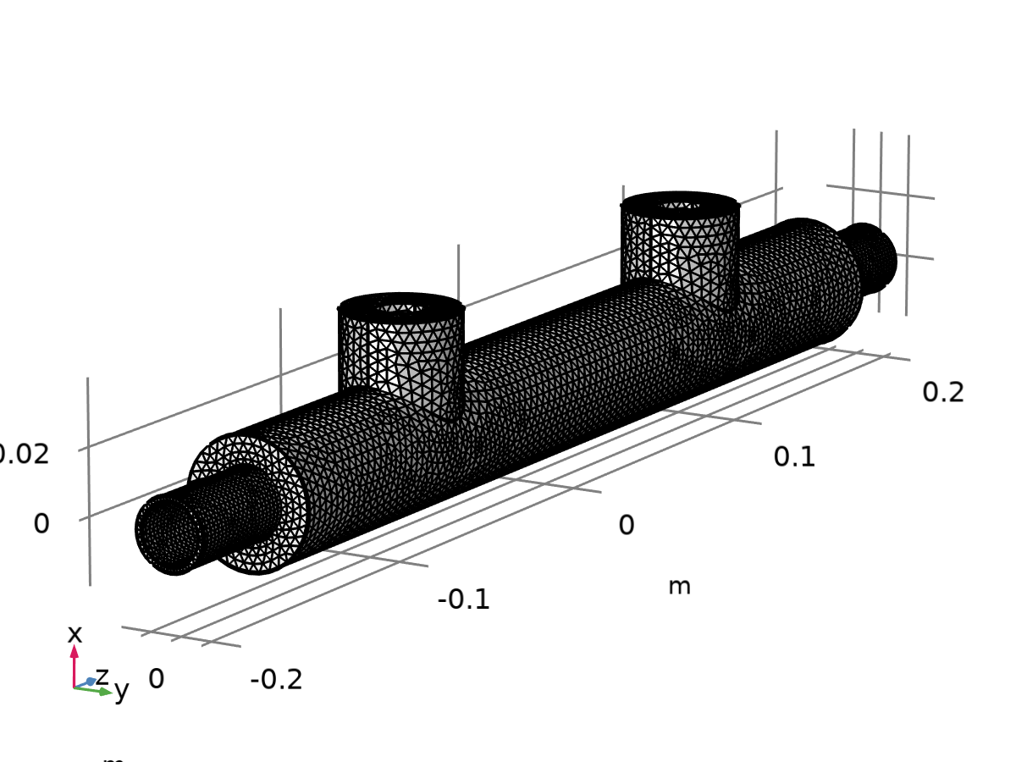
Mesh 1
Mesh statistics
Description | Value
Status | Complete mesh
Mesh vertices | 27023
Tetrahedra | 132389
Triangles | 19720
Edge elements | 1007
Vertex elements | 32
Number of elements | 132389
Minimum element quality | 0.194
Average element quality | 0.6665
Element volume ratio | 0.03351
Mesh volume | 3.632E-4 m³

Size (size)
Settings
Description | Value
Calibrate for | Fluid dynamics
Maximum element size | 0.00354
Minimum element size | 0.00106
Curvature factor | 0.6
Resolution of narrow regions | 0.7
Maximum element growth rate | 1.15

Free Tetrahedral 1 (auto_f1)
Selection
Geometric entity level | Domain
Selection | Remaining

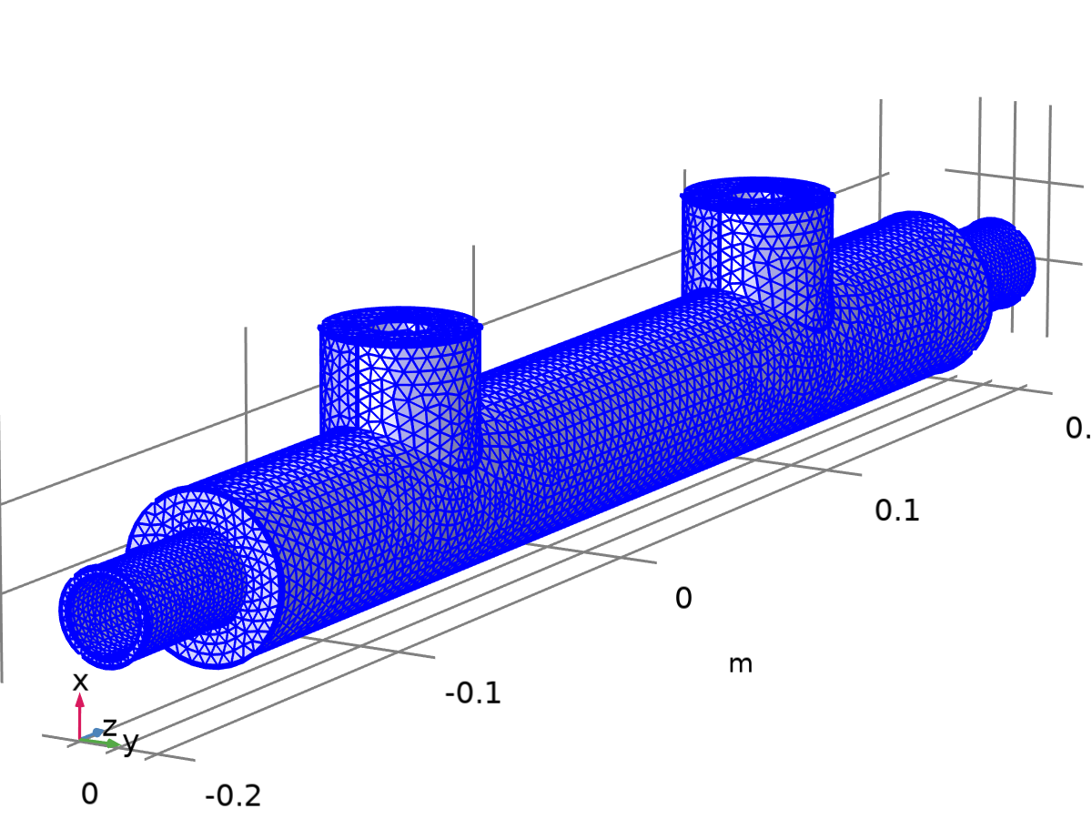
Free Tetrahedral 1
Settings
Description | Value
Avoid inverted curved elements | On

Information
Description | Value
Last build time | < 1 second
Built with | COMSOL 6.2.0.339 (win64), Mar 8, 2025, 2:08:07 PM

Study 1
Computation information
Computation time | 45 min 38 s

Wall Distance Initialization
Study settings
Description | Value
Include geometric nonlinearity | Off

Physics and variables selection
Physics interface | Solve for | Equation form
Heat Transfer in Fluids (ht) | Off | Automatic (Stationary)
Turbulent Flow, k-ω (spf) | On | Automatic (Wall distance initialization)

Physics and variables selection
Multiphysics couplings | Solve for | Equation form
Nonisothermal Flow 1 (nitf1) | On | Automatic (Wall distance initialization)

Store in output
Interface | Output | Selection
Heat Transfer in Fluids (ht) | Physics controlled
Turbulent Flow, k-ω (spf) | Physics controlled
Nonisothermal Flow 1 (nitf1) | Physics controlled

Mesh selection
Component | Mesh
Component 1 | Mesh 1

Stationary
Study settings
Description | Value
Include geometric nonlinearity | Off

Physics and variables selection
Physics interface | Solve for | Equation form
Heat Transfer in Fluids (ht) | On | Automatic (Stationary)
Turbulent Flow, k-ω (spf) | On | Automatic (Stationary)

Physics and variables selection
Multiphysics couplings | Solve for | Equation form
Nonisothermal Flow 1 (nitf1) | On | Automatic (Stationary)

Store in output
Interface | Output | Selection
Heat Transfer in Fluids (ht) | Physics controlled
Turbulent Flow, k-ω (spf) | Physics controlled
Nonisothermal Flow 1 (nitf1) | Physics controlled

Mesh selection
Component | Mesh
Component 1 | Mesh 1

Solver Configurations

Solution 1

Compile Equations: Wall Distance Initialization (st1)
Study and step
Description | Value
Use study
Use study step | Wall Distance Initialization

Log
<---- Compile Equations: Wall Distance Initialization in Study 1/Solution 1
(sol1) -------------------------------------------------------------------
Started at Mar 11, 2025, 4:51:47 PM.
Geometry shape function: Linear Lagrange
Running on 12th Gen Intel(R) Core(TM) i5-1235U.
Using 1 socket with 6 cores in total on DESKTOP-Q33USJ8.
Available memory: 16.02 GB.
Time: 3 s.
Physical memory: 1.41 GB
Virtual memory: 1.99 GB
Ended at Mar 11, 2025, 4:51:50 PM.
----- Compile Equations: Wall Distance Initialization in Study 1/Solution 1
(sol1) ------------------------------------------------------------------>

Dependent Variables 1 (v1)
General
Description | Value
Defined by study step

Log
<---- Dependent Variables 1 in Study 1/Solution 1 (sol1) -----------------------
Started at Mar 11, 2025, 4:51:50 PM.
Solution time: 0 s.
Physical memory: 1.41 GB
Virtual memory: 1.97 GB
Ended at Mar 11, 2025, 4:51:50 PM.
----- Dependent Variables 1 in Study 1/Solution 1 (sol1) ---------------------->

Turbulent Kinetic Energy (comp1.k) (comp1_k)
General
Description | Value
Field components | comp1.k
Solve for this field | Off

Wall Temperature, Downside (comp1.nitf1.TWall_d) (comp1_nitf1_TWall_d)
General
Description | Value
Field components | comp1.nitf1.TWall_d
Internal variables | {comp1.nitf1.uflux.TWall_d, comp1.nitf1.dflux.TWall_d}
Solve for this field | Off

Wall Temperature, Upside (comp1.nitf1.TWall_u) (comp1_nitf1_TWall_u)
General
Description | Value
Field components | comp1.nitf1.TWall_u
Internal variables | {comp1.nitf1.uflux.TWall_u, comp1.nitf1.dflux.TWall_u}
Solve for this field | Off

Velocity Magnitude, Average (comp1.nitf1.Uave) (comp1_nitf1_Uave)
General
Description | Value
Internal variables | comp1.nitf1.Uave
Solve for this field | Off

Specific Dissipation Rate (comp1.om) (comp1_om)
General
Description | Value
Field components | comp1.om
Solve for this field | Off

Pressure (comp1.p) (comp1_p)
General
Description | Value
Field components | comp1.p
Solve for this field | Off

Temperature (comp1.T) (comp1_T)
General
Description | Value
Field components | comp1.T
Internal variables | {comp1.uflux.T, comp1.dflux.T}
Solve for this field | Off

Velocity Field (comp1.u) (comp1_u)
General
Description | Value
Field components | {comp1.u, comp1.v, comp1.w}
Internal variables | comp1.spf.isFluidHasBeenSolved
Solve for this field | Off

Stationary Solver 1 (s1)
General
Description | Value
Defined by study step

Log
<---- Stationary Solver 1 in Study 1/Solution 1 (sol1) -------------------------
Started at Mar 11, 2025, 4:51:50 PM.
Linear solver
Number of degrees of freedom solved for: 0.
Symmetric matrices found.
Scales for dependent variables:
Orthonormal null-space function used.
Iter SolEst Damping Stepsize #Res #Jac #Sol LinErr LinRes
1 0 1.0000000 0 1 1 1 0 0
Solution time: 1 s.
Physical memory: 1.45 GB
Virtual memory: 2 GB
Ended at Mar 11, 2025, 4:51:51 PM.
----- Stationary Solver 1 in Study 1/Solution 1 (sol1) ------------------------>

Fully Coupled (fcDef)
General
Description | Value
Linear solver

Solution Store 1 (su1)
General
Description | Value
Solution | Solution Store 1 (sol2)

Compile Equations: Stationary (st2)
Study and step
Description | Value
Use study
Use study step | Stationary

Log
<---- Compile Equations: Stationary in Study 1/Solution 1 (sol1) ---------------
Started at Mar 11, 2025, 4:51:51 PM.
Geometry shape function: Linear Lagrange
Time: 5 s.
Physical memory: 1.49 GB
Virtual memory: 2.04 GB
Ended at Mar 11, 2025, 4:51:56 PM.
----- Compile Equations: Stationary in Study 1/Solution 1 (sol1) -------------->

Dependent Variables 2 (v2)
General
Description | Value
Defined by study step

Initial values of variables solved for
Description | Value
Method | Solution
Solution

Values of variables not solved for
Description | Value
Method | Solution
Solution

Log
<---- Dependent Variables 2 in Study 1/Solution 1 (sol1) -----------------------
Started at Mar 11, 2025, 4:51:56 PM.
Initial values of variables solved for: Solution 1 (sol1).
Values of variables not solved for: Solution 1 (sol1).
Solution time: 0 s.
Physical memory: 1.5 GB
Virtual memory: 2.03 GB
Ended at Mar 11, 2025, 4:51:56 PM.
----- Dependent Variables 2 in Study 1/Solution 1 (sol1) ---------------------->

Turbulent Kinetic Energy (comp1.k) (comp1_k)
General
Description | Value
Field components | comp1.k

Wall Temperature, Downside (comp1.nitf1.TWall_d) (comp1_nitf1_TWall_d)
General
Description | Value
Field components | comp1.nitf1.TWall_d
Internal variables | {comp1.nitf1.uflux.TWall_d, comp1.nitf1.dflux.TWall_d}

Wall Temperature, Upside (comp1.nitf1.TWall_u) (comp1_nitf1_TWall_u)
General
Description | Value
Field components | comp1.nitf1.TWall_u
Internal variables | {comp1.nitf1.uflux.TWall_u, comp1.nitf1.dflux.TWall_u}

Velocity Magnitude, Average (comp1.nitf1.Uave) (comp1_nitf1_Uave)
General
Description | Value
Internal variables | comp1.nitf1.Uave

Specific Dissipation Rate (comp1.om) (comp1_om)
General
Description | Value
Field components | comp1.om

Pressure (comp1.p) (comp1_p)
General
Description | Value
Field components | comp1.p

Temperature (comp1.T) (comp1_T)
General
Description | Value
Field components | comp1.T
Internal variables | {comp1.uflux.T, comp1.dflux.T}

Velocity Field (comp1.u) (comp1_u)
General
Description | Value
Field components | {comp1.u, comp1.v, comp1.w}
Internal variables | comp1.spf.isFluidHasBeenSolved

Stationary Solver 2 (s2)
General
Description | Value
Defined by study step

Log
Iter SolEst ResEst Damping Stepsize #Res #Jac #Sol LinErr LinRes
1 0.028 2.1e+03 0.4500000 0.028 193 115 115 4.7e-16 5.8e-16
2 0.017 1.4e+03 0.4500000 0.017 194 116 116 5.5e-16 6.6e-16
3 0.011 9.7e+02 0.4500000 0.011 195 117 117 4.6e-16 7e-16
Solution error estimates for segregated groups
0.083, 0.00075, 0.025
Residual error estimates for segregated groups
4.1e+02, 9.6e+02, 9.7e+02
Pseudo time-stepping CFL-ratio:
0.31
Segregated solver iteration 40.
Velocity u, Pressure p
Iter SolEst Damping Stepsize #Res #Jac #Sol LinIt LinErr LinRes
1 0.18 0.5000000 0.18 80 40 40 500 0.00063 -
Temperature
Iter SolEst Damping Stepsize #Res #Jac #Sol LinErr LinRes
1 0.0013 0.5000000 0.0013 80 40 40 6e-16 1.6e-15
Turbulence Variables
Iter SolEst ResEst Damping Stepsize #Res #Jac #Sol LinErr LinRes
1 0.027 2.3e+03 0.4500000 0.027 198 118 118 4.6e-16 5.6e-16
2 0.017 1.5e+03 0.4500000 0.017 199 119 119 5.1e-16 6.1e-16
3 0.012 1.1e+03 0.4500000 0.012 200 120 120 4.7e-16 7.4e-16
Solution error estimates for segregated groups
0.09, 0.00066, 0.024
Residual error estimates for segregated groups
4.7e+02, 9.6e+02, 1.1e+03
Pseudo time-stepping CFL-ratio:
0.31
Segregated solver iteration 41.
Velocity u, Pressure p
Iter SolEst Damping Stepsize #Res #Jac #Sol LinIt LinErr LinRes
1 0.18 0.5000000 0.18 82 41 41 516 0.00092 -
Temperature
Iter SolEst Damping Stepsize #Res #Jac #Sol LinErr LinRes
1 0.0013 0.5000000 0.0013 82 41 41 5.9e-16 1.5e-15
Turbulence Variables
Iter SolEst ResEst Damping Stepsize #Res #Jac #Sol LinErr LinRes
1 0.027 2.6e+03 0.4500000 0.027 203 121 121 4.1e-16 4.6e-16
2 0.017 1.6e+03 0.4500000 0.017 204 122 122 5e-16 6e-16
3 0.012 1.1e+03 0.4500000 0.012 205 123 123 4.2e-16 6.4e-16
Solution error estimates for segregated groups
0.091, 0.00063, 0.025
Residual error estimates for segregated groups
5.3e+02, 9.9e+02, 1.1e+03
Pseudo time-stepping CFL-ratio:
0.31
Segregated solver iteration 42.
Velocity u, Pressure p
Iter SolEst Damping Stepsize #Res #Jac #Sol LinIt LinErr LinRes
1 0.23 0.5000000 0.23 84 42 42 532 0.0009 -
Temperature
Iter SolEst Damping Stepsize #Res #Jac #Sol LinErr LinRes
1 0.0013 0.5000000 0.0013 84 42 42 6.5e-16 1.7e-15
Turbulence Variables
Iter SolEst ResEst Damping Stepsize #Res #Jac #Sol LinErr LinRes
1 0.028 2.7e+03 0.4500000 0.028 208 124 124 4.2e-16 4.7e-16
2 0.018 1.7e+03 0.4500000 0.018 209 125 125 4.5e-16 5.7e-16
3 0.012 1.1e+03 0.4500000 0.012 210 126 126 4.1e-16 5.7e-16
Solution error estimates for segregated groups
0.11, 0.00065, 0.026
Residual error estimates for segregated groups
5.6e+02, 1e+03, 1.1e+03
Pseudo time-stepping CFL-ratio:
0.32
Segregated solver iteration 43.
Velocity u, Pressure p
Iter SolEst Damping Stepsize #Res #Jac #Sol LinIt LinErr LinRes
1 0.21 0.5000000 0.21 86 43 43 552 0.00079 6.9e-05
Temperature
Iter SolEst Damping Stepsize #Res #Jac #Sol LinErr LinRes
1 0.0013 0.5000000 0.0013 86 43 43 5.5e-16 1.7e-15
Turbulence Variables
Iter SolEst ResEst Damping Stepsize #Res #Jac #Sol LinErr LinRes
1 0.028 2.5e+03 0.4500000 0.028 213 127 127 3.9e-16 4.8e-16
2 0.018 1.6e+03 0.4500000 0.018 214 128 128 4.2e-16 5.2e-16
3 0.013 1.1e+03 0.4500000 0.013 215 129 129 4.6e-16 6.5e-16
Solution error estimates for segregated groups
0.11, 0.00065, 0.026
Residual error estimates for segregated groups
6e+02, 1.1e+03, 1.1e+03
Pseudo time-stepping CFL-ratio:
0.31
Segregated solver iteration 44.
Velocity u, Pressure p
Iter SolEst Damping Stepsize #Res #Jac #Sol LinIt LinErr LinRes
1 0.26 0.5000000 0.26 88 44 44 573 0.00079 7.6e-05
Temperature
Iter SolEst Damping Stepsize #Res #Jac #Sol LinErr LinRes
1 0.0015 0.5000000 0.0015 88 44 44 5.9e-16 1.8e-15
Turbulence Variables
Iter SolEst ResEst Damping Stepsize #Res #Jac #Sol LinErr LinRes
1 0.034 2.8e+03 0.4500000 0.034 218 130 130 5.7e-16 5.6e-16
2 0.021 1.7e+03 0.4500000 0.021 219 131 131 4.6e-16 5.5e-16
3 0.015 1.2e+03 0.4500000 0.015 220 132 132 4.2e-16 5.6e-16
Solution error estimates for segregated groups
0.13, 0.00076, 0.031
Residual error estimates for segregated groups
6.8e+02, 1.3e+03, 1.2e+03
Pseudo time-stepping CFL-ratio:
0.32
Segregated solver iteration 45.
Velocity u, Pressure p
Iter SolEst Damping Stepsize #Res #Jac #Sol LinIt LinErr LinRes
1 0.27 0.5000000 0.27 90 45 45 593 0.00097 9.2e-05
Temperature
Iter SolEst Damping Stepsize #Res #Jac #Sol LinErr LinRes
1 0.0017 0.5000000 0.0017 90 45 45 5.9e-16 1.7e-15
Turbulence Variables
Iter SolEst ResEst Damping Stepsize #Res #Jac #Sol LinErr LinRes
1 0.037 2.7e+03 0.4500000 0.037 223 133 133 4.7e-16 6.1e-16
2 0.023 1.8e+03 0.4500000 0.023 224 134 134 5.4e-16 7.4e-16
3 0.016 1.2e+03 0.4500000 0.016 225 135 135 4.7e-16 6.9e-16
Solution error estimates for segregated groups
0.14, 0.00084, 0.034
Residual error estimates for segregated groups
7e+02, 1.4e+03, 1.2e+03
Pseudo time-stepping CFL-ratio:
0.3
Segregated solver iteration 46.
Velocity u, Pressure p
Iter SolEst Damping Stepsize #Res #Jac #Sol LinIt LinErr LinRes
1 0.32 0.5000000 0.32 92 46 46 613 0.00084 9.1e-05
Temperature
Iter SolEst Damping Stepsize #Res #Jac #Sol LinErr LinRes
1 0.0021 0.5000000 0.0021 92 46 46 5.5e-16 1.7e-15
Turbulence Variables
Iter SolEst ResEst Damping Stepsize #Res #Jac #Sol LinErr LinRes
1 0.047 2.9e+03 0.4500000 0.047 228 136 136 4.8e-16 6.1e-16
2 0.028 1.9e+03 0.4500000 0.028 229 137 137 5.3e-16 7.3e-16
3 0.019 1.4e+03 0.4500000 0.019 230 138 138 4.9e-16 8e-16
Solution error estimates for segregated groups
0.16, 0.0011, 0.042
Residual error estimates for segregated groups
7.5e+02, 1.6e+03, 1.4e+03
Pseudo time-stepping CFL-ratio:
0.3
Segregated solver iteration 47.
Velocity u, Pressure p
Iter SolEst Damping Stepsize #Res #Jac #Sol LinIt LinErr LinRes
1 0.37 0.5000000 0.37 94 47 47 632 0.00086 0.00015
Temperature
Iter SolEst Damping Stepsize #Res #Jac #Sol LinErr LinRes
1 0.0027 0.5000000 0.0027 94 47 47 6.5e-16 1.9e-15
Turbulence Variables
Iter SolEst ResEst Damping Stepsize #Res #Jac #Sol LinErr LinRes
1 0.06 3.1e+03 0.4500000 0.06 233 139 139 4.6e-16 6.5e-16
2 0.035 2.1e+03 0.4500000 0.035 234 140 140 5e-16 7.3e-16
3 0.024 1.5e+03 0.4500000 0.024 235 141 141 5.2e-16 1e-15
Solution error estimates for segregated groups
0.19, 0.0013, 0.053
Residual error estimates for segregated groups
8.3e+02, 1.9e+03, 1.5e+03
Pseudo time-stepping CFL-ratio:
0.29
Segregated solver iteration 48.
Velocity u, Pressure p
Iter SolEst Damping Stepsize #Res #Jac #Sol LinIt LinErr LinRes
1 0.44 0.5000000 0.44 96 48 48 652 0.00093 0.00016
Temperature
Iter SolEst Damping Stepsize #Res #Jac #Sol LinErr LinRes
1 0.0035 0.5000000 0.0035 96 48 48 6.4e-16 1.9e-15
Turbulence Variables
Iter SolEst ResEst Damping Stepsize #Res #Jac #Sol LinErr LinRes
1 0.078 3.5e+03 0.4500000 0.078 238 142 142 5e-16 6.6e-16
2 0.045 2.3e+03 0.4500000 0.045 239 143 143 4.5e-16 6.3e-16
3 0.032 1.7e+03 0.4500000 0.032 240 144 144 4.3e-16 7.4e-16
Solution error estimates for segregated groups
0.22, 0.0017, 0.069
Residual error estimates for segregated groups
1.1e+03, 2.1e+03, 1.7e+03
Pseudo time-stepping CFL-ratio:
0.28
Segregated solver iteration 49.
Velocity u, Pressure p
Iter SolEst Damping Stepsize #Res #Jac #Sol LinIt LinErr LinRes
1 0.38 0.5000000 0.38 98 49 49 673 0.00085 0.00015
Temperature
Iter SolEst Damping Stepsize #Res #Jac #Sol LinErr LinRes
1 0.0033 0.5000000 0.0033 98 49 49 5.2e-16 1.8e-15
Turbulence Variables
Iter SolEst ResEst Damping Stepsize #Res #Jac #Sol LinErr LinRes
1 0.071 3.2e+03 0.4500000 0.071 243 145 145 4.2e-16 5.6e-16
2 0.043 2.1e+03 0.4500000 0.043 244 146 146 5.6e-16 8.9e-16
3 0.031 1.5e+03 0.4500000 0.031 245 147 147 4.6e-16 7.5e-16
Solution error estimates for segregated groups
0.19, 0.0017, 0.065
Residual error estimates for segregated groups
1e+03, 1.9e+03, 1.5e+03
Pseudo time-stepping CFL-ratio:
0.27
Segregated solver iteration 50.
Velocity u, Pressure p
Iter SolEst Damping Stepsize #Res #Jac #Sol LinIt LinErr LinRes
1 0.33 0.5000000 0.33 100 50 50 693 0.00079 0.00011
Temperature
Iter SolEst Damping Stepsize #Res #Jac #Sol LinErr LinRes
1 0.0028 0.5000000 0.0028 100 50 50 5.9e-16 2.1e-15
Turbulence Variables
Iter SolEst ResEst Damping Stepsize #Res #Jac #Sol LinErr LinRes
1 0.057 3.3e+03 0.4500000 0.057 248 148 148 3.8e-16 4.9e-16
2 0.038 2.1e+03 0.4500000 0.038 249 149 149 4.6e-16 5.9e-16
3 0.028 1.4e+03 0.4500000 0.028 250 150 150 4.3e-16 6.5e-16
Solution error estimates for segregated groups
0.16, 0.0014, 0.056
Residual error estimates for segregated groups
1.1e+03, 1.5e+03, 1.4e+03
Pseudo time-stepping CFL-ratio:
0.28
Segregated solver iteration 51.
Velocity u, Pressure p
Iter SolEst Damping Stepsize #Res #Jac #Sol LinIt LinErr LinRes
1 0.28 0.5000000 0.28 102 51 51 713 0.00094 0.00011
Temperature
Iter SolEst Damping Stepsize #Res #Jac #Sol LinErr LinRes
1 0.0023 0.5000000 0.0023 102 51 51 5.1e-16 2.1e-15
Turbulence Variables
Iter SolEst ResEst Damping Stepsize #Res #Jac #Sol LinErr LinRes
1 0.046 2.8e+03 0.4500000 0.046 253 151 151 3.7e-16 4.3e-16
2 0.031 1.8e+03 0.4500000 0.031 254 152 152 4.3e-16 5.9e-16
3 0.024 1.3e+03 0.4500000 0.024 255 153 153 4.7e-16 7.2e-16
Solution error estimates for segregated groups
0.14, 0.0011, 0.045
Residual error estimates for segregated groups
1e+03, 1.2e+03, 1.3e+03
Pseudo time-stepping CFL-ratio:
0.29
Segregated solver iteration 52.
Velocity u, Pressure p
Iter SolEst Damping Stepsize #Res #Jac #Sol LinIt LinErr LinRes
1 0.21 0.5000000 0.21 104 52 52 733 0.00089 9e-05
Temperature
Iter SolEst Damping Stepsize #Res #Jac #Sol LinErr LinRes
1 0.0018 0.5000000 0.0018 104 52 52 5.6e-16 2e-15
Turbulence Variables
Iter SolEst ResEst Damping Stepsize #Res #Jac #Sol LinErr LinRes
1 0.036 2.2e+03 0.4500000 0.036 258 154 154 3.5e-16 4.8e-16
2 0.025 1.4e+03 0.4500000 0.025 259 155 155 4.1e-16 5.3e-16
3 0.02 1e+03 0.4500000 0.02 260 156 156 5e-16 8e-16
Solution error estimates for segregated groups
0.11, 0.00088, 0.036
Residual error estimates for segregated groups
7.6e+02, 8.7e+02, 1e+03
Pseudo time-stepping CFL-ratio:
0.31
Segregated solver iteration 53.
Velocity u, Pressure p
Iter SolEst Damping Stepsize #Res #Jac #Sol LinIt LinErr LinRes
1 0.15 0.5000000 0.15 106 53 53 754 0.00072 7.6e-05
Temperature
Iter SolEst Damping Stepsize #Res #Jac #Sol LinErr LinRes
1 0.0013 0.5000000 0.0013 106 53 53 5.4e-16 1.9e-15
Turbulence Variables
Iter SolEst ResEst Damping Stepsize #Res #Jac #Sol LinErr LinRes
1 0.027 1.5e+03 0.4500000 0.027 263 157 157 4.4e-16 6.7e-16
2 0.02 1e+03 0.4500000 0.02 264 158 158 4.3e-16 7.6e-16
3 0.015 7.6e+02 0.4500000 0.015 265 159 159 4.5e-16 8.4e-16
Solution error estimates for segregated groups
0.075, 0.00064, 0.028
Residual error estimates for segregated groups
4.9e+02, 6.4e+02, 7.6e+02
Pseudo time-stepping CFL-ratio:
0.33
Segregated solver iteration 54.
Velocity u, Pressure p
Iter SolEst Damping Stepsize #Res #Jac #Sol LinIt LinErr LinRes
1 0.096 0.5000000 0.096 108 54 54 772 0.00073 -
Temperature
Iter SolEst Damping Stepsize #Res #Jac #Sol LinErr LinRes
1 0.00089 0.5000000 0.00089 108 54 54 5.2e-16 1.9e-15
Turbulence Variables
Iter SolEst ResEst Damping Stepsize #Res #Jac #Sol LinErr LinRes
1 0.02 1.1e+03 0.4500000 0.02 268 160 160 4.2e-16 7.1e-16
2 0.015 7.5e+02 0.4500000 0.015 269 161 161 4.4e-16 7.5e-16
3 0.011 5.8e+02 0.4500000 0.011 270 162 162 4.5e-16 8.9e-16
Solution error estimates for segregated groups
0.048, 0.00044, 0.02
Residual error estimates for segregated groups
3e+02, 4.9e+02, 5.8e+02
Pseudo time-stepping CFL-ratio:
0.36
Segregated solver iteration 55.
Velocity u, Pressure p
Iter SolEst Damping Stepsize #Res #Jac #Sol LinIt LinErr LinRes
1 0.064 0.5000000 0.064 110 55 55 791 0.00094 -
Temperature
Iter SolEst Damping Stepsize #Res #Jac #Sol LinErr LinRes
1 0.00064 0.5000000 0.00064 110 55 55 5.2e-16 1.7e-15
Turbulence Variables
Iter SolEst ResEst Damping Stepsize #Res #Jac #Sol LinErr LinRes
1 0.016 7.4e+02 0.4500000 0.016 273 163 163 4.4e-16 7.9e-16
2 0.011 5.6e+02 0.4500000 0.011 274 164 164 4.1e-16 8e-16
3 0.0081 4.4e+02 0.4500000 0.0081 275 165 165 4.7e-16 9.7e-16
Solution error estimates for segregated groups
0.032, 0.00032, 0.015
Residual error estimates for segregated groups
2e+02, 3.9e+02, 4.4e+02
Pseudo time-stepping CFL-ratio:
0.4
Segregated solver iteration 56.
Velocity u, Pressure p
Iter SolEst Damping Stepsize #Res #Jac #Sol LinIt LinErr LinRes
1 0.043 0.5000000 0.043 112 56 56 813 0.00083 -
Temperature
Iter SolEst Damping Stepsize #Res #Jac #Sol LinErr LinRes
1 0.00046 0.5000000 0.00046 112 56 56 6.1e-16 1.5e-15
Turbulence Variables
Iter SolEst ResEst Damping Stepsize #Res #Jac #Sol LinErr LinRes
1 0.012 5.2e+02 0.4500000 0.012 278 166 166 4.2e-16 8.5e-16
2 0.0079 4e+02 0.4500000 0.0079 279 167 167 3.9e-16 8.4e-16
3 0.0058 3.3e+02 0.4500000 0.0058 280 168 168 4.1e-16 8.9e-16
Solution error estimates for segregated groups
0.022, 0.00023, 0.011
Residual error estimates for segregated groups
1.3e+02, 2.8e+02, 3.3e+02
Pseudo time-stepping CFL-ratio:
0.43
Segregated solver iteration 57.
Velocity u, Pressure p
Iter SolEst Damping Stepsize #Res #Jac #Sol LinIt LinErr LinRes
1 0.036 0.5000000 0.036 114 57 57 837 0.0008 -
Temperature
Iter SolEst Damping Stepsize #Res #Jac #Sol LinErr LinRes
1 0.00031 0.5000000 0.00031 114 57 57 6.1e-16 1.5e-15
Turbulence Variables
Iter SolEst ResEst Damping Stepsize #Res #Jac #Sol LinErr LinRes
1 0.0083 3.8e+02 0.4500000 0.0083 283 169 169 3.8e-16 7.5e-16
2 0.0055 2.9e+02 0.4500000 0.0055 284 170 170 4.1e-16 7.8e-16
3 0.0041 2.4e+02 0.4500000 0.0041 285 171 171 4.5e-16 8.9e-16
Solution error estimates for segregated groups
0.018, 0.00016, 0.0079
Residual error estimates for segregated groups
94, 1.8e+02, 2.4e+02
Pseudo time-stepping CFL-ratio:
0.47
Segregated solver iteration 58.
Velocity u, Pressure p
Iter SolEst Damping Stepsize #Res #Jac #Sol LinIt LinErr LinRes
1 0.033 0.5000000 0.033 116 58 58 861 0.00072 -
Temperature
Iter SolEst Damping Stepsize #Res #Jac #Sol LinErr LinRes
1 0.00024 0.5000000 0.00024 116 58 58 6.4e-16 1.5e-15
Turbulence Variables
Iter SolEst ResEst Damping Stepsize #Res #Jac #Sol LinErr LinRes
1 0.0071 3e+02 0.4500000 0.0071 288 172 172 3.8e-16 7.3e-16
2 0.0044 2.3e+02 0.4500000 0.0044 289 173 173 4.1e-16 8.2e-16
3 0.0031 1.9e+02 0.4500000 0.0031 290 174 174 4.9e-16 9.7e-16
Solution error estimates for segregated groups
0.017, 0.00012, 0.0064
Residual error estimates for segregated groups
70, 1.3e+02, 1.9e+02
Pseudo time-stepping CFL-ratio:
0.5
Segregated solver iteration 59.
Velocity u, Pressure p
Iter SolEst Damping Stepsize #Res #Jac #Sol LinIt LinErr LinRes
1 0.026 0.5000000 0.026 118 59 59 883 0.00086 -
Temperature
Iter SolEst Damping Stepsize #Res #Jac #Sol LinErr LinRes
1 0.00021 0.5000000 0.00021 118 59 59 5.7e-16 1.4e-15
Turbulence Variables
Iter SolEst ResEst Damping Stepsize #Res #Jac #Sol LinErr LinRes
1 0.0058 2.3e+02 0.4500000 0.0058 293 175 175 4.1e-16 7.3e-16
2 0.0036 1.8e+02 0.4500000 0.0036 294 176 176 4.1e-16 8.2e-16
3 0.0025 1.5e+02 0.4500000 0.0025 295 177 177 4.6e-16 9.6e-16
Solution error estimates for segregated groups
0.013, 0.0001, 0.0052
Residual error estimates for segregated groups
53, 1e+02, 1.5e+02
Pseudo time-stepping CFL-ratio:
0.52
Segregated solver iteration 60.
Velocity u, Pressure p
Iter SolEst Damping Stepsize #Res #Jac #Sol LinIt LinErr LinRes
1 0.019 0.5000000 0.019 120 60 60 904 0.00077 -
Temperature
Iter SolEst Damping Stepsize #Res #Jac #Sol LinErr LinRes
1 0.00016 0.5000000 0.00016 120 60 60 5.8e-16 1.4e-15
Turbulence Variables
Iter SolEst ResEst Damping Stepsize #Res #Jac #Sol LinErr LinRes
1 0.0045 1.6e+02 0.4500000 0.0045 298 178 178 4.6e-16 8.2e-16
2 0.0028 1.3e+02 0.4500000 0.0028 299 179 179 4.3e-16 8.6e-16
3 0.0021 1.1e+02 0.4500000 0.0021 300 180 180 4.7e-16 9.8e-16
Solution error estimates for segregated groups
0.0095, 8.1e-05, 0.0041
Residual error estimates for segregated groups
39, 76, 1.1e+02
Pseudo time-stepping CFL-ratio:
0.55
Segregated solver iteration 61.
Velocity u, Pressure p
Iter SolEst Damping Stepsize #Res #Jac #Sol LinIt LinErr LinRes
1 0.014 0.5000000 0.014 122 61 61 923 0.00081 -
Temperature
Iter SolEst Damping Stepsize #Res #Jac #Sol LinErr LinRes
1 0.00011 0.5000000 0.00011 122 61 61 5.7e-16 1.3e-15
Turbulence Variables
Iter SolEst ResEst Damping Stepsize #Res #Jac #Sol LinErr LinRes
1 0.0035 1.1e+02 0.4500000 0.0035 303 181 181 4.8e-16 9.2e-16
2 0.0023 86 0.4500000 0.0023 304 182 182 4.7e-16 9.1e-16
3 0.0017 71 0.4500000 0.0017 305 183 183 4.9e-16 1e-15
Solution error estimates for segregated groups
0.0071, 5.5e-05, 0.0033
Residual error estimates for segregated groups
28, 54, 71
Pseudo time-stepping CFL-ratio:
0.59
Segregated solver iteration 62.
Velocity u, Pressure p
Iter SolEst Damping Stepsize #Res #Jac #Sol LinIt LinErr LinRes
1 0.011 0.5000000 0.011 124 62 62 940 0.00093 -
Temperature
Iter SolEst Damping Stepsize #Res #Jac #Sol LinErr LinRes
1 7.4e-05 0.5000000 7.4e-05 124 62 62 6.4e-16 1.3e-15
Turbulence Variables
Iter SolEst ResEst Damping Stepsize #Res #Jac #Sol LinErr LinRes
1 0.0028 70 0.4500000 0.0028 308 184 184 4.4e-16 8.9e-16
2 0.0019 56 0.4500000 0.0019 309 185 185 5.4e-16 1.1e-15
3 0.0014 47 0.4500000 0.0014 310 186 186 5.2e-16 1.1e-15
Solution error estimates for segregated groups
0.0056, 3.7e-05, 0.0027
Residual error estimates for segregated groups
21, 38, 47
Pseudo time-stepping CFL-ratio:
0.63
Segregated solver iteration 63.
Velocity u, Pressure p
Iter SolEst Damping Stepsize #Res #Jac #Sol LinIt LinErr LinRes
1 0.0089 0.5000000 0.0089 126 63 63 956 0.00094 -
Temperature
Iter SolEst Damping Stepsize #Res #Jac #Sol LinErr LinRes
1 5.2e-05 0.5000000 5.2e-05 126 63 63 7.5e-16 1.3e-15
Turbulence Variables
Iter SolEst ResEst Damping Stepsize #Res #Jac #Sol LinErr LinRes
1 0.0024 45 0.4500000 0.0024 313 187 187 4.4e-16 8.7e-16
2 0.0016 37 0.4500000 0.0016 314 188 188 4.6e-16 9.9e-16
3 0.0012 31 0.4500000 0.0012 315 189 189 6.2e-16 1.1e-15
Solution error estimates for segregated groups
0.0045, 2.6e-05, 0.0022
Residual error estimates for segregated groups
16, 27, 31
Pseudo time-stepping CFL-ratio:
0.66
Segregated solver iteration 64.
Velocity u, Pressure p
Iter SolEst Damping Stepsize #Res #Jac #Sol LinIt LinErr LinRes
1 0.007 0.5000000 0.007 128 64 64 972 0.00078 -
Temperature
Iter SolEst Damping Stepsize #Res #Jac #Sol LinErr LinRes
1 3.9e-05 0.5000000 3.9e-05 128 64 64 6.5e-16 1.2e-15
Turbulence Variables
Iter SolEst ResEst Damping Stepsize #Res #Jac #Sol LinErr LinRes
1 0.0019 30 0.4500000 0.0019 318 190 190 5.7e-16 9.7e-16
2 0.0013 24 0.4500000 0.0013 319 191 191 4.6e-16 1e-15
3 0.00095 20 0.4500000 0.00095 320 192 192 5.7e-16 1.2e-15
Solution error estimates for segregated groups
0.0035, 2e-05, 0.0018
Residual error estimates for segregated groups
12, 20, 20
Pseudo time-stepping CFL-ratio:
0.7
Segregated solver iteration 65.
Velocity u, Pressure p
Iter SolEst Damping Stepsize #Res #Jac #Sol LinIt LinErr LinRes
1 0.0055 0.5000000 0.0055 130 65 65 987 0.00092 -
Temperature
Iter SolEst Damping Stepsize #Res #Jac #Sol LinErr LinRes
1 3.1e-05 0.5000000 3.1e-05 130 65 65 7e-16 1.2e-15
Turbulence Variables
Iter SolEst ResEst Damping Stepsize #Res #Jac #Sol LinErr LinRes
1 0.0016 20 0.4500000 0.0016 323 193 193 5.4e-16 9.9e-16
2 0.001 16 0.4500000 0.001 324 194 194 5.3e-16 1e-15
3 0.00079 14 0.4500000 0.00079 325 195 195 5e-16 1.2e-15
Solution error estimates for segregated groups
0.0028, 1.6e-05, 0.0015
Residual error estimates for segregated groups
9.8, 15, 14
Pseudo time-stepping CFL-ratio:
0.74
Segregated solver iteration 66.
Velocity u, Pressure p
Iter SolEst Damping Stepsize #Res #Jac #Sol LinIt LinErr LinRes
1 0.0045 0.5000000 0.0045 132 66 66 1002 0.00081 -
Temperature
Iter SolEst Damping Stepsize #Res #Jac #Sol LinErr LinRes
1 2.6e-05 0.5000000 2.6e-05 132 66 66 6.8e-16 1.2e-15
Turbulence Variables
Iter SolEst ResEst Damping Stepsize #Res #Jac #Sol LinErr LinRes
1 0.0013 14 0.4500000 0.0013 328 196 196 5.6e-16 9.5e-16
2 0.00085 11 0.4500000 0.00085 329 197 197 5.2e-16 1e-15
Solution error estimates for segregated groups
0.0023, 1.3e-05, 0.00095
Residual error estimates for segregated groups
7.6, 11, 11
Pseudo time-stepping CFL-ratio:
0.78
Segregated solver iteration 67.
Velocity u, Pressure p
Iter SolEst Damping Stepsize #Res #Jac #Sol LinIt LinErr LinRes
1 0.0037 0.5000000 0.0037 134 67 67 1016 0.00098 -
Temperature
Iter SolEst Damping Stepsize #Res #Jac #Sol LinErr LinRes
1 2.2e-05 0.5000000 2.2e-05 134 67 67 8.8e-16 1.3e-15
Turbulence Variables
Iter SolEst ResEst Damping Stepsize #Res #Jac #Sol LinErr LinRes
1 0.0012 12 0.4500000 0.0012 332 198 198 5.2e-16 9.2e-16
2 0.00079 9.6 0.4500000 0.00079 333 199 199 5.1e-16 1e-15
Solution error estimates for segregated groups
0.0018, 1.1e-05, 0.00088
Residual error estimates for segregated groups
6, 8.9, 9.6
Pseudo time-stepping CFL-ratio:
0.82
Segregated solver iteration 68.
Velocity u, Pressure p
Iter SolEst Damping Stepsize #Res #Jac #Sol LinIt LinErr LinRes
1 0.0031 0.5000000 0.0031 136 68 68 1030 0.00087 -
Temperature
Iter SolEst Damping Stepsize #Res #Jac #Sol LinErr LinRes
1 1.8e-05 0.5000000 1.8e-05 136 68 68 6.8e-16 1.3e-15
Turbulence Variables
Iter SolEst ResEst Damping Stepsize #Res #Jac #Sol LinErr LinRes
1 0.001 10 0.4500000 0.001 336 200 200 5e-16 9.8e-16
2 0.00071 8.2 0.4500000 0.00071 337 201 201 5.2e-16 1e-15
Solution error estimates for segregated groups
0.0015, 9.2e-06, 0.00078
Residual error estimates for segregated groups
4.9, 7.3, 8.2
Pseudo time-stepping CFL-ratio:
0.86
Segregated solver iteration 69.
Velocity u, Pressure p
Iter SolEst Damping Stepsize #Res #Jac #Sol LinIt LinErr LinRes
1 0.0025 0.5000000 0.0025 138 69 69 1043 0.00097 -
Temperature
Iter SolEst Damping Stepsize #Res #Jac #Sol LinErr LinRes
1 1.6e-05 0.5000000 1.6e-05 138 69 69 6.8e-16 1.4e-15
Turbulence Variables
Iter SolEst ResEst Damping Stepsize #Res #Jac #Sol LinErr LinRes
1 0.00089 9 0.4500000 0.00089 340 202 202 4.7e-16 9.9e-16
Solution error estimates for segregated groups
0.0013, 7.8e-06, 0.00049
Residual error estimates for segregated groups
3.8, 6, 9
Pseudo time-stepping CFL-ratio:
0.9
Segregated solver iteration 70.
Velocity u, Pressure p
Iter SolEst Damping Stepsize #Res #Jac #Sol LinIt LinErr LinRes
1 0.0021 0.5000000 0.0021 140 70 70 1056 0.00081 -
Temperature
Iter SolEst Damping Stepsize #Res #Jac #Sol LinErr LinRes
1 1.3e-05 0.5000000 1.3e-05 140 70 70 6.6e-16 1.4e-15
Turbulence Variables
Iter SolEst ResEst Damping Stepsize #Res #Jac #Sol LinErr LinRes
1 0.00094 9.3 0.4500000 0.00094 343 203 203 5.3e-16 1e-15
Solution error estimates for segregated groups
0.0011, 6.7e-06, 0.00052
Residual error estimates for segregated groups
3.2, 5.2, 9.3
Pseudo time-stepping CFL-ratio:
0.94
Segregated solver iteration 71.
Velocity u, Pressure p
Iter SolEst Damping Stepsize #Res #Jac #Sol LinIt LinErr LinRes
1 0.0017 0.5000000 0.0017 142 71 71 1068 0.00097 -
Temperature
Iter SolEst Damping Stepsize #Res #Jac #Sol LinErr LinRes
1 1.1e-05 0.5000000 1.1e-05 142 71 71 7.2e-16 1.3e-15
Turbulence Variables
Iter SolEst ResEst Damping Stepsize #Res #Jac #Sol LinErr LinRes
1 0.00089 9.2 0.4500000 0.00089 346 204 204 6.5e-16 1.1e-15
Solution error estimates for segregated groups
0.00085, 5.7e-06, 0.00049
Residual error estimates for segregated groups
2.6, 4.2, 9.2
Pseudo time-stepping CFL-ratio:
0.98
Segregated solver iteration 72.
Velocity u, Pressure p
Iter SolEst Damping Stepsize #Res #Jac #Sol LinIt LinErr LinRes
1 0.0014 0.5000000 0.0014 144 72 72 1080 0.00082 -
Temperature
Iter SolEst Damping Stepsize #Res #Jac #Sol LinErr LinRes
1 9.7e-06 0.5000000 9.7e-06 144 72 72 6.2e-16 1.4e-15
Turbulence Variables
Iter SolEst ResEst Damping Stepsize #Res #Jac #Sol LinErr LinRes
1 0.00083 8.8 0.4500000 0.00083 349 205 205 6.1e-16 1.1e-15
Solution error estimates for segregated groups
0.00072, 4.9e-06, 0.00046
Residual error estimates for segregated groups
2.2, 4, 8.8
Pseudo time-stepping CFL-ratio:
1
Solution time: 2729 s. (45 minutes, 29 seconds)
Physical memory: 2.38 GB
Virtual memory: 3.14 GB
Ended at Mar 11, 2025, 5:37:25 PM.
----- Stationary Solver 2 in Study 1/Solution 1 (sol1) ------------------------>

Advanced (aDef)
Assembly settings
Description | Value
Reuse sparsity pattern | On

Segregated 1 (se1)
General
Description | Value
Maximum number of iterations | 400
Stabilization and acceleration | Pseudo time-stepping
Initial CFL number | 2
Anderson acceleration | On
CFL threshold | 9000
Threshold for Anderson step | 1

Velocity u, Pressure p (ss1)
General
Description | Value
Variables | {Pressure (comp1.p), Velocity Field (comp1.u)}
Linear solver

Method and termination
Description | Value
Damping factor | 0.5

Temperature (ss2)
General
Description | Value
Variables | {Temperature (comp1.T), Wall Temperature, Downside (comp1.nitf1.TWall_d), Wall Temperature, Upside (comp1.nitf1.TWall_u)}
Linear solver

Method and termination
Description | Value
Damping factor | 0.5

Turbulence Variables (ss3)
General
Description | Value
Variables | {Turbulent Kinetic Energy (comp1.k), Specific Dissipation Rate (comp1.om)}
Linear solver

Method and termination
Description | Value
Damping factor | 0.45
Termination technique | Iterations or tolerance
Number of iterations | 3
Tolerance factor | 1

Lower Limit 1 (ll1)
Lower limit
Description | Value
Lower limits (field variables) | comp1.om 0 comp1.k 0 comp1.T 0

AMG, fluid flow variables (spf) (i1)
General
Description | Value
Nonlinear-based error norm | On
Maximum number of iterations | 1000

Error
Description | Value
Factor in error estimate | 20

Multigrid 1 (mg1)
General
Description | Value
Solver | Smoothed aggregation AMG
Maximum number of DOFs at coarsest level | 80000
Strength of connections | 0.02
Construct prolongators componentwise | On
Prolongator smoothing | Off

Presmoother (pr)

SCGS 1 (sc1)
Main
Description | Value
Sweep type | SSOR
Number of iterations | 0

Postsmoother (po)

SCGS 1 (sc1)
Main
Description | Value
Sweep type | SSOR
Number of iterations | 1

Coarse Solver (cs)

Direct 1 (d1)
General
Description | Value
Solver | PARDISO
Pivoting perturbation | 1E-13

Direct, heat transfer variables (ht) (d1)
General
Description | Value
Solver | PARDISO
Pivoting perturbation | 1E-13

Direct, turbulence variables (spf) (d2)
General
Description | Value
Solver | PARDISO
Pivoting perturbation | 1E-13

Results

Datasets

Study 1/Solution 1
Solution
Description | Value
Solution
Component | Component 1 (comp1)

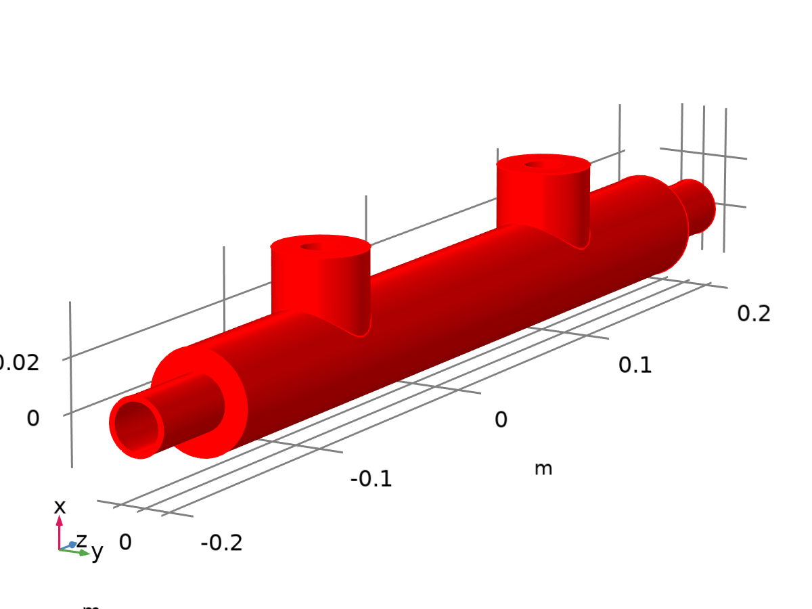
Dataset: Study 1/Solution 1

Exterior Walls 1
Data
Description | Value
Dataset

Parameterization
Description | Value
x- and y-axes | Surface parameters

Study 1/Solution Store 1
Solution
Description | Value
Solution | Solution Store 1 (sol2)
Component | Component 1 (comp1)


Dataset: Study 1/Solution Store 1

Plot Groups

Velocity (spf) 1
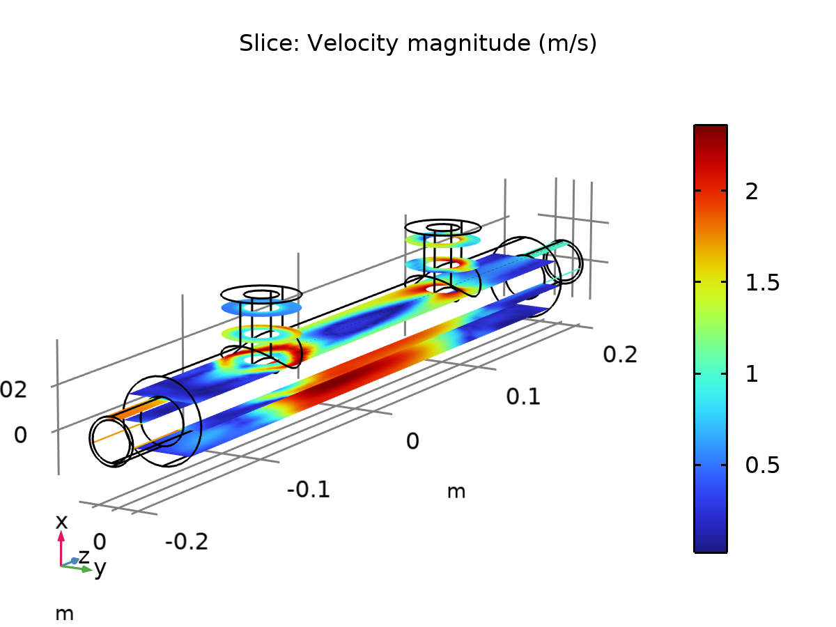
Slice: Velocity magnitude (m/s)

Pressure (spf) 1
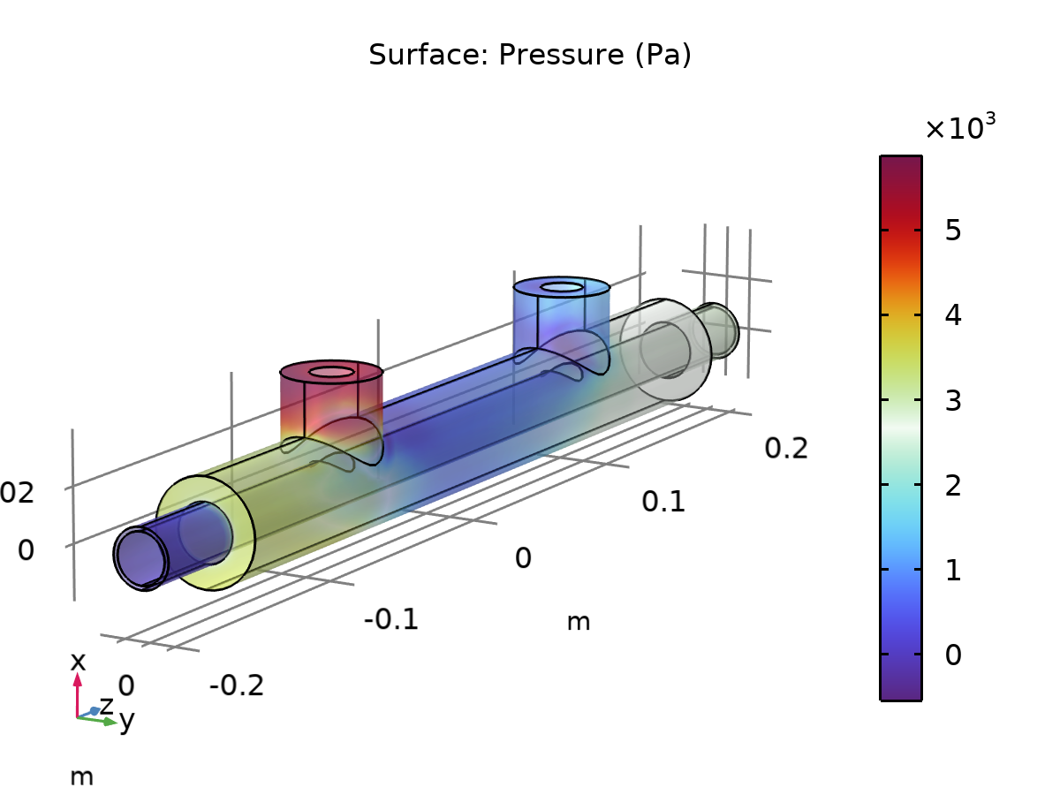
Surface: Pressure (Pa)

Wall Resolution (spf) 1
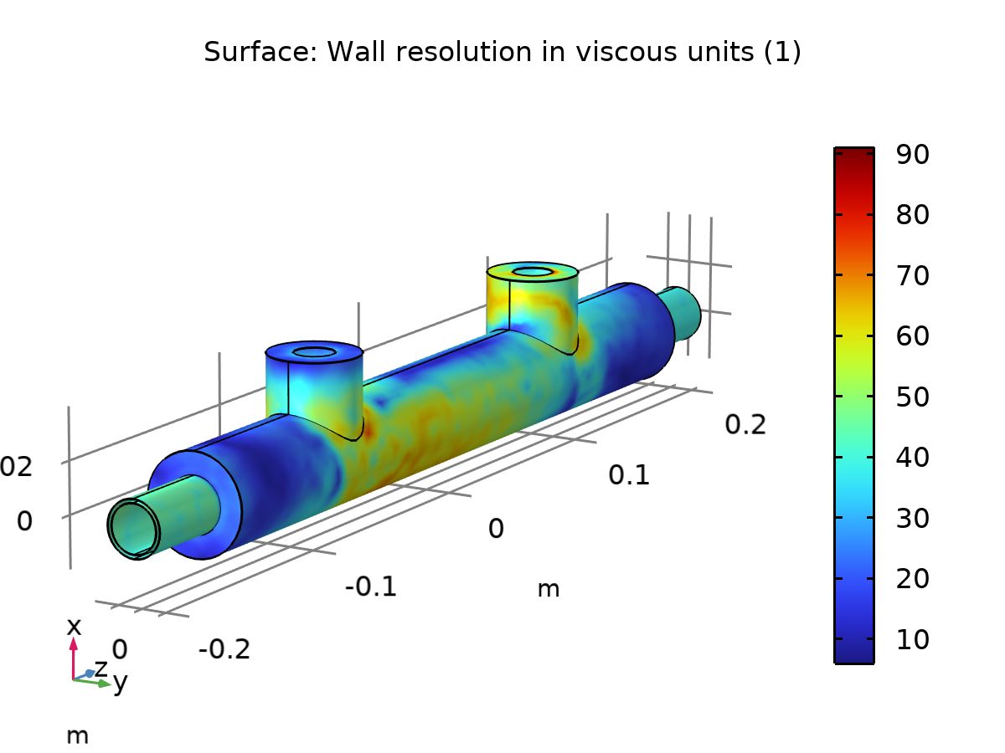
Surface: Wall resolution in viscous units (1)

Temperature and Fluid Flow (nitf1) 1
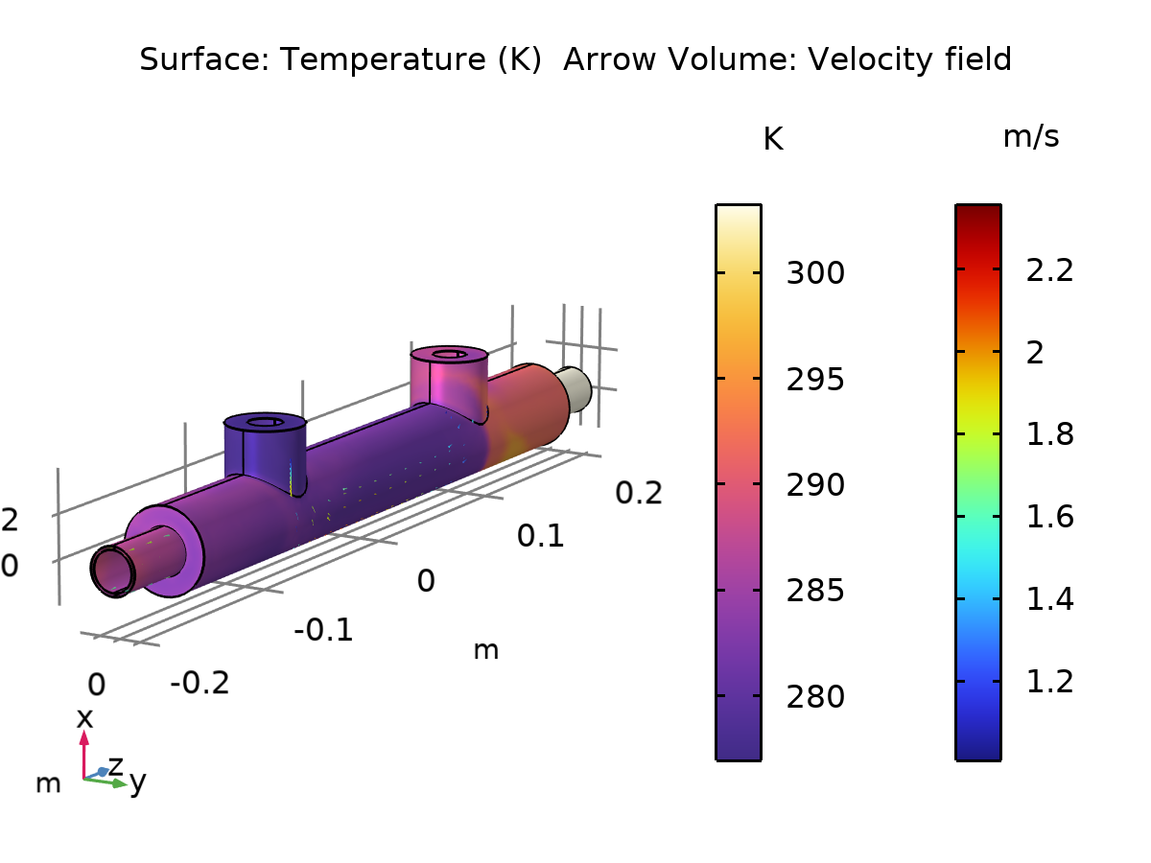
Surface: Temperature (K) Arrow Volume: Velocity field

