---------------------------------------------------------------------

-- LAB 04

--

-- Exercise 1

---------------------------------------------------------------------

USE TSQL;

GO

---------------------------------------------------------------------

-- Task 1

--

1-- Write a SELECT statement that will return the productname column from the Production.Products table (use table alias “p”) and the categoryname column from the Production.Categories table (use table alias “c”) using an inner join.

--

2-- Execute the written statement and compare the results that you got with the desired results shown in the file 52 - Lab Exercise 1 - Task 1 Result.txt.

--

3-- Which column did you specify as a predicate in the ON clause of the join? Why?

--

4-- Let us say that there is a new row in the Production.Categories table and this new product category does not have any products associated with it in the Production.Products table. Would this row be included in the result of the SELECT statement written in task 1? Please explain.

---------------------------------------------------------------------

---------------------------------------------------------------------

-- Detyre 1

--

1--Selektoni kolonen productname nga tabela Production.Products (perdor alias “p” per tabelen) dhe kolonen categoryname nga tabela Production.Categories (perdor alias “c” per tabelen) duke perdorur nje inner join.

--

2-- Ekzekutoni veprimet e mesiperme dhe krahasoni rezultatet qe ju moret me rezultatet e deshiruara ne dokumentin 52 - Lab Exercise 1 - Task 1 Result.txt.

--

3-- Cilen kolone specifikuat si predicate ne klazulen On te join? Pse?

--

4-- Le te themi qe ka nje rrjesht te ri ne tabelen Production.Categories dhe kjo kategori e re e produktit nuk ka ndonje produkt te lidhur me te ne tabelen Production.Products. A do te perfshihet ky rrjesht ne rezultatin e veprimeve te shkruara ne Detyren 1? Shpjegoni.

--------------------------------------------------------------------------

1--

Select p.productname ProductName,c.categoryname From Production.Products p INNER JOIN Production.Categories c ON p.categoryid = c.categoryid

2—

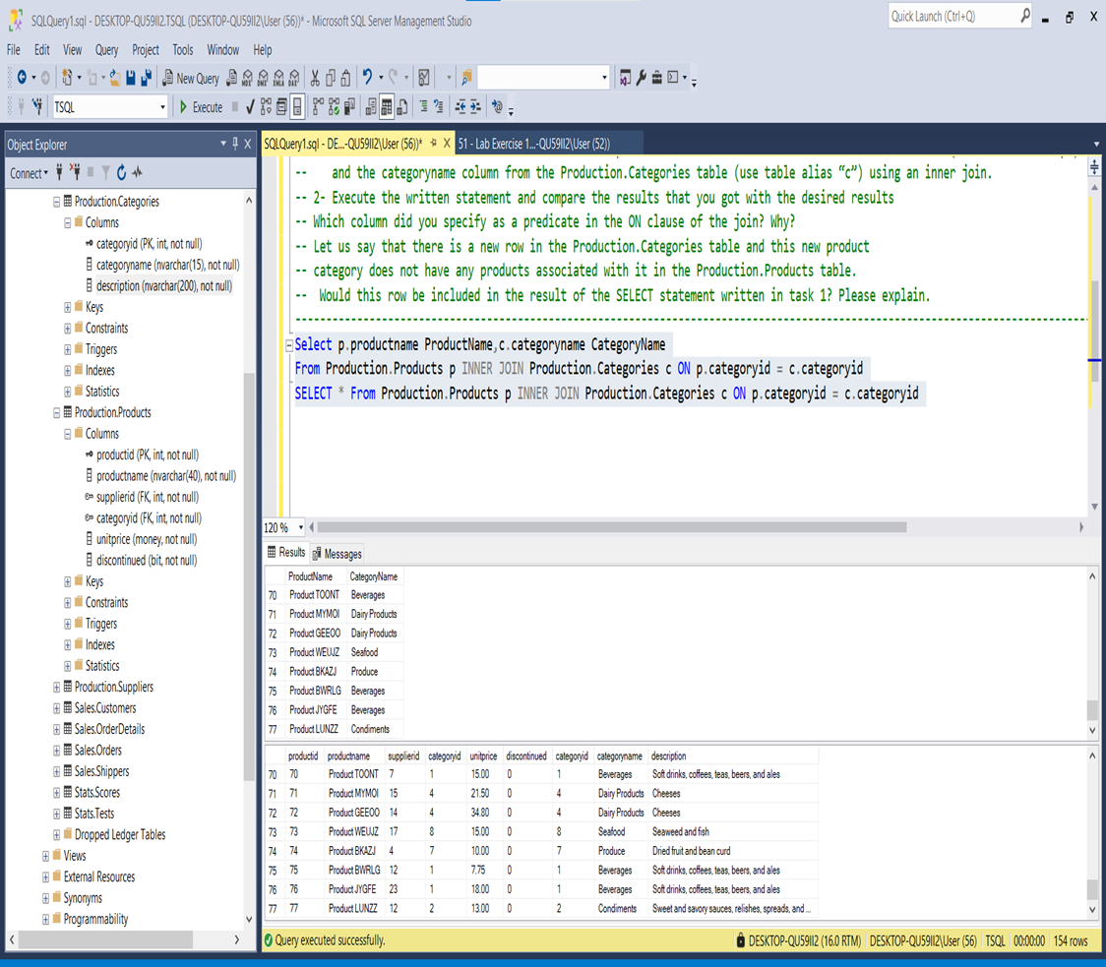

3—There is 1:N Relationship between two entities such as: Production.Categories and

Production.Products where Primary Key of ‘Categories ’ is added as a Foreign Key in

‘Products’-Table🡺 p.categoryid = c.categoryid

4—Po , pritet në vazhdimësi të shtohen produkte të kësaj kategorie.Edhe ne kete rast queria do te ekzekutohet me sukses .Konkretisht:

