---------------------------------------------------------------------

-- LAB 04

--

-- Exercise 3

---------------------------------------------------------------------

USE TSQL;

GO

---------------------------------------------------------------------

-- Task 1

--

1-- In order to better understand the needed tasks, you will first write a SELECT statement against the HR.Employees table showing the empid, lastname, firstname, title, and mgrid columns.

--

2-- Execute the written statement and compare the results that you got with the recommended result shown in the file 72 - Lab Exercise 3 - Task 1 Result.txt. Notice the values in the mgrid column. The mgrid column is in a relationship with empid column. This is called a self-referencing relationship.

---------------------------------------------------------------------

---------------------------------------------------------------------

-- Detyre 1

--

1-- Qe te kuptoni me mire detyrat e kerkuara, fillimisht selektoni kolonat empid, lastname, firstname, title dhe mgrid nga tabela HR.Employees.

--

2-- Ekzekutoni veprimet dhe krahasoni rezultatet qe moret me rezultatet e rekomanduara ne dokumentin 72 - Lab Exercise 3 - Task 1 Result.txt. Vereni vlerat ne kolonen mgrid. Kolona mgrid eshte e lidhur me kolonen empid. Kjo eshte e quajtur lidhja vete-referim.

---------------------------------------------------------------------

1--

Select hrEmp.empid,hrEmp.firstname EmployeeFirstName,hrEmp.lastname EmployeeLastName,hrEmp.title Employee_Title,

hrMgr.mgrid,hrMgr.firstname ManagerFirstName,hrMgr.lastname ManagerLastName,hrMgr.title ManagerTitle

From HR.Employees hrEmp INNER JOIN HR.Employees hrMgr ON hrEmp.empid=hrMgr.mgrid

Select hrEmp.empid,hrEmp.firstname EmployeeFirstName,hrEmp.lastname EmployeeLastName,hrEmp.title Employee_Title,

hrMgr.mgrid,hrMgr.firstname ManagerFirstName,hrMgr.lastname ManagerLastName,hrMgr.title ManagerTitle,*

From HR.Employees hrEmp INNER JOIN HR.Employees hrMgr ON hrEmp.empid=hrMgr.mgrid

2--

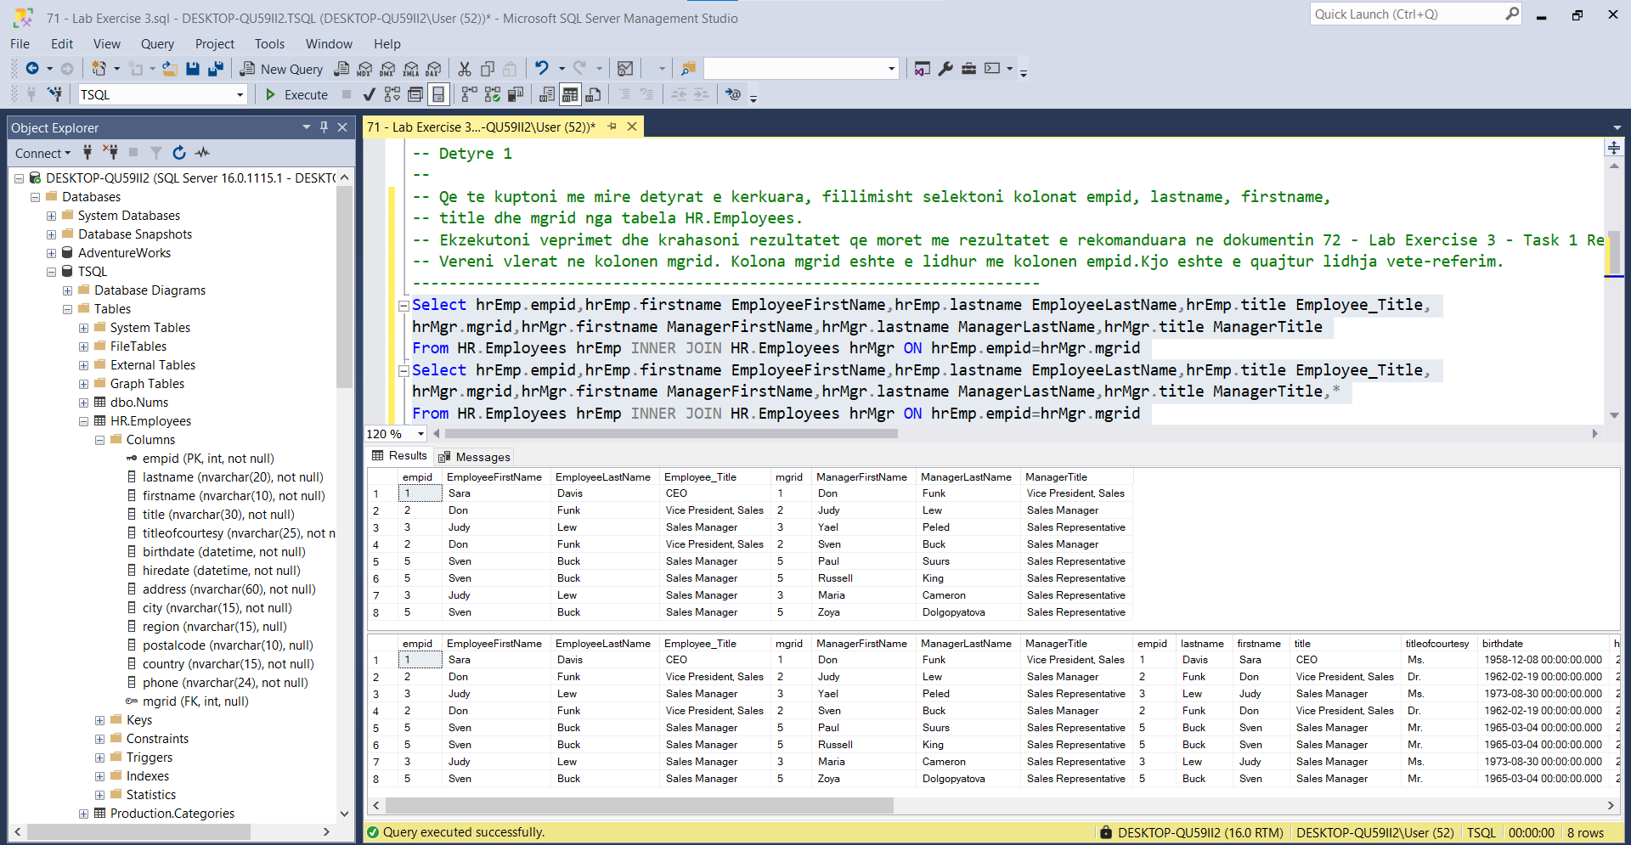

---------------------------------------------------------------------

-- Task 2

--

1-- Copy the SELECT statement from task 1 and modify it to include additional columns for the

manager information (lastname, firstname) using a self-join. Assign the aliases mgrlastname

and mgrfirstname, respectively, to distinguish the manager names from the employee names.

--

2-- Execute the written statement and compare the results that you got with the recommended result

shown in the file 73 - Lab Exercise 3 - Task 2 Result.txt. Notice the number of rows returned.

--

3-- Is it mandatory to usetable aliases when writing a statement with a self-join? Can you use a

full source table name as alias? Please explain.

--

4-- Why did you get fewer rows in the T-SQL statement under task 2 compared to task 1?

---------------------------------------------------------------------

---------------------------------------------------------------------

-- Detyre 2

--

1-- Kopjo veprimet nga Detyra 1 dhe modifiko ate duke shtuar kolona duke shfaqur informacion mbi

manaxherin (lastname, firstname)duke perdorur nje self-join. Perdorni alias mgrlastname dhe

mgrfirstname, respektivisht, per te dalluar emrat e manaxhereve nga emrat e punonjesve.

--

2-- Ekzekutoni veprimet dhe krahasoni rezultatet qe moret me rezultatet e rekomanduara ne

dokumentin 73 - Lab Exercise 3 - Task 2 Result.txt. Vereni numrin e rrjeshtave qe

kthehen.Execute the written statement and compare the results that you got with the

recommended result shown in the file 73 - Lab Exercise 3 - Task 2 Result.txt. Notice the

number of rows returned.

--

3-- A eshte e detyrueshme perdorimi i alias te tabelave kur jeni duke perdorur nje self-join? A

mund te perdoresh nje tabele te plote me emra si alias? Shpjego.

--

4-- Pse kemi me pak rrjeshta ne T-SQL statement ne Detyren 2 krahasuar me Detyren 1?

---------------------------------------------------------------------

1--

Select hrEmp.empid EmployeeId,hrEmp.firstname EmployeeFirstName,hrEmp.lastname EmployeeLastName,hrEmp.title Employee_Title,

hrMgr.mgrid ManagerId,hrMgr.firstname mgrfirstname,hrMgr.lastname mgrlastname,hrMgr.title mgrTitle

From HR.Employees hrEmp INNER JOIN HR.Employees hrMgr ON hrEmp.empid=hrMgr.mgrid

2—Rezultatet jane te njejta në të dyja rastet

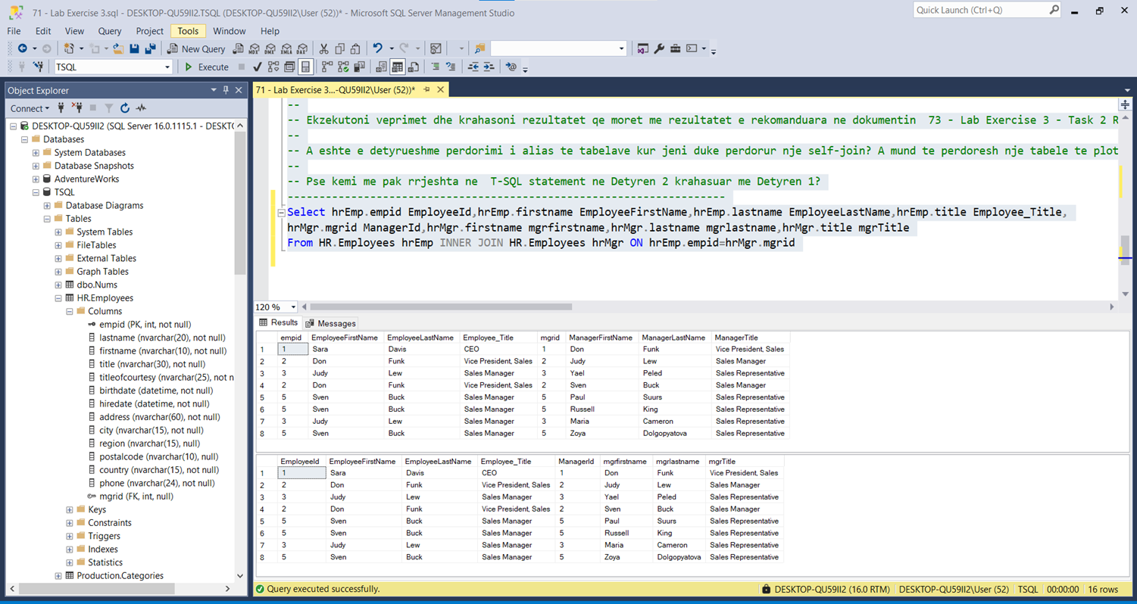

3—Patjeter qe po , si ne çdo relacion tjetër apo therritje tabelash dhe specifikim atributesh

4—Numri I rreshtave eshte I njejte ne te dyja rastet