---------------------------------------------------------------------

-- LAB 04

--

-- Exercise 5

---------------------------------------------------------------------

USE TSQL;

GO

---------------------------------------------------------------------

-- Task 1

--

--

1-- Execute the T-SQL code under Task 1. Do not worry if you do not understand the provided T-SQL

code, as it is used here to provide a more realistic example for a cross join in the next task.

---------------------------------------------------------------------

SET NOCOUNT ON;

IF OBJECT_ID('HR.Calendar') IS NOT NULL

DROP TABLE HR.Calendar;

CREATE TABLE HR.Calendar (

calendardate DATE CONSTRAINT PK_Calendar PRIMARY KEY

);

DECLARE

@startdate DATE = DATEFROMPARTS(YEAR(SYSDATETIME()), 1, 1),

@enddate DATE = DATEFROMPARTS(YEAR(SYSDATETIME()), 12, 31);

WHILE @startdate <= @enddate

BEGIN

INSERT INTO HR.Calendar (calendardate)

VALUES (@startdate);

SET @startdate = DATEADD(DAY, 1, @startdate);

END;

SET NOCOUNT OFF;

GO

-- observe the HR.Calendar table

SELECT

calendardate

FROM HR.Calendar;

---------------------------------------------------------------------

-- Detyre 1

--

--

1-- Ekzekutoni kodin T-SQL poshte ne Detyren 1. Mos u shqetesoni ne qoftese nuk kuptoni kodin e ofruar

te T-SQL code, pasi eshte perdorur ketu per te ofruar nje shembull me realistik per cross join

ne detyren tjeter.

---------------------------------------------------------------------

SET NOCOUNT ON;

IF OBJECT_ID('HR.Calendar') IS NOT NULL

DROP TABLE HR.Calendar;

CREATE TABLE HR.Calendar (

calendardate DATE CONSTRAINT PK_Calendar PRIMARY KEY

);

DECLARE

@startdate DATE = DATEFROMPARTS(YEAR(SYSDATETIME()), 1, 1),

@enddate DATE = DATEFROMPARTS(YEAR(SYSDATETIME()), 12, 31);

WHILE @startdate <= @enddate

BEGIN

INSERT INTO HR.Calendar (calendardate)

VALUES (@startdate);

SET @startdate = DATEADD(DAY, 1, @startdate);

END;

SET NOCOUNT OFF;

GO

-- observe the HR.Calendar table

SELECT

calendardate

FROM HR.Calendar;

---------------------------------------------------------------------

1--

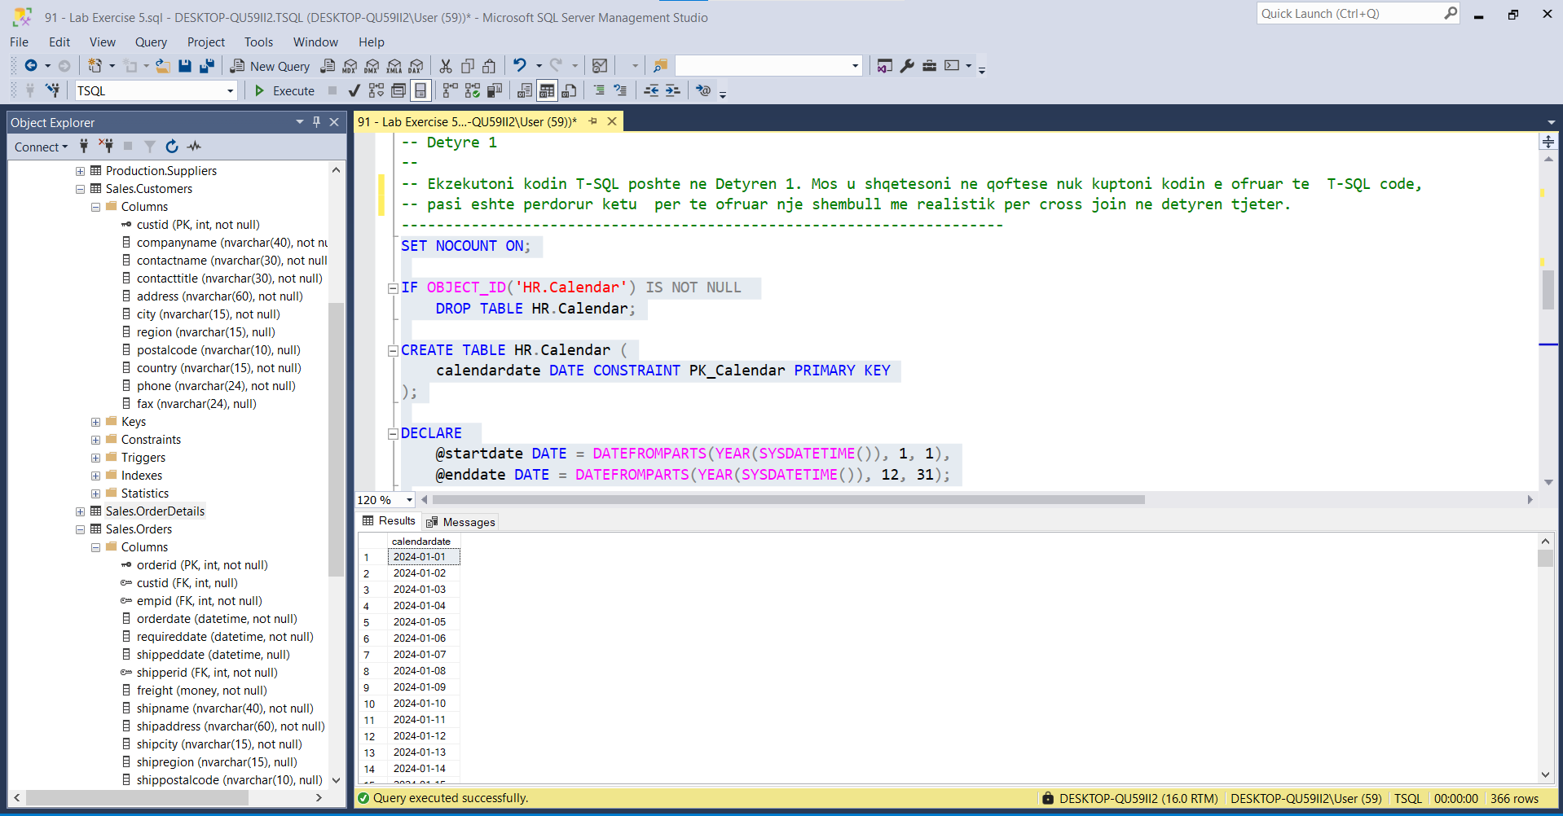

Vijon… pjesa tjeter e vitit

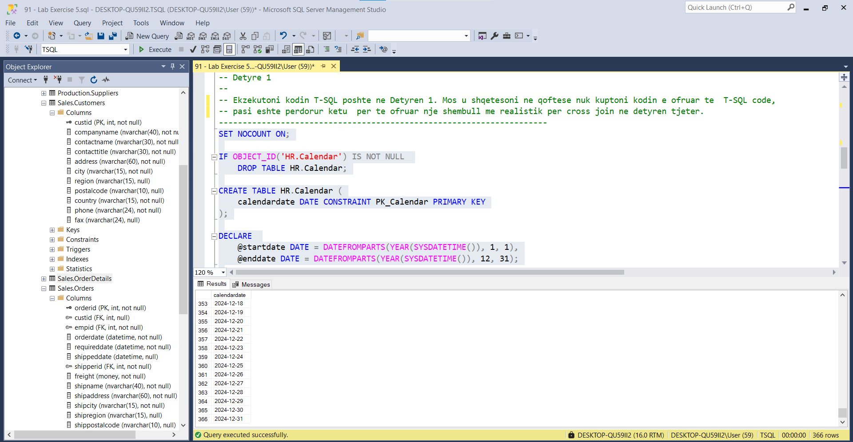

-- Task 2

--

1-- Write a SELECT statement to retrieve the *empid, firstname, and lastname* columns from the

HR.Employees table and the calendardate column from the HR.Calendar table.

--

2-- Execute the written statement and compare the results that you got with the recommended result

shown in the file 92 - Lab Exercise 5 - Task 2 Result.txt.

--

3-- What is the number of rows returned by the query? There are nine rows in the HR.Employees table.

Try to calculate the total number of rows in the HR.Calendar table.

---------------------------------------------------------------------

---------------------------------------------------------------------

-- Detyre 2

--

1-- Selektoni kolonat empid, firstname, dhe lastname nga tabela HR.Employees dhe kolonen calendardate

nga tabela HR.Calendar.

--

2-- Ekzekutoni veprimet dhe krahasoni rezultatet qe moret me rezultatet e rekomanduara ne dokumentin

92 - Lab Exercise 5 - Task 2 Result.txt.

--

3-- Sa eshte numri i rrjeshtave qe nxjerr query? Jane 9 rrjeshta ne tabelen HR.Employees. Perpiquni te

llogaritni numrin total te rrjeshtave ne tabelen in the HR.Calendar.

---------------------------------------------------------------------

1--

Select e.empid,e.firstname,e.lastname,c.calendardate

From HR.Employees e CROSS JOIN HR.Calendar c

2--

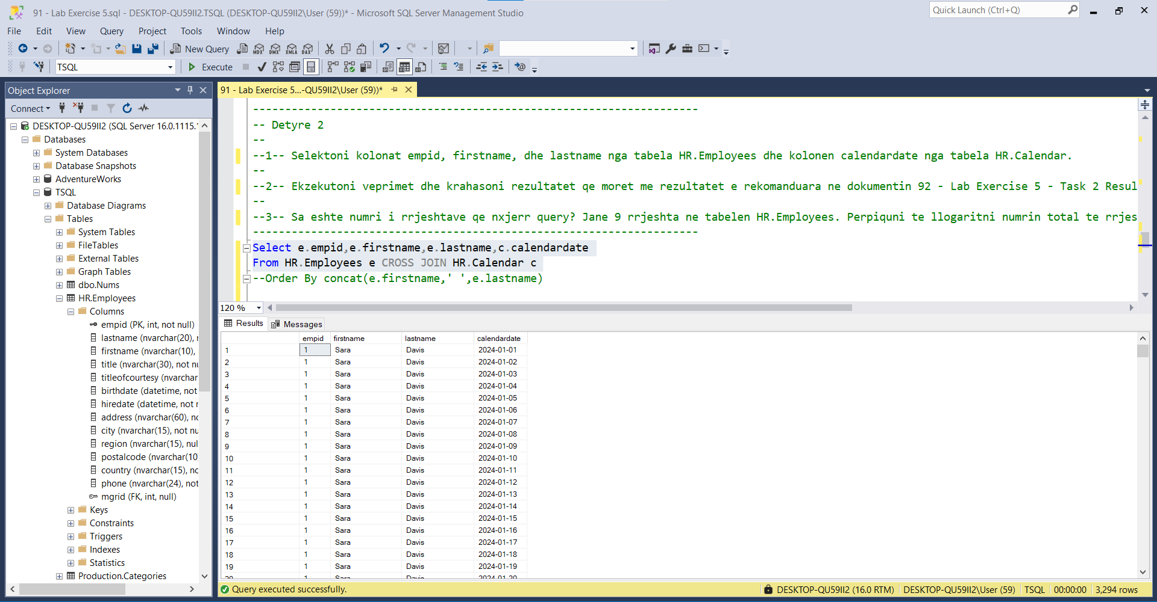

Vijon…

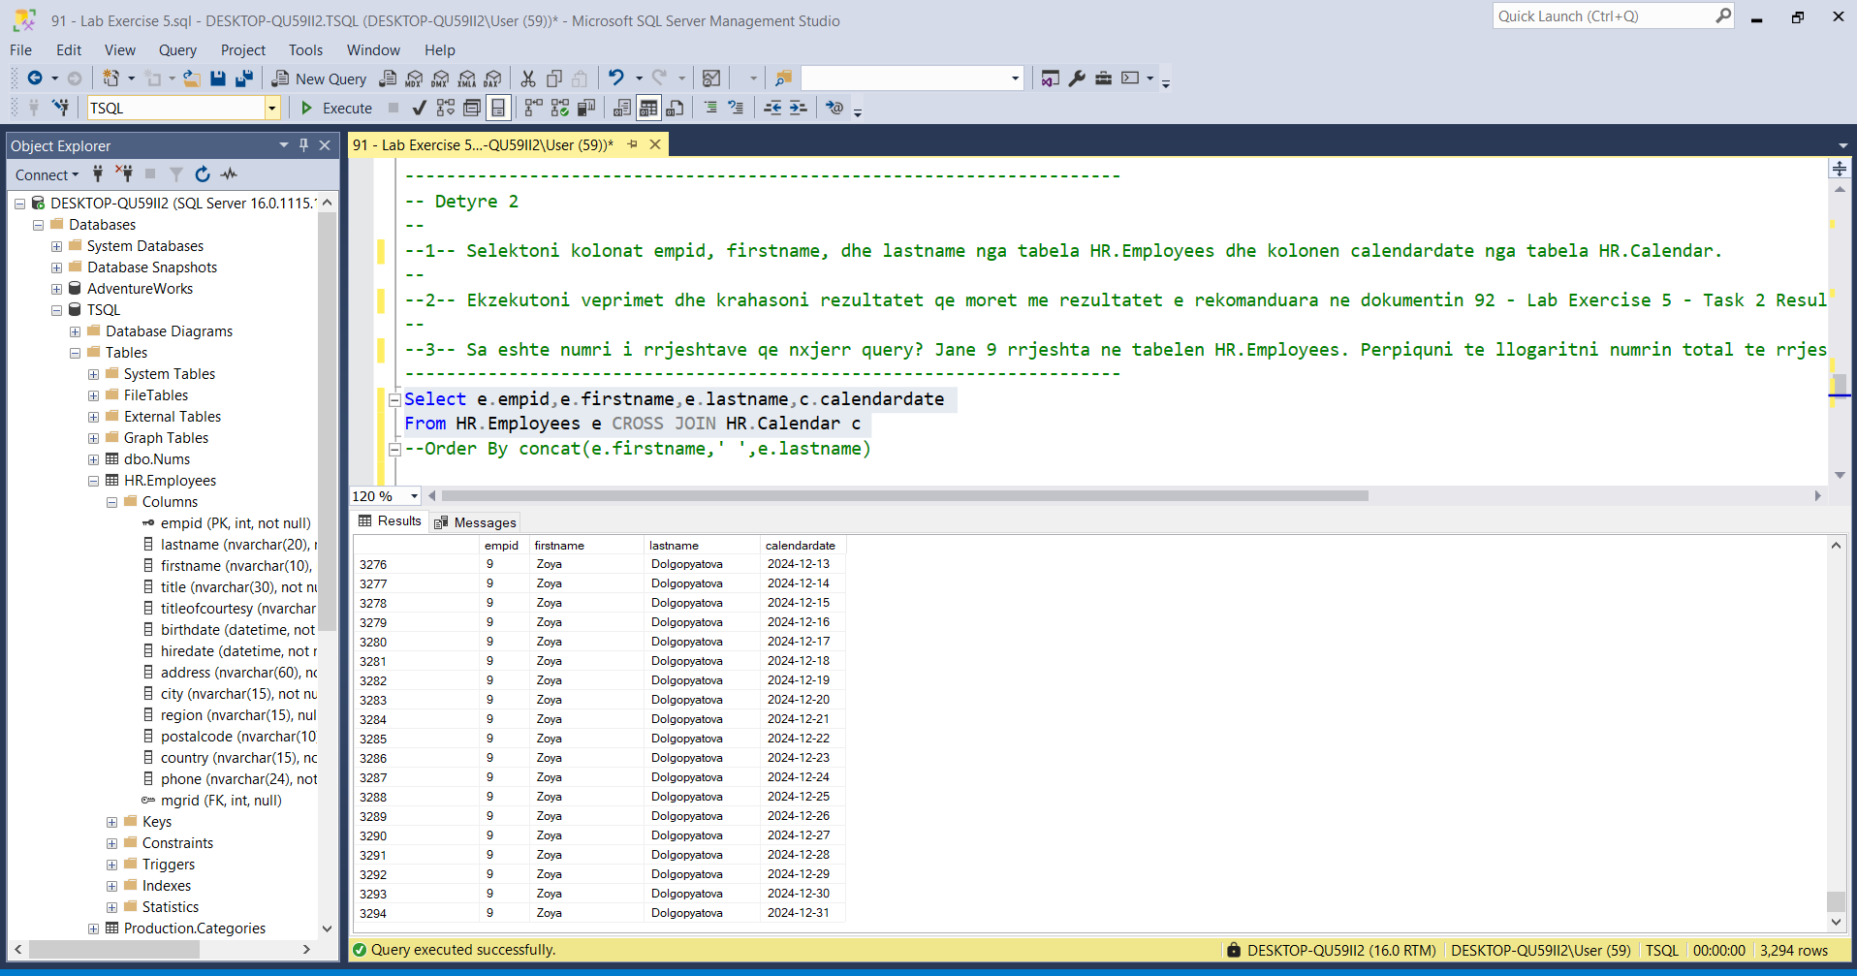

3--numri i rreshtave eshte :9x366=3294 pra çdo punonjës në çdo ditë të vitit

---------------------------------------------------------------------

-- Task 3

--

-- Execute the provided T-SQL statement to remove the HR.Calendar table.

---------------------------------------------------------------------

IF OBJECT_ID('HR.Calendar') IS NOT NULL

DROP TABLE HR.Calendar;

---------------------------------------------------------------------

-- Detyre 3

--

-- EKzekutoni kodin T-SQL per te hequr tabelen the HR.Calendar.

---------------------------------------------------------------------

IF OBJECT_ID('HR.Calendar') IS NOT NULL

DROP TABLE HR.Calendar;

--Ekzekutimi I kodit u krye me sukses!!

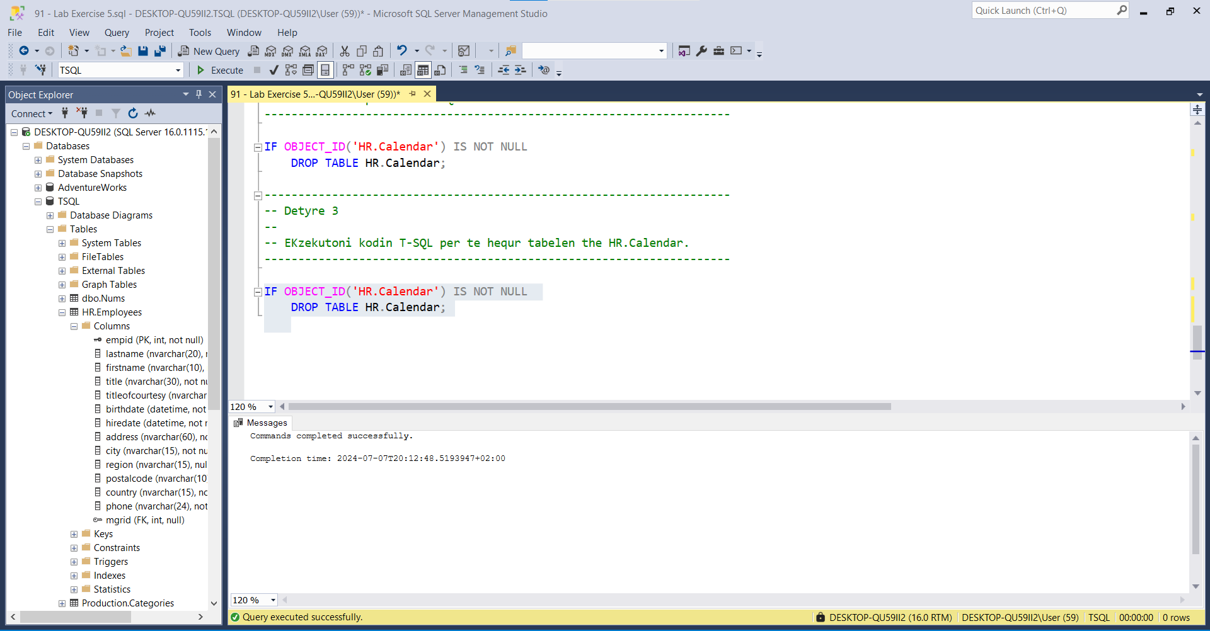

Sikurse shihet edhe më poshtë ,queria nuk ekzekutohet , që do të thotë se table HR.Calendar ESHTE FSHIRE.

