USE AdventureWorks

GO

1)--Extra Detyra ne databazen AdventureWorks

--1-- Nga tabela HumanResources.Departments perditesoni GroupName nga 'Executive General Administration" ne "General Administration"

--2-- Duam te perditesojme pagen e punonjesit me shtese prej 15% per punonjesit qe kane

-- mbi 10 vite të punesuar. Data e punesimit gjendet tek tabela HumanResources.Employees

-- ndersa paga gjendet tek EmployeePayHistory.

--1--

UPDATE HumanResources.Department

SET GroupName = 'General Administration'

OUTPUT

inserted.DepartmentID,

deleted.GroupName as old_value,

inserted.GroupName as new_value

WHERE GroupName = 'Executive General and Administration'

GO

-------

Select * From HumanResources.Department

-------

Select e.BusinessEntityID,eph.Rate,DATEDIFF(year,edh.StartDate,edh.EndDate) as experience

From HumanResources.EmployeePayHistory eph INNER JOIN HumanResources.EmployeeDepartmentHistory edh ON eph.BusinessEntityID = edh.BusinessEntityID

INNER JOIN HumanResources.Employee e ON edh.BusinessEntityID = e.BusinessEntityID

Where DATEDIFF(year,edh.StartDate,GETDATE()) >10

----

Select * From HumanResources.EmployeeDepartmentHistory

--2--

Update HumanResources.EmployeePayHistory

SET Rate = Rate*(1+ 0.15)

OUTPUT

inserted.BusinessEntityID,

deleted.Rate as oldSalary,

inserted.Rate as newSalary

Where BusinessEntityID IN(

Select e.BusinessEntityID

From HumanResources.EmployeePayHistory eph INNER JOIN HumanResources.EmployeeDepartmentHistory edh ON eph.BusinessEntityID = edh.BusinessEntityID

INNER JOIN HumanResources.Employee e ON edh.BusinessEntityID = e.BusinessEntityID

Where DATEDIFF(year,edh.StartDate,edh.EndDate) >10

)

GO

--2. Perditesojme vetem pagat e punonjesve te departamentit te "Production"

Select * From HumanResources.EmployeePayHistory eph INNER JOIN HumanResources.Employee e ON eph.BusinessEntityID = e.BusinessEntityID

INNER JOIN HumanResources.EmployeeDepartmentHistory d ON e.BusinessEntityID = D.BusinessEntityID

INNER JOIN HumanResources.Department dep ON d.DepartmentID = dep.DepartmentID

Where dep.Name = 'Production'

----------------------------------------------------

update HumanResources.EmployeePayHistory

set Rate = Rate*(1 + 0.15)

OUTPUT

inserted.BusinessEntityID ,

deleted.Rate as oldSalary,

inserted.Rate as newSalary

where EXISTS (

Select e.BusinessEntityID

From HumanResources.EmployeePayHistory eph INNER JOIN HumanResources.Employee e ON eph.BusinessEntityID = e.BusinessEntityID

INNER JOIN HumanResources.EmployeeDepartmentHistory d ON e.BusinessEntityID = D.BusinessEntityID

INNER JOIN HumanResources.Department dep ON d.DepartmentID = dep.DepartmentID

Where dep.Name = 'Production'

)

2)--Neser do fillojme te shesim disa produkte te reja, te cilat duhen importuar nga databaza TSQL

--ne databazen AdventureWorks. Databaza AdventureWorks ka kategori dhe subcategory; kete plotesojeni

--me emrin e kategorise se databazes TSQL; vendosini njesoj edhe category dhe subcategory.

--Cmimin do e vendosni 25% me te larte se cmimi i databazes TSQL. StandartCost njesoj si cmimi i databazes TSQL.

--Ndersa productnumber vendose TSQL-dy germa nga fjala e dyte e emrit te produktit-10- - -

--dhe filloni me 10001 deri sa te kete produkte ne numer rendor.

--Ne disa kolona si MakeFlag dhe FinishedGoods thjeshte vendosni numrin 1.

--Ne kolona te tjera si reorderpoint etj vendosni vete nje numer si 900.

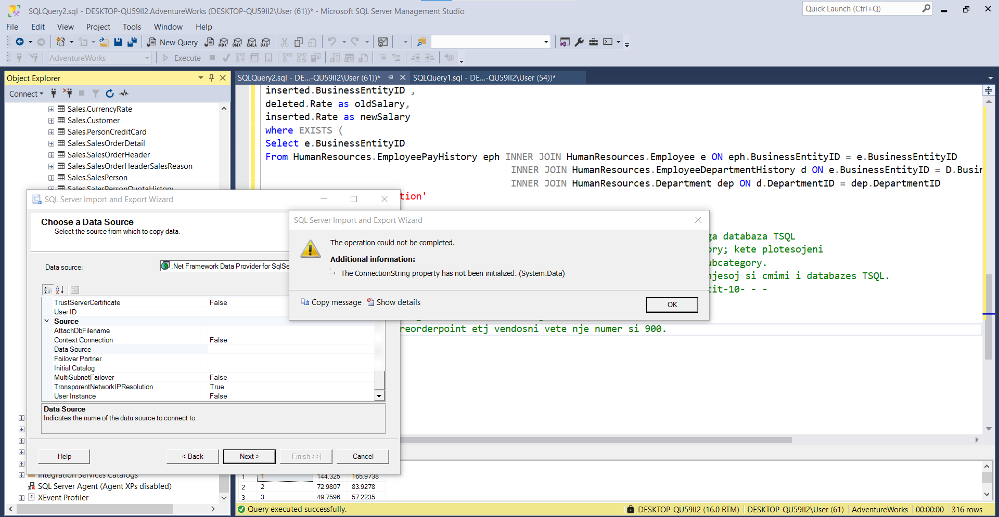

***Importi nuk mund te realizohet…..