
Bilkent University
Department of Computer Engineering

Senior Design Project
CS319: Kill The Bugs
Analysis Report
Anisa Llaveshi, Cüneyt Erem, Ertunç Efe, Mert Gürcan
Course Instructor: Uğur Doğrusöz

Progress/Requirements Elicitation
Feb 20, 2016

Contents
1 Introduction 1
2 Proposed System 1
a. Overview 1
i. General Explanation of the game 1
ii. Objects Specifications 2
b. Functional Requirements 5
i. New Game 5
ii. Pause Game 5
iii. Continue Game 5
iv. Restart Game 5
v. Buy gun 5
vi. Collect Coins 5
vii. View settings 5
viii. View Tutorial 6
ix. View Credits 6
x. Exit Game 6
c. Non-functional Requirements 6
i. Response time 6
ii. Manageability 6
iii. Graphical Smoothness 6
iv. Pleasing audio 6
d. System Models 7
i. Scenarios 7
ii. Use-Case Model 10
3 References 15

Analysis Report
CS319 Project: Kill The Bugs

Introduction
The project we are going to develop is a game named Kill The Bugs. It is a greenfield project inspired from the game Plants and Zombies[1]. It will be a Desktop based game.
The game consists in a set of bugs and a number of different food products. The bugs aim to eat the food and the player’s aim is to not let the bugs reach them. The game’s difficulty level will change as the user progresses in the game. The score system of this game will be based on the number and types of bug killed. Once a game is over the score will be saved locally.
In this report, we are going to give a general overview of our project, the gameplay and the game objects. Next, the functional and non-functional requirements, some of the main scenarios and the use cases of the game are going to be discussed.

Proposed System

Overview

General Explanation of the game
In this section, we are firstly going to give a general description of the gameplay. Next, we are going to describe the main features and the objects’ characteristics of the game.
Kill the Bugs consists of a field of tiles on which different kinds of bugs can walk in a single direction only. Bugs are positioned on one side of the field and on the other side there are different kinds of groceries which the bugs can eat if they manage to get there. The player's aim is to not let the bugs reach the groceries' side. To do this, there will be a set of weapons available to the player each having different prices and abilities to attack the bugs and there will be a character carrying some of these weapons. These weapons can be bought by the player and positioned in different tiles. Occasionally there will be money appearing in some random tiles that will disappear in a short amount of time and that the player has to collect before they disappear. The score system will be based on the number and types of bugs killed. The money account and the score system are independent, so the player can only improve his/her score but can both increase and decrease the amount of money in his/her account. At any time the game player can see his/her score and also the highest scores won on that machine in the high score page.
The game will be controlled by a mouse and it will have two keyboard shortcuts which are pause game (P) and mute (M). Also, the player can set the game volume and the music volume acordingly, and also s/he can choose to change the theme of the game between 3 different graphics in the Settings option.

Objects Specifications

- Bugs
The game has 5 kinds of bugs sitting in different houses and all of them have different health points, graphical designs, and names. Their abilities change according to the progress of the player in the game and to the total score earned. Any bug can go out from any house and walk towards the food. Next we are going to give a detailed description of these bugs.
- Spider
Spider is the strongest bug in the game and it has the highest health point. It walks slowly in the field and since it is the strongest ones gives the highest score when killed.
Speed: 50 units
Health: 120 units
Coins earned when killed: 100 units
- Cockroach
Cockroach is the second slowest bug after spider. It dies slowly but it walks very fast. It is less valuable than spider.
Speed: 80 units
Health: 80 units
Coins earned when killed: 50 units
- Worm
Worm is the slowest bug and it is easier than the previous two bugs to be killed. As a result it is less valuable than them contributing less to the score when killed.
Speed: 50 units
Health: 50 units
Coins earned when killed: 25 units
- Ant
Ant is the second weakest bug in the game. It dies easily and walks slowly. Its value when killed is very small.
Speed: 30 units
Health: 30 units
Coins earned when killed: 10 units

- Flea
Flea is the weakest bug in the game. Its health value is very small and the amount of contribution to the total score when killed is the smallest among all bugs.
Speed: 10 units
Health: 10 units
Coins earned when killed: 5 units

- Groceries
Just opposite the bugs there will be a range of food products placed in the field. These food products should be saved from the bugs. These groceries will be, cheese, flower, bread, a fruit basket, and chocolate bar.

- Bits & Pieces
Occasionally there will be bits & pieces of the groceries present in the game appear in different tiles in the field. If a bug reaches that tile, it will consume the food found there and its speed will increase for a certain time. This temporary powerup’s time can change according to the difficulty level of the game.

- Weapons and Bullets
There will be five different weapon models. Three of these guns fire the same bullet type; however the amount and frequency of the bullets fired will be different. The two other ones fire a different bullet type and these guns are called super weapons.

Normal Weapons:
- Pistol
This is the least powerful gun and the cheapest one.
Features;
-price: 10 units
-power: 10 units
-frequency: 1 unit

- Rifle
The rifle is a combination of high bullet frequency and price. When you need cheap and efficient gun, rifles are very useful.
Features;
-price: 35 units
-power: 10 units
-frequency: 2 units

- Machine Gun
Machine guns are the most efficient weapons. However, they are very expensive.
Features;
-price: 50 units
-power: 10 units
-frequency: 4 units

Super Weapons:

- Laser Gun
Laser guns can kill all the bugs in one line. Once purchased it can be used only once and it has a high price.
Features;
-price: 500 units

- Grenade
Grenades can kill all the bugs in a sqaure of 9 tiles. Once purchased it can be used only once and it has a high price.
-price: 500 units

- Coins
In order to be able to buy weapons the player needs to collect coins. Coins will randomly appear in different tiles during the game and they will stay for only a short amount of time. Collecting coins is very important for a player to be able to succeed. Coins have different values which are 5,10,25,50,100 units.

Functional Requirements

New Game
When a game is first started the player will be able to choose to play a new game. In this case, the player will start a game from the beginning with all the settings set to the default initial ones. The bugs and the groceries will be positioned on opposite sides, only one basic gun will be available to use and the score and money account will be set to 30 units of coin which will be enough for buying five pistols.

Pause Game
While playing the players will be given the option to pause the game temporarily. In this case the game status remains the same as it was the moment when the player decided to pause. The score, money account and availability of guns does not change. Neither does the position of the bugs and the guns in the field.

Continue Game
If the player has paused the game s/he is given the chance to continue it. In this case the player will be redirected to the game that s/he was playing before clicking pause, and the status of the game will be the same as previously described.

Restart Game
The player can choose to quit the game s/he is currently playing on to restart it. In this case a new game will be loaded.

Buy gun
With a certain amount of money a player will be able to buy a new gun. Each gun has a different price so the amount of money needed to buy each gun will vary. The player can buy only amongst the available guns at that moment. Once he buys the gun the player will be able to click on the desired position to place it into the field.

Collect Coins
Oftentimes, in different tiles in the main field there will be money in different amounts/value appearing and staying there for only a short amount of time. The player will be able to collect this money. The value of this money will be added to his money account.

View settings
There will be a settings page available to the player. S/he can set the music volume and game volume accordingly. Furthermore, the player will be able to choose among three different game themes.

View Tutorial
The player can check a tutorial for the game. In this tutorial basic explanations of how the game works and what the player has to do will be given. In addition, different events that might happen during the game progress and that the player might not previously be aware of will also be described. Such an event would be the increase in the bug’s speed after a certain time.

View Credits
Player will be able to see the credits of the game. In the credits, there will be names of the authors and their contact information.

Exit Game
If the player chooses to not play the game anymore s/he can do so by choosing to exit the game.

Non-functional Requirements

Response time
When a player will buy a gun, it will become immediately available to the player to use.When a player will decide to use a gun available to him, the gun will be put in the tile required by the player in a maximum of 1 second.

Manageability
Any person will be able to play the game regardless of previous experience in gaming. The game will not be very difficult to grasp and to play. A reasonable number of features will be available for the player to use so that the game does not become very complex in terms of difficulty to remember everything and it still remains manageable for the player to play and win high scores.

Graphical Smoothness
The game will consist of smooth graphics that will not strain users’ eyes. Also the game will have well balanced colour chart. Colors are customized according to the theme of the game.

Pleasing audio
High quality audio that will not bother users’ ears will be chosen. Also chosen audio will perfectly match with the graphical content in terms of harmony.

System Models

Scenarios

- Scenario #1
  - Scenario name: New Game
  - Participating actor instances: Anisa, Enemy(Computer system)
  - Flow of events:
    - Anisa downloads the game and wants to play it.
    - She opens the game from the directory where it is located.
    - This is the first time Anisa is playing the game so she chooses the New Game option. She wants to start playing it.
    - A new game KillTheBugs is loaded with the initial default configurations and features.
    - Anisa starts playing the game and continues till she looses.

- Scenario #2
  - Scenario name: High score
  - Participating actors: Anisa,Enemy(Computer system)
  - Flow of events:
    - Anisa has been playing KillTheBugs for a long time. She has killed a lot of bugs.
    - Suddenly Anisa sees a High Score display appearing in her screen. She has killed more bugs/more powerful bugs than she had ever before so her score now is the highest score she has achieved.
    - Anisa continues playing the game still.

- Scenario #3
  - Scenario name: Pause/Continue
  - Participating actors: Anisa,Cüneyt, Enemy(Computer system)
  - Flow of events:
    - Anisa is playing the game.
    - Cüneyt calls her to help her with something. Anisa doesn’t want to lose all the progress she has done in the game till that moment.
    - Anisa clicks the button pause.
    - Anisa after a while turns back and presses continue. She now continues playing the game where she had left it.

- Scenario #4
  - Scenario name: Grocery infected
  - Participating actors: Anisa, Enemy(Computer system)
  - Flow of events:
    - Anisa has been playing the game for a while now. The difficulty has increased.
    - Anisa hasn’t collected a lot of money so she cannot buy many powerful guns.
    - There are more bugs in the field and some of them are walking fast. The available guns in the field cannot kill all of them.
    - One of the bugs reaches the other side and eats the grapes found there.
    - Anisa loses the game and a Game Over screen is displayed.

- Scenario #5
  - Scenario name: Gain bonuses
  - Participating actors: Mert, Enemy(computer system)
  - Flow of events:
    - Mert has been playing the game for a while.
    - He plays so well and eventually he has so much coins.
    - Because Mert has so much coins, Mert buys a lot of guns and kills the bugs in a short time.
    - Extra coins pops up because Mert kills the bugs so fast.
    - Mert continues playing game with more coins.

- Scenario #6
  - Scenario name: Buy guns
  - Participating Actors: Mert , Enemy(Computer system)
  - Flow of events:
    - Mert has just started the game and he has to buy guns in order to kill the bugs.
    - Mert buys guns that he can afford.
    - Guns are fired and Mert starts having fun.

- Scenario #7
  - Scenario name: Use Grenade
  - Participating Actors: Ertunç , Enemy(computer system)
  - Flow of events:
    - Ertunc has been playing the game and he has killed at least 5 spiders and earned 500 unit coins.
    - The difficulty has increased and lots of bugs are coming out of their houses.
    - Ertunç buys a grenade which is 500 coins and throws it into the crowd of bugs.
    - Nine tiles have been cleaned from bugs.
    - Now, Ertunç feel himself relieved and continues playing the game.

- Scenario #8
  - Scenario name: Use Laser Gun
  - Participating Actors: Ertunç , Enemy(computer system)
  - Flow of events:
    - Ertunc has been playing the game and he has killed at least 5 spiders to earn 500 unit coins.
    - The difficulty has increased and lots of bugs are coming out of their houses.
    - Ertunç buys a laser gun which is 500 units coin and puts it into the most crowded line.
    - The whole line has been cleaned from bugs.
    - Now, Ertunç feels himself relieved and continues playing the game.

- Scenario #9
  - Scenario name: End of the tiles.
  - Participating Actors: Ertunç, Enemy(computer system)
  - Flow of events:
    - Ertunç has nearly 1050 coins right now.
    - Enemy is too close to win the game.
    - But Ertunç decided to buy two laser guns and one machine gun which are 1050 unit coins.
    - He destroyed two lines with a laser gun and one line with a machine gun and earned 500 units of coins.
    - Suddenly, he realizes that in one line the spider is so close to eat the grocery
    - He bought one more gun and cannot destroy that spider because he didn’t place the gun to the last tile.
    - Game is over and Ertunç’s score is recorded into the high scores file locally.

- Scenario #10
  - Scenario name: Bugs eat bits & pieces
  - Participating Actors:Anisa, Enemy(Computer system)
  - Flow of events:
    - Anisa has been playing the game for a while.
    - Anisa suddenly sees a piece of cheese appear in one of the tiles.
    - A bug is walking in that row of the field and is approaching the tile with the cheese piece. There is no gun in that row to kill the bug.
    - The bug eats the cheese, and it starts walking faster towards the other side of the field.
    - Then, Anisa realizes that the bug’s speed returned to its normal speed within 3 seconds.
- Scenario #11
  - Scenario name: Quit game
  - Participating Actors: Mert, Enemy(Computer system)
  - Flow of events:
    - Mert has been playing the game for a while.
    - Mert suddenly finds this game boring and doesn’t want to play anymore.
    - Mert pauses the game and Pause screen pops out.
    - Mert clicks quit and quits the game.
- Scenario #12
  - Scenario name: Buying more powerful guns
  - Participating Actors: Cüneyt, Enemy(computer system)
  - Flow of events:
1. Cüneyt has been playing the game for a while.
2. The Enemy sends lots of bugs
3. Cüneyt buys rifles to kill the bugs
4. Enemy sends new bugs
5. Cüneyt buys new powerful gun, rifles,
6. Enemy sends new powerful bugs
7. Cüneyt buys new powerful gun; machine guns
8. Enemy sends more bugs and Cüneyt loses the game

- Scenario #13
  - Scenario name: Playing bad
  - Participating Actors: Cüneyt, Enemy(computer system)
  - Flow of events:
1. Cüneyt has been playing the game for a while.
2. The enemy sends bugs
3. Cüneyt plays terribly because he does not know how to play
4. Enemy sends more bugs
5. Cüneyt loses match and returns to main menu to read tutorial and learn how to play well.
6. Cüneyt reads tutorials and plays well the game this time.

- Scenario #14
  - Scenario name: Changing Theme
  - Participating Actors: Cüneyt
  - Flow of events:
1. Cüneyt has been playing the game for a while.
2. Cüneyt returns to main menu because he does not like the background
3. Cüneyt changes the theme and starts new game

Use-Case Model

- Use case #1 (figure 1)
Use case name: Play Game
Participating actors: Player, System
Entry condition:
-Player clicks on the ‘start game’ button, game will starts
Exit condition:
-Player loses the game and player exits the game
Main Flow of events;
1.Player starts to play the game after he clicks on the start game button.
2.The system constructs and loads the main game screen and makes the game available to be played.
3.System starts the game and lots of bugs start to approach the food products.
4.Player tries to kill the bugs by buying and using weapons.
5.System displays the score table and money amount.
6.Player can buy new weapons which have new powerful abilities.
7.Then player fails to stop the bugs and loses the game.
8.System records the score locally and display the score on the screen.
9.Player click on the replay button and continues to playing game.
10.System starts the new game.
Alternative flow of events:
1.Player starts new game and sets a new record.
2.After player lose the game, and see the score table, he clicks on the Exit button and player returns to main menu.
3.Player can continue to play the game or can exit by clicking on the exit button.
4.During the game, player exits the game.

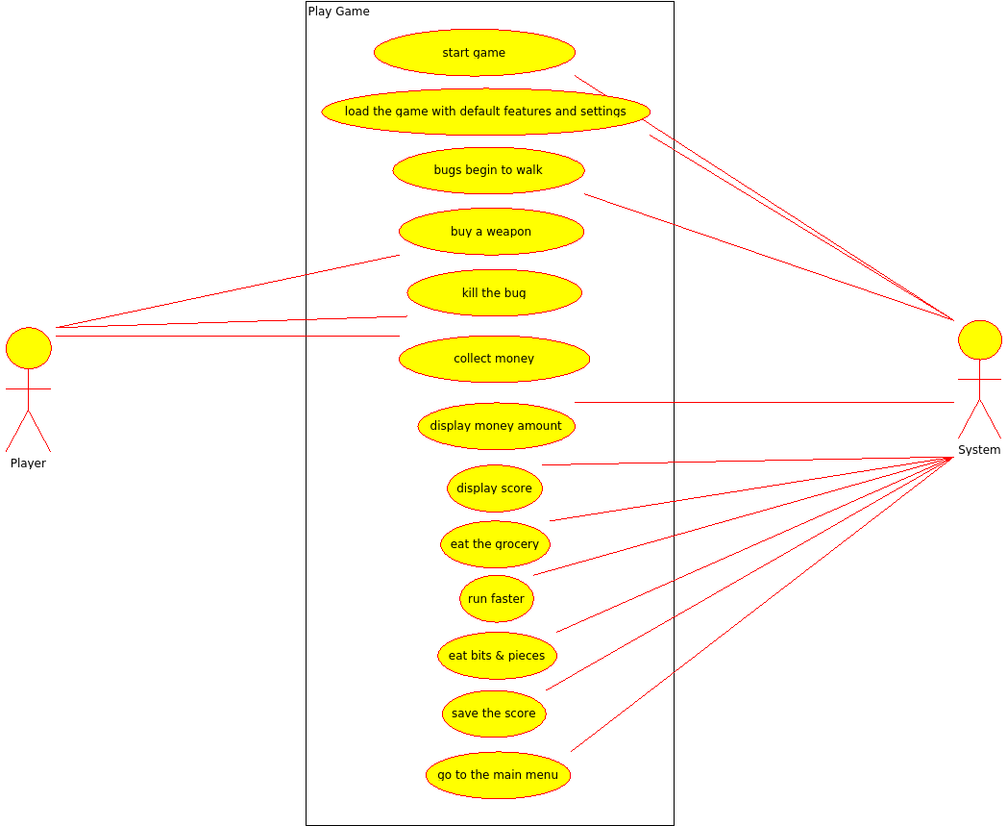
(figure 1)
- Use case #2
Use case name: Settings
Participating actors: Player
Entry condition: Player clicks the settings button in the main menu
Exit condition: After some changes and player can click on the apply button, player clicks on the back button and returns to the main menu
Main Flow of Events:
1. Player enters to the settings.
2. The system displays the settings screen.
3. Player can change music sound, game sound, and theme as s/he wants.
4. The system saves and applies these changes.
5. Player clicks on the back button to return to main menu.
Alternative Flow of Events:
- Player only looks at the screen and then returns to the main menu.
- Player only changes the theme, does not change the sound.
- Player only adjusts the sound, doesn’t change the theme.

- Use case #3
Use case name: High Scores
Participating actors: Player
Entry condition: Player clicks the HighScores button in the main menu
Exit condition: Player returns to main menu after s/he see the scores.
Main Flow of Events
1. Player enters to the High Scores.
2. The system shows the high scores on the screen.
3.After player sees the high scores, he returns to the main menu by clicking back button.

- Use case #4
Use case name: Credits
Participating actors: Player
Entry condition: Player clicks the Credits button in the main menu
Exit condition: Player returns to main menu after s/he sees credits information.
Main Flow of Events
1. Player enters to the Credits.
2. The system shows the information about programmers and other game features on the screen.
3.After player sees the credits, s/he returns to the main menu by clicking back button.

- Use case #5
Use case name: Tutorial
Participating actors: Player
Entry condition: Player clicks the Help button in the main menu.
Exit condition: Player returns to main menu after s/he read how-to-play information.
Main Flow of Events
1. Player enters to the Help.
2. The system shows the game rules.
3. Player learns how to play step by step.
4. The system shows icons, screenshots and rules from the game.
5. After player learns the game, s/he returns the main menu by clicking the back button.

- Use case #6
Use case name: Use Super Weapons
Participating actors: Player, System
Entry condition: Player clicks buy button which is under the related super weapon’s image
Exit condition: Player clicks one of available tiles to place super gun into the area.
Main Flow of Events
1. Player selects the grenade and buys it.
2. Player selects the available tile for the weapon
3. Grenade exploits and destroys the bugs which are in the range of explosion and disappears
Alternative Flow of Events
1. Player selects the laser gun and buys it.
2. Player selects the available tile for the weapon
3. Laser gun does its job and destroys whole line of bugs and disappears

- Use case #7
Use case name: Buy Guns
Participating actors: Player
Entry condition: Player clicks buy button which is under the related regular weapon’s image
Exit condition: Player clicks one of available tiles to place super gun into the area.
Main Flow of Events
1. Player selects the weapon and buys it.
2. Player selects the available tile for the weapon
3. Weapon starts to fire to the bugs

- Use case #8
Use case name:Quit Game
Participating actors: Player
Entry condition: Player clicks the Quit button.
Exit condition: Player starts the game.
Main flow of events:
1.Player clicks the quit button in the main menu
2.The program closes itself.
3.After some time , player starts the game again.
Alternative flow of event
-Player can quit the game when s/he is in the pause screen

- Use case #9
Use case name:Bits & Pieces
Participating actors: Player, System
Entry condition: Bits & pieces pops out on the game field.
Exit condition:Bug that ate these bits & pieces lost his temporally gained speed.
Main flow of events:
1.Bits & pieces pops out on the game field.
2.If the bug eats the bits & pieces , it will gain temporary speed
3.Bug loses its speed in certain amount of time.
Alternative flow of event
-Bits & pieces pops out on the game field.
-Bugs cant eat it in certain amount of time
-Bits & pieces disappears

- Use case #10
Use case name: Gain Bonuses
Participating actors: Player,System
Entry condition: Player is playing the game really well and kills the bugs abnormally faster.
Exit condition: Player returns to the normal flow of the game.
Main Flow of Events
1. Player kills bugs faster than the normal flow of the game.
2. System gives the extra coins.

- Use case #11
Use case name:Pause
Participating actors: Player, System
Entry condition: Player pauses the game in the game screen.
Exit condition:Player continues the game in the paused screen or exits the game or goes back to main menu.
Main flow of events:
1. Player clicks pause button in the game screen.
2. System pauses the game.
3. Pause screen pops out.
4. Player continues the game whenever he wants.
Alternative flow of event
1. Player clicks pause button in the game screen.
2. System pauses the game.
3. Pause screen pops out.
4. Player quits the game.
or
1. Player clicks pause button in the game screen.
2. System pauses the game.
3. Pause screen pops out.
4. Player goes back to main menu.

- Use case #12
Use case name: Grocery Infected
Participating actors: System
Entry condition: one of the bug reaches to one the groceries.
Exit condition: The game ends.
Main Flow of Events
1. Bug eats the grocery
2. The game ends and the system directs the player to the main menu.

- Use case #13
Use case name: Continue
Participating actors: Player, System
Entry condition: Player continues the game in the pause screen.
Exit condition: Player pauses the game in the game screen or game is over.
Main flow of events:
1. Player clicks continue button in the pause
2. System continues the game.
3. Player clicks pause game whenever he wants
or
1. Player clicks continue button in the pause
2. System continues the game.
3. Game is over

- Use case #14
Use case name: Collect Coins
Participating actors: Player, System
Entry condition: Coins are present in one of the tiles.
Exit condition: Player collect the coins from the tiles OR
The coins disappear from the tiles.
Main flow of events:
1.A coin appears on one of the tiles.
2.The player collects the coin present.
3.The money account is increased with the value of the coin collected.
4.Player continues playing the game.
Alternative flow of events:
1.A coin appears on one of the tiles.
2.A certain amount of time passes and the coin disappears.
3.Player continues playing the game.

References
- Object-Oriented Software Engineering, Using UML, Patterns, and Java, 2nd Edition, by Bernd Bruegge and Allen H. Dutoit, Prentice-Hall, 2004, ISBN: 0-13-047110-0.

Popcap.com, "PopCap Games - Home of the World's Best Free Online Games", 2016. [Online]. Available: http://www.popcap.com/plants-vs-zombies. [Accessed: 19- Feb- 2016].

