RENTO – AN AI-POWERED CAR RENTAL PLATFORM WITH SMART DYNAMIC PRICING AND VEHICLE RECOMMENDATION

ANISHA GHATAN
(LCID: LC00017002320)

FINAL YEAR PROJECT REPORT SUBMITTED IN PARTIAL FULFILMENT FOR THE DEGREE OF BACHELOR OF INFORMATION TECHNOLOGY (HONOURS)

FACULTY OF COMPUTER SCIENCE IN MULTIMEDIA
LINCOLN UNIVERSITY COLLEGE
MALAYSIA

[INSERT MONTH, YEAR OF SUBMISSION]

RENTO – AN AI-POWERED CAR RENTAL PLATFORM WITH SMART DYNAMIC PRICING AND VEHICLE RECOMMENDATION

ANISHA GHATAN
(LCID: LC00017002320)

FINAL YEAR PROJECT REPORT SUBMITTED IN PARTIAL FULFILMENT FOR THE DEGREE OF BACHELOR OF INFORMATION TECHNOLOGY (HONOURS)

FACULTY OF COMPUTER SCIENCE IN MULTIMEDIA
LINCOLN UNIVERSITY COLLEGE
MALAYSIA

[INSERT MONTH, YEAR OF SUBMISSION]

RECOMMENDATION
[To be received from Resource Center]

CERTIFICATION
This is to certify that the Final Year Project report entitled “Rento – An AI-Powered Car Rental Platform with Smart Dynamic Pricing and Vehicle Recommendation” submitted by Anisha Ghatan (LCID: LC00017002320) has been examined and is recommended for acceptance in partial fulfilment of the requirements for the degree of Bachelor of Information Technology (Honours), Faculty of Computer Science in Multimedia, Lincoln University College, Malaysia.

............................................................
Mr. Rohit Pandey
Internal Supervisor
Date: ..............................

............................................................
Prof. Dr. Govinda Prasad Acharya
Chairperson, RDSC
Date: ..............................

............................................................
Dr. Suman Thapaliya
Director / Department Head
Date: ..............................

............................................................
Ms. Sarala Karki
Research Learning & Development
Date: ..............................

DECLARATION OF AUTHENTICITY
I, Anisha Ghatan (LCID: LC00017002320), hereby declare that this Final Year Project report entitled “Rento – An AI-Powered Car Rental Platform with Smart Dynamic Pricing and Vehicle Recommendation” is the result of my own project work, carried out under the supervision of Mr. Rohit Pandey, except where otherwise stated and acknowledged. All sources of information used in this report have been cited and are listed in the References.
The system was developed from an open-source PHP car-rental template (“Car Rental Portal”). The template is identified and cited in Chapter 3, which also sets out which parts of the system were rebuilt or newly added during this project.
I declare that an artificial-intelligence assistant, Claude (Anthropic), was used during this project as a coding and documentation assistant. It helped to write and refactor source code, automated tests and diagrams, and to draft and edit parts of this report. I directed the work, set the requirements and design decisions, reviewed, tested and verified all outputs, and I take full responsibility for the system and for the content of this report. Every commit produced with this assistance is marked as co-authored in the project's Git history. This use of AI tools is in line with the policy of Lincoln University College: [INSERT statement on the college's AI policy].
This report has not been submitted, in whole or in part, for any other degree or qualification at this or any other institution.

............................................................
Anisha Ghatan
LCID: LC00017002320
Date: ..............................

ACKNOWLEDGEMENTS
I would like to express my sincere gratitude to my internal supervisor, Mr. Rohit Pandey, for his guidance, patience and constructive feedback throughout this project. His advice on scope, methodology and evaluation shaped both the system and this report.
I am grateful to Dr. Suman Thapaliya, Head of Department, and to the Faculty of Computer Science in Multimedia at Lincoln University College for the knowledge, facilities and support provided during the Bachelor of Information Technology (Honours) programme.
I also acknowledge the open-source communities whose work made this project possible, including the authors of the original car-rental template, PHP, MySQL, Bootstrap, scikit-learn and PyTorch, and the use of the AI assistant Claude (Anthropic) as a coding and documentation aid, as described in the Declaration of Authenticity.
Finally, I thank my family and friends for their encouragement, understanding and support throughout my studies.
Anisha Ghatan

TABLE OF CONTENTS
RECOMMENDATION i
CERTIFICATION ii
DECLARATION OF AUTHENTICITY iii
ACKNOWLEDGEMENTS iv
TABLE OF CONTENTS v
LIST OF TABLES viii
LIST OF FIGURES ix
ABBREVIATIONS AND ACRONYMS x
EXECUTIVE SUMMARY xii
CHAPTER 1: INTRODUCTION 1
1.1 Background of the Study 1
1.2 Problem Statement 2
1.3 Objectives 3
1.3.1 General Objective 3
1.3.2 Specific Objectives 3
1.4 Scope of the Study 4
1.5 Significance of the Study 4
1.6 Limitations 5
1.7 Organization of the Report 6
CHAPTER 2: LITERATURE REVIEW 7
2.1 Introduction 7
2.2 Review of Related Works 7
2.2.1 Dynamic Pricing and Revenue Management 7
2.2.2 Demand Forecasting 9
2.2.3 Recommender Systems 11
2.2.4 Existing Rental Platforms 12
2.3 Theoretical Framework 15
2.3.1 Rule-Based Dynamic Pricing 16
2.3.2 Ensemble Learning Methods 17
2.3.3 Regression Evaluation Metrics 17
2.3.4 Content-Based Recommendation Scoring 18
2.4 Research Gap 19
2.5 Summary 20
CHAPTER 3: METHODOLOGY 21
3.1 Introduction 21
3.2 Development Methodology 21
3.2.1 Choice of Methodology 21
3.2.2 Starting Point of the Project 23
3.2.3 Use of Artificial-Intelligence Assistance 25
3.2.4 Version Control and Project Timeline 26
3.3 Data and Requirements Collection 27
3.4 Software Requirements Specification 28
3.4.1 Users of the System 28
3.4.2 Functional Requirements 29
3.4.3 Non-Functional Requirements 30
3.5 Tools and Technologies 31
3.6 Feasibility Study 32
3.6.1 Technical Feasibility 32
3.6.2 Operational Feasibility 33
3.6.3 Economic Feasibility 33
3.6.4 Schedule Feasibility 33
3.6.5 Legal and Ethical Feasibility 33
3.7 System Architecture 34
3.8 Summary 35
REFERENCES 37

LIST OF TABLES
Table 1.1 Scope of the project 4
Table 2.1 Summary of related works 13
Table 2.2 Feature comparison of existing platforms and Rento 15
Table 3.1 Development phases and their main outputs 23
Table 3.2 Comparison of the baseline template and the final system 24
Table 3.3 Project timeline 27
Table 3.4 Functional requirements 29
Table 3.5 Non-functional requirements 31
Table 3.6 Tools and technologies 32

LIST OF FIGURES
Figure 2.1 Conceptual framework of the study 16
Figure 3.1 Phased iterative development methodology 22
Figure 3.2 Gantt chart of the recorded development phases, generated from the Git commit history 27
Figure 3.3 System architecture of Rento 35

ABBREVIATIONS AND ACRONYMS
AI | Artificial Intelligence
API | Application Programming Interface
APA | American Psychological Association (citation style)
BIT | Bachelor of Information Technology
BS | Bikram Sambat (the official calendar of Nepal)
CRUD | Create, Read, Update, Delete
CSRF | Cross-Site Request Forgery
CSS | Cascading Style Sheets
CV | Cross-Validation
DB | Database
DFD | Data Flow Diagram
ERD | Entity Relationship Diagram
EV | Electric Vehicle
FK | Foreign Key
FR | Functional Requirement
FYP | Final Year Project
GB | Gradient Boosting
HTML | HyperText Markup Language
HTTP(S) | HyperText Transfer Protocol (Secure)
JS | JavaScript
JSON | JavaScript Object Notation
KPI | Key Performance Indicator
LR | Linear Regression
MAE | Mean Absolute Error
MAMP | macOS, Apache, MySQL, PHP (local server package)
ML | Machine Learning
MLP | Multilayer Perceptron
NFR | Non-Functional Requirement
NPR | Nepalese Rupee (shown as “Rs”)
OWASP | Open Worldwide Application Security Project
PDO | PHP Data Objects
PK | Primary Key
R² | Coefficient of determination
RF | Random Forest
RMSE | Root Mean Squared Error
SEO | Search Engine Optimisation
SMTP | Simple Mail Transfer Protocol
SQL | Structured Query Language
SRS | Software Requirements Specification
UI / UX | User Interface / User Experience
UML | Unified Modeling Language
URL | Uniform Resource Locator
WCAG | Web Content Accessibility Guidelines
XSS | Cross-Site Scripting

EXECUTIVE SUMMARY
Car rental businesses in Nepal usually quote one fixed daily price, even though demand rises sharply around Dashain, Tihar, weekends and last-minute trips, and most bookings are still arranged by phone or social media. Customers also find it hard to know which vehicle suits a trip to, for example, the mountain roads of Mustang. This project developed Rento, a web-based car rental platform for Nepal with explainable AI-based pricing and trip-based vehicle recommendation.
Rento was built with PHP 8.3, MySQL 8, Bootstrap 5.3 and Python 3.12, using a phased, iterative method on top of an open-source car-rental template that was almost entirely rebuilt. Its intelligent components are a rule-based smart pricer that combines seven demand factors with a −15% / +25% cap and a human-readable reason for every price; a 60-day price forecast recomputed nightly and after every relevant change; a content-based recommendation engine that scores cars against a natural-language trip description; and offline machine-learning experiments that prepare a learned pricer for the time when enough bookings exist.
Evaluation showed that all 480 forecast prices respected the caps and rounding rules, and that the recommendation engine reached a normalised precision@3 of 0.94 and a hit rate of 0.91 on twelve test trips. Among the models compared, a Random Forest explained 49% of daily demand variance on an external rental dataset and 98% of price variance on 1,640 scraped Nepali listings. Fifty-four PHPUnit and forty-six pytest tests passed, and page weight fell by up to 80% compared with the original template. Because Rento has only four real bookings, the live site uses the rule-based pricer; the learned models are ready to be switched on once about 200 bookings exist.

CHAPTER 1: INTRODUCTION

1.1 Background of the Study
Vehicle rental is a practical necessity in Nepal. Much of the country is reached only by road, public transport between cities is limited, and domestic travel peaks sharply around the national festivals of Dashain and Tihar, when large numbers of people travel from Kathmandu to their home districts. Visitors, families and businesses therefore rely on hired cars, jeeps and vans for trips to destinations such as Pokhara, Chitwan, Lumbini and Mustang, as well as for airport transfers and daily use within the Kathmandu valley.
A market survey carried out for this project in September 2026 (documented in the project repository) shows how the local rental market currently operates. The largest online marketplace, Sajilo Rental, lists more than a thousand vehicles, almost all rented with a driver, at prices that are nearly flat by vehicle category: about Rs 8,000 per day for hatchbacks, sedans and the Mahindra Scorpio, and about Rs 10,000 for vans (Sajilo Rental, n.d.). Only one operator surveyed, Self Drive Nepal, published a self-drive rate card, with rates of about Rs 5,000 per day for hatchbacks and sedans and Rs 7,000 to Rs 10,000 for sport utility vehicles (Self Drive Nepal, 2025). Most other operators handle bookings through enquiry forms, telephone calls and messaging applications such as WhatsApp and Viber, and few publish fixed prices for tours or packages. Where seasonal surcharges exist, they are usually stated informally; one operator, for example, notes that prices rise by 10–15% in the October–November peak season (Nepal Vehicle Hiring, 2026).
In other industries with fixed capacity and perishable inventory, such as airlines, hotels and international car rental, prices have long been set dynamically according to expected demand. This practice, known as revenue management or yield management, aims to sell the right capacity to the right customer at the right price (Weatherford & Bodily, 1992; Talluri & van Ryzin, 2004). Car rental companies were among its early adopters: National Car Rental reported substantial revenue gains after introducing a demand-based pricing and fleet system (Geraghty & Johnson, 1997), and Hertz applied similar techniques to rental rates and fleet allocation (Carroll & Grimes, 1995). More recently, online platforms have combined such pricing with machine-learning models of demand, as in the pricing tips offered to Airbnb hosts (Ye et al., 2018).
A second development is the use of recommender systems to help customers choose among many options. Recommender systems filter a catalogue according to a user's stated needs or past behaviour and present the most suitable items with an explanation (Ricci et al., 2015). For car rental, the relevant needs are practical: the number of travellers, the budget, the type of road and the purpose of the trip. A customer planning a family trip to Pokhara, for instance, needs a comfortable car with at least five seats, whereas a trip on the rough mountain roads of Mustang calls for a rugged four-wheel-drive vehicle.
This project, Rento, brings these ideas to the Nepali rental context. Rento is a web-based car rental platform for self-drive cars, cars with a driver and tour packages, with all prices in Nepalese rupees. It sets a price for every car on every day from explainable demand rules, shows customers why a price is higher or lower, and recommends vehicles for a trip described in plain language. The system was developed from an existing open-source PHP car-rental template, which was rebuilt almost entirely during the project; Chapter 3 describes this starting point and the work carried out.

1.2 Problem Statement
Car rental businesses in Nepal usually charge a fixed daily price that does not reflect changes in demand. The same car costs the same during Dashain and Tihar, on weekends and for last-minute bookings as on a quiet weekday, even though demand in these periods is much higher. Businesses either lose revenue at peak times or apply informal surcharges that customers cannot anticipate. Customers, in turn, find prices unclear, because the published price often excludes fuel, driver costs and peak-season charges that are only explained over the phone.
Customers also find it difficult to choose the right vehicle for their trip. Rental websites typically offer a list of cars with basic filters, but they do not help a customer decide whether a compact car is suitable for a family of five, or whether a particular sport utility vehicle can handle the road to Mustang. The choice is left to the customer or to a telephone conversation with the operator.
Finally, bookings are largely handled manually over telephone and social media. This makes availability uncertain, prevents customers from seeing and comparing prices in advance, and leaves no reliable record of the price that was agreed.
The problem addressed by this project is therefore the lack of an online rental platform for Nepal that sets demand-aware prices transparently, recommends suitable vehicles for a given trip, and records bookings at a price calculated and stored by the system. Rento addresses this with an online booking platform that combines explainable, AI-based pricing with trip-based vehicle recommendation.

1.3 Objectives

1.3.1 General Objective
The general objective of this project is to design, develop and evaluate a secure web-based car rental platform for Nepal that prices vehicles dynamically according to expected demand, explains every price to the customer, and recommends suitable vehicles for a trip.

1.3.2 Specific Objectives
The specific objectives are:
- To develop a responsive web application for customers and administrators with a PHP backend, a MySQL database and a JSON application programming interface (API), covering vehicle listing, booking, invoices, packages and administration.
- To design and implement a smart pricing engine that adjusts each car's daily price for weekends, festivals and festival travel days, travel seasons, booking lead time, occupancy and recent demand, within configurable limits, and that gives a human-readable reason for every adjustment.
- To build a forecast pipeline that computes and stores the price of every active car for the next 60 days, recomputed automatically every night and after every relevant change.
- To implement a recommendation engine that interprets a natural-language trip description and ranks the available cars with a match score and reasons.
- To train and evaluate machine-learning models for demand and price prediction, and to compare them with baselines using standard regression metrics, in preparation for a learned pricer.
- To apply recognised web security practices, including password hashing, protection against cross-site request forgery (CSRF) and injection, rate limiting and server-side price calculation.
- To test the system through unit, integration and system tests, and to evaluate its performance, accessibility and responsiveness on desktop and mobile screens.

1.4 Scope of the Study
The scope of the study covers the features, users and environment summarised in Table 1.1.
Table 1.1 Scope of the project
Area | In scope | Out of scope
Users | Guests, registered customers and one or more administrators | Vehicle owners listing their own cars (marketplace model)
Services | Self-drive cars, cars rented only with a driver, and tour or transfer packages in Nepal | Other countries; buses and goods transport
Customer features | Search and filters, car page with a price calendar, trip-based recommendation, booking request, My Bookings and printable invoice, package enquiries, testimonials, FAQs, contact | Online payment, mobile application, live chat assistant
Administration | Bookings, vehicles, brands, packages and enquiries, festivals, smart-pricing settings, AI Insights, content, email and system checks | Accounting, payroll and fleet maintenance
Intelligence | Rule-based dynamic pricing, 60-day forecast, content-based recommendation, offline evaluation of machine-learning models | A learned pricer in live use (planned once enough bookings exist)
Prices and data | Nepalese rupees; festival calendar for BS 2083 and provisional BS 2084 | Currency conversion; automatic import of official holiday lists
Deployment | Local server (MAMP: Apache, MySQL and PHP on macOS) with a deployment guide for real hosting | Public cloud deployment

1.5 Significance of the Study
For customers, Rento makes rental prices transparent. The price of every day is shown in advance with its reasons, such as a weekend or a Dashain travel day, and the total quoted when a booking is requested is stored and appears unchanged on the invoice. The recommendation feature helps customers choose a suitable vehicle without needing detailed knowledge of the fleet.
For rental businesses, the system shows how demand-based pricing can be introduced in a controlled and explainable way. Prices follow the festival calendar and booking patterns automatically, but the adjustments are limited by a configurable maximum discount and surcharge, and the administrator can review suggestions, apply them or set manual prices. Online booking requests with stored prices reduce the manual work of telephone bookings and the risk of disputes over the agreed price.
Academically, the project applies revenue-management and recommender-system concepts to a small business in a developing market, where historical booking data is scarce. It demonstrates a practical approach to this "cold start": a transparent rule-based pricer is used from the first day, while machine-learning models are trained and evaluated on external data so that they can replace or complement the rules once enough bookings exist.

1.6 Limitations
The study has the following limitations:
- Limited booking data. The system holds only four real bookings, two of them confirmed. The machine-learning models could not be trained on Rento's own data and were evaluated on external datasets; the occupancy and demand pricing factors remain switched off until 50 confirmed bookings exist, and the learned pricer until about 200.
- External datasets. The demand dataset is an external hourly rental dataset and not Nepali booking data, and the price dataset consists of publicly listed prices collected by scraping one marketplace. Results from these datasets indicate how the models behave but cannot be transferred directly to Rento.
- Market benchmarks. Only one published self-drive rate card was found, so the market price used for comparison is based on a single source.
- Festival calendar. Nepali festivals follow the lunar calendar and move every year. The dates must be checked each year; the BS 2084 dates in the system are provisional until the government publishes its official holiday list.
- Deployment. The system runs on a local server only. A deployment guide and an automated production check were prepared, but the system has not been deployed publicly.
- Features not implemented. There is no online payment gateway, mobile application or conversational AI assistant.
- Template origin and AI assistance. The system was built on an open-source template, and an AI coding assistant was used during development, as stated in the Declaration of Authenticity and in Chapter 3.

1.7 Organization of the Report
This report is organised into seven chapters. Chapter 1 has introduced the background, problem, objectives, scope, significance and limitations of the project. Chapter 2 reviews related work on dynamic pricing, demand forecasting, recommender systems and existing rental platforms, and identifies the research gap. Chapter 3 describes the development methodology, the software requirements specification, the tools and technologies, the feasibility study and the system architecture. Chapter 4 presents the system design through use case, data flow, entity relationship, class, sequence and activity diagrams, together with the user interface design. Chapter 5 explains the implementation of the modules, the application programming interface, the database and the algorithms, including the pricing engine, the forecast pipeline, the machine-learning experiments and the recommendation engine. Chapter 6 reports the test plan, test cases and results of unit, integration and system testing, and the performance evaluation. Chapter 7 summarises the work, draws conclusions and suggests future enhancements. The references and appendices follow.

CHAPTER 2: LITERATURE REVIEW

2.1 Introduction
This chapter reviews the literature and existing systems that inform the design of Rento. The review is organised around the three intelligent functions of the system. The first is dynamic pricing, which is studied mainly under the heading of revenue management, together with research on how customers perceive the fairness of variable prices. The second is demand forecasting, which provides the evidence on which demand-based prices can be set and which motivates the machine-learning experiments of this project. The third is recommender systems, which help customers choose a suitable item from a catalogue. The chapter then examines the rental platforms currently operating in Nepal, using the market survey carried out for this project, and compares them with Rento.
Section 2.2 reviews related works in each of these areas and summarises them in Table 2.1 and Table 2.2. Section 2.3 presents the theoretical framework of the study: the rule-based pricing model, the ensemble learning methods and error metrics used in the experiments, and the weighted scoring model and precision measures used for recommendation. Section 2.4 identifies the research gap that Rento addresses, and Section 2.5 summarises the chapter.

2.2 Review of Related Works

2.2.1 Dynamic Pricing and Revenue Management
Revenue management, also called yield management, is the practice of controlling the price and availability of a fixed, perishable capacity in order to maximise revenue. Kimes (1989) identified the conditions under which it is most useful: capacity is relatively fixed, inventory perishes if it is not sold by a given date, demand fluctuates and can be forecast, customers can be segmented, and the marginal cost of a sale is low compared with the cost of adding capacity. A rental car meets all of these conditions. A day on which a car stands idle cannot be sold later, the size of the fleet cannot be changed quickly, and demand rises and falls with weekends, holidays and seasons.
Weatherford and Bodily (1992) proposed a taxonomy of what they called perishable-asset revenue management, which brings together overbooking, capacity allocation and pricing, and noted that the same principles apply to airlines, hotels and car rental. Talluri and van Ryzin (2004) later provided a comprehensive treatment of the theory and practice of the field. They distinguish quantity-based revenue management, in which the firm decides how much capacity to offer at each fixed price, from price-based revenue management, in which the price itself is changed over time in response to demand. Rento follows the second approach, because it changes the daily price of each car rather than the number of cars offered.
The theoretical basis of price-based revenue management was established by Gallego and van Ryzin (1994), who showed how the optimal price of a limited inventory depends on the remaining stock and the time left to sell it when demand is stochastic. Their model shows why prices should normally rise as the remaining capacity shrinks close to the sale date, and why a small number of fixed price levels can perform nearly as well as a continuously changing price. Den Boer (2015) reviewed the later literature on dynamic pricing and learning, in which the seller does not know the demand function in advance and must learn it from observed sales while setting prices. This problem is directly relevant to a new platform such as Rento, which has almost no sales history from which to estimate demand.
Car rental has a long history in this field. Carroll and Grimes (1995) described how Hertz developed its rate and fleet management over several decades, from simple rules towards systems that forecast demand and plan fleet movement between locations. Geraghty and Johnson (1997) reported that the revenue management system introduced at National Car Rental, which combined demand forecasting, pricing and capacity control, made a significant contribution to the company's recovery in the 1990s. Oliveira, Carravilla and Oliveira (2017) reviewed the literature on fleet and revenue management in car rental. They noted that car rental differs from airline and hotel revenue management because rental durations vary, cars can be moved between locations and the fleet can be adjusted over the medium term, and they proposed an integrated framework that links pricing with fleet decisions. These studies show that demand-based pricing is established practice among large car rental companies, but they concern firms with extensive booking histories and dedicated analytics teams, which a small Nepali operator does not have.
Online marketplaces have more recently applied machine learning to pricing. Ye et al. (2018) described the model used by Airbnb to suggest nightly prices to its hosts. The model estimates the probability that a listing will be booked on each night at different prices and combines this with a customised regression that suggests a price for every future date. The approach depends on a very large volume of booking data, and the suggested price is shown to the host, who can accept or override it. Rento adopts a similar division of responsibility: the system suggests and explains prices, while the administrator can apply or override them.
Dynamic pricing also raises questions of fairness. Kahneman, Knetsch and Thaler (1986) found that customers regard price increases as unfair when they appear to exploit a rise in demand rather than to reflect a rise in cost. Xia, Monroe and Cox (2004) developed a framework in which perceived fairness depends on comparisons with past prices, with prices paid by other customers and with prices charged by competitors, and on whether the reasons for a price difference are understood. Haws and Bearden (2006) showed experimentally that customers judge price differences between buyers more harshly than differences over time, and that satisfaction falls when a customer learns that another customer paid less. These findings suggest that variable prices are better accepted when they are limited, predictable and explained. Rento therefore caps every adjustment, shows the price of each future day in advance and gives a plain reason, such as a weekend or a Dashain travel day, for every change.

2.2.2 Demand Forecasting
Pricing according to demand requires an estimate of future demand. Hyndman and Athanasopoulos (2021) present the main forecasting methods for time series, from simple benchmarks to exponential smoothing and regression models. They stress that every forecasting method should be compared with simple benchmarks. One such benchmark is the seasonal naïve method, which predicts that a value will equal the value observed at the same point of the previous season, for example the same hour one week earlier. A model that cannot outperform such a benchmark adds little value. The experiments in this project follow this advice by comparing every model with a seasonal or median baseline.
Tree-based ensemble methods are widely used for demand prediction from tabular data. Breiman (2001) introduced the random forest, which averages the predictions of many decision trees, each trained on a bootstrap sample of the data and a random subset of the features, and showed that it reduces the variance of single trees while remaining robust to noise. Friedman (2001) developed gradient boosting, which builds an additive model by fitting each new tree to the errors of the model built so far. Chen and Guestrin (2016) described XGBoost, a scalable implementation of gradient boosting that became popular in data science competitions. Grinsztajn, Oyallon and Varoquaux (2022) compared tree-based models with deep neural networks on a range of tabular datasets and found that tree-based models still performed better on typical medium-sized tabular data, partly because they are less sensitive to uninformative features. This supports the choice of random forest and gradient boosting as the main candidates for Rento's learned pricer.
Makridakis, Spiliotis and Assimakopoulos (2018) compared statistical and machine-learning forecasting methods on a large set of monthly time series and found that the machine-learning methods were often less accurate than simple statistical methods, while also being more costly to compute. They argued that machine-learning methods should be evaluated carefully against statistical benchmarks before being adopted. Their findings are consistent with the experience of this project, in which the more complex models gained only modestly over the seasonal baseline on hourly demand, as reported in Chapter 5.
The choice of evaluation method also matters. Bergmeir and Benítez (2012) studied cross-validation for time series and noted that standard random cross-validation can give optimistic results when observations are dependent in time, whereas a blocked or time-ordered split preserves the order of the data. The experiments in this project therefore use a chronological train and test split for the demand data. For error measurement, Hyndman and Koehler (2006) reviewed the common measures of forecast accuracy and discussed their weaknesses, including the instability of percentage errors when actual values are close to zero. Willmott and Matsuura (2005) argued that the mean absolute error is a more natural measure of average error than the root mean squared error, whereas Chai and Draxler (2014) argued that the root mean squared error is more appropriate when errors are expected to follow a normal distribution and large errors should be penalised more heavily. Because the two measures answer different questions, this project reports both, together with the coefficient of determination.

2.2.3 Recommender Systems
Recommender systems suggest items that are likely to be useful to a particular user. Ricci, Rokach and Shapira (2015) describe the main families of recommender systems: collaborative filtering, which recommends items that similar users have liked; content-based filtering, which recommends items whose attributes match the user's preferences; knowledge-based systems, which reason explicitly about how item attributes meet the user's stated requirements; and hybrid systems that combine these approaches. Burke (2002) surveyed hybrid recommender systems and noted that knowledge-based methods are especially suitable when items are purchased rarely and each purchase depends on specific requirements, as in the choice of a car or a house, because there is little rating history to learn from.
Collaborative filtering has been very successful where large amounts of interaction data are available. Koren, Bell and Volinsky (2009) showed how matrix factorisation models, which represent users and items by latent factors learned from ratings, achieved leading accuracy in the Netflix Prize competition. However, collaborative methods suffer from the cold-start problem: they cannot recommend well for new users or new items that have no ratings. Schein, Popescul, Ungar and Pennock (2002) examined this problem and showed that methods which use item content perform better when interaction data are missing. A small rental platform with a fleet of eight active cars and a handful of bookings is an extreme cold-start case, so a collaborative approach is not feasible for Rento.
Content-based methods avoid this limitation by matching item attributes with the user's profile. Lops, de Gemmis and Semeraro (2011) reviewed the state of the art in content-based recommendation and identified its advantages: it does not depend on other users, it can recommend new items immediately and its recommendations can be explained by pointing to the matching attributes. Its main weakness is that its quality depends on how well the attributes describe the items. In Rento, the relevant attributes of a car, such as its type, seats, fuel, price and suitability for rough roads, are recorded in the database, and the customer's requirements are taken from a plain-language description of the trip. The approach therefore combines content-based matching with knowledge-based rules about which vehicle types suit city, highway and mountain roads.
Explanation is an important quality of a recommender system. Tintarev and Masthoff (2015) identified the purposes that explanations serve, including transparency, trust, persuasiveness and helping users to make good decisions, and noted that an explanation should reflect the real reasoning of the system. Rento shows a match percentage and a list of reasons, such as "7 seats for your 6 travellers" or "Rugged, off-road capable: built for mountain and rough roads", derived directly from the criteria that contributed to the score.
For evaluation, Herlocker, Konstan, Terveen and Riedl (2004) reviewed the measures used for recommender systems and distinguished accuracy of predicted ratings from the quality of the ranked list shown to users. For a system that shows a short list of items, measures such as precision among the top-ranked items are appropriate, because the user will usually consider only the first few suggestions. Rento's recommendation engine is evaluated in this way in Chapter 6, using precision at three and the rate at which the first suggestion is relevant.

2.2.4 Existing Rental Platforms
A market survey of Nepali car rental websites was carried out for this project on 27 September 2026. Its findings are recorded in the project repository and summarised here.
Sajilo Rental is the largest online marketplace found. It lists vehicles from many owners, all of which are rented with a driver, and offers instant booking with online payment through eSewa, Khalti and cards (Sajilo Rental, n.d.). Its daily prices are nearly flat within each vehicle category, at about Rs 8,000 for hatchbacks, sedans and the Mahindra Scorpio and about Rs 10,000 for vans, and the customer pays for fuel separately. No change of price with the date, the season or demand was observed.
Self Drive Nepal was the only operator found that published a self-drive rate card (Self Drive Nepal, 2025). Its prices vary by vehicle category and by whether the car stays inside the Kathmandu valley, ranging from about Rs 5,000 per day for hatchbacks and sedans to Rs 10,000 for automatic, luxury and electric sport utility vehicles, with fuel, tolls and parking excluded and a large security deposit required.
Rent in Nepal offers electric cars and vans with a driver at fixed daily rates, with fixed prices for popular routes and a 25% surcharge for night travel (Rent In Nepal, n.d.). Nepal Vehicle Hiring publishes all-inclusive price ranges with a driver and states that prices rise by 10–15% in the October–November peak season (Nepal Vehicle Hiring, 2026). Kathmandu Car Services lists fares by destination, with surcharges for hill and mountain roads and discounts for long-term hire (Kathmandu Car Services, 2026). Most of these operators take bookings through enquiry forms, telephone and messaging applications such as WhatsApp and Viber, and few publish fixed prices for tours and packages.
Among global systems, the car rental companies Hertz and National Car Rental used demand-based pricing supported by forecasting systems (Carroll & Grimes, 1995; Geraghty & Johnson, 1997), and Airbnb suggests a price for each night to its hosts from a learned model (Ye et al., 2018). These systems price dynamically but do so with large volumes of data that a new Nepali platform does not have. Finally, the open-source "Car Rental Portal" template on which Rento was built provides vehicle listing, search, booking requests at a fixed price per day, testimonials and an administration panel [INSERT template citation]. It has no dynamic pricing, recommendation, invoice or package features.
Table 2.1 summarises the main related works reviewed in this section, and Table 2.2 compares the features of the surveyed platforms with those of Rento.
Table 2.1 Summary of related works
Work | Area | Approach | Main finding | Relevance to Rento
Kimes (1989) | Revenue management | Conceptual analysis | Yield management suits fixed, perishable capacity with variable, forecastable demand | Car rental meets these conditions
Gallego and van Ryzin (1994) | Dynamic pricing | Stochastic optimisation model | Optimal price depends on remaining stock and time; few price levels are nearly optimal | Justifies bounded, stepwise price changes
Geraghty and Johnson (1997) | Car rental | Industry case study | Forecasting and pricing system raised revenue at National Car Rental | Evidence that demand pricing works in car rental
Oliveira et al. (2017) | Car rental | Literature review and framework | Pricing and fleet decisions should be integrated | Positions Rento's pricing within car rental research
Ye et al. (2018) | Accommodation marketplace | Booking-probability and regression model | Learned daily price suggestions for hosts at scale | Suggest-and-override design; needs large data
Xia et al. (2004); Haws and Bearden (2006) | Price fairness | Framework; experiments | Unexplained or inconsistent prices are seen as unfair | Caps, advance calendar and reasons for each price
Breiman (2001); Friedman (2001) | Machine learning | Random forest; gradient boosting | Tree ensembles reduce error of single models | Models compared in the ML experiments
Grinsztajn et al. (2022) | Machine learning | Benchmark on tabular data | Tree models outperform deep networks on typical tabular data | Supports tree ensembles over the MLP
Makridakis et al. (2018) | Forecasting | Empirical comparison | ML methods often fail to beat statistical benchmarks | Every model is compared with a baseline
Schein et al. (2002) | Recommender systems | Cold-start methods | Content information helps when ratings are missing | Rento has almost no interaction data
Lops et al. (2011) | Recommender systems | Survey of content-based methods | Content-based systems are independent of other users and explainable | Basis of the recommendation engine
Tintarev and Masthoff (2015) | Recommender systems | Survey of explanations | Explanations build transparency and trust | Match percentage and reasons

Table 2.2 Feature comparison of existing platforms and Rento
Feature | Sajilo Rental | Self Drive Nepal | Rent in Nepal | Nepal Vehicle Hiring | Kathmandu Car Services | Base template | Rento
Online booking | Yes, instant | – | Enquiry form, phone, chat apps | Form, chat apps | Yes | Booking request | Booking request
Published daily prices | Yes | Yes | Partly | Price ranges | Price ranges | Yes | Yes, for each day
Self-drive | No | Yes | No | No | No | Not specified | Yes
With driver | Yes | Yes | Yes | Yes | Yes | No | Yes
Prices change with date or demand | Not observed | Not observed | Fixed night surcharge | Informal peak surcharge | Road surcharges, long-hire discount | No | Yes, seven rules, capped
Reason shown for each price | No | No | No | No | No | No | Yes
Suggests cars for a trip | No | No | No | No | No | No | Yes
Tour or transfer packages | Hourly and day hire | – | Yes | Yes | Yes | No | Yes, by enquiry
Online payment | Yes | – | – | No | – | No | No
Stored quote and invoice | – | – | – | – | – | No | Yes

Sources: market survey of 27 September 2026 (see Section 2.2.4 and Appendix [INSERT appendix letter]). A dash (–) means that the feature was not described on the pages reviewed; "chat apps" refers to WhatsApp or Viber; "Not observed" means that the published prices showed no such variation.

2.3 Theoretical Framework
The theoretical framework of the study, shown in Figure 2.1, links the theories reviewed above with the inputs, components and outcomes of Rento. Revenue management and price fairness inform the rule-based smart pricer and its 60-day forecast; demand forecasting informs the offline machine-learning models; and content- and knowledge-based recommendation informs the recommendation engine. The following subsections present the formal models used in each component.
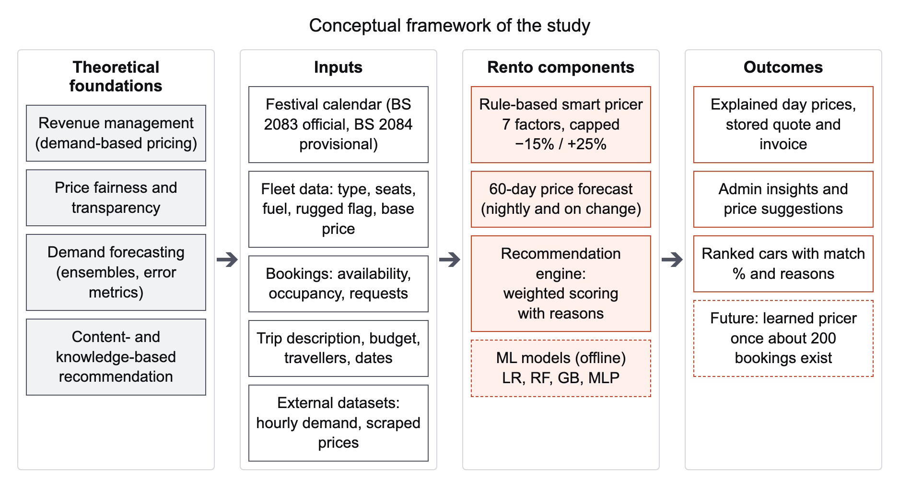
Figure 2.1 Conceptual framework of the study

2.3.1 Rule-Based Dynamic Pricing
A rule-based pricing model sets the price as a base price adjusted by a set of explicit factors, each triggered by a known condition. Unlike a learned model, it needs no historical sales data, and every adjustment can be stated to the customer, which addresses the fairness concerns discussed in Section 2.2.1. Its weakness is that the size of each adjustment is chosen by judgement rather than estimated from data.
In Rento, the price of a car on day d is calculated from its base daily price b and the percentages f of the factors that apply to that day, as shown in Equation 2.1.
 (2.1)
where A is the set of factors active on day d, δ⁻ and δ⁺ are the maximum discount and surcharge, and R rounds the result to the nearest multiple of s rupees. The factors are additive, so a Friday that is also a festival travel day receives the sum of both surcharges. Only the strongest festival factor applies on any day, and the last-minute and early-booking factors are mutually exclusive. With the settings used in this project, the caps are 15% and 25% and prices are rounded to Rs 50. The cap reflects the finding of Gallego and van Ryzin (1994) that a limited range of prices can capture most of the benefit of dynamic pricing, and it keeps the variation predictable for customers. The factors and their values are described in Chapter 5.

2.3.2 Ensemble Learning Methods
A regression model estimates a target value y, such as hourly demand or a daily rental price, from a vector of features x. The ensemble methods used in this project combine many decision trees.
Gradient boosting (Friedman, 2001) builds the model in M stages. It starts from a constant and, at each stage m, fits a regression tree to the negative gradient of the loss function L, called the pseudo-residual, as shown in Equation 2.2.
 (2.2)
The new tree is then added to the model with a learning rate ν between 0 and 1, which shrinks the contribution of each tree and reduces overfitting, as shown in Equation 2.3.
 (2.3)
For the squared-error loss, the pseudo-residual is simply the difference between the actual value and the current prediction, so each tree learns to correct the errors of the trees before it.
A random forest (Breiman, 2001) instead trains B trees independently, each on a bootstrap sample of the training data with a random subset of features considered at each split, and averages their predictions, as shown in Equation 2.4.
 (2.4)
Averaging many decorrelated trees reduces the variance of the prediction. Boosting mainly reduces bias, whereas a random forest mainly reduces variance; which works better depends on the size and noise of the dataset, so both are evaluated in this project.

2.3.3 Regression Evaluation Metrics
For a test set of n observations with actual values y and predictions ŷ, the mean absolute error (MAE) measures the average size of the errors in the units of the target, as shown in Equation 2.5.
 (2.5)
The root mean squared error (RMSE) squares the errors before averaging, so it gives more weight to large errors, as shown in Equation 2.6.
 (2.6)
The coefficient of determination (R²) compares the squared error of the model with that of a model that always predicts the mean of the actual values, as shown in Equation 2.7.
 (2.7)
An R² of 1 indicates perfect prediction and an R² of 0 indicates no improvement on the mean; a negative value means that the model is worse than predicting the mean. Lower MAE and RMSE and higher R² indicate a better model. Because error on a single split may depend on how the data happened to be divided, the experiments also use cross-validation, with folds that respect time order for demand data (Bergmeir & Benítez, 2012) and folds grouped by car model for price data, so that the models are tested on cars they have not seen.

2.3.4 Content-Based Recommendation Scoring
A content- and knowledge-based recommender can be expressed as a weighted scoring model. For a trip query q, a set of criteria K(q) applies, such as the number of seats, the budget, the type of road and the preferred fuel. Each criterion k has a weight w and gives a car c a partial score s between 0 and 1, which measures how well the car meets that criterion. The match score of the car is the share of the applicable weights that it earns, as shown in Equation 2.8.
 (2.8)
Because only criteria that apply to the trip are counted, a car scores 100% only when it fully meets every requirement the customer has expressed, and the score of a vague query is not diluted by criteria that the customer did not mention. The partial scores also provide the reasons shown to the customer, in line with the principle that an explanation should reflect the real reasoning of the system (Tintarev & Masthoff, 2015). The criteria and weights used by Rento are presented in Chapter 5.
The quality of the ranked list is measured by precision at k, the proportion of the top k recommended cars that belong to the set G of cars judged relevant for the trip (Herlocker et al., 2004). When fewer than k cars are relevant, even a perfect ranking cannot reach a precision of 1, so a normalised precision is also used, which divides by the smaller of k and the number of relevant cars, as shown in Equation 2.9.
 (2.9)
where R is the set of the top k cars returned. A related measure, the hit rate at one, records whether the first recommended car is relevant.

2.4 Research Gap
The review shows that demand-based pricing is well established in the international car rental, airline and hotel industries (Geraghty & Johnson, 1997; Talluri & van Ryzin, 2004) and that online platforms such as Airbnb use learned models to suggest prices (Ye et al., 2018). These approaches, however, rely on large amounts of booking data and dedicated systems. The research on dynamic pricing and learning (den Boer, 2015) and on cold-start recommendation (Schein et al., 2002) shows that a new platform with little data needs a different approach, but it gives little practical guidance on how a small operator in a developing market can introduce demand-based pricing from the first day.
In the Nepali rental market, the survey found no platform that changes prices systematically by date or demand. Prices are either flat by vehicle category or subject to informal surcharges, such as a peak-season increase stated only as a range, and none of the platforms reviewed explains the price of a particular day or recommends vehicles for a described trip. Festival demand around Dashain and Tihar, which drives much of the variation in rental demand in Nepal, is not reflected in any published price. Research on price fairness (Xia et al., 2004) suggests that variable prices would need to be transparent and bounded to be accepted in such a market.
The gap addressed by this project is therefore the absence of a rental platform for Nepal that combines transparent, bounded, day-by-day dynamic pricing based on the Nepali festival calendar and booking conditions with explainable, trip-based vehicle recommendation, and that is designed to operate without historical data while preparing for a learned pricer once data become available. Rento addresses this gap with a rule-based pricer that works from the first day, a content-based recommendation engine that needs no rating history, and offline machine-learning experiments that establish which models should replace the rules when enough bookings exist.

2.5 Summary
This chapter reviewed the literature on revenue management and dynamic pricing, price fairness, demand forecasting and recommender systems, together with the rental platforms operating in Nepal. Revenue management research establishes that car rental is well suited to demand-based pricing, and fairness research indicates that such prices should be bounded and explained. Forecasting research supports tree-based ensemble models for tabular demand data while warning that they must be compared with simple baselines and evaluated with time-aware methods. Recommender systems research shows that content- and knowledge-based methods are appropriate when interaction data are scarce, and that explanations increase transparency and trust. The survey of Nepali platforms found flat or informally adjusted prices, booking by enquiry, and no price explanation or trip-based recommendation.
The theoretical framework defined the capped, rule-based pricing model, the gradient boosting and random forest methods, the MAE, RMSE and R² metrics, and the weighted scoring model and precision measures used for recommendation. The research gap identified is the lack of a transparent, data-independent dynamic pricing and recommendation platform for the Nepali rental market. Chapter 3 describes the methodology used to develop Rento in response to this gap.

CHAPTER 3: METHODOLOGY

3.1 Introduction
This chapter describes how Rento was developed. Section 3.2 explains the development methodology, the starting point of the project, the use of an artificial-intelligence assistant and the project timeline recorded in the version control history. Section 3.3 describes the methods used to collect data and requirements. Section 3.4 presents the software requirements specification, Section 3.5 lists the tools and technologies used, and Section 3.6 reports the feasibility study. Section 3.7 describes the overall architecture of the system, and Section 3.8 summarises the chapter.

3.2 Development Methodology

3.2.1 Choice of Methodology
The project followed a phased, iterative and incremental development model. In incremental development, a system is built as a series of versions, each of which adds functionality to the previous one, and the specification, development and validation activities are interleaved rather than carried out once in strict sequence (Sommerville, 2016). Larman and Basili (2003) traced the long history of iterative and incremental development and noted that it reduces risk by producing working software early and by allowing requirements to be refined through feedback.
This model was chosen for three reasons. First, the project started from existing software rather than from a blank page, so the work consisted of a sequence of improvements to a system that had to keep working after each step. A linear waterfall model, in which all requirements are fixed before any design or coding, would have suited this situation poorly. Second, some requirements could only be settled after earlier work had been completed. For example, the prices used by the pricing engine depended on the market survey, and the festival pricing depended on the festival calendar research. Third, the intelligent components carried the greatest technical uncertainty, so they were built only after the platform had been secured and stabilised, which allowed them to be tested on a reliable base.
The work was divided into eight phases, shown in Figure 3.1 and summarised in Table 3.1. Each phase had a defined goal and followed the same cycle: the phase was planned and its scope agreed; the database was backed up and a working branch created; the changes were built and committed in small steps; automated and manual tests were run; and a phase report was reviewed by the student before the next phase began. Faults found in later phases were handled as follow-up fixes rather than by reopening earlier phases.
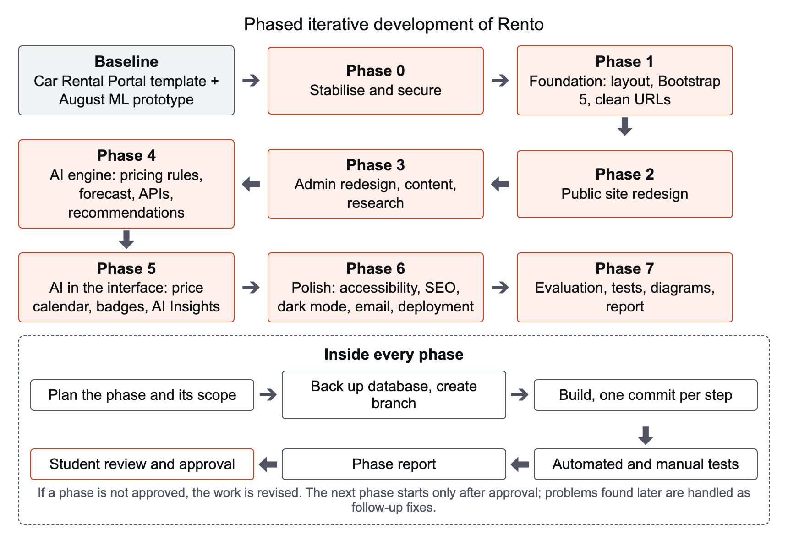
Figure 3.1 Phased iterative development methodology
Table 3.1 Development phases and their main outputs
Phase | Goal | Main outputs
0 Stabilise and secure | Make the inherited system safe and working | Password hashing, CSRF tokens, secure password reset, protected uploads, rate limiting, separate admin and customer sessions, bug fixes
1 Foundation | Prepare a maintainable code base | Shared layout files, Bootstrap 5.3 and Font Awesome 6, prices in rupees, removal of unused code and images, clean URLs
2 Public redesign | Rebuild the customer-facing site | New design system, home page, car listing with filters, car page, Find My Car, account area, WCAG AA contrast
3 Admin redesign and content | Rebuild administration and add content | New admin area, editable site content, active and inactive vehicles, market research data, festival calendar, packages and enquiries
4 AI engine | Build the intelligent back end | Rule-based pricer, 60-day forecast, JSON API, stored booking prices, rebuilt recommendation engine
5 AI in the interface | Show the intelligence to users | Price calendar, card prices and badges, invoice, AI Insights, price overrides, festival travel days
6 Polish | Prepare for real use | Rugged flag, accessibility, search engine optimisation, dark mode, email, legal drafts, deployment guide, production check
7 Evaluation and documentation | Measure and document the system | Machine-learning experiments, test suites, performance and page-weight measurements, diagrams, screenshots, this report

3.2.2 Starting Point of the Project
Rento was not developed from nothing. Its starting point, recorded as the first commit of the project repository ("baseline before refactor", commit 9250954), consisted of two parts.
The first part was an open-source PHP car rental template named "Car Rental Portal" [INSERT template citation]. The template provided a small car rental website with vehicle listing, brand search, booking requests at a fixed price per day, testimonials, contact and newsletter forms, a set of content pages and an administration panel for vehicles, brands, bookings and users. It used ten database tables, Bootstrap 3 and PHP pages that mixed database queries with HTML.
The second part was an earlier machine-learning prototype developed by the student in August 2026, before the repository was created. According to the file timestamps, the scraper and the scraped Sajilo Rental dataset date from 27 August 2026 and the price model files from 29 August 2026. The prototype comprised a web scraper for public vehicle listings, data preprocessing scripts, a PyTorch neural network for price prediction, a gradient boosting demand model, and PHP pages that attempted to use these models for dynamic pricing and car recommendation. At the start of Phase 0, the dynamic pricing integration always fell back to the base price because the model call failed, and the recommendation results page ended with a fatal error; both faults were corrected in Phase 0 before the components were later rebuilt.
The inherited code also had serious security weaknesses. Passwords were stored as MD5 hashes, which are unsuitable for password storage; no form was protected against cross-site request forgery; and the password reset form allowed anyone who knew an account's email address and mobile number to set a new password. These weaknesses correspond to categories of the OWASP Top 10, notably broken access control, cryptographic failures and identification and authentication failures (OWASP Foundation, 2021), and they were the reason why Phase 0 was dedicated to security.
Table 3.2 compares the baseline with the system at the end of the project. The comparison is based on the code at commit 9250954 and on measurements reported in Chapter 6. It shows that the template served as a starting structure, but that the security layer, the user interfaces, most of the database, and all of the pricing, forecasting, recommendation, testing and documentation work were rebuilt or newly added during the project.
Table 3.2 Comparison of the baseline template and the final system
Aspect | Baseline (template and prototype) | Rento at the end of the project
Front-end libraries | Bootstrap 3.3.7 (public site) and 3.3.6 (admin), Font Awesome 4.4.0, jQuery 1.10.2 | Bootstrap 5.3.8, Font Awesome 6.7.2, jQuery 3.7.1, own design tokens, dark mode
Currency | US dollar sign ($) | Nepalese rupees (Rs) throughout
Password storage | MD5 hash | PHP password_hash (bcrypt); old MD5 hashes are upgraded at the next login
Password reset | New password set by anyone who knows the email address and mobile number | Time-limited, single-use reset link, emailed to the account when email is configured
Form protection | No CSRF protection; admin actions by GET links | CSRF token on every POST form; admin actions by POST only
Login protection | No rate limiting; one shared session | Rate-limited login and reset; separate admin and customer sessions
URLs | File names with .php | Clean URLs and readable car URLs; old URLs redirected
Pricing | Fixed price per day; prototype model not working | Seven-factor rule-based pricer, 60-day forecast, price calendar, stored quote and invoice
Recommendation | Prototype page with a fatal error that also overwrote vehicle data | Read-only weighted scoring engine with match percentage, reasons and cautions
Administration | Bootstrap 3 admin theme with basic lists | New admin area with dashboard, Smart Pricing, AI Insights, festivals, packages, content and system check
Database | 10 tables | 23 tables (13 added by 22 additive migrations)
PHP files (excluding libraries) | 56 | 122
Home page weight (desktop) | 40 requests, 4,090 KB | 23 requests, 831 KB
Automated tests | None | 54 PHPUnit tests and 46 pytest tests

3.2.3 Use of Artificial-Intelligence Assistance
An artificial-intelligence assistant, Claude (Anthropic), was used throughout the development and documentation of the project as a coding and documentation assistant. The assistant was used to inspect the inherited code, propose changes, write and refactor source code, database migrations, automated tests, evaluation scripts and diagrams, run tests and measurements on the local server, and draft and edit parts of this report.
The student directed this work. The student defined the goals and scope of every phase and set rules that the assistant had to follow, including that database changes must be additive only and preceded by a backup, that existing URLs, file names and form field names must be kept unless a change was explicitly approved, that each logical change must be committed separately, that no credential may be changed without the student's permission, and that no numbers, features or references may be invented in the documentation. At the end of each phase the assistant produced a report listing every changed file, the test results and the open issues, and the student reviewed and tested the result before approving the next phase. The student is responsible for the system and for the content of this report.
The use of the assistant is recorded openly in the version control history: every commit carries a "Co-Authored-By" line naming the assistant. The assistant also explains the pace of development shown in Section 3.2.4. This use of AI tools is in line with the policy of Lincoln University College: [INSERT statement on the college's AI policy].

3.2.4 Version Control and Project Timeline
The project was managed with Git. The main branch holds the released state of the project, a dev branch collects completed work, and each larger piece of work in Phase 7 was developed on its own feature branch (for example feature/tests, feature/diagrams and feature/report) and merged into dev when complete. All commits were made locally and pushed to the remote repository by the student. The history has not been rewritten or back-dated.
Table 3.3 lists the activities of the project with their dates, and Figure 3.2 shows the recorded development phases as a Gantt chart generated directly from the commit times. The Git history begins with the baseline commit on 26 September 2026 and, up to the completion of Chapter 2 of this report (commit 9151b7b), contains 102 commits excluding merge commits. The rebuild of the system recorded in the repository therefore took place over about 27 hours on 26 and 27 September 2026. This short period reflects the use of the AI assistant described in Section 3.2.3; it does not include the earlier prototype work, which was not under version control, or the time spent on planning and reviewing between commits. The bars in Figure 3.2 run from the first to the last commit of each phase and show when work was committed rather than the total effort spent.
Table 3.3 Project timeline
Activity | Dates | Evidence
Project proposal and supervisor approval | [INSERT dates] | [INSERT]
Machine-learning prototype: scraping, preprocessing, price and demand models | 27–29 August 2026 | File timestamps of the prototype files
Phase 0 and Phase 1 | 26 September 2026 | 34 commits, 20:24–22:24
Phase 2 to Phase 6 | 27 September 2026 | 59 commits, 07:43–20:59
Phase 7: evaluation, tests, diagrams and screenshots | 27 September 2026 | 6 commits, 21:18–22:32
Phase 7: writing of the report and slides | From 27 September 2026 to [INSERT submission date] | Commits on feature/report
Submission and presentation | [INSERT dates] | –

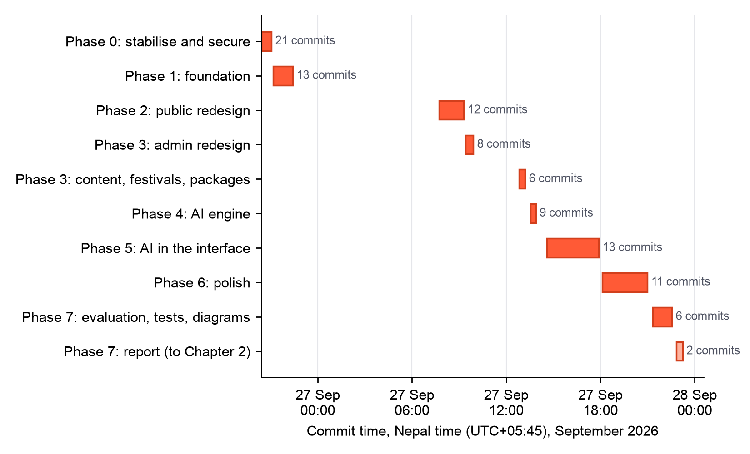
Figure 3.2 Gantt chart of the recorded development phases, generated from the Git commit history

3.3 Data and Requirements Collection
The requirements and data for the project were collected by the following methods.
- Analysis of the existing system. The inherited template and prototype were reviewed page by page and file by file to identify faults, security weaknesses and missing features. The findings formed the requirements of Phase 0 and Phase 1.
- Market survey of existing platforms. The websites of Nepali rental operators were reviewed on 27 September 2026 to record their services, prices, inclusions and booking methods, as summarised in Section 2.2.4. The survey was used to set the base prices of the active fleet at the published self-drive rates of Self Drive Nepal (2025), to choose the vehicles and packages offered, and to define the comparison benchmarks shown on the car pages.
- Festival calendar research. The dates of the main Nepali festivals and public holidays for BS 2083 were taken from the official list published by the Ministry of Home Affairs (Ministry of Home Affairs, n.d.) and cross-checked with at least one other calendar. Because the official list for BS 2084 had not yet been published, the BS 2084 dates were taken from independent calendars and marked as provisional. Forty festival entries were recorded in the database.
- Price dataset. For the price experiment, 1,640 public vehicle listings were collected from the Sajilo Rental website with the scraper developed in the August prototype. The scraper collected only vehicle attributes and listed prices, such as the vehicle model, type, fuel, year and daily price, and waited one second between requests. No personal data were collected.
- Demand dataset. Because Rento has almost no booking history, the demand models were trained on an external hourly rental demand dataset, [INSERT demand dataset name and URL] ([INSERT citation]). The dataset contains 18,247 hourly observations and is used only to compare forecasting methods; it is not Rento booking data.
- Literature and documentation. Published research, reviewed in Chapter 2, and the documentation of the technologies used informed the design of the pricing, forecasting and recommendation components.

3.4 Software Requirements Specification
The requirements were specified following the general structure recommended in IEEE Std 830-1998 (IEEE, 1998), which distinguishes functional requirements, describing what the system must do, from non-functional requirements, describing the qualities with which it must do it.

3.4.1 Users of the System
The system has three classes of users. Guests can browse the fleet, view prices, use Find My Car, read content pages and send enquiries. Registered customers can additionally request bookings, view their bookings and invoices, and post testimonials. Administrators manage the fleet, bookings, packages, festivals, pricing settings, content and system settings through a separate administration area with its own login.

3.4.2 Functional Requirements
The functional requirements of the system are listed in Table 3.4.
Table 3.4 Functional requirements
ID | Requirement | Description
FR1 | Accounts | Customers can register, log in, log out, update their profile and change their password, and reset a forgotten password through a time-limited link. Administrators have a separate login.
FR2 | Car search | Users can browse active cars and filter them by keyword, type, brand, fuel and maximum price, sort them and page through the results.
FR3 | Car page | Each car has a page with its images, specifications, description and a price calendar that shows the price of each of the next 60 days with its reasons.
FR4 | Price quote | For chosen dates, the system shows the total price, the price of each day, the reasons for each adjustment and whether the car is available.
FR5 | Booking request | Logged-in customers can request a booking for valid dates. The server calculates the price and stores it with the booking, together with the breakdown by day.
FR6 | My Bookings and invoice | Customers can see the status of their bookings and print an invoice that shows the stored price.
FR7 | Find My Car | Users can describe a trip in plain language, with optional dates, budget and number of travellers, and receive a ranked list of suitable cars with a match percentage, reasons and cautions.
FR8 | Packages and services | Users can view tour, transfer and other packages and send an enquiry; cars available only with a driver are booked through an enquiry.
FR9 | Content and contact | The site provides About, FAQs, Terms and Privacy pages, testimonials, a contact form and a newsletter subscription.
FR10 | Fleet and booking management | Administrators can add and edit vehicles and brands, set vehicles active or inactive, mark rugged and driver-only vehicles, manage images, and confirm or cancel bookings.
FR11 | Content management | Administrators can edit content pages, draft legal pages and change the text and images of the public site.
FR12 | Festival calendar | Administrators can add and edit festivals with their dates, demand level and travel days.
FR13 | Smart pricing settings | Administrators can set the percentage of each pricing factor, the maximum discount and surcharge and the rounding, recompute the forecast and view the health of the pricing model.
FR14 | AI Insights | Administrators can see price suggestions and a 60-day price chart for each car, apply suggestions and set manual price overrides.
FR15 | Price forecast | The system computes and stores the price of every active car for the next 60 days every night and after every relevant change.
FR16 | Application programming interface | The system provides JSON endpoints for price quotes, price calendars and recommendations.
FR17 | Notifications | When email is configured, the system sends password reset links and confirmations of bookings and enquiries.
FR18 | Dashboard and system check | Administrators see summary statistics and a check of the production settings.

3.4.3 Non-Functional Requirements
The non-functional requirements are listed in Table 3.5. They were grouped using the product quality characteristics of ISO/IEC 25010 (International Organization for Standardization, 2011), and the method used to verify each requirement is given; the results of the verification are reported in Chapter 6.
Table 3.5 Non-functional requirements
ID | Quality | Requirement | Verification
NFR1 | Security | Passwords are hashed with a modern algorithm; every state-changing form is protected against CSRF; all database queries use prepared statements; output is escaped; login and reset attempts are rate-limited; uploads cannot execute scripts; the application uses a least-privilege database user with secrets kept outside the repository. | Unit and HTTP security tests
NFR2 | Correctness of prices | Prices are always calculated on the server, stay within the configured caps, are rounded as configured, and the price stored with a booking is the price shown on the invoice. | Pricing checks and integration tests
NFR3 | Explainability | Every price adjustment and every recommendation is shown with a human-readable reason; the system never claims that a customer asked for something they did not ask for. | Recommendation scenarios
NFR4 | Performance | Pages and API calls respond quickly on the local server, and pages transfer less data than the original template. | Timing and page-weight measurements
NFR5 | Usability and accessibility | The interface meets WCAG 2 level AA colour contrast (World Wide Web Consortium, 2023), can be used with the keyboard, and respects the reduced-motion setting. | Automated accessibility checks and manual testing
NFR6 | Compatibility | The site works on desktop and mobile screens from 390 pixels wide, in light and dark mode. | Screenshots and manual testing
NFR7 | Reliability and data integrity | Database changes are additive and preceded by a backup; the forecast can be recomputed at any time; the site keeps showing base prices if the forecast is unavailable. | Migration review and tests
NFR8 | Maintainability | Shared layout and logic files, one commit per change, documentation for developers and administrators, and automated test suites. | Code review
NFR9 | Portability | The system runs on a standard Apache, PHP and MySQL stack, with configuration through environment variables and a deployment guide. | Production check
NFR10 | Privacy | Only the personal data needed for accounts and bookings are stored, and draft privacy and terms pages are prepared for review. | Review of the database and pages

3.5 Tools and Technologies
Table 3.6 lists the tools and technologies used in the project, with the versions installed in the development environment.
Table 3.6 Tools and technologies
Category | Tool and version | Purpose
Local server | MAMP with Apache 2.4.62, PHP 8.3.14, MySQL 8.0.40 | Web server, server-side language and database
Back end | PHP Data Objects (PDO), Composer 2.9.2, PHPMailer 6.12 | Database access with prepared statements, dependency management, email
Front end | HTML5, CSS3, JavaScript, Bootstrap 5.3.8, Font Awesome 6.7.2, jQuery 3.7.1 | User interface, layout and icons
Admin interface | DataTables 2.3.8, Chart.js 4.5.1, Quill 2.0.3 | Tables, charts and the content editor
Intelligence | Python 3.12.14, pandas 3.0.6, NumPy 2.5.3, scikit-learn 1.9.1 (Pedregosa et al., 2011), PyMySQL 1.2.3 | Pricing rules, forecast pipeline and machine-learning models
Development only | PyTorch 2.14.0, matplotlib 3.11.2, pytest 9.1.1, PHPUnit 12.5.36 | Neural network experiment, charts and automated tests
Documentation | Mermaid, headless Google Chrome 153, Node.js 25.2.1, python-docx 1.2.0, Microsoft Word 16.113 | Diagrams, screenshots, measurements and this report
Version control | Git 2.52.0, GitHub | Source control and remote repository ([INSERT GitHub link])
Development assistance | Claude (Anthropic); code editor [INSERT editor used] | Coding and documentation assistant, as described in Section 3.2.3
Hardware | Apple MacBook Air with M3 processor and 16 GB memory, macOS 26.5 | Development and testing machine

3.6 Feasibility Study

3.6.1 Technical Feasibility
The project was technically feasible with widely used, well-documented technologies. PHP and MySQL run on almost every shared hosting service, and the Python components need only a standard Python installation with a few libraries. The heaviest computation in normal operation, the 60-day forecast for every active car, is a rule-based calculation that completes quickly on an ordinary laptop, so no special hardware is required. The machine-learning experiments were run offline on the same machine. The main technical risk, the lack of booking data for training a learned pricer, was addressed by designing a rule-based pricer that works without data and by keeping the learned models switched off until enough bookings exist.

3.6.2 Operational Feasibility
The system is designed to be operated by a small business without technical staff. Administrators manage the fleet, festivals, prices and content through web forms, and the forecast is recomputed automatically every night and after every change. Every automatic price is explained and can be overridden, so the operator stays in control of prices. For customers, the booking process uses familiar web forms, and the prices and reasons are shown before a booking is requested. The main operational task that remains manual is checking the festival dates each year when the government publishes the official holiday list.

3.6.3 Economic Feasibility
All software used to build and run the system is free and open-source, including PHP, MySQL, Apache, Python and its libraries, Bootstrap and the other front-end libraries. The development used an existing laptop, so no hardware was purchased. Microsoft Word was used only to produce this report [INSERT licence, e.g. student licence]. Running the system publicly would require web hosting and a domain name, at a cost of [INSERT estimated annual hosting and domain cost]. Because the system can run on ordinary shared hosting, these costs are small compared with the potential benefit of online bookings and demand-based pricing for a rental business.

3.6.4 Schedule Feasibility
The project was completed within the time available for the final year project. The phased approach allowed a working system to exist at the end of every phase, so that the project could have been stopped at any point with a usable result. As explained in Section 3.2.4, the use of an AI assistant shortened the implementation considerably, which left time for evaluation, testing and documentation.

3.6.5 Legal and Ethical Feasibility
The system stores only the personal data needed for accounts and bookings: names, email addresses, telephone numbers, the optional profile fields inherited from the template (date of birth and address) and booking details. Draft Terms and Privacy pages were prepared with reference to the Individual Privacy Act, 2075 (2018) and the Consumer Protection Act, 2075 (2018) of Nepal, and they are kept as drafts until they are reviewed, because they must be checked by a qualified person before publication. The template on which the system is based is open-source and is credited in this report and in the project documentation. The price data used in the experiment were public listing prices collected at a slow rate, without personal data, and used only for research. Dynamic pricing raises questions of fairness, as discussed in Section 2.2.1; the system addresses them by capping every adjustment, showing prices in advance and explaining every change. The use of an AI assistant is disclosed in the Declaration of Authenticity, in Section 3.2.3 and in the commit history.

3.7 System Architecture
Rento follows a layered architecture, shown in Figure 3.3. The presentation layer consists of the public pages and the administration area, rendered in the browser with Bootstrap and a small amount of JavaScript for the price calendar, the trip search and the colour theme. The application layer runs on Apache and PHP: web server rules provide clean URLs and block access to internal folders, shared PHP modules implement security, pricing, price insights, recommendation, search engine optimisation and email, and a JSON application programming interface serves price quotes, price calendars and recommendations to the pages.
The intelligence layer is written in Python. The live pricer applies the pricing rules to every active car for the next 60 days and stores the results in the database. It is started by PHP after every relevant change and by the operating system scheduler every night. The machine-learning experiments run offline on external datasets and are not part of the live system. The data layer is a MySQL database with 23 tables, accessed by PHP through prepared statements and by Python through PyMySQL, using a database user with only the privileges the application needs.
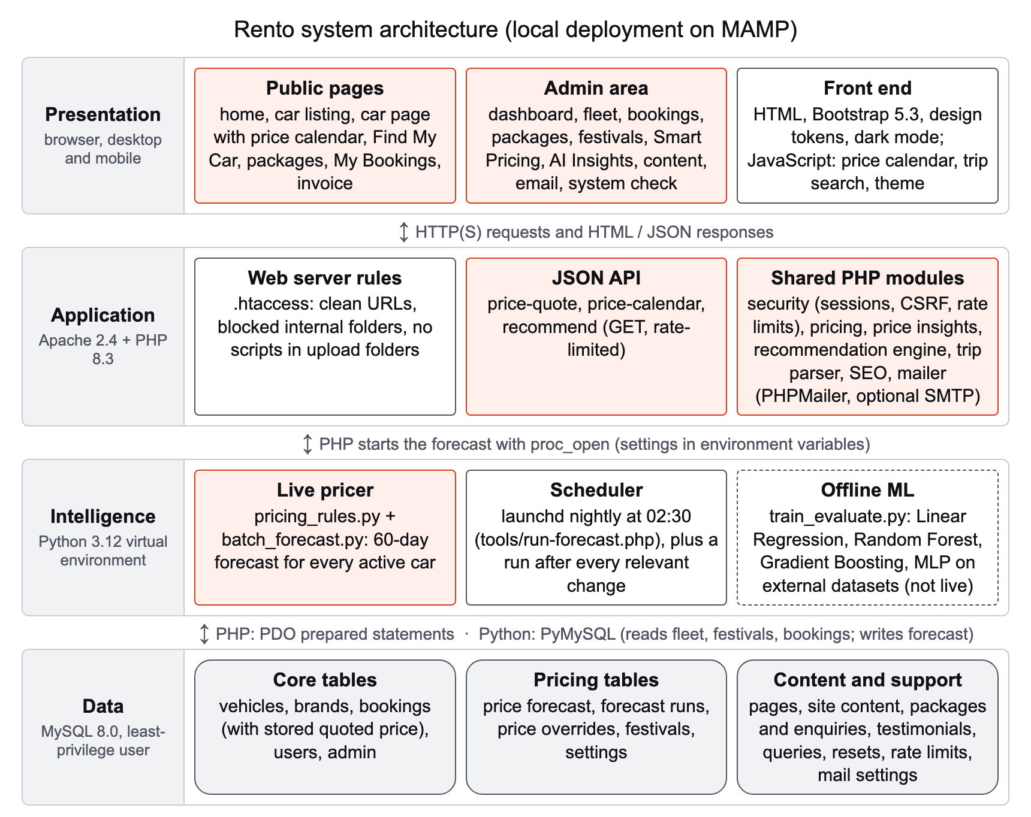
Figure 3.3 System architecture of Rento
This separation keeps the web pages fast, because they read prices that have already been calculated rather than running the pricing model on every request, and it allows the pricing engine to be replaced by a learned model in the future without changing the pages or the API. The detailed design of the system is presented in Chapter 4.

3.8 Summary
This chapter described the methodology used to develop Rento. The system was developed in eight phases following an iterative and incremental model, starting from an open-source car rental template and an earlier machine-learning prototype, both of which were largely rebuilt. An AI assistant was used as a coding and documentation assistant under the direction of the student, and its use is recorded in the commit history, which shows that the recorded rebuild took place over about 27 hours in September 2026. Requirements were collected through analysis of the existing system, a market survey, festival calendar research and external datasets, and were specified as eighteen functional and ten non-functional requirements. The project was found to be technically, operationally, economically, legally and ethically feasible. Finally, the layered architecture of the system was presented. Chapter 4 describes the design of the system in detail.

REFERENCES
Bergmeir, C., & Benítez, J. M. (2012). On the use of cross-validation for time series predictor evaluation. Information Sciences, 191, 192–213. https://doi.org/10.1016/j.ins.2011.12.028
Breiman, L. (2001). Random forests. Machine Learning, 45(1), 5–32. https://doi.org/10.1023/A:1010933404324
Burke, R. (2002). Hybrid recommender systems: Survey and experiments. User Modeling and User-Adapted Interaction, 12(4), 331–370. https://doi.org/10.1023/A:1021240730564
Carroll, W. J., & Grimes, R. C. (1995). Evolutionary change in product management: Experiences in the car rental industry. Interfaces, 25(5), 84–104. https://doi.org/10.1287/inte.25.5.84
Chai, T., & Draxler, R. R. (2014). Root mean square error (RMSE) or mean absolute error (MAE)? – Arguments against avoiding RMSE in the literature. Geoscientific Model Development, 7(3), 1247–1250. https://doi.org/10.5194/gmd-7-1247-2014
Chen, T., & Guestrin, C. (2016). XGBoost: A scalable tree boosting system. In Proceedings of the 22nd ACM SIGKDD International Conference on Knowledge Discovery and Data Mining (pp. 785–794). Association for Computing Machinery. https://doi.org/10.1145/2939672.2939785
Consumer Protection Act, 2075 (2018). Government of Nepal. [VERIFY official source and URL]
den Boer, A. V. (2015). Dynamic pricing and learning: Historical origins, current research, and new directions. Surveys in Operations Research and Management Science, 20(1), 1–18. https://doi.org/10.1016/j.sorms.2015.03.001
Friedman, J. H. (2001). Greedy function approximation: A gradient boosting machine. The Annals of Statistics, 29(5), 1189–1232. https://doi.org/10.1214/aos/1013203451
Gallego, G., & van Ryzin, G. (1994). Optimal dynamic pricing of inventories with stochastic demand over finite horizons. Management Science, 40(8), 999–1020. https://doi.org/10.1287/mnsc.40.8.999
Geraghty, M. K., & Johnson, E. (1997). Revenue management saves National Car Rental. Interfaces, 27(1), 107–127. https://doi.org/10.1287/inte.27.1.107
Grinsztajn, L., Oyallon, E., & Varoquaux, G. (2022). Why do tree-based models still outperform deep learning on typical tabular data? In Advances in Neural Information Processing Systems 35 (Datasets and Benchmarks Track). Curran Associates. [VERIFY pages]
Haws, K. L., & Bearden, W. O. (2006). Dynamic pricing and consumer fairness perceptions. Journal of Consumer Research, 33(3), 304–311. https://doi.org/10.1086/508435
Herlocker, J. L., Konstan, J. A., Terveen, L. G., & Riedl, J. T. (2004). Evaluating collaborative filtering recommender systems. ACM Transactions on Information Systems, 22(1), 5–53. https://doi.org/10.1145/963770.963772
Hyndman, R. J., & Athanasopoulos, G. (2021). Forecasting: Principles and practice (3rd ed.). OTexts. https://otexts.com/fpp3/
Hyndman, R. J., & Koehler, A. B. (2006). Another look at measures of forecast accuracy. International Journal of Forecasting, 22(4), 679–688. https://doi.org/10.1016/j.ijforecast.2006.03.001
IEEE. (1998). IEEE recommended practice for software requirements specifications (IEEE Std 830-1998). Institute of Electrical and Electronics Engineers. https://doi.org/10.1109/IEEESTD.1998.88286
Individual Privacy Act, 2075 (2018). Government of Nepal. [VERIFY official source and URL]
International Organization for Standardization. (2011). Systems and software engineering – Systems and software Quality Requirements and Evaluation (SQuaRE) – System and software quality models (ISO/IEC 25010:2011). ISO.
Kahneman, D., Knetsch, J. L., & Thaler, R. (1986). Fairness as a constraint on profit seeking: Entitlements in the market. The American Economic Review, 76(4), 728–741.
Kathmandu Car Services. (2026, September 26). Car rental prices in Kathmandu. Retrieved September 27, 2026, from https://www.kathmanducarservices.com/car-rental-prices-in-kathmandu/
Kimes, S. E. (1989). Yield management: A tool for capacity-constrained service firms. Journal of Operations Management, 8(4), 348–363. https://doi.org/10.1016/0272-6963(89)90035-1
Koren, Y., Bell, R., & Volinsky, C. (2009). Matrix factorization techniques for recommender systems. Computer, 42(8), 30–37. https://doi.org/10.1109/MC.2009.263
Larman, C., & Basili, V. R. (2003). Iterative and incremental development: A brief history. Computer, 36(6), 47–56. https://doi.org/10.1109/MC.2003.1204375
Lops, P., de Gemmis, M., & Semeraro, G. (2011). Content-based recommender systems: State of the art and trends. In F. Ricci, L. Rokach, B. Shapira, & P. B. Kantor (Eds.), Recommender systems handbook (pp. 73–105). Springer. https://doi.org/10.1007/978-0-387-85820-3_3
Makridakis, S., Spiliotis, E., & Assimakopoulos, V. (2018). Statistical and machine learning forecasting methods: Concerns and ways forward. PLoS ONE, 13(3), e0194889. https://doi.org/10.1371/journal.pone.0194889
Ministry of Home Affairs. (n.d.). Government and public holidays in 2083. Government of Nepal. Retrieved September 27, 2026, from https://www.moha.gov.np/page/government-and-public-holidays-in-2083
Nepal Vehicle Hiring. (2026, September 9). How much does it cost to hire a car in Nepal? Retrieved September 27, 2026, from https://vehiclehiringnepal.com/how-much-does-it-cost-to-hire-a-car-in-nepal/
Oliveira, B. B., Carravilla, M. A., & Oliveira, J. F. (2017). Fleet and revenue management in car rental companies: A literature review and an integrated conceptual framework. Omega, 71, 11–26. https://doi.org/10.1016/j.omega.2016.08.011
OWASP Foundation. (2021). OWASP Top 10:2021. https://owasp.org/Top10/
Pedregosa, F., Varoquaux, G., Gramfort, A., Michel, V., Thirion, B., Grisel, O., Blondel, M., Prettenhofer, P., Weiss, R., Dubourg, V., Vanderplas, J., Passos, A., Cournapeau, D., Brucher, M., Perrot, M., & Duchesnay, É. (2011). Scikit-learn: Machine learning in Python. Journal of Machine Learning Research, 12, 2825–2830.
Rent In Nepal. (n.d.). Electric car rental in Nepal [Web page]. Retrieved September 27, 2026, from https://rentinnepal.com/electric-car-rental
Ricci, F., Rokach, L., & Shapira, B. (Eds.). (2015). Recommender systems handbook (2nd ed.). Springer. https://doi.org/10.1007/978-1-4899-7637-6
Sajilo Rental. (n.d.). Sajilo Rental: Vehicle rental in Nepal [Website]. Retrieved September 27, 2026, from https://sajilorental.com/
Schein, A. I., Popescul, A., Ungar, L. H., & Pennock, D. M. (2002). Methods and metrics for cold-start recommendations. In Proceedings of the 25th Annual International ACM SIGIR Conference on Research and Development in Information Retrieval (pp. 253–260). Association for Computing Machinery. https://doi.org/10.1145/564376.564421
Self Drive Nepal. (2025, December 15). Car rental price in Nepal for self drive. Retrieved September 27, 2026, from https://selfdrivenepal.com/news/car-rental-price-in-nepal-for-self-drive
Sommerville, I. (2016). Software engineering (10th ed.). Pearson.
Talluri, K. T., & van Ryzin, G. J. (2004). The theory and practice of revenue management. Kluwer Academic Publishers. https://doi.org/10.1007/b139000
Tintarev, N., & Masthoff, J. (2015). Explaining recommendations: Design and evaluation. In F. Ricci, L. Rokach, & B. Shapira (Eds.), Recommender systems handbook (2nd ed., pp. 353–382). Springer. https://doi.org/10.1007/978-1-4899-7637-6_10
Weatherford, L. R., & Bodily, S. E. (1992). A taxonomy and research overview of perishable-asset revenue management: Yield management, overbooking, and pricing. Operations Research, 40(5), 831–844. https://doi.org/10.1287/opre.40.5.831
Willmott, C. J., & Matsuura, K. (2005). Advantages of the mean absolute error (MAE) over the root mean square error (RMSE) in assessing average model performance. Climate Research, 30(1), 79–82. https://doi.org/10.3354/cr030079
World Wide Web Consortium. (2023). Web Content Accessibility Guidelines (WCAG) 2.2 (W3C Recommendation). https://www.w3.org/TR/WCAG22/
Xia, L., Monroe, K. B., & Cox, J. L. (2004). The price is unfair! A conceptual framework of price fairness perceptions. Journal of Marketing, 68(4), 1–15. https://doi.org/10.1509/jmkg.68.4.1.42733
Ye, P., Qian, J., Chen, J., Wu, C.-h., Zhou, Y., De Mars, S., Yang, F., & Zhang, L. (2018). Customized regression model for Airbnb dynamic pricing. In Proceedings of the 24th ACM SIGKDD International Conference on Knowledge Discovery & Data Mining (pp. 932–940). Association for Computing Machinery. https://doi.org/10.1145/3219819.3219830

