**ABDI ANISA MOHAMED 666455**

**APT3090: CRYPTOGRAPHY**

**LAB ASSIGNMENT**

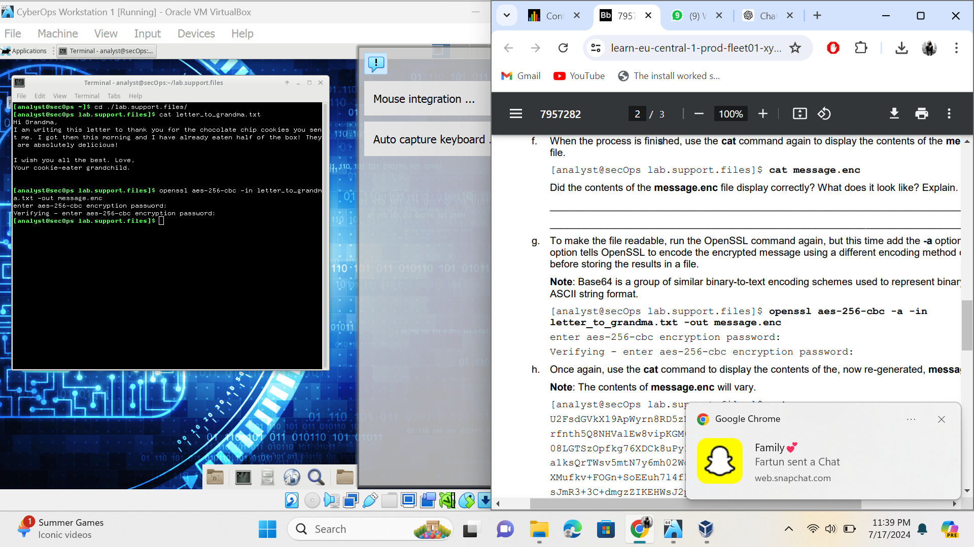

When the process is finished, use the cat command again to display the contents of the message.enc file. [analyst@secOps lab.support.files]$ cat message.enc Did the contents of the message.enc file display correctly? What does it look like? Explain.

The content did not display correctly. It looks like garbled up texts and sybmbols.

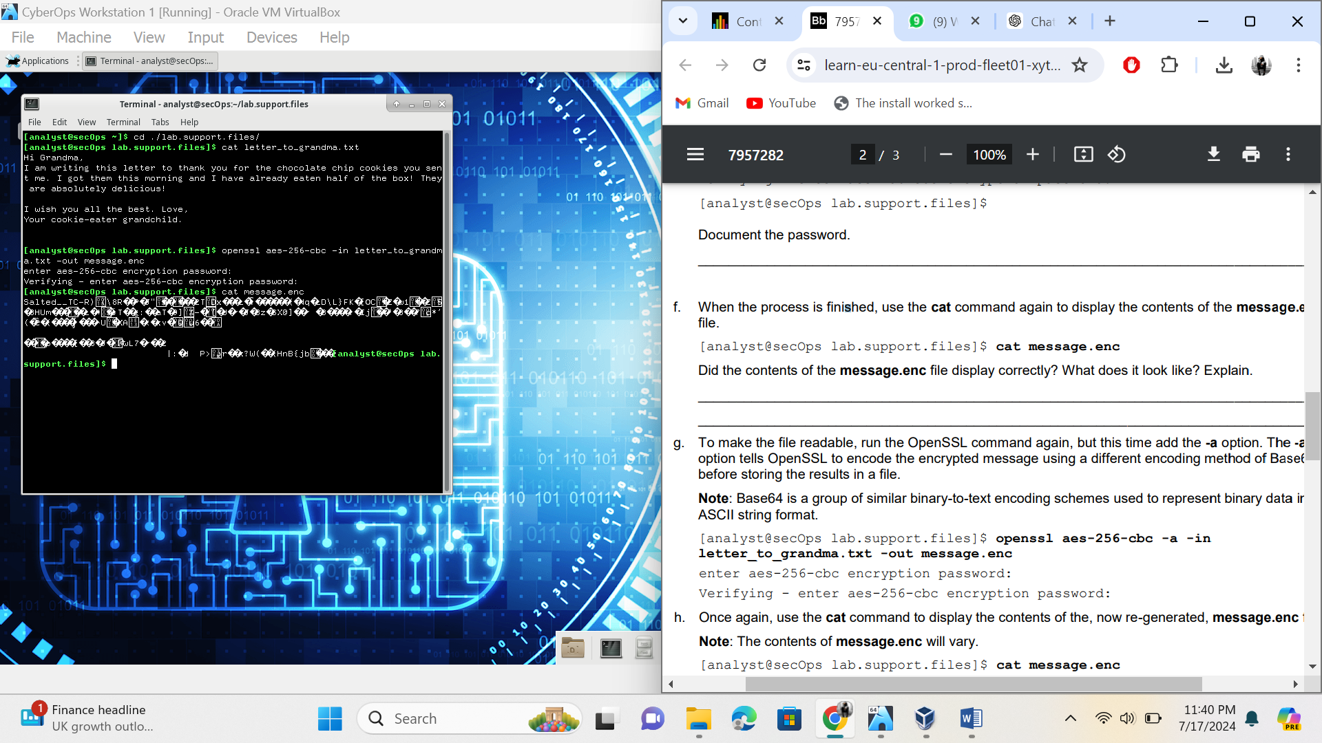

Is message.enc displayed correctly now? Explain.

The message is not displayed correctly yet. The letters are still not readable and still are garbled up texts and numbers.

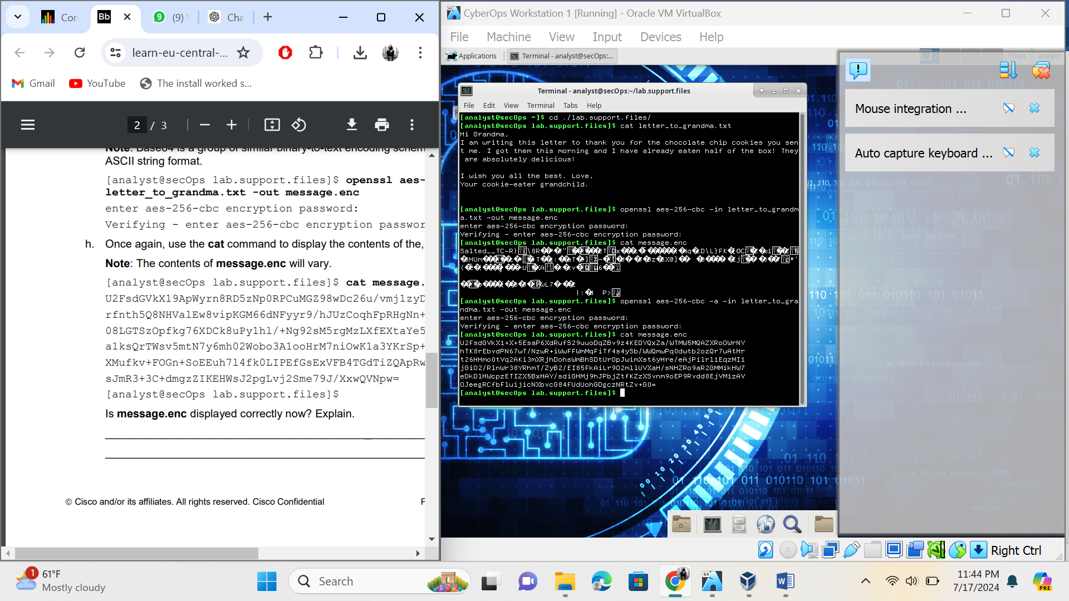

When OpenSSL finishes decrypting the message.enc file, it saves the decrypted message in a text file called decrypted_letter.txt. Use the cat display the contents of decrypted_letter.txt: [analyst@secOps lab.support.files]$ cat decrypted_letter.txt Was the letter decrypted correctly?

The letters are decrypted correctly.

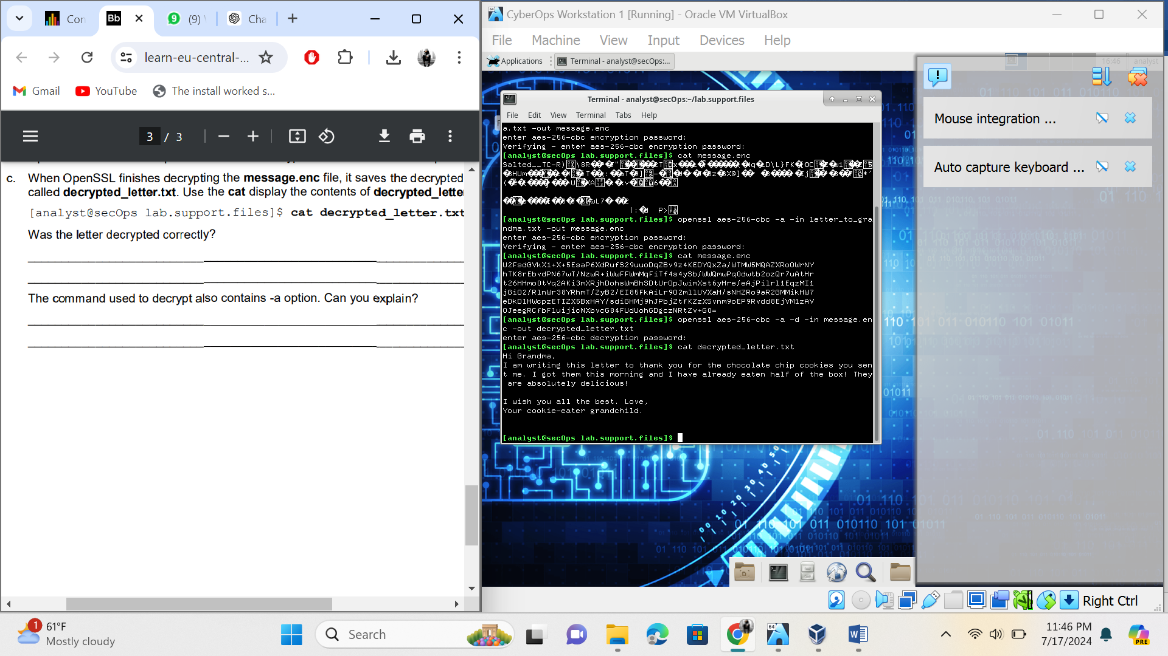

The command used to decrypt also contains -a option. Can you explain?

The -a option converts the encrypted output to base64, making it ASCII text.