Creating new user with IAM roles and attaching policies to restrict them from using s3 database of company:
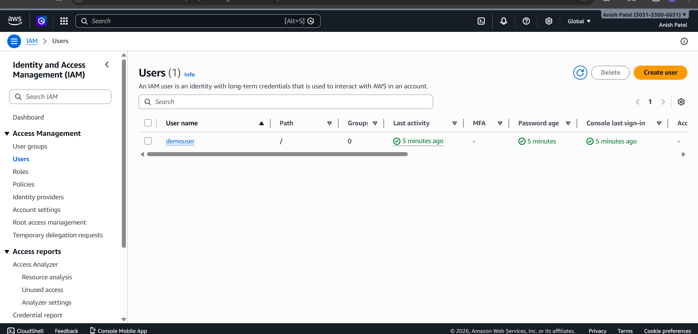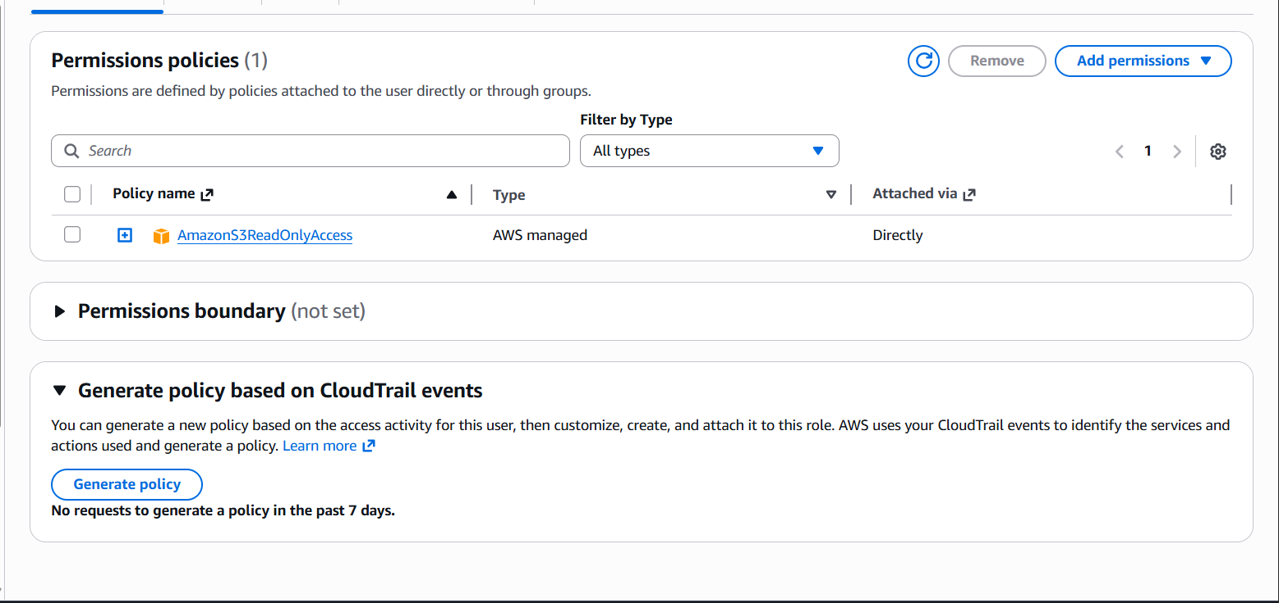
Demo user not being able to use the s3 bucket because of attached policies:
