1 Create table with any name.

2 Create two tables : STUDENT and RESULT

STUDENT(without Primary key and any constraints)

RESULT(without Foreign key and any constraints)

3 Show the structure of the table.

4 Make Admno of student as Primary key.

5 Make address as NOT NULL.

6 Add a field ‘Aadhaar ‘ in STUDENT table with data type as text and DEFAULT as ‘NA’.

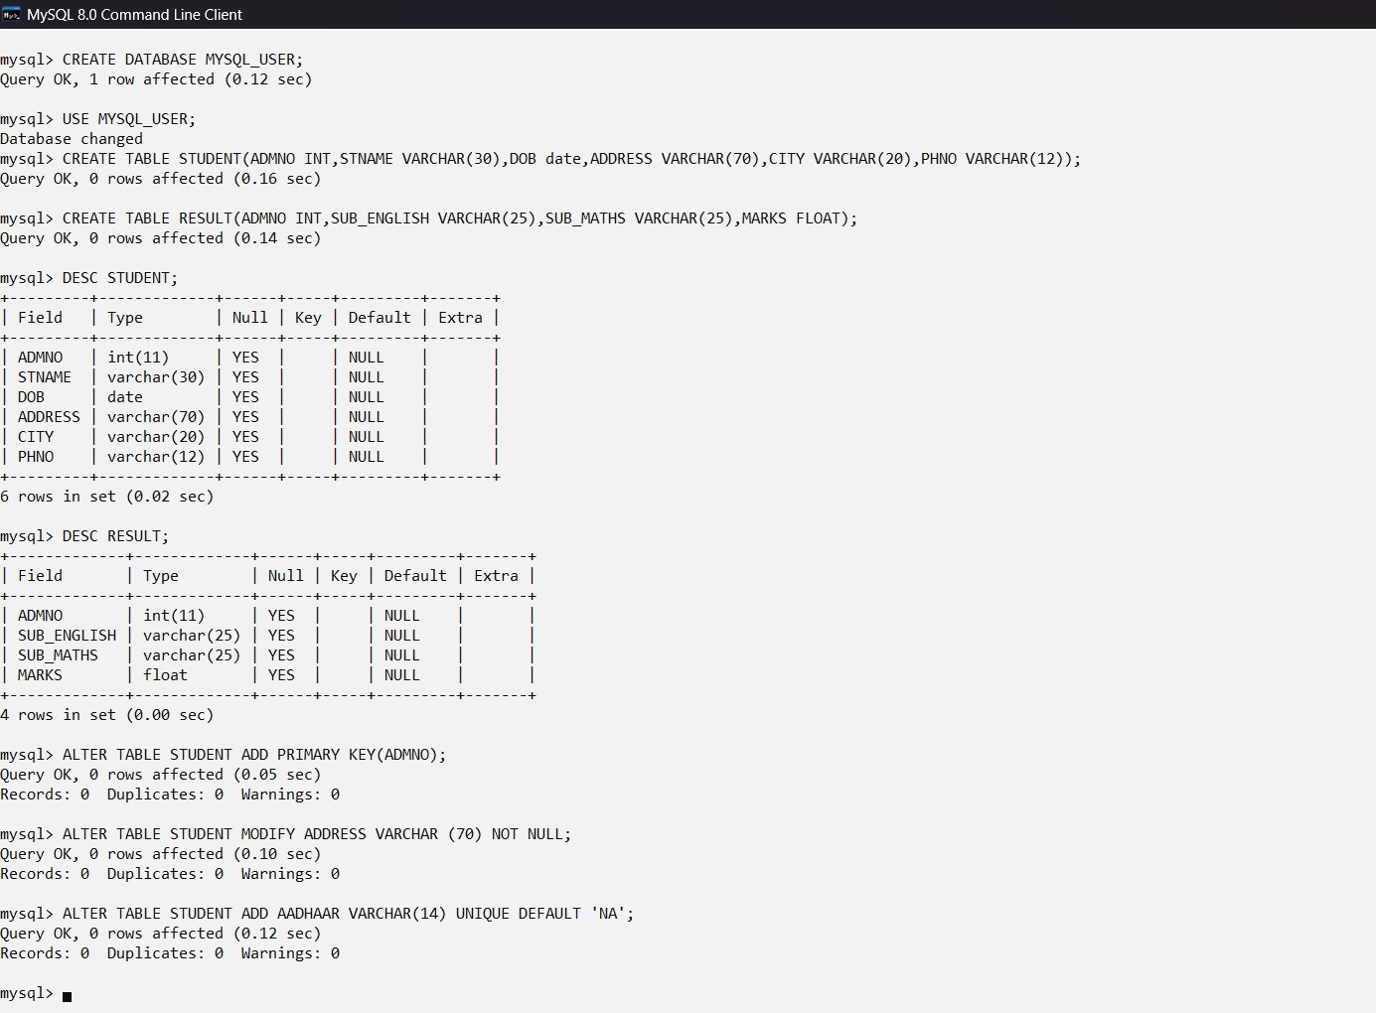

7 Change the name of the field ‘Phno’ to ‘PhoneNo’.



8 Insert record in both the tables.

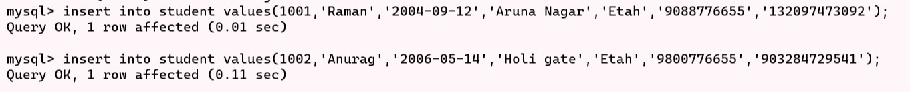

9 Display all the records of STUDENT table.

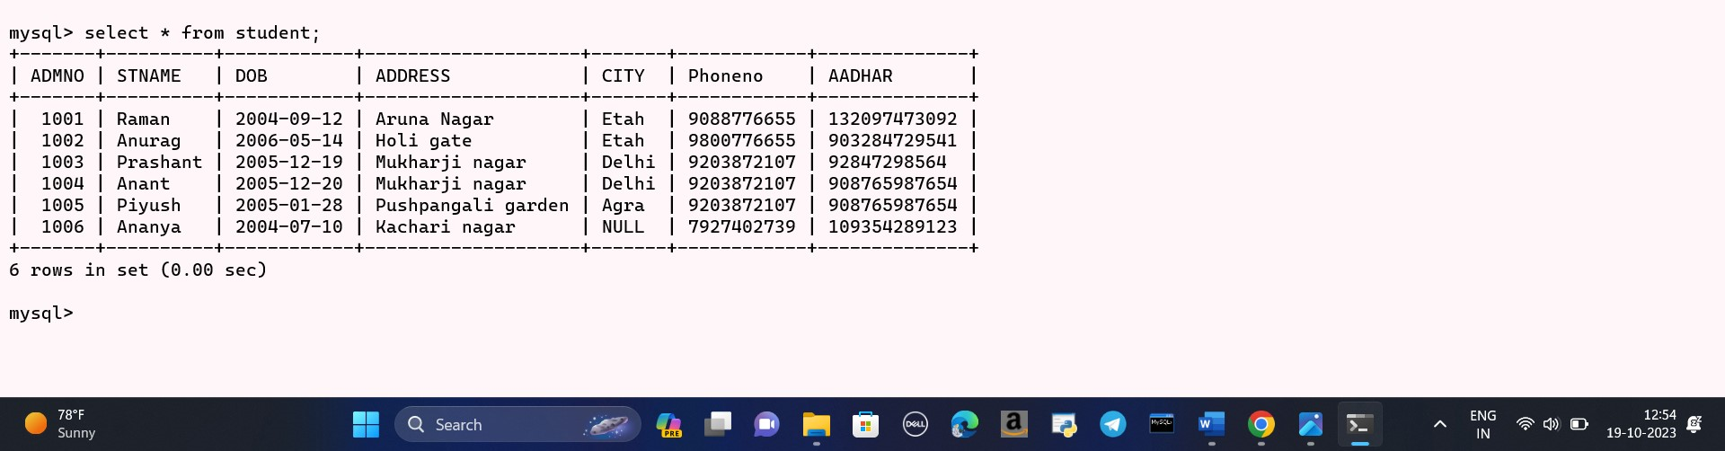

10 Display the record from STUDENT table whose Admno>1003 and Admno<1007.

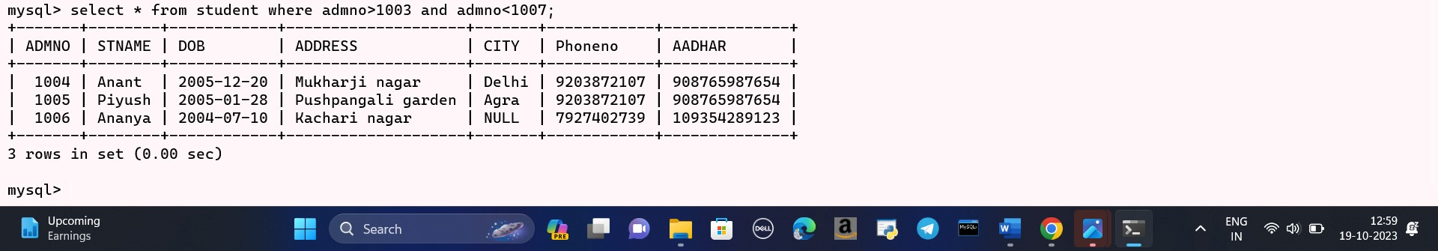

11 Display the records of STUDENT where city is “Delhi ” or “Agra”.

12 Display the records of STUDENT where city is except “Delhi ” or “Agra”.

13 Display the records of STUDENT whose name starts with “A”.

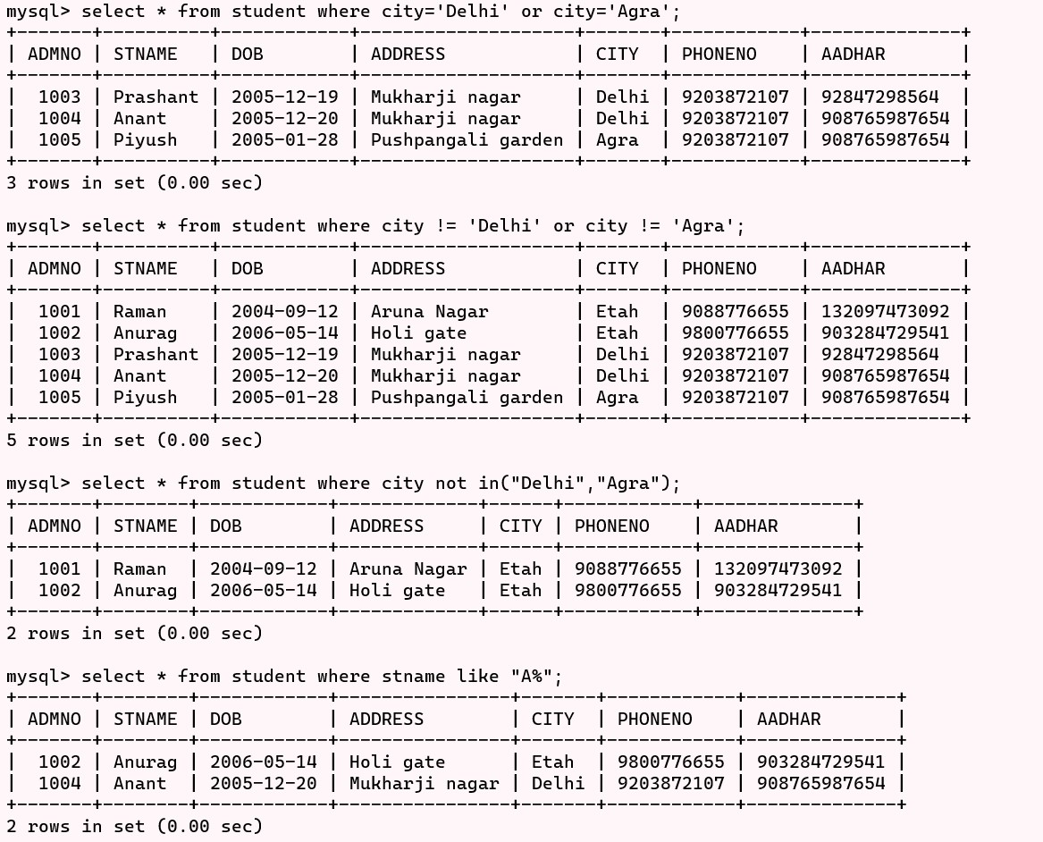

14 Display the records of the STUDENT whose name starts with ‘A’ and having exactly 4 characters in it.

15 Display the records of STUDENT in ascending order of stname.

16 Display the records of STUDENT in descending order of their DOB.

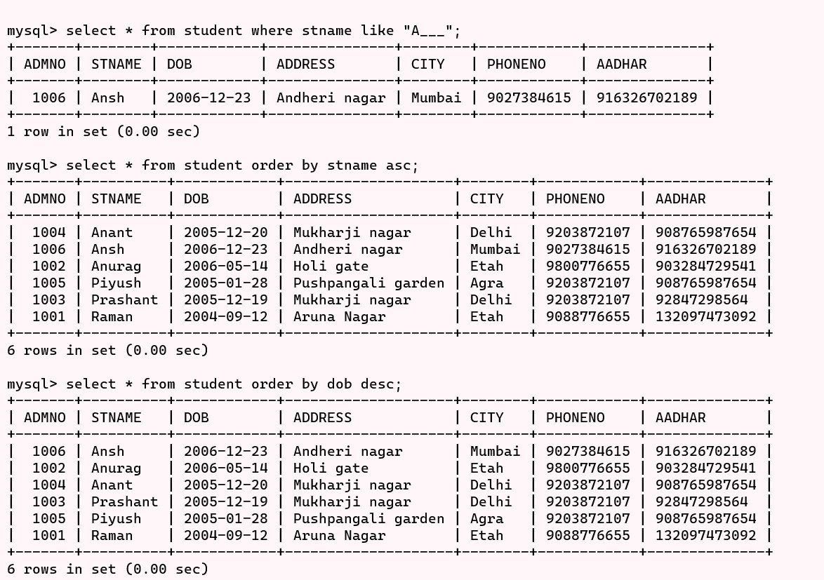

17 Update any record in table STUDENT.

18 Delete any record from table STUDENT.

19 Show STUDENT table status after deletion.

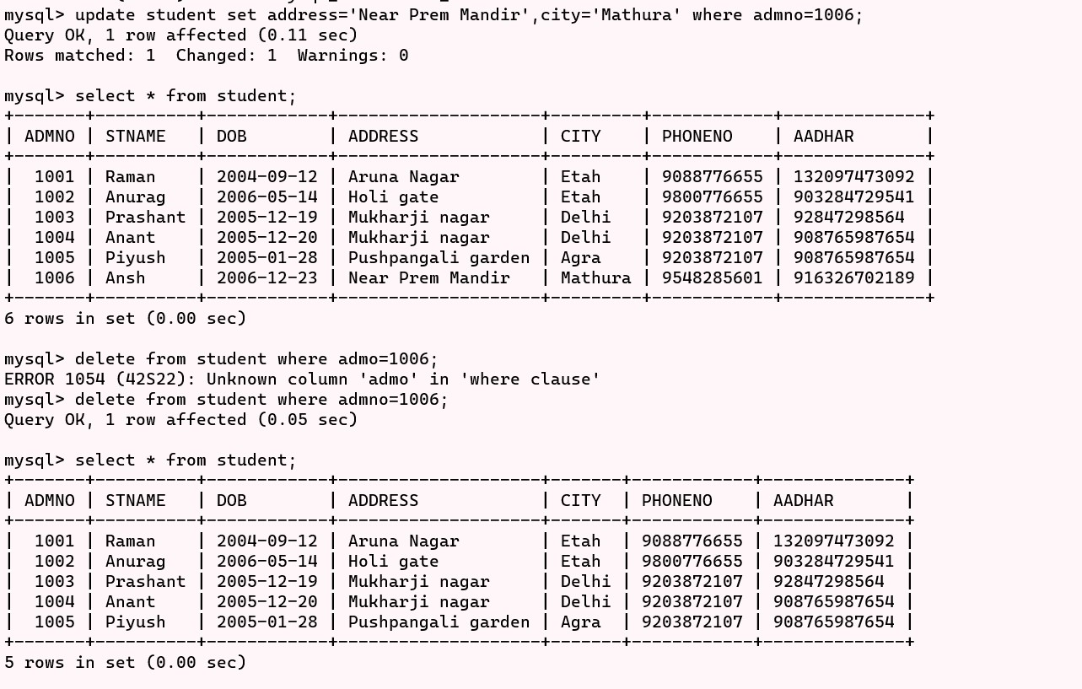

20 Display Admno and total marks obtained by the student from the table RESULT.

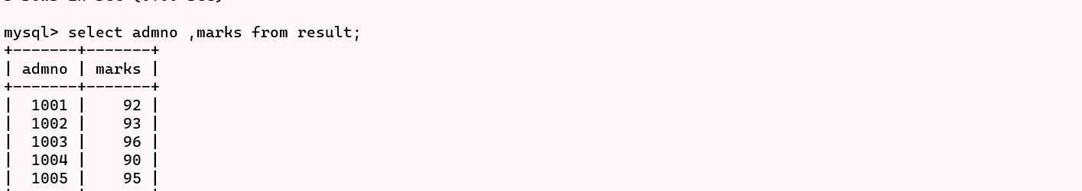

21 Add one record in table STUDENT for all the field except CITY.

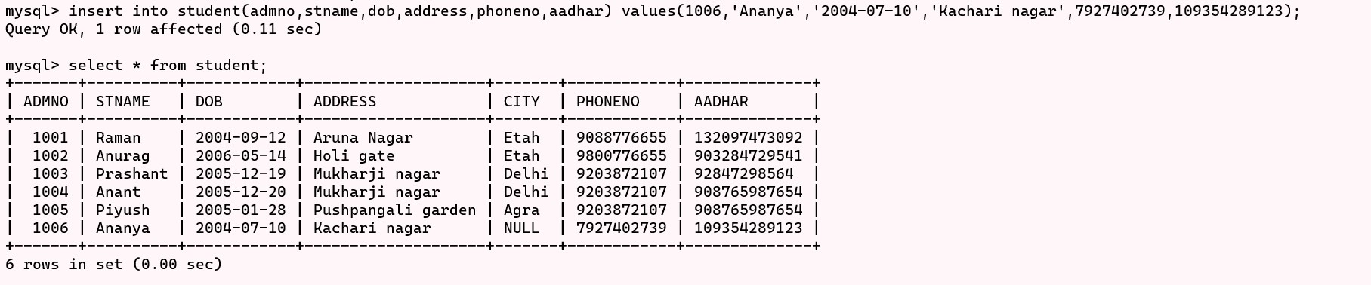

22 Display the record from the table STUDENT where the value of the CITY is null.

23 Display unique CITY from the table STUDENT.

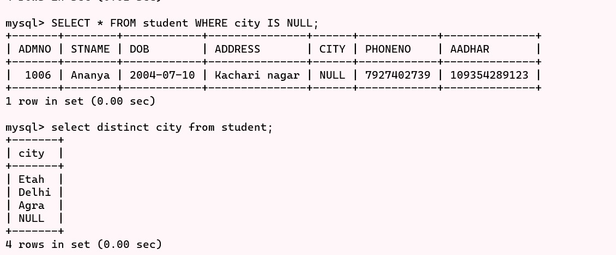

24 Display admno and total marks obtained by any particular student from both the tables

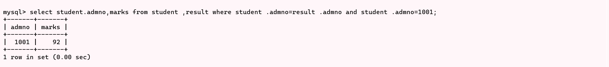

25 Display name and marks of all the student in ENGLISH SUBJECT(Both tables).

26 Create a new table STNEW (Admno,Stname,City)through table student for all those who live in any particular city(Give city name of your choice).

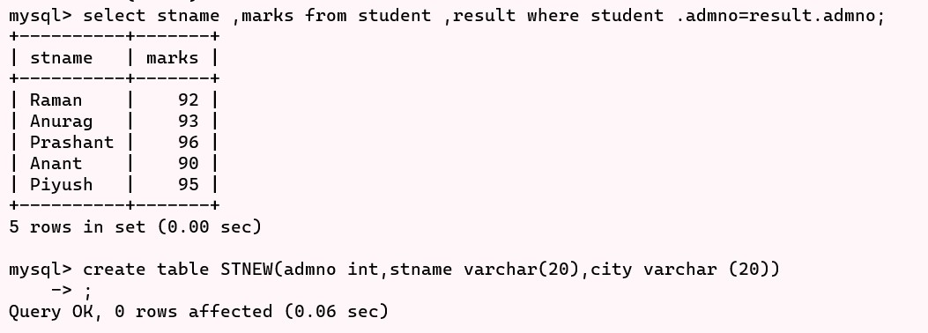

27 Display 30% of marks for all the subject with calculating field title as “CONVERTED” from table RESULT.

