Experiment Number: 8

Problem Statement: Write a program to check whether a given system is in safe state or not using Banker’s Deadlock Avoidance algorithm.

NAME: **Anish Kamble**  ROLLNO: 55

CLASS: TY(AI-A) BATCH: 3

DATE OF PERFORMANCE: 10/11/22

___________________________________________________________________________

PROGARM:

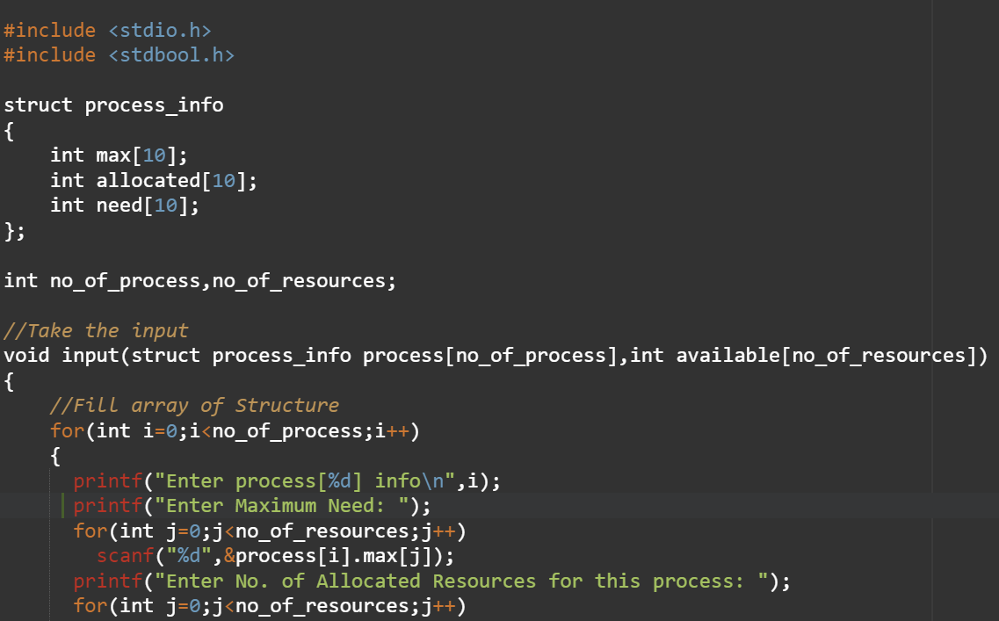

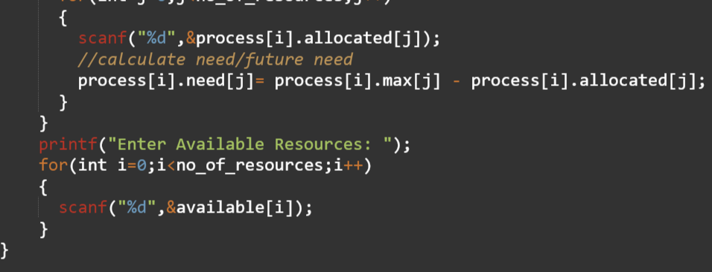

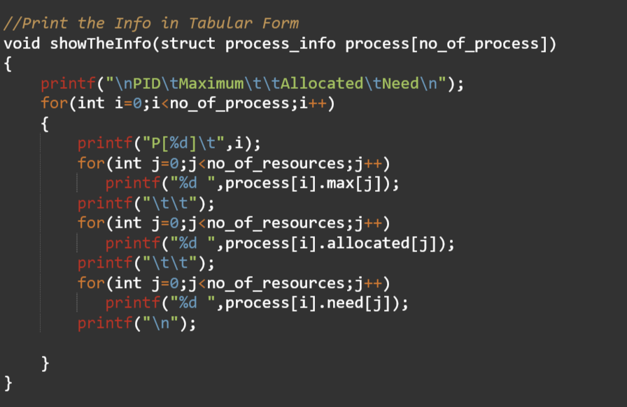

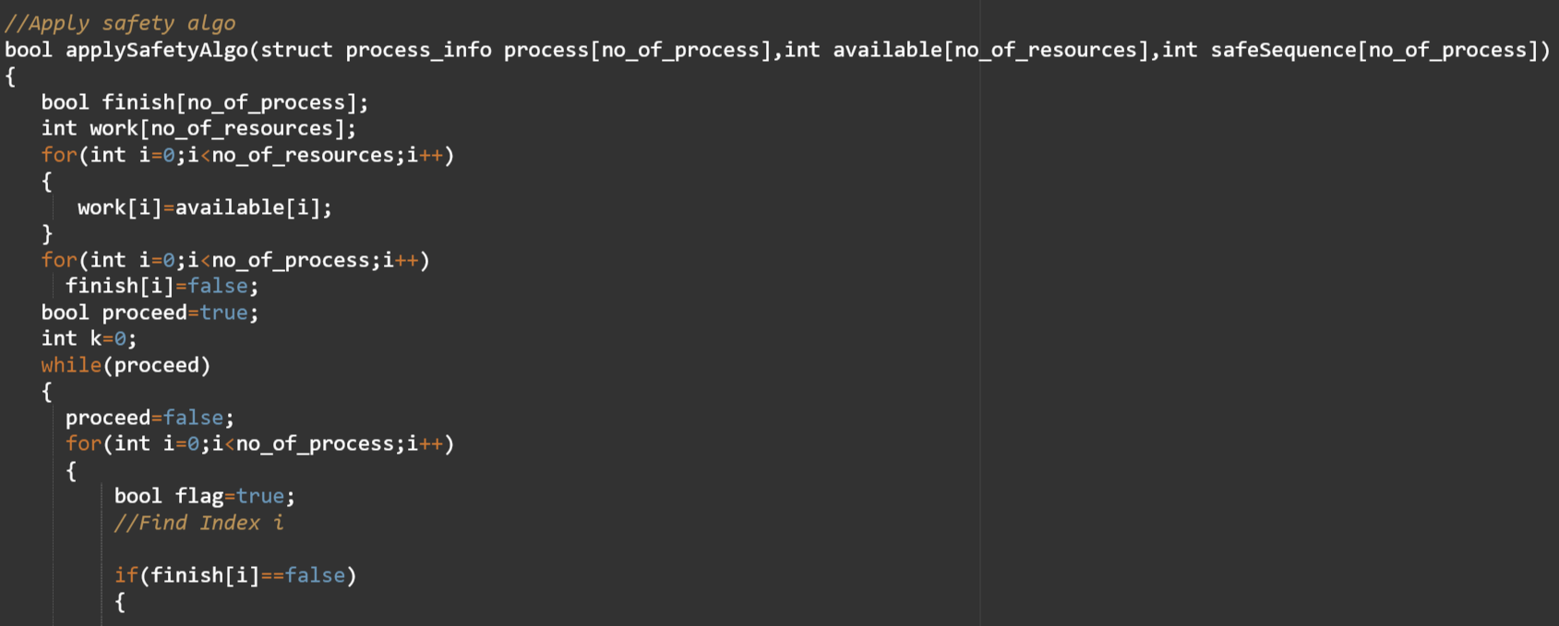

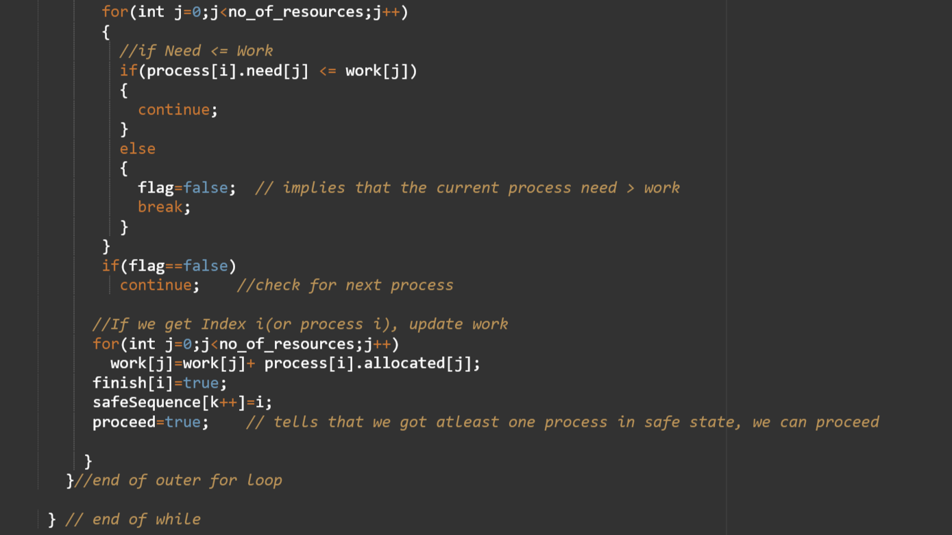

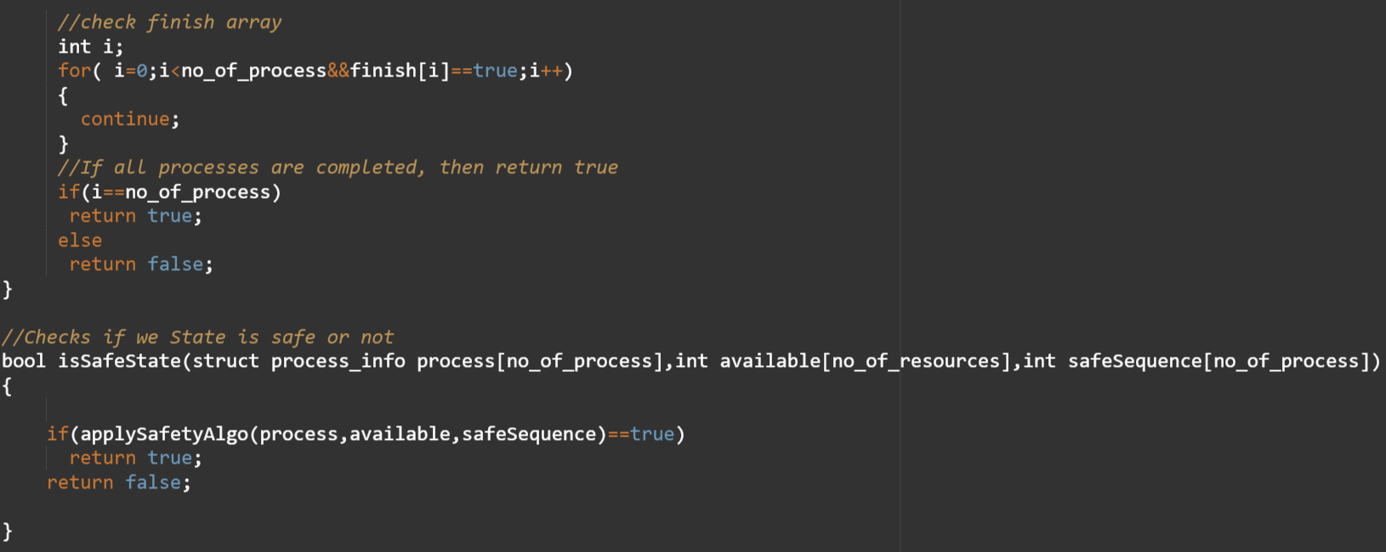

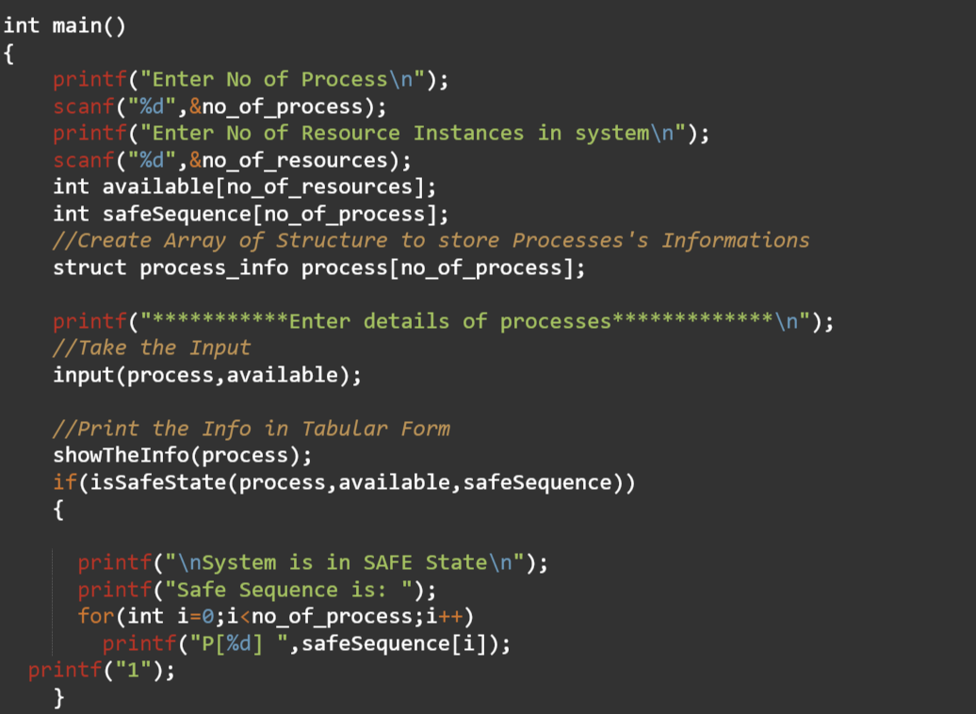

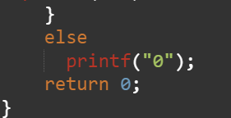

**OUTPUT:**

