Experiment Number: 3

Problem Statement: : Shell Programming

NAME: Anish Kamble ROLLNO: 55

CLASS: TY(AI-A) BATCH: 3

DATE OF PERFORMANCE: 8/09/22

___________________________________________________________________________

1. Problem Statement: **Write a shell program to print given number in reverse order**

PROGARM:

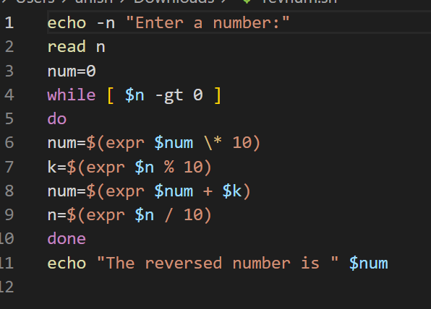

**OUTPUT:**

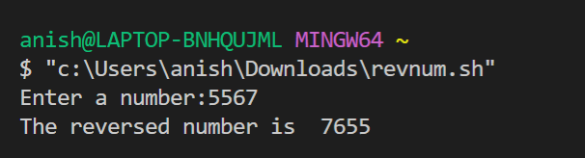

1. Problem Statement: **Write a shell program to perform arithmetic operations using case**

PROGARM:

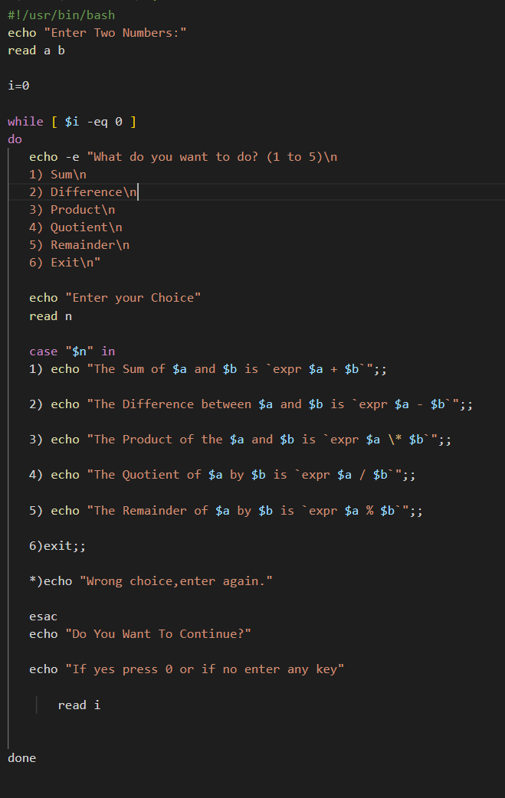

**OUTPUT:**

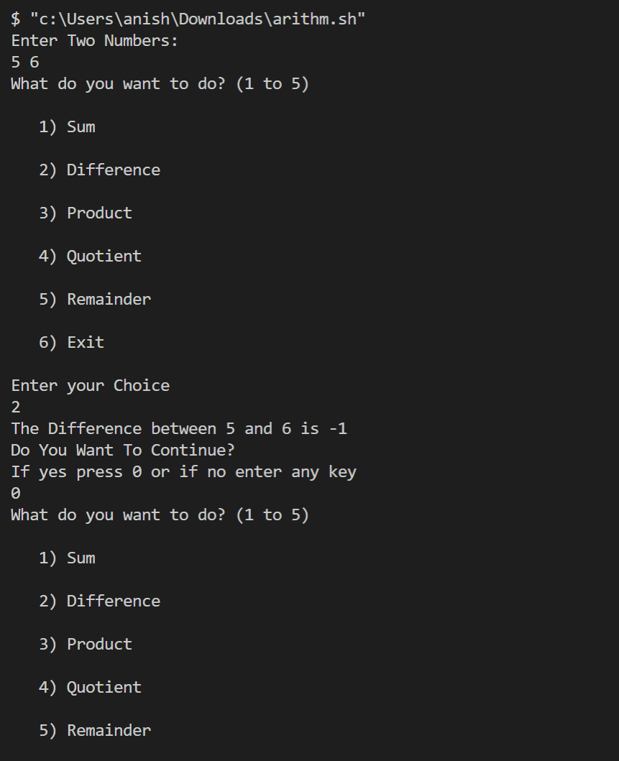

1. Problem Statement: **Write a shell script to check file type and permissions of a given input by user**

PROGARM:

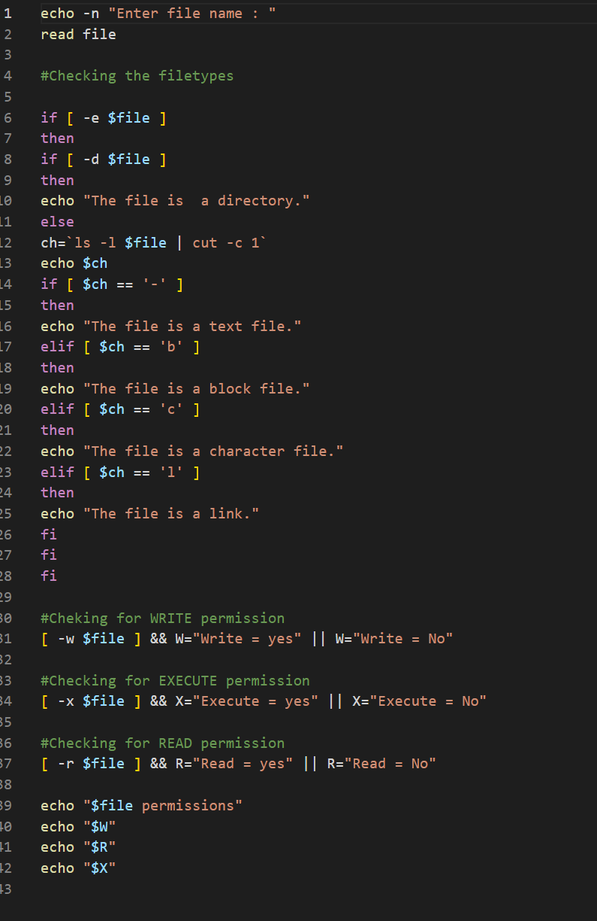

**OUTPUT:**

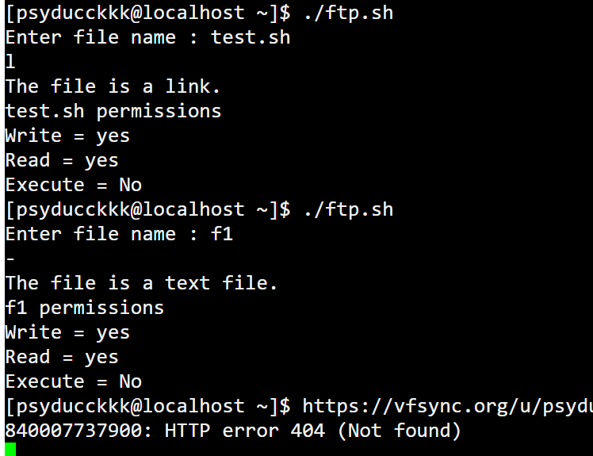

1. Problem Statement: **Write a shell script to Find factorial of a given number using function**

PROGARM:

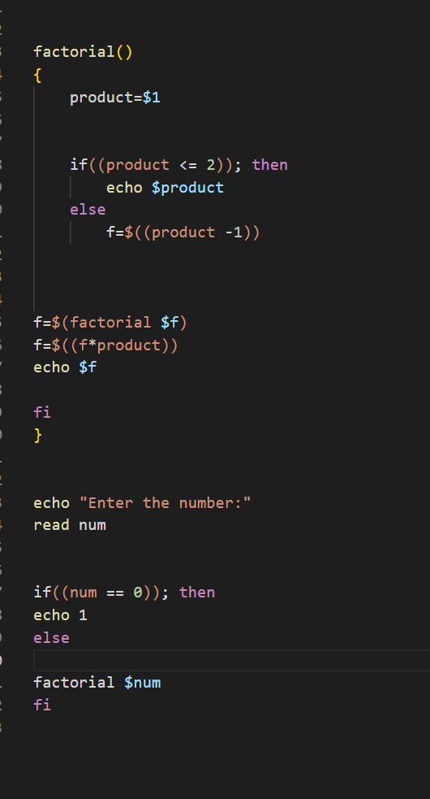

**OUTPUT:**

