STOCKGUARD MANAGEMENT SYSTEM

Synopsis

A database-driven inventory and warehouse operations platform demonstrating relational database design, transaction processing, concurrency control benchmarking, and structured management of multi-warehouse logistics.

Introduction

Modern supply chain applications require robust databases to prevent overselling and support transaction safety. StockGuard is a DBMS prototype for centralized warehouse operations. It manages the complete product lifecycle from temporary cart reservations and payment tracking to delivery assignments and returns.
Problem Statement

Poorly structured inventory records lead to out-of-sync stock counts, lost items, and inefficient fulfillment. High-traffic e-commerce operations demand concurrency-safe data handling to maintain consistent inventory levels under simultaneous load. StockGuard utilizes strict schemas, keys, and advanced concurrency controls to prevent race conditions such as overselling during simultaneous checkouts without unnecessarily locking the database.

Objectives

- Design a scalable, 3NF-compliant relational database for multi-warehouse operations.

- Manage the complete logistics lifecycle, including payments, delivery routing, cancellations, and return pickups.

- Ensure transactional safety during intra-warehouse stock transfers to prevent lost or duplicated inventory.

- Demonstrate and benchmark concurrency control strategies to evaluate throughput vs. correctness tradeoffs.

Proposed System

StockGuard acts as a centralized source of truth divided into Core Inventory, Order Fulfillment, and Procurement. It tracks exact stock quantities across multiple locations. Customer checkouts temporarily reserve stock, which is permanently deducted upon payment verification. Warehouse staff can initiate stock transfers or receive supplier purchase orders, which automatically update master counts via relational triggers. Crucially, the system evaluates multiple concurrency models under simultaneous load while maintaining strict referential integrity between inbound procurement and outbound fulfillment.

Main Modules

- Identity & Access: Two-tier access control for warehouse staff and organization administrators.

- Inventory & Warehouse: Real-time stock tracking and intra-warehouse transfers.

- Order Fulfillment: Customer checkouts, cart reservations, payment tracking, delivery routing, and return processing.

- Procurement: Supplier tracking, purchase orders, and inbound stock receipts.

- Analytics: Data aggregation for dead-stock detection and warehouse performance.

DBMS Concepts

- ER Model & Normalization: Tables are designed up to 3NF to eliminate redundancy, backed by strict PK/FK constraints to maintain domain boundaries.

- Advanced SQL: Utilizes complex JOINs, GROUP BY, and aggregate functions to power cross-warehouse analytics.

Expected Outcome

A concurrency-safe database prototype capable of securely handling high-volume warehouse records. The highly structured data model will successfully benchmark three concurrency models during simultaneous cart reservations, precisely track moving stock through delivery cycles, and generate robust operational analytics.

Future Scope

Abstracting the shipping logistics into a dedicated microservice for broader scale, and integrating real-time webhook notifications to automatically trigger procurement workflows when stock hits minimum thresholds.

Schema Diagram

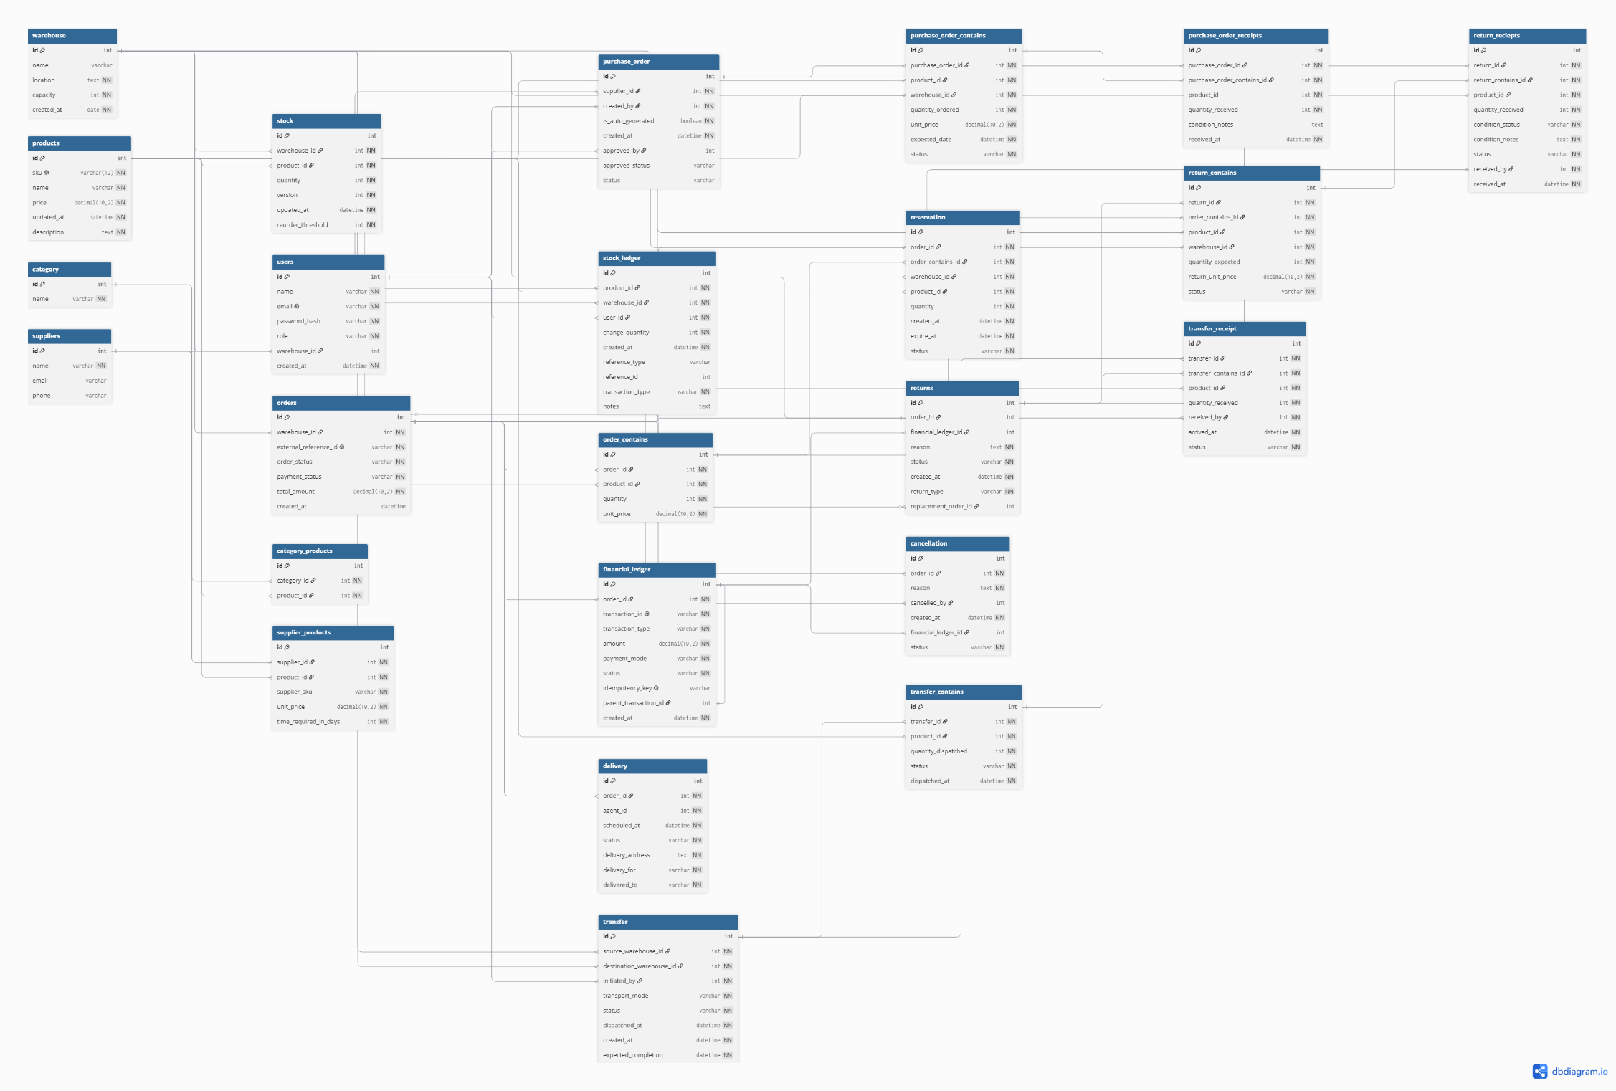
ER Diagram