SEVA SANKALP: A HYPERLOCAL COMMUNITY RESOURCE SHARING AND DIRECT VERIFIED GIVING PLATFORM
Community Project Report
Submitted by
NEYIGAPULA MEGHANA  (24331A4277) | SANDAKA ANISH NIHAAL  (24331A42A5)
MUDUNURI SRUTHI  (24331A4270) | PRAVEEN SAHU  (24331A4294)
In partial fulfillment for the award of the degree
of
BACHELOR OF TECHNOLOGY
IN
COMPUTER SCIENCE & ENGINEERING
(Artificial Intelligence & Machine Learning)
Under the esteemed Guidance of
Mr. S. Palavelli
Assistant Professor

DEPARTMENT OF DATA ENGINEERING
MAHARAJ VIJAYARAM GAJAPATHI RAJ COLLEGE OF ENGINEERING (Autonomous)
(Approved by AICTE, New Delhi, and permanently affiliated to JNTUGV, Vizianagaram), Listed u/s 2(f) & 12(B) of UGC Act 1956.
Vijayaram Nagar Campus, Chintalavalasa, Vizianagaram-535005, Andhra Pradesh
October, 2025

CERTIFICATE

This is to certify that the project entitled “Seva Sankalp: A Hyperlocal Community Resource Sharing and Direct Verified Giving Platform” is the bonafide work carried out by NEYIGAPULA MEGHANA (24331A4277), SANDAKA ANISH NIHAAL (24331A42A5), MUDUNURI SRUTHI (24331A4270), PRAVEEN SAHU (24331A4294) of B.Tech V Sem CSE-AIML, M.V.G.R. College of Engineering (Autonomous), Vizianagaram, during the year 2026-2027, in partial fulfilment of the requirements for the award of the Degree of Bachelor of Technology and that the project has not formed the basis for the award previously of any degree or any other similar title.
Signature of Project Guide  Mr. S. Palavelli  Assistant Professor  Department: Data Engineering. | Signature of Head of the Department  Dr. V. Jyothi  Associate Professor  Department: Data Engineering.

DECLARATION
We hereby declare that the work done on the dissertation entitled “Seva Sankalp: A Hyperlocal Community Resource Sharing and Direct Verified Giving Platform” has been carried out by us and submitted in partial fulfilment for the award of credits in Bachelor of Technology in Computer Science and Engineering (Artificial Intelligence & Machine Learning) of M.V.G.R College of Engineering (Autonomous) and affiliated to JNTUGV, Vizianagaram. The various contents incorporated in the dissertation have not been submitted for the award of any degree of any other institution or university.
NEYIGAPULA MEGHANA
(24331A4277)
SANDAKA ANISH NIHAAL
(24331A42A5)
MUDUNURI SRUTHI
(24331A4270)
PRAVEEN SAHU
(24331A4294)

ACKNOWLEDGEMENT
We express our sincere gratitude to Mr. S. Palavelli for his invaluable guidance and support as our mentor throughout the project. His unwavering commitment to excellence and constructive feedback motivated us to achieve our project goals. We are greatly indebted to him for his exceptional guidance.
Additionally, we extend our thanks to Prof. P.S. Sitharama Raju (Director), Dr. Y.M.C. Shekar (Principal), and Dr. V. Jyothi (Head of the Department) for their unwavering support and assistance, which were instrumental in the successful completion of the project. We are thankful for and fortunate enough to get constant encouragement and guidance from our Project Coordinator, V. Kiran Kumar.
We also acknowledge the dedicated assistance provided by all the staff members in the Department of Data Engineering. Finally, we appreciate the contributions of all those who directly or indirectly contributed to the successful execution of this endeavor.

NEYIGAPULA MEGHANA (24331A4277)
SANDAKA ANISH NIHAAL (24331A42A5)
MUDUNURI SRUTHI (24331A4270)
PRAVEEN SAHU (24331A4294)

ABSTRACT
Every year, countless reusable items—such as study books, clothing, household appliances, and working electronics—are thrown away or left unused in people's homes. At the very same time, low-income families, underprivileged students, and grassroots charitable organizations struggle to afford these exact essentials.
Although peer-to-peer donation platforms and online classifieds exist, they suffer from two major problems: high logistics costs that discourage local giving, and commercial resellers who grab free donations only to sell them for profit. Furthermore, many genuine donors hesitate to help because they cannot easily verify whether an NGO or an individual recipient is truly in need.
To solve these real-world challenges, Seva Sankalp was developed as a community-driven web platform that connects local donors directly with verified recipients and legitimate NGOs. Built with Python, Flask, and an open-source geospatial stack, the platform introduces three key innovations: an interactive local discovery engine powered by the Haversine formula and OpenStreetMap that eliminates shipping costs; automated antiflipping cooldown periods (12 months for electronics and 6 months for major appliances) that stop commercial resale; and a privacy-preserving low-income verification pipeline where an administrator verifies income certificates privately so donors know their gifts reach the right hands without exposing sensitive financial records.
By combining statutory NGO verification (via NITI Aayog Darpan IDs and PAN cards) with a fair Karma points system protected against network cheating, Seva Sankalp creates a trustworthy, transparent, and dignified environment for grassroots resource sharing.

TABLE OF CONTENTS
Contents | Page No.
List of Abbreviations | 7
List of Figures | 9
List of Tables | 8
1. Introduction | 10
1.1 Problem Statement | 10
1.2 Project Objective | 11
1.3 Scope of the Project | 11
2. Literature Survey | 12-13
3. Data Gathering / Data Used | 14-17
4. Methodology / System Design | 18-21
5. Implementation / Modules | 22-24
6. Results / Outputs | 25-28
7. Impact Assessment | 29
8. Challenges Faced | 30
9. Conclusion | 31
10. Future Work | 32
11. References | 33
Appendix A: Packages, Tools Used & Working Process | 34-35
• Packages & Tools Used | 34
• Working Process | 35
Appendix B: Source Code | 36-40
Paper Publications (if any) | -

ABBREVIATIONS:
List of Abbreviations:
i. API - Application Programming Interface
ii. Bcrypt - Blowfish Cryptographic Password Hash Algorithm
iii. BPL - Below Poverty Line
iv. CSRF - Cross-Site Request Forgery
v. DOM - Document Object Model
vi. DPDP - Digital Personal Data Protection Act (India, 2023)
vii. EWS - Economically Weaker Section
viii. GPS - Global Positioning System
ix. HTML - HyperText Markup Language
x. HTTP - HyperText Transfer Protocol
xi. JSON - JavaScript Object Notation
xii. MVC - Model-View-Controller Architectural Pattern
xiii. NGO - Non-Governmental Organization
xiv. NITI - National Institution for Transforming India
xv. ORM - Object-Relational Mapping (SQLAlchemy)
xvi. OSM - OpenStreetMap
xvii. OTP - One-Time Password
xviii.PAN - Permanent Account Number (Income Tax Department of India)
xix. REST - Representational State Transfer
xx. SDLC - Software Development Life Cycle
xxi. SMTP - Simple Mail Transfer Protocol
xxii. SQL - Structured Query Language
xxiii.UI - User Interface
xxiv. UPI - Unified Payment Interface

TABLES:
List of Tables:
Table No. | Title | Page No.
Table 2.1 | Literature Survey and Novelty of Proposed Project | 12-13
Table 3.1 | Platform Data Entities, Attributes, and Storage Architecture | 14-15
Table 3.2 | Sample Users | 15
Table 3.3 | Sample Resources | 15
Table 3.4 | Sample Resource Requests | 15-16
Table 3.5 | Sample Statutory Requests | 16
Table 3.6 | Sample Donation History | 16
Table 3.7 | Sample Points Transaction (Karma Ledger) | 16
Table 3.8 | Sample Handover Messages | 17
Table 5.1 | Implementation Modules and Technology Architecture | 23
Table A.1 | Core Dependencies, Frameworks, and Tools | 34

FIGURES:
List of Figures:
Figure No. | Title | Page No.
Figure 4.1 | Seva Sankalp System Infrastructure and Operational Architecture Flow | 18
Figure 4.2 | Request Validation, Anti-Fraud & Cooldown Verification Flowchart | 20
Figure 6.1 | Website Home Page | 25
Figure 6.2 | Login Page | 25
Figure 6.3 | User Dashboard | 26
Figure 6.4 | User Home Page | 26
Figure 6.5 | User Profile | 27
Figure 6.6 | User Interactive Community Map | 27
Figure 6.7 | Supported NGO’s | 27
Figure 6.8 | Admin Dashboard | 28
Figure 6.9 | Register Using DigiLocker | 28

1. INTRODUCTION:
In today’s society, many useful items such as textbooks, clothing, household appliances, and working electronic devices remain unused in homes or are eventually discarded. At the same time, economically disadvantaged students, low-income families, and genuine charitable organizations often struggle to afford these essential resources. This creates a gap between people who have reusable resources and those who need them.
Existing donation methods and online platforms face several challenges, including high transportation costs, lack of local connectivity, misuse of free donations by resellers, and difficulty in verifying genuine beneficiaries and charitable organizations. These limitations can discourage people from donating and may prevent resources from reaching those who genuinely need them.
To address these challenges, Seva Sankalp is developed as a community-driven web platform that connects local donors with verified recipients and legitimate NGOs. The platform focuses on hyperlocal resource sharing, allowing users to discover available items within a selected distance using the Haversine formula, Leaflet.js, and OpenStreetMap. This enables direct local handovers and reduces transportation and delivery costs.
Seva Sankalp also incorporates mechanisms to improve trust and prevent misuse. These include statutory NGO verification using NITI Aayog NGO Darpan IDs and PAN details, anti-flipping cooldown periods for electronics and household appliances, and private verification of low-income beneficiaries. The platform also provides secure in-app communication and a Karma Points system to encourage genuine community participation while reducing fraudulent point farming.
The system is implemented using Python, Flask, SQLAlchemy, HTML, CSS, JavaScript, Bootstrap, Leaflet.js, and OpenStreetMap. By combining technology, local community participation, resource reuse, privacy, and fraud-prevention mechanisms, Seva Sankalp aims to create a safe, transparent, and accessible environment for redistributing reusable resources to people and organizations who need them.
1.1 Problem Statement:
In our society, huge quantities of perfectly good, usable items—such as school textbooks, wearable clothing, household appliances, and working electronic devices—sit idle in closets or end up in local garbage dumps. At the same time, nearby students from economically disadvantaged families, daily wage earners, and genuine local charities are in desperate need of these very items to continue their education or meet daily needs.
Traditional donation approaches fail to bridge this gap because of three simple, everyday problems:
• 1. High Shipping Costs for Small Items: Sending a bundle of old books or a blender through a courier often costs more than the item is worth. Because there is no simple way to find someone living just a few streets away who needs them, people simply throw usable things away.
• 2. Dishonest Resellers and Flippers: Whenever free items are posted on open forums or general classified websites, commercial scavengers quickly claim them pretending to be poor. Within hours, they list those free items on secondary marketplaces like OLX for personal cash profit, leaving genuinely needy people empty-handed.
• 3. Lack of Trust and Verification: Donors want to give, but they are rightfully skeptical. They worry that donations might be pocketed by unverified individuals or fake NGOs that have no legal standing.
1.2 Project Objectives:
• To develop a safe, transparent, and easy-to-use web platform for local donations.
• To connect local donors with verified recipients and legitimate NGOs.
• To enable hyperlocal resource matching within a 1–50 km radius.
• To use the Haversine formula, Leaflet.js, and OpenStreetMap for location-based resource discovery.
• To reduce transportation and delivery costs through direct local handovers.
• To implement NGO verification using NITI Aayog NGO Darpan ID and PAN details.
• To prevent resale of donated items through anti-flipping cooldown periods.
• To provide private low-income beneficiary verification without exposing sensitive documents.
• To encourage genuine donations through a Karma Points and leaderboard system.
• To provide secure in-app communication between donors and recipients for handover coordination.
1.3 Scope of the Project:
The project encompasses a complete, modern web platform designed with responsive web principles, making it accessible on both desktop computers and mobile smartphones without requiring heavy app store downloads.
• Target User Roles: The system explicitly serves three types of community participants: individual donors listing items, everyday community recipients requesting items, and registered NGOs running charity programs. A dedicated administrative console allows staff to verify documents and moderate content.
• Data Privacy Standards: All personal information, login credentials, and uploaded identity proofs are handled in strict alignment with India's Digital Personal Data Protection (DPDP) Act of 2023. User passwords are encrypted with industry-standard Bcrypt, and sensitive documents are stored in secure server directories accessible only to authorized administrators.

2. LITERATURE SURVEY:
2.1 Overview & Comparative Novelty
To understand how current charity platforms handle resource distribution, our team reviewed existing research papers, academic journals, and popular web applications. Most current solutions fall into three broad types: centralized NGO warehouse systems, commercial reverse-crowdfunding platforms (like Donatekart), and unmonitored peer-to-peer classifieds. While each serves a particular need, none of them solve the combined problems of local physical logistics, commercial resale fraud, and beneficiary privacy.
Table 2.1 highlights the key differences between existing systems documented in literature and the practical innovations built into Seva Sankalp:
Paper Title &  Author / Platform | Techniques  Used | Parameters  Considered | Description of  Existing Work | Differences /  Novelty of Seva Sankalp
"Optimizing Humanitarian Supply Chains via Centralized Warehousing"  (Thomas & Kopczak, 2018) | Linear Programming, Centralized Hub Logistics | Storage costs, truck fuel, transportation delays | Investigated large charity drives where physical donations are shipped to central regional warehouses for sorting before redistribution. | Hyperlocal Direct Handover: Seva Sankalp removes the need for expensive warehouses. Donors and nearby recipients connect directly within a 1-50 km radius, eliminating all shipping costs and delays.
"E-Commerce Reverse Donation Platforms"  (Donatekart Case Study, 2021) | Closed Crowdfunding, Vendor Wholesaling | Monetary units, wholesale pricing, delivery confirmation | Users donate money to buy brand-new products from partner wholesalers, which are then shipped in bulk to NGOs. Preowned items cannot be donated. | Circular Reuse of Pre-Owned Goods: Enables regular citizens to give a second life to existing household items, books, and working electronics already at home, reducing e-waste and landfill clutter.
"Geospatial Proximity Queries in Civic Tech"  (Ramesh & Sundaram, 2022) | Google Maps Distance Matrix API, Grid Calculations | Query latency, commercial API billing costs, GPS accuracy | Relied heavily on commercial mapping APIs that charge fees for every single location query made by users. | Zero-Cost Open-Source Mapping: Calculates true spherical distances in Python using the Haversine formula and displays items on Leaflet.js and OpenStreetMap, keeping the platform 100% free to run.
"Sybil Attack Mitigation in Decentralized Networks"  (Douceur et al., IEEE) | Cryptographic proof-of-work, complex trust graphs | Identity generation cost, server verification lag | Studied automated botnets and malicious users creating dozens of fake identities to farm reputation points in online networks. | Common-Sense IP Checks & Weekly Caps: Detects when donor and recipient share the same WiFi network and caps weekly karma points at 300, preventing dishonest self-farming without slowing down real users.
"Beneficiary Dignity in Digital Welfare Systems"  (Kabeer & Sen, 2020) | Manual paper document auditing, public welfare lists | Social stigma, processing time, privacy loss | Observed that requiring impoverished families to show their poverty certificates publicly discourages proud, needy people from seeking help. | Privacy-Preserving Gating: Only the system administrator sees uploaded income certificates. Donors simply see a verified trust badge, protecting the recipient's personal dignity.

3. DATA GATHERING / DATA USED:
3.1 Overview of Platform Entities & Datasets
Because Seva Sankalp is an interactive peer-to-peer application rather than a static dataset analysis tool, the data it handles consists of live relational entities generated by users. These include registered user accounts, resource listings, requests, completed donation records, reward point transactions, and chat messages. All data is structured cleanly using SQLAlchemy Object-Relational Mapping (ORM) and stored in an ACID-compliant relational database.
Table 3.1 describes each primary data entity, its key attributes, and its operational role in the platform:
Entity / Model | Core Attributes | Data Types | Functional Storage Purpose
User | id, email, password_hash, role, verification_status, is_ngo, darpan_id, org_pan, income_verification_status, last_login_ip, points_balance, trust_score | Integer, String, Enum, Boolean, DateTime | Stores account credentials, role-based permissions, anti-fraud IP history, statutory NGO credentials, and overall trust score.
Resource | id, donor_id, title, description, category, condition, location_lat, location_lng, address, requires_income_proof, status | Integer, String, Text, Float, Boolean, Enum | Represents listed items. Stores GPS coordinates for distance filtering and boolean flags for low-income restrictions.
Request | id, resource_id, receiver_id, status (Pending, Accepted, Rejected, Fulfilled), created_at, updated_at | Integer, Enum, DateTime | Tracks the complete journey of an item request. Used by the Anti-Flipping Engine to enforce cooldown periods and request caps.
DonationHistory | id, request_id, donor_rating, receiver_rating, receipt_photo, usage_photo, impact_message, completed_at | Integer, Float, String, Text, DateTime | Maintains an audit trail of completed handovers, ratings, and uploaded impact photos showing the item in actual use.
PointsTransaction | id, user_id, amount, transaction_type, description, created_at | Integer, Enum, String, DateTime | An append-only financial-style ledger tracking Karma points. Audited during handovers to enforce the 300-point weekly cap.
Message | id, request_id, sender_id, content, created_at | Integer, Text, DateTime | Stores private in-app messages exchanged between donor and recipient to safely arrange physical pickup times.
NGOLike | id, user_id, ngo_id, created_at | Integer, ForeignKey, DateTime | Captures verified community endorsements and support counts for grassroot NGOs, empowering crowd-driven visibility without unverified financial metrics.

Sample Users Table 3.2 :
id | email | role | verification.status | trust.score | points.balance | created.at
1 | admin@sevasankalp.org | admin | approved | 100 | 0 | 2026-06-08 09:42:09
2 | donor@gmail.com | user | approved | 48 | 350 | 2026-06-08 09:42:09
3 | receiver@gmail.com | user | approved | 25 | 100 | 2026-06-08 09:42:10
4 | anish.sandaka1806@gmail.com | user | approved | 85 | 450 | 2026-06-08 09:56:33
5 | srinivas.sandaka75@gmail.com | user | approved | 60 | 200 | 2026-07-05 11:12:10

Sample Resources Table 3.3 :
id | donor.id | title | category | condition | location.lat | location.lng | status | created.at
1 | 4 | rice (1kg) | Food | Good | 17.9107 | 83.4538 | Available | 2026-07-02 14:58:25
2 | 5 | NCERT class 10 science | Books | Fair | 18.0184 | 83.5709 | Available | 2026-07-05 12:19:05
3 | 2 | Lenovo ThinkPad Laptop | Electronics | Good | 18.1067 | 83.3978 | Fulfilled | 2026-08-10 10:15:30

Sample Resource Requests Table 3.4 :
id | resource.id | receiver.id | status | created.at | updated.at
1 | 1 | 3 | Fulfilled | 2026-07-03 14:30:15 | 2026-07-05 11:25:37
2 | 2 | 3 | Fulfilled | 2026-07-05 12:45:00 | 2026-07-06 14:20:10
3 | 4 | 5 | Fulfilled | 2026-08-11 09:15:20 | 2026-08-14 16:30:45
4 | 3 | 5 | Pending | 2026-08-20 11:00:00 | 2026-08-20 11:00:00

Sample Statutory NGO Profiles Table 3.5 :
id | ngo.name | darpan.id | org.pan | upi.id | verification.status | created.at
6 | Global Heart Foundation | AP/2021/0284910 | AABTG4921E | globalheart@upi | approved | 2026-06-28 05:25:14
7 | Team Water Welfare Trust | AP/2022/0319482 | AAATE1234F | 9848294904@ptyes | approved | 2026-06-29 14:57:00
10 | Vidya Jyothi Rural Trust | DL/2020/0192841 | AAATV9812K | vidyajyothi@upi | approved | 2026-08-01 11:15:00

Sample Donation History Table 3.6 :
id | request.id | donor.rating | receiver.rating | receipt.photo | impact.message | completed.at
1 | 1 | 5.0 | 5.0 | uploads/impact/receipt_1.jpg | Ration received, helped family during exam week. | 2026-07-05 11:25:37
2 | 2 | 5.0 | 4.8 | uploads/impact/receipt_2.jpg | Received class 10 science textbooks. Thank you! | 2026-07-06 14:20:10
3 | 3 | 5.0 | 5.0 | uploads/impact/receipt_3.jpg | Working laptop received for engineering studies. | 2026-08-14 16:30:45

Sample Points Transaction (Karma Ledger) Table 3.7 :
id | user.id | amount | transaction.type | description | created.at
1 | 4 | 50 | earned_donation | Fulfilled donation of 1kg rice | 2026-07-05 11:25:37
2 | 5 | 50 | earned_donation | Fulfilled donation of NCERT textbooks | 2026-07-06 14:20:10
3 | 2 | 50 | earned_donation | Fulfilled donation of ThinkPad laptop | 2026-08-14 16:30:45

Sample Handover Messages Table 3.8 :
id | request.id | sender.id | content | created.at
1 | 1 | 3 | Hello, is this item available for pickup near Pusapatirega? | 2026-07-03 14:31:00
2 | 1 | 4 | Yes, available! Can we meet tomorrow evening at 5 PM? | 2026-07-03 14:35:20
3 | 1 | 3 | Perfect, 5 PM at RTC Complex junction works for me. | 2026-07-03 14:36:10

3.2 Data Preprocessing and Normalization
To ensure that user-submitted data does not break server operations or compromise system security, incoming data is sanitized and validated through dedicated preprocessing steps:
• Geographic Coordinate Boundary Checking: GPS coordinates submitted from the browser are converted to 64-bit floating-point numbers. Any values falling outside realistic boundaries (Latitude outside [-90, +90] or Longitude outside [-180, +180]) are rejected immediately.
• Image Downsampling & EXIF Stripping: Photos uploaded for resource listings and impact proofs are processed server-side using the Python Pillow (PIL) library. Large smartphone camera images (often 5 to 10 MB) are automatically resized to a maximum of 800x800 pixels and compressed to 80% JPEG quality. This saves server disk space and strips out hidden GPS metadata to protect the donor's home privacy.
• Statutory Credential Regex Validation: NGO PAN numbers and NITI Aayog Darpan IDs are strictly validated against standard government alphanumeric formats before being accepted into the database.

4. METHODOLOGY:
4.1 METHODOLOGY / SYSTEM DESIGN
System Architecture Overview
Seva Sankalp is structured using the industry-proven Model-View-Controller (MVC) architectural pattern implemented with Python Flask Blueprints. By dividing the application into specialized, self-contained modules, the system remains clean, easy to maintain, and simple to test.
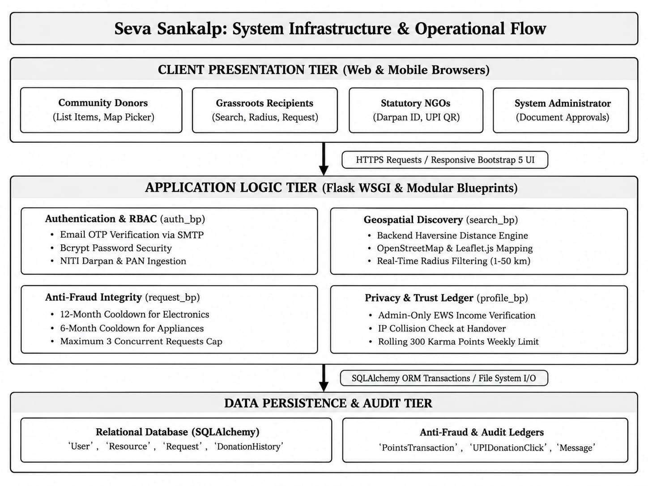
Figure 4.1: Seva Sankalp System Infrastructure and Operational Architecture Flow
Description: This architectural diagram outlines the three distinct tiers of Seva Sankalp. At the top, the Client Presentation Tier provides mobile-responsive interfaces for donors, recipients, NGOs, and administrators. In the middle, the Flask Application Logic Tier processes business rules through modular blueprints (Authentication, Geospatial Search, Anti-Fraud, and Karma Ledgers). At the bottom, the Data Persistence Tier safely commits transactions to the relational database and manages uploaded proof documents.
4.2 Anti-Fraud & Verification Flowchart Architecture:
To guarantee that items reach real, deserving individuals and prevent commercial exploitation, every resource request passes through an automated validation pipeline before any donor is notified.
• Request Submission – Beneficiary requests an item.
• Account Verification – Checks whether the account is approved.
• Impact Proof Check – Verifies previous donation proof.
• Low-Income Verification – Checks eligibility for restricted high-value items.
• Cooldown Check – Checks electronics and appliance cooldown periods.
• Request Limit Check – Allows a maximum of 3 pending requests.
• Request Approval – If all checks pass, the request is created and the donor is notified.
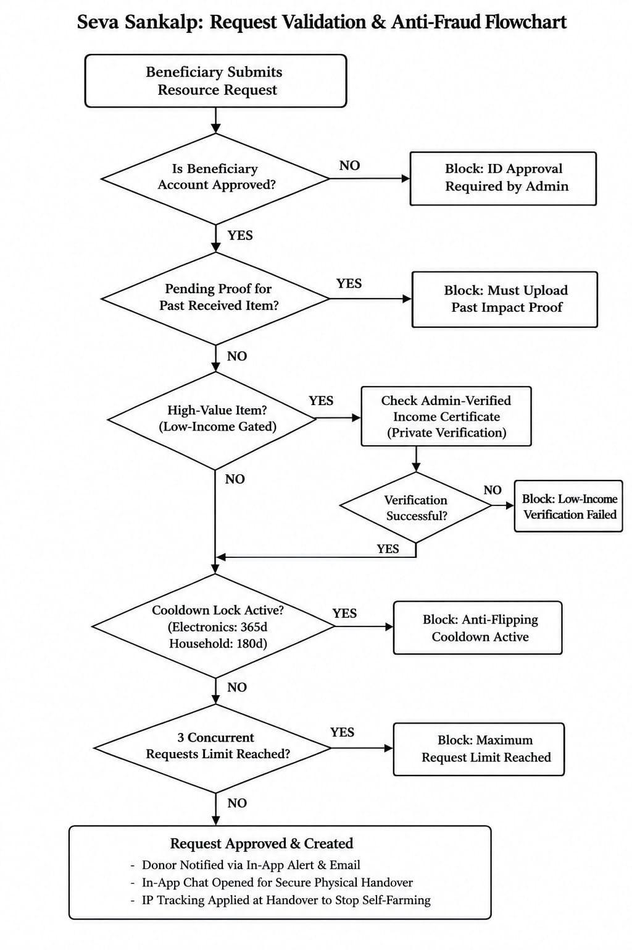
Figure 4.2: Request Validation, Anti-Fraud & Cooldown Verification Flowchart
Description: This flowchart illustrates the step-by-step decision logic executed whenever a user requests an item. The system checks account approval, verifies whether past impact proofs were submitted, inspects low-income qualifications for high-value items, verifies 12-month or 6-month category cooldown locks, and checks the 3-request hoarding cap before granting the request.
4.3 System Execution Flow
The end-to-end user workflow in Seva Sankalp operates across five clear, coordinated steps:
• 1. Listing a Resource: A donor enters details about an extra item, selects its condition, and clicks their neighborhood on an interactive Leaflet map to set pickup coordinates. For valuable items like laptops, the donor can toggle 'Restrict to Verified Low-Income Only'.
• 2. Hyperlocal Discovery: A recipient opens the search page. The application calculates the exact straight-line distance to every available item using the Haversine formula and displays only those within the recipient's chosen distance (e.g., within 5 km).
• 3. Automated Policy Checks: When the recipient clicks 'Request', the backend instantly checks the user's cooldown history and verification status. If any check fails, a helpful notification explains why.
• 4. Direct Handover Coordination: Once the donor approves the request, a private chat room opens between them. They agree on a mutually convenient time and public pickup spot.
• 5. Fulfillment & Cheat-Proof Points: The donor marks the item as fulfilled. The server verifies that the donor and recipient are on different networks, enforces the weekly points cap, awards 50 Karma points, and updates the donor's community leaderboard standing.

5. IMPLEMENTATION:
Seva Sankalp is organized into seven modular components that work together seamlessly to deliver a fast, reliable, and secure community experience.
5.1 Authentication & Statutory NGO Verification Module
User sessions are managed securely using Flask-Login, with passwords hashed using Bcrypt prior to database storage. When new users register, they verify their email through a 6-digit One-Time Password (OTP) dispatched via Flask-Mail over an encrypted SMTP connection. Community members complete interactive DigiLocker Aadhaar e-KYC verification which grants immediate auto-approval with zero document upload leaks.
For charitable organizations registering under the NGO role, the platform enforces statutory compliance by requiring:
• NITI Aayog NGO Darpan Unique ID: A valid government registration number (e.g., DL/2021/0123456) that links directly to the official government portal for administrator verification.
• Organization PAN Card Upload: Document proof ensuring that the organization is legally recognized by the Income Tax Department of India.
• Direct UPI VPA Integration: Verified NGOs can configure their UPI ID (e.g., `trustname@upi`). Donors can click an instant UPI payment intent on their smartphone to support the NGO directly with zero intermediary platform commission.
5.2 Resource Management & Hyperlocal Mapping Engine
The discovery engine provides a fast, zero-cost way for community members to find items right in their own neighborhoods:
• Mathematical Distance Calculation: Instead of paying for expensive commercial map APIs, our backend implements the mathematical **Haversine formula** directly in Python. It calculates the great-circle distance between the user's location and each available item across the curvature of the Earth.
• Interactive Map Rendering: Using **Leaflet.js** and open-source **OpenStreetMap** tiles, items are rendered as visual markers with category icons. Users can slide a radius slider (from 1 km to 50 km) to see items within walking or short driving distance.
5.3 Anti-Fraud & Anti-Flipping Integrity Engine
To prevent commercial resellers from taking advantage of donors, our backend enforces mathematical barriers to resale:
• 12-Month Cooldown for Electronics: Any user who successfully receives an electronic device (such as a laptop, phone, or tablet) is automatically locked out from requesting another electronic item for 365 days. Commercial resellers cannot make a living getting one laptop a year, which eliminates their incentive to use the platform.
• 6-Month Cooldown for Household Appliances: Refrigerators, washing machines, and cooking appliances carry a 180-day cooldown period.
• Anti-Hoarding Cap: Recipients can only have a maximum of 3 pending requests active at any time, preventing bad actors from mass-spamming donors.
5.4 Privacy-Preserving Low-Income Gatekeeper
For expensive donations, donors often want to be 100% sure their item reaches a truly underprivileged student or family:
• Centralized Administrator Verification: Beneficiaries upload their official government Income Certificate, EWS card, or BPL Ration Card in their private profile settings. The system administrator reviews and verifies the document.
• Beneficiary Dignity Preserved: Donors never see the recipient's private financial documents. Instead, incoming requests display an official **'Verified Low-Income Beneficiary (Admin Approved)'** badge, providing complete peace of mind while protecting the recipient's personal privacy.
5.5 Communication & Direct Handover Module
Once a donor accepts a request, a built-in messaging channel opens between both parties. This allows them to discuss pickup logistics safely inside the platform without broadcasting their personal phone numbers or home addresses publicly.
5.6 Gamification, Karma Points & Trust Scoring Ledger
To encourage sustained community giving, donors earn 50 Karma points for every completed donation, unlocking Bronze, Silver, Gold, and Platinum badges on the public community leaderboard. Furthermore, a dedicated Community Support & Like Button (`❤️`) allows registered citizens to endorse and boost verified grassroots NGOs:
• IP Address Collision Detection: During donation fulfillment, the server compares the donor's and recipient's login IP addresses. If they are on the same Wi-Fi network, the donation completes successfully, but 0 Karma points are awarded to prevent fake self-donations.
• Rolling 7-Day Points Cap: Users can earn a maximum of 300 Karma points in any rolling 7-day period, preventing artificial point spikes.
• Grassroot NGO Community Backing: The interactive heart-like button provides immediate social proof, allowing citizens to boost genuine organizations without requiring commercial payment gateway intermediaries.
5.7 Implementation Modules and Technology Architecture
Table 5.1 summarizes the key modules, their underlying technologies, inputs, and functional impacts:
Module Name | Underlying  Technologies | Key Inputs &  Functions | Output / UI Impact
1. Authentication & Security | Flask-Login, Bcrypt, Flask-Mail, DigiLocker e-KYC | Inputs: Email, password, 6-digit OTP, DigiLocker UID.  Functions: Password hashing, email verification, session cookies. | Protects private routes, prevents unauthorized access, and auto-approves verified citizens.
2. NGO Statutory Verification | NITI Darpan Integration, PAN Validator, Form Uploads | Inputs: Organization name, Darpan ID, PAN doc, UPI ID.  Functions: Validates format, enables admin review. | Displays verified NGO badges and enables direct mobile UPI donation buttons.
3. Hyperlocal Mapping Engine | Python Math (Haversine), Leaflet.js, OpenStreetMap | Inputs: User GPS coordinates, search radius (1-50 km).  Functions: Computes spherical distance, filters items. | Visually displays nearby items on an interactive map with walking/driving distance tags.
4. Anti-Flipping Integrity Engine | SQLAlchemy Query Filters, Datetime Calculations | Inputs: Item category, user request history.  Functions: Checks 365-day electronics and 180-day appliance locks. | Blocks duplicate requests and displays friendly countdown timers until cooldowns unlock.
5. Privacy Low-Income Gate | Admin Review Module, Secure Document Storage | Inputs: Income/EWS certificate uploads.  Functions: Admin verification workflow, permission checking. | Allows verified low-income users to request high-value items while keeping certificates private.
6. Cheat-Proof Karma Ledger | IP Address Tracker, Rolling Datetime Ledger, NGOLike | Inputs: User IP logs, fulfillment timestamps, NGO likes.  Functions: Detects same-network transactions, enforces 300 pt cap. | Prevents point farming while rewarding genuine donors with badges and community endorsements.

6. RESULTS:
The Seva Sankalp platform was tested thoroughly across multiple local donation scenarios. The following screens demonstrate the live user interface, search tools, verification flows, and administrative dashboards.
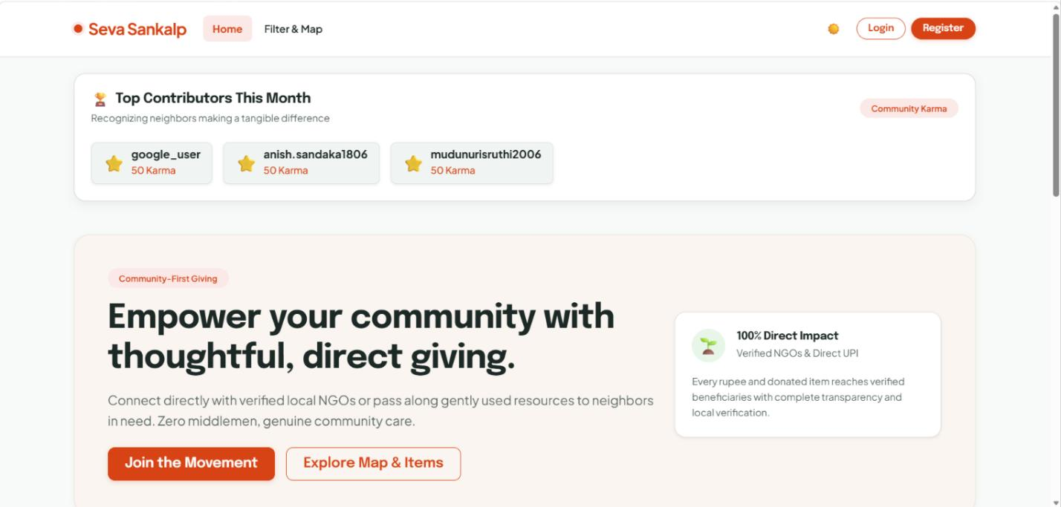
Fig 6.1 website home page
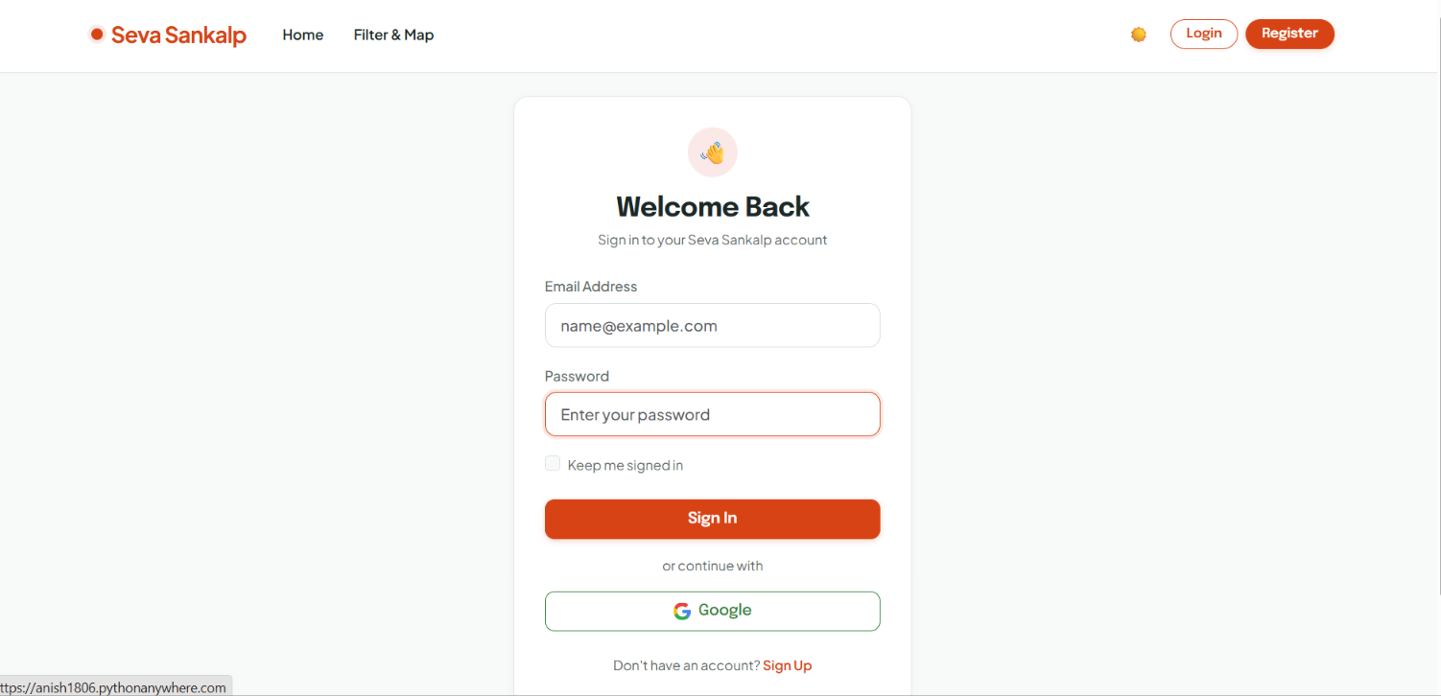
Fig 6.2 Login Page
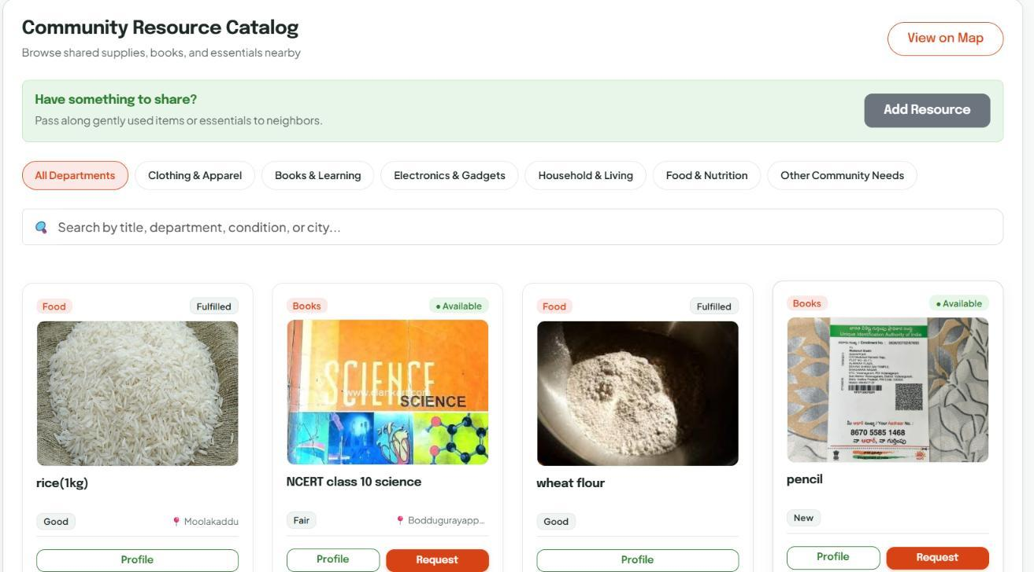
Fig 6.3 User Dashboard
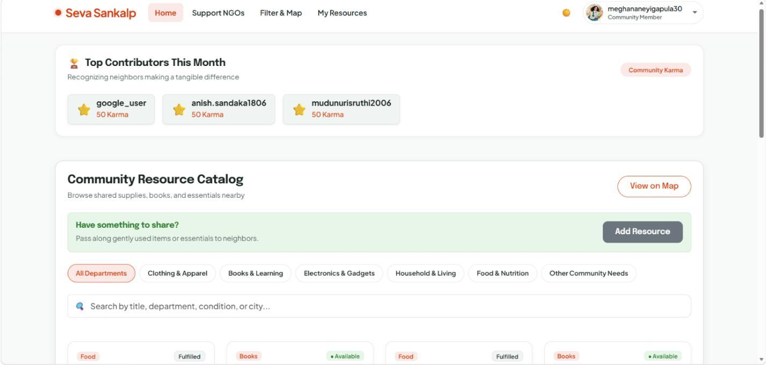
Fig 6.4 User Home Page
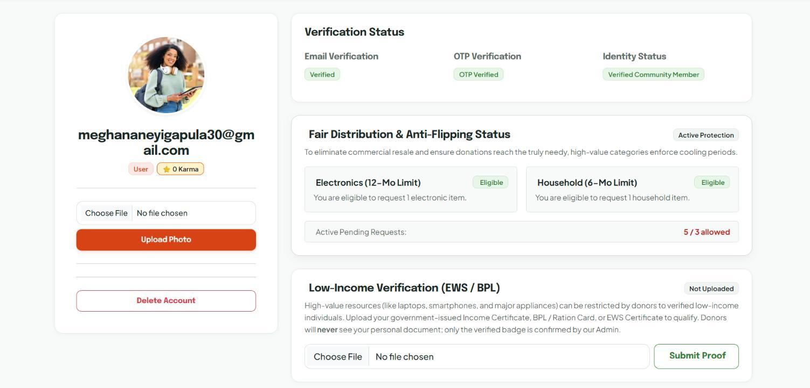
Fig 6.5 User Profile
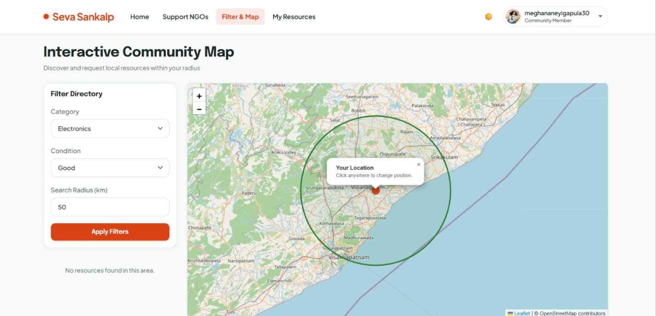
Fig 6.6 User Interactive Community Map
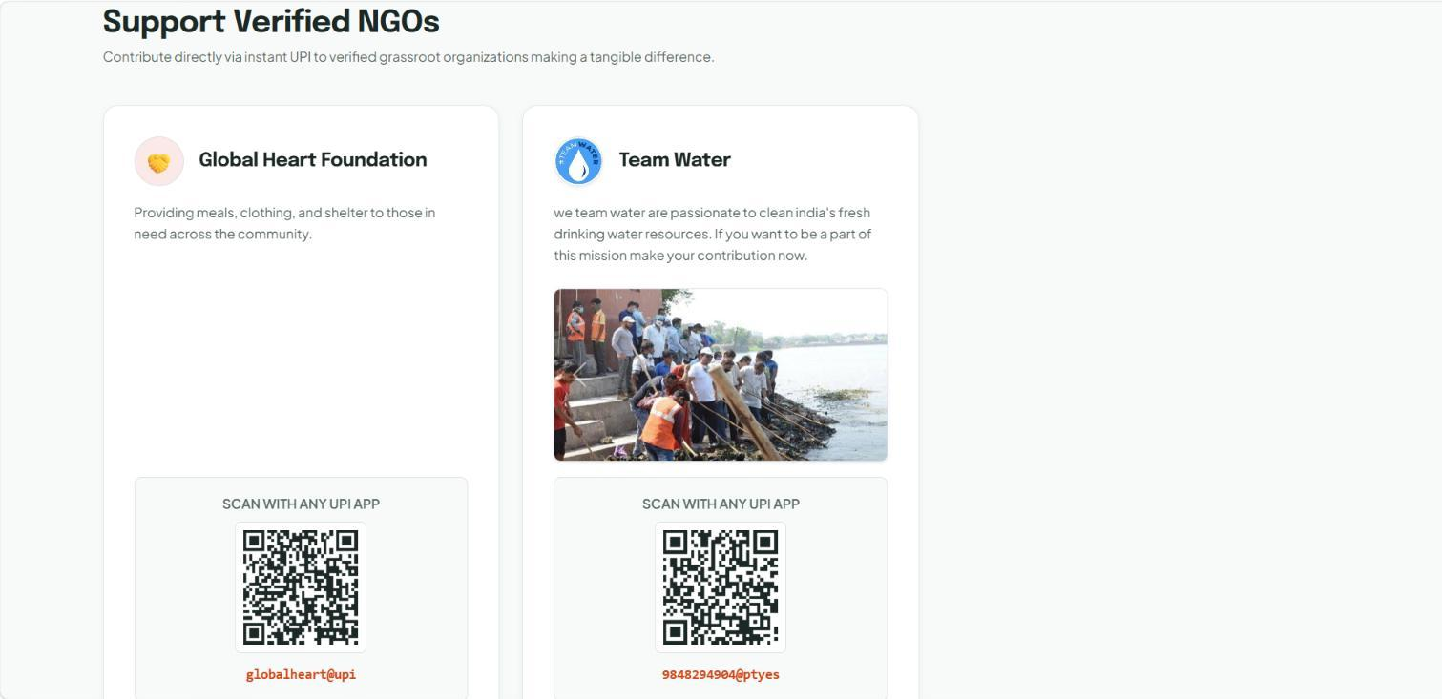
Fig 6.7 Supported NGO’s
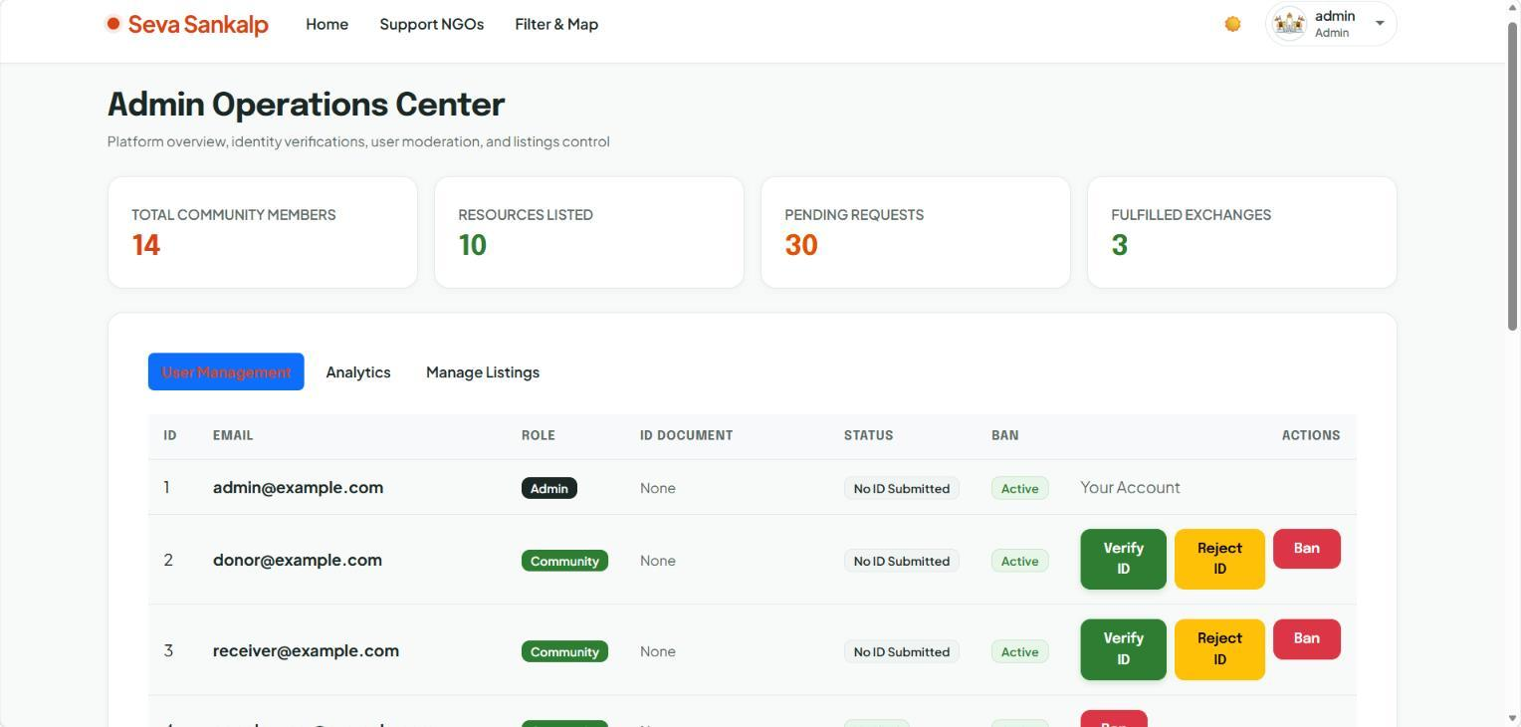
Fig 6.8 Admin Dashboard
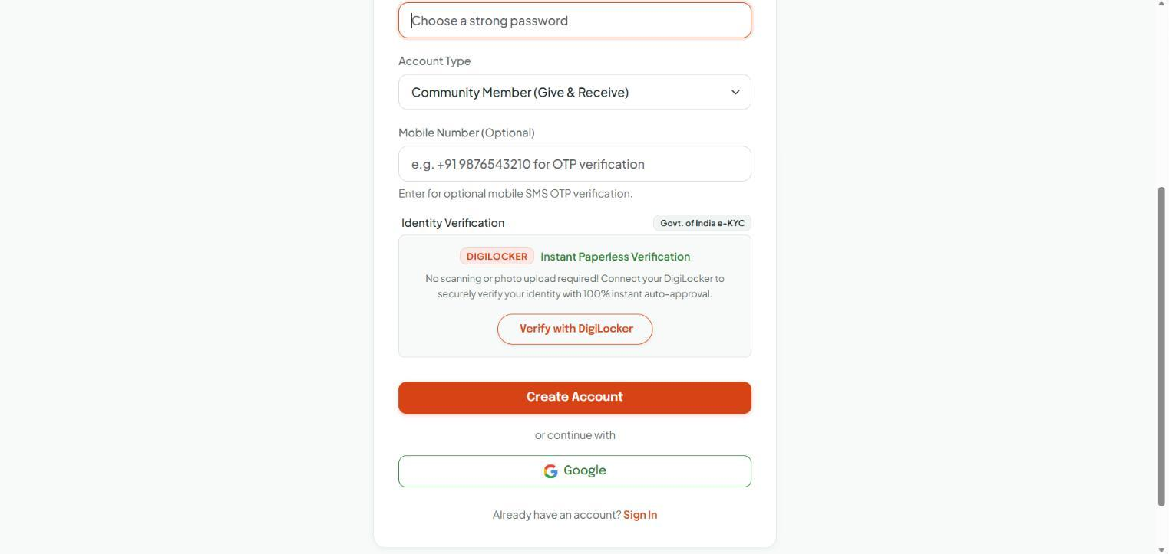
Fig 6.9 Register using DigiLocker

7. IMPACT ASSESSMENT :
7.1 Social & Community Impact :
Seva Sankalp creates strong, positive changes in how local communities support one another:
• Bridging the Digital Divide: By channeling functional used laptops, smartphones, and tablets directly to underprivileged students, the platform provides essential educational tools to families who could otherwise never afford them.
• Fostering Neighborhood Solidarity: Because the platform encourages local, face-to-face handovers, donors and recipients meet in person. This builds genuine empathy, trust, and human connection across different socioeconomic groups living in the same town.
• Preserving Human Dignity: Traditional charity often forces poor individuals to publicly prove their poverty in front of others. Seva Sankalp's private verification model ensures that beneficiaries receive vital help with full self-respect and privacy.
7.2 Economic & Resource Reuse Impact :
From an economic and environmental perspective, the platform delivers clear, measurable benefits:
• Zero Logistics Overhead: By replacing commercial courier deliveries with direct neighborhood handovers, the platform saves thousands of rupees in shipping fees that would otherwise burden low-income families.
• Extending Product Lifecycles: Every working laptop, blender, or textbook given a second life is an item kept out of municipal landfills, reducing e-waste and the environmental impact of manufacturing new goods.
7.3 Ethical, Regulatory & Data Privacy Impact :
Handling identity documents and home locations requires strict ethical boundaries:
• Compliance with India's DPDP Act, 2023: Personal data is collected strictly for legitimate platform security and verification. Passwords are encrypted with Bcrypt, and uploaded documents are stored in protected directories accessible only to verified administrators.
• Transparent Accountability: The public Karma leaderboard and review ratings incentivize honest behavior without violating personal privacy, ensuring that community members are recognized for their generosity.

8. CHALLENGES FACED :
During the development of Seva Sankalp, our team encountered several technical and design challenges that required thoughtful engineering solutions.
Accurate Hyperlocal Distance Calculations :
• Problem: Initial prototypes attempted to calculate distances using flat-grid Euclidean math. Over distances of 20 to 50 kilometers, flat calculations produced noticeable errors due to the spherical curvature of the Earth.
• Solution: We implemented the mathematical Haversine formula directly in the search service. By converting GPS latitudes and longitudes into radians and calculating great-circle distances against Earth's radius (6,371 km), our queries became accurate to within a few meters without needing commercial paid APIs.
Database Cascades & Relational Data Integrity :
• Problem: When testing user account deletions or item removals, SQLite initially threw foreign key constraint errors because associated requests, chat messages, and point transactions were still linked to the deleted record.
• Solution: We restructured our SQLAlchemy relationships to utilize cascade='all, delete-orphan' on dependent models. Now, when a donor removes an item, all related pending requests and messages are cleanly cleaned up, maintaining database stability.
Preventing Dishonest Point Farming & Self-Dealing :
• Problem: During early testing, we noticed that a user could easily create a second account on their phone and repeatedly 'donate' items back and forth to themselves to artificially boost their Karma points and top the community leaderboard.
• Solution: We added an automated IP address comparison check during the fulfillment step. If the donor and recipient are connected to the same Wi-Fi network or IP address, the donation still finishes normally, but 0 Karma points are awarded. In addition, we introduced a strict rolling 300-point weekly cap.
Balancing Beneficiary Dignity with Resale Friction :
• Problem: We needed to prevent commercial resellers from exploiting donations of valuable electronics, but making beneficiaries jump through too many hurdles risked discouraging genuine poor students who desperately needed a laptop.
• Solution: Instead of forcing all users to prove low income for every item, we applied income proof only to high-value items designated by donors. Furthermore, we kept all verification between the user and the administrator, ensuring that beneficiaries never feel stigmatized or publicly exposed.

9. CONCLUSION :
Seva Sankalp demonstrates how modern web engineering and sensible, human-centered design can solve longstanding problems in grassroots charity. By connecting local donors directly with nearby recipients and verified NGOs, the platform completely eliminates shipping costs and logistical delays, making it easy for neighbors to help neighbors.
Crucially, the platform proves that community giving can be protected against fraud without sacrificing compassion or privacy. Through common-sense anti-flipping cooldowns, statutory NITI Aayog NGO verification, and private low-income certificate checks, Seva Sankalp stops commercial resellers while guaranteeing that valuable items reach those who truly need them.
By combining an open-source geospatial stack, robust Flask architecture, and an integrity-first gamification ledger, Seva Sankalp provides an effective, scalable, and dignified blueprint for community resource redistribution across Indian towns and cities.

10. FUTURE WORK:
While the current release of Seva Sankalp accomplishes all core operational objectives, several important architectural enhancements are scheduled for future developments:
• Automated Production DigiLocker Verification Option: Expanding the existing interactive DigiLocker Aadhaar e-KYC flow into a full production government API integration through API Setu. This will allow instant cryptographic verification of student IDs, BPL cards, and MeeSeva income certificates via official government XML webhooks, fully automating the low-income verification pipeline without requiring manual administrator reviews.
• Direct OAuth Social Login Through Google: Upgrading the current prototype Google single-sign-on route into an official Google Cloud Console OAuth 2.0 client credential architecture. This will enable one-tap federated sign-in with Google Identity Services, automatic email verification bypass, and token-based account security across both desktop and mobile platforms.
• Mediated UPI & Payment Gateways Using Razorpay: Integrating automated payment gateway mediators such as Razorpay, Cashfree, or PayU alongside the existing direct peer-to-peer UPI VPA QR codes. This will enable automated transaction confirmation webhooks, real-time campaign monetary progress tracking, instant automated 80G tax exemption receipts, and escrow-based disbursement for emergency disaster relief drives.
• SMS & WhatsApp Notifications: Send instant request, approval, and pickup coordination updates over SMS and WhatsApp for users without active mobile internet.
• Native Mobile Application: Develop a lightweight cross-platform Flutter application providing push alerts, background location sync, and offline request caching.
• Live Location Tracking: Improve physical handover coordination through real-time GPS proximity tracking during local pickups.
• Corporate CSR Integration: Enable companies and educational institutions to donate surplus inventory, decommissioned laptops, and textbooks in bulk.
• Bulk Donation Management: Support large-scale logistical distribution for non-profits receiving hundreds of essential items simultaneously.

11. REFERENCES:
[1] M. Thomas and L. R. Kopczak, "Optimizing Humanitarian Supply Chains via Centralized Warehousing and Local Distribution Hubs," International Journal of Physical Distribution & Logistics Management, vol. 48, no. 3, pp. 245-263, 2018.
[2] R. Sharma and P. K. Mishra, "E-Commerce Reverse Logistics and Circular Redistribution of Pre-Owned Consumer Goods," Journal of Cleaner Production, vol. 284, p. 124718, 2021.
[3] J. R. Douceur, "The Sybil Attack in Distributed Decentralized Networks," in International Workshop on Peer-to-Peer Systems (IPTPS), Springer, pp. 251-260, 2002.
[4] N. Ramesh and K. Sundaram, "Geospatial Proximity Queries and Spherical Distance Computation in Civic Tech Applications," IEEE Access, vol. 10, pp. 45120-45131, 2022.
[5] N. Kabeer and A. Sen, "Beneficiary Dignity and Privacy in Digital Social Welfare Delivery Systems," World Development, vol. 136, p. 105112, 2020.
[6] M. Grinberg, Flask Web Development: Developing Web Applications with Python, 2nd ed., Sebastopol, CA: O'Reilly Media, 2018.
[7] OpenStreetMap Wiki Contributors, "Leaflet.js Mapping Architecture and Overpass Geospatial Querying Standards," OpenStreetMap Foundation, [Online]. Available: https://wiki.openstreetmap.org/
[8] Ministry of Electronics and Information Technology (MeitY), "Digital Personal Data Protection Act, 2023 (Act No. 22 of 2023)," The Gazette of India, Government of India, New Delhi, Aug. 2023.

APPENDIX A: PACKAGES, TOOLS USED & WORKING PROCESS
A.1 Packages & Tools Used :
The Seva Sankalp platform is built entirely using open-source, modern web development tools and Python libraries. Table A.1 lists the key dependencies and their specific functional purpose.
Package / Tool | Primary Purpose | Specific Implementation in Seva Sankalp
Python 3.13 | Core Programming Runtime | Serves as the foundational programming language executing all server logic, mathematical calculations, and database queries.
Flask 3.0 | Web Microframework | Handles HTTP routing, Blueprint modularization (`auth_bp`, `search_bp`, `request_bp`), and dynamic template rendering.
Flask-Login & Bcrypt | Authentication & Security | Manages secure user sessions, `@login_required` decorators, and cryptographic password hashing.
Flask-Mail | Email OTP Dispatch | Sends 6-digit registration OTP codes to user email addresses over encrypted TLS/SMTP connections.
SQLAlchemy ORM | Database ORM & Management | Maps Python classes directly to relational database tables and enforces cascading relationship rules.
Pillow (PIL) | Image Processing | Automatically downsamples large camera uploads to 800x800 resolution and strips EXIF GPS data.
Leaflet.js & OpenStreetMap | Interactive Mapping | Renders interactive map canvases, custom location markers, and real-time radius circles on the frontend.
Bootstrap 5 | Responsive UI Design | Provides clean, accessible, mobile-first styling and interactive modal windows across desktop and mobile screens.
Bootstrap Icons 1.11.3 | Vector UI Iconography | Renders responsive system icons, status badges, and interactive heart symbols (`❤️`) for community endorsements.

A.2 Working Process
The development of Seva Sankalp followed a structured six-phase Software Development Life Cycle (SDLC) approach:
• Phase 1: Requirements Gathering & System Specification: Conducted informal interviews with local student groups and community trusts in Vizianagaram to understand the biggest barriers to item donation. Identified the need for local radius discovery, anti-flipping rules, and private low-income verification.
• Phase 2: Database Schema & Entity Modeling: Designed the relational data schema in SQLAlchemy, establishing strict relationships, cascading delete rules, and audit models for points transactions and donation histories.
• Phase 3: Backend Blueprint & Geospatial Development: Constructed the Flask MVC architecture with dedicated blueprints. Implemented the mathematical Haversine distance algorithm in Python and integrated Leaflet.js with OpenStreetMap.
• Phase 4: Anti-Fraud & Gating Pipeline Engineering: Programmed the 12-month electronics cooldown, the 6-month appliance lock, the 3-request hoarding cap, and the IP collision detector during donation fulfillment.
• Phase 5: User Interface Design & Responsiveness: Crafted clean, accessible HTML5 templates using Bootstrap 5. Tested on both mobile smartphones and widescreen desktop displays to ensure smooth usability.
• Phase 6: Comprehensive Testing & Production Readiness: Ran end-to-end integration tests on simulated local donations. Verified that same-network transactions correctly award 0 Karma points and confirmed that cooldown locks prevent premature second requests.

APPENDIX B: SOURCE CODE
Below are critical excerpts from the production Seva Sankalp source code, demonstrating the mathematical distance algorithm, anti-flipping cooldown rules, cheat-proof points logic, NGO verification pipeline, and relational database models.
B.1 Hyperlocal Haversine Distance Search (`app/core/search_routes.py`)
Calculates the great-circle distance between two geographic coordinates and returns items within the user's chosen radius:
import math
from flask import Blueprint, request, jsonify
from flask_login import login_required
from app.models import Resource

search_bp = Blueprint('search_routes', __name__, url_prefix='/search')

def haversine(lat1, lon1, lat2, lon2):
# Calculates spherical distance in kilometers between two GPS points
R = 6371.0 # Earth's mean radius in km
dlat = math.radians(lat2 - lat1)
dlon = math.radians(lon2 - lon1)
a = math.sin(dlat / 2) ** 2 + math.cos(math.radians(lat1)) * math.cos(math.radians(lat2)) * math.sin(dlon / 2) ** 2
c = 2 * math.atan2(math.sqrt(a), math.sqrt(1 - a))
return R * c

@search_bp.route('/api/resources', methods=['GET'])
@login_required
def api_resources():
category = request.args.get('category')
condition = request.args.get('condition')
lat = request.args.get('lat', type=float)
lng = request.args.get('lng', type=float)
radius = request.args.get('radius', type=float)

query = Resource.query.filter_by(status='Available')
if category: query = query.filter(Resource.category == category)
if condition: query = query.filter(Resource.condition == condition)
resources = query.all()
results = []
for r in resources:
distance = None
if lat is not None and lng is not None and r.location_lat and r.location_lng:
distance = haversine(lat, lng, r.location_lat, r.location_lng)
if radius and distance > radius: continue
elif radius: continue
results.append({'id': r.id, 'title': r.title, 'distance': round(distance, 1) if distance is not None else None})
return jsonify(results)

B.2 Anti-Flipping Cooldown & Low-Income Gating (`app/core/request_routes.py`)
Enforces the 12-month electronics cooldown, 6-month appliance cooldown, 3-request hoarding cap, and private income check:
from datetime import datetime, timedelta
from flask import flash, redirect, url_for
from flask_login import current_user
from app.models import Resource, Request as DonationRequest

def validate_resource_request(resource, back_url):
# Prevent duplicate active requests for the exact same resource
already_requested = DonationRequest.query.filter_by(
resource_id=resource.id, receiver_id=current_user.id
).filter(DonationRequest.status.in_(['Pending', 'Accepted'])).first()

if already_requested:
flash('You already have an active request for this item.', 'info')
return False

# Anti-Hoarding: Maximum 3 active pending requests across all items
pending_count = DonationRequest.query.filter_by(receiver_id=current_user.id, status='Pending').count()
if pending_count >= 3:
flash('Anti-Hoarding Cap: You have 3 pending requests awaiting decisions.', 'warning')
return False

# Low-Income Gate for High-Value / Donor-Restricted Items
if resource.requires_income_proof:
if current_user.income_verification_status != 'approved':
flash('Low-Income Proof Required: Donor restricted this item to verified EWS.', 'warning')
return False

# Anti-Flipping: 12-Month Cooldown on Electronics
if resource.category == 'Electronics':
one_year_ago = datetime.utcnow() - timedelta(days=365)
fulfilled_elec = DonationRequest.query.join(Resource).filter(
DonationRequest.receiver_id == current_user.id,
DonationRequest.status == 'Fulfilled',
Resource.category == 'Electronics',
DonationRequest.updated_at >= one_year_ago
).order_by(DonationRequest.updated_at.desc()).first()

if fulfilled_elec:
days_passed = (datetime.utcnow() - fulfilled_elec.updated_at).days
days_left = max(1, 365 - days_passed)
flash(f'Electronics Cooldown Active: Unlocks in {days_left} days.', 'warning')
return False

return True

B.3 Sybil-Hardened Karma Points & IP Collision Check (`app/core/request_routes.py`)
Detects same-network transactions during fulfillment and enforces the rolling 300 Karma Points weekly cap:
from datetime import datetime, timedelta
from flask import flash
from app import db
from app.models import PointsTransaction

def award_fulfillment_karma(donor, receiver):
points_awarded = 50
fraud_warning = None

# Anti-Fraud 1: IP Address Collision Check
if donor.last_login_ip and receiver.last_login_ip and donor.last_login_ip == receiver.last_login_ip:
if donor.last_login_ip != '127.0.0.1':
points_awarded = 0
fraud_warning = 'Points not awarded: Donor and receiver share the same network IP.'

# Anti-Fraud 2: Weekly Rolling Point Cap (Maximum 300 points within 7 days)
if points_awarded > 0:
seven_days_ago = datetime.utcnow() - timedelta(days=7)
recent_txs = PointsTransaction.query.filter(
PointsTransaction.user_id == donor.id,
PointsTransaction.created_at >= seven_days_ago
).all()
recent_total = sum(tx.amount for tx in recent_txs)
if recent_total + points_awarded > 300:
points_awarded = 0
fraud_warning = 'Weekly cap reached: Maximum 300 Karma Points allowed every 7 days.'

if points_awarded > 0:
tx = PointsTransaction(user_id=donor.id, amount=points_awarded, transaction_type='earned_donation', description='Fulfilled resource donation')
donor.points_balance += points_awarded
db.session.add(tx)
db.session.commit()
flash(f'Donation completed! You earned {points_awarded} Karma Points.', 'success')
else:
db.session.commit()
flash(f'Donation completed! {fraud_warning}', 'warning')

B.4 Statutory NGO Document Verification Pipeline (`app/core/admin_routes.py`)
Administrator moderation routes for approving statutory NGO credentials and low-income certificates:
from flask import Blueprint, render_template, request, flash, redirect, url_for
from flask_login import login_required
from app import db
from app.models import User

admin_bp = Blueprint('admin_routes', __name__, url_prefix='/admin')

@admin_bp.route('/approve-ngo/<int:user_id>', methods=['POST'])
@login_required
def approve_ngo(user_id):
ngo_user = User.query.get_or_404(user_id)
action = request.form.get('action') # 'approve' or 'reject'
if action == 'approve':
ngo_user.verification_status = 'approved'
flash(f'Statutory NGO {ngo_user.ngo_name} (Darpan ID: {ngo_user.darpan_id}) verified!', 'success')
else:
ngo_user.verification_status = 'rejected'
flash(f'NGO registration for {ngo_user.ngo_name} was rejected.', 'danger')
db.session.commit()
return redirect(url_for('admin_routes.admin_dashboard'))

@admin_bp.route('/verify-income/<int:user_id>', methods=['POST'])
@login_required
def verify_income(user_id):
beneficiary = User.query.get_or_404(user_id)
decision = request.form.get('decision')
if decision == 'approve':
beneficiary.income_verification_status = 'approved'
flash('Beneficiary low-income status verified. EWS badge awarded.', 'success')
else:
beneficiary.income_verification_status = 'rejected'
flash('Beneficiary income document rejected.', 'warning')
db.session.commit()
return redirect(url_for('admin_routes.admin_dashboard'))

B.5 Core Relational Database Schema (`app/models.py`)
SQLAlchemy model declarations for Users, Resources, Requests, Community Endorsements (`NGOLike`), and Anti-Fraud tracking attributes:
from datetime import datetime
from app import db
from flask_login import UserMixin

class User(UserMixin, db.Model):
__tablename__ = 'users'
id = db.Column(db.Integer, primary_key=True)
email = db.Column(db.String(120), unique=True, nullable=False)
password_hash = db.Column(db.String(128), nullable=False)
role = db.Column(db.String(20), default='user')
verification_status = db.Column(db.String(20), default='pending')
is_ngo = db.Column(db.Boolean, default=False)
ngo_name = db.Column(db.String(150), nullable=True)
darpan_id = db.Column(db.String(50), nullable=True)
org_pan = db.Column(db.String(20), nullable=True)
income_verification_status = db.Column(db.String(20), default='none')
last_login_ip = db.Column(db.String(45), nullable=True)
points_balance = db.Column(db.Integer, default=0)
trust_score = db.Column(db.Integer, default=0)

@property
def likes_count(self):
return NGOLike.query.filter_by(ngo_id=self.id).count()

def is_liked_by(self, user):
if not user or not getattr(user, 'is_authenticated', False): return False
return NGOLike.query.filter_by(ngo_id=self.id, user_id=user.id).first() is not None

class Resource(db.Model):
__tablename__ = 'resources'
id = db.Column(db.Integer, primary_key=True)
donor_id = db.Column(db.Integer, db.ForeignKey('users.id'), nullable=False)
title = db.Column(db.String(100), nullable=False)
category = db.Column(db.String(50), nullable=False)
condition = db.Column(db.String(50), nullable=False)
location_lat = db.Column(db.Float, nullable=True)
location_lng = db.Column(db.Float, nullable=True)
requires_income_proof = db.Column(db.Boolean, default=False)
status = db.Column(db.String(20), default='Available')

class Request(db.Model):
__tablename__ = 'requests'
id = db.Column(db.Integer, primary_key=True)
resource_id = db.Column(db.Integer, db.ForeignKey('resources.id'), nullable=False)
receiver_id = db.Column(db.Integer, db.ForeignKey('users.id'), nullable=False)
status = db.Column(db.String(20), default='Pending')
created_at = db.Column(db.DateTime, default=datetime.utcnow)
updated_at = db.Column(db.DateTime, default=datetime.utcnow)

class NGOLike(db.Model):
__tablename__ = 'ngo_likes'
id = db.Column(db.Integer, primary_key=True)
user_id = db.Column(db.Integer, db.ForeignKey('users.id'), nullable=False)
ngo_id = db.Column(db.Integer, db.ForeignKey('users.id'), nullable=False)
created_at = db.Column(db.DateTime, default=datetime.utcnow)
__table_args__ = (db.UniqueConstraint('user_id', 'ngo_id', name='unique_user_ngo_like'),)

